**EXPERIMENT-12  
LabBook:**

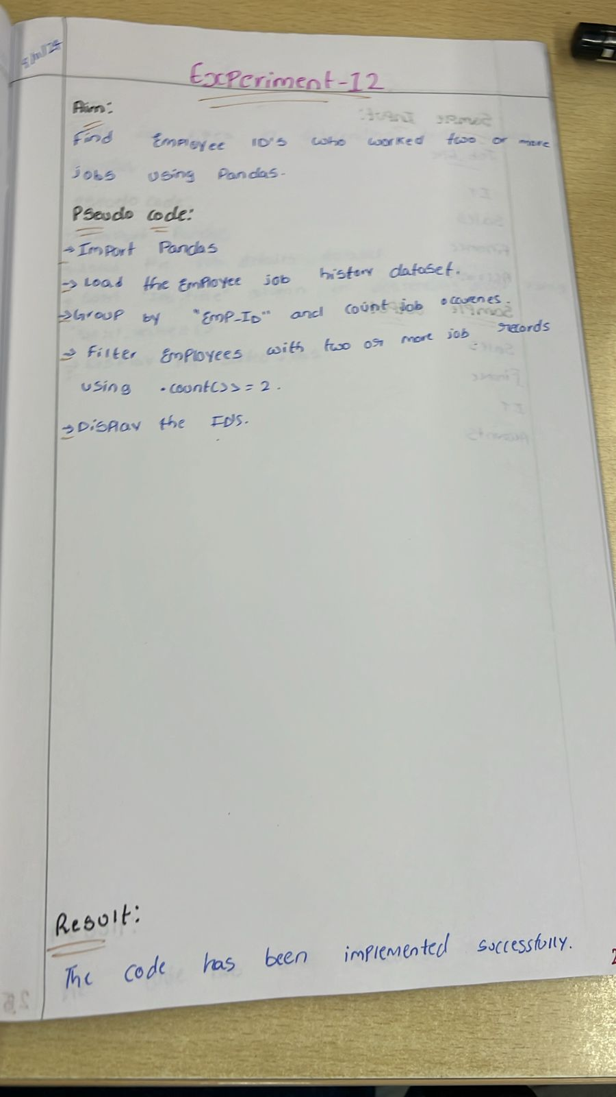

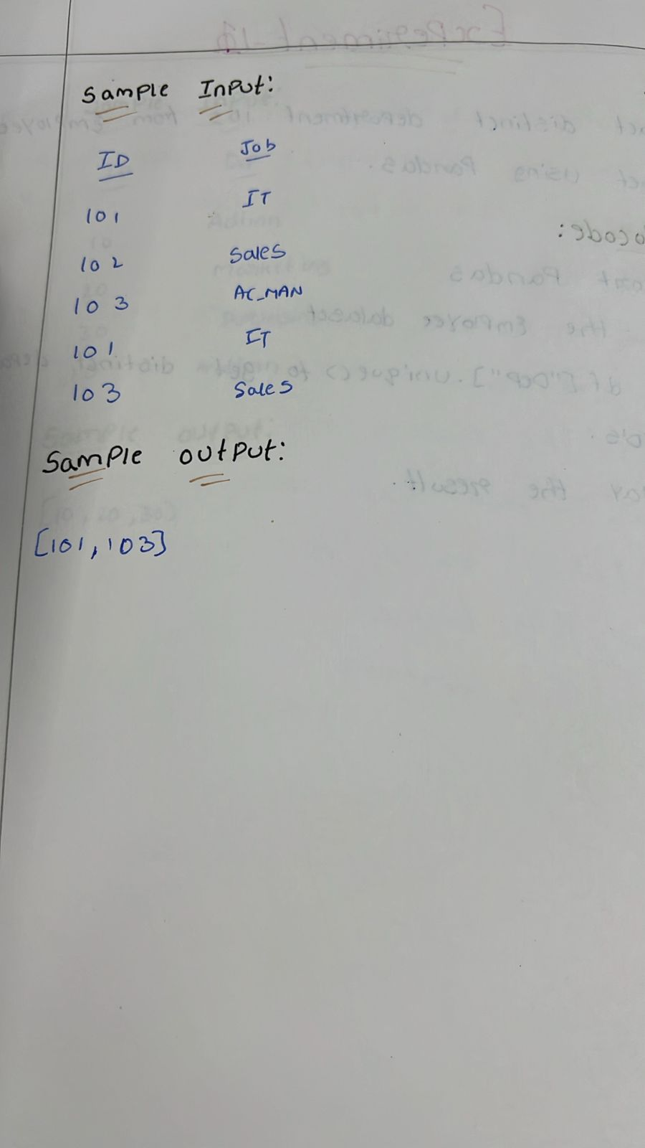

**Sample code:**

import numpy as np

import pandas as pd

np.random.seed(0)

df = pd.DataFrame(np.random.randn(10, 5), columns=list("ABCDE"))

black_bg = '\033[40m'

yellow_text = '\033[33m'

reset = '\033[0m'

for index, row in df.iterrows():

    formatted_row = [f"{black_bg}{yellow_text}{value:.5f}{reset}" for value in row]

    print(' | '.join(formatted_row))

**Sample output:**

