**EXPERIMENT-13  
LabBook:**

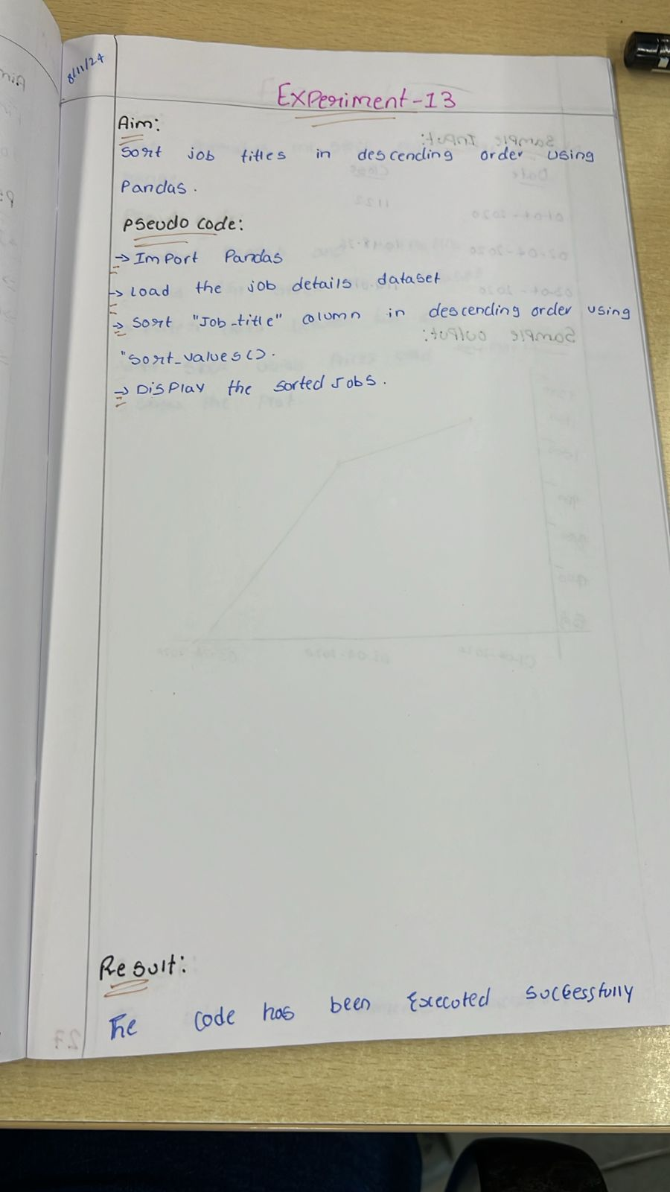



**Sample code:**

import pandas as pd

import numpy as np

data = {

    'ord_no': [70001, np.nan, 70002, 70004, np.nan, 70005, np.nan, 70010, 70003, 70012, np.nan, 70013],

    'purch_amt': [150.5, 270.65, 65.26, 110.5, 948.5, 2400.6, 5760.0, 1983.43, 2480.4, 250.45, 75.29, 3045.6],

    'ord_date': ['2012-10-05', '2012-09-10', np.nan, '2012-08-17', '2012-09-10', '2012-07-27', '2012-09-10', '2012-10-10', '2012-06-27', '2012-08-17', '2012-08-17', '2012-04-25'],

    'customer_id': [3002, 3001, 3001, 3003, 3002, 3001, 3001, 3001, 3003, 3002, 3001, 3001],

    'salesman_id': [5002, 5003, 5001, np.nan, 5002, 5001, 5001, 5003, 5003, 5002, 5003, np.nan]

}

df = pd.DataFrame(data)

missing_values = df.isnull()

print(missing_values)

**Sample output:**

