**EXPERIMENT-16  
LabBook:**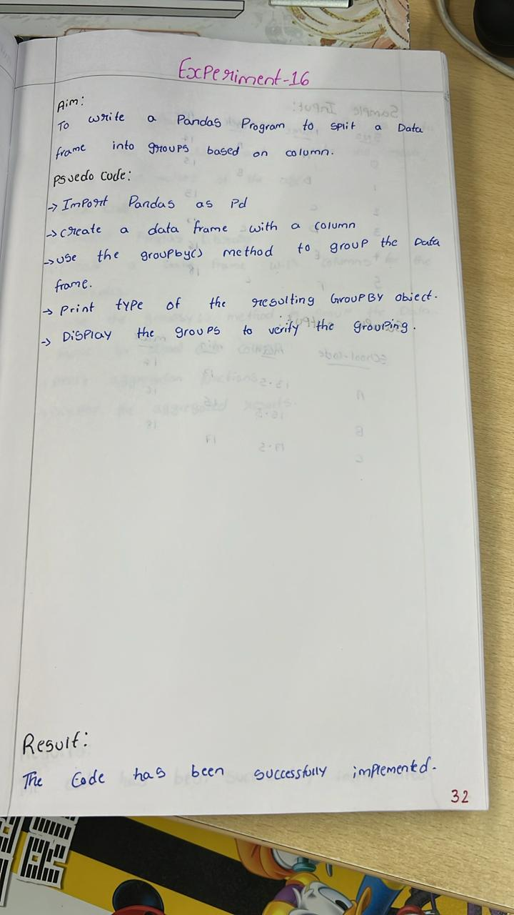

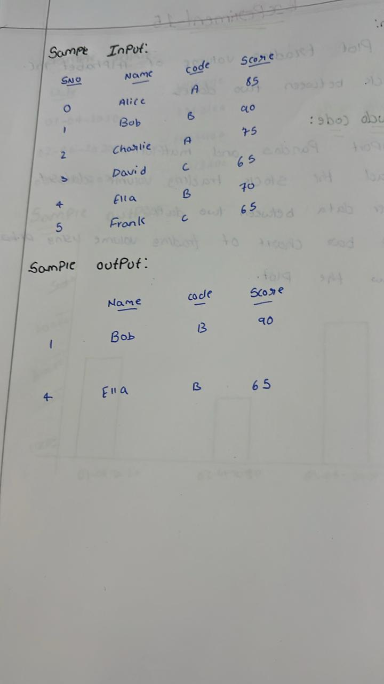

**Sample code:**

import pandas as pd

data = {

    'student_name': ['Alice', 'Bob', 'Charlie', 'David', 'Ella', 'Frank'],

    'school_code': ['A', 'B', 'A', 'C', 'B', 'C'],

    'score': [85, 90, 78, 88, 76, 95]

}

df = pd.DataFrame(data)

grouped_df = df.groupby('school_code')

print("Type of GroupBy object:", type(grouped_df))

for name, group in grouped_df:

    print(f"\nGroup: {name}")

    print(group)

**Sample output:**

