**EXPERIMENT-18  
LabBook:**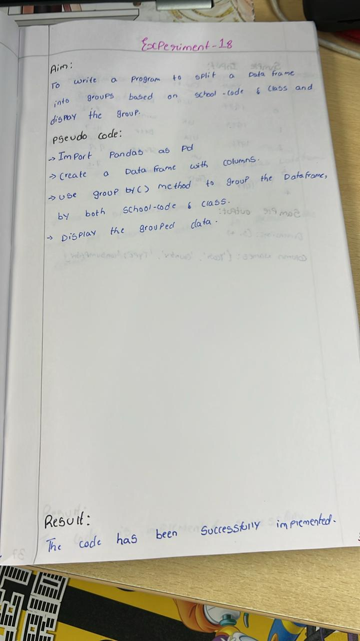



**Sample code:**

import pandas as pd

data = {

    'student_name': ['Alice', 'Bob', 'Charlie', 'David', 'Ella', 'Frank'],

    'school_code': ['A', 'B', 'A', 'C', 'B', 'C'],

    'class': ['X', 'Y', 'X', 'Z', 'Y', 'Z'],

    'score': [85, 90, 78, 88, 76, 95]

}

df = pd.DataFrame(data)

grouped_df = df.groupby(['school_code', 'class'])

print("Grouped DataFrame:")

for (school, class_name), group in grouped_df:

    print(f"\nGroup: School Code = {school}, Class = {class_name}")

    print(group)

**Sample output:**

