**EXPERIMENT-19  
LabBook:**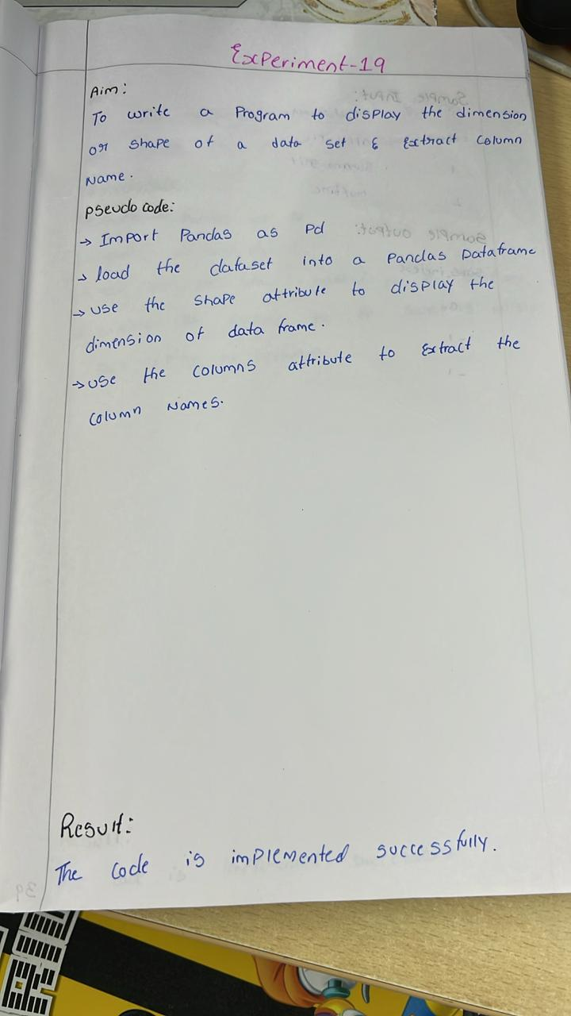

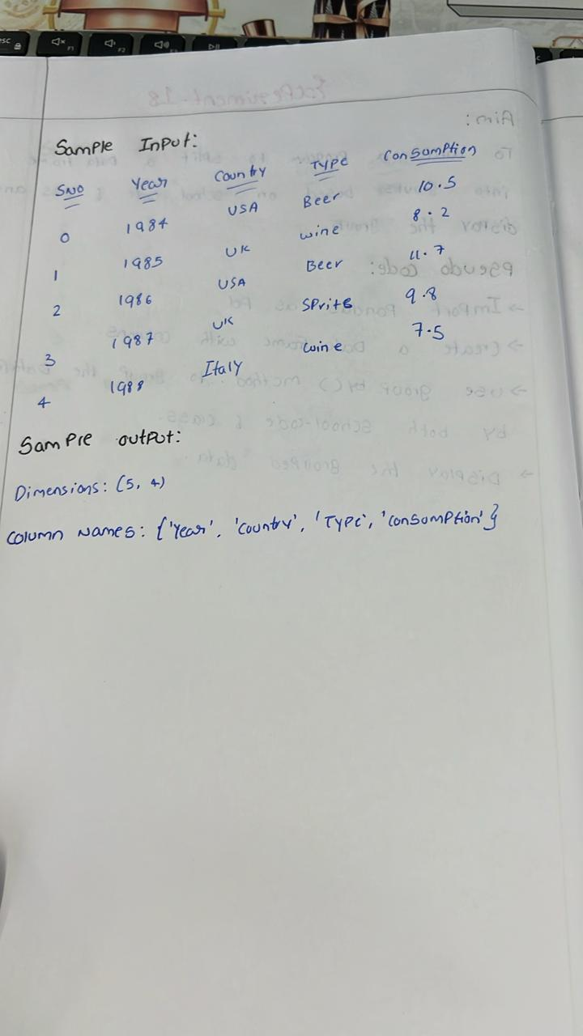

**Sample code:**

import pandas as pd

df = pd.DataFrame({

    'Year': [1984, 1985, 1986, 1987, 1988],

    'Country': ['USA', 'Canada', 'France', 'Germany', 'Italy'],

    'Beverage Type': ['Beer', 'Wine', 'Beer', 'Spirits', 'Wine'],

    'Consumption': [10.5, 8.2, 11.7, 9.8, 7.5]

})

print("Dimensions of the dataset (rows, columns):", df.shape)

print("Column names in the dataset:")

print(df.columns.tolist())

**Sample output:**

