**EXPERIMENT-2**

**Lab Book:**

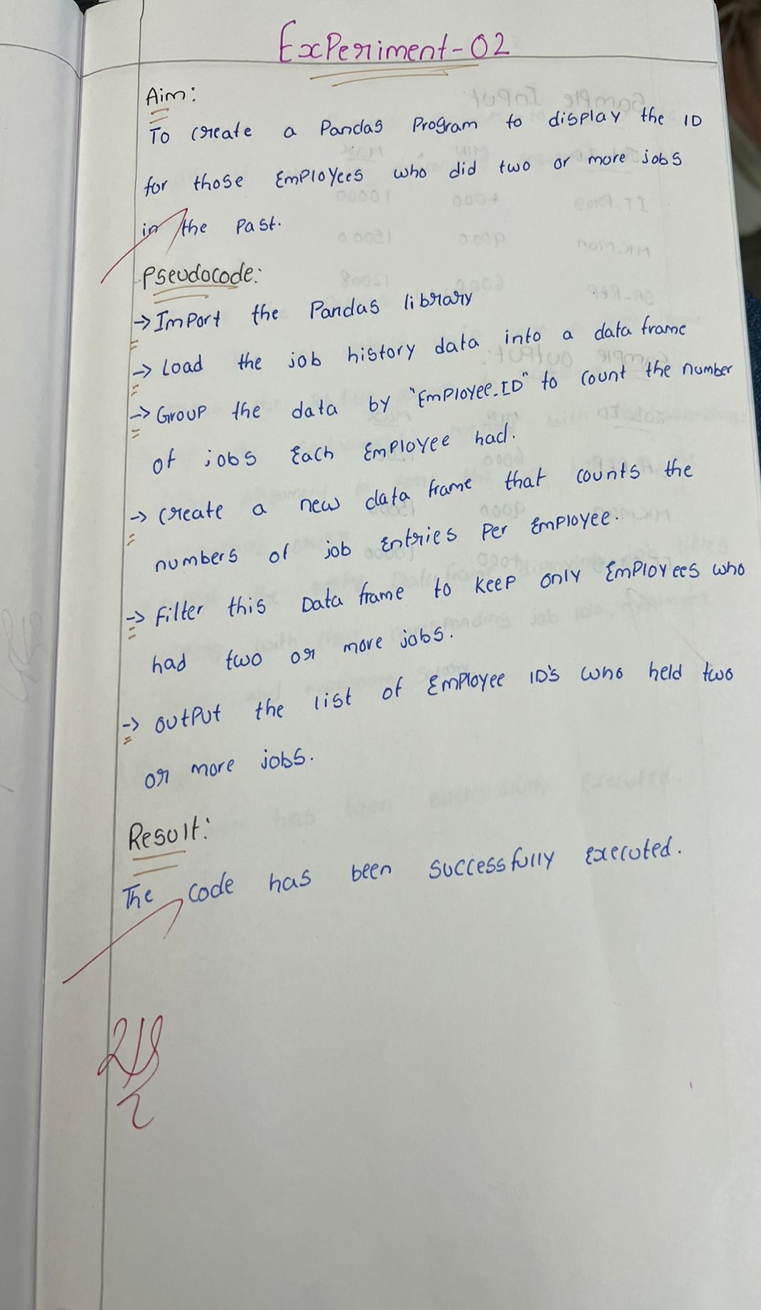

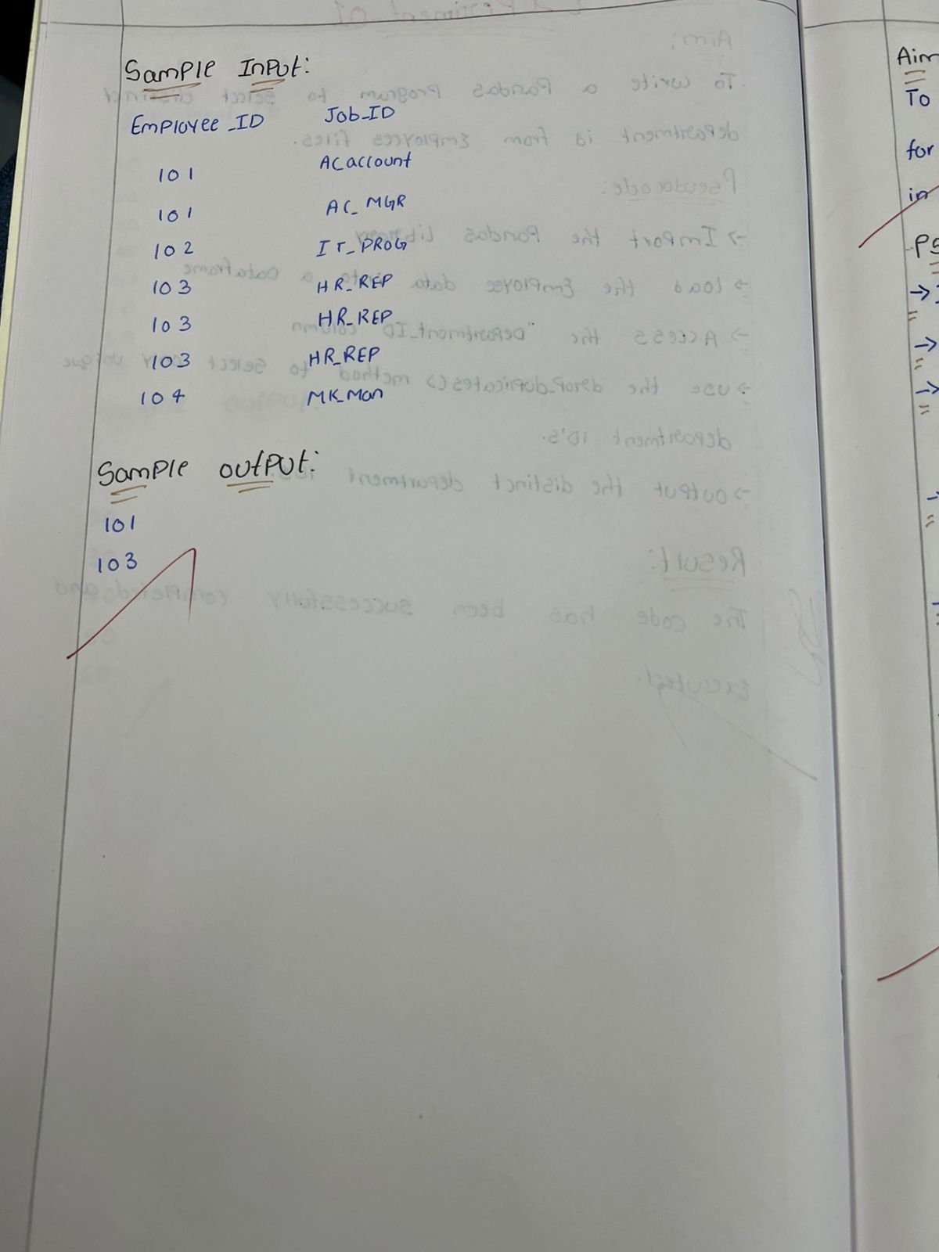

**Sample code:**

import pandas as pd

data = {'EMPLOYEE_ID': [102, 101, 101, 201, 114, 122, 200, 176, 176, 200],

        'JOB_ID': ['IT_PROG', 'AC_ACCOUNT', 'AC_MGR', 'MK_REP', 'ST_CLERK', 'ST_CLERK', 'AD_ASST', 'SA_REP', 'SA_MAN', 'AC_ACCOUNT']}

df = pd.DataFrame(data)

employee_multiple_jobs = df.groupby('EMPLOYEE_ID').filter(lambda x: len(x) > 1)['EMPLOYEE_ID'].unique()

print(employee_multiple_jobs)

**Sample output:**

