**EXPERIMENT-20  
LabBook:**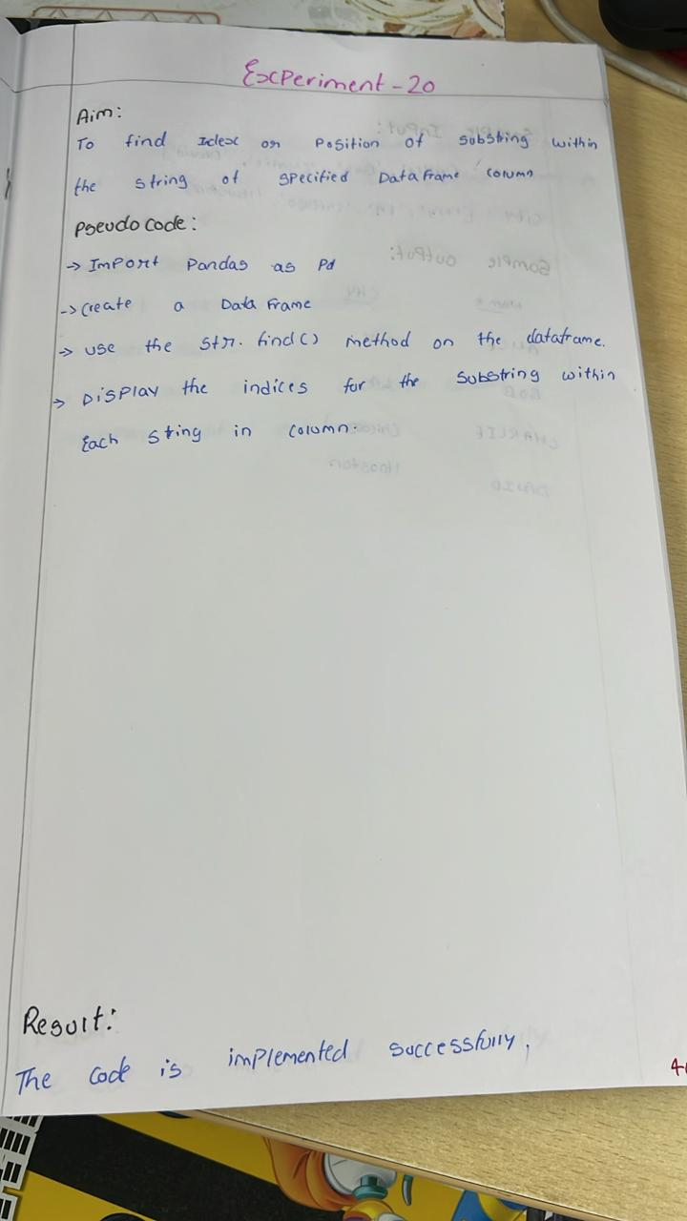

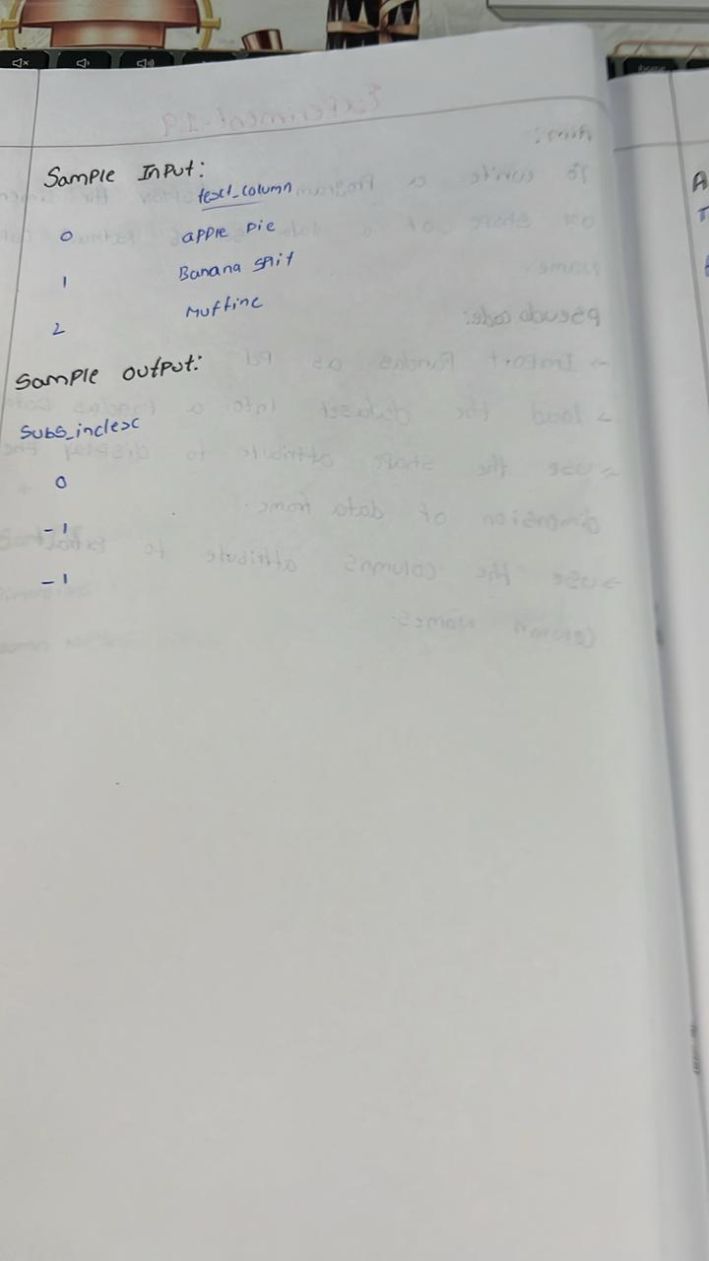

**Sample code:**

import pandas as pd

data = {

    'text_column': ['apple pie', 'banana split', 'cherry tart', 'apple turnover', 'blueberry muffin']

}

df = pd.DataFrame(data)

substring = 'apple'

df['substring_index'] = df['text_column'].str.find(substring)

print("DataFrame with indices of the substring:")

print(df)

**Sample output:**

