**EXPERIMENT-24  
LabBook:**



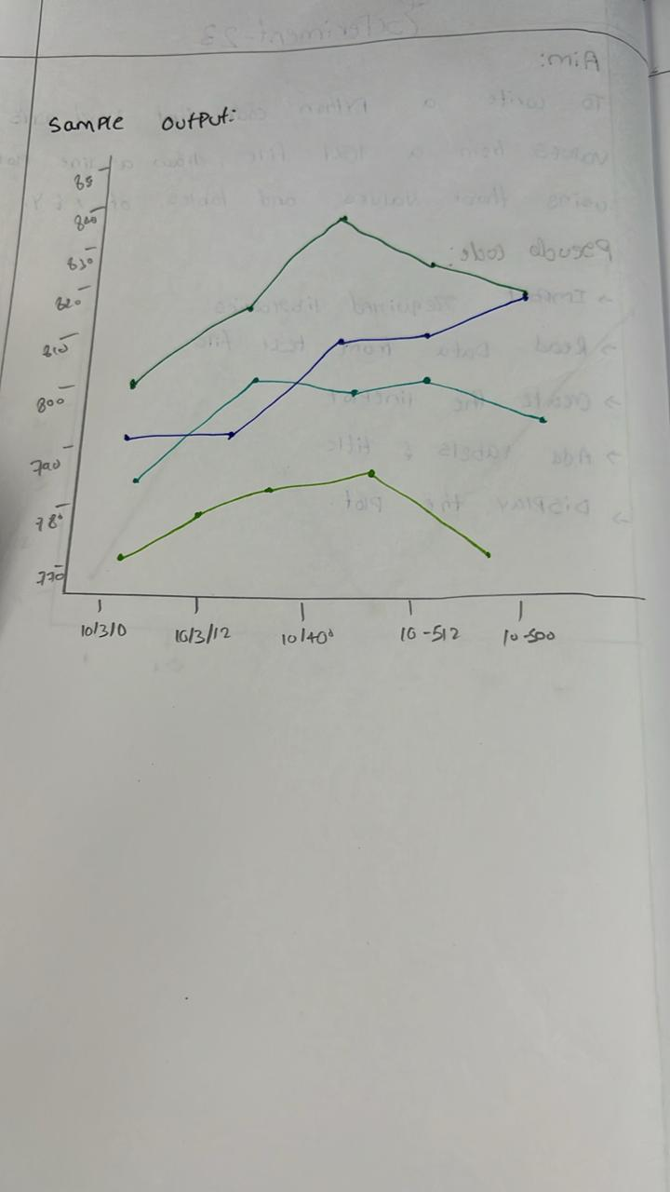

**Sample code:**

import pandas as pd

import matplotlib.pyplot as plt

data = {

    'Date': ['10-03-16', '10-04-16', '10-05-16', '10-06-16', '10-07-16'],

    'Open': [774.25, 776.030029, 779.309998, 779, 779.659973],

    'High': [776.065002, 778.710022, 782.070007, 780.47998, 779.659973],

    'Low': [769.5, 772.890015, 775.650024, 775.539978, 770.75],

    'Close': [772.559998, 776.429993, 776.469971, 776.859985, 775.080017]

}

df = pd.DataFrame(data)

df['Date'] = pd.to_datetime(df['Date'], format='%m-%d-%y')

df.set_index('Date', inplace=True)

plt.figure(figsize=(10, 6))

plt.plot(df.index, df['Open'], label='Open', marker='o')

plt.plot(df.index, df['High'], label='High', marker='o')

plt.plot(df.index, df['Low'], label='Low', marker='o')

plt.plot(df.index, df['Close'], label='Close', marker='o')

plt.xlabel('Date')

plt.ylabel('Price (USD)')

plt.title('Financial Data of Alphabet Inc. (Oct 3, 2016 - Oct 7, 2016)')

plt.legend()

plt.grid(True)

plt.show()

**Sample output:**

