**EXPERIMENT-3**

**Lab Book:**

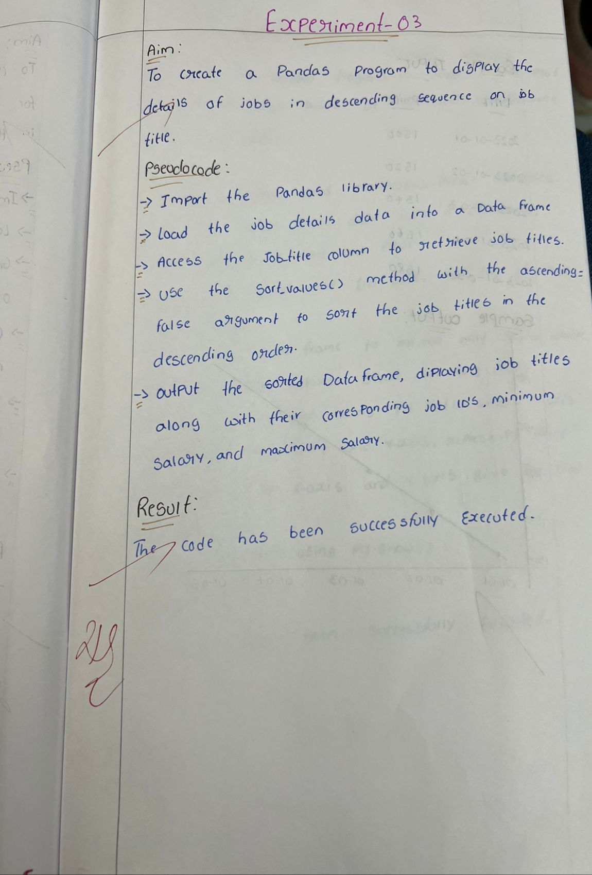

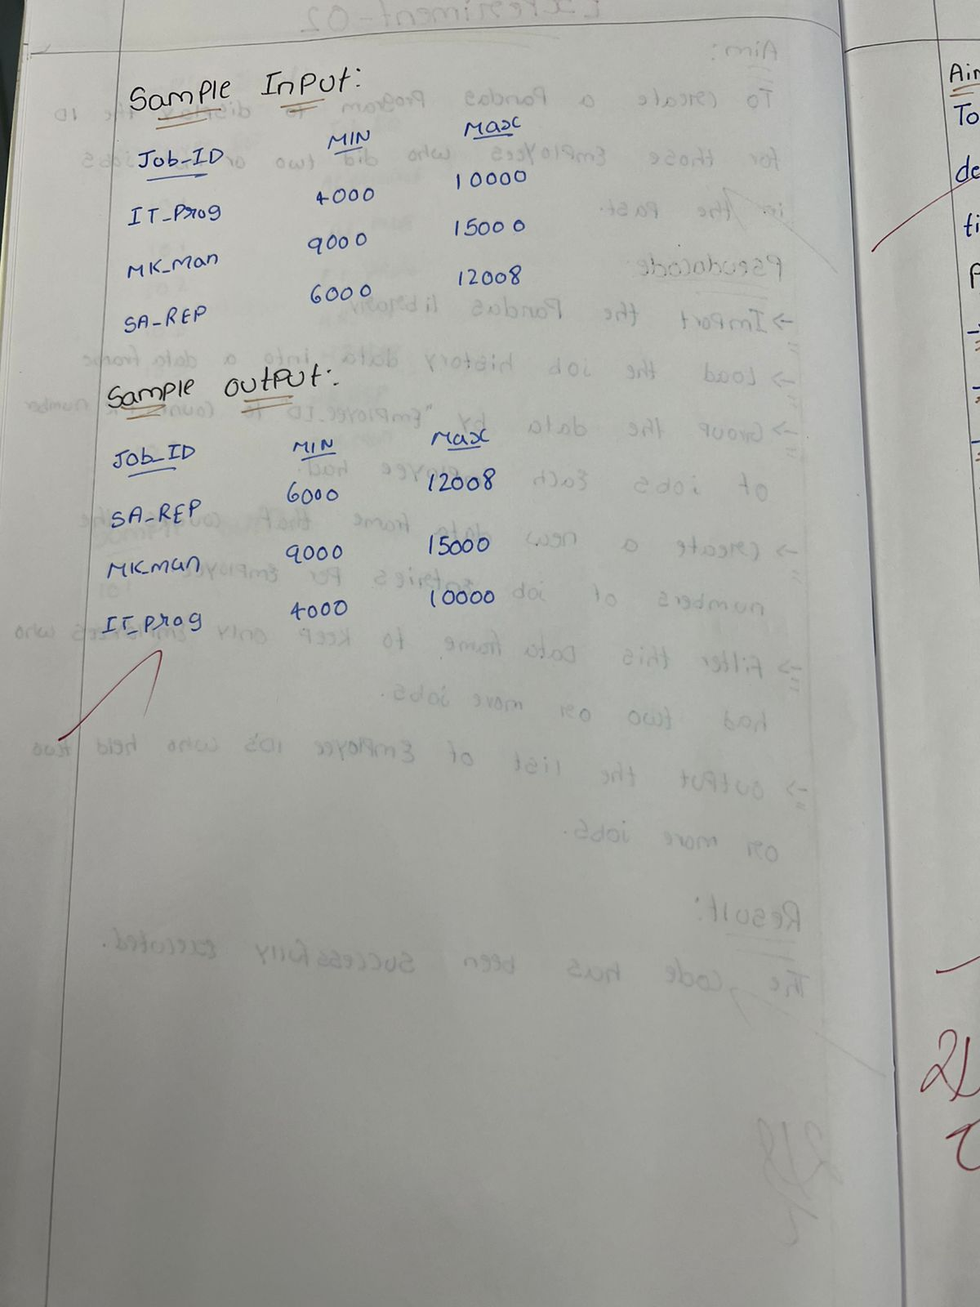

**Sample code:**

import pandas as pd

data = {'JOB_ID': ['AD_PRES', 'AD_VP', 'AD_ASST', 'FI_MGR', 'FI_ACCOUNT', 'AC_MGR', 'AC_ACCOUNT', 'SA_MAN', 'SA_REP', 'PU_MAN'],

        'JOB_TITLE': ['President', 'Administration Vice President', 'Administration Assistant', 'Finance Manager', 'Accountant', 'Accounting Manager', 'Public Accountant', 'Sales Manager', 'Sales Representative', 'Purchasing Manager'],

        'MIN_SALARY': [20080, 15000, 3000, 8200, 4200, 8200, 4200, 10000, 6000, 8000],

        'MAX_SALARY': [40000, 30000, 6000, 16000, 9000, 16000, 9000, 20080, 12008, 15000]}

df = pd.DataFrame(data)

sorted_jobs = df.sort_values(by='JOB_TITLE', ascending=False)

print(sorted_jobs)

**Sample output:**

