**EXPERIMENT-34  
LabBook:**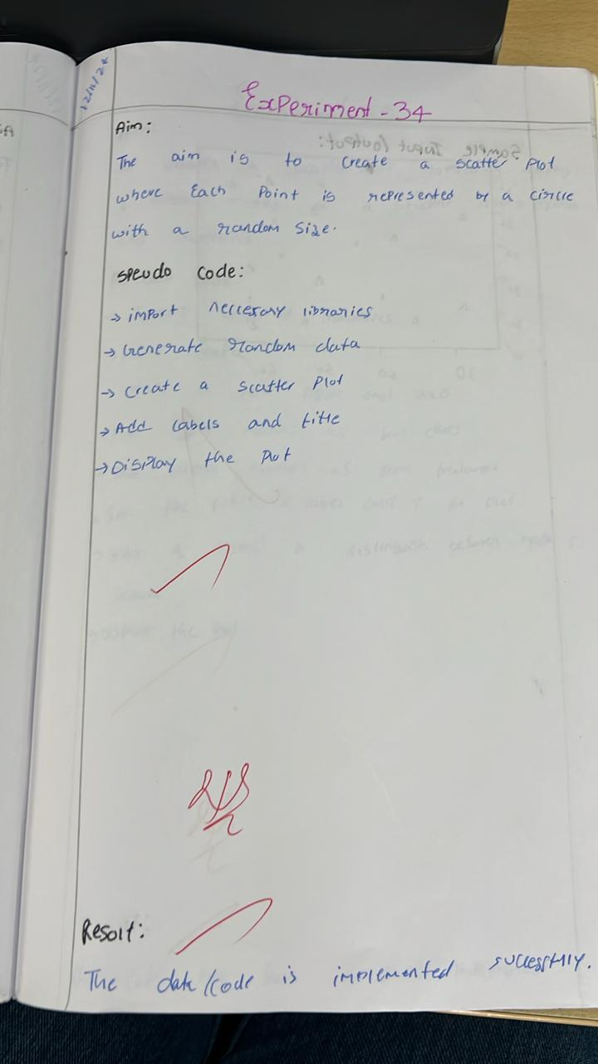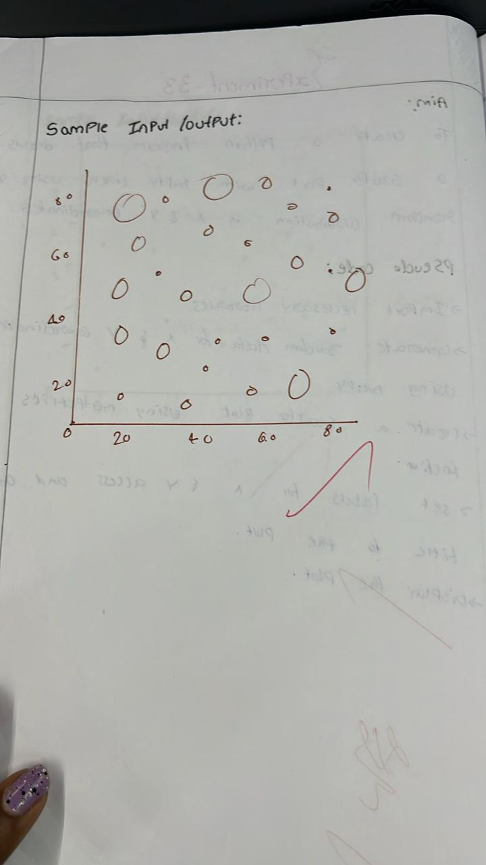

**Sample code:**

import matplotlib.pyplot as plt

import numpy as np

x = np.random.rand(50)

y = np.random.rand(50)

sizes = np.random.rand(50) * 1000  # Random sizes for the balls

plt.scatter(x, y, s=sizes, color='b', alpha=0.5)

plt.title('Scatter Plot with Random Ball Sizes')

plt.show()

**Sample output:**

