**EXPERIMENT-4**

**Lab Book:**

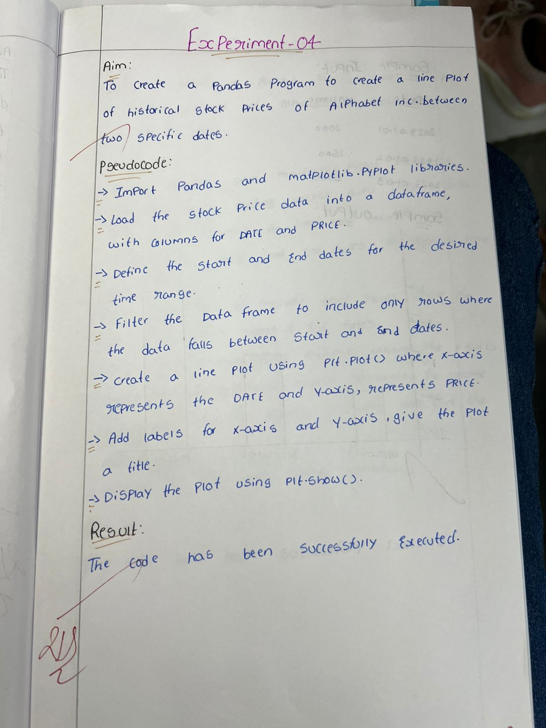

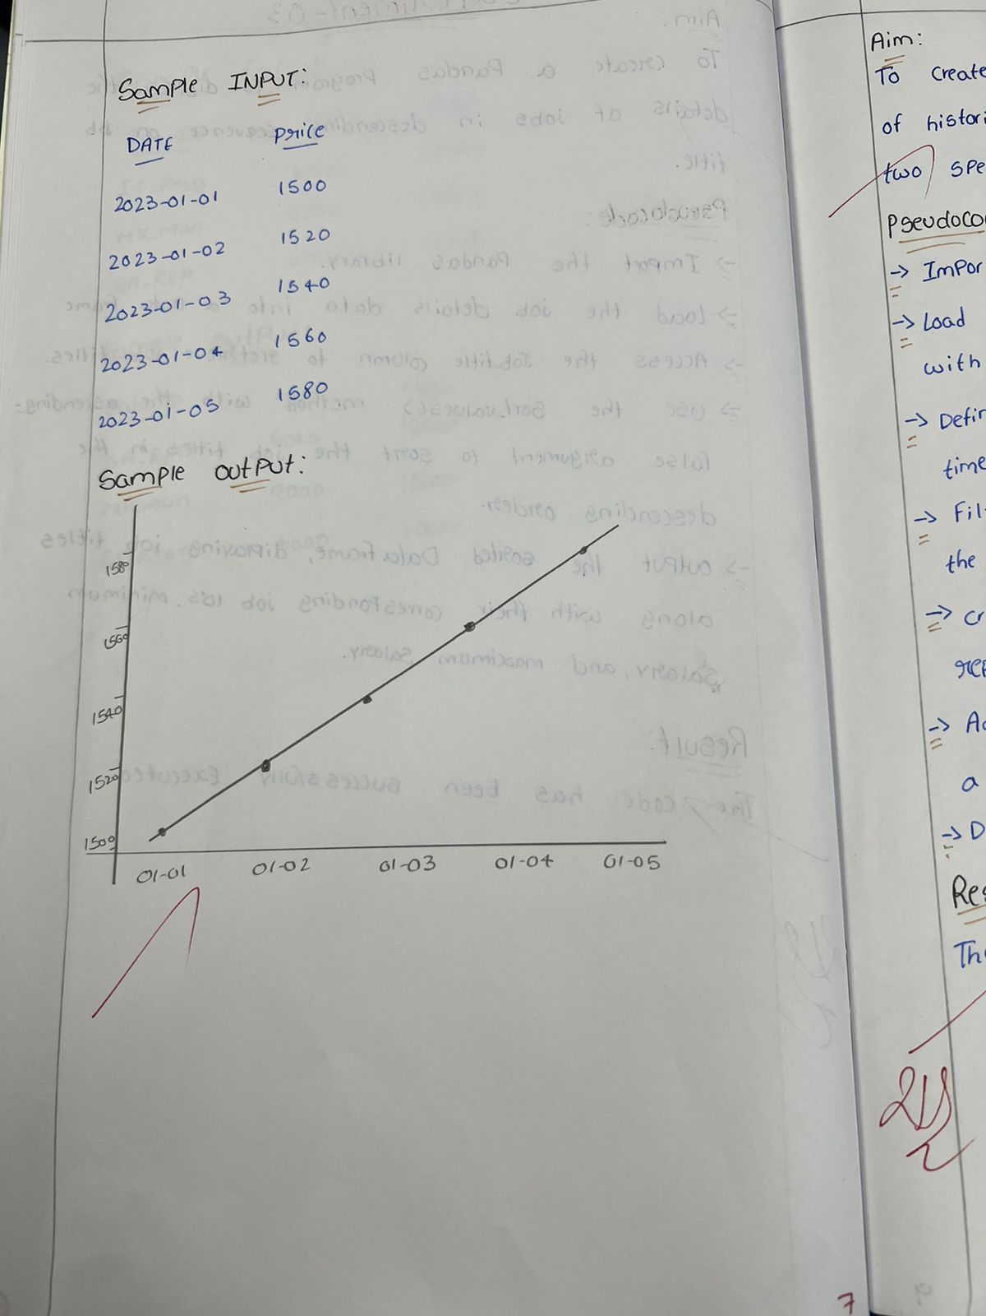

**Sample code:**

import pandas as pd

import matplotlib.pyplot as plt

import yfinance as yf

data = yf.download('GOOGL', start='2023-01-01', end='2023-05-01')

data['Close'].plot(title="Alphabet Inc. Stock Prices", xlabel='Date', ylabel='Price', figsize=(10,6))

plt.show()

**Sample output:**

