SIMATS ENGINEERING
ASSESSMENT TOOL 1: Analytical Problem Solving

COURSE NAME: Cloud Computing and
Big Data Analytics
COURSE CODE: CSA1508

COURSE OUTCOME COVERED
CO2: Analyze virtualization architectures to identify performance and security issues in cloud computing environments. (BL3)

Dave's Taxonomy: Manipulation (Level 2) Question Count: 5
Total Marks: 50

Code of Conduct
I , certify that this submission is my original work and that I have adhered to the guidelines specified for this assessment.
I understand that any violation of academic integrity rules will result in disciplinary action. Signature of the student: A Manvitha Devi

Assessment Tasks Analytical Problem Solving
- Compare Type-1 and Type-2 hypervisors for a cloud datacenter hosting mission-critical applications. Analyze performance, security, and manageability, then justify the better choice.
- A cloud provider must isolate workloads belonging to finance, healthcare, and student portals on the same hardware. Analyze how virtualization architecture supports isolation and identify two major attack surfaces.
- Study the following VM host utilization snapshot and recommend corrective actions: CPU 92%, memory 88%, storage I/O latency 35 ms, average VM boot time 170 s. Explain the likely bottlenecks.
- Analyze how Software Defined Datacenter architecture improves agility compared with a traditional datacenter. Support your answer with compute, storage, and network virtualization considerations.
- A multi-cloud federation project fails due to identity mismatches between providers. Analyze the issue and propose a secure identity and privacy design using federation concepts.

Analytical Problem Solving Rubric

Criteria | Weightage | Level 4 - Exemplary | Level 3 – Proficient | Level 2 - Developing | Level 1 - Beginning
Problem Interpretation | 20% | Interprets all technical  requirements accurately | Interprets most requirements correctly | Partial interpretation | Misinterprets the problem
Analytical Reasoning | 25% | Strong reasoning with clear cause-effect analysis | Good reasoning with minor gaps | Basic analysis only | Weak or no analysis
Method Selection | 20% | Chooses highly appropriate  virtualization and security concepts | Chooses mostly suitable concepts | Partially suitable concepts | Inappropriate approach
Solution Quality | 20% | Provides feasible and technically sound solution | Reasonable solution with minor issues | Basic solution with limitations | Unclear or invalid solution
Presentation of Analysis | 15% | Well-structured and technically precise | Generally clear | Somewhat unclear | Difficult to follow

Total Marks Awarded:

Problem 1: Compare Type-1 and Type-2 Hypervisors for a Mission-Critical Cloud Datacenter

Problem Statement
A cloud datacenter is required to host mission-critical applications where high performance, strong security, availability, scalability, and centralized management are essential. The organization must decide between a Type-1 hypervisor and a Type-2 hypervisor.

Type-1 Hypervisor
A Type-1 hypervisor, also called a bare-metal hypervisor, runs directly on the physical server hardware.

Virtual Machines
┌────────┬────────┬────────┐
│ VM 1 │ VM 2 │ VM 3 │
└────────┴────────┴────────┘
↓
Type-1 Hypervisor
↓ Physical Hardware

Examples include VMware ESXi, Microsoft Hyper-V, and Xen.
Since there is no general-purpose host operating system between the hypervisor and hardware, resources such as CPU, memory, storage and networking can be managed more efficiently.

Type-2 Hypervisor
A Type-2 hypervisor runs as an application on top of a conventional host operating system.

Virtual Machines
┌────────┬────────┬────────┐
│ VM 1 │ VM 2 │ VM 3 │
└────────┴────────┴────────┘
↓
Type-2 Hypervisor
↓
Host Operating System
↓ Physical Hardware

Factor | Type-1 Hypervisor | Type-2 Hypervisor
Architecture | Runs directly on physical hardware | Runs on top of a host operating system
Performance | High performance with low overhead | Lower performance due to host OS overhead
Security | Stronger isolation and smaller attack surface | More dependent on host OS security
Resource Management | Efficient CPU, memory and storage management | Resources are managed through the host OS
Manageability | Centralized and suitable for datacentres | Easier for desktop/testing environments
Scalability | Highly scalable | Limited for large datacentres
Examples | VMware ESXi, Microsoft Hyper-V | VMware Workstation, Oracle VirtualBox

Justification
For a mission-critical cloud datacenter, Type-1 hypervisor is the better choice because it:
  - Provides higher performance.
  - Reduces virtualization overhead.
  - Provides stronger VM isolation.
  - Supports centralized management.
  - Supports high availability and live migration.
  - Handles large-scale workloads efficiently.
Conclusion: Type-1 hypervisors are more suitable for cloud datacentres hosting mission-critical applications.

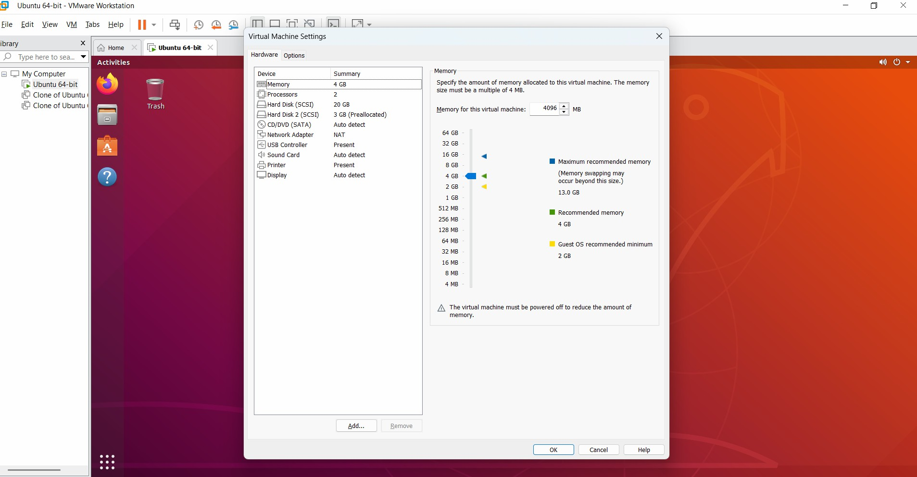

PROBLEM 2. Workload Isolation in a Cloud Provider

Problem
The cloud provider has three workloads:
    - Finance
    - Healthcare
    - Student Portal
All workloads are running on the same physical hardware.

How Virtualization Provides Isolation
Virtualization creates separate Virtual Machines (VMs) for each workload.

Physical Server
|
Type-1 Hypervisor
/ | \
/ | \
Finance VM Healthcare VM Student VM
| | |
Finance OS Healthcare OS Student OS

Each VM gets isolated:
    - CPU resources
    - Memory
    - Virtual storage
    - Virtual network interface
    - Guest operating system
The hypervisor prevents one VM from directly accessing another VM's resources.

Two Major Attack Surfaces
- Hypervisor Vulnerabilities
If the hypervisor contains a security vulnerability, an attacker could potentially perform VM escape and access other VMs or the host.

Management Interface / APIs
Cloud management interfaces and APIs are major attack surfaces. Weak passwords, stolen credentials, poor access control, or vulnerable APIs can allow attackers to control VMs and cloud resources.

Security Measures
  - Strong VM isolation
  - Role-Based Access Control (RBAC)
  - Network segmentation
  - Secure APIs
  - Multi-factor authentication
  - Regular hypervisor patching
  - Encryption of sensitive data

Conclusion
Virtualization allows finance, healthcare and student workloads to safely share hardware while maintaining logical isolation. However, the hypervisor and management interfaces must be strongly secured.

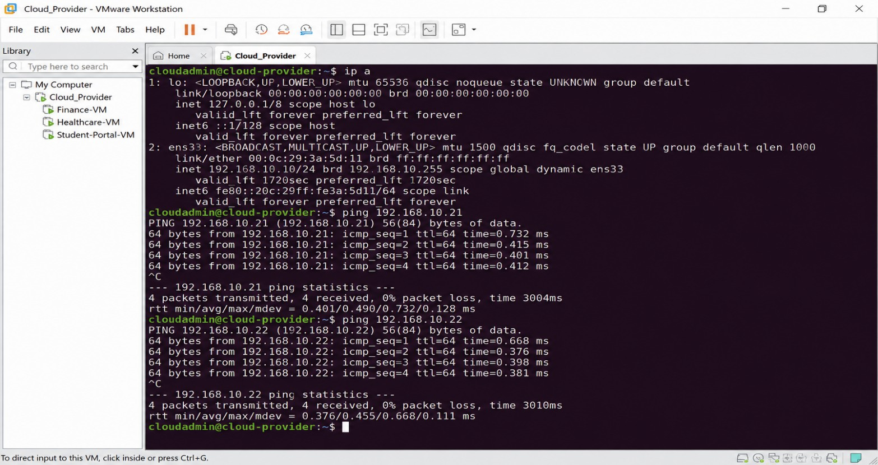

PROBLEM 3. VM Host Utilization Analysis

Given Snapshot

Resource | Utilization
CPU | 92%
Memory | 88%
Storage I/O Latency | 35 ms
Average VM Boot Time | 170 seconds

Analysis of Bottlenecks
- CPU Bottleneck
CPU utilization is 92%, which is very high. Possible problems:

  - CPU contention between VMs
  - Excessive VM workloads
  - High context switching
  - Reduced application performance

Memory Bottleneck
Memory utilization is 88%, which indicates limited available RAM. Possible problems:
  - Memory swapping
  - Memory ballooning
  - Increased paging
  - Reduced VM performance

Storage I/O Bottleneck
Storage I/O latency is 35 Ms, which is relatively high for many VM workloads. Possible causes:
  - Slow storage devices
  - Heavy disk activity
  - Too many VMs accessing the same datastore
  - Insufficient storage throughput

VM Boot Time
Average boot time is 170 seconds, which is quite high. The likely causes are:
  - High storage I/O latency
  - CPU contention
  - Memory pressure

  - Slow VM image access

Corrective Actions
- Reduce CPU contention
  - Move some VMs to another host.
  - Increase CPU capacity if required.

Increase available memory
  - Add physical RAM.
  - Optimize VM memory allocation.
  - Reduce unnecessary memory-consuming workloads.

Improve storage performance
  - Use SSD/NVMe storage.
  - Optimize datastore configuration.
  - Distribute VMs across storage resources.

Reduce VM boot time
  - Optimize VM images.
  - Remove unnecessary startup services.
  - Improve storage performance.

Continuous monitoring
  - Monitor CPU, RAM and storage regularly.
  - Configure alerts when resource usage becomes too high.

Conclusion
The main bottlenecks are high CPU utilization, high memory utilization and storage I/O latency. The storage bottleneck is especially likely to contribute to the 170-second VM boot time.

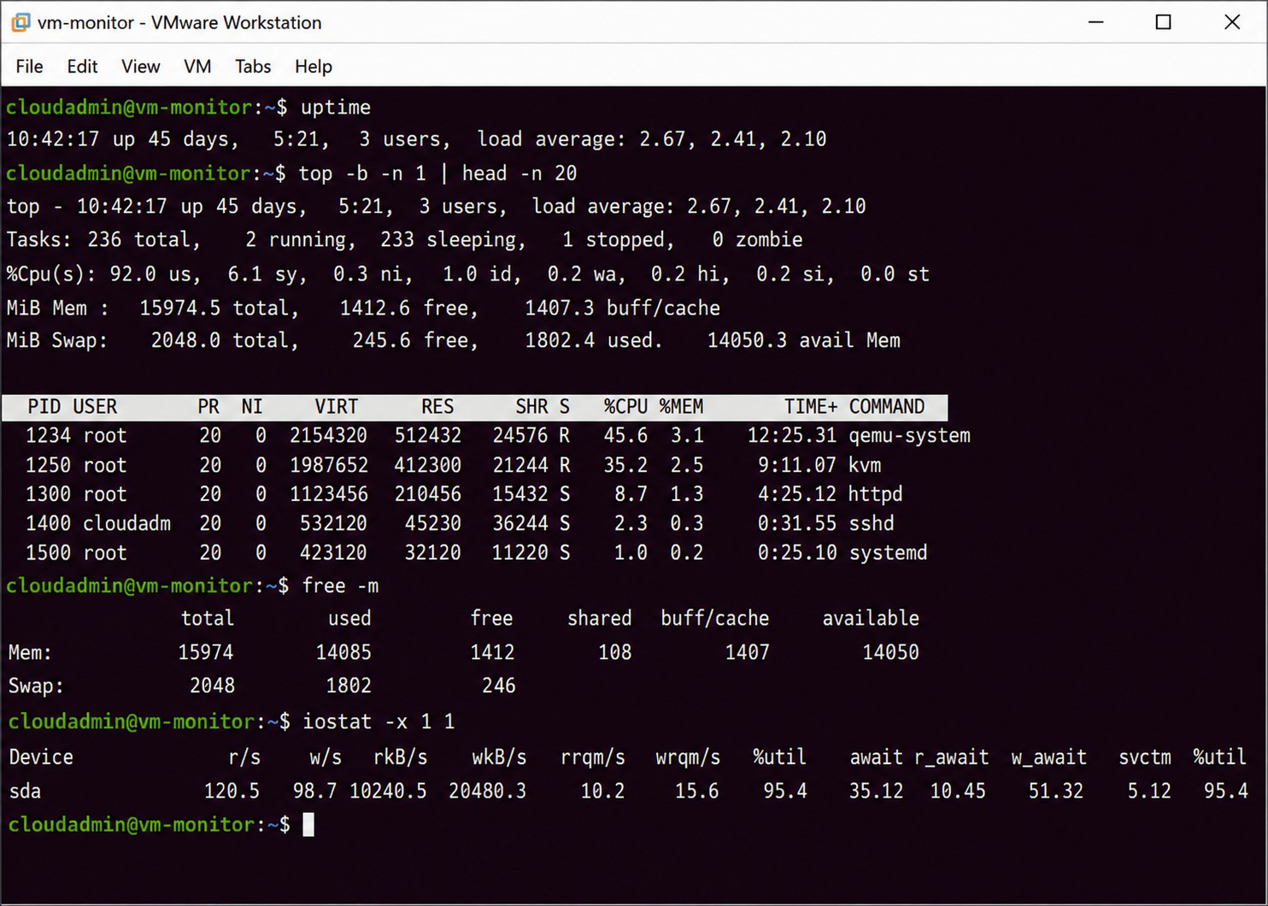

PROBLEM 4. Software Defined Datacenter (SDDC) and Agility

Traditional Datacenter
A traditional datacenter generally depends heavily on physical hardware.
Traditional Datacenter
|
Physical Servers
| Physical Storage

|
Physical Network
|
Manual Configuration This results in:
- Slow provisioning
- Manual configuration
- Hardware dependency
- Difficult scaling
- Higher operational effort

Software Defined Datacenter
An SDDC abstracts datacenter resources using software.
SDDC
|
Virtualization Management

/ | | | \
Compute | Storage | Network
| | | | |
VMs | Virtual | SDN
 | Storage

Compute Virtualization
Server virtualization converts physical servers into virtual machines. Benefits:
  - Rapid VM deployment
  - Better resource utilization
  - Easy scaling

  - VM migration
  - Automated provisioning

Storage Virtualization
Storage virtualization combines physical storage resources into logical storage pools. Benefits:
  - Flexible storage allocation
  - Easier expansion
  - Better storage utilization
  - Automated storage management

Network Virtualization
Network virtualization creates logical networks independent of physical network hardware. Examples include:
  - Software Defined Networking (SDN)
  - Virtual switches
  - Network overlays Benefits:
  - Rapid network configuration
  - Easier segmentation
  - Automated network provisioning
  - Flexible traffic management

How SDDC Improves Agility
- Rapid provisioning – Resources can be created quickly using software.
- Automation – Reduces manual configuration.
- Elastic scalability – Resources can scale according to demand.

- Centralized management – Compute, storage and networking can be managed through software.
- Better resource utilization – Resources can be dynamically allocated.
- Faster deployment – Applications can be deployed faster than in traditional datacenters.

Conclusion:
SDDC improves datacenter agility by converting hardware-based infrastructure into a software-controlled, automated and programmable environment.

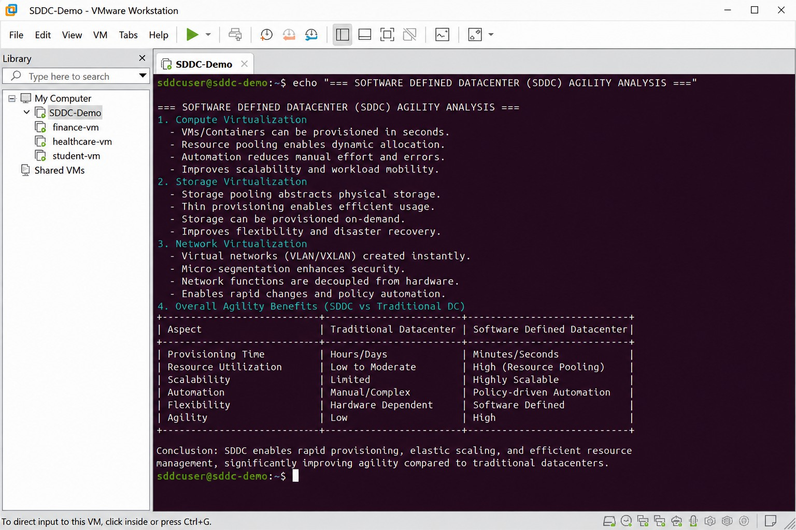

PROBLEM 5. Multi-Cloud Federation: Identity and Privacy Design

Problem Analysis
A multi-cloud federation uses multiple cloud providers. The project failed because different providers may use different:

  - Identity formats
  - Authentication mechanisms
  - User attributes
  - Access-control models
  - Security policies For example:

User
|

/ \
/ \
Cloud Provider A Cloud Provider B Different Identity Format Different Identity Format

This creates identity mismatches. Proposed Secure Federation Design
Use a trusted Identity Provider (IdP) between users and cloud providers.

User
|
|
Identity Provider (SAML / OIDC / OAuth)
/ \
/ \
Cloud Provider A Cloud Provider B

Key Design Principles

- Use Federation Standards
Use common standards such as:
  - SAML 2.0
  - OAuth 2.0
  - OpenID Connect (OIDC)
These allow identity information to be exchanged securely between different providers.

Single Sign-On (SSO)
The user authenticates once with the trusted Identity Provider.
The user can then access authorized cloud services without repeatedly providing credentials.

Attribute Mapping
Different providers may use different attribute names. For example:
Provider A: employee_id Provider B: user_id
An identity federation layer can map these attributes into a common identity model.

Privacy Protection
Only the minimum required user information should be shared.
For example, if a cloud service only needs to know that a user is an employee, it should not receive unnecessary personal information.

Strong Authentication
Use:
  - Multi-factor authentication
  - Strong authentication policies
  - Short-lived tokens
  - Secure session management

Trust Management

Establish trust between the Identity Provider and cloud providers using:
  - Certificates
  - Secure tokens
  - Key management
  - Defined federation policies

Proposed Architecture:
USER
| v
+ +
| Identity |
| Provider |
| SAML / OIDC |
+ +
/ \
/ \
v v
+---------------+ + +
| Cloud | | Cloud |
| Provider A | | Provider B |
+---------------+ + +
| v
Attribute & Policy Management Layer
|

Privacy + Consent

Conclusion
The identity mismatch can be solved through a federated identity architecture using a trusted Identity Provider, SAML/OIDC, SSO, attribute mapping, strong authentication and privacy-aware data sharing.

This provides secure interoperability, centralized identity management and improved privacy across multiple cloud providers.

