**BigData**

**Source Code:**

#!/usr/bin/python

import os

import sys

import re

import simplejson as json

from collections import Counter

def writeJson(file,data):

json = open(file+".json","w")

json.write(data)

json.close()

json.close

return

def createJsonFile(filename):

myIdCount=1;

file = open(filename, 'r')

totalInfo="";

for line in file:

if(line[0] != "*"):

totalInfo+=line.strip()

jObject="{\"reviews\":[\n";

row=list();

positiveBlock=list();

negativeBlock=list();

row= totalInfo.split("[t]");

for i in range(1,len(row)):

if( i == 1):

jObject += "{\"id\""+":"+str(int(myIdCount))+",";

else:

jObject += "{\"id\""+":"+str(int(myIdCount))+",";

titleName="";

myIdCount = myIdCount+1

for k in range(0, len(row[i])):

if( (row[i][k] != "[")):

titleName+=row[i][k]

else:

break;

titleName = re.sub("[^a-zA-Z]", " ",titleName)

jObject += "\"titleName\""+":"+'"'+titleName+'"'+",\n"

blocks=list();

blocks = row[i].split("[");

for j in range(0,len(blocks)):

if( blocks[j][0] == "+"):

positiveBlock.append(re.sub("[^a-zA-Z]", " ",blocks[j][3:]))

if( blocks[j][0] == "-"):

negativeBlock.append(re.sub("[^a-zA-Z]", " ",blocks[j][3:]))

jObject+="\"positive\": ["

for p in range(0,len(positiveBlock)):

if p == len(positiveBlock)-1:

jObject+='"'+positiveBlock[p]+'"'

else:

jObject+='"'+positiveBlock[p]+'"'+","

jObject+="]\n,\"negative\": ["

for n in range(0,len(negativeBlock)):

if n == len(negativeBlock)-1:

jObject+='"'+negativeBlock[n]+'"'

else:

jObject+='"'+negativeBlock[n]+'"'+","

if i != len(row)-1:

jObject+="]},\n"

else:

jObject+="]}\n"

jObject+="\n]}"

writeJson(filename[:-4],jObject);

return

for arg in range(1,len(sys.argv)):

print "\nLoading the file ", sys.argv[arg]

createJsonFile(sys.argv[arg]);

Execution images:

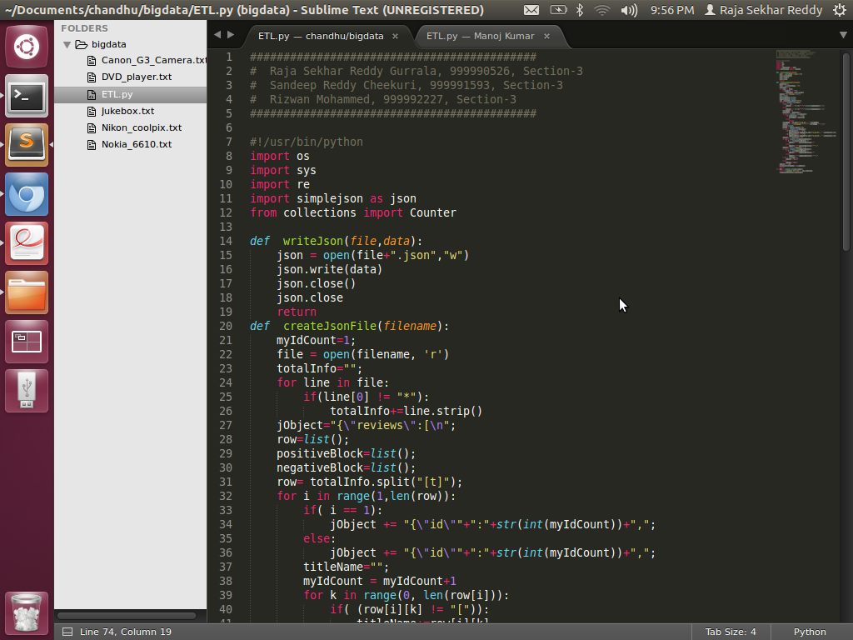

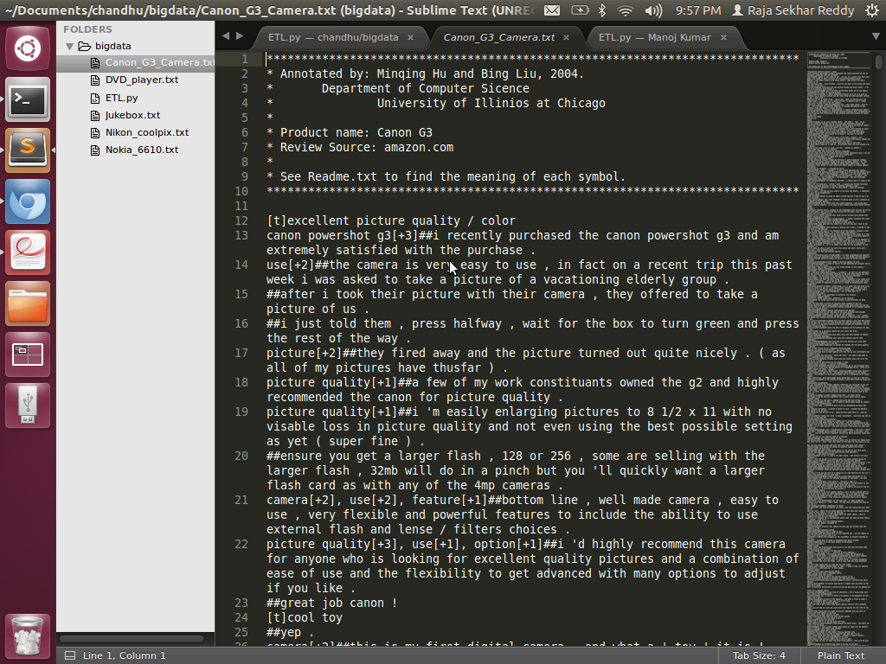

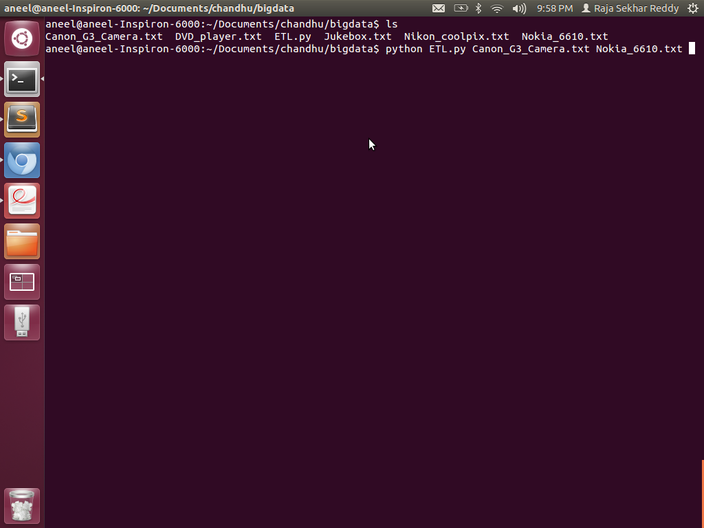

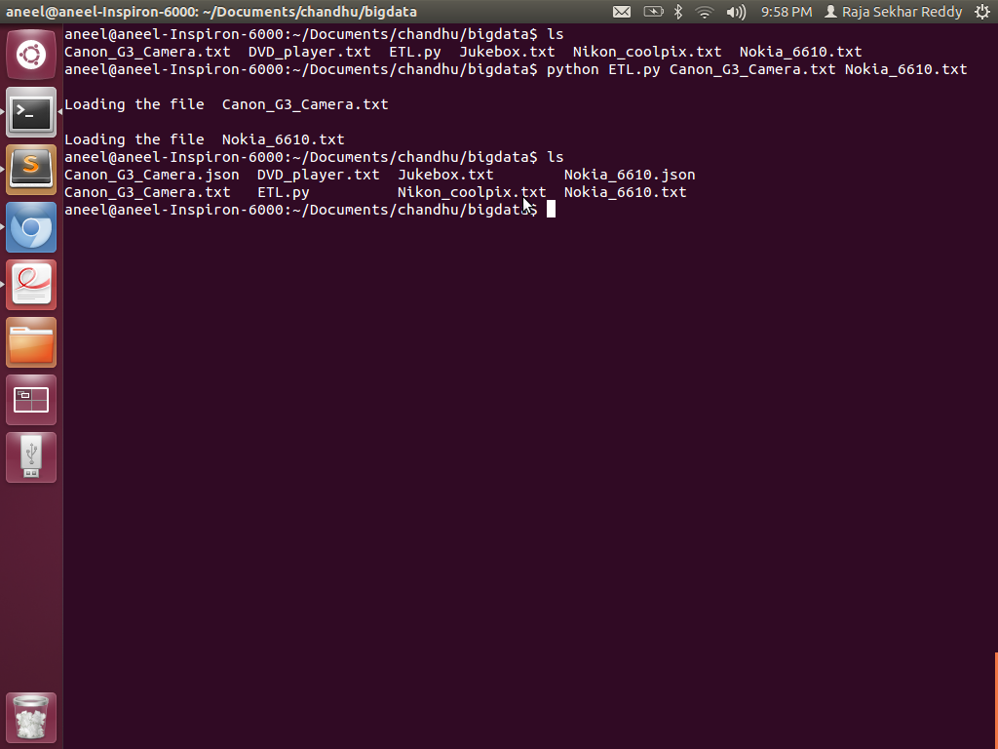

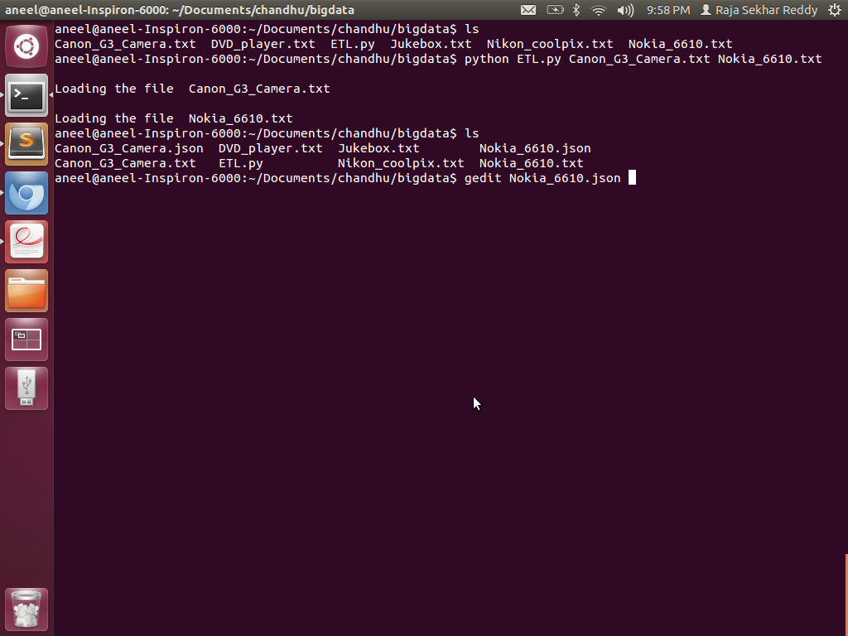

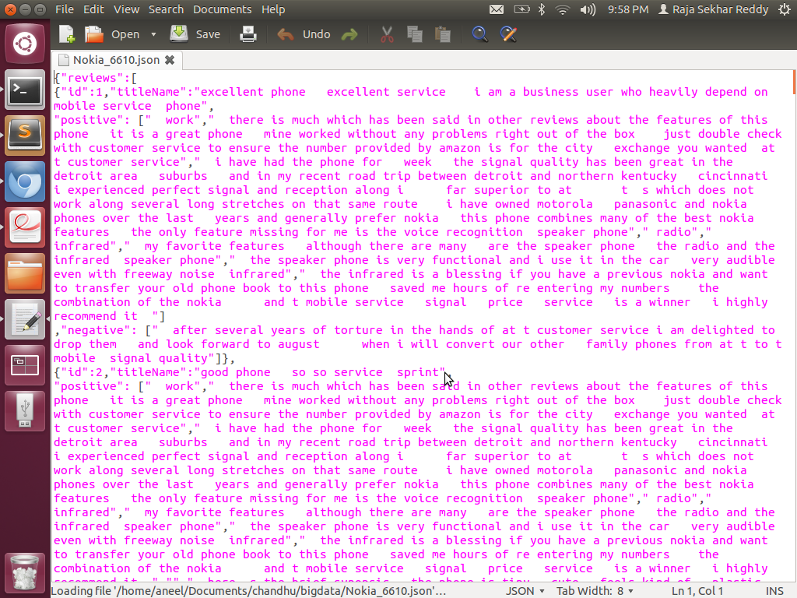

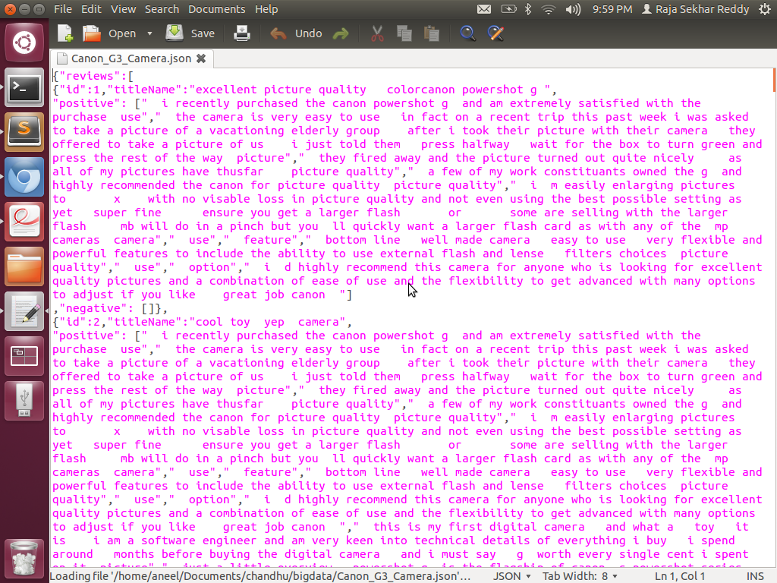

Result: Successfully executed the JSON file from the input files in command line arguments.