Student Name :

Student ID :

Student Section :

Student Name :

Student ID :

Student Section :

Student Name :

Student ID :

Student Section :

1- Write a query to **count** how many documents the collection has.

Ans:

**> db.users.find().count()**

**11188**

**>**

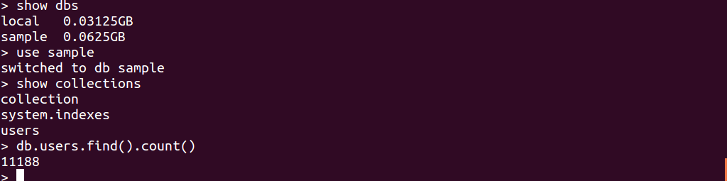

2- Write a query to show the first **5** documents nicely formatted.

Ans:

**> db.users.find().limit(5).pretty()**

{

"_id" : ObjectId("578ffa8e7eb9513f4f55a935"),

"user_name" : "koteras",

"retweet_count" : 0,

"tweet_followers_count" : 461,

"source" : "<a href=\"http://twitter.com/download/iphone\" rel=\"nofollow\">Twitter for iPhone</a>",

"coordinates" : null,

"tweet_mentioned_count" : 1,

"tweet_ID" : "755891629932675072",

"tweet_text" : "RT @ochocinco: I beat them all for 10 straight hours #FIFA16KING https://t.co/BFnV6jfkBL",

"user" : {

"CreatedAt" : ISODate("2011-12-27T09:04:01Z"),

"FavouritesCount" : 5223,

"FollowersCount" : 461,

"FriendsCount" : 619,

"UserId" : 447818090,

"Location" : "501"

}

}

{

"_id" : ObjectId("578ffa8f7eb9513f4f55a937"),

"user_name" : "AllieLovesR5_1D",

"retweet_count" : 0,

"tweet_followers_count" : 4601,

"source" : "<a href=\"http://twitter.com/download/iphone\" rel=\"nofollow\">Twitter for iPhone</a>",

"coordinates" : null,

"tweet_mentioned_count" : 3,

"tweet_ID" : "755891632759681024",

"tweet_text" : "RT @NiallOfficial: @Louis_Tomlinson @socceraid when I retired from playing because of my knee . I went and did my uefa A badges in Dublin",

"user" : {

"CreatedAt" : ISODate("2012-10-19T00:47:23Z"),

"FavouritesCount" : 15758,

"FollowersCount" : 4601,

"FriendsCount" : 5059,

"UserId" : 890030330,

"Location" : null

}

}

{

"_id" : ObjectId("578ffa917eb9513f4f55a939"),

"user_name" : "Tonkatol",

"retweet_count" : 0,

"tweet_followers_count" : 616,

"source" : "<a href=\"http://twitter.com\" rel=\"nofollow\">Twitter Web Client</a>",

"coordinates" : null,

"tweet_mentioned_count" : 1,

"tweet_ID" : "755891638921232384",

"tweet_text" : "RT @GameSeek: Follow & Retweet for your chance to win a copy of FIFA 17 Deluxe Edition (platform of your choice) in our #giveaway! https://…",

"user" : {

"CreatedAt" : ISODate("2012-07-28T21:00:59Z"),

"FavouritesCount" : 350,

"FollowersCount" : 616,

"FriendsCount" : 2675,

"UserId" : 722815650,

"Location" : null

}

}

{

"_id" : ObjectId("578ffa957eb9513f4f55a93b"),

"user_name" : "Gaslet",

"retweet_count" : 0,

"tweet_followers_count" : 101,

"source" : "<a href=\"http://twitter.com/#!/download/ipad\" rel=\"nofollow\">Twitter for iPad</a>",

"coordinates" : null,

"tweet_mentioned_count" : 1,

"tweet_ID" : "755891659729145856",

"tweet_text" : "@CIVARAGI ...I was putting ffs but it autocorrected it too FIFA",

"user" : {

"CreatedAt" : ISODate("2010-04-29T12:32:47Z"),

"FavouritesCount" : 5207,

"FollowersCount" : 101,

"FriendsCount" : 198,

"UserId" : 138393730,

"Location" : null

}

}

{

"_id" : ObjectId("578ffa967eb9513f4f55a93d"),

"user_name" : "Syaxmii_",

"retweet_count" : 0,

"tweet_followers_count" : 685,

"source" : "<a href=\"http://twitter.com/download/android\" rel=\"nofollow\">Twitter for Android</a>",

"coordinates" : null,

"tweet_mentioned_count" : 1,

"tweet_ID" : "755891664787353600",

"tweet_text" : "RT @GeniusFootball: You know it's FIFA... https://t.co/tLK6sTnPaM",

"user" : {

"CreatedAt" : ISODate("2012-07-22T08:05:25Z"),

"FavouritesCount" : 575,

"FollowersCount" : 685,

"FriendsCount" : 415,

"UserId" : 710328204,

"Location" : null

}

}

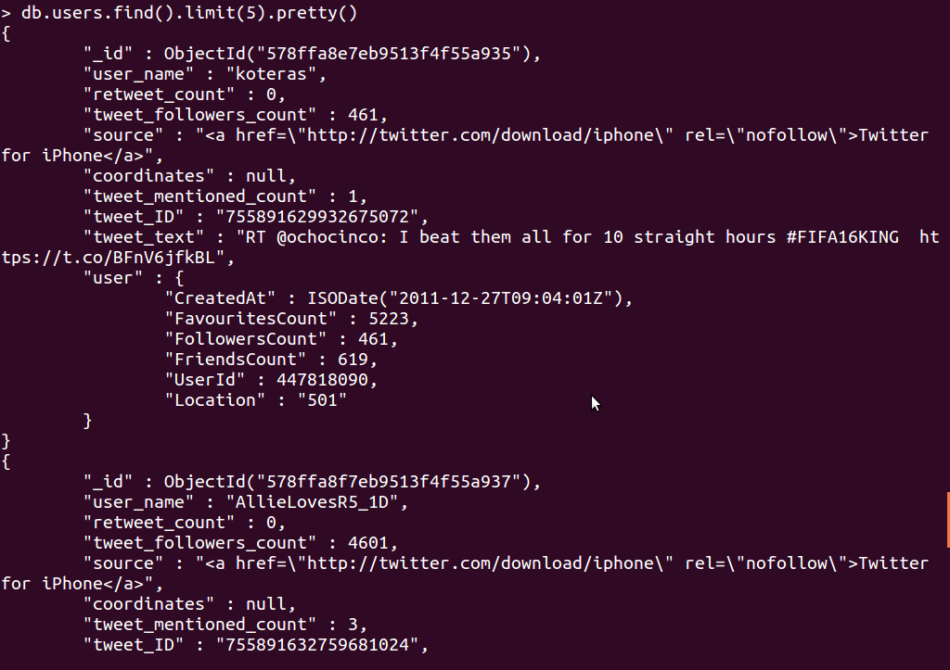

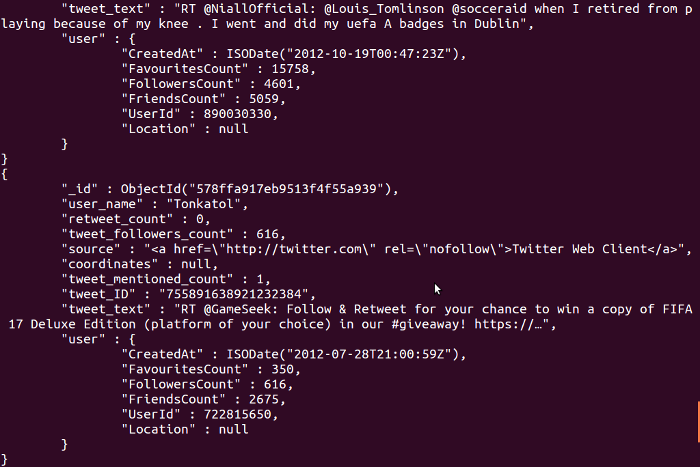

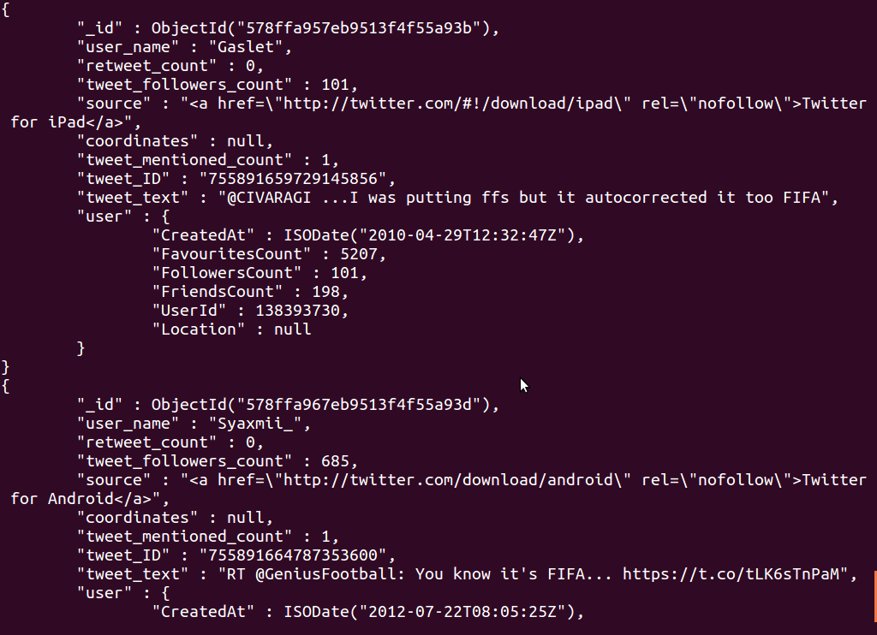

3- Write a query to find the unique values for **user_name** field.

Ans:

**db.users.distinct( "user_name" )**

A description...

[

"Klab10Tete",

"Reddslim",

"abhijeet_ZADE",

"Bimbo_Slicee",

"_shelbyleeanne",

"ObiHawkKenobi",

"WolverinesViews",

"Tmartial11",

"PubRelationsWiz",

"nufcno1fan",

"dabadee_tv",

"FlyMan_T",

"BeaversSpyder",

"mattoak",

"bigmike76_757",

"shawturnheads",

"Corey_Clark",

"StanfordSpyder",

"yekeme",

"arntwine",

"paulmcdonnell7",

"finch_regan",

"palacepaul65",

"AprilleRoberts",

"FarrellyParaic1",

"Josee_Cule2",

"InPlay_Top_Tips",

"bmoorewhu82",

"RedAlieNeT",

"randysavageson",

"John_Hofman",

"3pointiscash",

"rhetschrauben",

"kyreek20",

"xI3uLLetz36",

"action76jackson",

"APkrawczynski",

"owen__6",

"Coach_U",

"darrenfinn49",

"HeraldStriker",

"_akuma_s",

"SavannahSyron",

"caneseye22",

"_London12_",

"OsorioM93",

"AlfaAllahguide",

"loflin_janice",

"NPSportFootball",

"Kytey1981",

"PaulWiecek",

"BeedotGaming",

"EricD_23",

"BlaQ_Speaks",

"AshWoody90",

"manutdbelieve",

"ddim_yn_sant",

"sport_board",

"pabl_ohhh",

"INDYBOY_91",

"dadmund10",

"AlexisMerlino",

"ClockMerchant",

"noticiasfutbol",

"carvaluka",

"InfogFSQ",

"apuestasfutbol",

"GabeKindaCares",

"SportsDbate99",

"Ephesians6123",

"joebucka",

"buakaw1904",

"liaamU",

"_elashxo",

"LMB_02",

"chrisfriend89",

"Neville1278",

"landon_fowler1",

"eyedenmusic",

"SakhoForCaptain",

"kemoooo55",

"boi_base",

"drmom89",

"grif_37",

"ben_rf",

"1Wilke",

"MotoringAllianc",

"BolaJawa",

"EvanBarton20",

"jabtiger50",

"RabiuKabir_",

"JamieRobertso6",

"GlasgowGandW",

"Ashmw67",

"iam_deolu",

"QuidBetsDotCom",

"ManLikeTimbo",

"annealicia",

"autumnnorthcutt",

"stephenmina",

"soccernewsbeat",

"Brighton_Omondi",

"mohapatraraman",

"Ak1xxAzed",

"Flannogram",

"velimirius",

"Modernghananews",

"CamilleCpn",

"therealrobcook",

"Zack1Mason",

"KemlynRoadStand",

"MrsClareKBaker",

"PMoore_11",

"FulhamHarv",

"hadriel10",

"HighTreesCDT",

"batueser",

"TopCat_TC",

"anthony_the_ref",

"FootballFurious",

"Luke_Cameron1",

"NonsenseEngine",

"shaliax0x0",

"NUFCCollective",

"walk1892",

"all_foot_teams",

"BetFastcom",

"Neikter",

"Breanna_Wooten6",

"SSweetBabyJesus",

"thegratefuldeb",

"amiyahwalker",

"sheslayingg",

"OKStateViews",

"asherren814",

"theswan64",

"7DarrenAnderson",

"ieriko911",

"peyrard42",

"JosJimnezduran4",

"mickcutler1",

"Sintellins",

"LeBRON_NATION6",

"TheFace34",

"Bloggsy86",

"geig_erzaehler",

"G_SCOOBO",

"Oldham_Hour",

"shandaretta_",

"celtic_1411",

"BankrollDami",

"Major_Thoughts",

"Keazus",

"ElishivaAhmose",

"omotomilola",

"sltribsports",

"sam0007ster",

"flavioambrosio",

"Peyton_Miller1",

"boyo2803scott",

"flyin_felipe",

"AY00CHINK",

"alake178",

"HearAllAbtIt",

"francosonrisa1",

"SGbogboade",

"Anfield_Maestro",

"oOKaSs10",

"lajuangis",

"carlwhite83",

"rayycarp",

"jay_alek18",

"anaiiika",

"CrossbarGrill",

"xtfootball",

"bodurbs",

"BASEDJESUS",

"damoroche24",

"LowestTickets",

"QPRFC_Ash",

"ChrisNTrevino",

"DutchPelican",

"Chalupajuana",

"TintinCymru",

"KatieSogorski",

"Dope_Ville",

"3NameSportsShow",

"musteee_b",

"JoshBreen_",

"shelovekicks",

"SharpTout",

"feed_nigeria",

"NeimanB21",

"jennnn_a",

"AriMartorano",

"ColtenEbeling",

"_aleyshamay",

"BetAndEarn",

"TomTom_Huns",

"sanjay88888",

"hannahgleave1",

"AhmaadHanny",

"Gainzy9",

"DaltoSam25",

"FionntanLFC",

"RuyaProv",

"proccie78",

"Steve_The_Nub",

"julietuuuuh",

"AcikalinHasret",

"IswadiRos",

"34bearcat",

"Baltimore0nline",

"conspiracylando",

"chrisboyce1806",

"darkmoon1196",

"wfaunt89",

"llyxzjooccgm1",

"Craigm0808",

"yosoyja1me",

"iPalaceApp",

"emtz989",

"Hicham_Manaa",

"c_kizzwizz",

"sportswisdom247",

"maryfclayton",

"Layomi_XO",

"gwillett13",

"andreuvila",

"mattyofwilliams",

"daniel_capshaw",

"7TENBOY",

"sam_ls",

"mayzwatson",

"Steve_Tyke",

"priceyM96",

"AkilahLaster",

"DJ20DJ",

"Benafrica01",

"ali_penfold",

"MickMcL18",

"JGEN54",

"FoxAccounts",

"chyke42",

"SeniorBadooSneh",

"kinjeketile",

"kcondeee3",

"Naijadailyfeed",

"EliManning_Fans",

"BigsexyySeth",

"Precipraise_Ay",

"AdriJepbur",

"emilyfabert1",

"dhachill",

"RaleighVance5",

"delrahim69",

"nochillgray",

"sloan_joannie",

"Grid_Network",

"ThtOneKid_David",

"_tm12",

"Ste_BlackParent",

"Aaron_TV14",

"WabashFootball",

"Pogbalite",

"jasew88",

"RichHavards",

"ESMART234",

"EthanChillen",

"Bob_Loblaw101",

"Englishhunk",

"rjacobray",

"toonhooooo",

"_NickHaughton",

"K9Football",

"touchofpierre",

"alex_jarasitis",

"LDBellFootball",

"FabioPendolino",

"ByJimCorbett",

"_stephenopoulos",

"FulvioMeloni",

"___billyhunda33",

"AlexOTimothy",

"Callumhowes34",

"alexiakroeff",

"John_Sabol",

"zikarkhan2",

"coachmunz",

"KevinPorron",

"zaksheskyman",

"cubsfan1005",

"GrahamBarfield",

"ManUtdNewz",

"AvondhuGAA",

"RotoStreetJ",

"wyattturner11",

"mackkreinbrink",

"GatorsDominate",

"ChopperRuscoe",

"3z_al501",

"_mmkimmy",

"Jon_Mackenzie",

"eswann",

"ZachZippe",

"NewcastleLive",

"takeagab",

"NateLatsch",

"MissouriOnScout",

"PercyToplis",

"fat2fitherts",

"StreetSouls16",

"nongdarko",

"marklovegrove",

"MilliebobsShaw",

"FreshPressUK",

"Pounds_Sterling",

"xohaneen",

"geepjay99",

"TextToSpeechMan",

"Francklegunner",

"AyeeSal_",

"samridds",

"H_Durrett2014",

"trolic",

"BenMitchum",

"NEYouth_",

"vgaskin40",

"JENtheGuru",

"coldasrashad",

"DavidJService",

"BigKaleb2",

"KHeneage",

"Richardherity",

"SingleMomb",

"bcooney4",

"chriskoo2",

"knbutts5",

"gloriadoris6901",

"GeraldMayfield_",

"98_zelo",

"BritttD___",

"Remmyyboi",

"NurZach",

"FootballScoop",

"HayashiYasuji",

"mxo_stephen",

"MikeConnell85",

"Ste_Higgy87",

"GuardiolaFlair",

"johntheil",

"BuffSausageKing",

"sarahkatenorman",

"Warchant",

"dariormj92",

"10_plus1",

"Tavisj97",

"bodenknights",

"shelbie_22",

"Grahmbo_",

"PittsburghMade",

"alsafin",

"Mendirek1899",

"csports101",

"sespino27",

"Pate9Sam",

"MadisonvilleJH",

"nobbyclark2014",

"NizamIsmaili",

"MercorOrg",

"Bradybo65",

"st_macs",

"MattPimperton",

"Vmg_Reddz",

"Alvarado3",

"StuD_MuffiN15",

"RyderandDutton",

"zeeezo0o01",

"IKiers",

"i4_swansea",

"R_BOMBS",

"Bowaz_7",

"odoffin",

"DaVirginJerry",

"Mikedeeotf",

"luced42",

"GeosNewsAtlanta",

"__Lvke",

"JustEmann",

"Olliemoore93",

"alford_brandon",

"YourGyalsYard",

"rabomed277",

"Greevur",

"__Murtala",

"EdwardsVee",

"brandonsafclad",

"Dunc4nuk",

"muZakS26",

"O_lBo_Kolb",

"loscar92",

"FFGuidance",

"KOtheTEDDY",

"DailyStar_Sport",

"loydebet",

"KushalSinghal",

"zia75018",

"MarcoGooner",

"ABCTriCities",

"Emergingtrends",

"CougarHands",

"NapLiberachi",

"iWestHamApp",

"landonbrown991",

"johnwillywilson",

"oladapoyusuf",

"ryannbrownn_",

"SeniaMarihely",

"MegaRams12",

"Rushs_Dad",

"Chizzy_GetsBusy",

"neavebishop_",

"OKCardinalChirp",

"_KvngXO",

"I_am_Simo18",

"Budgey_95",

"HamesNotJames",

"hanifxnaziri",

"mcall",

"mickmod1969",

"meghan_nikole",

"Titch_7",

"torileigh1220",

"Liverpool2Chris",

"_lonzi3",

"khaledumair",

"talywacker08",

"chuck_haze",

"slashedprices",

"DTresca",

"tdawg2016",

"Matt_Boluwaji",

"MBerg_lfc",

"nicholasbrewer_",

"TaylerMakenzie",

"mbkygu",

"charleepitts",

"belfastcoops",

"Dejaily",

"bayernoatcake1",

"LoooopyLou24",

"Spaceeh",

"adebanjojohn",

"hotmoklet",

"Joshua_Bennett",

"ahmedkm10",

"livefrommanila",

"NFLbuzzfeed",

"idcidcnya",

"itskennedyyy_",

"TerranceDLeeJr3",

"Luttxav",

"abmartinez95",

"nflnewzbot",

"the_anke",

"Mr_Rubes",

"GeneralNews_NGR",

"TaftFootballCT",

"TravisMason_",

"abbyxsclater",

"END2008",

"AnfieldObserver",

"dsbotkin123",

"malonza_007",

"salbush65",

"katylynne_mc",

"BobbyGraham5",

"Tha_ReALGooz",

"1andonlykiarra",

"james_the_cat1",

"lowerthansam182",

"craigie7",

"YogaBuff15",

"hpd1998",

"MichaelBryson_",

"EnaholoJohnson",

"Sugar_Daddy35",

"BSFHMD",

"NFLSportMag",

"pittspat",

"__Akram_",

"ActionSportsJax",

"ben_yano",

"joel_t34",

"THEREALALLENOU",

"1ldjy",

"RichardMarr3",

"crouse_jake",

"carefreesince",

"Kuhr91",

"DawsonNoleSC",

"ed_saturday",

"calrowlands",

"TKDawg1992",

"_lamide_",

"michaelellis120",

"ShammahGBrooks4",

"OTF_Mo",

"reefdellanos",

"erbes60"

]

4- Write a query to find the number of unique values for **user_name** field.

Ans:

**> db.users.distinct("user_name").length**

**9775**

**>**

A description...

5- Write a query to find the tweet text for the user **james_the_cat1**. Do not show the id field.

Ans:

**> db.users.find({user_name:/james_the_cat1/},{_id:0})**

{ "user_name" : "james_the_cat1", "retweet_count" : 0, "tweet_followers_count" : 86, "source" : "<a href=\"http://twitter.com/download/iphone\" rel=\"nofollow\">Twitter for iPhone</a>", "coordinates" : null, "tweet_mentioned_count" : 2, "tweet_ID" : "757667781810724865", "tweet_text" : "RT @BBCSporf: CLASSIC: When you could run away from the referee and not get booked on FIFA 94. (via @dreamteamfc)\n https://t.co/bbrZhS1tHP", "user" : { "CreatedAt" : ISODate("2012-07-12T11:25:50Z"), "FavouritesCount" : 104, "FollowersCount" : 86, "FriendsCount" : 175, "UserId" : 633663305, "Location" : null } }

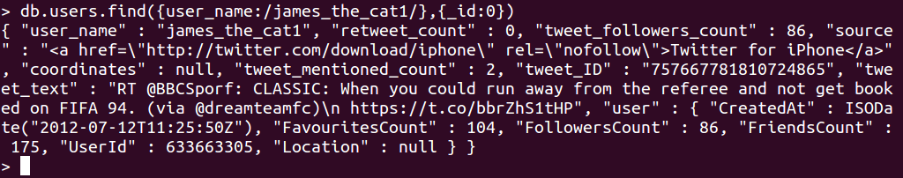

6- Write a query to find the count of documents where **Followers Count** is greater that the **Friends Count.**

**Ans:**

**> db.users.find({"$where": "this.user.FollowersCount > this.user.FriendsCount"}).count()**

**5809**

A description...

7- Write a query to find the count of documents **without location** information.

Ans:

**> db.users.find( { "user.Location": { $exists: true, $nin: [ null ] } } ).count()**

**6937**



8-Write a query to find the username of the user with the **most followers**.

Ans:

> **db.users.find({},{_id:0,retweet_count:0,tweet_followers_count:0,source:0,coordinates:0,tweet_mentioned_count:0,tweet_ID:0,tweet_text:0,user:0}).sort({"user.FollowersCount":-1}).limit(1)**

{ "user_name" : "FIFAcom" }

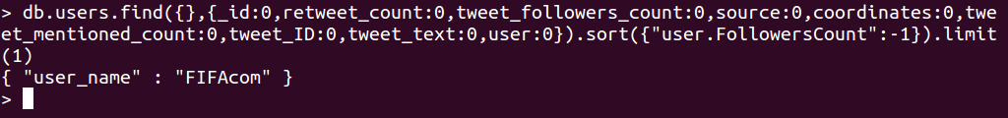

9-Write a query to find the username of the user with the **least friends**.

Ans:

**> db.users.find({},{_id:0,retweet_count:0,tweet_followers_count:0,source:0,coordinates:0,tweet_mentioned_count:0,tweet_ID:0,tweet_text:0,user:0}).sort({"user.FriendsCount":1}).limit(1)**

{ "user_name" : "FIFA_Cable" }

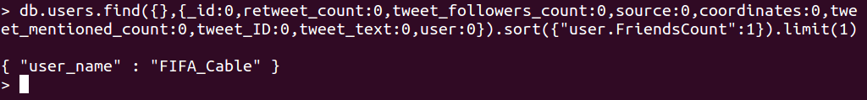

10-Write a query to count all the documents where tweet text includes the word **goal** and do not

include the word **FIFA**.

Ans:

**> db.users.find({tweet_text: {$not: /FIFA/}},{tweet_text: /goal/}).count()**

**7491**



**Part-2**

**MongoTweet.js**

**Student Name :**

**Student ID :**

**Section :**

**Student Name :**

**Student ID :**

**Section :**

**Student Name :**

**Student ID :**

**Section :**

**Map Function:**

**var map=function() {**

**emit(this.tweet_text , this.tweet_text);**

**}**

**Reduce Function:**

**var reduce=function(key_id,value){**

**return Array.sum(value);**

**}**

Execution:

**db.users.mapReduce( map,reduce,{ out: "MongoTweet" } )**

**Screenshot:**

