**Student Name :**

**Student Id :**

**Student Section :**

ER-Diagram:

ER-Diagram is a visual representation of data that describes how data is related to each other.

**Entities**, which are represented by rectangles. An entity is an object or concept about which you want to store information

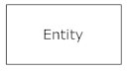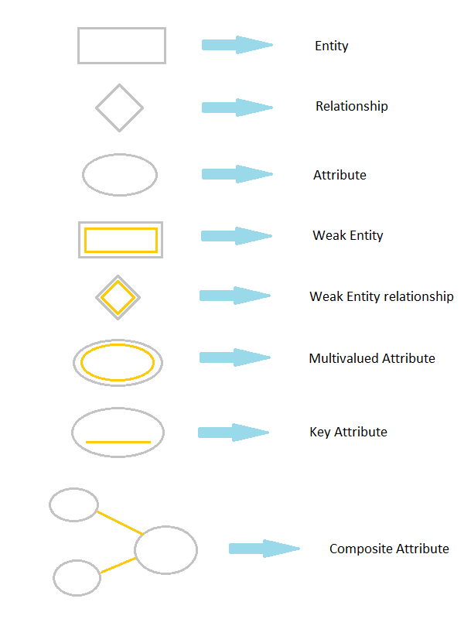

A weak entity is an entity that must defined by a foreign key relationship with another entity as it cannot be uniquely identified by its own attributes alone.

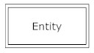

**Actions**, which are represented by diamond shapes, show how two entities share information in the database.

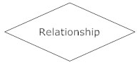

**Attributes**, which are represented by ovals. A key attribute is the unique, distinguishing characteristic of the entity. For example, an employee's social security number might be the employee's key attribute.

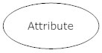

A multivalued attribute can have more than one value. For example, an employee entity can have multiple skill values.

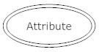

A derived attribute is based on another attribute. For example, an employee's monthly salary is based on the employee's annual salary.

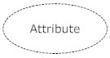

#### Symbols and Notations

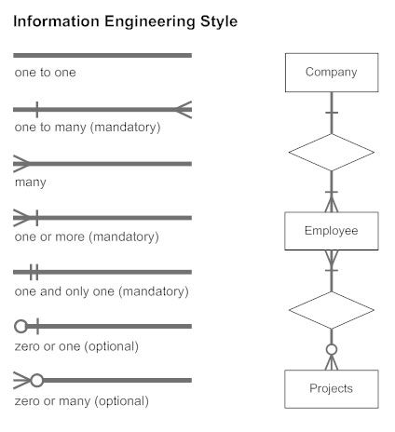

### Components of E-R Diagram:

The E-R diagram has three main components.

#### 1) Entity

An entity have numbers of attributes. (like table with tale properties).



**EER- Diagram for My Singers:**

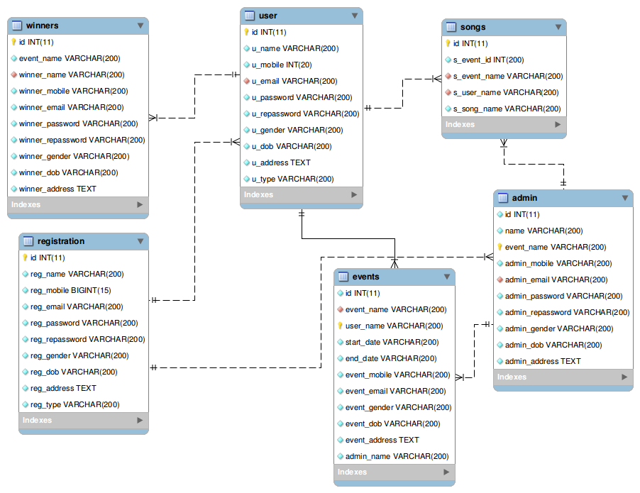

**Description:**

A Registration table have the `reg_name`, `reg_mobile`, `reg_email`, `reg_password`, `reg_repassword`, `reg_gender`, `reg_dob`, `reg_address`, `reg_type` coulumns and this table have many users and many admins for organization the events. A User have the `id`, `u_name`, `u_mobile`, `u_email`, `u_password`, `u_repassword`, `u_gender`, `u_dob`, `u_address`, `u_type` and this events table have to user and admin aslo. Belongs to User table participates the events and belongs to admin table events handled by the admin only.

As a admin have a managing the users and events based admin permissions. A admin have block the users also and create, Update and delete the events by the administrator only whom created administrator. Many users are participating in events and may be changes to get many winners.

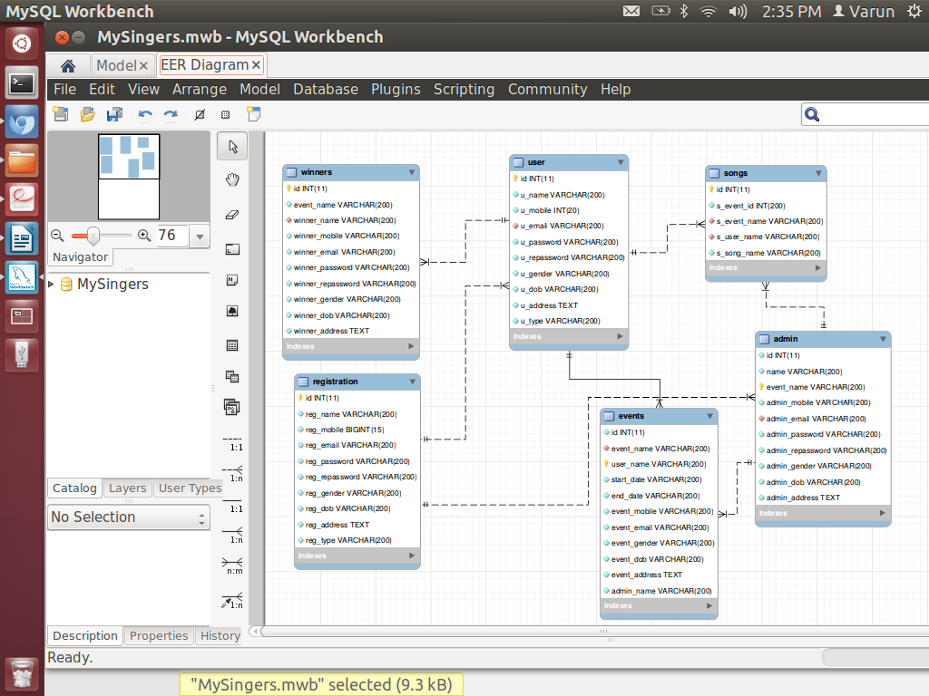

**Meta Data Tables:**



