**MY SINGERS**

In this project we are using Dia tool for designing the use case diagrams. The below diagram shows the basic structure of My singers with basic notation symbols about the flow execution.

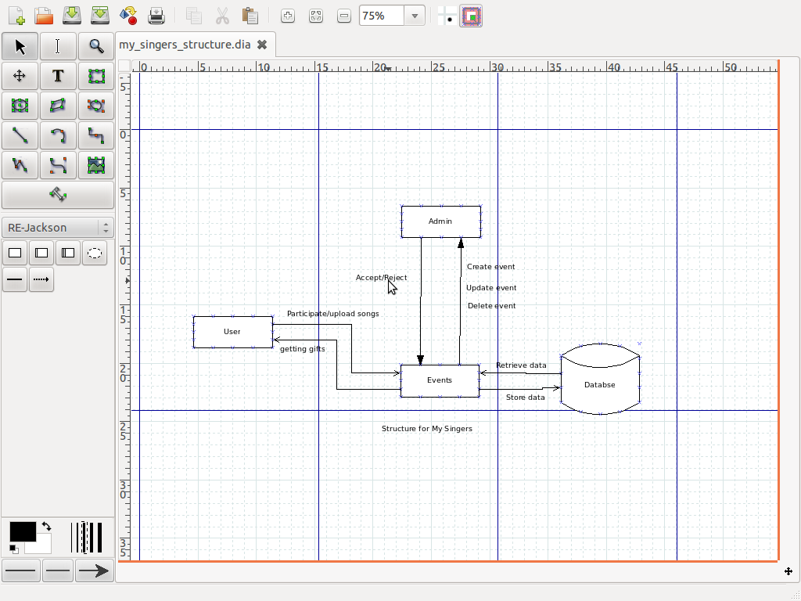

**BASIC STRUCTURE OF MY SINGERS**

**Description**: The admin is the one who creates, updates and deletes the events. The user asks the permission of the admin to participate in the event, if the admin accepts the user uploads his songs and the information is stored in the database. Depending on the number of likes the user has got, the winner is announced by retrieving the data from database. All the information is stored and retrieved from the database and depending on the number of likes, the winner is announced and given gifts.

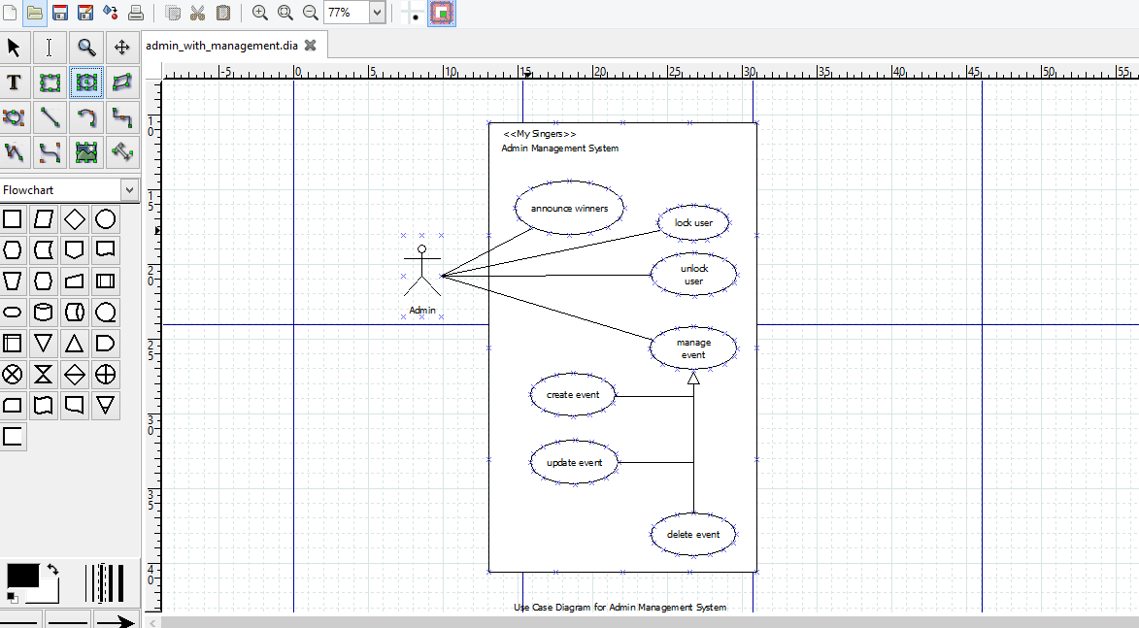

**Admin Management System**

**Description:** In the above use case diagram we have only one actor (Admin). The admin can create, update and delete an event. The winner of the event is announced by the admin before deleting the event. The admin has the access to lock or unlock the user permissions. This is how the admin management system works.

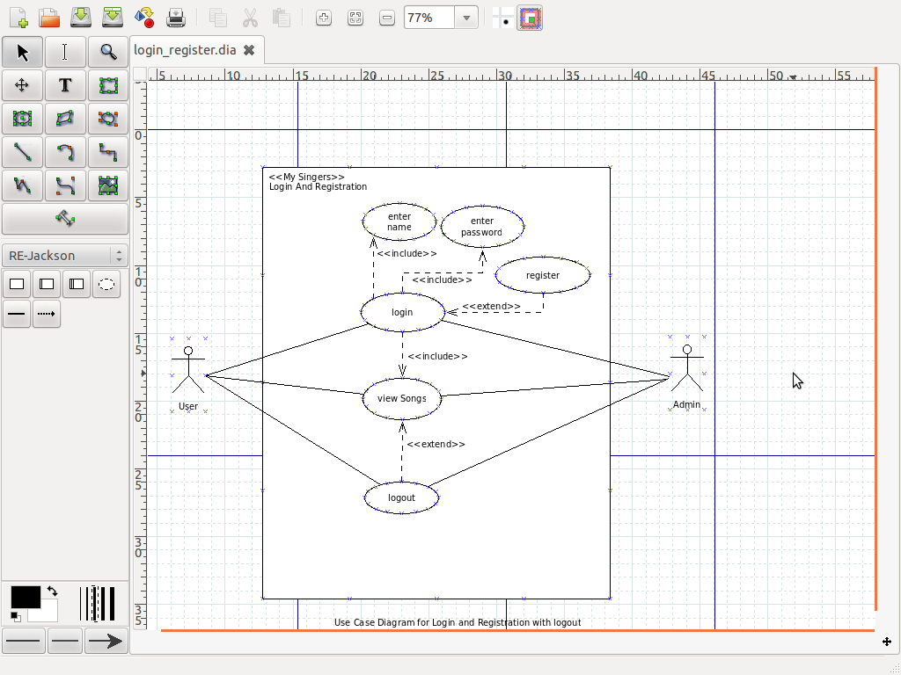

**Login and Registration System**

**Description:** In the above use case diagram we have two actor’s user and admin. They both should login first to view the songs of the event and then logout.

In the login and registration system, the user and the admin should include (mandatory to enter) the name and password to login. Register use case extends to login i.e., no need of registering every time once they are registered. Extend means optional requirement for logout.

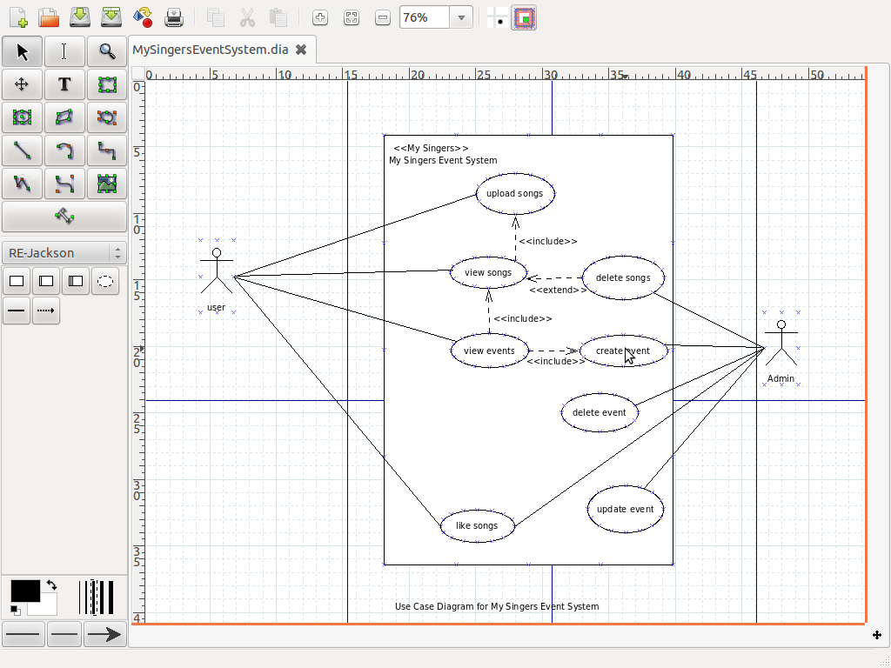

**Use Case Diagram for My Singers Event System**

**Description:** In the above diagram the user uploads the songs and participates in the events. The view events use case includes the view songs because the singer first views the songs of the event and uploads their song. The extends the delete songs because the admin views the songs if they are not related to the event he deletes them (its optional here) so we are using extends for this use case.

Finally, the user and the admin can like the songs of the event. Depending on the likes winners are announced. Once the winner is announced the admin deletes the event and updates new events.

|  |  |
| --- | --- |
| **Actor** | **Description** |
|  | The admin is the main actor in My Singers. The admin creates, updates and deletes the event. Admin looks after the whole event and finally announces the winners by retrieving the event data from the database. |
|  | The users are the participants and listeners of the event. They register for the event and uploads their songs in the event. Depending on their talent they get likes for the event and the one who has more number of likes are announced as winners. |

|  |  |
| --- | --- |
| **Use case** | **Description** |
|  | In the admin management system, the event is generalized as the event can be created, updated and deleted by the admin. The event use case is connected to the admin and there is association linkage between them. |
|  | In the admin management system, the admin announces the winner. The announced winner gets gifts from My singers. The admin and the announce winner use case have association linkage between them. |
|  | In the admin management system, the lock user and unlock user are done by the admin if the user misuse or causes any inconvenience to other users or to My singers website. These uses cases are connected to the admin using association linkages. |
|  |  |
|  |  |
|  |  |
|  |  |