Week 7 Hands-On

Task 9

Create a React Application named “cricketapp” with the following components:

1. ListofPlayers

* Declare an array with 11 players and store details of their names and scores using the map feature of ES6
* Filter the players with scores below 70 using arrow functions of ES6.

1. IndianPlayers
   1. Display the Odd Team Player and Even Team players using the Destructuring features of ES6
   2. Declare two arrays T20players and RanjiTrophy players and merge the two arrays and display them using the Merge feature of ES6

Display these two components in the same home page using a simple if else in the flag variable.

CODE:

ListOfPlayers.js

import React from 'react';

const ListOfPlayers = () => {

  const players = [

    { name: 'Rohit', score: 80 },

    { name: 'Virat', score: 90 },

    { name: 'Rahul', score: 60 },

    { name: 'Shreyas', score: 50 },

    { name: 'Hardik', score: 85 },

    { name: 'Pant', score: 55 },

    { name: 'Jadeja', score: 95 },

    { name: 'Bumrah', score: 70 },

    { name: 'Shami', score: 30 },

    { name: 'Ashwin', score: 40 },

    { name: 'Chahal', score: 45 },

  ];

  const filtered = players.filter(player => player.score < 70); // arrow function

  return (

    <div>

      <h3>All Players</h3>

      <ul>

        {players.map((p, index) => (

          <li key={index}>{p.name} - {p.score}</li>

        ))}

      </ul>

      <h3>Players with score below 70</h3>

      <ul>

        {filtered.map((p, index) => (

          <li key={index}>{p.name} - {p.score}</li>

        ))}

      </ul>

    </div>

  );

};

export default ListOfPlayers;

**Output:**

When Flag=true

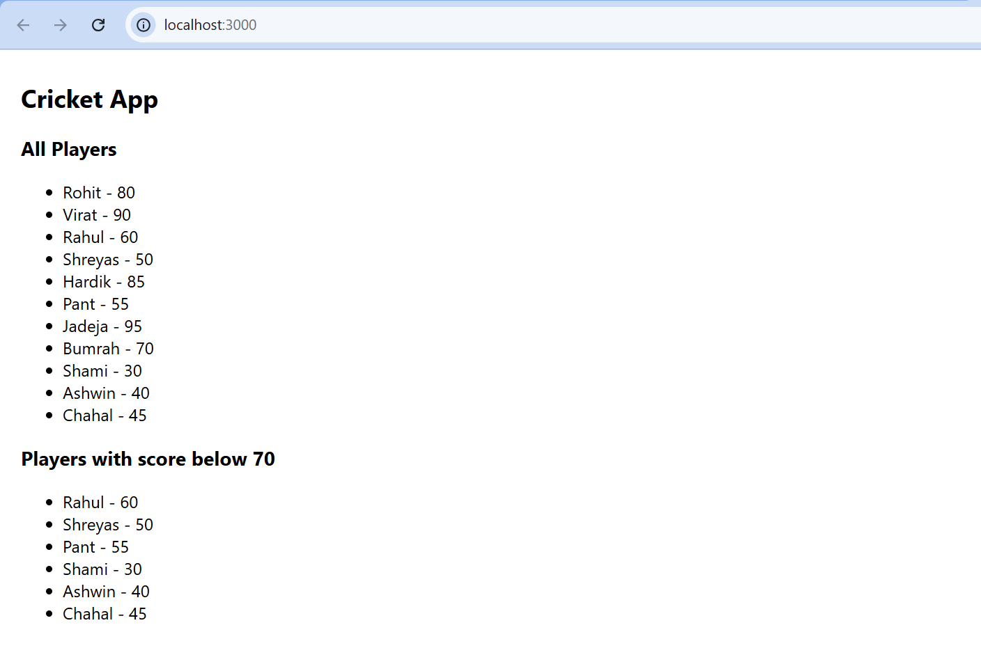

When

Flag = false

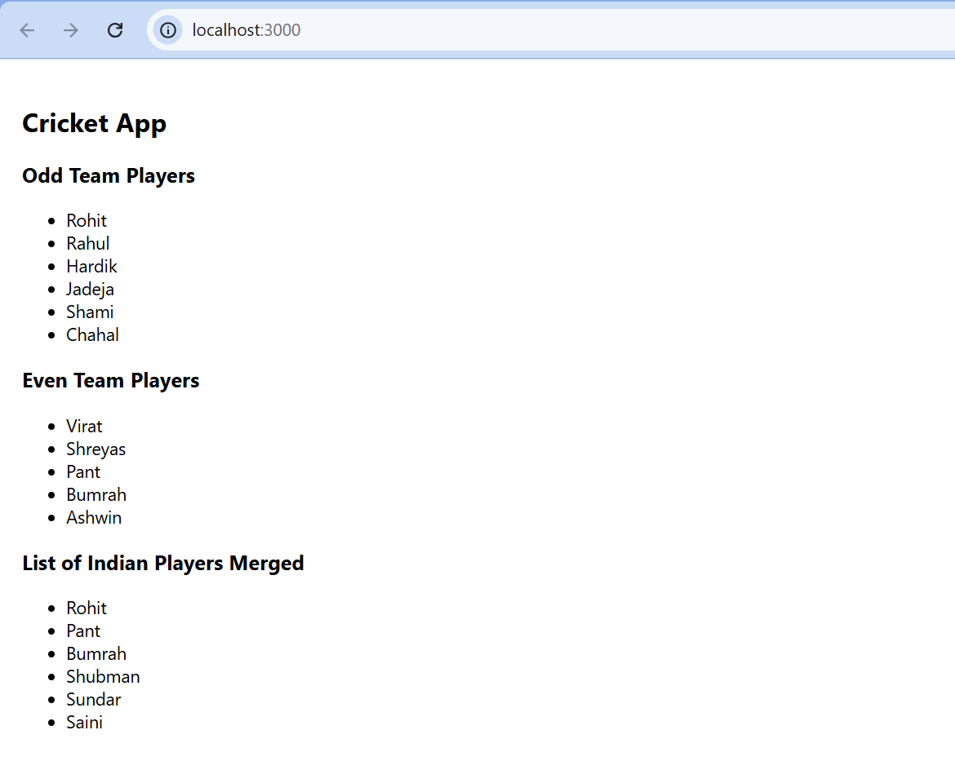

Task 10

Create a React Application named “officespacerentalapp” which uses React JSX to create elements, attributes and renders DOM to display the page.

Create an element to display the heading of the page.

Attribute to display the image of the office space

Create an object of office to display the details like Name, Rent and Address.

Create a list of Object and loop through the office space item to display more data.

To apply Css, Display the color of the Rent in Red if it’s below 60000 and in Green if it’s above 60000.

CODE:

import React from 'react';

function App() {

  const heading = <h1>Office Space, at Affordable</h1>;

  const officeImage = "https://officebanao.com/wp-content/uploads/2024/06/office-with-lot-desks-computers-1200x799.jpg";

  const office = {

    name: "Startup Hub",

    rent: 45000,

    address: "Gachibowli, Hyderabad"

  };

  const getRentStyle = (rent) => {

    return {

      color: rent < 60000 ? 'red' : 'green',

      fontWeight: 'bold'

    };

  };

  return (

    <div style={{ padding: "20px", fontFamily: "Arial" }}>

      {heading}

      <img src={officeImage} alt="Office" style={{ width: "400px", margin: "20px 0" }} />

      <h2>Office Details</h2>

      <p><strong>Name:</strong> {office.name}</p>

      <p><strong>Rent:</strong> <span style={getRentStyle(office.rent)}>{office.rent}</span></p>

      <p><strong>Address:</strong> {office.address}</p>

    </div>

  );

}

export default App;

**Output:**

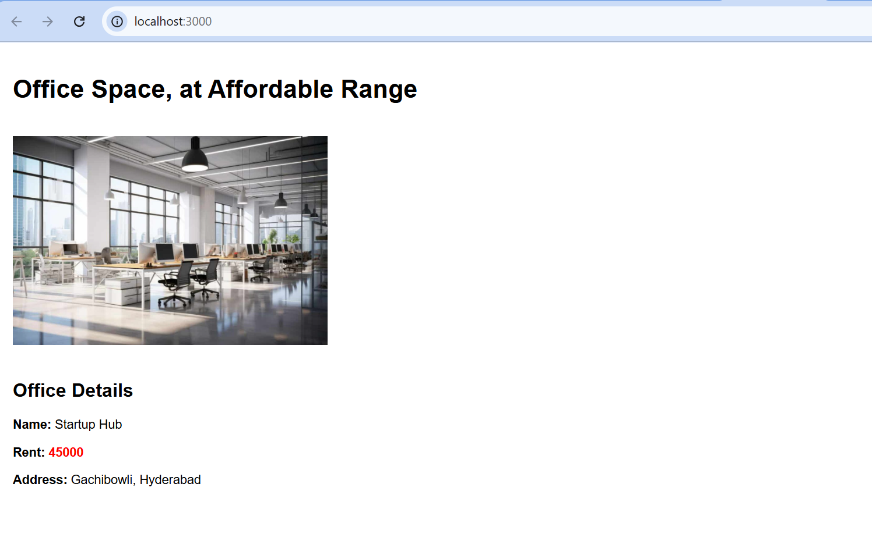

Task 11

Create a React Application “eventexamplesapp” to handle various events of the form elements in HTML.

1. Create “Increment” button to increase the value of the counter and “Decrement” button to decrease the value of the counter. The “Increase” button should invoke multiple methods.
   1. To increment the value
   2. Say Hello followed by a static message.
2. Create a button “Say Welcome” which invokes the function which takes “welcome” as an argument.
3. Create a button which invokes synthetic event “OnPress” which display “I was clicked”
4. Create a “CurrencyConvertor” component which will convert the Indian Rupees to Euro when the Convert button is clicked.
5. Handle the Click event of the button to invoke the handleSubmit event and handle the conversion of the euro to rupees.

CODE:

CurrencyConverter.js

import React, { Component } from 'react';

class CurrencyConvertor extends Component {

  constructor() {

    super();

    this.state = {

      rupees: '',

      euro: ''

    };

  }

  handleChange = (event) => {

    this.setState({ rupees: event.target.value });

  };

  handleSubmit = (event) => {

    event.preventDefault();

    const euroRate = 0.011; // Assume 1 INR = 0.011 EUR

    const euro = parseFloat(this.state.rupees) * euroRate;

    this.setState({ euro: euro.toFixed(2) });

  };

  render() {

    return (

      <div>

        <h2>Currency Convertor (INR to EUR)</h2>

        <form onSubmit={this.handleSubmit}>

          <input

            type="number"

            placeholder="Enter amount in INR"

            value={this.state.rupees}

            onChange={this.handleChange}

            required

          />

          <button type="submit">Convert</button>

        </form>

        {this.state.euro && (

          <p>

            Converted Amount in Euro: <strong>€{this.state.euro}</strong>

          </p>

        )}

      </div>

    );

  }

}

export default CurrencyConvertor;

App.js

import React, { Component } from 'react';

import CurrencyConvertor from './components/CurrencyConvertor';

class App extends Component {

  constructor() {

    super();

    this.state = {

      counter: 0,

    };

  }

  increment = () => {

    this.setState({ counter: this.state.counter + 1 });

    this.sayHello();

  };

  decrement = () => {

    this.setState({ counter: this.state.counter - 1 });

  };

  sayHello = () => {

    alert('Hello! Counter incremented.');

  };

  sayWelcome = (message) => {

    alert(message);

  };

  handleSyntheticEvent = (event) => {

    alert('I was clicked');

  };

  render() {

    return (

      <div style={{ padding: '20px', fontFamily: 'Arial' }}>

        <h1>React Events Demo</h1>

        <h2>Counter: {this.state.counter}</h2>

        <button onClick={this.increment}>Increment</button>{' '}

        <button onClick={this.decrement}>Decrement</button>

        <br /><br />

        <button onClick={() => this.sayWelcome('Welcome to React Events!')}>

          Say Welcome

        </button>

        <br /><br />

        <button onClick={this.handleSyntheticEvent}>Synthetic Event</button>

        <hr />

        <CurrencyConvertor />

      </div>

    );

  }

}

export default App;

Output:

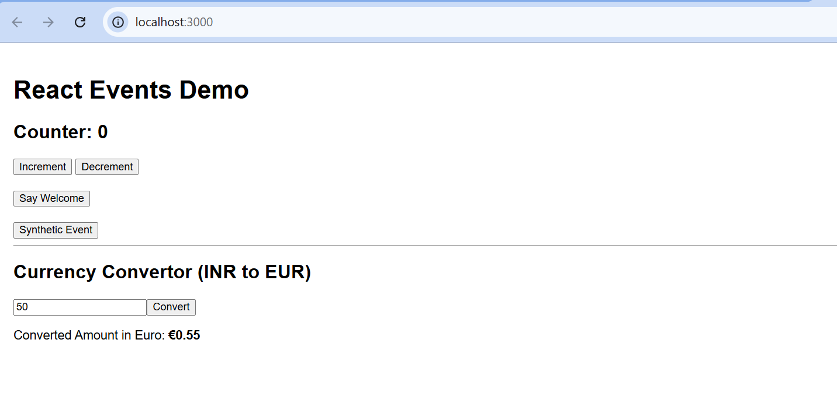

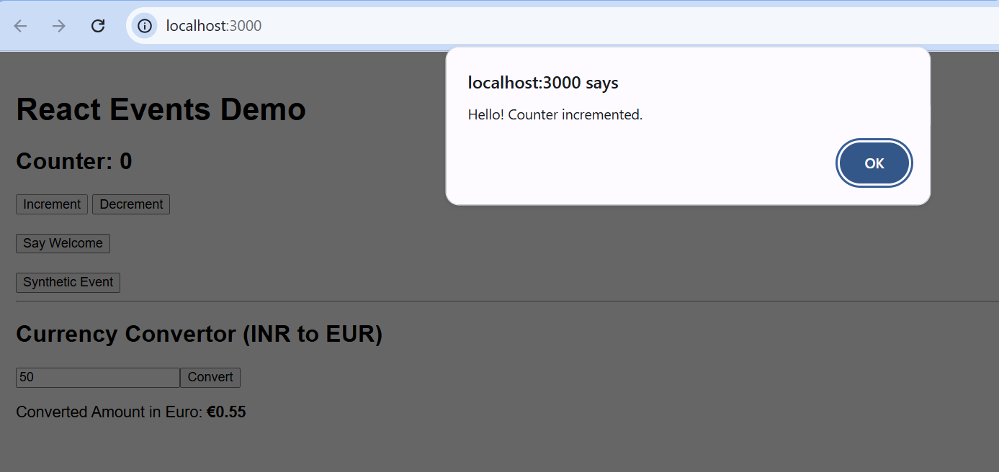

Count incremented

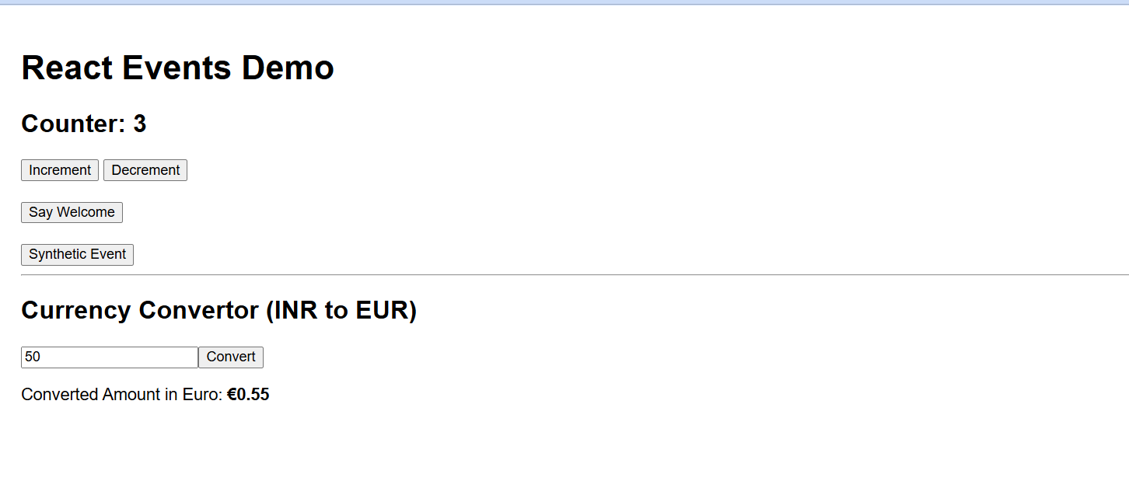

Count Decremented

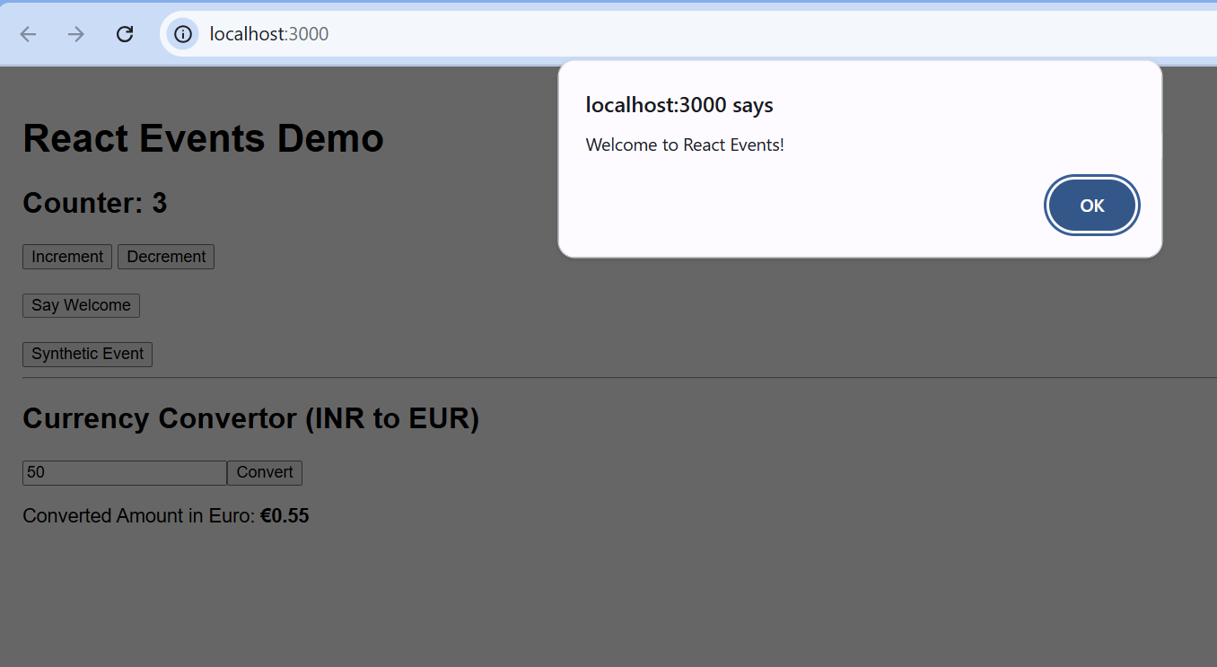

Say Welcome

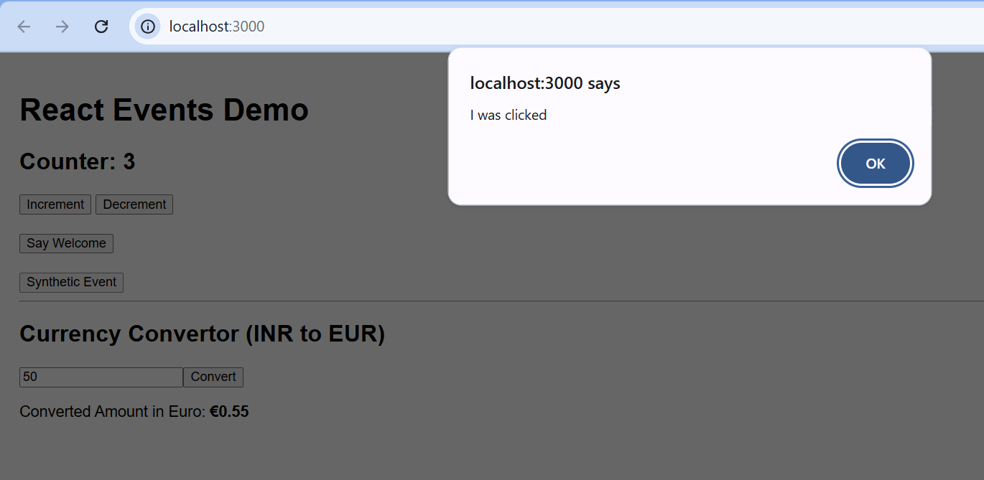

Synthetic Event

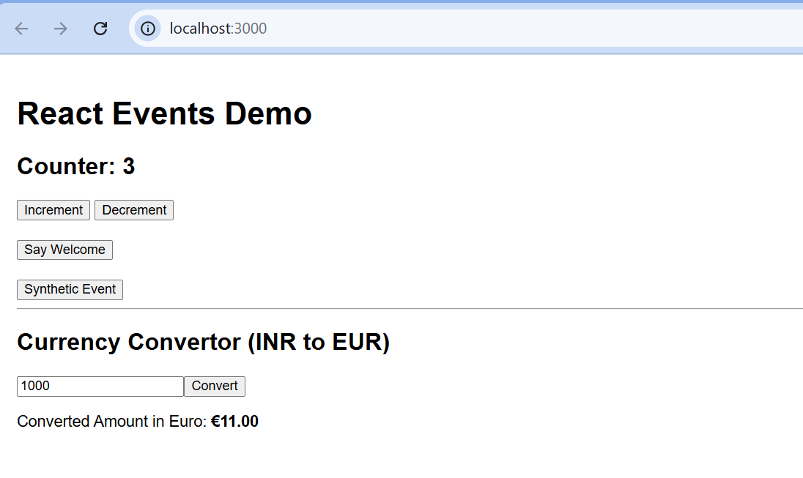

Currency Converter

Task 12

Create a React Application named “ticketbookingapp” where the guest user can browse the page where the flight details are displayed whereas the logged in user only can book tickets.

The Login and Logout buttons should accordingly display different pages. Once the user is logged in the User page should be displayed. When the user clicks on Logout, the Guest page should be displayed.

CODE:

App.js

import React, { Component } from 'react';

class App extends Component {

  constructor() {

    super();

    this.state = {

      isLoggedIn: false

    };

  }

  handleLogin = () => {

    this.setState({ isLoggedIn: true });

  };

  handleLogout = () => {

    this.setState({ isLoggedIn: false });

  };

  render() {

    const { isLoggedIn } = this.state;

    return (

      <div style={{ padding: '20px', fontFamily: 'Arial' }}>

        <h1>{isLoggedIn ? 'Welcome Back' : 'Please Sign Up!'}</h1>

        <button onClick={isLoggedIn ? this.handleLogout : this.handleLogin}>

          {isLoggedIn ? 'Logout' : 'Login'}

        </button>

      </div>

    );

  }

}

export default App;

Output:

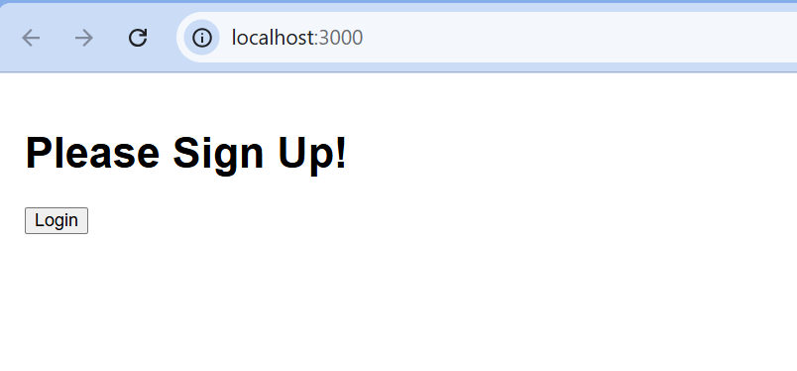

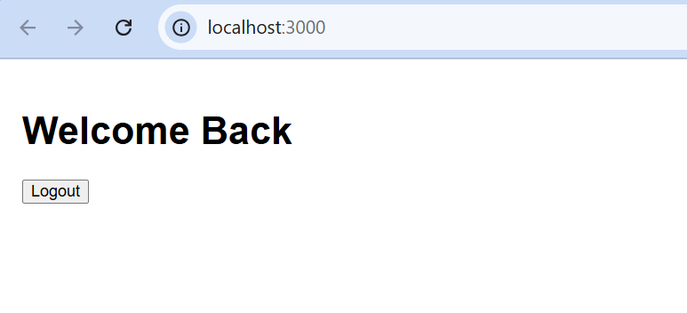

Task 13

Create a React App named “bloggerapp” in with 3 components.

1. Book Details
2. Blog Details
3. Course Details

Implement this with as many ways possible of Conditional Rendering.

CODE:

App.js

import React from 'react';

import CourseDetails from './components/CourseDetails';

import BookDetails from './components/BookDetails';

import BlogDetails from './components/BlogDetails';

function App() {

  return (

    <div style={styles.container}>

      <div style={styles.column}>

        <CourseDetails />

      </div>

      <div style={styles.middleColumn}>

        <BookDetails />

      </div>

      <div style={styles.column}>

        <BlogDetails />

      </div>

    </div>

  );

}

const styles = {

  container: {

    display: 'flex',

    justifyContent: 'space-between',

    alignItems: 'flex-start',

    padding: '40px',

    fontFamily: 'Arial, sans-serif',

    textAlign: 'left'

  },

  column: {

    width: '30%',

  },

  middleColumn: {

    width: '30%',

    borderLeft: '3px solid green',

    borderRight: '3px solid green',

    padding: '0 15px',

  }

};

export default App;

BookDetails.js

import React from 'react';

function BookDetails() {

  return (

    <div>

      <h2>Book Details</h2>

      <h3>Master React</h3>

      <p>670</p>

      <h3>Deep Dive into Angular 11</h3>

      <p>800</p>

      <h3>Mongo Essentials</h3>

      <p>450</p>

    </div>

  );

}

export default BookDetails;

BlogDetails.js

import React from 'react';

function BlogDetails() {

  return (

    <div>

      <h2>Blog Details</h2>

      <h3>React Learning</h3>

      <p><strong>Stephen Biz</strong></p>

      <p>Welcome to learning React!</p>

      <h3>Installation</h3>

      <p><strong>Schewzdenier</strong></p>

      <p>You can install React from npm.</p>

    </div>

  );

}

export default BlogDetails;

CourseDetails.js

import React from 'react';

function CourseDetails() {

  return (

    <div>

      <h2>Course Details</h2>

      <h3>Angular</h3>

      <p>4/5/2021</p>

      <h3>React</h3>

      <p>6/3/20201</p>

    </div>

  );

}

export default CourseDetails;

Output:

