Database System Engineering and Distributed Backend Development
Course Code: 25CS1302E
Week-2

Roll No:2520030189
Name:Alluru Akshaya
Section:7

Query 1 — Create Database
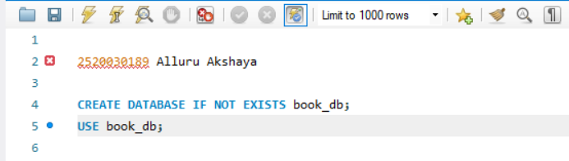
Output:

Query 2 — Create Books Table (DDL + Constraints)
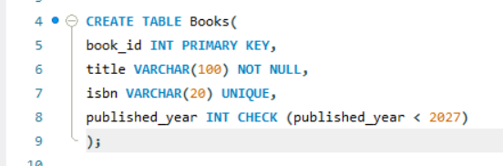
Output:

Query-3-Insert Books

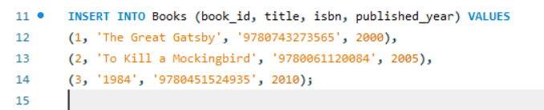

Output:

Query-4-Display Books
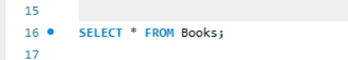

Output:
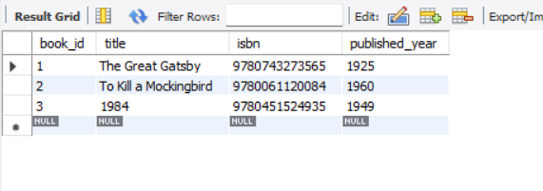
Query-5-Create Members table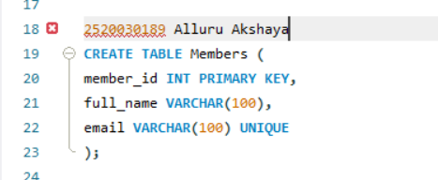
Output:
Query-6-Insert Members
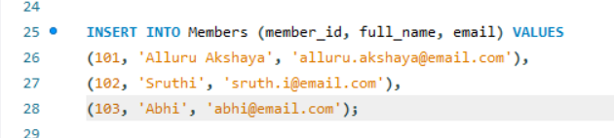
Output:
Query-7-Display Members
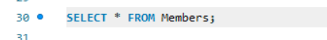
Output:
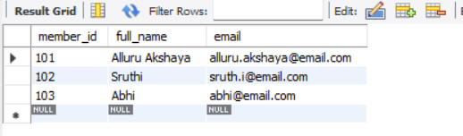
Query-8-Create Loans Table (FOREIGN KEYS)
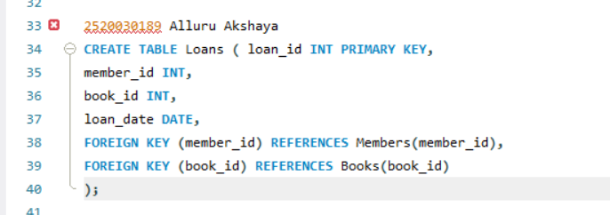
Output:

Query-9-Insert 10 Loans
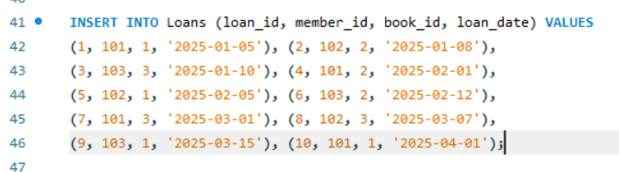
Output:

Query-10-Display Loans
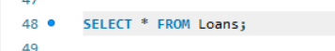

Output:
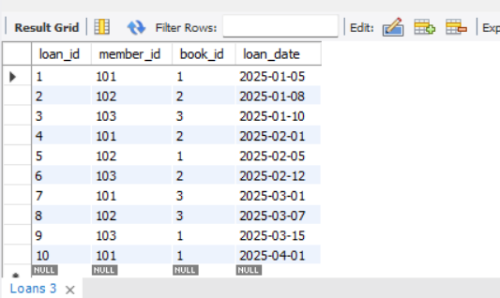

Query-11-JOIN Query (Who Borrowed What)
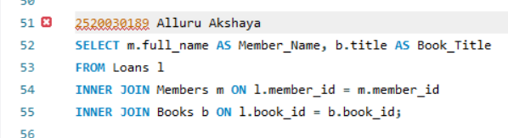

Output:
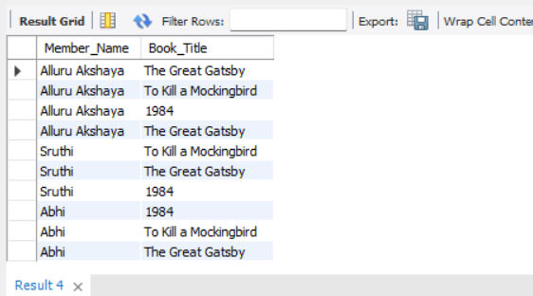

Query-12 — GROUP BY Query (Books per Year)
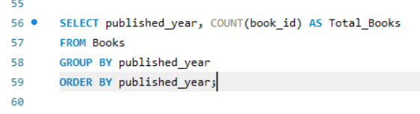

Output:
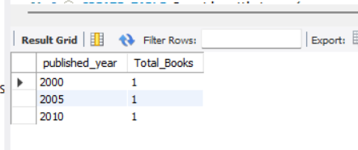

Query-13
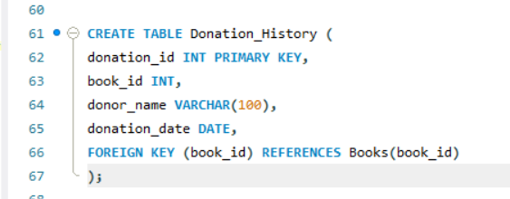
Output:

Query-14
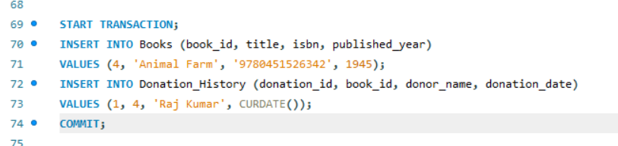
Output:

Qury-15

Output:

Qury-16
Output:
