Database System Engineering and Distributed Backend Development
Course Code: 25CS1302E
Week-1

Roll No:2520030189
Name:Alluru Akshaya
Section:7

Query-1-Create the database
Output:
Query-2-Select the database

Output:

Query-3: Create the books table
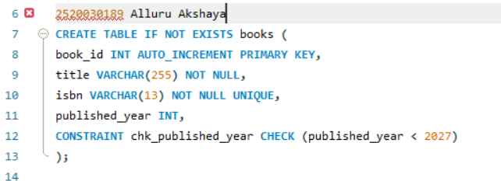
Output:

Query-4-Create the members table
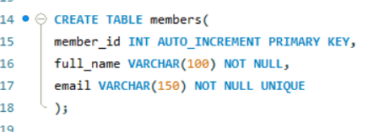
Output:

Query-5-Inspect the table structures

Output:
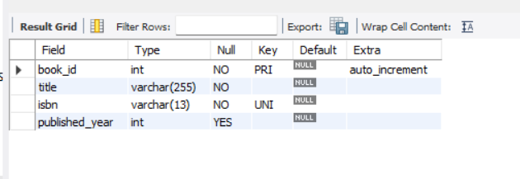
Query-6:
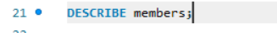
Output:
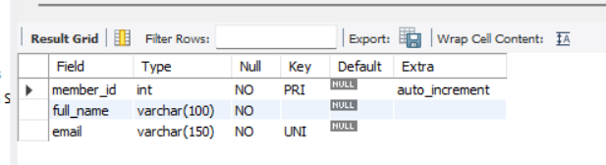

Query-7-Insert 3 books
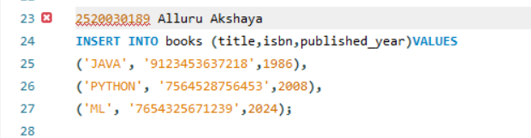
Output:

Query-8-Insert 3 members
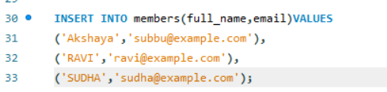
Output:

Query-9-
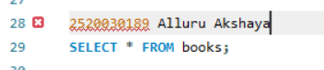
Output:
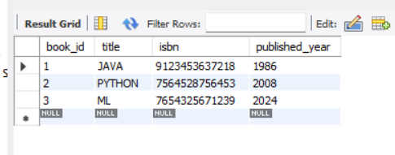

Query-10-


Output:
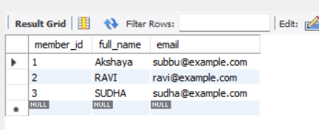

Query-11-
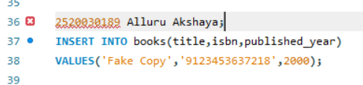
Output:

