Database System Engineering and Distributed Backend Development
Course Code: 25CS1302E
DDL, DML, DCL, TCL Handson
Roll No:2520030189
Name:Alluru Akshaya
Section:7

Query-1:
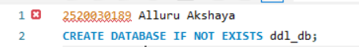
Output:

Query-2:

Output:
Query-3:
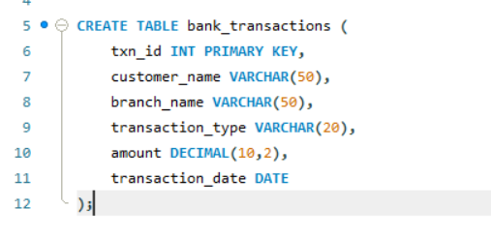
Output:

Query-4:
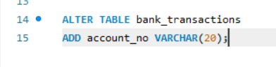
Output:

Query-5:
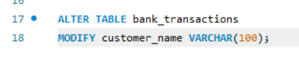
Output:

Query-6:
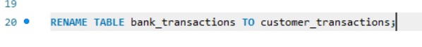
Output:

Query-7:
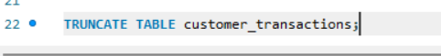
Output:

Query-8:
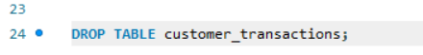
Output:
Query-9:
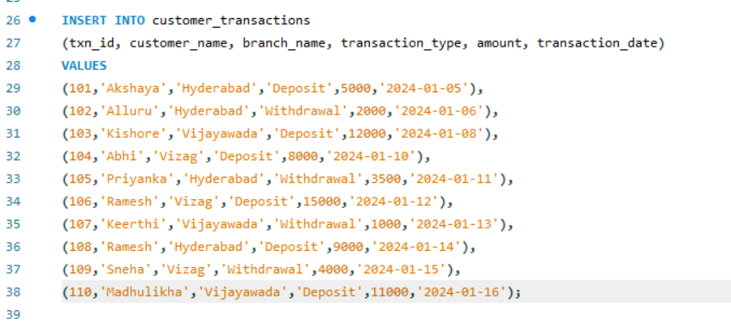
Output:
Query-10:
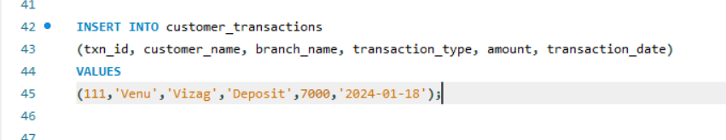
Output:
Query-11:
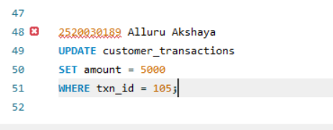

Output:

Query-12:
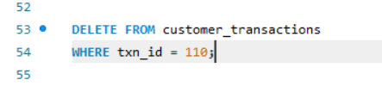
Output:

Query-13:
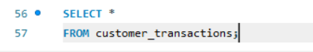
Output:
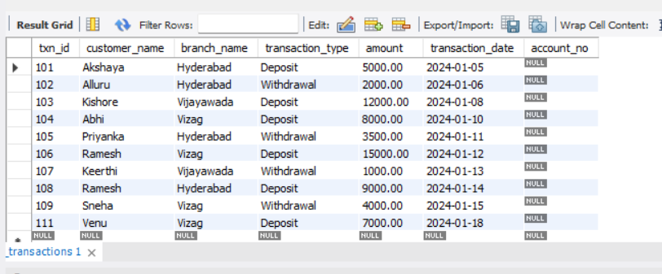

Query-14:
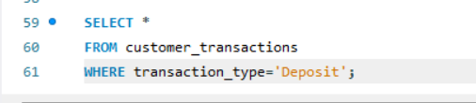

Output:
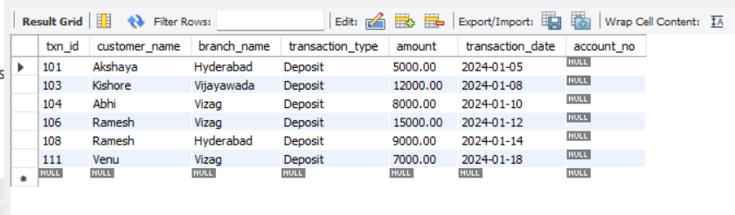

Query-15:
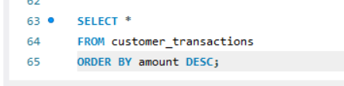
Output:
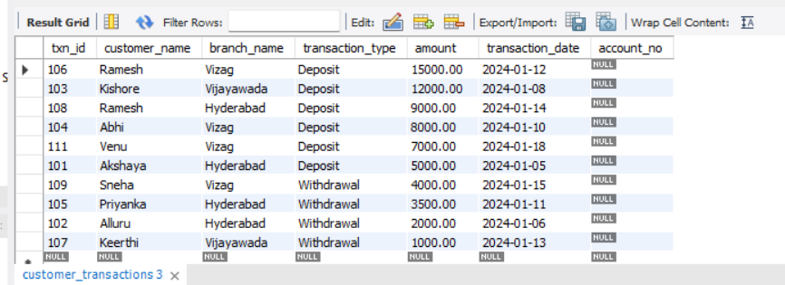

Query-16:
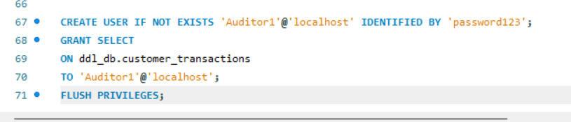
Output:
Query-17:
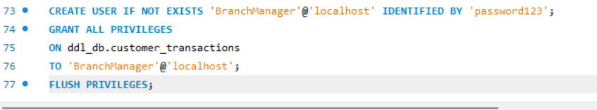
Output:

Query-18:
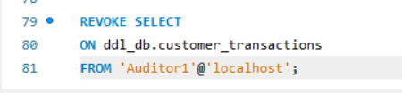
Output:

Query-19:
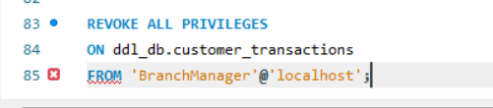
Output:

Query-20:
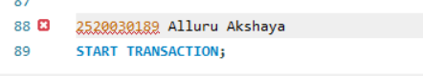
Output:
Query-21:
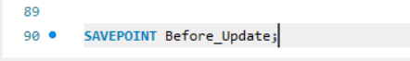
Output:

Query-22:
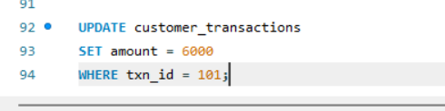

Output:

Query-23:
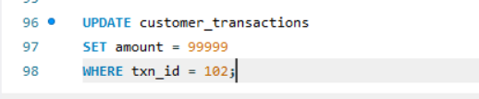
Output:

Query-24:
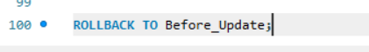
Output:

Query-25:
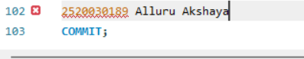
Output:

