Database System Engineering and Distributed Backend Development
Course Code: 25CS1302E
SKILL SESSION - 4 AND 5

Roll No:2520030189
Name:Alluru Akshaya
Section:7

Insert customer data
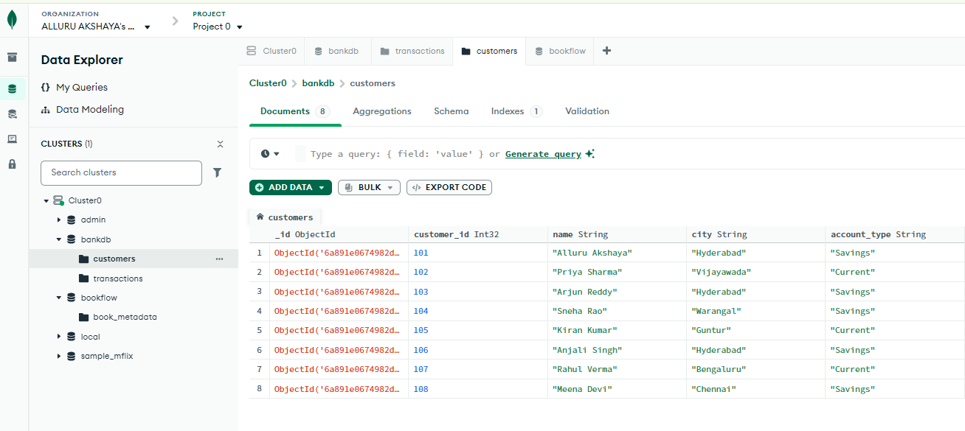
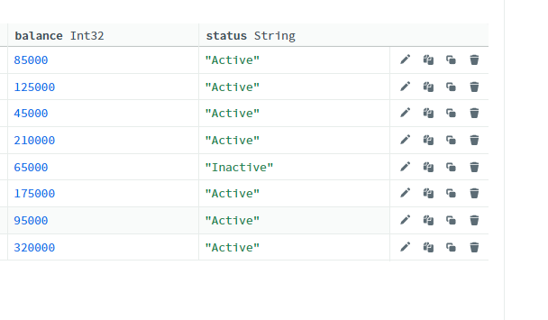

Insert Transactions data
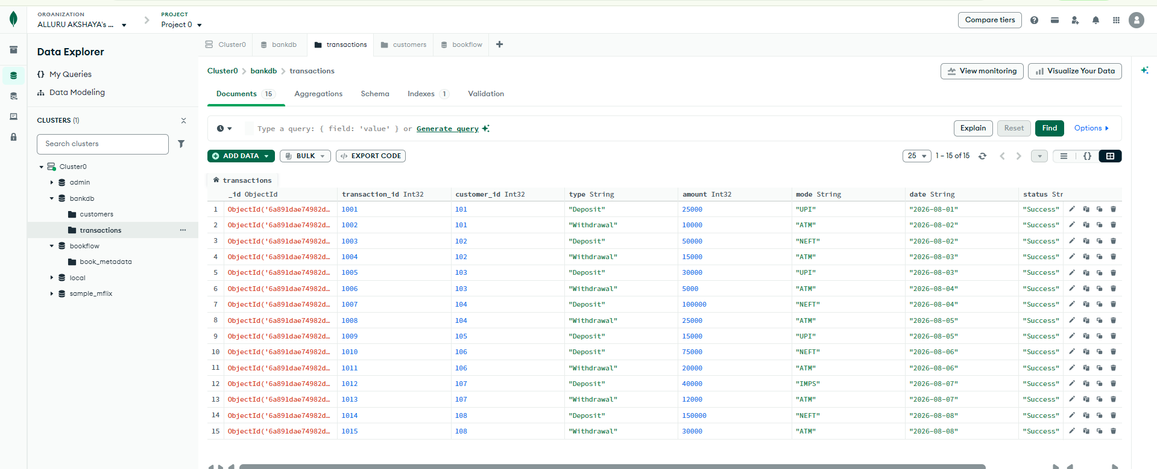
DISPLAY ALL CUSTOMERS:
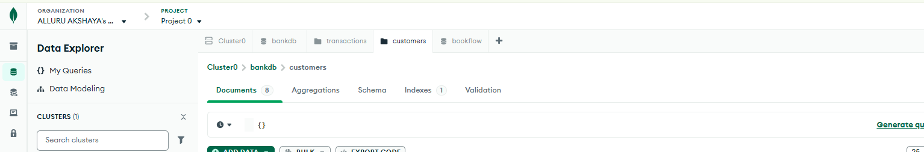
Output:
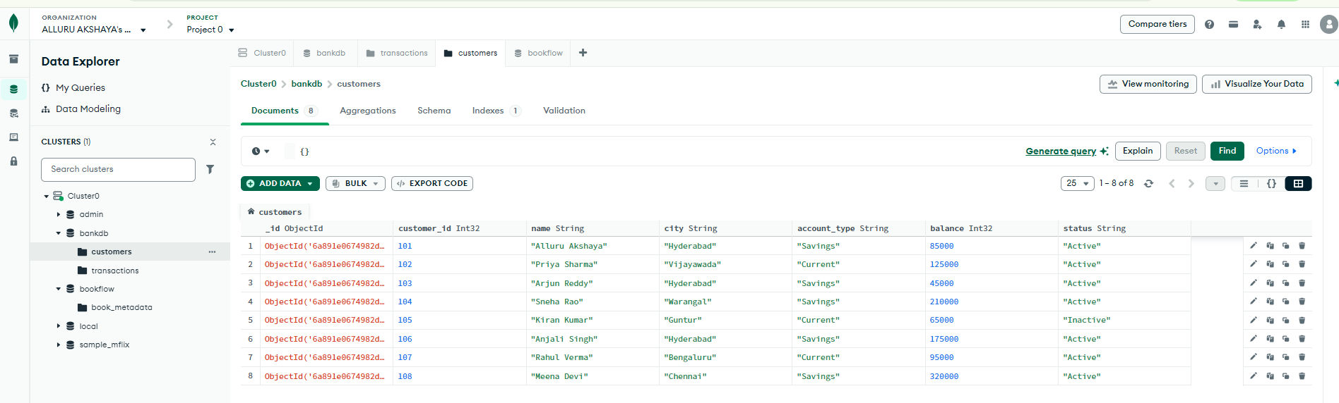
FIND ACTIVE CUSTOMERS
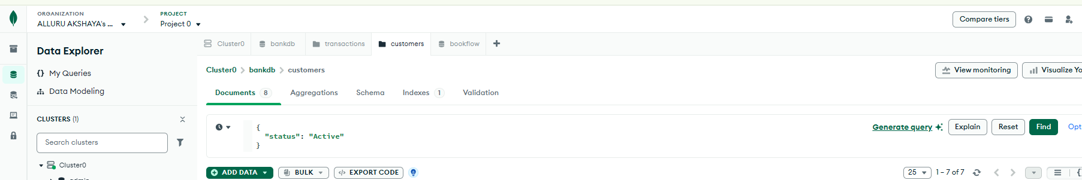
Output:
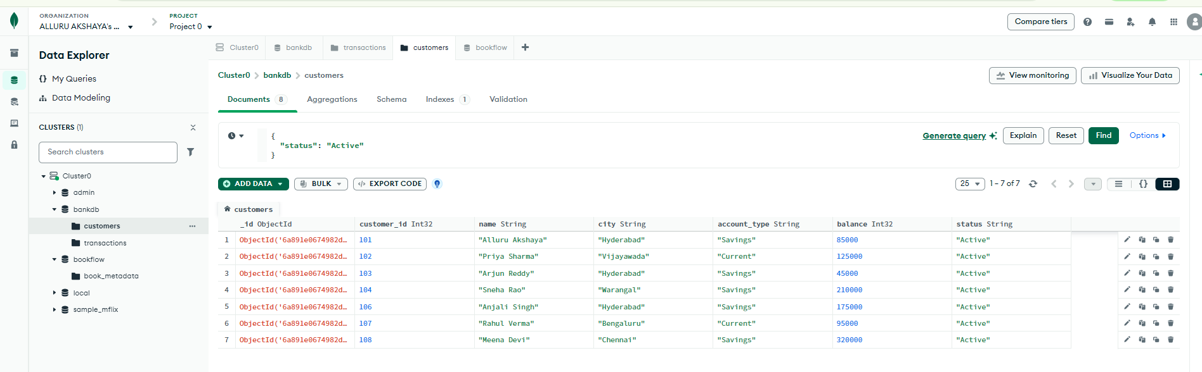
FIND CUSTOMERS WITH BALANCE GREATER THAN 100000
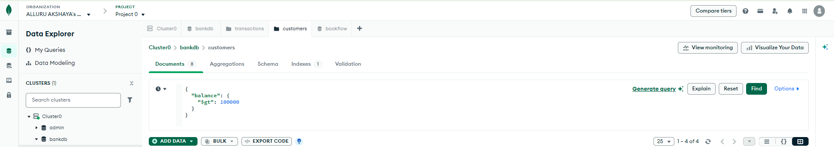
Output:
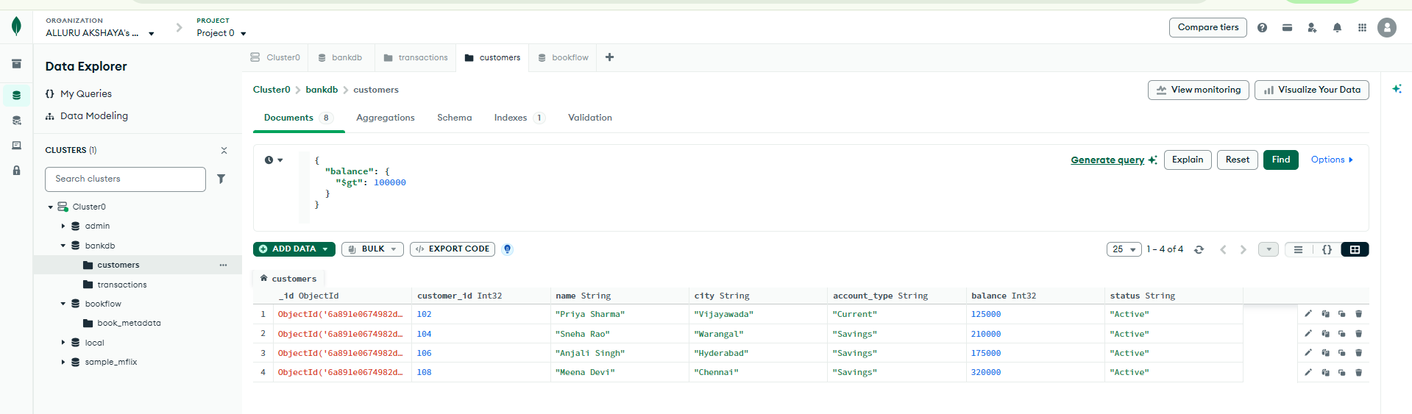
FIND HYDERABAD CUSTOMERS:
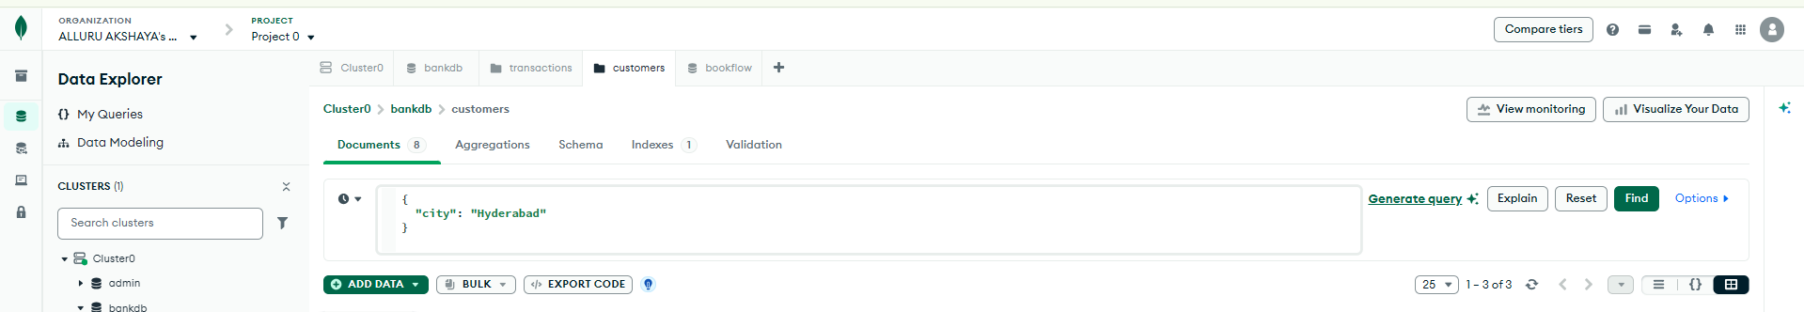
Output:
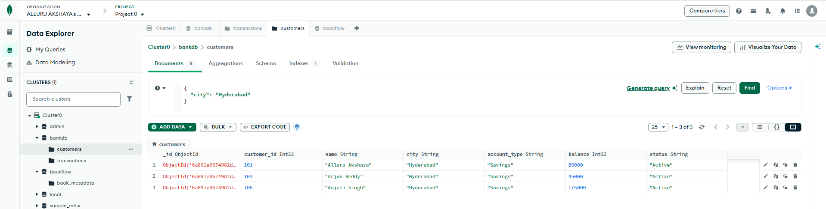
FIND SAVINGS ACCOUNT CUSTOMERS:
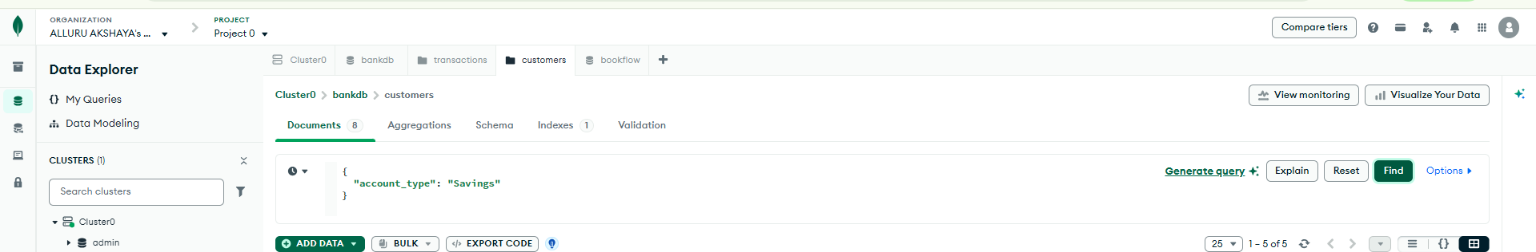
Output:
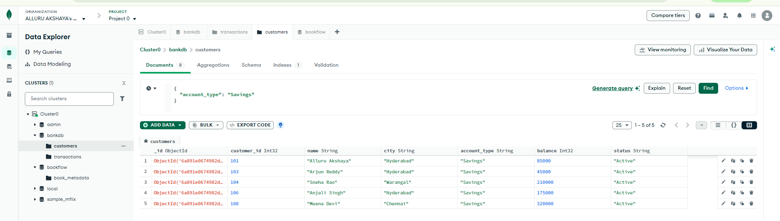
FIND TRANSACTIONS GREATER THAN 20000:
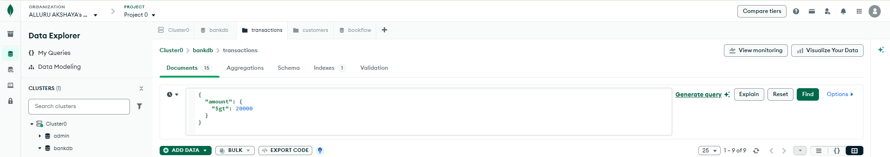
Output:
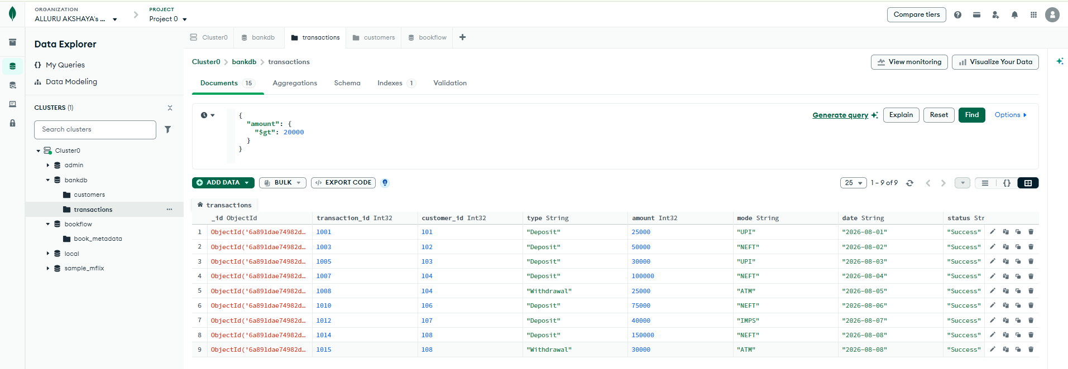
FIND DEPOSITS
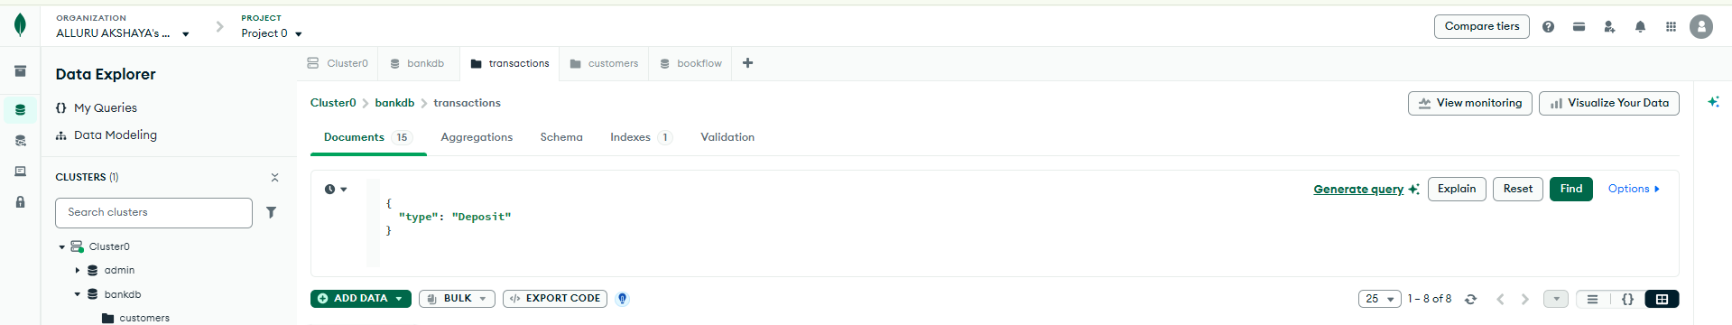
Output:
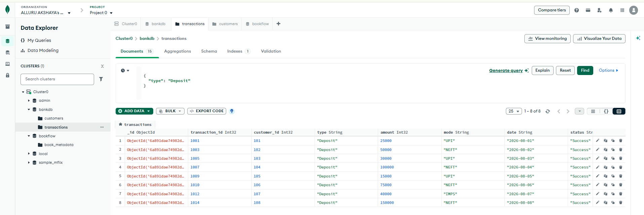
FIND ATM TRANSACTIONS
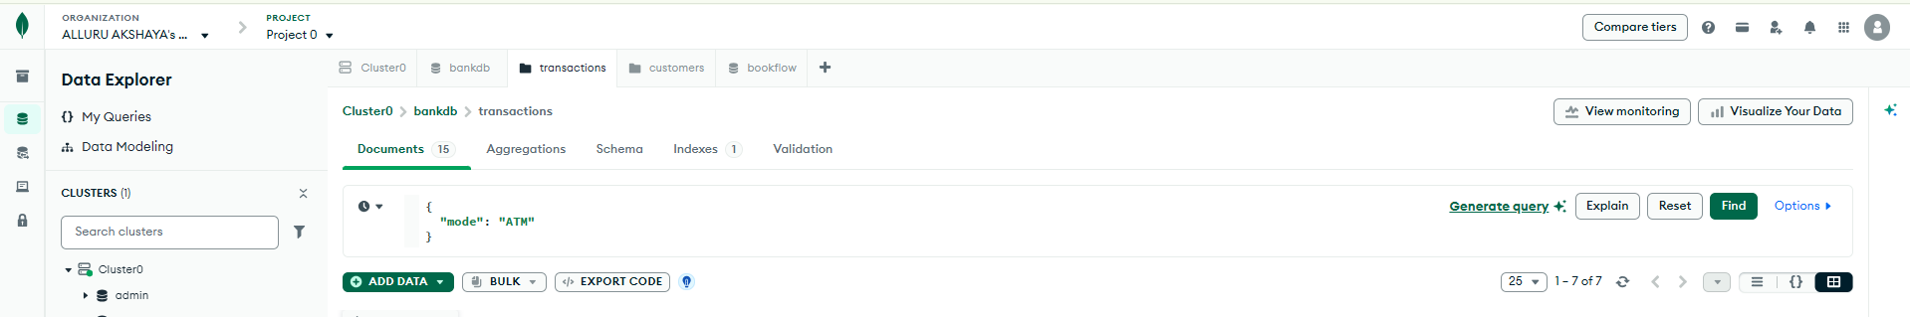
Output:
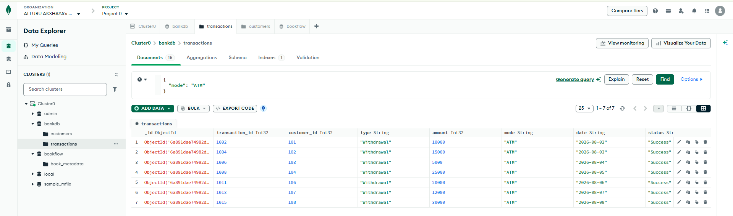
FIND DEPOSITS GREATER THAN 50000
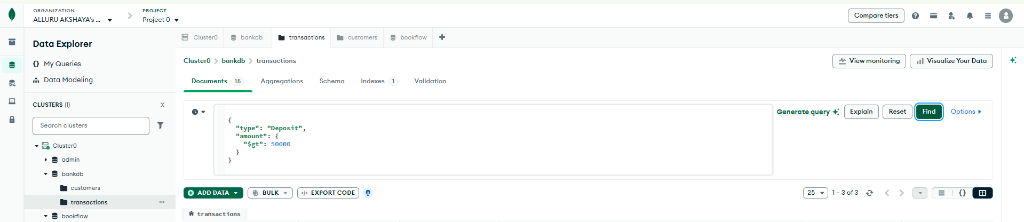

Output:
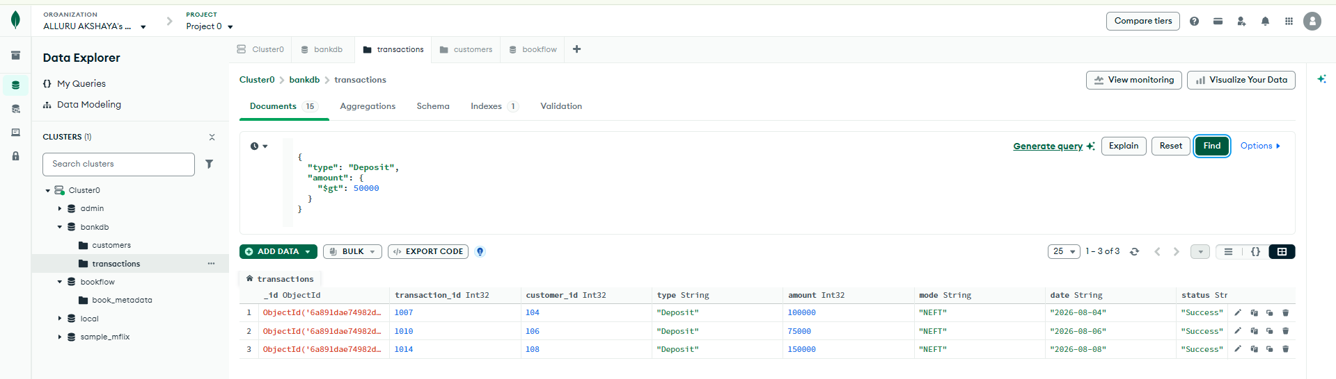
FIND HYDERABAD CUSTOMERS WITH HIGH BALANCE
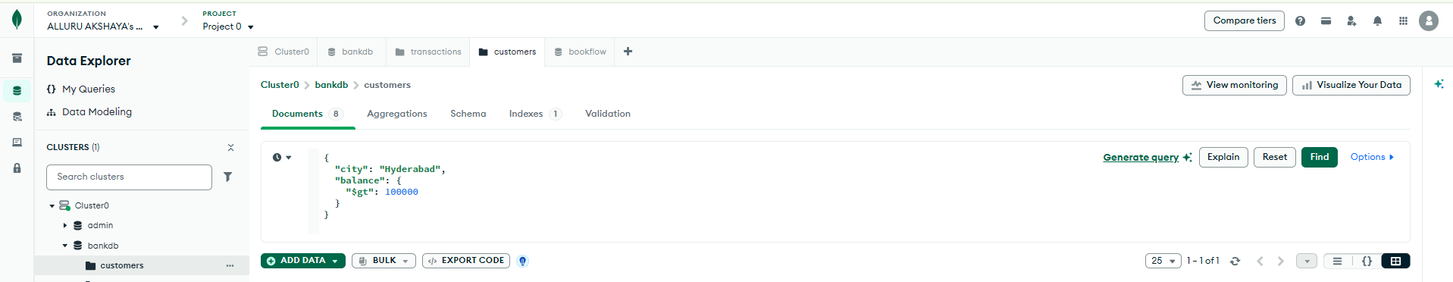
Output:
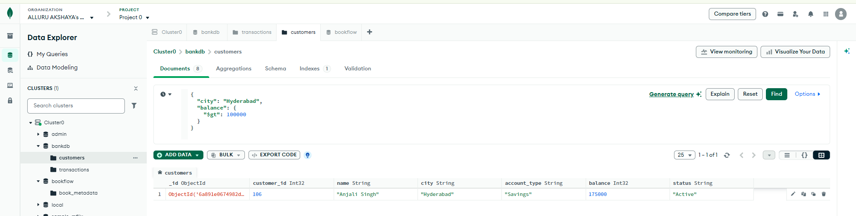
FIND CUSTOMERS IN MULTIPLE CITIES
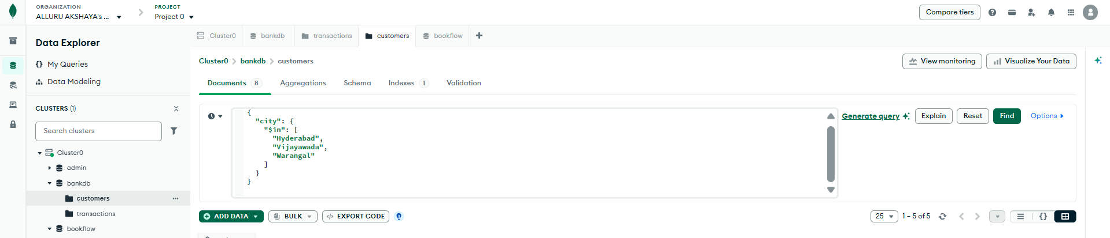
Output:
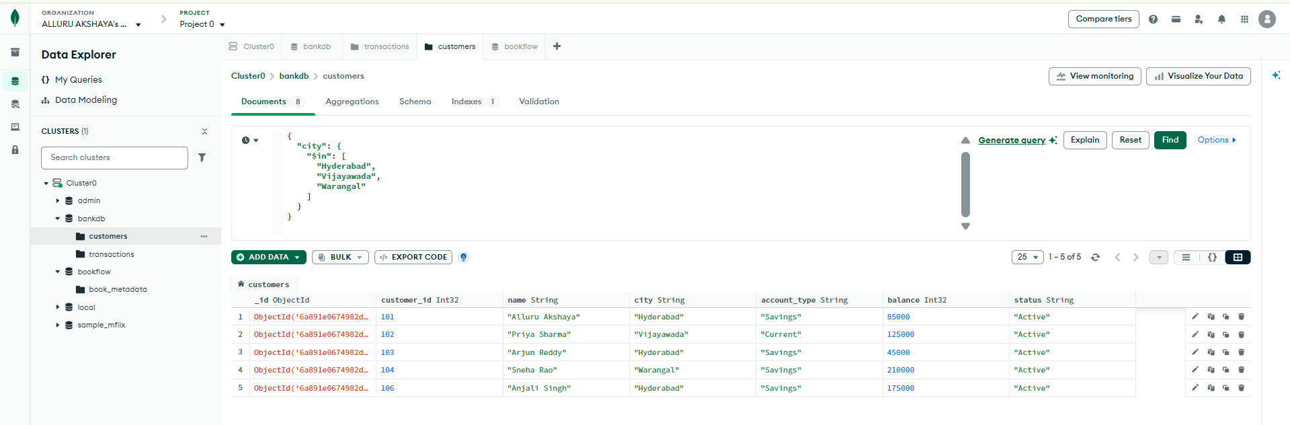
SORT CUSTOMERS BY BALANCE
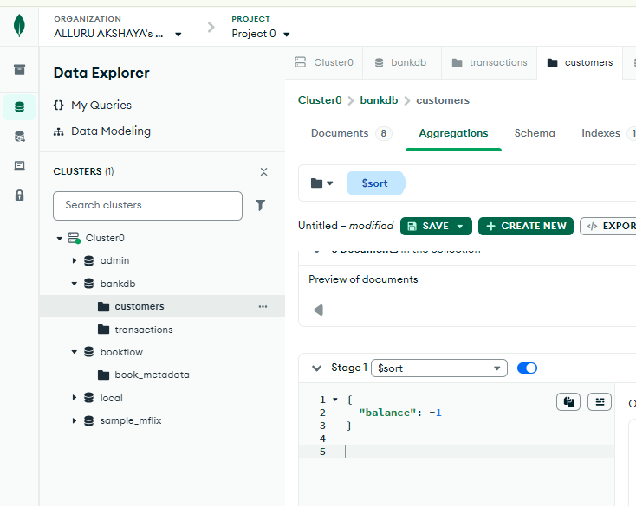
Output:
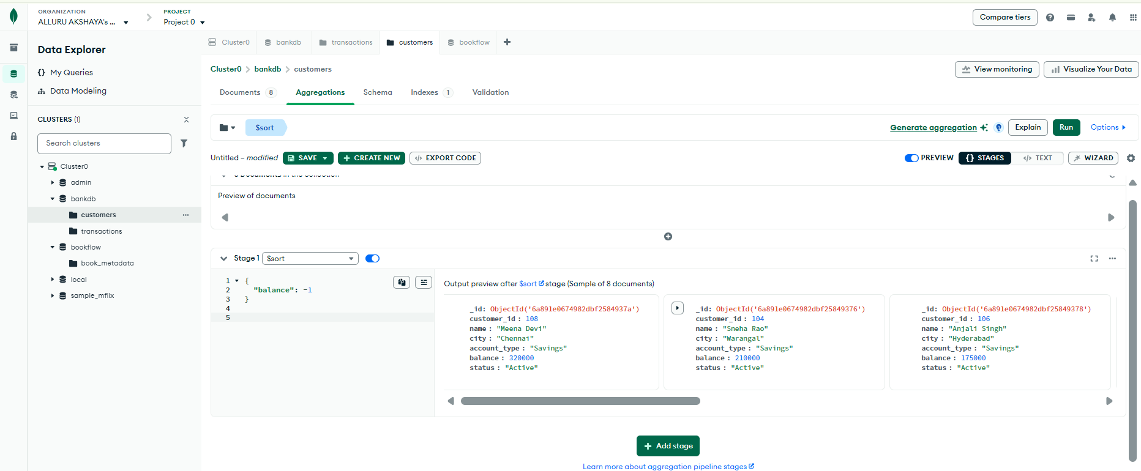
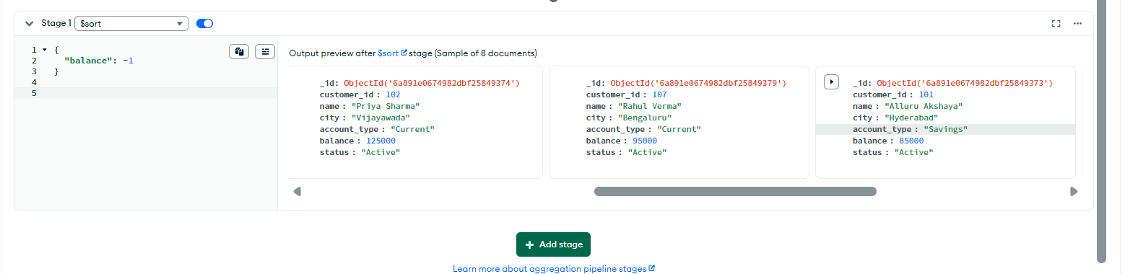
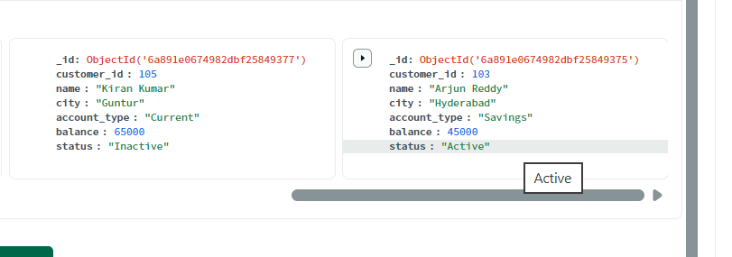
CALCULATE TOTAL TRANSACTION AMOUNT
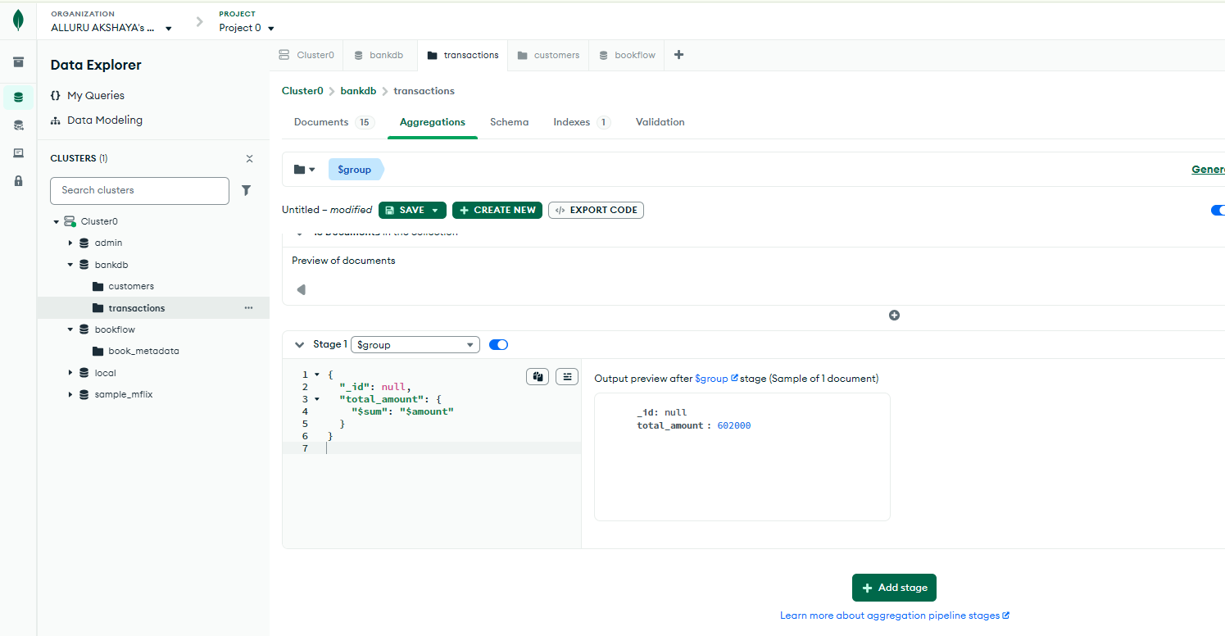
CALCULATE AVERAGE TRANSACTION AMOUNT
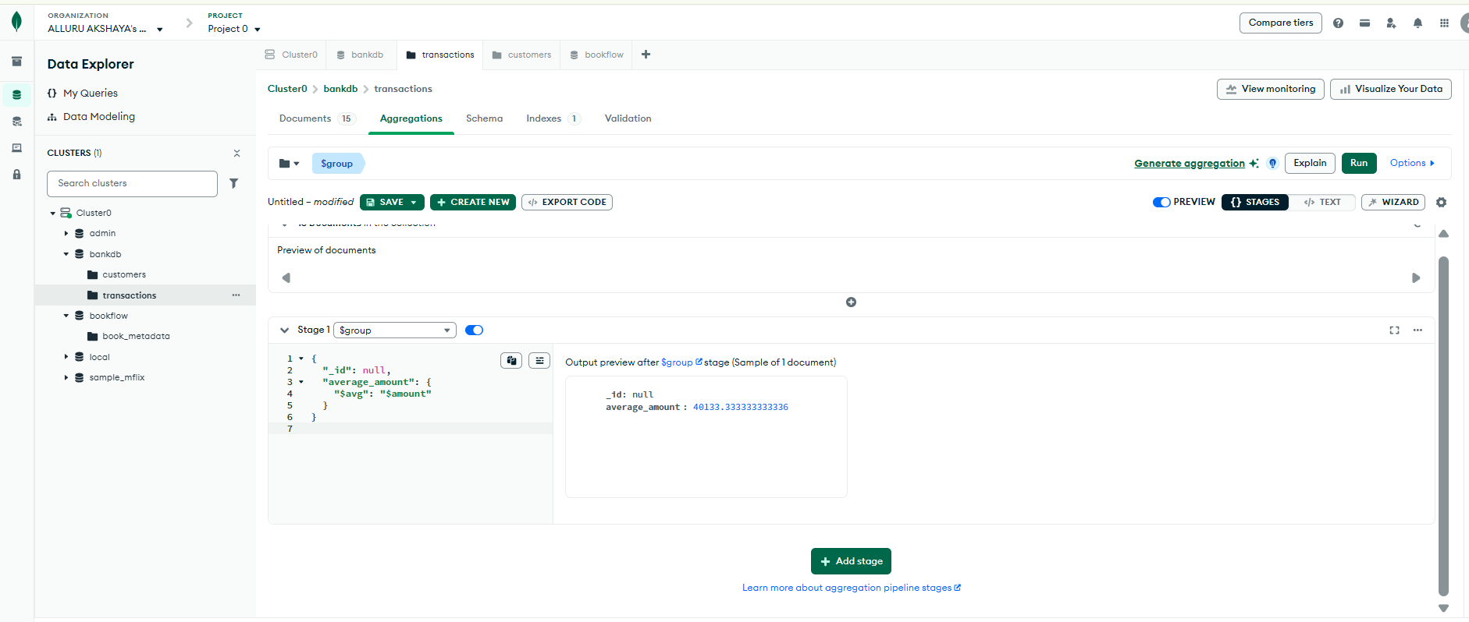
TOTAL TRANSACTION AMOUNT BY TYPE
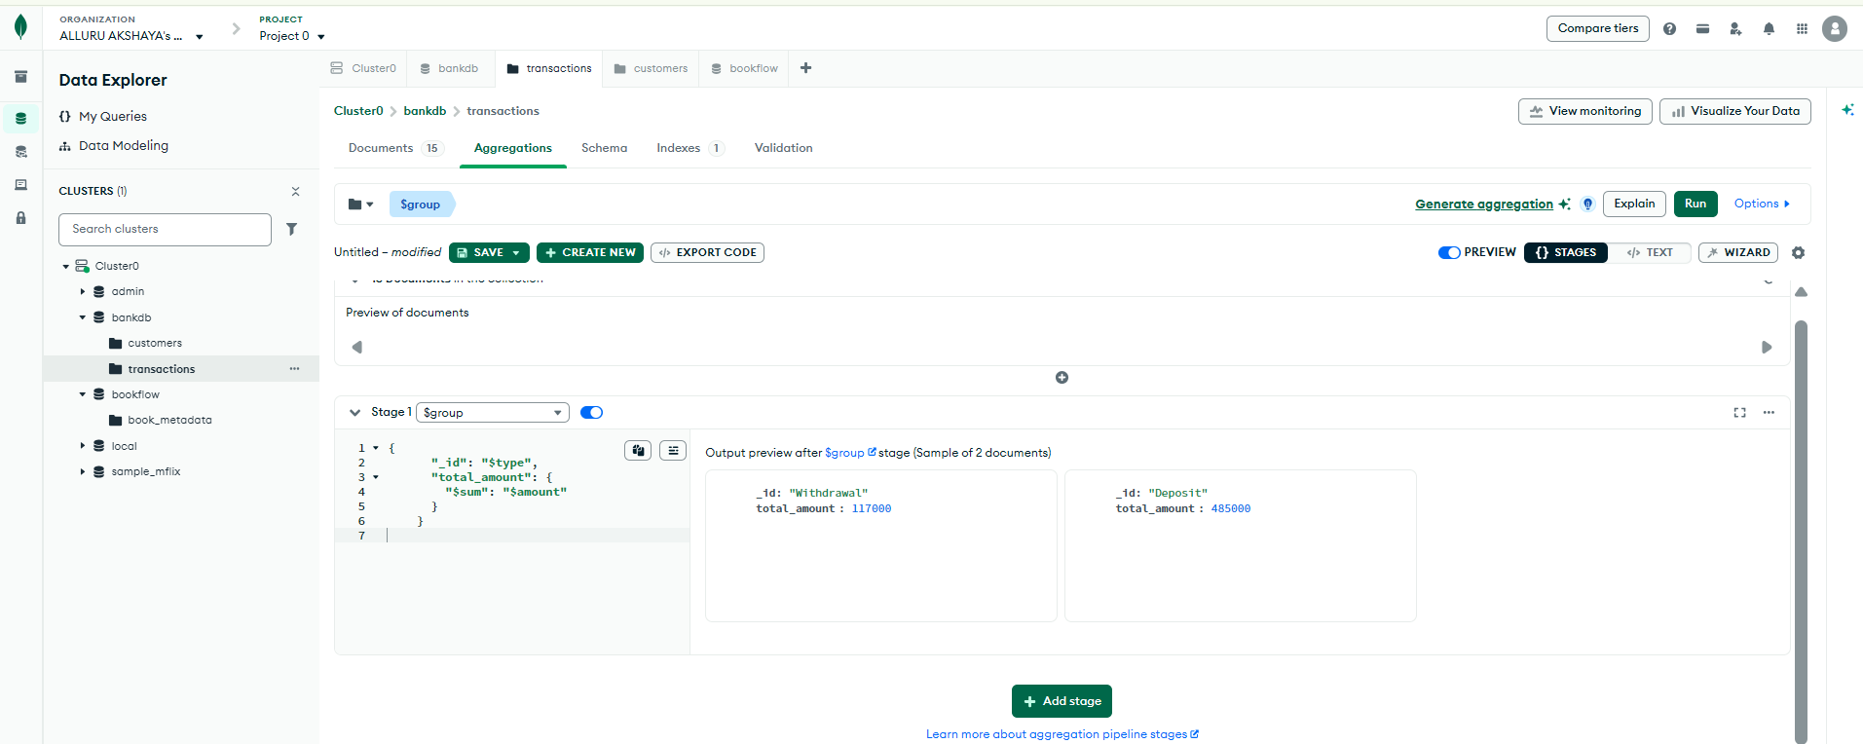
NUMBER OF TRANSACTIONS PER CUSTOMER
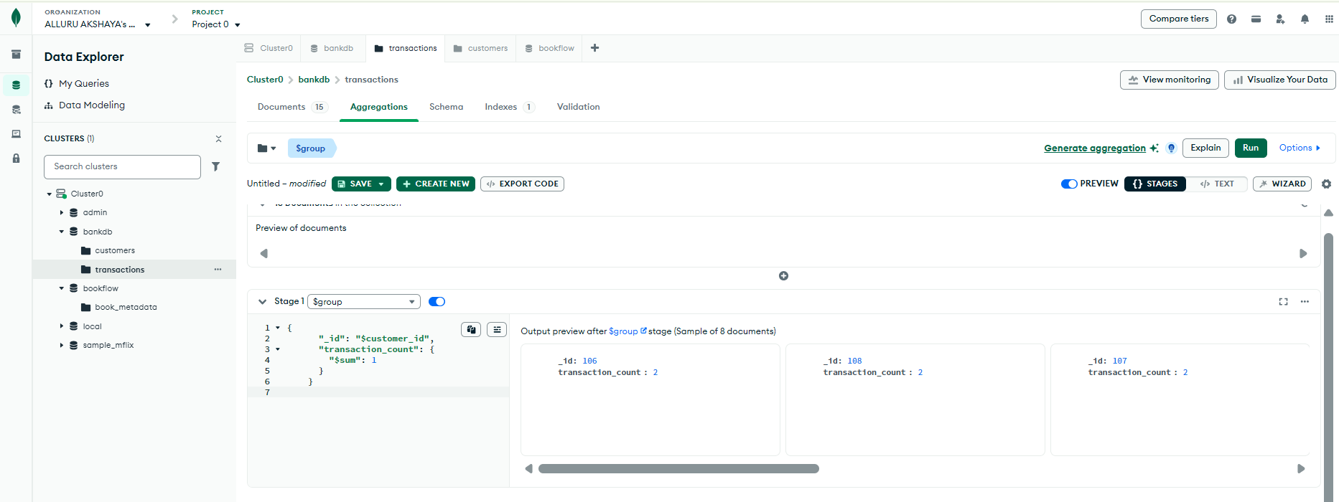
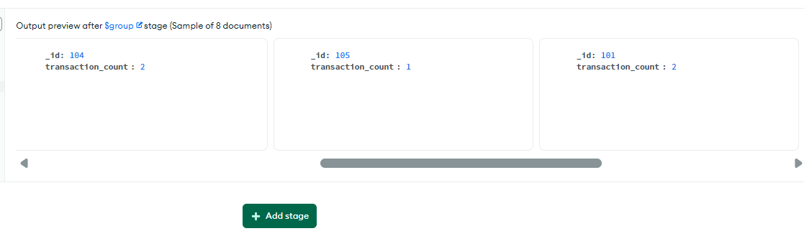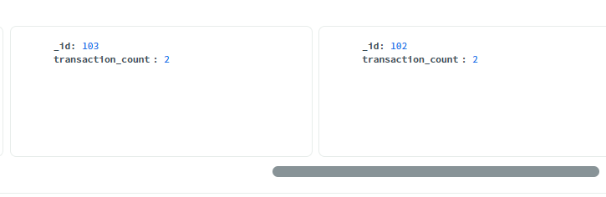
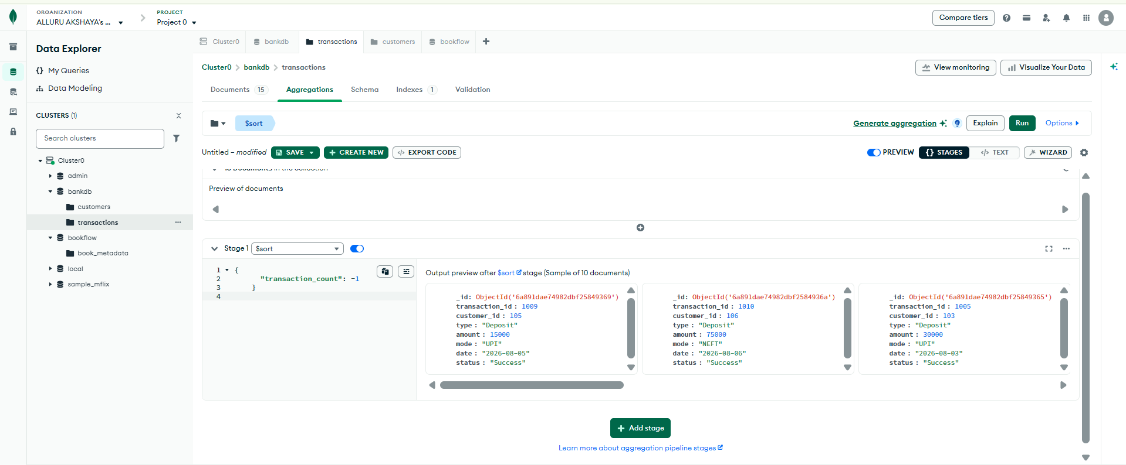
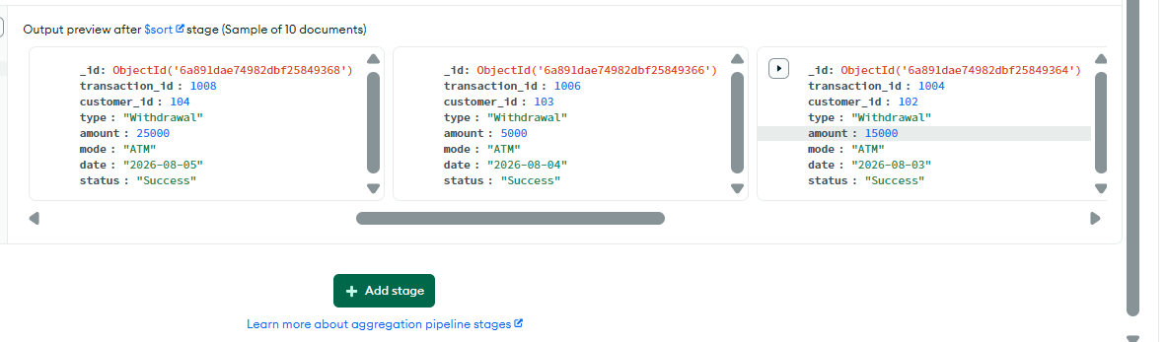
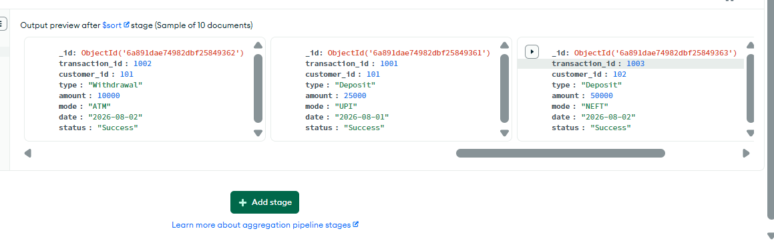

CUSTOMER + TRANSACTION JOIN
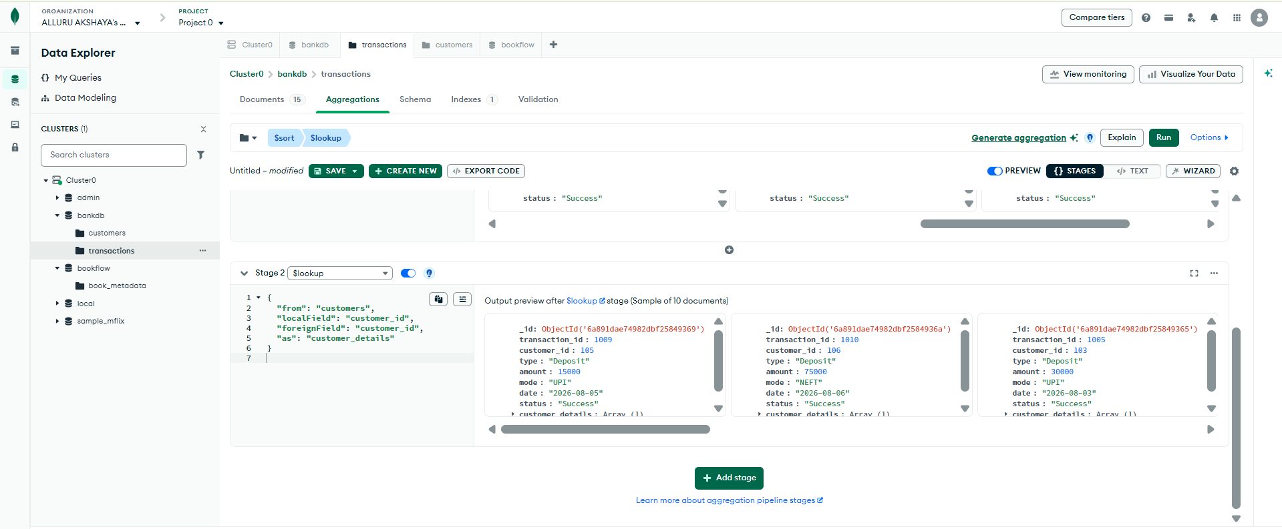
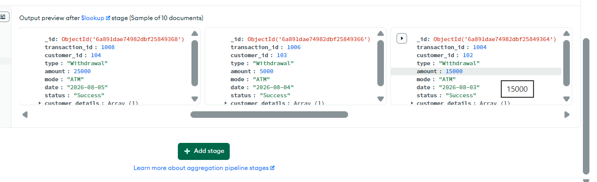
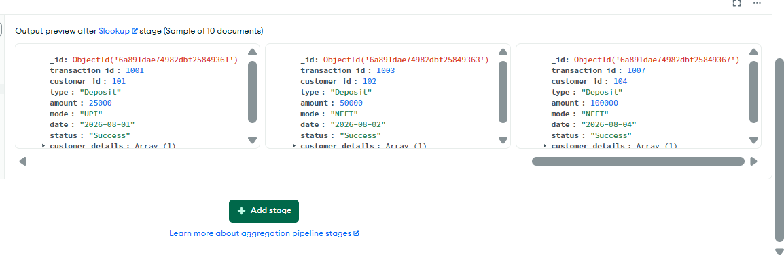
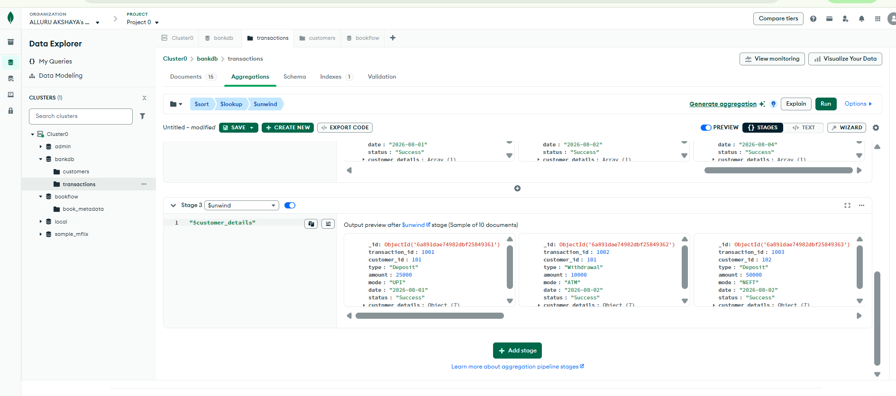
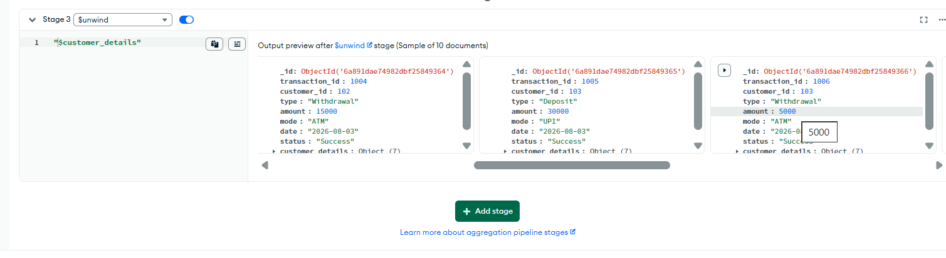
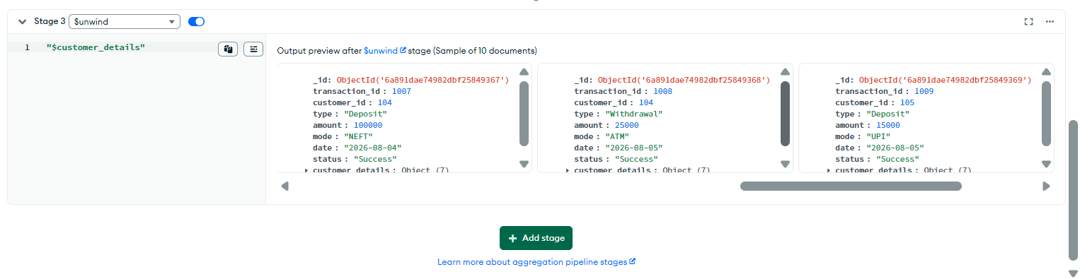

DISPLAY CUSTOMER NAME AND TRANSACTION AMOUNT
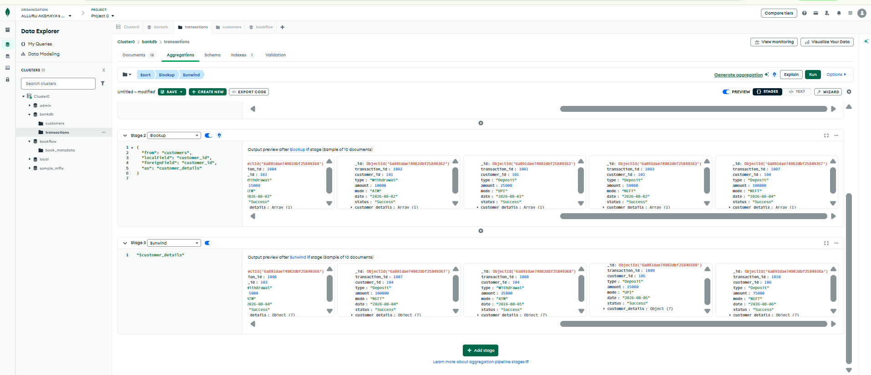
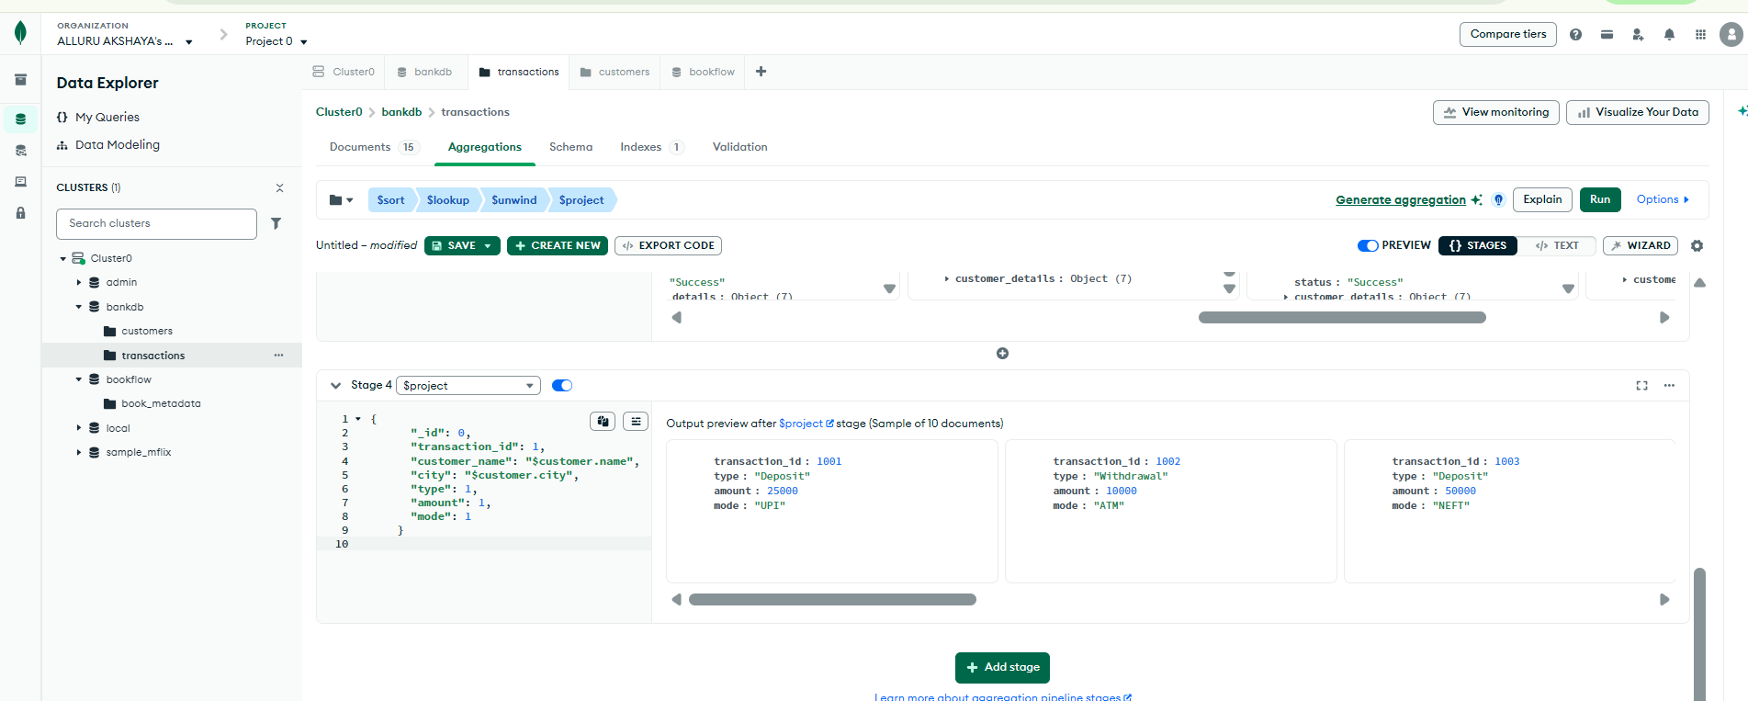
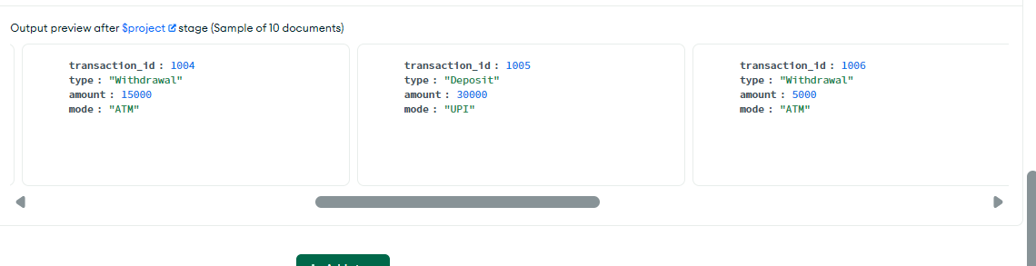
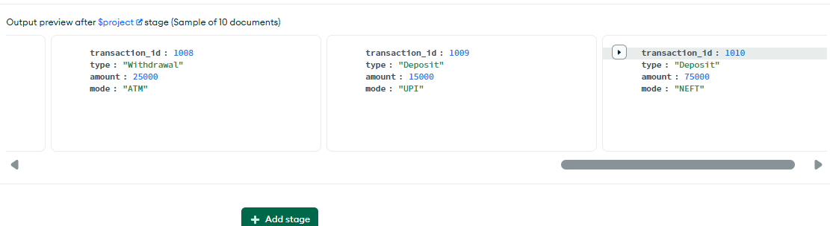

TOTAL TRANSACTION AMOUNT FOR EACH CUSTOMER
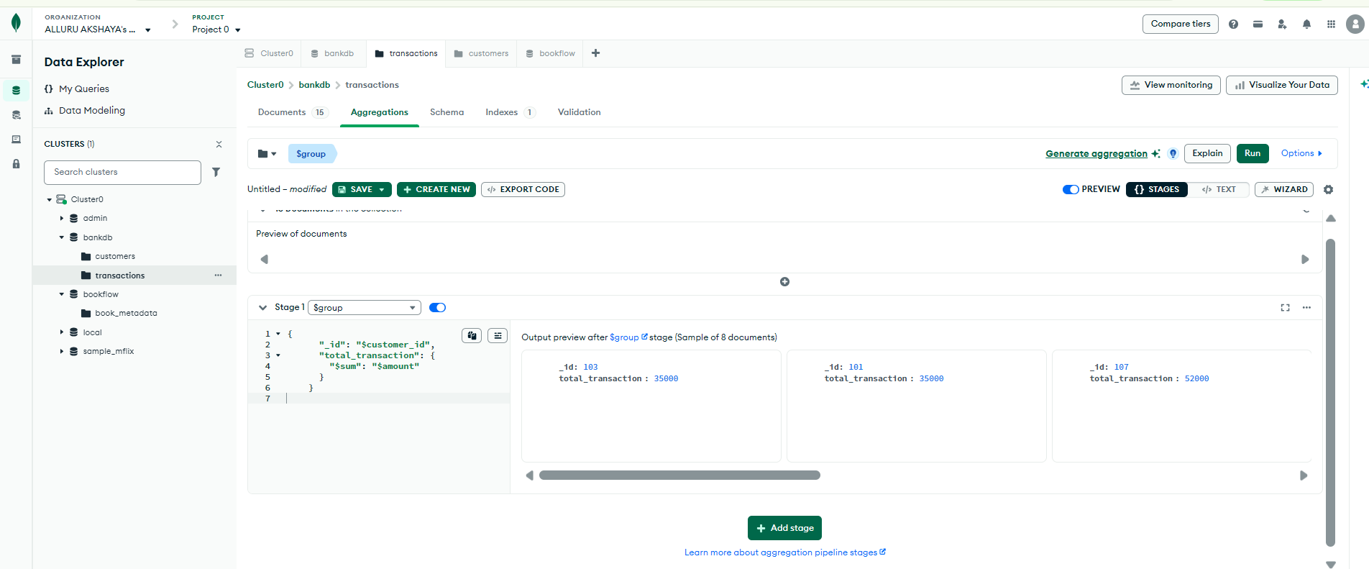
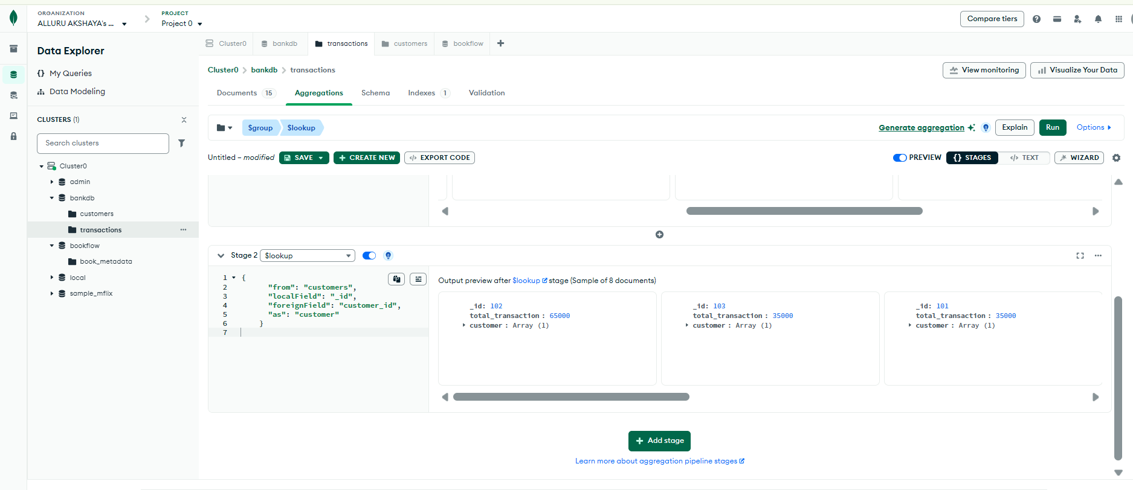
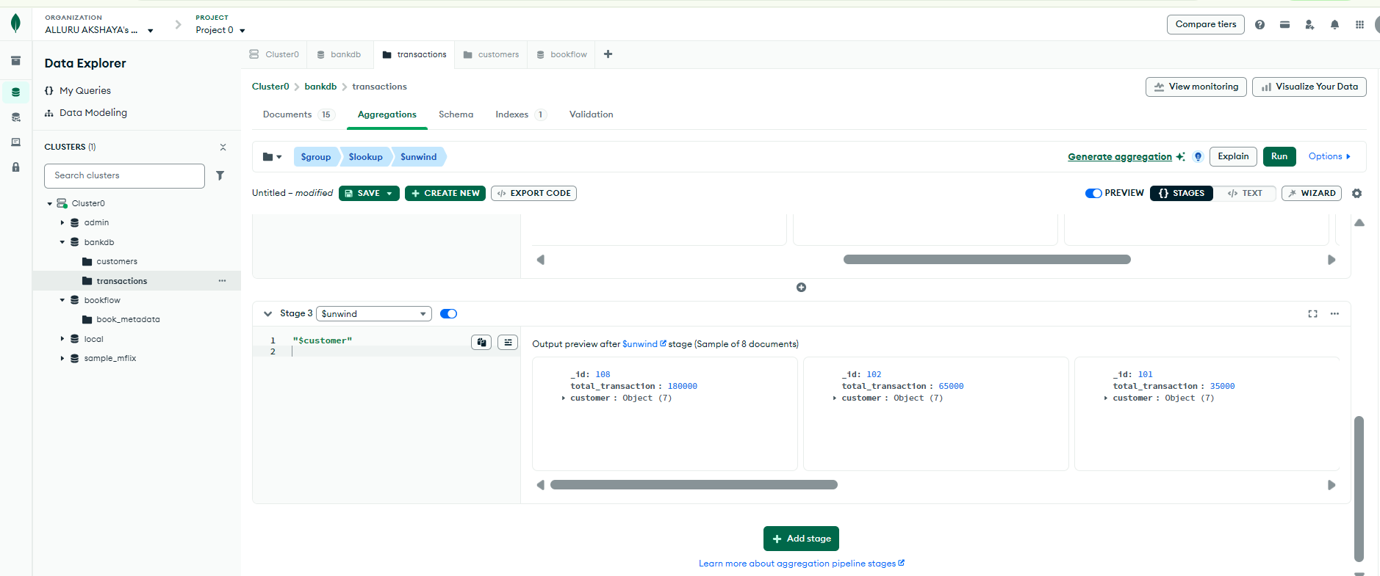
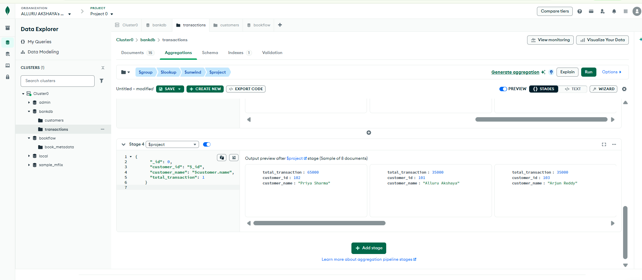
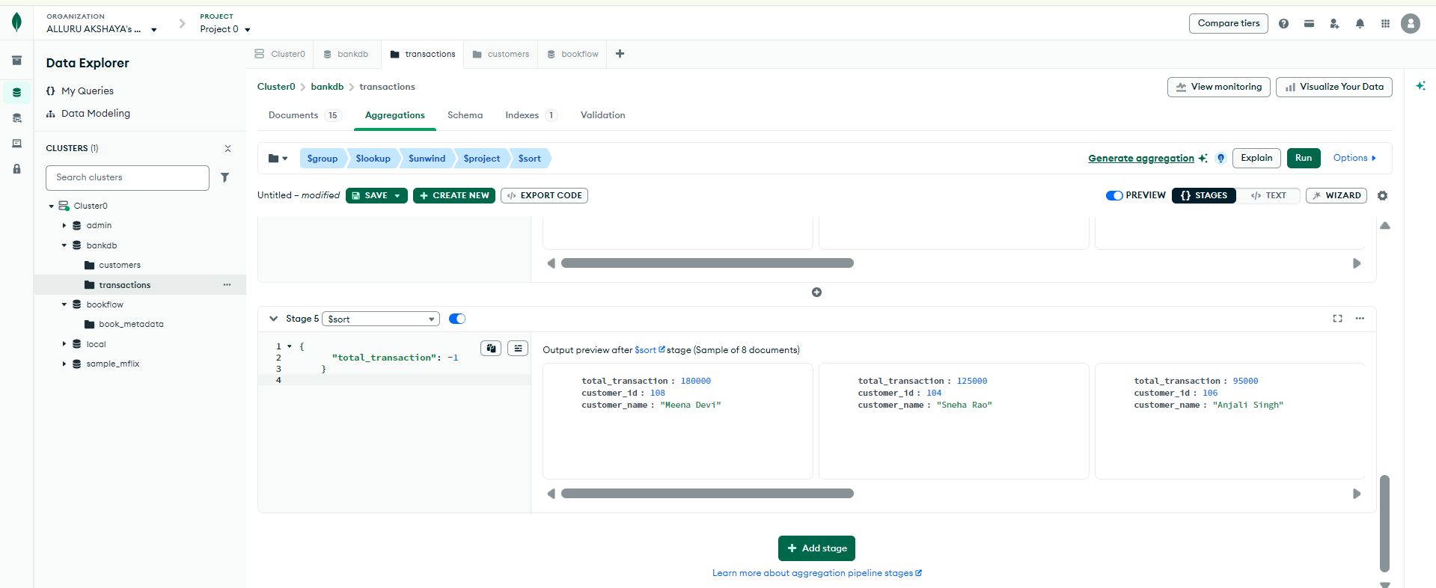

COMPLEX BANK TRANSACTION REPORT
