“DESIGN AND DEVELOPMENT OF A FREELANCE
MARKETPLACE WITH ESCROW PAYMENTS”
A Project Report Submitted in the partial fulfilment of the requirements for the award of the degree of

BACHELOROFTECHNOLOGY
In
DEPARTMENT OF COMPUTER SCIENCE ENGINNERING
&
DEPARTMENT OF COMPUTER SCIENCE AND INFORMATION TECHNOLOGY By
A. Akshaya – 2520030189
Y. Bhaarathi – 2520030211
Madhan Gopal – 2520030263
Under the Esteemed Guidance of
Dr Yerragudipadu Subbarayudu
Assistant Professor

Department of Computer Science and Engineering

K L (Deemed to be) University DEPARTMENT OF COMPUTER SCIENCE ENGINEERING
&

DEPARTMENT OF COMPUTER SCIENCE AND INFORMATION TECHNOLOGY

Declaration

The Project Report entitled “DESIGN AND DEVELOPMENT OF A FREELANCE-MARKETPLACE WITH ESCROW PAYMENTS” is a record of Bonafide work of A. Akshaya – 2520030189, Y. Bhaarathi – 2520030211, Madhan Gopal – 2520030263 submitted in partial fulfilment for the award of B. Tech in Computer Science and Engineering (or) Computer Science and Information Technology to the K L University. The results embodied in this report have not been copied from any other departments/University/Institute.

A. Akshaya – 2520030189

Y. Bhaarathi – 2520030211

Madhan Gopal – 2520030263

K L (Deemed to be) University
DEPARTMENT OF COMPUTER SCIENCE ENGINEERING
&
DEPARTMENT OF COMPUTER SCIENCE AND INFORMATION TECHNOLOGY

CERTIFICATE

This is certify that the mini project based report entitled “DESIGN AND DEVELOPMENT OF A FREELANCE-MARKETPLACE WITH ESCROW PAYMENTS” is a Bonafide work done and submitted by A. Akshaya – 2520030189, Y. Bhaarathi – 2520030211, Madhan Gopal – 2520030263
in partial fulfilment of the requirements for the award of the degree of BACHELOR OF TECHNOLOGY in Department of Computer Science Engineering, K L (Deemed to be University), during the academic year 2026-2027.
Signature of the Guide
Signature of the Course Coordinator Signature of the HOD

ACKNOWLEDGEMENT

The success in this project would not have been possible but for the timely help and guidance rendered by many people. Our wish to express my sincere thanks to all those who has assisted us in one way or the other for the completion of my project.
Our greatest appreciation to my Course Coordinator Dr Yerragudipadu Subbarayudu, and our guide Dr Yerragudipadu Subbarayudu, Department of Computer Science which cannot be expressed in words for his/her tremendous support, encouragement and guidance for this project.
We express our gratitude to Head of the Department for Computer Science Engineering/ Department for Computer Science and Information Technology for providing us with adequate facilities, ways and means by which we are able to complete this project-based Lab.
We thank all the members of teaching and non-teaching staff members, and also who have assisted me directly or indirectly for successful completion of this project. Finally, I sincerely thank my parents, friends and classmates for their kind help and cooperation during my work.
A. Akshaya – 2520030189
Y. Bhaarathi – 2520030211
Madhan Gopal – 2520030263

ABSTRACT
The rapid development of digital technologies has significantly changed the way individuals and organizations collaborate, communicate, and conduct professional activities. Freelancing has become an important part of the modern digital economy, providing opportunities for skilled professionals to work with clients without geographical limitations. However, managing freelance projects involves several activities such as finding suitable projects, evaluating freelancers, submitting proposals, communicating requirements, managing contracts, tracking milestones, handling payments, and resolving disputes. When these activities are performed using separate platforms or informal communication channels, the overall process can become difficult to manage and may create trust and payment-related concerns.
The Freelance Marketplace with Escrow Payments is a web-based application designed to provide a centralized environment for clients and freelancers to manage the complete project lifecycle. The system provides separate role-based workflows for clients and freelancers. Clients can create projects, specify requirements, define budgets and deadlines, review proposals, approve suitable freelancers, manage contracts, monitor milestones, and handle project-related transactions. Freelancers can create profiles, browse available projects, submit proposals, communicate with clients, manage approved contracts, and track their assigned milestones.
A major focus of the proposed system is structured payment management through an escrow-oriented workflow. In freelance transactions, both parties require confidence regarding the completion of work and the associated payment. The system therefore connects payment information with contracts and milestones so that project-related financial records can be managed in an organized manner. This provides a structured approach to payment tracking and helps reduce ambiguity during project execution.
The application is developed using React.js, JavaScript, React Router, and CSS for the frontend, Java and Spring Boot for the backend, and MySQL for database management. REST APIs are used for communication between the frontend and backend. The system incorporates authentication, role-based authorization, project management, proposal management, contract management, milestone tracking, payment records, messaging, notifications, disputes, and reviews.

Index
S.  No. | Chapters | Topics | Page.no
 |  | Acknowledgement
 |  | Abstract
1 | Introduction | 1.1 Background of the project  1.2 Problem statement  1.3 Scope of the project  1.4 Objective(s)  1.5 Importance of the application  1.6 Target users/audience | 8-12
2 | System Requirements | 2.1 Hardware requirements  2.2 Software requirements  2.3 Development tools and frameworks | 12-19
3 | Technology Stack | 3.1 Front-end (e.g., React.js, Angular, HTML/CSS)  3.2 Back-end (e.g., Node.js, Django, Spring Boot)  3.3 Database (e.g., MongoDB, MySQL, PostgreSQL)  3.4 Version Control (e.g., Git, GitHub)  3.5 APIs or External services (e.g., Firebase, Stripe) | 20-38
4 | System Architecture | 4.1 High-level architecture diagram  4.2 Description of each layer (frontend, backend, database)  4.3 Deployment architecture (e.g., cloud, local, CI/CD pipelines) | 38-40
5 | Design | 5.2 ER Diagram / Database schema | 41
6 | Implementation | 6.1 Module-wise implementation  6.2 Front-end logic (UI rendering, state management)  6.3 API integration  6.4 Authentication & Authorization | 41-49
7 | Features | 7.1 List of main features  7.2 How each feature works (user perspective + technical description) | 49-53
8 | Testing | 8.1 Postman testing (frontend/backend)  8.2 Integration testing  8.3 Tools used for testing  8.4 Test cases and results | 53-56
9 | Deployment | 9.1 Steps to deploy  9.2 Environment configuration  9.3 Hosting of frontend and backend | 57-59
10 | Challenges &  Limitations | 10.1 Issues faced during development  10.2 Solutions applied  10.3 Current limitations or known bugs | 59-62
11 | Future Enhancements | 11.1 Planned features  11.2 Possible integrations or optimizations | 62-64
12 | Conclusion | 12.1 Summary of the project  12.2 What was achieved  12.3 Skills learned during development | 64-68
13 | References | - Books, tutorials, APIs, documentation sites used | 68-70

14 | Appendices | - Screenshots of the app  - Sample code snippets  - Installation/setup instructions  - User manual or guide  -Geo Tag photos with guide  -Review forms with guide signatures | 70-76

CHAPTER 1 INTRODUCTION
1.1 Background of the Project
The growth of the internet and digital communication has transformed traditional employment and business models. Organizations are increasingly using online platforms to access specialized skills without depending entirely on permanent employees or geographically restricted talent. Freelancing has developed as an important part of this transformation. A freelancer can provide services to different clients on a project basis, while clients can hire professionals according to their requirements, budget, skills, and deadlines.
Freelance work is particularly useful for startups, small businesses, students, independent professionals, and organizations that require specialized expertise for a limited period. Services may include software development, web development, graphic design, content writing, digital marketing, data analysis, consulting, and many other professional activities. The digital nature of freelance work allows clients and freelancers to collaborate remotely and exchange information through online systems.
Although freelance platforms have simplified the process of connecting clients and professionals, managing a complete freelance project still involves several stages. A client must define a project requirement, publish the requirement, receive proposals, compare freelancers, communicate with candidates, select a suitable freelancer, establish project terms, monitor work, and process payment. Similarly, a freelancer must maintain a profile, identify appropriate projects, prepare proposals, communicate with clients, complete milestones, submit work, and receive payment.
If these activities are managed independently through emails, messaging applications, spreadsheets, and separate payment systems, important information can become fragmented. Communication may be difficult to track, project progress may not be clearly recorded, and payment-related disagreements may arise. Therefore, there is a requirement for an integrated platform that can combine project management, freelancer selection, communication, contract management, and payment tracking.
The proposed Freelance Marketplace with Escrow Payments addresses this requirement by providing a centralized web application. The platform connects two major categories of users: clients and freelancers. Clients can create projects with detailed descriptions, requirements, budgets, and deadlines. Freelancers can browse projects and submit proposals explaining their skills, experience, expected cost, and suitability for the project.
After receiving proposals, the client can compare the available freelancers and approve a suitable candidate. The approved freelancer can then be associated with a contract. The contract provides a structured representation of the agreement between the client and freelancer and can contain milestones representing different stages of project execution.
Payment management is another important aspect of the system. Financial transactions in freelance work require transparency and trust. Clients need to know that their payments are associated with the agreed work, while freelancers need confidence that completed work will be linked to the corresponding payment. The escrow-oriented workflow in the proposed system provides a structured way to associate payments with contracts and milestones.
The project also includes communication and notification mechanisms. Communication between the client and freelancer is important because project requirements can change and clarification may be required during development. A messaging module allows participants to communicate within the project environment, while notifications can inform users about important workflow events.
Dispute management is included to provide a structured mechanism for handling disagreements. If an issue occurs during an active contract, the relevant information can be recorded and associated with the contract. Reviews and ratings can also be provided after the appropriate completion stage, allowing participants to maintain feedback records.
From a technical perspective, the application combines several areas of computer science. The frontend is implemented using React.js and JavaScript, providing reusable components and dynamic user interfaces. React Router is used for navigation between different application pages. The backend is implemented using Java and Spring Boot, which provides REST APIs and business logic. MySQL is used for persistent relational data storage.
The project therefore represents a complete full-stack application rather than an isolated frontend or backend system. It combines user management, database operations, REST communication, role-based workflows, project management, payment records, messaging, and testing into one integrated application.

1.2 Problem Statement
Freelance project management involves multiple activities that must be coordinated between clients and freelancers. Existing methods may require separate systems for project discovery, communication, contract management, payment processing, and feedback. This can result in fragmented information and inefficient project management.
Clients require a platform through which they can publish project requirements, evaluate freelancer proposals, select suitable professionals, and manage project execution. Freelancers require a platform through which they can discover relevant projects, submit proposals, communicate with clients, and manage their work.
Payment security is another major concern. Without a structured payment workflow, disagreements may occur regarding whether work has been completed or whether payment should be released. Therefore, a centralized system is required to provide project management together with contract, milestone, and escrow-oriented payment management.
The problem addressed by this project is the design and development of a unified freelance marketplace that provides an organized workflow for project creation, freelancer selection, contract management, milestone tracking, payment management, communication, dispute handling, and reviews.

1.3 Scope of the Project
The scope of the project includes the development of a web-based platform for managing freelance projects between clients and freelancers.
The major areas covered are:
- User registration and login.
- Client and freelancer role management.
- Profile management.
- Project creation.
- Project browsing.
- Project details and requirements.
- Freelancer proposal submission.
- Proposal review.
- Freelancer approval.
- Contract creation and management.
- Milestone management.
- Escrow-oriented payment management.
- Payment records.
- Client-freelancer messaging.
- Notifications.
- Dispute management.
- Reviews and ratings.
- Project status management.
- Database storage using MySQL.
- REST API communication between frontend and backend.
The system is designed primarily for academic and demonstration purposes but provides a foundation that can be extended for production deployment.

1.4 Objectives
The main objective of the project is to develop a centralized freelance marketplace that simplifies the interaction between clients and freelancers.
The specific objectives are:
- To provide a platform for clients and freelancers to register and manage their profiles.
- To allow clients to create and publish freelance projects.
- To allow freelancers to browse available projects.
- To provide a proposal submission mechanism.
- To allow clients to review and approve freelancer proposals.
- To establish contracts between clients and selected freelancers.
- To divide projects into manageable milestones.
- To provide structured payment and escrow-oriented transaction management.
- To provide communication between project participants.
- To generate notifications for important project events.
- To provide a mechanism for handling disputes.
- To provide reviews and ratings after project completion.
- To maintain project-related data using MySQL.
- To implement the application using modern full-stack development technologies.
- To provide a secure role-based application workflow.

1.5 Importance of the Project
The project is important because freelance work has become an increasingly common method of professional collaboration. A centralized platform can simplify the interaction between clients and freelancers by keeping important project information within a common environment.
The system also demonstrates the practical implementation of several software engineering concepts. It combines frontend development, backend development, database management, authentication, authorization, REST APIs, validation, testing, and deployment.
The escrow-oriented payment workflow provides an additional layer of organization to the financial aspect of freelance projects. By associating payment information with contracts and milestones, the system can maintain a clearer project transaction history.

1.6 Target Users
Clients
Clients are users who require professional services. They can create projects, specify requirements, receive proposals, approve freelancers, manage contracts, track milestones, communicate with freelancers, and provide reviews.
Freelancers
Freelancers are professionals who offer their skills and services. They can create profiles, browse projects, submit proposals, communicate with clients, manage approved contracts, complete milestones, and receive reviews.
System Administrator
An administrative role can be used to monitor system activity, manage application records, handle disputes, and maintain platform-level controls where required.

CHAPTER – 2 SYSTEM REQUIREMENTS
2.1 Hardware Requirements
Hardware requirements form an important foundation for the development, testing, and deployment of the Freelance Marketplace with Escrow Payments. Since the proposed system is a full-stack web application consisting of a React-based frontend, Spring Boot backend, and MySQL database, the development environment must provide sufficient processing power, memory, storage, and network connectivity to operate multiple development tools simultaneously. The hardware requirements are primarily divided into the requirements for the development environment, server environment, and end-user environment.
The development machine should have a modern multi-core processor capable of handling an Integrated Development Environment (IDE), browser, database server, backend server, frontend development server, version-control tools, and other supporting applications at the same time. An Intel Core i5 processor or equivalent AMD Ryzen 5 processor is recommended for smooth development. A processor with multiple cores is particularly useful because the developer may need to run the Spring Boot application, React development server, MySQL server, browser testing sessions, and development tools concurrently. A minimum clock speed of approximately 2.4 GHz is suitable for normal development activities, while modern processors with higher clock speeds provide better performance during compilation and multitasking.
Memory is another important hardware requirement for this project. A minimum of 8 GB RAM can support basic development activities, but 16 GB RAM is recommended for comfortable full-stack development. Running Visual Studio Code or another IDE together with a browser containing multiple tabs, MySQL Workbench, the Spring Boot application, React development server, Git tools, and testing utilities can consume considerable memory. Additional RAM also becomes useful when multiple browser sessions are used to test the client and freelancer workflows simultaneously.
Storage requirements are mainly determined by the source code, development dependencies, database files, browser data, build files, Git repositories, and project documentation. A minimum of 250 GB of storage is sufficient for development, although a 512 GB SSD or larger is preferable. Solid-state drives provide significantly faster read and write performance compared with traditional hard disk drives. This reduces application startup time, improves dependency installation speed, and makes database and source-code operations more responsive. Maintaining additional backup storage or cloud storage is also recommended for preserving source code, documentation, database backups, and project versions.
A stable internet connection is essential during the development of the freelance marketplace. The application requires internet connectivity for downloading project dependencies, accessing documentation, synchronizing GitHub repositories, installing npm packages, updating Maven dependencies, and testing the application through different browsers and environments. A broadband connection with a minimum speed of approximately 10 Mbps is sufficient for normal development activities. A faster and stable connection is preferable when downloading large dependencies, synchronizing repositories, or deploying the application to cloud infrastructure.
The operating system used for development can be Windows, Linux, or macOS. Windows 10 or Windows 11 provides compatibility with commonly used development environments and database management tools. Ubuntu and other Linux distributions are also suitable because of their strong support for Java, Node.js, MySQL, Git, and server-side development. macOS can similarly support the complete development stack. The choice of operating system does not significantly affect the application because React, Java, Spring Boot, MySQL, Git, and related tools are cross-platform technologies.
A modern Full HD display with a resolution of 1920 × 1080 pixels or higher is recommended. Full-stack development frequently requires multiple windows to be viewed simultaneously, such as the source-code editor, browser, terminal, database management software, and application output. A larger display therefore improves development productivity and makes it easier to inspect the user interface and debug application behaviour.
Basic peripherals such as a keyboard and mouse are required for development. Headphones or speakers may also be useful during online meetings, project discussions, demonstrations, and presentations. External storage devices can be used for backup purposes.
The server-side hardware requirements depend on the number of users and the expected workload. For development and internal testing, a moderately configured machine with a multi-core processor, 8–16 GB RAM, and SSD storage is sufficient to run the Spring Boot backend and MySQL database. For a production environment with a larger number of users, cloud-based infrastructure can be used to provide scalable computing resources, database services, backups, and monitoring.
From the end-user perspective, the hardware requirements are relatively low because the application is accessed through a web browser. A desktop computer, laptop, tablet, or smartphone with a modern browser can be used. A dual-core processor, approximately 4 GB RAM, and a stable internet connection are sufficient for normal interaction with the application. Since the major processing activities are performed by the backend server, the user's device does not require high computational capability.
The responsive design of the application also allows users to access the platform from different screen sizes. Clients and freelancers can therefore access the marketplace using laptops, desktops, tablets, and supported mobile devices. The application primarily requires browser storage for temporary information such as cached resources and session-related data rather than large amounts of local storage.
In summary, the hardware requirements for the Freelance Marketplace with Escrow Payments are designed to support efficient development, testing, database management, and deployment. Developers require moderately powerful systems capable of running several development services simultaneously, whereas end users require only standard computing devices and stable internet connectivity. This difference allows the platform to remain accessible to users without requiring specialized hardware.

2.2 Software Requirements
Software requirements define the software environment required to design, develop, test, and deploy the Freelance Marketplace with Escrow Payments. Since the system is implemented using a modern full-stack architecture, the software environment consists of an operating system, programming languages, frontend technologies, backend frameworks, database management software, development environments, version-control systems, testing tools, and web browsers.
The operating system forms the base layer of the development environment. The project can be developed on Windows 10 or Windows 11, Ubuntu Linux, or macOS. Windows provides a convenient environment for running Visual Studio Code, MySQL Workbench, Node.js, Java, Maven, Git, and modern browsers. Linux provides a strong server-oriented environment and is widely used for Java-based backend development and deployment. macOS also provides compatibility with the required development tools. Therefore, the project remains platform independent at the development level.
Java is used as the primary programming language for the backend implementation. The Java Development Kit (JDK) provides the compiler, runtime environment, and development tools necessary to build and execute the Spring Boot application. Java provides object-oriented programming features, exception handling, collections, interfaces, inheritance, and other language capabilities required for implementing the application's business logic.
Spring Boot is used as the primary backend framework. It simplifies the development of Java-based web applications by providing configuration support, dependency management, embedded server support, REST API development, and integration with database technologies. The Spring Boot backend acts as the main processing layer between the React frontend and MySQL database.
The frontend of the application is developed using React.js and JavaScript. React.js provides a component-based architecture for developing interactive user interfaces. JavaScript is used to implement application logic, handle user interactions, validate input, process responses, and communicate with the backend APIs.
React Router is used for navigation within the frontend application. It allows different views to be associated with different routes without requiring a complete browser page reload. This is particularly useful for the marketplace because the application contains different sections such as login, registration, client dashboard, freelancer dashboard, projects, proposals, contracts, milestones, payments, messages, disputes, and reviews.
CSS is used for the visual presentation of the application. It defines layouts, spacing, typography, buttons, forms, cards, tables, dashboards, navigation components, and responsive behaviour. Proper CSS organization helps maintain a consistent appearance across the application.
Node.js and npm are required for frontend development. Node.js provides the runtime environment used by the React development ecosystem, while npm is used for installing and managing frontend packages. Project dependencies can be installed through the package configuration file, allowing the development environment to reproduce the required frontend setup.
Maven is used for managing the Spring Boot backend project. Maven handles dependencies, project compilation, testing, packaging, and execution. The backend project contains a Maven configuration file that specifies the required libraries and project information.
MySQL is used as the database management system. It stores persistent information related to users, projects, proposals, contracts, milestones, payments, messages, notifications, disputes, and reviews. A relational database is appropriate for the project because the entities have clearly defined relationships. For example, projects are associated with clients, proposals are associated with projects and freelancers, and contracts are associated with approved project relationships.
MySQL Workbench can be used to manage and inspect the database. It provides an interface for creating databases, executing SQL queries, viewing tables, checking records, and analysing database structures. It is also useful during development for verifying whether information submitted through the application is correctly stored in the database.
RESTful APIs provide communication between the frontend and backend. The React application sends HTTP requests to the Spring Boot backend, while the backend processes these requests and returns responses. JSON is used as the primary data-exchange format because it is lightweight and easily handled by JavaScript applications.
The software environment also requires a modern web browser such as Google Chrome, Mozilla Firefox, or Microsoft Edge. Browser developer tools are particularly useful for checking network requests, inspecting frontend components, identifying JavaScript errors, and analyzing page behavior.
Visual Studio Code can be used as the primary Integrated Development Environment (IDE) for frontend and general project development. It supports JavaScript, React, CSS, HTML, Git, terminal operations, extensions, and project navigation. A Java-compatible IDE may also be used for Spring Boot development. The choice of IDE can depend on developer preference.
Git is used for source-code version control. It allows the development team to maintain different versions of the project and track modifications. Git is especially important when several team members are working on different modules. GitHub can be used as the remote repository for storing the project and coordinating development.
Security-related software practices are also important because the application handles user accounts and project-related information. Authentication and authorization mechanisms should be implemented to ensure that only valid users can access protected resources. Passwords should not be stored as plain text, and sensitive configuration information such as database credentials should be maintained through secure configuration mechanisms.
The application also requires testing software and tools. API testing can be performed using Postman or similar tools to verify REST endpoints. Browser developer tools can be used to inspect frontend behaviour and network communication. Database testing can be performed using MySQL Workbench by checking whether API operations produce the expected database changes.
For project deployment, the application can be hosted using cloud infrastructure or a suitable server environment. The React frontend can be deployed on a static hosting service, while the Spring Boot backend can be deployed on a Java-compatible server or cloud platform. MySQL can be hosted using a managed database service or a configured database server. Environment variables should be used to maintain configuration values separately from source code.
In conclusion, the software requirements of the Freelance Marketplace with Escrow Payments are designed around a modern full-stack development environment. React.js and JavaScript provide the frontend layer, Spring Boot and Java provide backend processing, and MySQL provides persistent data storage. Node.js, npm, Maven, Git, GitHub, Visual Studio Code, MySQL Workbench, Postman, and modern browsers support development, testing, and maintenance. The combination of these technologies provides a structured and maintainable environment for developing the proposed system.

2.3 Development Tools and Frameworks
Developing a complete freelance marketplace requires an appropriate combination of programming languages, frameworks, development environments, database tools, testing tools, and version-control systems. Since the proposed application contains multiple interconnected modules, the selected tools must support frontend development, backend processing, database operations, API communication, testing, debugging, and collaborative development.
At the frontend layer, React.js forms the primary framework used to create the user interface. React follows a component-based development approach in which individual interface elements can be created as reusable components. This approach is useful for the freelance marketplace because several pages share common elements such as navigation bars, project cards, buttons, forms, status indicators, dashboards, and user information.
JavaScript is used together with React to provide application functionality. JavaScript handles events, form submissions, API calls, data processing, navigation, and dynamic changes to the user interface. Modern JavaScript features such as arrow functions, asynchronous operations, promises, modules, and array methods simplify the development of interactive application features.
React Router is used to manage client-side navigation. The application contains multiple pages and dashboards, and React Router allows these views to be accessed using appropriate routes. Role-specific navigation can also be implemented so that clients and freelancers are directed to their relevant application areas.
CSS is used for styling and layout. The project uses CSS to create structured dashboards, responsive forms, project cards, tables, buttons, navigation components, and other visual elements. Media queries and flexible layout techniques can be used to improve compatibility with different screen sizes.
At the backend layer, Java provides the programming foundation. Java's object-oriented architecture makes it suitable for implementing models, services, controllers, validation, and business rules.
Spring Boot provides the main backend framework. It simplifies the development of REST-based web services and supports the creation of structured backend modules. Controllers receive requests from the frontend, service components implement business logic, and repository or database-access components interact with MySQL.
Spring Boot also provides integration with commonly required technologies such as database connectivity, validation, dependency injection, and embedded web servers. This reduces the amount of configuration required during development and allows the development team to concentrate on application functionality.
Maven is used as the backend build and dependency-management tool. Dependencies required by the Spring Boot project are specified through the Maven project configuration. Maven can compile the project, execute tests, package the application, and manage external libraries.
At the database layer, MySQL provides relational data storage. The database maintains the application's persistent information and supports relationships among different entities. SQL queries are used for creating, retrieving, updating, and deleting records.
MySQL Workbench provides a graphical environment for database development and administration. Developers can use it to create databases, inspect tables, execute SQL statements, verify relationships, and troubleshoot database-related problems.
For API testing, Postman can be used to send requests directly to the Spring Boot backend. This allows developers to test individual endpoints without depending entirely on the frontend. POST, GET, PUT, and DELETE requests can be tested with different input values, and the resulting HTTP responses can be inspected.
Browser developer tools provide another important testing and debugging facility. The Console tab can be used to identify JavaScript errors, while the Network tab allows developers to inspect requests sent from the React frontend to the Spring Boot backend. This is especially useful when diagnosing incorrect API URLs, failed requests, invalid responses, or authentication issues.
Git provides distributed version control for the project. Each developer can work on project files locally and commit changes to the repository. Branches can be used to isolate feature development and reduce conflicts.
GitHub provides remote repository hosting and collaboration capabilities. The project source code can be stored in a GitHub repository so that team members can access the latest version and maintain a history of development changes. GitHub also provides facilities for reviewing changes and managing project collaboration.
An Integrated Development Environment such as Visual Studio Code can be used for frontend development, source-code editing, terminal operations, Git management, and debugging. Extensions provide syntax highlighting, code completion, formatting, and other development features.
The development process also requires proper documentation and debugging practices. Application errors can be analysed through backend console logs, frontend browser consoles, HTTP response codes, and database records. Debugging across these layers is necessary because an error visible in the frontend may actually originate from the backend API or database.
The development tools can therefore be summarized as follows:
Tool / Framework | Purpose
React.js | Frontend user-interface development
JavaScript | Frontend application logic
React Router | Frontend navigation
CSS | User-interface styling
Java | Backend programming
Spring Boot | Backend and REST API development
Maven | Backend dependency and build management
MySQL | Relational database management
MySQL Workbench | Database administration and SQL testing
Node.js | Frontend development runtime
npm | Frontend package management
Visual Studio Code | Source-code development
Git | Version control
GitHub | Remote repository and collaboration
Postman | API testing
Web Browser | Application execution and browser testing
The combination of these tools provides a complete development environment for the project. React.js handles the presentation layer, Spring Boot manages server-side operations, and MySQL provides persistent data storage. Supporting tools such as Git, GitHub, Maven, npm, MySQL Workbench, Postman, and browser developer tools improve the development, testing, debugging, and maintenance process.
Overall, the selected development tools and frameworks provide the required foundation for implementing a structured freelance marketplace. Their modular nature also allows individual components to be enhanced or replaced in the future without requiring a complete redesign of the application.

CHAPTER – 3 TECHNOLOGY STACK
3.1 Front-End Design
The front-end of the Freelance Marketplace with Escrow Payments represents the user interface layer through which clients and freelancers interact with the system. It is responsible for presenting project information, collecting user input, displaying application responses, and providing navigation between different modules of the platform. Since the proposed system involves multiple user roles and several interconnected workflows, the front-end has been designed to provide a structured, responsive, and user-friendly experience.
The front-end of the application is developed primarily using React.js, JavaScript, React Router, and CSS. These technologies provide the required foundation for developing a dynamic web application in which information can be loaded and updated without repeatedly refreshing the complete webpage. The component-based structure of React.js also makes it possible to divide the application into smaller and reusable interface components.
The primary objective of the front-end design is to provide a simple environment in which clients can create and manage projects while freelancers can discover projects and submit proposals. The interface also provides access to contracts, milestones, payment information, messages, notifications, disputes, and reviews according to the user's role and project status.
React.js
React.js is the main library used for developing the user interface. React follows a component-based architecture in which an application is divided into independent and reusable components. This approach is particularly suitable for the freelance marketplace because many interface elements are repeated throughout the application.
For example, project cards can be reused when displaying projects on the client dashboard, freelancer dashboard, search results, and project-management pages. Similarly, buttons, forms, status indicators, navigation elements, profile sections, and notification components can be implemented as reusable elements.
React also supports efficient rendering through its virtual DOM mechanism. Instead of unnecessarily rebuilding the entire page whenever information changes, React updates the components affected by the change. This improves the responsiveness of the interface when users interact with project information, proposals, contracts, or messages.
The application can therefore maintain a dynamic interface while keeping the individual components organized and easier to maintain.
JavaScript
JavaScript provides the main programming logic for the frontend. It handles user interactions, form submissions, API requests, validation, navigation, and data processing.
When a client submits a project, for example, JavaScript collects the form information and sends it to the backend API. Similarly, when a freelancer submits a proposal, JavaScript handles the proposal form and communicates the information to the Spring Boot backend.
Modern JavaScript features such as asynchronous functions, promises, array operations, object manipulation, and modular programming help simplify the implementation of these operations.
Asynchronous programming is especially important because communication with the backend should not block the user interface. API requests can therefore be processed asynchronously while the user interface remains responsive.
React Router
React Router is used for navigation within the application. Since the system contains multiple pages and role-specific dashboards, routing is necessary to organize the user experience.
Examples of application routes include:
- Login
- Registration
- Client Dashboard
- Freelancer Dashboard
- Projects
- Project Details
- Proposals
- Contracts
- Milestones
- Payments
- Messages
- Notifications
- Disputes
- Reviews
- Profile
React Router allows these sections to be accessed through separate routes while maintaining the behaviour of a single-page application.
Role-based navigation is particularly important in the project. A client should be directed towards client-related operations such as creating projects and reviewing proposals, while a freelancer should receive access to project discovery and proposal-related functions.
CSS
CSS is used to control the visual appearance of the application. It provides the styling required for dashboards, navigation bars, project cards, forms, tables, buttons, status labels, profile sections, and other components.
The design focuses on consistency across different modules. Common spacing, typography, button styles, form structures, and card layouts help maintain a uniform appearance.
Responsive CSS techniques can also be used to ensure that the application adapts to different screen sizes. Since users may access the platform through laptops, desktops, tablets, and mobile devices, responsive layouts improve accessibility and usability.
User Interface Structure
The user interface is organized according to the responsibilities of each user role.
For clients, the interface provides options to:
- Create projects.
- View created projects.
- View proposals.
- Approve freelancers.
- Manage contracts.
- Manage milestones.
- View payment information.
- Communicate with freelancers.
- Handle disputes.
- Submit reviews.
For freelancers, the interface provides options to:
- Manage profiles.
- Browse available projects.
- View project requirements.
- Submit proposals.
- Track proposal status.
- View approved contracts.
- Manage milestones.
- Communicate with clients.
- View payment information.
- Participate in dispute workflows.
- Submit reviews.
This separation makes the interface easier to understand and prevents users from being presented with unnecessary operations.
Forms and Validation
Forms represent an important part of the frontend because most marketplace operations require users to submit information.
Project creation forms collect information such as project title, description, requirements, budget, deadline, and other relevant details.
Proposal forms collect information such as proposed price, explanation, skills, experience, and estimated completion information.
Client and freelancer registration forms collect account-related information required for authentication and profile creation.
Frontend validation is used to prevent incomplete or obviously invalid information from being submitted. Required fields, appropriate input types, length restrictions, and logical validation can be implemented before information is sent to the backend.
However, frontend validation is not considered a replacement for backend validation. The Spring Boot backend performs its own validation before processing important operations.
API Data Handling
The frontend communicates with the backend using HTTP requests. Data is generally exchanged using JSON because JSON is lightweight and is naturally supported by JavaScript.
For example, when the freelancer dashboard requests available projects, the frontend sends a request to the appropriate backend endpoint. The backend retrieves the information from MySQL and returns a JSON response. React then uses the returned information to display project cards or project lists.
The same process occurs for proposals, contracts, milestones, payments, messages, notifications, and reviews.

Status-Based Interface
Several modules of the freelance marketplace depend on status values. Projects, proposals, contracts, milestones, payments, disputes, and reviews may have different states during their lifecycle.
For example, a proposal may move through stages such as submitted, approved, rejected, or withdrawn. A contract may be active, completed, or associated with a dispute.
The frontend uses these statuses to determine which actions should be displayed to the user. This prevents users from performing operations that are not appropriate for the current stage of the workflow.
Status values received from the backend must also be handled consistently. During testing, differences in capitalization between backend status values and frontend comparisons can cause valid interface actions to disappear. Therefore, status values are normalized before comparison where necessary.
Responsive and User-Centred Design
The application is designed to maintain usability across different devices. The main objective is to ensure that important information such as project requirements, proposal details, contact information, and payment records remains readable and accessible.
The interface avoids unnecessarily complicated navigation and groups related functionality into logical sections. Dashboards provide users with a central location from which they can access their major activities.
In conclusion, the frontend combines React.js, JavaScript, React Router, and CSS to create a dynamic interface for the freelance marketplace. The component-based structure improves maintainability, while responsive design and role-based navigation provide a clear experience for clients and freelancers.

3.2 Back-End Design
The backend of the Freelance Marketplace with Escrow Payments acts as the central processing layer of the application. It receives requests from the React frontend, validates user input, applies business rules, communicates with the MySQL database, and returns appropriate responses.
The backend is developed using Java and Spring Boot. Spring Boot provides a structured environment for implementing REST APIs and backend services. The architecture separates request handling, business logic, and database operations so that each part of the system can be maintained independently.

Spring Boot
Spring Boot is used as the primary backend framework because it simplifies the development of Java-based web applications. It provides support for REST controllers, dependency injection, database integration, validation, configuration, and embedded server execution.
The backend receives HTTP requests from the frontend and maps them to appropriate controller methods.
For example, when a client creates a project, the request is received by the project controller. The controller passes the information to the relevant service layer, which applies the required business logic and stores the project in the database.
REST API Architecture
The backend exposes RESTful API endpoints that allow the frontend to communicate with the application.
Common HTTP methods include:
- GET – Used to retrieve information.
- POST – Used to create new records.
- PUT – Used to update existing records.
- DELETE – Used to remove records where applicable.
Examples of backend operations include:
- User registration.
- User login.
- Project creation.
- Project retrieval.
- Proposal submission.
- Proposal approval.
- Contract creation.
- Milestone updates.
- Payment record management.
- Message handling.
- Notification management.
- Dispute management.
- Review management.
The use of REST APIs separates the frontend from the backend and allows each layer to evolve independently.
Controller Layer
The controller layer handles incoming HTTP requests. Controllers define API endpoints and receive request parameters or JSON request bodies.
For example, a project controller may receive a request containing project title, description, budget, and deadline. After receiving the request, it passes the information to the service layer.
Controllers should remain focused primarily on request and response handling rather than containing large amounts of business logic.
Service Layer
The service layer contains the business logic of the application.
For example, approving a freelancer is not simply a database update. The system must verify that the user performing the operation is the client associated with the project and that the proposal belongs to the correct project.
Similarly, review creation should only be allowed when the relevant contract has reached an appropriate stage.
The service layer therefore helps enforce the rules governing the freelance marketplace.
Repository and Database Layer
The repository or data-access layer communicates with MySQL. It is responsible for retrieving, creating, updating, and deleting database records.
Separating database operations from business logic improves maintainability and makes the application easier to debug.
Authentication and Authorization
Authentication verifies the identity of a user, while authorization determines what that user is allowed to do.
The application contains different roles, primarily clients and freelancers. These roles have different permissions.
For example, a client can create projects and approve proposals, while a freelancer can submit proposals for available projects.
Role-based authorization prevents users from accessing operations that do not belong to their role.

Project Processing
The backend manages the complete project lifecycle.
When a client creates a project, the backend validates the information and stores it in MySQL.
When freelancers browse projects, the backend retrieves suitable project records and sends them to the frontend.
When a freelancer submits a proposal, the backend associates the proposal with both the freelancer and the selected project.
Proposal Processing
Proposal management is another major backend function.
The backend stores proposal information and maintains its relationship with the project and freelancer.
When the client approves a proposal, the backend verifies the project and proposal relationship before updating the appropriate records.
This creates a controlled transition from project discovery to freelancer selection.
Contract Processing
After freelancer approval, contract information can be created and associated with the selected project and users.
The backend maintains contract status and related information. Contract status is important because subsequent actions such as milestones, disputes, and reviews may depend on the contract state.
Milestone Processing
Milestones allow a contract to be divided into smaller stages.
The backend stores milestone information and maintains its relationship with the contract. Updates to milestone status are validated before being saved.
This allows the application to represent project progress in a structured manner.
Payment Processing
The backend maintains payment-related records associated with contracts or milestones.
The system's escrow-oriented workflow provides a structured way to associate payment information with project execution. Payment records may contain amount, contract reference, milestone reference, status, and transaction information.
Actual financial settlement in a production environment would require integration with a suitable payment gateway and additional security mechanisms.
Messaging and Notifications
The backend also manages communication records between clients and freelancers.
Messages can be associated with relevant users and project or contract information.
Notifications are generated or stored for important events such as proposal submissions, approvals, contract updates, milestone changes, payment updates, disputes, and reviews.
Error Handling
Backend error handling ensures that invalid requests do not result in unexpected application behaviour.
Examples of errors include:
- Invalid login credentials.
- Missing required information.
- Invalid project identifiers.
- Unauthorized operations.
- Invalid proposal submissions.
- Incorrect contract states.
- Database failures.
The backend returns appropriate HTTP responses so that the frontend can display meaningful information to users.
In conclusion, the Spring Boot backend provides the central business and data-processing functionality of the application. Its layered structure separates controllers, business logic, and database operations, making the system easier to maintain, test, and extend.

3.3 Database
The database is one of the most important components of the Freelance Marketplace with Escrow Payments because the application contains several entities that must be stored and connected.
The project uses MySQL, a relational database management system, for persistent data storage. A relational database is suitable because the application contains structured entities with clearly defined relationships.
The database stores information related to users, projects, proposals, contracts, milestones, payments, messages, notifications, disputes, and reviews.

User Data
User records contain account and profile information required for authentication and marketplace operations.
A user is associated with a specific role, such as client or freelancer.
Project Data
The project table stores information created by clients.
Typical project information includes:
- Project title.
- Description.
- Requirements.
- Budget.
- Deadline.
- Client reference.
- Project status.
The client relationship allows the system to identify which user created a particular project.
Proposal Data
Proposal records connect freelancers with projects.
A proposal may contain:
- Freelancer reference.
- Project reference.
- Proposed price.
- Proposal description.
- Estimated completion time.
- Proposal status.
A project can therefore have multiple proposals from different freelancers.
Contract Data
Contract records represent the working relationship established after a proposal is approved.
A contract can reference:
- Client.
- Freelancer.
- Project.
- Contract status.
- Start information.
- Completion information.
The contract becomes the central entity for managing milestones, payments, disputes, and reviews.
Milestone Data
Milestone records divide contracts into smaller stages.
Each milestone can contain:
- Contract reference.
- Title.
- Description.
- Amount.
- Due date.
- Status.
This allows progress to be tracked at a more detailed level.
Payment Data
Payment records maintain information associated with the financial workflow.
The payment table can contain:
- Contract reference.
- Milestone reference.
- Amount.
- Payment status.
- Transaction reference.
- Payment date.
This structure provides a clear relationship between a financial record and the work to which it belongs.

Message Data
Messages store communication between users.
A message can contain sender and receiver references, message content, timestamps, and relevant project or contract information.
Notification Data
Notifications store alerts generated for users.
For example, when a freelancer submits a proposal, the client may receive a notification. Similarly, when a proposal is approved, the freelancer may receive a notification.
Dispute Data
Dispute records are associated with relevant contracts and users. The table can contain the reason, description, status, and resolution information.
Review Data
Review records store feedback provided after appropriate project completion.
A review can contain:
- Reviewer.
- Reviewed user.
- Contract.
- Rating.
- Comment.
- Date.
Relational Structure
The relational structure allows the application to connect multiple activities.
A client can create multiple projects.
A project can receive multiple proposals.
A freelancer can submit proposals for multiple projects.
An approved proposal can result in a contract.
A contract can contain multiple milestones.
A contract can have multiple payment records.
Users can exchange multiple messages and receive multiple notifications.
This relational structure provides consistency and allows the backend to retrieve related information efficiently.
Data Integrity
Database constraints and relationships help maintain data integrity.
Foreign-key relationships can be used to ensure that records reference valid users, projects, contracts, and milestones.
Validation at both the backend and database levels helps prevent inconsistent data from entering the system.
MySQL Workbench
MySQL Workbench can be used to inspect and manage the database during development. Developers can execute SQL queries, inspect table records, verify relationships, and troubleshoot database issues.
In conclusion, MySQL provides the structured data-storage foundation of the freelance marketplace. Its relational model is suitable for representing the connections between users, projects, proposals, contracts, milestones, payments, communication, disputes, and reviews.

3.4 Version Control
Version control is an important part of software development because it allows developers to track changes to source code and maintain different versions of the project.
The Freelance Marketplace project uses Git for version control and GitHub for remote repository management and collaboration.
Git allows each team member to maintain a local copy of the project and record modifications through commits. Each commit represents a specific set of changes, making it possible to understand how the project has evolved during development.
Git
Git is a distributed version-control system. It allows developers to work independently and synchronize their changes with the shared project repository.
Git commands can be used to:
- Initialize repositories.
- Track files.
- Commit changes.
- Create branches.
- Merge changes.
- View history.
- Synchronize with remote repositories.
Version control is particularly important for this project because the frontend, backend, database configuration, and documentation contain many files that may be modified during development.
GitHub
GitHub provides remote storage for the project repository. It allows team members to access the source code, review changes, maintain branches, and collaborate.
The repository also serves as a backup of the project source code.
Branching
Branches can be used to develop individual features without immediately modifying the main project version.
For example, separate branches can be created for:
- Frontend development.
- Backend development.
- Payment module.
- Messaging module.
- Bug fixes.
After testing, changes can be merged into the main development branch.
Commit Management
Meaningful commit messages help identify the purpose of changes.
For example:
- Add project creation form.
- Fix proposal approval workflow.
- Connect contracts to MySQL.
- Update payment status handling.
- Fix contract status comparison.
This makes it easier to locate changes when debugging the application.

Collaboration
GitHub supports collaboration between the project team members. Each team member can contribute to different components while maintaining the complete project history.
Version control also reduces the risk of losing source code and allows earlier versions to be recovered when required.
Academic Importance
From an academic and professional perspective, the use of Git and GitHub demonstrates the team's adoption of modern software engineering practices. Version control provides traceability, collaboration, and organized project development.
In conclusion, Git and GitHub provide the version-control foundation for the project. They help the team manage source-code changes, collaborate effectively, maintain project history, and preserve different stages of development.

3.5 APIs or External Services
APIs, or Application Programming Interfaces, provide the communication mechanism between different components of the Freelance Marketplace with Escrow Payments. They allow the React frontend to communicate with the Spring Boot backend and enable the backend to provide structured access to application functionality.
The system primarily follows a REST-based API architecture. REST APIs allow the frontend to request, create, update, and manage information through standardized HTTP methods.
REST APIs
The backend provides APIs for major application modules such as:
- Authentication.
- Users.
- Projects.
- Proposals.
- Contracts.
- Milestones.
- Payments.
- Messages.
- Notifications.
- Disputes.
- Reviews.
These APIs form the communication bridge between the frontend and backend.
For example, when a client creates a project, the frontend sends a POST request containing the project information. The Spring Boot backend receives the request, validates the data, stores the project in MySQL, and returns a response to the frontend.
Similarly, when the freelancer dashboard requests available projects, the frontend sends a GET request and receives project information from the backend.
HTTP Methods
The API architecture uses standard HTTP methods.
GET requests are used to retrieve information.
POST requests are used to create new records.
PUT requests are used to update existing information.
DELETE requests can be used to remove records where the operation is permitted.
This standard structure makes the API easier to understand and maintain.
JSON Data Exchange
JSON is used as the primary data-exchange format between the React frontend and Spring Boot backend.
JSON is lightweight, readable, and directly supported by JavaScript.
For example, project information can be transferred in a structured format containing fields such as title, description, budget, deadline, and status.
Authentication APIs
Authentication APIs manage user registration and login.
During registration, the backend validates the provided information and creates the appropriate user record.
During login, the backend verifies the credentials and establishes the authenticated user session or authentication state according to the application's implementation.
Project APIs
Project APIs allow clients to create and manage projects and allow freelancers to retrieve available project information.
Typical operations include:
- Create project.
- Retrieve project.
- Retrieve projects.
- Update project.
- Change project status.
Proposal APIs
Proposal APIs allow freelancers to submit proposals and clients to retrieve and manage those proposals.
The proposal APIs also support the approval process through which a client selects a freelancer.
Contract APIs
Contract APIs manage the relationship established between a client and an approved freelancer.
They provide information required to view and update contract status and related project information.
Milestone APIs
Milestone APIs allow the system to create, retrieve, and update contract milestones.
These APIs connect milestone progress with the relevant contract.
Payment APIs
Payment APIs manage payment records associated with contracts and milestones.
The current system provides structured payment and escrow-oriented workflow management. A production system can extend these APIs to integrate an external payment gateway capable of processing real financial transactions.
Messaging APIs
Messaging APIs allow users to send and retrieve messages.
The backend stores messages in the database so that project communication can be associated with the relevant users and project or contract.
Notification APIs
Notification APIs allow users to retrieve relevant notifications.
Notifications can be generated for events such as proposal submission, proposal approval, contract creation, milestone updates, payment changes, messages, disputes, and reviews.
Dispute APIs
Dispute APIs provide functionality for creating and retrieving dispute information associated with contracts.
The dispute workflow can be extended in the future with administrative review and resolution functionality.
Review APIs
Review APIs manage ratings and feedback associated with completed contracts.
The backend validates whether the relevant contract is in an appropriate state before allowing a review to be submitted.
API Testing
Postman or similar tools can be used to test API endpoints independently of the frontend.
API testing verifies:
- Request structure.
- Response structure.
- HTTP status codes.
- Validation.
- Authentication.
- Authorization.
- Database operations.
- Error handling.
This approach makes it easier to identify whether an issue exists in the frontend or backend.
External Services and Future Integration
The architecture can be extended to integrate external services in the future.
A production payment provider could be connected to support real payment processing and escrow settlement.
Email services could be integrated for sending account verification, project notifications, contract updates, and payment-related messages.
Cloud storage could be used for project files and document attachments.
Real-time communication services or WebSocket infrastructure could be integrated to improve the messaging experience.
AI services could also be integrated in the future to recommend freelancers, improve project descriptions, analyse proposals, and assist users in marketplace activities.
The use of APIs therefore provides flexibility for future expansion without requiring major changes to the basic frontend architecture.
API Security
API security is important because the backend handles user information, project information, contracts, and payment-related records.
Authentication must be applied to protected endpoints. Authorization should ensure that users can only perform operations permitted by their role and relationship to a project or contract.
Input validation should be performed before database operations, and sensitive configuration values should not be exposed through the frontend or source repository.
In conclusion, APIs provide the communication foundation of the Freelance Marketplace with Escrow Payments. REST APIs connect the React frontend with the Spring Boot backend, while JSON provides a standardized data format. The modular API architecture supports project management, proposals, contracts, milestones, payment records, communication, notifications, disputes, and reviews, while also providing a foundation for future external-service integrations.

CHAPTER 4 SYSTEM ARCHITECTURE

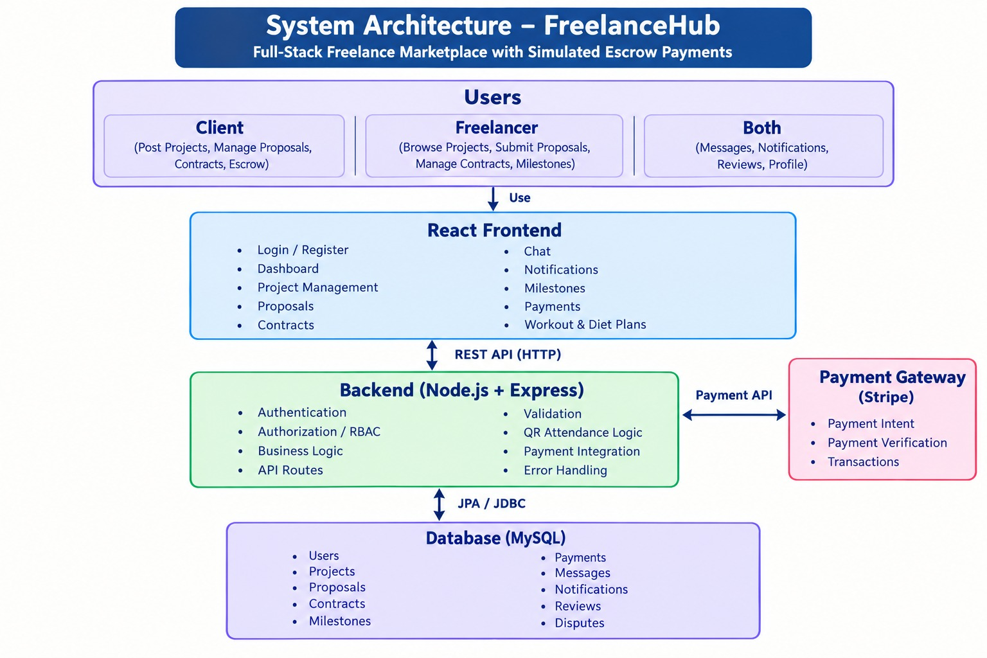

4.1 High-Level Architecture
The system follows a layered architecture consisting of:
User → React Frontend → REST API → Spring Boot Backend → MySQL Database
The user interacts with the React frontend. The frontend sends requests to the Spring Boot backend through REST APIs. The backend processes the request, applies business rules, communicates with MySQL, and returns the required response.

4.2 Frontend Layer
The frontend is responsible for presenting information to users and receiving user input.
It contains:
- Login and registration pages.
- Client dashboard.
- Freelancer dashboard.
- Project pages.
- Proposal pages.
- Contract pages.
- Milestone pages.
- Payment pages.
- Messaging interface.
- Notification interface.
- Dispute interface.
- Review interface.

4.3 Backend Layer
The backend acts as the central processing layer.
It performs:
- Authentication.
- Authorization.
- Validation.
- Business logic.
- Database operations.
- Project processing.
- Proposal processing.
- Contract processing.
- Payment processing.
- Communication management.

4.4 Database Layer
The database layer stores persistent information. Relational tables maintain links between users and their activities.
For example:
A client can create multiple projects.
A project can receive multiple proposals.
A proposal belongs to a freelancer.
An approved proposal can result in a contract.
A contract can contain multiple milestones.
A contract can have associated payment records.
A completed contract can have reviews.

CHAPTER 5 DESIGN
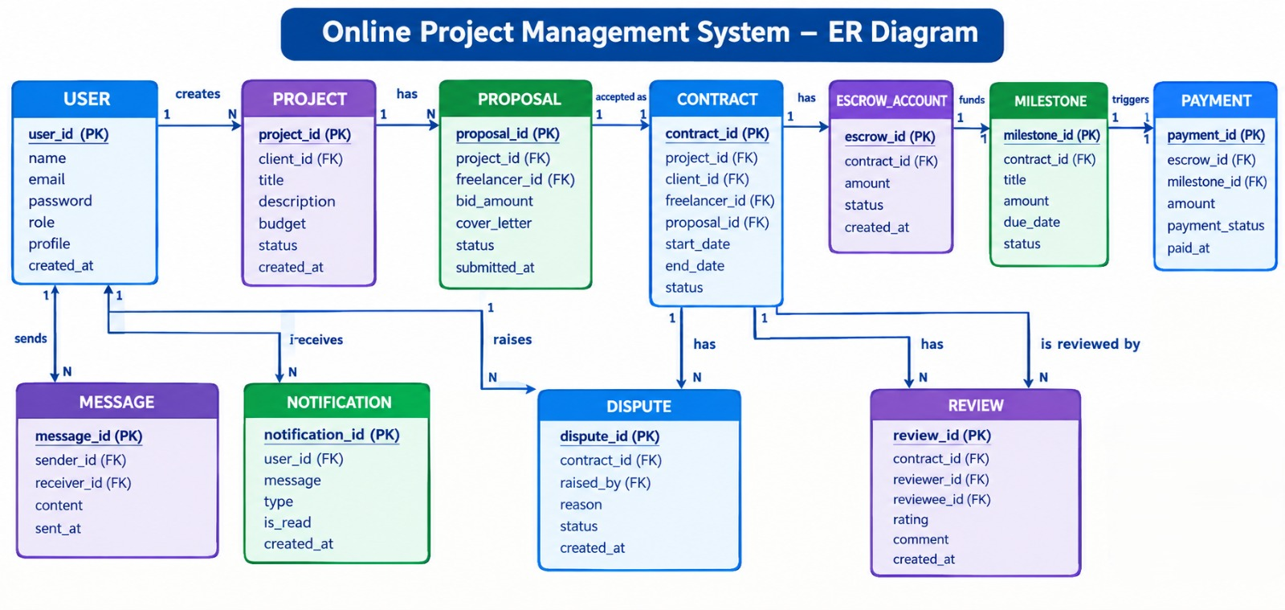

CHAPTER – 6 IMPLEMENTATION
6.1 Module-Wise Implementation
The implementation phase represents the transition of the Freelance Marketplace with Escrow Payments from a conceptual design into a functional full-stack web application. The implementation process involved converting the requirements, database design, system architecture, and user workflows into working software modules. The application was developed as a role-based freelance marketplace in which clients can create projects and freelancers can discover suitable opportunities, submit proposals, communicate with clients, and participate in contract and milestone-based workflows.
The system was implemented using React.js and JavaScript for the frontend, Spring Boot with Java for the backend, and MySQL for persistent data storage. The frontend provides the interactive user interface through which clients and freelancers perform their respective activities. The Spring Boot backend manages business logic, validation, authentication, authorization, project processing, proposals, contracts, milestones, payments, messaging, notifications, disputes, and reviews. MySQL provides structured and persistent storage for the application's transactional information.
The implementation was divided into several functional modules so that individual responsibilities could be developed, tested, and maintained independently. The modular structure also improves maintainability because changes made to one functional area can be performed without unnecessarily affecting unrelated modules.
The major modules implemented in the application are:
- User Registration and Login Module
- Role Management Module
- Client Dashboard Module
- Freelancer Dashboard Module
- Project Management Module
- Proposal Management Module
- Contract Management Module
- Milestone Management Module
- Escrow and Payment Management Module
- Messaging Module
- Notification Module
- Dispute Management Module
- Review and Rating Module
- Database and Persistence Module
User Registration and Login Module
The registration module allows users to create accounts on the platform by entering the required account information. During registration, the system stores user information in the MySQL database after performing the required validations. The login module verifies the supplied credentials and provides access to the appropriate application area according to the user's role.
The application supports two primary user roles: Client and Freelancer. The role selected during registration determines the features and actions available after authentication. This separation is important because the activities performed by clients and freelancers are different.
A client is primarily responsible for creating projects, reviewing proposals, selecting freelancers, managing contracts, funding milestones, communicating with freelancers, and reviewing completed work. A freelancer, on the other hand, can browse available projects, submit proposals, communicate with clients, manage accepted contracts, work on milestones, and submit completed work.
Role Management Module
Role management provides controlled access to application functionality. The system identifies whether the authenticated user is a client or freelancer and displays the corresponding dashboard and operations.
Role-based restrictions are also applied to backend operations. For example, a freelancer should not be able to perform client-only operations such as creating a project on behalf of another client, while a client should not be able to submit a freelancer proposal to their own project.
The role-management mechanism therefore acts as an important part of the application's authorization structure.
Client Module
The client module provides functionality required for users who want to hire freelancers. Clients can create new projects by specifying information such as project title, description, required skills, budget, deadline, and other relevant project details.
Once a project is created, it becomes available for freelancers to view according to the project's status and visibility rules. Clients can review submitted proposals and examine freelancer information before selecting an appropriate candidate.
The client module also provides access to active projects, contracts, milestones, payment records, messages, notifications, disputes, and completed project reviews.

Freelancer Module
The freelancer module is designed around finding and completing freelance opportunities. Freelancers can browse available projects and inspect project requirements before deciding whether to submit a proposal.
A proposal contains information such as the freelancer's proposed price, estimated completion period, skills, experience, and explanation of why the freelancer is suitable for the project.
After the client approves a proposal, the freelancer can access the associated contract and participate in the milestone workflow. The freelancer can communicate with the client through the messaging module and receive notifications about project and contract changes.

Project Management Module
Project management forms the central functional module of the marketplace. Clients can create, view, update, and manage projects through the application interface.
A project contains structured information including project title, project description, budget, deadline, required skills, project status, client details, and associated proposals.
The backend validates project information before storing it in MySQL. Project records are associated with the user who created them, establishing the relationship between clients and their projects.
Project status is used to represent the current stage of the project lifecycle. Depending on the workflow, a project can move through stages such as open, proposal review, assigned, active, completed, or closed.
Proposal Management Module
The proposal module connects freelancers with client-created projects. When a freelancer finds a suitable project, the freelancer can submit a proposal through the application.
The proposal is stored as a separate database record and is associated with both the project and freelancer. The client can then view the submitted proposal and evaluate the freelancer's information.
A client can approve or reject proposals based on the project's requirements. When a proposal is approved, the system can proceed toward contract creation and project assignment.
This module provides an important transition between project discovery and actual project execution.
Contract Management Module
The contract module represents the formal working relationship established between a client and freelancer after proposal approval.
A contract contains information relating to the selected project, client, freelancer, contract status, agreed amount, and associated milestones. The contract provides the foundation for tracking project progress and payment-related activities.
Contract statuses are handled carefully in both the backend and frontend. During development, differences between the status representation received from the backend and the format expected by frontend conditions caused certain completed-contract and active-contract actions not to appear correctly. The interface logic was corrected by normalizing status comparisons before evaluating contract-related actions.
This illustrates the importance of maintaining consistent data representations between frontend and backend systems.

Milestone Management Module
The milestone module divides a contract into smaller stages of work. Instead of treating an entire project as one large transaction, the project can be represented through multiple milestone records.
Each milestone can contain a title, description, amount, due date, and status. This structure provides a more organized way of monitoring project progress.
Milestones are also important to the escrow-oriented payment workflow because payment records can be associated with individual stages of a contract. The client can track milestone progress, while the freelancer can identify the work that needs to be completed.
Escrow and Payment Management Module
The payment module is designed around the concept of holding and releasing project funds according to the contract and milestone workflow. The purpose of the escrow-oriented model is to provide a structured relationship between project work and payment records.
Payment information is maintained separately from the main project record. This allows the system to maintain transaction-related information without unnecessarily mixing financial records with project metadata.
The implementation provides a workflow in which milestone-related payment information can be created, tracked, and associated with the corresponding contract. The architecture also allows a real payment gateway to be integrated in a future production version.
The current academic implementation focuses on the marketplace workflow, payment records, escrow states, and the relationship between contracts, milestones, and payments rather than claiming a complete production banking or payment settlement infrastructure.

Messaging Module
The messaging module provides communication between clients and freelancers. Communication is associated with the relevant users and project or contract context so that messages can be interpreted within the correct working relationship.
The messaging interface allows users to exchange project-related information without leaving the marketplace application. This reduces the need to depend entirely on external communication channels during the project lifecycle.
Notification Module
Notifications inform users about important changes in the application. Examples include proposal submission, proposal approval, contract changes, milestone updates, payment-related events, messages, dispute events, and project completion.
The notification system helps users identify actions that require attention. Notifications are associated with users and can be displayed through the appropriate dashboard interface.
Dispute Management Module
The dispute module provides a structured mechanism for handling disagreements associated with active contracts. A dispute can be initiated when a relevant contract condition requires formal attention.
The module maintains dispute information and associates it with the corresponding contract and users. This provides a structured record rather than relying only on informal communication.
The frontend also uses contract status to determine when dispute-related actions should be available. This ensures that dispute operations are presented in the appropriate stage of the project lifecycle.
Review and Rating Module
The review module supports post-project feedback between the participants. Once a contract reaches the appropriate completed state, the system can expose review functionality.
Reviews help maintain a record of project experiences and provide additional information about completed freelance engagements.
The implementation ensures that review functionality depends on the relevant contract state. During browser testing, status normalization was particularly important because inconsistent status formatting initially prevented some completed-contract review actions from appearing.
Database and Persistence Module
The persistence layer uses MySQL to store the application's structured information. Spring Boot communicates with the database through the backend persistence layer.
The database contains records representing users, projects, proposals, contracts, milestones, payments, messages, notifications, disputes, and reviews. Relationships between these entities allow the system to maintain the complete lifecycle of a freelance transaction.
The relational database structure provides data consistency and allows related records to be retrieved through appropriate queries.

6.2 Front-End Logic
The frontend represents the interaction layer of the application. React.js was used to develop the interface as reusable components rather than as a collection of independent static pages.
The application uses React components to separate different interface responsibilities. Components can represent navigation bars, dashboards, project cards, proposal forms, contract information, milestone lists, payment information, messages, notifications, and review sections.
React Router is used to manage navigation between different application views. Based on the authenticated user's role, the application provides access to appropriate client or freelancer routes.
Forms are used extensively throughout the application. Project creation, proposal submission, registration, login, messaging, milestone management, and dispute creation all require structured user input.
The frontend performs basic validation before sending information to the backend. This improves usability by allowing common input errors to be identified before an API request is submitted.
The frontend also communicates with backend REST endpoints to retrieve and update application information. Responses received from the backend are converted into data structures that can be displayed through React components.
An important part of the frontend implementation is state handling. Information such as authenticated user details, project records, proposals, contracts, messages, notifications, and payment status needs to be reflected dynamically in the interface.
The interface was also developed with reusable CSS and component structures so that visual changes could be made without rewriting the complete application.

6.3 API Integration
The frontend and backend communicate using RESTful APIs. API integration forms the communication bridge between React components and the Spring Boot application.
The client sends HTTP requests to backend endpoints using methods such as GET, POST, PUT, and DELETE according to the operation being performed.
For example, a GET request can retrieve available projects, while a POST request can create a new project or submit a proposal. Update operations can modify project, contract, milestone, or status information.
The backend processes each request, validates the supplied information, performs the required business logic, communicates with MySQL, and returns a response to the frontend.
The response is generally represented using JSON because JSON provides a lightweight and widely supported format for communication between JavaScript applications and backend services.
API integration was implemented for major application areas including:
- User registration and login
- User profile information
- Project creation and retrieval
- Proposal submission
- Proposal approval
- Contract management
- Milestone management
- Payment and escrow records
- Messaging
- Notifications
- Disputes
- Reviews
API testing is an important part of integration because an individual frontend component may appear correct while still failing to communicate properly with the backend. Therefore, requests, response structures, HTTP status codes, and database updates must be verified together.

6.4 Authentication and Authorization
Authentication establishes the identity of a user, while authorization determines which operations that authenticated user is permitted to perform.
The authentication process begins when the user submits login credentials. The backend validates the supplied information against stored account data. After successful authentication, the application provides access to the corresponding user interface.
Authorization is implemented through role-based access. The two main roles are Client and Freelancer.
A client receives access to client-specific functionality such as:
- Creating projects
- Viewing proposals
- Approving freelancers
- Managing contracts
- Managing milestones
- Managing payment-related records
- Handling disputes
- Providing reviews
A freelancer receives access to freelancer-specific functionality such as:
- Browsing projects
- Submitting proposals
- Managing accepted contracts
- Working with milestones
- Communicating with clients
- Viewing relevant notifications
- Participating in disputes
- Providing or receiving reviews where applicable
Authorization checks are necessary both at the interface level and backend level. Hiding a button in the frontend alone does not provide sufficient security because a user could attempt to call an endpoint directly. Therefore, backend authorization must also verify whether the current user is permitted to perform the requested operation.
The authentication and authorization design therefore contributes to maintaining separation between client and freelancer activities throughout the application.

CHAPTER – 7 FEATURES
7.1 List of Main Features
The Freelance Marketplace with Escrow Payments is designed as a complete digital environment for managing freelance relationships from project creation to completion. The major features implemented in the system include:
- User Registration and Login
- Client and Freelancer Role Management
- Client Dashboard
- Freelancer Dashboard
- Project Creation and Management
- Project Discovery
- Freelancer Proposal Submission
- Proposal Review and Approval
- Contract Creation and Management
- Milestone-Based Project Management
- Escrow-Oriented Payment Workflow
- Messaging and Communication
- Notifications
- Dispute Management
- Project Completion
- Reviews and Ratings
- Database-Based Record Management
These features are interconnected so that an action performed in one module can influence the information displayed by another module.

7.2 How Each Feature Works
User Registration and Login
Users begin their interaction with the marketplace by registering an account. The registration process collects the required information and identifies whether the account is intended for client or freelancer activities.
After registration, users can log in using their credentials. The application verifies the account and provides access to the corresponding dashboard.
Client and Freelancer Roles
The platform separates functionality according to user role.
The client role focuses on hiring and project management, whereas the freelancer role focuses on discovering projects and completing assigned work.
This role separation simplifies the interface because users are presented with the operations relevant to their activities.
Project Creation
A client can create a project by entering information such as title, description, budget, deadline, and required skills.
After validation, the project is stored in the database and becomes available to freelancers according to its status.
The project acts as the starting point of the marketplace workflow.
Project Discovery
Freelancers can browse available projects and examine their requirements.
The information displayed allows freelancers to determine whether a project matches their skills, experience, expected budget, and availability.
This feature provides the discovery mechanism through which the supply and demand sides of the marketplace interact.
Proposal Submission
A freelancer can submit a proposal for a project.
The proposal communicates the freelancer's interest and may include a proposed price, estimated delivery period, relevant skills, experience, and a description explaining why the freelancer is suitable for the project.
The proposal is stored in the database and associated with both the freelancer and project.
Proposal Approval
The client can review submitted proposals and select a freelancer.
When a proposal is approved, the system records the selection and moves the workflow toward contract creation.
This stage represents the transition from an open marketplace opportunity into a formal working relationship.
Contract Management
A contract connects the client, freelancer, and selected project.
The contract records information about the agreed working relationship and provides the structure for milestones, payment records, communication, and completion.
Contract status is used throughout the system to determine which operations are currently available.
Milestone Management
Large projects can be divided into smaller milestones.
Each milestone represents a defined stage of work and can contain its own description, amount, due date, and status.
This provides greater transparency because both parties can identify what stage of the project is currently being handled.
Escrow-Oriented Payment Workflow
The escrow-oriented workflow connects payment records with project milestones.
Instead of treating payment as an unrelated operation, the system associates payment information with the contract and its milestones.
This structure provides a clear relationship between work completion and financial records.
The architecture can later be connected to a production payment provider when required.
Messaging
The messaging feature enables direct communication between the client and freelancer.
Messages can be used for discussing requirements, clarifying milestones, sharing progress information, and resolving normal project communication issues.
Notifications
Notifications inform users when important activities occur.
For example, a freelancer can be notified when a proposal is approved, while a client can receive notifications when a freelancer submits a proposal or updates relevant project information.
Dispute Management
The dispute feature provides a formal mechanism for raising issues related to active contracts.
The system records dispute information and associates it with the relevant contract and participants.
This creates a structured history of the dispute instead of depending only on external communication.
Project Completion
After all required project activities and milestones are completed, the contract can move toward a completed state.
Completion is important because it controls access to post-project functionality such as reviews.
Reviews and Ratings
The review system provides post-project feedback.
Once the relevant contract reaches the completed state, eligible users can submit reviews according to the application's workflow.
The review information is stored and associated with the appropriate project participants.
Role-Specific Dashboards
The client dashboard and freelancer dashboard present different information.
The client dashboard focuses on created projects, proposals, selected freelancers, contracts, milestones, payments, messages, notifications, disputes, and reviews.
The freelancer dashboard focuses on available projects, submitted proposals, accepted contracts, milestones, messages, notifications, and relevant project activity.
The dashboard design therefore acts as the primary control centre for each user.

CHAPTER – 8 TESTING
8.1 Postman Testing
API testing forms an important part of the testing process because the application depends on communication between the React frontend and Spring Boot backend.
Postman can be used to send requests directly to backend endpoints without requiring the frontend interface for every test. This makes it possible to independently verify whether the backend receives the expected information and returns an appropriate response.
The major API categories tested include authentication, users, projects, proposals, contracts, milestones, payments, messages, notifications, disputes, and reviews.
For example, the project creation endpoint can be tested by sending a POST request containing project information. The expected result is successful creation of a project record and an appropriate response from the backend.
Similarly, proposal submission can be tested by supplying the relevant project identifier, freelancer information, proposal amount, delivery estimate, and proposal description.
Postman also makes it possible to test unsuccessful requests. Invalid credentials, missing required fields, unauthorized access, invalid identifiers, and incorrect request formats can be used to verify backend validation.
Typical HTTP response categories include successful responses such as 200-level responses and error responses such as unauthorized or invalid-resource responses.
Postman collections can be organized according to application modules. This provides a repeatable method for checking the backend during development.

8.2 Integration Testing
Integration testing verifies whether different modules operate correctly when connected together.
In the Freelance Marketplace, integration testing is particularly important because most major features depend on multiple layers.
For example, creating a project involves:
- React project form
- API request
- Spring Boot controller
- Business/service logic
- Repository/database operation
- MySQL record creation
- API response
- Frontend interface update
A failure at any one of these stages can result in an incomplete operation.
The proposal workflow provides another important integration scenario. A freelancer submits a proposal through the frontend, the backend validates it, the proposal is stored in MySQL, and the client should subsequently be able to see the proposal.
Contract testing similarly involves proposal approval, contract creation, status changes, milestone records, payment information, and dashboard updates.
Browser-based smoke testing was also used during development to verify complete user flows through the actual application interface. During this process, a status-format issue was identified in which backend contract statuses were received in uppercase while frontend checks expected a different format. Normalizing the status values corrected the issue and restored dependent actions such as completed-contract reviews and active-contract dispute options.
This demonstrates the importance of integration testing because the individual components themselves can appear functional while their communication still contains compatibility problems.

8.3 Tools Used for Testing
1. Postman
Postman is used for testing REST API endpoints. It allows developers to create requests, inspect responses, verify HTTP status codes, and test different input conditions.
2. Web Browser
Browsers such as Google Chrome and Microsoft Edge can be used to test the actual application interface.
Browser testing helps identify navigation problems, rendering issues, incorrect state updates, and user-flow defects.
3. Browser Developer Tools
Developer tools are useful for examining console errors, network requests, API responses, HTML structures, and CSS behaviour.
The Network tab can be used to determine whether frontend requests reach the backend successfully.

4. MySQL Workbench
MySQL Workbench provides direct access to the database and can be used to verify whether operations performed through the application are correctly reflected in database records.
5. Git and GitHub
Git and GitHub support version control throughout testing and debugging. Changes can be tracked and reverted when necessary.
6. Spring Boot Logs
Backend logs provide information about incoming requests, application errors, database problems, and runtime behaviour.
7. React Developer Tools
React Developer Tools can be used to inspect components, props, state, and component hierarchy during frontend debugging.

8.4 Test Cases and Results
Testing was organized around the major functional requirements of the system.
Test Case | Module | Test Condition | Expected Result
TC01 | Registration | Valid user details | Account created successfully
TC02 | Registration | Missing required field | Validation/error message displayed
TC03 | Login | Valid credentials | User successfully authenticated
TC04 | Login | Invalid credentials | Login rejected
TC05 | Role Access | Client accesses client feature | Operation permitted
TC06 | Role Access | Freelancer attempts client-only operation | Operation restricted
TC07 | Project | Client creates valid project | Project stored successfully
TC08 | Project | Invalid project information | Validation prevents incorrect submission
TC09 | Project Discovery | Freelancer views open projects | Available projects displayed
TC10 | Proposal | Freelancer submits proposal | Proposal stored
TC11 | Proposal Approval | Client approves proposal | Freelancer selected
TC12 | Contract | Approved proposal creates contract | Contract information available
TC13 | Milestone | Valid milestone created | Milestone stored
TC14 | Payment | Payment record associated with milestone | Payment information displayed
TC15 | Messaging | User sends message | Message stored/displayed
TC16 | Notification | Important event occurs | Notification generated/displayed
TC17 | Dispute | Eligible contract opens dispute action | Dispute option available
TC18 | Review | Completed contract | Review functionality available
TC19 | Unauthorized Access | Restricted operation attempted | Access rejected
TC20 | Database | Application record created | Corresponding MySQL record available
The testing process also involved repeated regression checks after modifications. When a defect was identified in one module, related modules were checked to ensure that the change did not introduce new inconsistencies.
Testing therefore acted not only as a final validation stage but also as a continuous part of development.

CHAPTER – 9 DEPLOYMENT
9.1 Steps to Deploy
Deployment represents the process of preparing the Freelance Marketplace application so that the frontend, backend, and database can operate together in a usable environment.
The first stage is environment preparation. The required Java Development Kit, Node.js environment, npm, Maven, MySQL, and browser tools must be installed and configured.
The source code is maintained through Git and can be stored in a GitHub repository. Before deployment, the latest stable version of the project should be reviewed and tested.
The frontend and backend are built as separate application components.
The React frontend is prepared using the project's npm configuration. Dependencies are installed and the production build process is executed.
The Spring Boot backend is prepared using Maven. Maven resolves the required Java dependencies and creates the backend application package.
The MySQL database must then be created and configured. The required database schema and tables must be available before the backend attempts to perform application operations.
After environment configuration, the backend is started and checked for successful database connectivity. The frontend is then configured to communicate with the correct backend API address.
Finally, application workflows are tested after deployment. Login, project creation, proposal submission, contract management, milestone operations, messaging, payment records, and review functionality should be verified.

9.2 Environment Configuration
Environment configuration is necessary because frontend and backend applications require information about their runtime environment.
The backend requires database configuration such as:
- Database URL
- Database name
- Database username
- Database password
- Server port
- Application configuration values
Sensitive information should not be directly embedded into source code. Environment-specific configuration should be maintained separately from the main application logic.
The frontend also requires the correct backend API base URL. During local development, this may point toward the local Spring Boot server.
For example, the architecture can be represented as:
React Frontend → Spring Boot REST API → MySQL Database
When the environment changes, the frontend API address and backend database configuration must be updated accordingly.
The configuration process should also verify that required ports are available. During development, port conflicts can prevent either the frontend or backend server from starting. Such conflicts must be identified and resolved before deployment.

9.3 Hosting of Frontend and Backend
The application is designed so that the frontend and backend can be hosted separately.
The React frontend can be deployed to a static web hosting platform capable of serving the generated production build.
The Spring Boot backend can be hosted on a Java-compatible server or cloud application platform.
The MySQL database can be hosted locally for academic demonstration or on a managed database service for a production environment.
A production architecture can therefore follow the structure:
User Browser
↓
React Frontend
↓
Spring Boot Backend
↓
MySQL Database

The separation between frontend and backend provides flexibility because either component can be updated independently as long as the API contract remains compatible.
For a production deployment, HTTPS should be used to protect communication between the browser and backend. Database credentials should be stored securely and should not be exposed through the frontend.
Post-deployment verification is necessary after every major deployment. Critical user flows should be executed to ensure that deployment has not introduced configuration-related failures.

CHAPTER – 10 CHALLENGES & LIMITATIONS
10.1 Issues Faced During Development
The development of the Freelance Marketplace with Escrow Payments involved several technical and organizational challenges. Because the application combines frontend development, backend programming, relational database management, authentication, role-based workflows, project management, payment records, communication, and status-dependent functionality, changes in one part of the application could affect another part.
One of the initial challenges was coordinating the frontend and backend development. The React interface depends on specific API endpoints and response structures provided by Spring Boot. When endpoint names, request fields, response formats, or status values changed, the frontend had to be updated accordingly.
Another challenge was maintaining consistency between the application interface and the database structure. The project contains multiple related entities, including users, projects, proposals, contracts, milestones, payments, messages, notifications, disputes, and reviews. Maintaining correct relationships between these entities required careful database design and validation.
Authentication and role management also required attention because client and freelancer users perform different operations. A user interface may hide a particular action, but the backend must also verify whether the user is authorized to perform it.
Project and proposal workflows created another challenge because several actions depend on the current state of the project. For example, a freelancer should be able to submit a proposal only when the project is available, while contract-specific actions should become available only after a proposal has been approved.
Contract status handling produced a practical integration issue during browser testing. The backend returned contract status values in uppercase, while certain frontend conditions expected another representation. Because of this mismatch, some actions related to completed contracts and active-contract disputes were not displayed correctly.
Database connectivity was another area requiring careful configuration. The backend must establish a connection with MySQL using the correct database details. Incorrect database names, credentials, ports, or server status can prevent the application from functioning correctly.
Frontend development also presented challenges in maintaining a consistent user interface across different pages. Since the application contains multiple dashboards and workflows, shared components and CSS had to be managed carefully.
Git-based collaboration created additional challenges because multiple team members can modify different parts of the project. Changes to shared files can create merge conflicts if they are not coordinated properly.
Finally, testing the complete workflow was more complex than testing individual pages. A freelance transaction is not a single operation; it involves multiple stages beginning with project creation and continuing through proposal submission, approval, contract creation, milestones, payment records, communication, completion, and reviews.

10.2 Solutions Applied
The challenges encountered during development were addressed through a combination of modular design, systematic debugging, validation, database verification, and repeated integration testing.
To address frontend-backend compatibility problems, API structures were kept clearly defined and the frontend was updated according to the actual response received from the backend.
The project was divided into modules so that development and debugging could be performed independently. Instead of placing all business logic in a single component or class, responsibilities were distributed among appropriate frontend components and backend layers.
For database-related issues, MySQL Workbench was used to inspect the database and verify stored records. This made it possible to determine whether a problem originated in the frontend, backend processing, or database operation.
Role-related issues were addressed by implementing role-aware interfaces and backend authorization checks. This ensured that client and freelancer operations remained separated.
Validation was introduced at multiple stages. Frontend validation helps users identify incorrect input before submitting a request, while backend validation protects the application from invalid or incomplete requests.
The contract status issue discovered during browser smoke testing was resolved by normalizing the status value before performing frontend comparisons. Instead of depending on one exact capitalization format, the interface converts the received status into a consistent representation before deciding which actions should be displayed.
This correction restored functionality for completed-contract reviews and active-contract dispute actions.
Database and backend connection issues were addressed by checking the MySQL server, database configuration, credentials, application properties, and backend startup logs.
For frontend issues, browser developer tools were used to inspect console errors and network requests. This made it possible to identify whether an issue originated from React rendering, CSS, API communication, or backend responses.
Git and GitHub were used to maintain versions of the project. Changes could be committed and reviewed, making it easier to track modifications and recover earlier working versions when necessary.
The development process therefore followed an iterative approach. Features were implemented, tested, corrected, and tested again rather than waiting until the entire system was completed before debugging.

10.3 Current Limitations or Known Bugs
Although the Freelance Marketplace provides a broad set of marketplace functions, several limitations remain because the project is an academic implementation rather than a large-scale commercial platform.
The first limitation concerns production payment processing. The current implementation provides an escrow-oriented workflow and payment records, but a fully operational financial settlement system requires integration with a real payment provider, secure transaction verification, refund processing, webhook handling, and financial compliance mechanisms.
Another limitation is that the marketplace does not yet contain a complete automated freelancer recommendation engine. Users can browse projects and evaluate proposals, but advanced matching based on skills, experience, previous performance, budget, and project similarity can be introduced in a future version.
The communication system can also be extended. Although messaging functionality is available, a production-scale platform may require real-time WebSocket communication, message delivery indicators, typing indicators, file sharing, message search, and stronger message-management capabilities.
The dispute system currently provides the structural workflow for recording disputes. A large-scale marketplace would require an administrative dispute-resolution interface, evidence submission, moderation, escalation procedures, and final settlement mechanisms.
The application also requires further testing across a wider range of devices, browsers, network conditions, and concurrent user sessions before production-scale deployment.
Another limitation concerns notification infrastructure. A complete commercial platform would benefit from email notifications, browser notifications, mobile notifications, and configurable notification preferences.
Search functionality can also be enhanced. Advanced filtering, sorting, skill-based matching, project recommendations, and full-text search could make it easier for freelancers to discover relevant projects.
The project also depends on consistent communication between frontend and backend. Any future changes to API response formats or status values must be reflected carefully in the frontend to avoid compatibility issues.
The status-format problem identified during development illustrates this limitation. Although it was corrected through status normalization, similar inconsistencies could occur in other areas if API contracts are changed without corresponding frontend updates.
Security can also be strengthened further for production deployment through advanced authentication, stronger password policies, rate limiting, audit logging, secure session management, and additional security testing.
These limitations do not prevent the academic system from demonstrating the intended marketplace workflow, but they identify areas that would require additional development before commercial-scale deployment.

CHAPTER – 11 FUTURE ENHANCEMENTS
11.1 Planned Features
The Freelance Marketplace with Escrow Payments has been designed with an extensible architecture so that additional features can be introduced without completely redesigning the existing application.
One of the most important future enhancements is integration with a real payment gateway. A production version can connect the existing escrow-oriented workflow with a secure payment provider. Such integration can support payment authorization, milestone funding, payment release, refunds, transaction verification, and webhook-based status updates.
A dedicated administrative dashboard can also be introduced. Administrators could manage users, projects, contracts, disputes, payments, reports, and platform activity.
Another planned enhancement is an advanced freelancer recommendation system. The system could analyze project requirements and freelancer information to suggest potentially relevant matches. Skills, experience, proposal history, ratings, project categories, budget, and completion history could be considered.
An improved search engine could allow freelancers to filter projects according to skills, budget, deadline, category, experience requirements, and project status.
The messaging module can be extended into a real-time communication system. WebSocket technology can be used to provide instant message delivery, typing indicators, online status, read receipts, and real-time notifications.
File sharing is another useful enhancement. Clients and freelancers frequently need to exchange documents, designs, reports, source code, or other project resources. A secure file-storage mechanism can therefore be integrated into the communication and contract modules.
The review system can also be extended with detailed rating categories. Instead of a single overall rating, users could provide ratings for communication, quality, professionalism, timeliness, and cooperation.
A project activity timeline could also be introduced. Such a timeline would provide a chronological view of proposals, contract events, milestone changes, payment events, messages, and completion activities.
Mobile support represents another possible enhancement. A dedicated mobile application could provide freelancers and clients with access to projects, messages, notifications, and contract information from smartphones.

11.2 Possible Integrations or Optimizations
The platform can be enhanced through integration with external services.
A payment service can provide secure financial processing. Email services can be integrated to send account verification, proposal, contract, milestone, payment, and completion notifications.
Cloud storage services can be used for project documents and file attachments. This would allow large files to be stored separately from the relational database while keeping references to those files in MySQL.
Real-time communication can be improved through WebSocket-based technologies. This would allow messages and notifications to appear without requiring users to manually refresh the page.
Artificial intelligence can also be incorporated into the marketplace in controlled ways. An AI-based project assistant could help clients improve project descriptions by identifying missing requirements or unclear specifications.
AI-assisted matching could analyze project descriptions and freelancer profiles to identify relevant skills and similarities.
A recommendation system could learn from previous interactions and suggest projects to freelancers based on their selected skills and previous applications.
AI could also assist with proposal drafting, while ensuring that the freelancer remains responsible for reviewing and submitting the final proposal.
Analytics represents another future direction. The system could generate dashboards showing project completion rates, average proposal values, milestone performance, response times, payment activity, and user engagement.
Performance optimization can be achieved through database indexing, query optimization, pagination, caching, and efficient frontend rendering.
As the number of users increases, the backend architecture can also be optimized for higher concurrency. Load balancing, containerization, centralized logging, monitoring, and automated deployment can be introduced when required.
Security can be strengthened through multi-factor authentication, stronger authorization policies, API rate limiting, audit logs, encrypted sensitive information, security headers, and regular vulnerability assessments.
The database can also be optimized through indexing of frequently searched columns and careful management of relationships between users, projects, proposals, contracts, milestones, and payments.
Another possible enhancement is automated contract documentation. Once a client approves a freelancer, the platform could automatically generate a structured contract containing project details, milestones, agreed amounts, deadlines, and responsibilities.
Dispute management could also be expanded into a complete resolution workflow with evidence submission, administrative review, status tracking, and final decisions.
Finally, the platform can be deployed using a complete cloud infrastructure with separate frontend hosting, backend hosting, managed MySQL database, secure environment variables, monitoring, automated backups, and CI/CD pipelines.
These future enhancements demonstrate that the current architecture can serve as a foundation for developing a larger freelance ecosystem while maintaining the core marketplace workflow.

CHAPTER – 12 CONCLUSION
12.1 Summary of the Project
The Freelance Marketplace with Escrow Payments is a full-stack web application designed to provide a centralized environment for clients and freelancers to manage freelance projects from initial project creation through proposal selection, contract management, milestone tracking, payment records, communication, dispute handling, and project completion.
The project was developed to address the need for a structured digital environment in which clients can publish project requirements and freelancers can discover suitable opportunities without relying on disconnected communication and management systems.
The platform provides separate experiences for clients and freelancers. Clients can create projects, review proposals, select freelancers, manage contracts, define milestones, monitor project progress, manage payment-related information, communicate with freelancers, and participate in dispute and review workflows.
Freelancers can create accounts, browse available projects, submit proposals, communicate with clients, manage accepted contracts, work with milestones, and participate in the completion and review process.
From a technical perspective, the application demonstrates the integration of frontend, backend, and database technologies. React.js and JavaScript provide the frontend environment, while Spring Boot and Java provide the backend processing layer. MySQL provides persistent relational storage.
The system follows a layered approach in which the frontend is responsible for presentation and interaction, the backend manages application logic and API communication, and the database maintains persistent information.
The relational structure of MySQL supports the relationships among users, projects, proposals, contracts, milestones, payments, messages, notifications, disputes, and reviews.
The project also demonstrates the importance of API-based communication. REST APIs provide the connection between the React frontend and Spring Boot backend, allowing application information to be created, retrieved, updated, and processed dynamically.
A significant aspect of the project is the escrow-oriented payment workflow. By connecting payment records with contracts and milestones, the system provides a structured model for managing financial stages of freelance work.
The project also demonstrates the importance of status-based workflows. Projects, proposals, contracts, milestones, disputes, and reviews depend on different stages of the application lifecycle. Maintaining consistent status values between the frontend and backend is therefore essential.
During browser smoke testing, an actual integration issue involving contract-status formatting was identified. Backend statuses were returned in uppercase while some frontend checks expected a different representation. The issue prevented certain completed-contract review actions and active-contract dispute actions from appearing correctly. Normalizing the status representation resolved the problem.
The project therefore represents not only the implementation of individual features but also the integration of multiple software engineering concepts into one functional application.
12.2 What Was Achieved
The project achieved the primary objective of developing a functional freelance marketplace architecture with client and freelancer workflows.
The major achievements include the implementation of user registration and authentication, role-based application access, project creation, project discovery, proposal submission, proposal approval, contract management, milestone management, payment records, messaging, notifications, disputes, and reviews.
The client-side interface was developed using reusable React components and route-based navigation. This provides a structured and interactive experience for different user roles.
The backend was implemented using Spring Boot and Java. The backend manages API requests, business logic, validation, role-based operations, and database communication.
MySQL was successfully integrated as the relational database layer for storing the application's structured information.
The implementation also established relationships among major entities. A client can create multiple projects, a project can receive multiple proposals, an approved proposal can lead to a contract, a contract can contain multiple milestones, and payment records can be associated with the relevant contractual workflow.
The project also achieved integration between the frontend and backend through REST APIs.
Testing and debugging provided additional achievements. The application was examined through API-level testing and browser-based testing. Database records could be verified through MySQL tools, while browser developer tools supported frontend and network debugging.
The identification and correction of the contract-status formatting issue demonstrated successful debugging of a cross-layer integration problem.
The project also provided experience in version control through Git and GitHub. Source code could be maintained through commits and organized development workflows.
From an academic perspective, the project demonstrates the practical application of concepts from software engineering, database management, web development, object-oriented programming, REST API design, authentication, authorization, testing, and system integration.
The application provides a foundation that can be extended with real payment gateways, advanced recommendation systems, real-time communication, cloud deployment, analytics, and stronger security mechanisms.
The project therefore demonstrates the complete journey from requirement analysis and system design to implementation, testing, debugging, and deployment preparation.

12.3 Skills Learned During Development
The development of the Freelance Marketplace with Escrow Payments provided practical exposure to several technical and software engineering skills.
The first major skill developed was full-stack web development. The project required understanding how a frontend application communicates with a backend server and how the backend communicates with a database.
The development process improved understanding of React.js, including component-based design, routing, forms, state handling, conditional rendering, and API communication.
The project also provided practical experience with Java and Spring Boot. Developing REST APIs, controllers, services, repositories, validation, and backend business logic strengthened understanding of server-side application development.
Another major area of learning was MySQL database management. Designing tables, relationships, queries, and persistent records provided practical experience in relational database systems.
The project also improved understanding of REST API design. Different HTTP methods, request structures, response formats, status codes, and API integration were used throughout the application.
Authentication and authorization provided another important learning area. The distinction between identifying a user and controlling what that user can access became an important part of the implementation.
The project also strengthened understanding of role-based application design. Client and freelancer workflows had to be separated while still operating within the same application.
The implementation of projects, proposals, contracts, milestones, payments, disputes, and reviews provided practical experience with business workflow design.
The project also improved debugging skills. Problems were not always located in the code where the visible error appeared. Some issues required tracing information from the frontend through the API and backend to the database.
The contract-status issue was an example of this type of debugging because the underlying problem involved the representation of data moving between backend and frontend.
The development process also provided experience with software testing. API testing, browser testing, database verification, integration testing, and regression checking demonstrated the importance of validating software beyond simply confirming that individual pages load.
Another important skill developed was Git and GitHub version control. The project required source-code management, commits, collaboration, and tracking changes.
The project also strengthened problem-solving and teamwork skills. A full-stack project requires developers to coordinate frontend, backend, database, testing, and documentation activities.
Finally, the project improved understanding of the software development lifecycle. The development process covered requirement analysis, system design, technology selection, database design, implementation, integration, testing, debugging, deployment preparation, documentation, and future enhancement planning.
Overall, the Freelance Marketplace with Escrow Payments provided a practical platform for applying theoretical knowledge to a real-world software problem. The completed system demonstrates how modern web technologies can be combined to create a structured digital marketplace connecting clients and freelancers while maintaining project, contract, milestone, communication, and payment-related information within a unified application.

CHAPTER – 13 REFERENCES
The following references were consulted during the design, development, implementation, testing, and documentation of the Freelance Marketplace with Escrow Payments project. These resources provided technical information regarding frontend development, backend development, programming languages, database management, API development, version control, and software testing.
REFERENCES
- React.jsOfficialDocumentation https://react.dev/
- React.jsReferenceDocumentation https://react.dev/reference/react
- JavaOfficialDocumentation https://docs.oracle.com/en/java/
- SpringBootOfficialDocumentation https://docs.spring.io/spring-boot/
- SpringBootReferenceDocumentation
https://docs.spring.io/spring-boot/reference/index.html
- MySQL8.4ReferenceManual
https://dev.mysql.com/doc/refman/8.4/en/
- MySQLSQLStatementsReference
https://dev.mysql.com/doc/refman/8.4/en/sql-statements.html
- JavaScriptGuide–MDNWebDocs
https://developer.mozilla.org/en-US/docs/Web/JavaScript/Guide
- GitDocumentation
https://git-scm.com/doc
- GitHubDocumentation https://docs.github.com/en
- PostmanDocumentation https://learning.postman.com/docs/
- HTTPDocumentation–MDNWebDocs
https://developer.mozilla.org/en-US/docs/Web/HTTP
- ReactRouterDocumentation https://reactrouter.com/
- ApacheMavenDocumentation https://maven.apache.org/guides/
- MDNWebDevelopmentDocumentation https://developer.mozilla.org/
- JavaSpringFrameworkDocumentation
https://docs.spring.io/spring-framework/reference/
- SpringDataJPADocumentation
https://docs.spring.io/spring-data/jpa/reference/
- MySQLWorkbenchDocumentation
https://dev.mysql.com/doc/workbench/en/
- RESTAPIDocumentation–MDNWebDocs
https://developer.mozilla.org/en-US/docs/Glossary/REST
- JSONDocumentation–MDNWebDocs
https://developer.mozilla.org/en-US/docs/Learn_web_development/Core/Scripting/JSON

13.16 Reference Summary
The above resources were used as technical references throughout the development of the Freelance Marketplace. Official documentation was preferred wherever possible because it provides authoritative information about the frameworks, programming languages, database system, development tools, and testing technologies used in the project.
The references supported the development of the frontend using React and JavaScript, the backend using Java and Spring Boot, database implementation using MySQL, source-code management using Git and GitHub, API testing using Postman, and general web development using established HTTP and web standards.

CHAPTER -14 APPENDICES
Screenshots of the app
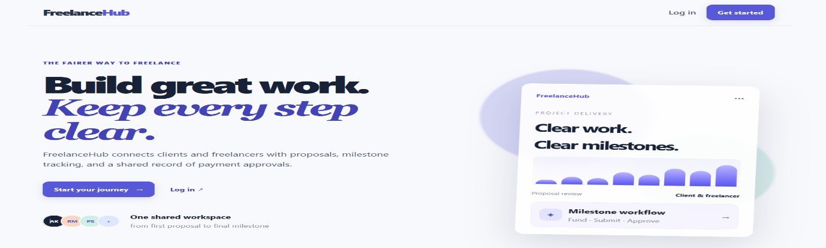
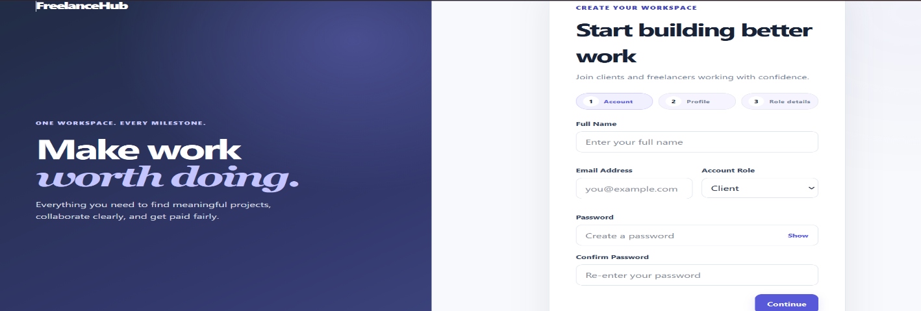
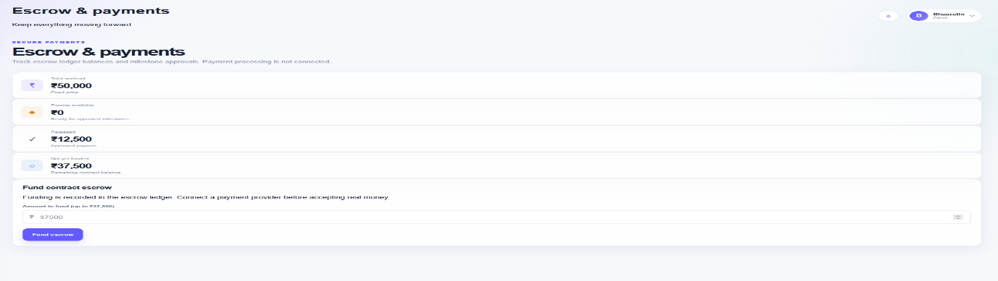

Sample Code Snippets
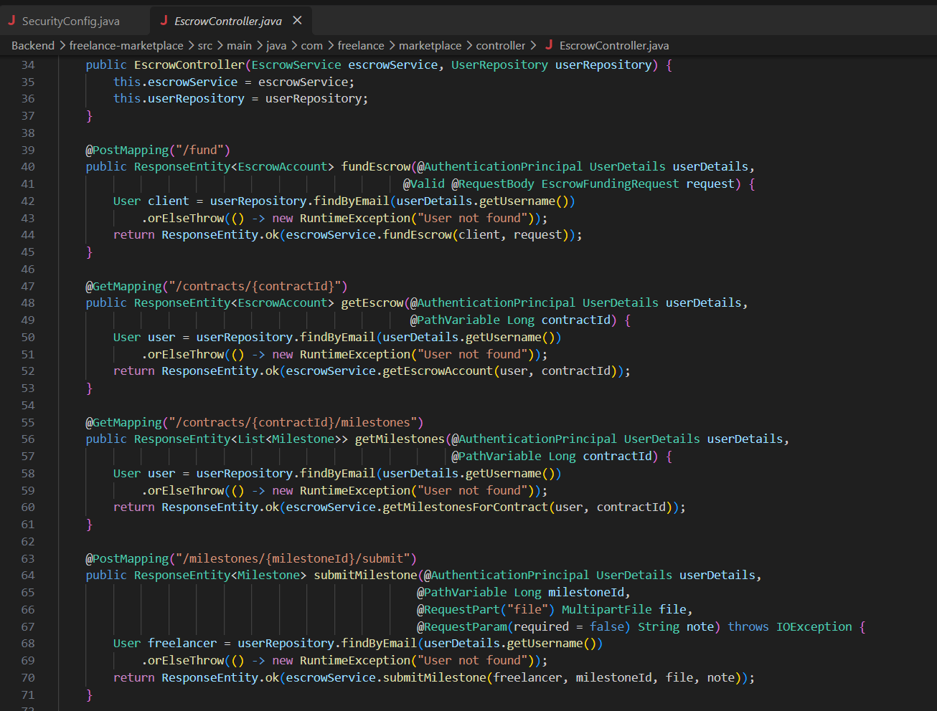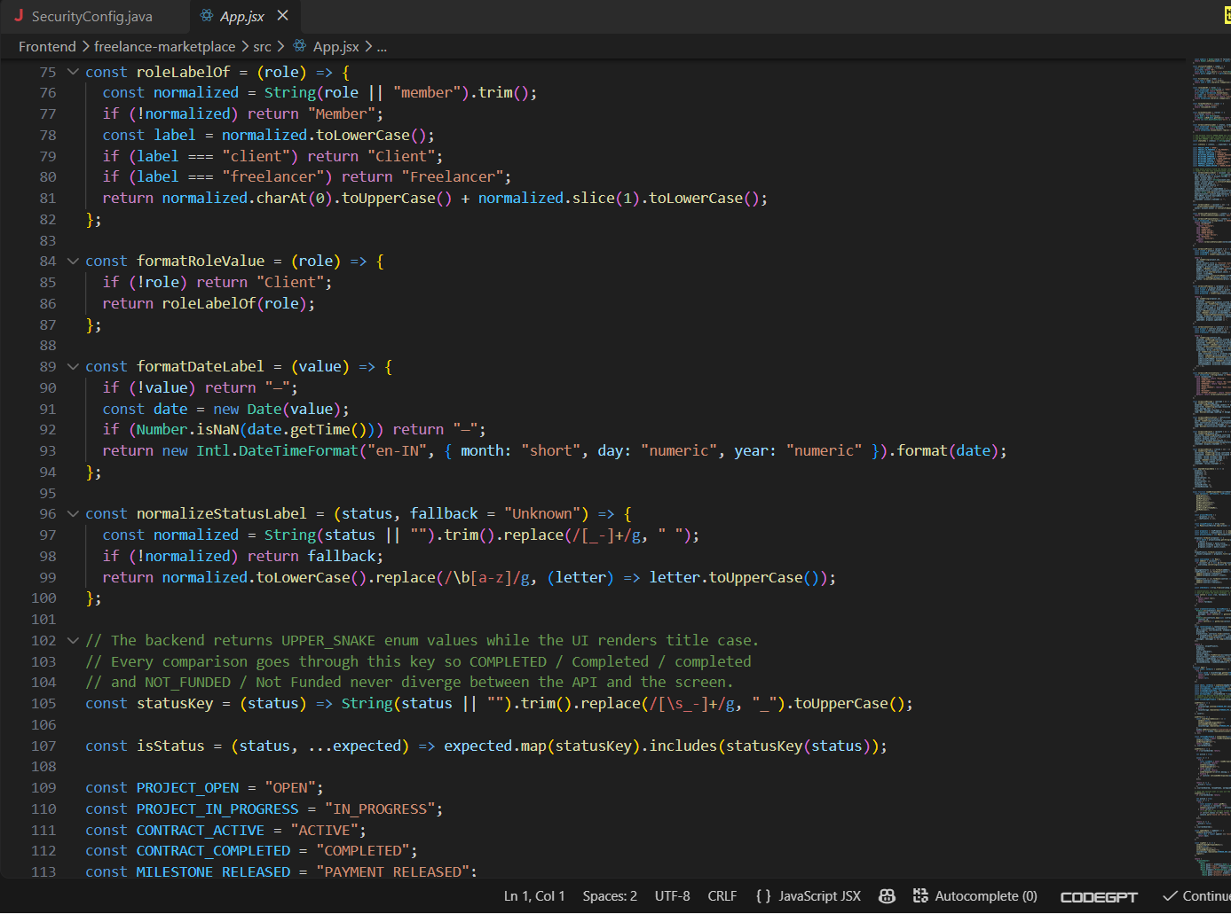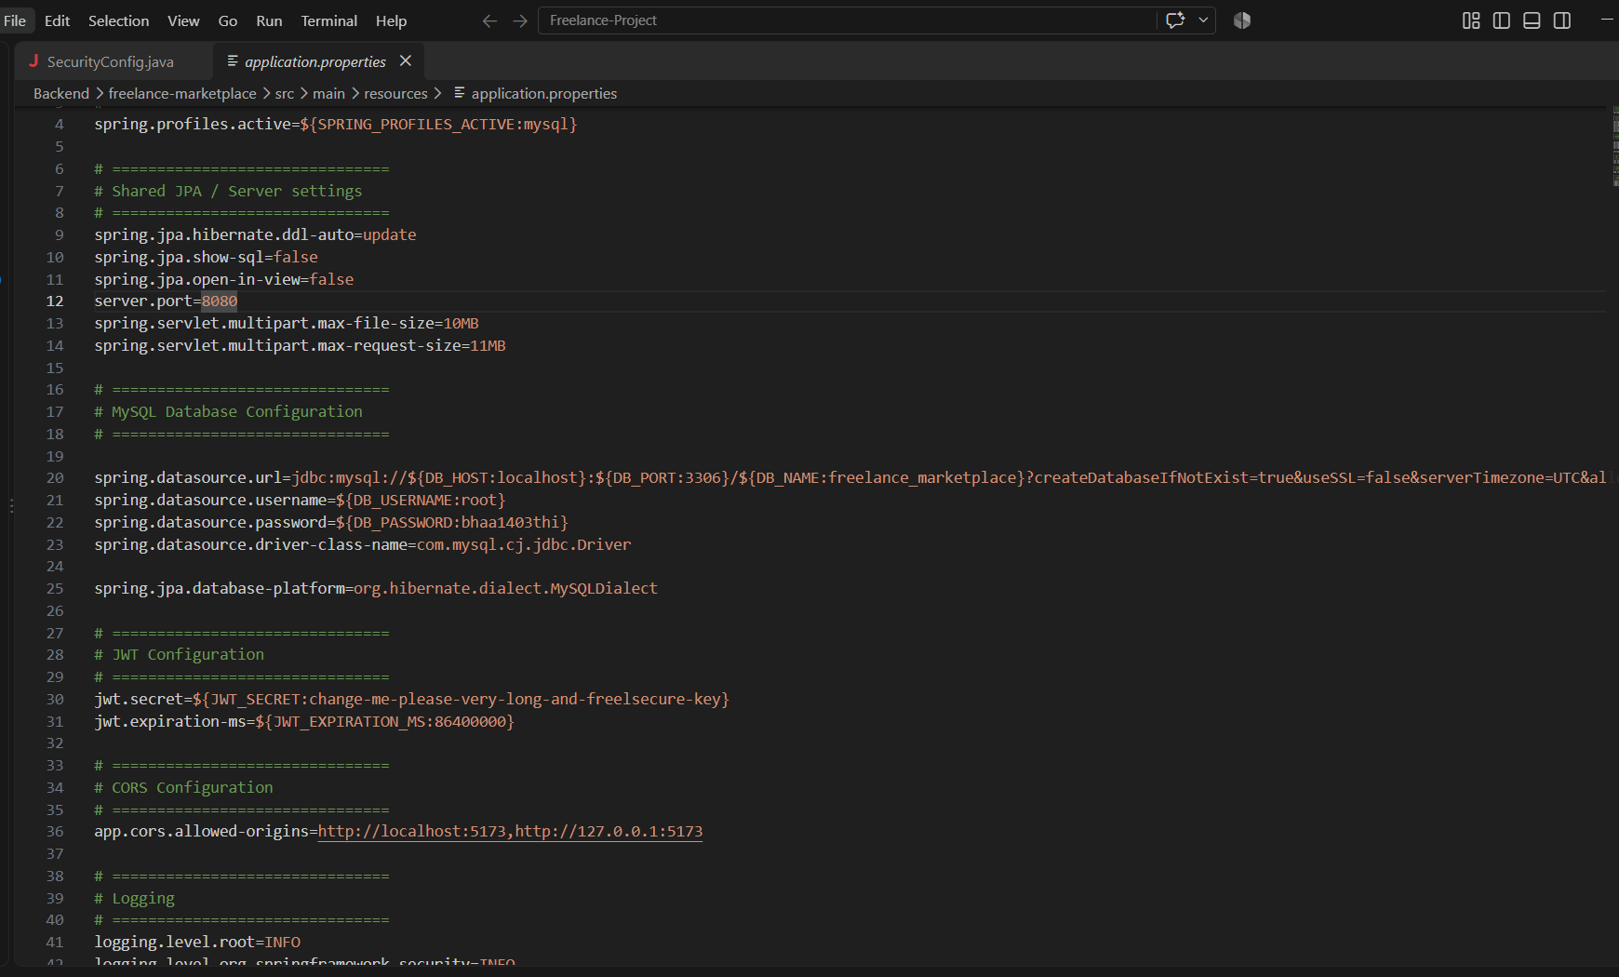

INSTALLATION AND SETUP INSTRUCTIONS
C.1 Project Location
The backend project is located at:
C:\Users\bhaar\OneDrive\Documents\KLH\Project KL\Java PROJECT 4\SQL\Freelance-Project\Backend\freelance-marketplace
Open the project using Visual Studio Code, IntelliJ IDEA, or another Java-supported IDE.

C.2 Software Requirements
The following software is required to run the project:
- Java JDK 21 or later
- Maven
- Node.js and npm
- MySQL Server
- MySQL Workbench
- Git
- Visual Studio Code or IntelliJ IDEA
- Google Chrome, Microsoft Edge, or another modern web browser

C.3 Backend Setup
Open Command Prompt or PowerShell and navigate to the actual backend project directory:
cd "C:\Users\bhaar\OneDrive\Documents\KLH\Project KL\Java PROJECT 4\SQL\Freelance-Project\Backend\freelance-marketplace"
Verify that the project files are present:
dir
The Spring Boot project should contain files such as pom.xml and the src directory.
Install Maven Dependencies
Run:
mvn clean install
This command cleans previous build files, downloads the required dependencies, compiles the project, and creates the application build.
Start the Spring Boot Backend
Run:
mvn spring-boot:run
After successful startup, the backend will normally be available at:
http://localhost:8080
Keep this terminal running while using the application.

C.4 Database Setup
Start MySQL Server and open MySQL Workbench.
Create the project database according to the database configuration used by the backend.
Example:
CREATE DATABASE freelance_marketplace;
The database connection details should be configured in the Spring Boot application's configuration file.
Example format:
spring.datasource.url=jdbc:mysql://localhost:3306/freelance_marketplace
spring.datasource.username=root
spring.datasource.password=YOUR_PASSWORD
The username, password, database name, and port must match the local MySQL installation.
After changing the database configuration, restart the backend:
mvn spring-boot:run

C.5 Frontend Setup
The React frontend should be opened from its project directory.
Navigate to the frontend project folder and install the required dependencies:
npm install
Start the React development server using the command defined by the frontend project. For a Vite-based React project, the command is:
npm run dev
The terminal will display the local frontend URL, normally:
http://localhost:5173
Open the displayed address in a web browser.
Note: The exact frontend folder path is not included here because the project information currently available confirms the backend path but does not confirm the frontend directory location.

C.6 Running the Complete Project
The complete application requires three components to be available:
React Frontend
↓
Spring Boot Backend
↓
MySQL Database
Terminal 1 – Backend
cd "C:\Users\bhaar\OneDrive\Documents\KLH\Project KL\Java PROJECT 4\SQL\Freelance-Project\Backend\freelance-marketplace"
mvn spring-boot:run
Terminal 2 – Frontend
From the actual frontend project directory:
npm install
npm run dev
MySQL
Make sure the MySQL service is running before testing database-dependent functionality.

C.7 Application Access
Once the backend and frontend are running, open the frontend URL displayed by the React development server.
The backend normally runs at:
http://localhost:8080
The frontend normally runs at:
http://localhost:5173
The React application sends requests to the Spring Boot REST APIs, while the Spring Boot application handles business logic and communicates with MySQL.

C.8 Basic Project Workflow
After starting the application:
- Register a user account.
- Log in to the application.
- Select or use the appropriate client/freelancer role.
- Clients can create projects.
- Freelancers can browse available projects.
- Freelancers can submit proposals.
- Clients can review and approve proposals.
- A contract can be created for the selected freelancer.
- Project work can be divided into milestones.
- Escrow-oriented payment records can be managed through the application workflow.
- Clients and freelancers can communicate through messaging.
- Notifications can be viewed by users.
- Disputes can be raised when required.
- Completed projects can be reviewed and rated.

C.9 Common Commands
Backend
cd "C:\Users\bhaar\OneDrive\Documents\KLH\Project KL\Java PROJECT 4\SQL\Freelance-Project\Backend\freelance-marketplace"
Clean the project:
mvn clean
Build the project:
mvn clean install
Run the application:
mvn spring-boot:run
Frontend
Install dependencies:
npm install
Start development server:
npm run dev
Build frontend:
npm run build

C.10 Stopping the Application
To stop the Spring Boot backend, select the backend terminal and press:
Ctrl + C
To stop the React development server, select the frontend terminal and press:
Ctrl + C
MySQL can be stopped separately through the Windows Services application or MySQL management tools when it is no longer required.

Geo Tag Photos with Guide
