# How user can log into American First Finance’s SonarCloud:

1. If they have never logged in before, they should go to <https://sonarcloud.io/>
2. Click Login, select With Bitbucket

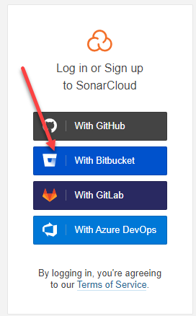

1. Click Browse your Organizations (which should show AmericanFirstFinance)

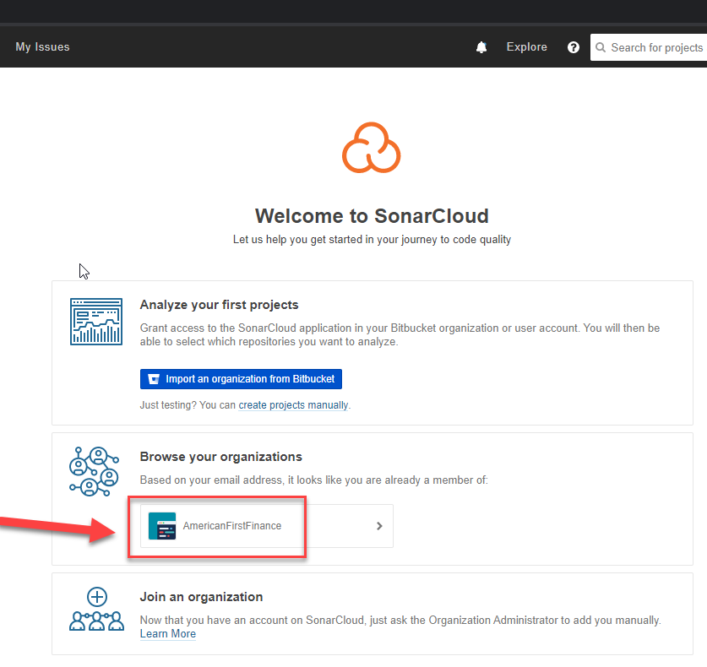

1. Then you will be logged in. At that point the Administrators can add you under Members tab or add additional permissions as needed.

