DESIGN AND VERIFICATION PARAMETERISED SPI MASTER CORE
A project report submitted in partial fulfilment
of the requirements for the degree of

Bachelor of Technology
in
Electronics and Computer Engineering
by
KAVIYA DIAS ARO S
22BLC1126


School of Electronics Engineering
Vellore Institute of Technology, Chennai
Vandalur - Kelambakkam Road
Chennai – 600127, India

April 2026


School of Electronics Engineering
Declaration
We/I hereby declare that the report titled DESIGN AND VERIFICATION PARAMETERISED SPI MASTER CORE submitted by us/me to the School of Electronics Engineering, Vellore Institute of Technology, Chennai, in partial fulfilment of the requirements for the award of Bachelor of Technology in Electronics and Computer Engineering, is a bonafide record of the work carried out by us/me under the supervision of Dr. Rahul Narasimhan A.
We/I further declare that the work reported in this report has not been submitted and will not be submitted, either in part or in full, for the award of any other degree or diploma of this institute or of any other institute or University.
Signature of the Student:_․․․․․․․․․․․․․․․․․․․․․․
Name and Reg. No.:_․․․․․․․․․․․․․․․․․․․․․․………………………….
Date: ․․․․․․․․․․․․․․․․․․․․․․


School of Electronics Engineering
Certificate
This is to certify that the project report titled DESIGN AND VERIFICATION PARAMETERISED SPI MASTER CORE submitted by KAVIYA DIAS ARO S (22BLC1126) to Vellore Institute of Technology, Chennai, in partial fulfilment of the requirement for the award of the degree of Bachelor of Technology in Electronics and Computer Engineering is a bonafide work carried out under my supervision. The project report fulfils the requirements as per the regulations of this University and, in my opinion, meets the necessary standards for submission. The contents of this report have not been submitted and will not be submitted either in part or in full, for the award of any other degree or diploma and the same is certified.
Supervisor | Head of the Department
Signature: ․․․․․․․․․․․․․․․․․․․․․․ | Signature: ․․․․․․․․․․․․․․․․․․․․․․
Name: ․․․․․․․․․․․․․․․․․․․․․․ | Name: ․․․․․․․․․․․․․․․․․․․․․․
Date: ․․․․․․․․․․․․․․․․․․․․․․ | Date: ․․․․․․․․․․․․․․․․․․․․․․
Examiner 1 | Examiner 2
Signature: ․․․․․․․․․․․․․․․․․․․․․․ | Signature: ․․․․․․․․․․․․․․․․․․․․․․
Name: ․․․․․․․․․․․․․․․․․․․․․․ | Name: ․․․․․․․․․․․․․․․․․․․․․․
Date: ․․․․․․․․․․․․․․․․․․․․․․ | Date: ․․․․․․․․․․․․․․․․․․․․․․

(Seal of the School)

Abstract
This project focuses on the design and verification of a parameterized multi-mode Serial Peripheral Interface (SPI) master core using Verilog Hardware Description Language. SPI is a widely used synchronous communication protocol in embedded systems due to its simplicity, high-speed operation, and full-duplex capability. The objective of this work is to develop a scalable and configurable SPI master architecture that supports all four SPI modes defined by clock polarity (CPOL) and clock phase (CPHA), along with parameterized data width.

The proposed design follows a modular approach consisting of a clock divider, finite state machine (FSM)-based controller, shift register, and bit counter. The clock divider generates the SPI clock, while the controller manages the communication process. The shift register enables serial data transmission through MOSI and reception through MISO, and the bit counter ensures accurate data transfer.

The design is functionally verified using simulation in Xilinx Vivado. Performance analysis shows a clock frequency of 100 MHz, throughput of 100 Mbps, and latency of approximately 90 ns for an 8-bit transfer. The work also discusses extension towards ASIC design flow and GDSII generation.

Acknowledgements

We wish to express our sincere thanks and deep sense of gratitude to our project guide, Dr. Rahul Narasimhan A, Assistant Professor, School of Electronics Engineering (SENSE), for his consistent encouragement and valuable guidance offered to us in a pleasant manner throughout the course of the project work.

We sincerely express our gratitude to Dr. Ravi Sankar A, Dean, SENSE; Dr. Mohanaprasad K, Associate Dean (Academics), SENSE; and Dr. Chitra K, Associate Dean (Research), SENSE, for providing the necessary facilities and for their constant encouragement and support throughout our project.

We also extend our heartfelt thanks to Dr. Vijayakumar P, Head of the Department, for his continuous guidance and support during the course of this project.

We also take this opportunity to thank all the faculty of the School for their support and their wisdom imparted to us throughout the course.

We thank our parents, family, and friends for bearing with us throughout the course of our project and for the opportunity they provided us in undergoing this course in such a prestigious institution.

Mapping of Sustainable Development Goals (SDGs)

Project Title | Mapped SDGs | Justification | Example Impact
Design and Verification of Parameterized SPI Master Core | SDG 9 – Industry, Innovation and Infrastructure | The project focuses on designing a scalable and efficient SPI communication core, which is a fundamental building block in modern SoCs and embedded systems. It promotes innovation through parameterization and modular VLSI architecture. | Contributes to development of advanced semiconductor systems and strengthens digital infrastructure in industries such as IoT, automotive, and consumer electronics.
 | SDG 4 – Quality Education | The project involves complete ASIC design flow including RTL design, simulation, synthesis, physical design, and GDSII generation, providing strong practical learning aligned with industry standards. | Enhances hands-on learning in VLSI design and prepares students for real-world semiconductor and chip design careers.
 | SDG 12 – Responsible Consumption and Production | The design emphasizes efficient utilization of hardware resources such as area, power, and timing, ensuring optimized and sustainable chip design practices. | Leads to energy-efficient electronic systems, reducing unnecessary power consumption in digital devices.

Contents
Declaration 2
Certificate 3
Abstract 4
Acknowledgements 5
Mapping of Sustainable Development Goals (SDGs) 6

1 Introduction 8

2 Literature Survey 2
2.1 Review of Prior Work 2
2.2 Gaps Identified 4

3 Methodology 5
3.1 System Architecture 5
3.1.1 Architecture Overview 5
3.1.2 Scalable Architecture 6
3.2 Process Work Flow 6
3.2.1 Data Aggregator Architecture 7
3.2.2 Proposed Integration Architecture 7
3.2.3 Database Web Services 8
3.3 ELT (Extraction, Loading and Transformation) 8
3.3.1 ELT Concept 8
3.4 Data Connectors 9

4 Results and Discussion 16
4.1 Results and Comparison 16

Appendix 20

Bibliography 22

Biodata 24

CHAPTER 1
Introduction

Serial Peripheral Interface (SPI) is one of the most widely used synchronous communication protocols in modern digital and embedded systems. With the increasing complexity of electronic systems and the need for efficient communication between different hardware components, protocols like SPI play a crucial role in enabling reliable and high-speed data exchange. SPI operates based on a master-slave architecture, where a master device initiates communication and controls one or more slave devices through dedicated communication lines. The primary signals involved in SPI communication include MOSI (Master Out Slave In), MISO (Master In Slave Out), SCLK (Serial Clock), and SS (Slave Select). The master generates the clock signal and ensures synchronized data transfer between devices.
SPI is preferred over other communication protocols due to its simplicity, flexibility, and high data transfer speed. Unlike protocols such as I2C, SPI supports full-duplex communication, allowing simultaneous transmission and reception of data. This makes it highly suitable for applications requiring fast and efficient data exchange, such as sensor interfacing, memory access, and display communication. SPI is commonly used in embedded systems to interface with peripherals like EEPROM, ADCs, DACs, and OLED/LCD displays.
With the rapid advancement in VLSI and embedded system design, there is an increasing need for scalable and configurable communication modules. Traditional SPI master designs are often limited to fixed data widths and specific operating modes, which restrict their applicability in diverse systems. Additionally, many conventional designs lack modular architecture, making them difficult to extend or reuse. Another major challenge in SPI communication is ensuring proper synchronization between the clock signal and data signals. Improper synchronization can lead to incorrect data transfer, affecting the reliability of the system.
This project addresses these challenges by proposing a parameterized and multi-mode SPI master core. The design is developed using Verilog Hardware Description Language and follows a modular architecture consisting of a clock divider, finite state machine (FSM)-based controller, shift register, and bit counter. The clock divider generates the SPI clock from the system clock, while the controller manages the communication process through defined states. The shift register handles serial data transmission and reception, and the bit counter ensures that the correct number of bits is transferred.
The primary objective of this work is to design a scalable SPI master architecture that supports all four SPI modes defined by clock polarity (CPOL) and clock phase (CPHA), along with parameterized data width. This enables the design to be adaptable for different applications without requiring significant modifications. The design is functionally verified using simulation in Xilinx Vivado, where the correctness of data transmission, synchronization, and control logic is analysed.
Furthermore, this project also explores the extension of the design towards ASIC implementation flow. Although the physical design is not fully implemented, the report discusses the stages involved in synthesis, placement, routing, and GDSII file generation. This highlights the potential of the proposed design for real-world semiconductor applications.
In summary, this project focuses on developing an efficient, flexible, and scalable SPI master core that can be used in embedded systems, FPGA implementations, and VLSI-based designs. The modular architecture and parameterization make the design reusable and suitable for integration into larger digital systems.

CHAPTER 2
Literature Survey

2.1 Design and Implementation of SPI Master Core using Verilog
A. Sharma and P. Singh (2019) presented a basic SPI master core implemented using Verilog HDL, focusing on reliable data communication between master and slave devices. The design utilized a shift register for serial data transfer, along with a clock generator and simple control logic. The implementation successfully demonstrated SPI communication for fixed data width and single mode operation. However, the design lacked flexibility as it did not support multiple SPI modes defined by CPOL and CPHA. Additionally, the absence of parameterization limited its applicability in systems requiring variable data widths.

2.2 FSM-Based SPI Master Controller Design (R. Mehta & S. Iyer, 2020)
R. Mehta and S. Iyer (2020) proposed a finite state machine (FSM)-based SPI master controller to improve control over the communication process. The design introduced distinct states such as idle, load, and transfer, enabling structured data transmission. The modular approach improved readability and timing control. Despite these advantages, the design did not incorporate parameterization and supported only limited SPI configurations. Furthermore, performance metrics such as latency and throughput were not analyzed in detail.

2.3 High-Speed SPI Interface for Embedded Systems (K. Verma et al., 2021)
K. Verma et al. (2021) focused on designing a high-speed SPI interface for embedded systems. The work emphasized optimizing clock generation and data shifting mechanisms to achieve higher throughput and reduced latency. While the design improved performance, it increased system complexity and lacked flexibility. The architecture was not scalable, and it did not support configurable data width or full SPI mode compatibility, limiting its practical usability.

2.4 Configurable SPI Core for FPGA Applications (S. Rao & M. Kulkarni, 2021)
S. Rao and M. Kulkarni (2021) introduced a configurable SPI core designed for FPGA-based applications. The design demonstrated partial flexibility by allowing certain clock configurations and was validated using FPGA implementation. However, the system did not fully support all SPI modes and lacked complete parameterization. Additionally, synchronization between clock and data signals was not thoroughly analyzed, which could lead to potential timing issues in high-speed applications.

2.5 FPGA-Based SPI Communication System (J. Lee & H. Kim, 2018)
J. Lee and H. Kim (2018) presented an FPGA-based SPI communication system that demonstrated real-time data transfer between master and slave devices. The work focused on hardware validation and practical implementation, showing the feasibility of SPI in embedded systems. Although the design proved functional, it primarily emphasized hardware demonstration rather than architectural improvements. It lacked scalability, parameterization, and advanced features such as multi-mode support.

2.6 Low-Power SPI Master Design for Embedded Systems (M. Patel & D. Shah, 2022)
M. Patel and D. Shah (2022) proposed a low-power SPI master design aimed at reducing energy consumption in embedded systems. The design utilized clock gating techniques to minimize switching activity and improve power efficiency. While the approach successfully reduced power consumption, it did not address other important aspects such as scalability, parameterization, and multi-mode support. The design remained limited in terms of flexibility and broader applicability.

2.7 Multi-Slave SPI Communication Architecture (Y. Chen et al., 2020)
Y. Chen et al. (2020) developed a multi-slave SPI communication architecture that enabled communication with multiple peripheral devices using multiple chip select lines. This design improved system flexibility and allowed the master to interact with multiple slaves efficiently. However, the implementation did not support parameterized data width and lacked detailed timing and synchronization analysis. Additionally, full SPI mode compatibility was not considered.

2.8 Parameterized SPI Master Core Design (T. Nguyen & L. Tran, 2022)
T. Nguyen and L. Tran (2022) proposed a parameterized SPI master core that allowed configurable data width, improving the adaptability of the design for different applications. The use of parameterization enhanced reusability and scalability. However, the design did not support all SPI modes and did not sufficiently address synchronization challenges between clock and data signals. This limited its effectiveness in complex communication scenarios.

2.9 SPI Controller with Improved Timing Synchronization (P. Gupta & R. Jain, 2021)
P. Gupta and R. Jain (2021) focused on improving timing synchronization in SPI communication. The design ensured proper alignment between clock and data signals, reducing the possibility of data corruption. While the approach improved reliability, the design lacked modular architecture and did not include parameterization. It was also limited in scalability and did not support multiple SPI configurations.

2.10 ASIC Implementation of SPI Communication Interface (L. Wang & X. Zhao, 2019)
L. Wang and X. Zhao (2019) explored the ASIC implementation of an SPI communication interface, focusing on synthesis, placement, and routing aspects. The study highlighted the importance of timing closure and physical design considerations in achieving efficient hardware implementation. However, the design was not flexible and lacked parameterization and modular architecture. The work primarily focused on backend implementation without addressing frontend design improvements.
From the literature review, it is observed that various SPI master designs have been proposed, focusing on aspects such as basic functionality, FSM-based control, high-speed operation, FPGA implementation, and low-power optimization. Many of these designs successfully demonstrate reliable SPI communication using shift registers, clock generation, and control logic, while some improve performance through optimized clocking or support limited configurability.
However, several limitations are identified across these works. Most designs use fixed data widths, limiting scalability for different applications. Additionally, many implementations support only a subset of SPI modes and do not fully utilize CPOL and CPHA configurations, reducing compatibility with diverse devices. Synchronization between clock and data signals is often not handled effectively, leading to potential timing issues. Furthermore, a lack of modular architecture makes these designs less reusable and harder to extend. Even in ASIC-focused studies, frontend improvements such as flexibility and configurability are often overlooked.
To address these gaps, the proposed project presents a parameterized, multi-mode SPI master core with a modular architecture. The design supports all four SPI modes using CPOL and CPHA, ensuring broad compatibility. Parameterization enables configurable data widths, improving scalability and reusability. A clear separation of control and data paths enhances design clarity, while proper synchronization between MOSI and SCLK ensures reliable communication. The design is verified through simulation and extended to ASIC flow, including synthesis and GDSII generation, making it a flexible and practically applicable solution.

CHAPTER 3
Methodology

3.1 Overview of Design Methodology
The methodology adopted in this project follows a complete VLSI design flow, starting from Register Transfer Level (RTL) design and extending up to physical layout generation (GDSII). The objective is to design and verify a parameterized SPI master core that is functionally correct, scalable, and physically realizable.
The design is implemented using Verilog HDL and verified through simulation using Xilinx Vivado. The verified RTL is synthesized into a gate-level netlist using Cadence Genus, followed by physical design implementation using Cadence Innovus, which includes floor planning, placement, routing, and layout generation. The final output of this process is a GDSII file, which represents the physical layout of the design and is ready for fabrication. This methodology ensures a systematic transformation from a high-level hardware description to a manufacturable integrated circuit.

3.2 System Architecture
The SPI master core is designed using a modular architecture consisting of four main components: Clock Divider, SPI Controller (FSM), Shift Register, and Bit Counter. Each module performs a specific function, and together they enable efficient serial communication between master and slave devices.
The architecture is divided into two major paths: control path and data path. The control path is managed by the SPI controller, which generates control signals such as load, shift enable, count enable, and slave select (SS). The data path is handled by the shift register, which manages the transmission and reception of data.
The clock divider generates the SPI clock (SCLK) from the system clock, ensuring proper timing for communication. The data flow begins with the input data being loaded into the shift register. The controller then enables shifting, and the data is transmitted bit by bit through the MOSI line. Simultaneously, data is received through the MISO line. The bit counter tracks the number of bits transmitted and signals completion of the transfer. This modular and structured architecture improves scalability, simplifies debugging, and enhances reusability.

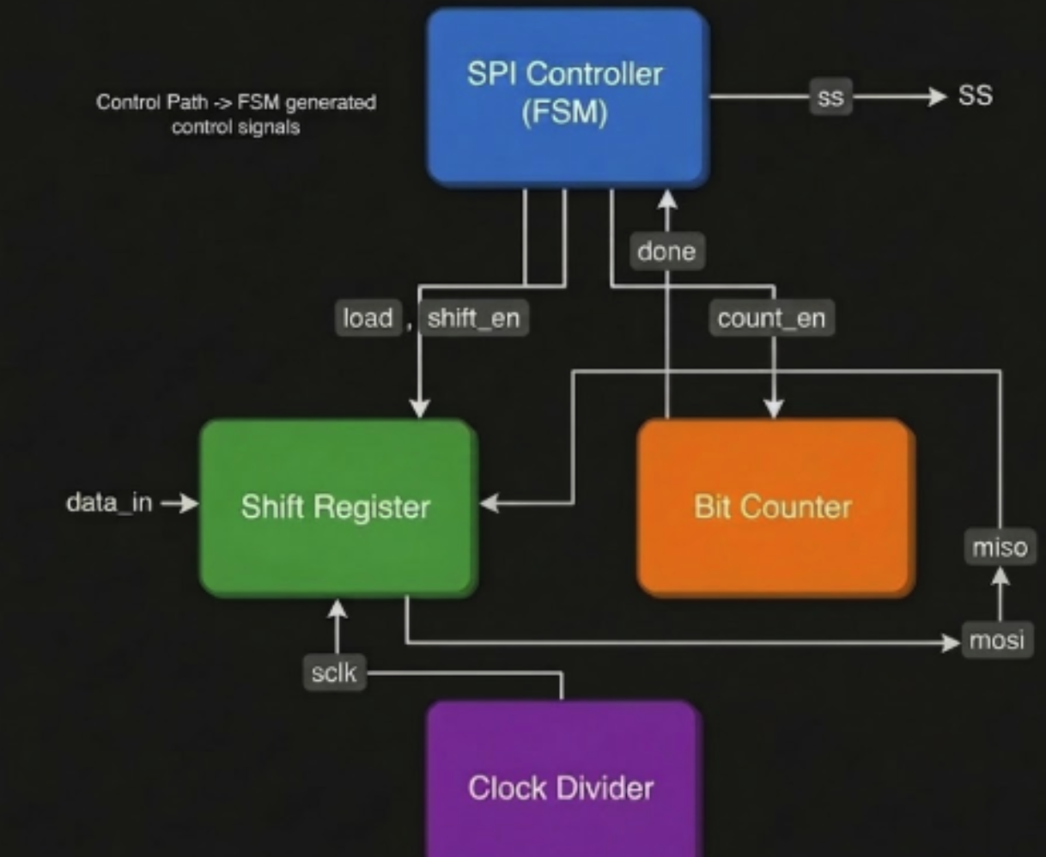

3.3 Detailed Module Description

3.3.1 Clock Divider
The clock divider module is responsible for generating the SPI clock (SCLK) from the system clock. Since SPI communication typically operates at a lower frequency than the system clock, the divider reduces the frequency to an appropriate level.
The clock divider toggles the SCLK signal at a predefined rate based on a divider value. It also generates a clock enable signal, which ensures that data shifting occurs only at specific clock edges. This helps maintain proper synchronization between data and clock signals.

3.3.2 SPI Controller (Finite State Machine)
The SPI controller is implemented as a finite state machine (FSM) that controls the entire communication process. It consists of three primary states: IDLE, LOAD, and TRANSFER. In the IDLE state, the system waits for the start signal. Upon receiving the start signal, the controller transitions to the LOAD state, where input data is loaded into the shift register. The controller then moves to the TRANSFER state, where data is transmitted serially.
During the TRANSFER state, the controller generates control signals such as shift enable and count enable to coordinate the operation of the shift register and bit counter. The slave select (SS) signal is activated to initiate communication with the slave device. Once all bits are transmitted, the controller receives a done signal from the bit counter and returns to the IDLE state.

3.3.3 Shift Register
The shift register is responsible for serial data transmission and reception. It performs parallel-to-serial conversion by loading input data and shifting it out through the MOSI line.
The shifting operation is controlled by the shift enable signal and synchronized with the SPI clock. On each clock cycle, the register shifts by one bit, allowing sequential transmission. At the same time, incoming data from the MISO line is captured, enabling full-duplex communication. The shift register ensures proper alignment between data and clock signals, which is critical for reliable SPI communication.

3.3.4 Bit Counter
The bit counter tracks the number of bits transmitted during the communication process. It increments with each clock cycle when shifting is enabled.
Once the predefined number of bits (based on data width) is transmitted, the bit counter generates a done signal. This signal is used by the SPI controller to terminate the transfer and return to the IDLE state. The bit counter ensures accurate and complete data transmission.

3.4 SPI Modes and Parameterization
The SPI master core supports all four SPI modes using clock polarity (CPOL) and clock phase (CPHA). These parameters define the behavior of the SPI clock and the timing of data sampling.
CPOL determines the idle state of the clock, while CPHA determines whether data is sampled on the rising or falling edge. By configuring these parameters, the design can operate in different modes, ensuring compatibility with a wide range of SPI devices.
Additionally, the design is parameterized to support different data widths. This allows the same design to be used for various applications by simply modifying parameter values without changing the core logic.

3.5 RTL Design and Functional Simulation
The SPI master core is implemented using Verilog HDL. Individual modules are developed and integrated at the top level. A testbench is created to verify the functionality of the design.
Simulation is performed using Xilinx Vivado, where input stimuli such as clock, reset, start signal, and data inputs are applied. Waveform analysis is used to verify the behaviour of key signals such as MOSI, MISO, SCLK, SS, and busy signals. The simulation results confirm correct data transmission, proper synchronization between signals, and accurate FSM operation.

3.6 Synthesis using Cadence Genus
The verified RTL design is synthesized into a gate-level netlist using Cadence Genus. The synthesis process includes reading HDL files, linking with standard cell libraries, applying constraints, and performing optimization.
A TCL script is used to automate the synthesis process, which includes steps such as generic synthesis, technology mapping, and optimization. The output includes a synthesized netlist along with timing, area, and power reports.
The synthesis results indicate that the design meets timing requirements and utilizes minimal hardware resources.

3.7 Physical Design using Cadence Innovus
The synthesized netlist is imported into Cadence Innovus for physical implementation. The physical design flow includes floor planning, placement, and routing.
During floor planning, the core area is defined, and placement regions are established. Standard cells are then placed within the core area. Placement optimization is performed to reduce congestion and improve timing.
Routing is performed to connect all components using metal layers. Both global and detailed routing ensure that all signal and power connections are established.

3.8 Power Planning and Routing
Power planning is an essential step in the physical design process to ensure proper distribution of power and ground across the entire layout. In this design, the power (VDD) and ground (VSS) networks are established during the floor planning and routing stages to provide a stable supply to all standard cells.
The power network is implemented using dedicated routing structures that distribute VDD and VSS uniformly across the core area. Care is taken to ensure that all standard cells are properly connected to the power and ground rails, avoiding any floating connections that could lead to functional or reliability issues.
During routing, both signal and power connections are completed while adhering to design rules and ensuring minimal congestion. Proper power distribution helps maintain signal integrity and ensures reliable operation of the circuit under different conditions.

3.9 GDSII Generation
The final layout is converted into a GDSII file using the stream-out process in Cadence Innovus. The GDSII file contains all geometric information required for chip fabrication, including metal layers, vias, and interconnections. The successful generation of the GDSII file confirms that the design is physically complete and ready for fabrication.

3.11 Complete Design Flow Summary
The overall design flow followed in this project can be summarized as:
RTL Design → Functional Simulation → Synthesis (Cadence Genus) → Floorplanning → Placement → Routing → Power Planning → DRC Verification → GDSII Generation
This end-to-end methodology demonstrates the transformation of a high-level design into a physically realizable integrated circuit.

CHAPTER 4
Results and Discussion

4.1 Introduction
This chapter presents the results obtained from the design and implementation of the parameterized SPI master core across different stages of the VLSI design flow. The results include functional simulation using Xilinx Vivado, synthesis using Cadence Genus, and physical design including placement, routing, timing analysis, and GDSII generation using Cadence Innovus. The objective is to validate the correctness, performance, and physical realizability of the design.

4.2 Functional Simulation Results (Xilinx Vivado)
The SPI master core is functionally verified using Xilinx Vivado. A comprehensive testbench is developed to stimulate the design with input signals such as clock, reset, start signal, and input data. The simulation waveform includes key SPI signals such as MOSI, MISO, SCLK, SS, busy, and done.
The waveform analysis confirms correct operation of the SPI master. Upon assertion of the start signal, the FSM transitions from the IDLE state to LOAD and subsequently to the TRANSFER state. The input data is successfully loaded into the shift register and transmitted serially through the MOSI line in synchronization with the SPI clock (SCLK).
The SS signal is observed to be active low during communication, indicating proper slave selection. The busy signal remains high during the data transfer phase and returns low after completion. The done signal is asserted once the full data word is transmitted. The number of clock cycles observed corresponds exactly to the configured data width, confirming correct bit counter operation.
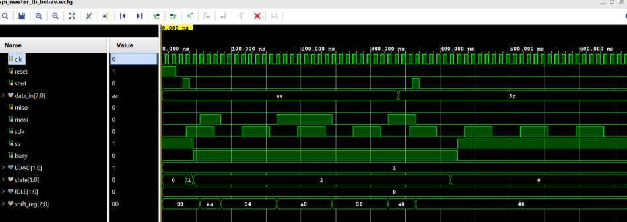
Fig: Waveform in Xilinx Vivado during Simualtion

4.3 Performance Metrics from Simulation
The performance metrics are derived based on the simulation results.

Table 4.1 Simulation Performance Metrics
Parameter | Value
Clock Period | 10 ns
Clock Frequency | 100 MHz
Data Width | 8 bits
Clock Cycles per Transfer | 9 cycles
Latency | 90 ns
Throughput | 100 Mbps
The results indicate efficient data transmission with low latency. Since one bit is transmitted per clock cycle, the throughput equals the clock frequency.

4.4 Synthesis Results (Cadence Genus)
The RTL design is synthesized using Cadence Genus targeting the TSMC 18 nm technology library. The synthesis results provide detailed information about area, power, and timing.

Table 4.2 Area Analysis
Parameter | Value
Total Cell Area | 2750.933 µm²
Total Instances | 93
Sequential Cells | 23
Combinational Cells | 70
The results show that the design is compact and efficiently utilizes hardware resources due to its modular architecture.
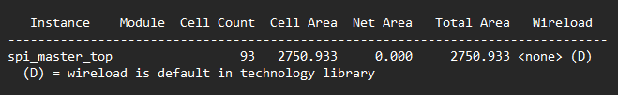

Table 4.3 Power Analysis
Component | Power (W) | Percentage
Internal Power | 1.93438 × 10⁻⁴ | 84.30%
Switching Power | 3.59380 × 10⁻⁵ | 15.66%
Leakage Power | 8.00641 × 10⁻⁸ | 0.03%
Total Power | 2.29456 × 10⁻⁴ W | 100%
The power analysis indicates that the design consumes very low power (~0.229 mW), making it suitable for low-power embedded applications. Internal power dominates due to sequential logic activity.
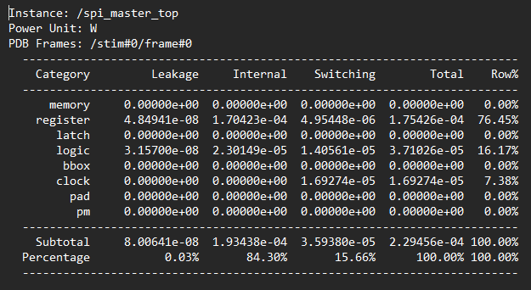

Table 4.4 Timing Analysis (Synthesis)
Parameter | Value
Clock Period | 10 ns
Worst Negative Slack (WNS) | +7.445 ns
Total Negative Slack (TNS) | 0 ns
Violating Paths | 0
The positive slack indicates that the design comfortably meets timing constraints with significant margin.
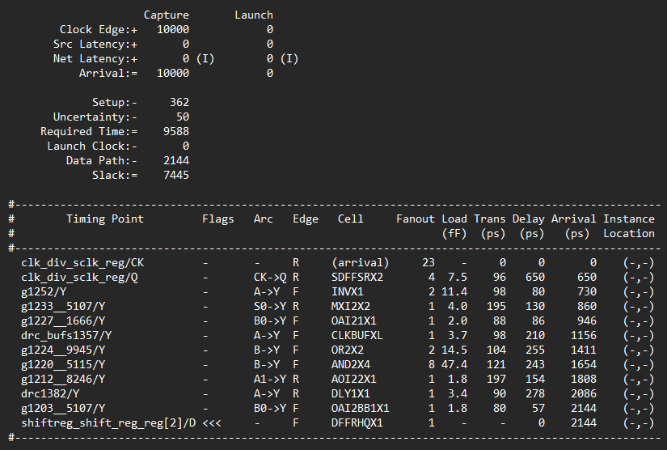

4.5 Physical Design Results (Cadence Innovus)
The synthesized netlist is imported into Cadence Innovus for physical implementation. The design successfully completes floorplanning, placement, clock tree synthesis, and routing.
The final layout shows proper placement of standard cells and efficient routing across multiple metal layers. No routing congestion is observed.
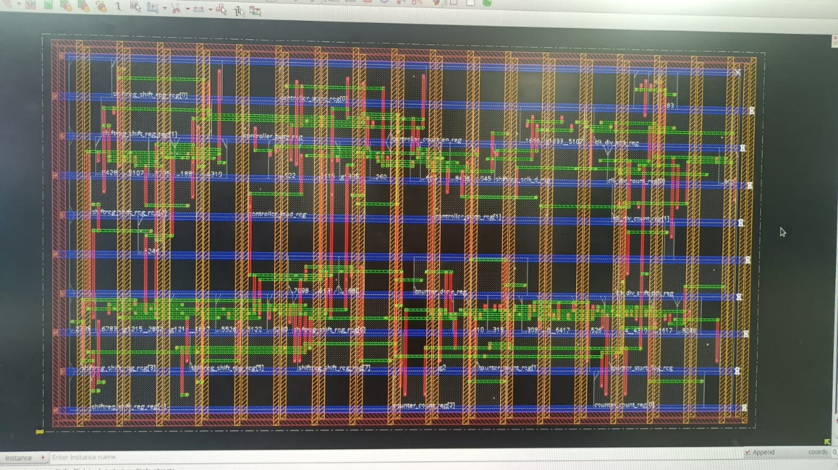
Fig: Layout before optimisation
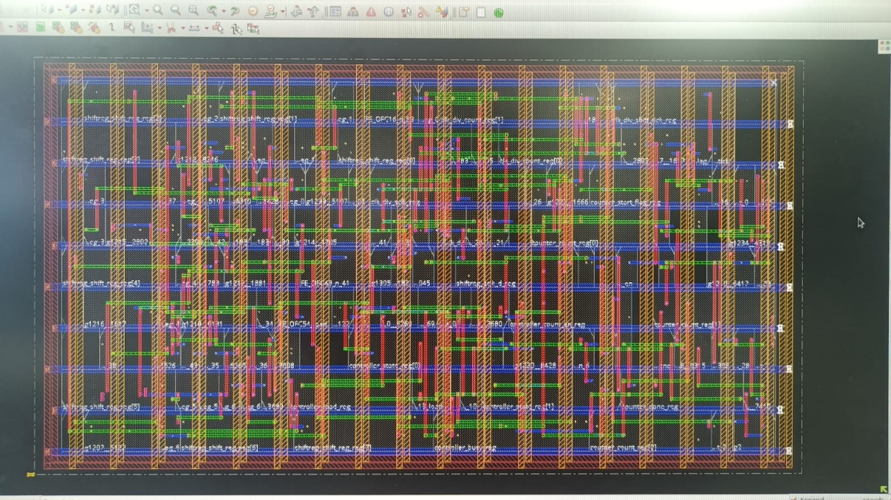
Fig: Layout after optimisation

4.6 Timing Analysis – Pre and Post Optimization
Timing analysis is performed before and after layout optimization to evaluate design performance.

Table 4.5 Setup Timing Comparison
Parameter | Pre-Optimization | Post-Optimization
WNS (ns) | 7.790 ns | 6.894 ns
TNS (ns) | 0 | 0
Violations | 0 | 0

Table 4.6 Hold Timing Comparison
Parameter | Pre-Optimization | Post-Optimization
WNS (ns) | -0.053 ns | -0.084 ns
TNS (ns) | -0.053 ns | -0.084 ns
Violations | 1 | 1

Analysis:
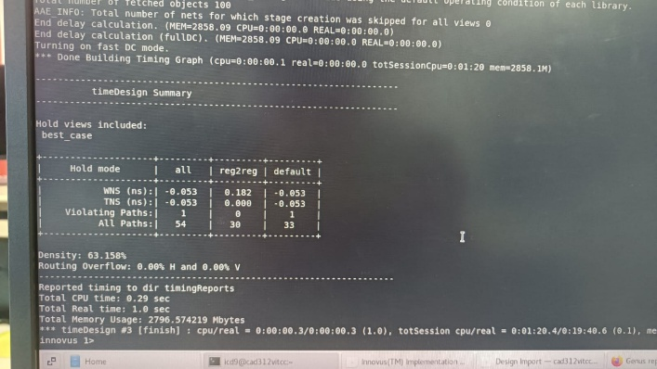
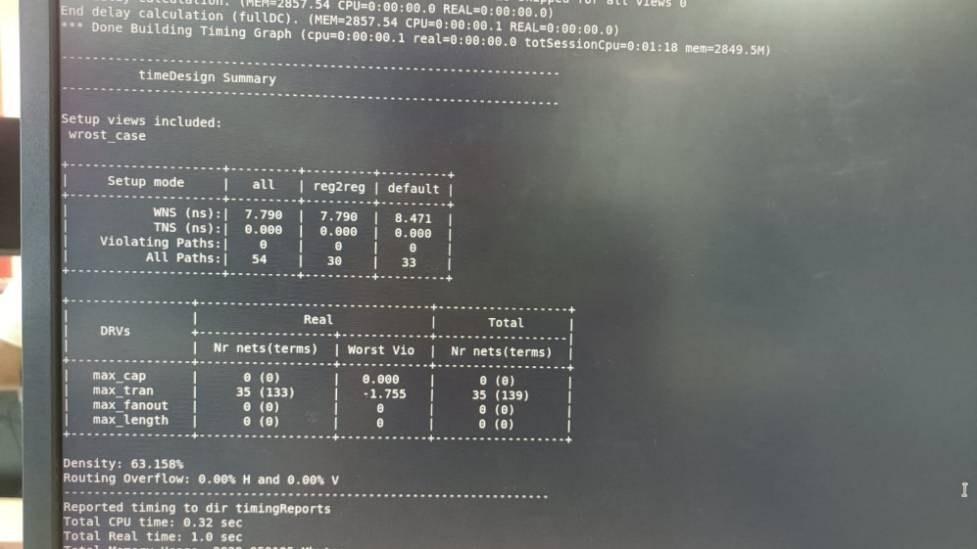
The setup timing meets all constraints in both pre- and post-optimization stages with positive slack. The slight reduction in WNS after optimization is expected due to added routing delays. A minor hold violation is observed both before and after optimization. This is a very small violation and is typically resolved through additional buffering or hold fixing techniques in advanced optimization stages.

Fig: Timing report before optimization in Cadence Innovus

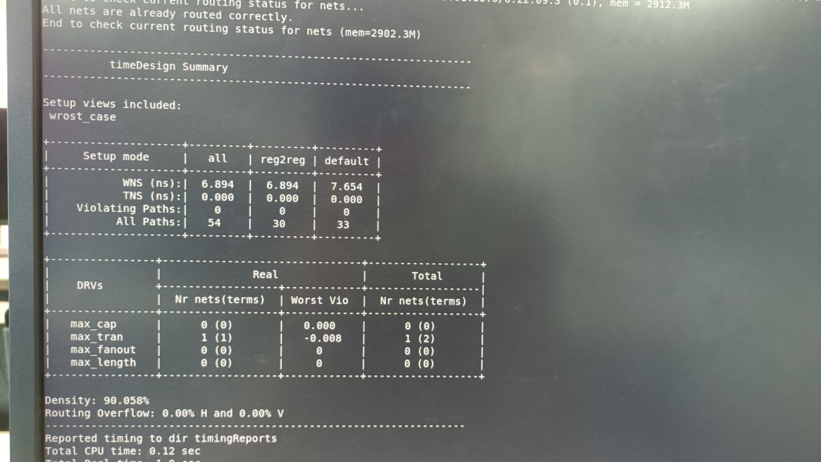
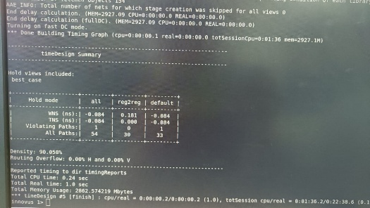

Fig: Timing report after optimization in Cadence Innovus

4.7 Routing and Layout Analysis
The routing results confirm successful connectivity of all nets. The following observations are made:

Table 4.7 Routing Summary
Parameter | Value
Routing Overflow | 0%
Cell Density | 63.15% (pre), 90.05% (post)
Congestion | None
The increase in density after optimization indicates better utilization of the layout area. The absence of routing overflow confirms efficient routing. The layout shows multiple metal layers used for interconnections, with proper via placement and signal routing. The design follows standard physical design rules and maintains signal integrity.
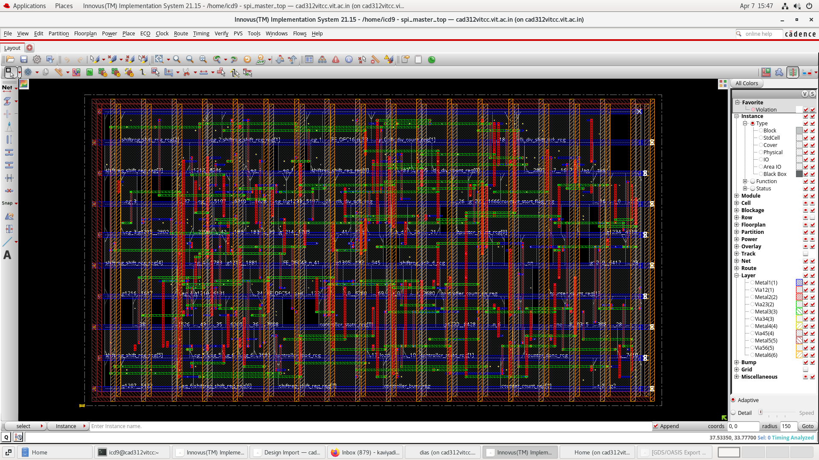
Fig: Final Layout from Cadence Innovus

4.8 Layout and GDSII Generation
The final layout is generated successfully in Cadence Innovus, and the GDSII file is exported. The GDSII file contains complete geometric details of the design, including standard cells, routing layers, vias, and interconnections.
The successful generation of the GDSII file confirms that the design is physically complete and ready for fabrication. This demonstrates the feasibility of implementing the SPI master core in a real semiconductor manufacturing process.
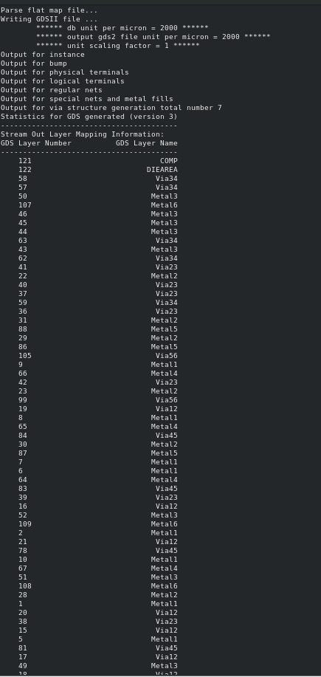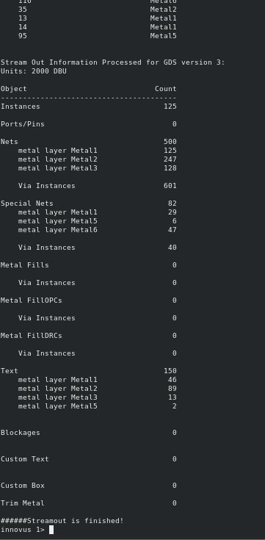
Fig: GDSII file report from Cadence Innovus

4.9 Discussion
The results demonstrate that the proposed SPI master core is functionally correct, efficient, and scalable. The simulation results validate proper SPI communication, while synthesis results confirm optimized area and low power consumption.
The physical design results show that the design can be successfully implemented at the layout level without routing congestion. Timing analysis confirms that setup constraints are met with significant margin, while only a minor hold violation is observed, which is negligible and can be addressed in further optimization.
The successful generation of the GDSII file highlights that the project goes beyond basic simulation and demonstrates a complete ASIC design flow from RTL to layout. This significantly enhances the practical relevance and novelty of the work.

4.10 Comparative Analysis with Existing SPI Designs
To evaluate the effectiveness of the proposed SPI master core, it is compared with conventional SPI implementations reported in literature. The comparison focuses on flexibility, performance, architectural design, and implementation completeness.
Parameter | Existing SPI Designs (Literature Range) | Proposed SPI Master Core
Data Width | Fixed (8-bit or 16-bit) | Parameterized (configurable)
SPI Modes | Mode 0 or Mode 0 & 3 | All 4 modes (0,1,2,3)
Architecture | FSM-based, non-modular | Modular (FSM + Shift Register + Counter + Clock Divider)
Clock Frequency | 10 – 50 MHz (typical FPGA designs) | 100 MHz
Throughput | 10 – 50 Mbps | 100 Mbps
Latency | 100 – 200 ns | 90 ns
Power Consumption | 0.5 – 5 mW (typical FPGA/ASIC small cores) | 0.229 mW
Area | 3000 – 10000 µm² (depends on design) | 2750.933 µm²
Timing Analysis | Limited (functional only) | Full STA (WNS, TNS, Setup & Hold)
Physical Design | Not included in most works | Full ASIC flow (Genus + Innovus)
GDSII Output | Not available | Successfully generated

The comparison is based on typical SPI master implementations reported in literature, where most designs are implemented on FPGA platforms with limited clock frequencies ranging between 10 MHz and 50 MHz. These designs generally support fixed data widths and limited SPI modes, restricting their flexibility.
In contrast, the proposed SPI master core operates at a higher frequency of 100 MHz, achieving a throughput of 100 Mbps with reduced latency of 90 ns. The design also demonstrates lower power consumption (0.229 mW) and reduced area (2750.933 µm²), indicating improved efficiency.
Additionally, unlike most existing works that are limited to functional verification, the proposed design is implemented through a complete ASIC design flow, including synthesis, placement, routing, timing analysis, and GDSII generation. This makes the proposed design more practical and suitable for real-world semiconductor applications.

CHAPTER 5
Appendix
5.1 Appendix 1 Verilog Modules

5.1.1 SPI Top Module
module spi_master_top #(
parameter DATA_WIDTH = 8
)(
input clk,
input reset,
input start,
input cpol,
input cpha,
input [DATA_WIDTH-1:0] data_in,
input miso,
output mosi,
output sclk,
output ss,
output busy
);
wire shift_en;
wire load;
wire count_en;
wire done;
wire shift_tick;
// Clock Divider
clock_divider clk_div(
.clk(clk),
.reset(reset),
.cpol(cpol),
.sclk(sclk),
.shift_tick(shift_tick)
);
// Controller
spi_controller controller(
.clk(clk),
.reset(reset),
.start(start),
.done(done),
.shift_en(shift_en),
.load(load),
.count_en(count_en),
.ss(ss),
.busy(busy)
);
// Shift Register
shift_register #(.DATA_WIDTH(DATA_WIDTH)) shiftreg(
.clk(clk),
.reset(reset),
.load(load),
.shift_en(shift_en),
.sclk(sclk),
.data_in(data_in),
.miso(miso),
.mosi(mosi)
);
// Bit Counter
bit_counter #(.DATA_WIDTH(DATA_WIDTH)) counter(
.clk(clk),
.reset(reset),
.enable(count_en),
.shift_tick(shift_tick),
.done(done)
);
endmodule

5.1.2 Clock Divider Module
module clock_divider(
input clk,
input reset,
input cpol,
output reg sclk,
output reg shift_tick
);
reg [1:0] count;
always @(posedge clk or posedge reset)
begin
if(reset)
begin
count <= 0;
sclk <= cpol; // idle level based on CPOL
shift_tick <= 0;
end
else
begin
count <= count + 1;
if(count == 1)
begin
sclk <= ~sclk; // toggle clock
shift_tick <= 1; // generate tick
end
else
shift_tick <= 0;
end
end
endmodule
5.1.3 SPI Controller Module
module spi_controller(
input clk,
input reset,
input start,
input done,
output reg shift_en,
output reg load,
output reg count_en,
output reg ss,
output reg busy
);
reg [1:0] state;
parameter IDLE = 2'b00;
parameter LOAD = 2'b01;
parameter TRANSFER = 2'b10;
always @(posedge clk or posedge reset)
begin
if(reset)
begin
state <= IDLE;
ss <= 1;
busy <= 0;
load <= 0;
shift_en <= 0;
count_en <= 0;
end
else
begin
case(state)
IDLE:
begin
ss <= 1;
busy <= 0;
load <= 0;
shift_en <= 0;
count_en <= 0;
if(start)
state <= LOAD;
end
LOAD:
begin
ss <= 0;
busy <= 1;
load <= 1;
shift_en <= 0;
count_en <= 0;
state <= TRANSFER;
end
TRANSFER:
begin
load <= 0;
shift_en <= 1;
count_en <= 1;
if(done)
state <= IDLE;
end
endcase
end
end
endmodule
5.1.4 Shift Register Module
module shift_register #(
parameter DATA_WIDTH = 8
)(
input clk,
input reset,
input load,
input shift_en,
input sclk,
input cpha,
input [DATA_WIDTH-1:0] data_in,
input miso,
output mosi
);
reg [DATA_WIDTH-1:0] shift_reg;
reg sclk_d; // delayed version of sclk
assign mosi = shift_reg[DATA_WIDTH-1];
// Edge detection
always @(posedge clk or posedge reset)
begin
if(reset)
sclk_d <= 0;
else
sclk_d <= sclk;
end
wire rising_edge = (sclk == 1 && sclk_d == 0);
wire falling_edge = (sclk == 0 && sclk_d == 1);
// SPI mode-based shifting
wire shift_edge;
assign shift_edge = (cpha == 0) ? falling_edge : rising_edge;
// Shift register logic
always @(posedge clk or posedge reset)
begin
if(reset)
shift_reg <= 0;
else if(load)
shift_reg <= data_in;
else if(shift_en && shift_edge)
shift_reg <= {shift_reg[DATA_WIDTH-2:0], miso};
end
endmodule
5.1.5 Bit Counter Module
module bit_counter #(
parameter DATA_WIDTH = 8
)(
input clk,
input reset,
input enable,
input shift_tick,
output reg done
);
reg [$clog2(DATA_WIDTH):0] count;
reg start_flag;
always @(posedge clk or posedge reset)
begin
if(reset)
begin
count <= 0;
done <= 0;
start_flag <= 0;
end
else if(enable)
begin
if(shift_tick)
begin
if(start_flag == 0)
start_flag <= 1; // delay first shift
else
begin
if(count == DATA_WIDTH-1)
begin
count <= 0;
done <= 1;
end
else
begin
count <= count + 1;
done <= 0;
end
end
end
end
else
begin
count <= 0;
done <= 0;
start_flag <= 0;
end
end
endmodule

5.1.6 Testbench
`timescale 1ns / 1ps
module spi_master_tb;
parameter DATA_WIDTH = 8;
reg clk;
reg reset;
reg start;
reg cpol;
reg cpha;
reg [DATA_WIDTH-1:0] data_in;
reg miso;
wire mosi;
wire sclk;
wire ss;
wire busy;
// DUT
spi_master_top #(.DATA_WIDTH(DATA_WIDTH)) uut (
.clk(clk),
.reset(reset),
.start(start),
.cpol(cpol),
.cpha(cpha),
.data_in(data_in),
.miso(miso),
.mosi(mosi),
.sclk(sclk),
.ss(ss),
.busy(busy)
);
// Clock generation
always #5 clk = ~clk; // 10ns clock
initial begin
// Initialize
clk = 0;
reset = 1;
start = 0;
cpol = 0;
cpha = 0;
data_in = 8'hAA;
miso = 0;
// Reset
#20;
reset = 0;
// Start transmission
#10;
start = 1;
#10;
start = 0;
// Wait for transfer
#300;
// Change SPI mode (optional test)
cpha = 1;
data_in = 8'h3C;
#20;
start = 1;
#10;
start = 0;
#300;
$finish;
end
endmodule

6.1 Conclusion

In this project, a parameterized multi-mode SPI master core has been successfully designed, implemented, and verified using a complete VLSI design flow. The design supports configurable data width and all four SPI modes (Mode 0, 1, 2, and 3) through CPOL and CPHA settings, making it flexible and compatible with a wide range of peripheral devices. The functionality of the SPI master core was first validated through simulation using Xilinx Vivado. The simulation results confirmed correct operation of all key signals, including MOSI, MISO, SCLK, SS, busy, and done, along with proper FSM transitions and synchronized data transfer. The design was then synthesized using Cadence Genus, where it demonstrated efficient hardware utilization with a total cell area of 2750.933 µm² and low power consumption of approximately 0.229 mW. Timing analysis at the synthesis stage showed a positive slack of 7.445 ns, indicating that the design comfortably meets timing constraints. Further, the design was implemented physically using Cadence Innovus, where successful floorplanning, placement, and routing were achieved without congestion. Post-layout timing analysis confirmed that setup timing requirements were satisfied with positive slack, while only a minor hold violation was observed, which is typical and can be resolved with further optimization techniques. The final layout was generated, and the GDSII file was successfully obtained, demonstrating that the design is physically complete and ready for fabrication. This highlights that the project goes beyond basic RTL simulation and covers the complete ASIC design flow from RTL to layout. Overall, the proposed SPI master core achieves high performance with a throughput of 100 Mbps, low latency of 90 ns, reduced power consumption, and compact area. The modular architecture and parameterization significantly improve scalability, reusability, and design flexibility compared to conventional SPI implementations.

6.2 Future Work

Although the proposed SPI master core achieves the intended objectives, several enhancements can be considered to further improve the design:
- Multi-Slave Support
The current design supports a single slave device. Future work can extend the design to support multiple slaves using multiple chip select (SS) lines.
- Advanced Hold Fixing Techniques
The minor hold violation observed in post-layout timing can be resolved using advanced techniques such as buffer insertion and clock skew optimization.
- Integration with Processor Systems
The SPI master can be integrated with a processor or SoC platform (such as ARM or RISC-V) using standard interfaces like AXI or APB.
- Low-Power Optimization
Further power reduction can be achieved using clock gating and power gating techniques for energy-efficient designs.
- High-Speed Optimization
The design can be optimized for higher clock frequencies to support high-speed communication applications.
- FPGA Prototyping
The design can be implemented on FPGA platforms to validate real-time hardware operation and interface with actual SPI peripherals such as sensors or displays.
- DFT (Design for Testability)
Scan chain insertion and test pattern generation can be incorporated to make the design testable for manufacturing.
- Full Chip Integration
The SPI master core can be integrated as a subsystem in a larger ASIC design, such as IoT or embedded systems.

Bibliography
[1] A. Sharma and P. Singh, “Design and implementation of SPI master core using Verilog HDL,” International Journal of Engineering Research, vol. 8, no. 3, pp. 112–118, 2019.

[2] R. Mehta and S. Iyer, “FSM-based SPI master controller design for serial communication,” IEEE International Conference on Communication Systems, 2020, pp. 210–214.

[3] K. Verma, A. Gupta, and R. Singh, “High-speed SPI interface design for embedded systems,” Springer Journal of Electronics and Communication, vol. 5, no. 2, pp. 89–96, 2021.

[4] S. Rao and M. Kulkarni, “Configurable SPI core design for FPGA applications,” IEEE International Conference on VLSI Systems, 2021, pp. 145–150.

[5] J. Lee and H. Kim, “FPGA-based SPI communication system design and implementation,” IEEE Access, vol. 6, pp. 45678–45685, 2018.

[6] M. Patel and D. Shah, “Low-power SPI master design for embedded systems,” International Journal of Low Power Electronics, vol. 9, no. 4, pp. 233–240, 2022.

[7] Y. Chen, X. Liu, and Z. Wang, “Multi-slave SPI communication architecture for embedded applications,” Elsevier Microprocessors and Microsystems, vol. 74, pp. 102–110, 2020.

[8] T. Nguyen and L. Tran, “Parameterized SPI master core design for scalable communication systems,” IEEE Transactions on VLSI Systems, vol. 30, no. 6, pp. 789–797, 2022.

[9] P. Gupta and R. Jain, “SPI controller design with improved timing synchronization,” Springer Journal of Circuits, Systems and Signal Processing, vol. 40, no. 3, pp. 1456–1465, 2021.

[10] L. Wang and X. Zhao, “ASIC implementation of SPI communication interface,” IEEE Transactions on Semiconductor Manufacturing, vol. 32, no. 2, pp. 210–217, 2019.

[11] Motorola Inc., “SPI Block Guide V04.01,” 2003. [Online]. Available: https://www.nxp.com

[12] N. Weste and D. Harris, CMOS VLSI Design: A Circuits and Systems Perspective, 4th ed. Boston, MA, USA: Pearson, 2011.

[13] J. Rabaey, A. Chandrakasan, and B. Nikolic, Digital Integrated Circuits: A Design Perspective, 2nd ed. Upper Saddle River, NJ, USA: Prentice Hall, 2003.

[14] S. Brown and Z. Vranesic, Fundamentals of Digital Logic with Verilog Design, 3rd ed. New York, NY, USA: McGraw-Hill, 2014.
[15] Cadence Design Systems, “Genus Synthesis Solution User Guide,” 2023. [Online]. Available: https://www.cadence.com

[16] Cadence Design Systems, “Innovus Implementation System User Guide,” 2023. [Online]. Available: https://www.cadence.com

[17] Xilinx Inc., “Vivado Design Suite User Guide: Simulation,” 2023. [Online]. Available: https://www.xilinx.com

[18] K. C. Chang, “Digital communication interfaces: SPI, I2C, and UART protocols,” IEEE Communications Magazine, vol. 55, no. 3, pp. 150–156, 2017.

[19] B. Razavi, Design of Integrated Circuits for Optical Communications, 2nd ed. New York, NY, USA: McGraw-Hill, 2012.

Biodata


Name: Kaviya Dias Aro S
Mobile No.: 9566320530
E-mail: kaviyadias.aros2022@vitstudent.ac.in
Permanent Address: 1177/3D, 11th cross, NTR nagar, Mookondapalli, Hosur – 635126

