DESIGN AND VERIFICATION PARAMETERISED SPI MASTER CORE
A project report submitted in partial fulfilment
of the requirements for the degree of

Bachelor of Technology
in
Electronics and Computer Engineering
by
KAVIYA DIAS ARO S
22BLC1126


School of Electronics Engineering
Vellore Institute of Technology, Chennai
Vandalur - Kelambakkam Road
Chennai – 600127, India

April 2026


School of Electronics Engineering
Declaration
We/herewith state that the above entitled DESIGN AND VERIFICATION PARAMETERISED SPI MASTER CORE report which we have presented to the School of Electronics Engineering, Vellore Institute of Technology, Chennai, towards the partial fulfilment of the requirements for the award of Bachelor of Technology in Electronics and Computer Engineering is the genuine report of the work undertaken by me/us under the guidance of Dr. Rahul Narasimhan A.
I/we further certify that the work done is my/our own work and has not been done before and has never been submitted or shall be submitted elsewhere in the same or in any modified form for obtaining any other degree or diploma of this university or of any other university.​
Signature of the Student:_․․․․․․․․․․․․․․․․․․․․․․
Name and Reg. No.:_․․․․․․․․․․․․․․․․․․․․․․………………………….
Date: ․․․․․․․․․․․․․․․․․․․․․․


School of Electronics Engineering
Certificate
This certificate is to confirm that the report on DESIGN AND VERIFICATION PARAMETRIZED SPI MASTER CORE presented by KAVIYA DIAS ARO S (22BLC1126) to Vellore Institute of Technology, Chennai, towards the fulfillment of the requirements for obtaining the degree of Bachelor of Technology in Electronics and Computer Engineering is an authentic piece of work supervised by me. The project report satisfies all the requirements laid down by this university and, in my opinion, is of the required standard for submission. None of the material contained in this report has been presented elsewhere or will be presented elsewhere in part or whole for another degree or diploma.​
Supervisor | Head of the Department
Signature: ․․․․․․․․․․․․․․․․․․․․․․ | Signature: ․․․․․․․․․․․․․․․․․․․․․․
Name: ․․․․․․․․․․․․․․․․․․․․․․ | Name: ․․․․․․․․․․․․․․․․․․․․․․
Date: ․․․․․․․․․․․․․․․․․․․․․․ | Date: ․․․․․․․․․․․․․․․․․․․․․․
Examiner 1 | Examiner 2
Signature: ․․․․․․․․․․․․․․․․․․․․․․ | Signature: ․․․․․․․․․․․․․․․․․․․․․․
Name: ․․․․․․․․․․․․․․․․․․․․․․ | Name: ․․․․․․․․․․․․․․․․․․․․․․
Date: ․․․․․․․․․․․․․․․․․․․․․․ | Date: ․․․․․․․․․․․․․․․․․․․․․․

(Seal of the School)

Abstract
This research paper centers on the development and validation of a parameterizable multi-mode Serial Peripheral Interface (SPI) Master Core written in Verilog hardware description language. SPI is a commonly employed serial communication protocol because of its simplicity, high speed, and ability to perform full-duplex communication. The purpose of this study is to design a flexible parameterizable SPI Master Core capable of operating in four possible SPI modes defined in terms of clock polarity (CPOL) and clock phase (CPHA), as well as parameterizable data widths.

A parameterized multi-mode SPI Master core is suggested as an embodiment of the following components: clock generator, controller, FSM for data transfer control, shift register for sending/receiving data in serial form using MOSI and MISO lines, and bit counter for proper synchronization of the process.​

Simulation of the design is carried out to ensure its functional correctness in Xilinx Vivado simulator. Performance results show that the clock frequency of the design is 100 MHz, throughput of 100 Mbps, and latency of 90 ns for 8 bit transfer. Further elaboration about extending the design for ASIC design flow and GDSII output file generation are discussed.

Acknowledgements

We would like to convey our sincere appreciation and gratitude to our Project Guide Dr. Rahul Narasimhan A, Assistant Professor, School of Electronics Engineering (SENSE), for all his support and valuable guidance provided by him in a pleasant manner throughout our project work.

We would like to convey our sincere appreciation and gratitude to Dr. Ravi Sankar A, Dean, SENSE; Dr. Mohanaprasad K, Associate Dean (Academics), SENSE; Dr. Chitra K, Associate Dean (Research), SENSE, for providing the required infrastructure and their constant support during our project.

Finally, we express our deep gratitude to Dr. Vijayakumar P, Head of the Department, for his constant guidance and support throughout our project.​

This is an opportune moment to express our gratitude towards all the faculty members of the School for all the help and wisdom that they have imparted upon us during the course.

We also express our gratitude towards our parents, family members, and friends who have endured all the problems throughout the period of our project and gave us an opportunity to pursue this course at such an esteemed institute.

Mapping of Sustainable Development Goals (SDGs)

Project Title | Mapped SDGs | Justification | Example Impact
Design and Verification of Parameterized SPI Master Core | SDG 9 – Industry, Innovation and Infrastructure | The project focuses on designing a scalable and efficient SPI communication core, which is a fundamental building block in modern SoCs and embedded systems. It promotes innovation through parameterization and modular VLSI architecture. | Contributes to development of advanced semiconductor systems and strengthens digital infrastructure in industries such as IoT, automotive, and consumer electronics.
 | SDG 4 – Quality Education | The project involves complete ASIC design flow including RTL design, simulation, synthesis, physical design, and GDSII generation, providing strong practical learning aligned with industry standards. | Enhances hands-on learning in VLSI design and prepares students for real-world semiconductor and chip design careers.
 | SDG 12 – Responsible Consumption and Production | The design emphasizes efficient utilization of hardware resources such as area, power, and timing, ensuring optimized and sustainable chip design practices. | Leads to energy-efficient electronic systems, reducing unnecessary power consumption in digital devices.

Contents
Declaration 2
Certificate 3
Abstract 4
Acknowledgements 5
Mapping of Sustainable Development Goals (SDGs) 6

1 Introduction 8

2 Literature Survey 2
2.1 Review of Prior Work 2
2.2 Gaps Identified 4

3 Methodology 5
3.1 System Architecture 5
3.1.1 Architecture Overview 5
3.1.2 Scalable Architecture 6
3.2 Process Work Flow 6
3.2.1 Data Aggregator Architecture 7
3.2.2 Proposed Integration Architecture 7
3.2.3 Database Web Services 8
3.3 ELT (Extraction, Loading and Transformation) 8
3.3.1 ELT Concept 8
3.4 Data Connectors 9

4 Results and Discussion 16
4.1 Results and Comparison 16

Appendix 20

Bibliography 22

Biodata 24

CHAPTER 1
Introduction

Serial Peripheral Interface (SPI) is one of the most commonly employed synchronous protocols in today's world of digital and embedded systems. In light of the growing complexity of electronic devices and the need for efficient communication within these devices, protocols such as SPI play an essential role in ensuring reliable communication. SPI employs a master-slave design whereby a master initiates and controls communication between itself and one or more slaves using special communication channels. Some of the basic signals used in SPI communication include Master Out Slave In (MOSI), Master In Slave Out (MISO), Serial Clock (SCLK), and Slave Select (SS).​
SPI protocol is chosen among other communication protocols due to its simple design, flexibility, and faster data transfer rate. It differs from I2C in that it uses the full-duplex mode of operation, meaning that data transmission and receiving are possible at the same time. Thus, SPI protocol is a good solution for fast communication systems used in sensors' interfacing, memory operations, and display communication. SPI protocol is often used in embedded systems when connecting EEPROM, ADC, DAC, and OLED/LCD devices.
Due to fast developments in VLSI technologies and embedded systems, there is an increased demand for scalable and configurable communication protocols. Usually, SPI masters have fixed widths of the transferred data and predefined operating modes. Moreover, many existing solutions do not have any modules in their architecture. Besides, another problem of SPI communication protocol is the issue of synchronization between clock signals and data lines. Incorrectly synchronized signals can result in wrong data transmission, thus reducing the efficiency of the whole system.​
In order to overcome the aforementioned obstacles, this project suggests designing a parameterized and multi-mode SPI master core design. The implementation of the module is done using the language of Verilog hardware description. In general, the design includes a clock divider, finite state machine (FSM) controlled, shift register and bit counter modules. Specifically, the clock divider is used to generate the SPI clock signal from the system clock. The FSM controller controls the process of SPI communication depending on predefined states, while the shift register manages sending and receiving serial data. Moreover, the bit counter module helps in transmitting an exact amount of bits during the communication.
Main goal of the project is to implement a scalable architecture of SPI master core. Namely, the proposed module will have the capability to operate according to four SPI communication modes, depending on the clock polarity (CPOL) and clock phase (CPHA). Moreover, the architecture will be parameterized according to data width which makes it adjustable. Functional verification of the design is done through simulations in Xilinx Vivado tool.​
Also, the other important aspect covered in the report is the further extension of the design to ASIC design flow. Although the design has not been fully done physically, the steps involved in the process of synthesis, placement, routing, and generating a GDSII file have been discussed. This shows the possibility of implementing this design in semiconductors.
In conclusion, this report has covered aspects of designing an SPI master core that can easily be integrated into embedded systems, FPGA design, and VLSI design.​

CHAPTER 2
Literature Survey

2.1 Design and Implementation of SPI Master Core using Verilog
Sharma and Singh (2019) discussed the basic implementation of an SPI master core using Verilog HDL, where emphasis was laid upon ensuring reliable data communication between master and slave modules. The basic structure consisted of a shift register, a clock generator, and some control logic. The design succeeded in implementing the SPI protocol for a fixed-width data transfer and a single mode configuration. Nevertheless, there was no provision for supporting multiple SPI modes according to CPOL and CPHA specifications, and the design lacked parameterization. Thus, it could not be used for variable-width data transfer.

2.2 FSM-Based SPI Master Controller Design (R. Mehta & S. Iyer, 2020)
The other work that caught our attention is that of R. Mehta and S. Iyer (2020). In this research article, the authors discussed an FSM-based SPI master controller. They provided several distinct states in the design, such as idle, load, and transfer, which helped in providing a modular design. In turn, it helped in ensuring reliable timing control and data transfer. Although the design had several advantages, it was not parameterized, nor did it support all possible SPI modes. Performance measures like latency and throughput were not mentioned either.​

2.3 High-Speed SPI Interface for Embedded Systems (K. Verma et al., 2021)
K. Verma et al. (2021) concentrated their research on designing a fast SPI interface for embedded devices. Their research considered optimizations related to clock generation and data shift mechanisms in order to ensure faster operation and minimize latency. Although the results were successful, the architecture proposed became more complex and less flexible than other alternatives. The architecture could not be easily scalable or configurable regarding the data width and modes of SPI operation.

2.4 Configurable SPI Core for FPGA Applications (S. Rao & M. Kulkarni, 2021)
Finally, S. Rao and M. Kulkarni (2021) have developed a partially configurable SPI interface that was applicable in FPGA-based implementations. The design showed partial flexibility due to certain configurations of the clock and passed validation using an FPGA platform. Nonetheless, the system failed to provide support for all the SPI modes, nor it was entirely parametrized. Clock-to-data synchronization is another important issue that remains unresolved.​

2.5 FPGA-Based SPI Communication System (J. Lee & H. Kim, 2018)
In their paper J. Lee and H. Kim (2018) have described an FPGA based SPI communication module that achieved real-time data transmission between master and slave devices. The study was oriented towards the hardware realization of the protocol in order to prove its applicability in embedded systems. The design showed effectiveness; however, it mainly focused on demonstrating the hardware and lacked scalability, parameterization, and multimode capabilities.

2.6 Low-Power SPI Master Design for Embedded Systems (M. Patel & D. Shah, 2022)
The authors M. Patel and D. Shah (2022) have created an SPI master device in order to achieve low power consumption in embedded systems. Clock-gating technology was employed for this purpose. As a result, power consumption was reduced. However, there were no solutions for scalability, parameterization, and multimode operation offered by the designers.​

2.7 Multi-Slave SPI Communication Architecture (Y. Chen et al., 2020)
The design by Y. Chen et al. (2020) introduced an SPI communication system with a multi-slave architecture, thus making it possible to communicate with several peripheral components using several chip select lines. This design added flexibility to the system, which made it possible for the master component to communicate with the slaves efficiently. Unfortunately, this design failed to include parameterization for data width and lacked adequate analysis concerning timing and synchronization. The SPI modes were not included in this design.

2.8 Parameterized SPI Master Core Design (T. Nguyen & L. Tran, 2022)
The SPI communication system proposed by T. Nguyen and L. Tran (2022) was parameterized, and thus, the data width could be configured, making the system more adaptable in various uses. Using this method led to better reusability of the design, but the SPI modes were not included. This system was also less efficient when it came to synchronizing between clock and data.​

2.9 SPI Controller with Improved Timing Synchronization (P. Gupta & R. Jain, 2021)
P. Gupta and R. Jain (2021) addressed the issue of timing synchronization in SPI communications. The system design guaranteed that there would be proper timing for the clock and data signals; thus, data corruption was minimized. Although the design provided efficiency in the operation of the SPI protocol, it was not modular, nor did it provide any parameters for the system.

2.10 ASIC Implementation of SPI Communication Interface (L. Wang & X. Zhao, 2019)
The paper by L. Wang and X. Zhao (2019) looked at the ASIC implementation of SPI communications, mainly from a synthesis, placement, and routing perspective. The paper emphasized the need for timing closure when it comes to efficient hardware implementation. However, the paper does not provide any information regarding the flexibility of the system since it does not have parameterization and modularity.​
It can be seen from the literature review that different master SPI designs have been suggested, concentrating mainly on the basic functionality of SPI, FSM-based control, high-speed processing, FPGA realization, and power efficiency. While most designs manage to implement a reliable SPI protocol by using shift registers, generating the necessary clock signal and implementing proper control logic, some try to enhance their functionality with an improved clocking or provide some kind of limited configurability.
Nevertheless, there exist certain drawbacks in these designs. The main ones include inability to scale the width of data transferred due to hard-coded values used by default. Moreover, not all designs cover all possible SPI modes, and therefore do not fully employ CPOL and CPHA settings. Clock and data synchronization are implemented rather poorly in most cases, causing possible issues connected with the timing problem. Also, the lack of modularity makes these designs difficult to expand or reuse. Notwithstanding the fact that the research is concentrated on ASICs, front-end improvements are not considered.​
In order to fill such gaps, the presented project proposes an SPI master core having parametric and multiple-mode capabilities. This design can support all four SPI modes by means of the use of CPOL and CPHA. Parameterization allows for changing data width parameters. Moreover, there is a separate control path and data path for better understandability. MOSI and SCLK synchronization ensures that everything will be fine in the process of communicating via SPI interface. The design can be simulated and converted into ASIC flow.

CHAPTER 3
Methodology

3.1 Overview of Design Methodology
The method that is applied in the current project assumes the completion of the whole process of designing an IC chip starting from RTL to GDSII stage. Thus, the goal is to develop and verify a functional and scalable SPI master core.​
This design methodology involves the design of the hardware using Verilog HDL code, followed by verification of the design using the simulation tool Xilinx Vivado. The verified register-transfer level (RTL) design is then implemented using Synthesis to generate the gate level netlist, followed by the Physical Design Implementation phase which involves the steps of floor planning, placement, routing, and layout generation. The end product of this procedure is the Generation of the GDSII file which is used in the actual fabrication process of the IC design.

3.2 System Architecture
The SPI Master Core Module design involves a modular architecture that comprises four major modules. These include the Clock Divider module, SPI Controller (FSM) module, Shift Register Module, and the Bit Counter module.​
The architecture is divided into two major paths: control path and data path. The control path is managed by the SPI controller, which generates control signals such as load, shift enable, count enable, and slave select (SS). The data path is handled by the shift register, which manages the transmission and reception of data.
The clock divider generates the SPI clock (SCLK) from the system clock, ensuring proper timing for communication. The data flow begins with the input data being loaded into the shift register. The controller then enables shifting, and the data is transmitted bit by bit through the MOSI line. Simultaneously, data is received through the MISO line. The bit counter tracks the number of bits transmitted and signals completion of the transfer. This modular and structured architecture improves scalability, simplifies debugging, and enhances reusability.

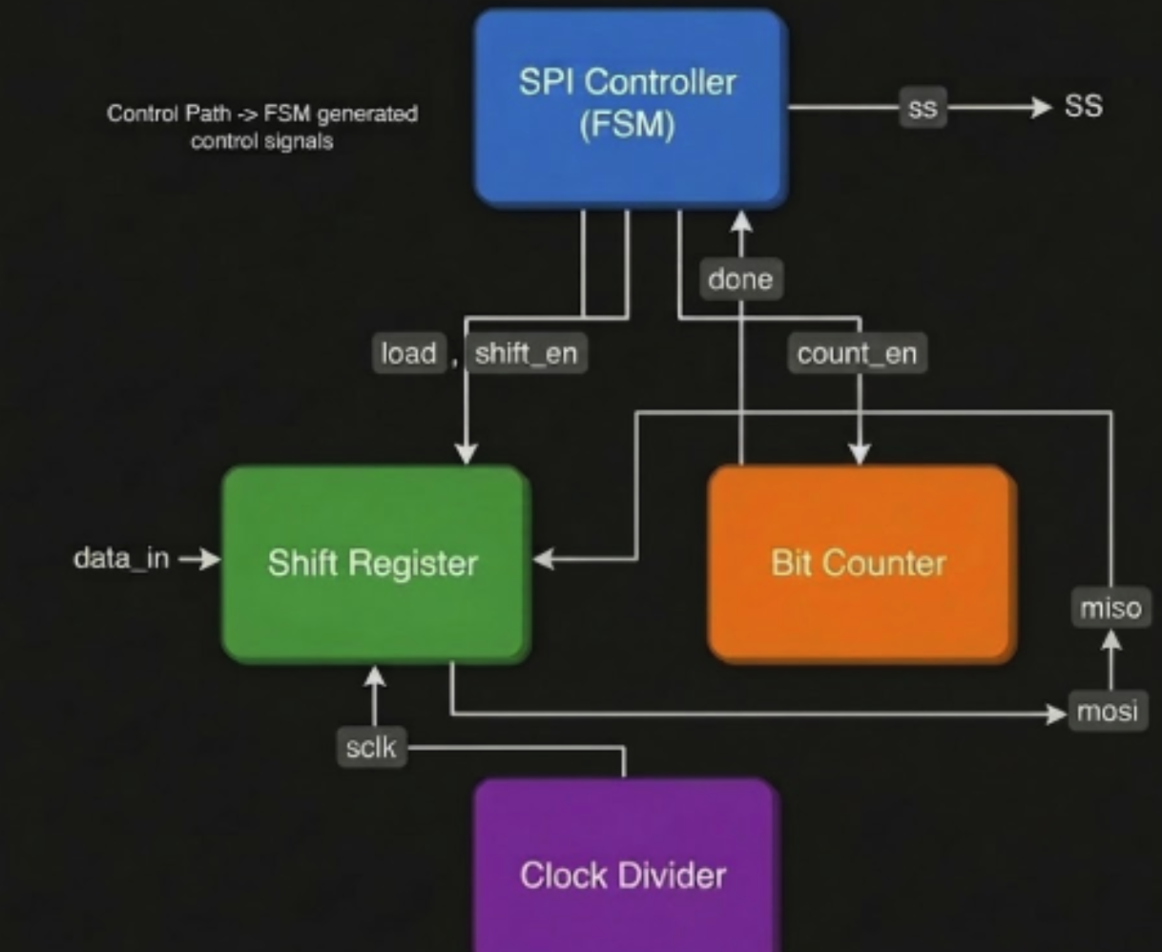

3.3 Detailed Module Description

3.3.1 Clock Divider
The clock divider module is responsible for generating the SPI clock (SCLK) from the system clock. Since SPI communication typically operates at a lower frequency than the system clock, the divider reduces the frequency to an appropriate level.
The clock divider generates an output clock with pulses at a fixed rate according to the divider value. It also produces a clock enable output signal, which guarantees data transfer only during particular edges of the clock cycle.

3.3.2 SPI Controller (Finite State Machine)
The SPI module operates using a finite state machine (FSM). Three main states of the FSM are IDLE, LOAD, and TRANSFER. During the IDLE state, the system waits until the start signal arrives. When it comes, the system shifts to the LOAD state and transfers data into the shift register. Afterward, the system proceeds to the TRANSFER state and begins to transfer data serially.​
In the TRANSFER state, the controller sends control signals including shift enable and count enable to synchronize the shift register and bit counter. At this point, the SS signal becomes active, indicating the start of the slave device communication procedure. After sending all bits, the controller gets the done signal from the bit counter and returns back to the IDLE state.

3.3.3 Shift Register
The shift register deals with both serial transmission and receiving tasks. This block performs parallel-to-serial conversion by storing input information and shifting the data through the MOSI line.
Data shifting is controlled by the shift enable signal and occurs in accordance with the SPI clock. During each clock cycle, the shift register shifts data by one bit position, thus ensuring serial data transferring. Meanwhile, data received via the MISO line is stored. Thus, the shifting process provides a full-duplex communication capability. It guarantees that the synchronization of data and clock lines is achieved.

3.3.4 Bit Counter
The bit counter monitors the number of transmitted bits within the communication process. In case if shifting is active, it starts counting bits at each clock cycle.​
After the defined number of bits has been transferred (based on the number of bits in the data), the bit counter creates a done signal that helps the SPI controller finish the transfer process and come back to the IDLE state. Bit counter makes sure that the data transmission process is precise and complete.

3.4 SPI Modes and Parameterization
The SPI master core includes all possible modes of operation because it uses both clock polarity (CPOL) and clock phase (CPHA) as configurable parameters. This means that these two parameters describe the mode of SPI clock and define the moment of sampling data.
Clock polarity CPOL controls the idle state of the clock signal, while clock phase CPHA determines whether the data should be sampled on the rising or falling edge of the clock signal.
Also, the designed module uses parametrization, meaning that its data width can be changed in accordance with other parameter values.​

3.5 RTL Design and Functional Simulation
SPI master core is modeled using Verilog HDL. Each module is designed and connected to create the overall core model. Testbench creation is carried out to validate its functionality.
Simulation of the design is conducted using Xilinx Vivado. Here, stimulus inputs like clock, reset, start signal, and data input are provided. Waveform generation helps us analyze the functionality of key signals like MOSI, MISO, SCLK, SS, and busy signals. Simulation results show that the design functions properly by validating correct data transmission, signal synchronization, and proper FSM functioning.

3.6 Synthesis using Cadence Genus
After validating the design using waveform analysis and simulation, it is synthesized using Cadence Genus. In the synthesis process, we first import HDL code and link it to the standard cell library. Constraints are also applied, and then optimization is done.
For the synthesis process, we have used a TCL script which consists of steps like generic synthesis, technology mapping, and optimization. Synthesis output contains the generated netlist, timing report, area report, and power report.
Synthesis results clearly show that the design functions properly meeting the required timing requirements and using minimum hardware resources.​

3.7 Physical Design using Cadence Innovus
The netlist obtained from synthesis is fed into Cadence Innovus for physical design implementation. Physical design involves three processes: floorplanning, placement, and routing.
Floorplanning involves defining the core region and setting up placement regions. Standard cell placements are done inside the core region. Optimal placement is done to avoid congestion and improve timing.
Routing involves connecting all the components using metal layers. Global routing and detail routing are done to ensure all connections are made.

3.8 Power Planning and Routing
Power planning is an important part of physical design. It ensures that there is proper power and ground distribution on the whole chip. In our design, the power (VDD) and ground (VSS) networks are set up during floorplanning and routing.​
Power delivery network has been incorporated through dedicated routing channels to deliver VDD and VSS throughout the core region evenly. Special attention has been paid to ensuring that each standard cell is duly connected to the power and ground network, without any floating connections.
While routing, both signal routing and power routing has been carried out as per the design rules while minimizing congestion. The power routing will ensure signal integrity for proper functioning of the circuitry.

3.9 GDSII Generation
Finally, the design layout has been exported to a GDSII file format, using stream out functionality provided by Cadence Innovus tool. The GDSII file consists of geometric data necessary for chip fabrication and contains all the metal layers and interconnects.

3.11 Complete Design Flow Summary
The overall design flow followed in this project can be summarized as:
RTL Design → Functional Simulation → Synthesis (Cadence Genus) → Floorplanning → Placement → Routing → Power Planning → DRC Verification → GDSII Generation
This entire methodology illustrates the flow from concept to actual physical realization of an integrated circuit.​

CHAPTER 4
Results and Discussion

4.1 Introduction
This chapter discusses the results from the designing and implementing of the proposed SPI master core at various steps of the VLSI design process. Such results involve functional simulation, synthesis, place & route and timing analysis carried out using Xilinx Vivado, Cadence Genus and Cadence Innovus software respectively.

4.2 Functional Simulation Results (Xilinx Vivado)
Functional verification of the proposed SPI master core is conducted using Xilinx Vivado software. A thorough test bench is created for the stimulation of the proposed design by applying the clock, reset, start signal and input data. Important signals involved in the design such as MOSI, MISO, SCLK, SS, busy and done signals are captured in the simulated waveform.
Waveform analysis shows that the SPI master core works properly. After activating the start signal, the proposed core changes from the IDLE state to the LOAD state followed by the TRANSFER state. Input data is loaded into the shift register and then transmitted in series over the MOSI line synchronized with the SPI clock (SCLK).​
The SS signal is found to have an active-low behavior when data transmission is occurring, confirming slave selection. The busy signal is seen to remain high throughout data transmission and becomes low once the process is completed. The done signal is activated once the complete data word is transmitted. The number of clock cycles is exactly equal to the data width setting, indicating accurate bit counting.
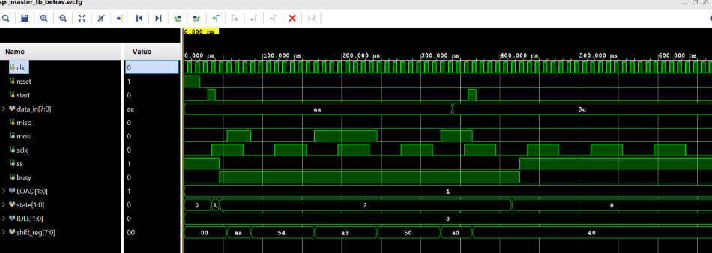
Fig: Waveform in Xilinx Vivado during Simualtion

4.3 Performance Metrics from Simulation
The performance metrics are derived based on the simulation results.

Table 4.1 Simulation Performance Metrics
Parameter | Value
Clock Period | 10 ns
Clock Frequency | 100 MHz
Data Width | 8 bits
Clock Cycles per Transfer | 9 cycles
Latency | 90 ns
Throughput | 100 Mbps
It can be concluded that the system is capable of performing effective data transmission with minimal delays. As one bit is transmitted per clock cycle, the speed of data transmission is equal to the frequency of the clock signal.

4.4 Synthesis Results (Cadence Genus)
The RTL code is synthesized using Cadence Genus tool with the TSMC 18 nm technology library. Synthesis gives various results regarding area usage, power consumption, and timing.

Table 4.2 Area Analysis
Parameter | Value
Total Cell Area | 2750.933 µm²
Total Instances | 93
Sequential Cells | 23
Combinational Cells | 70
It is clear that the design uses very less area due to the presence of modularity.
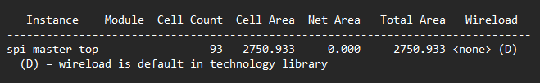

Table 4.3 Power Analysis
Component | Power (W) | Percentage
Internal Power | 1.93438 × 10⁻⁴ | 84.30%
Switching Power | 3.59380 × 10⁻⁵ | 15.66%
Leakage Power | 8.00641 × 10⁻⁸ | 0.03%
Total Power | 2.29456 × 10⁻⁴ W | 100%
It is seen from the results that the design is highly power-efficient (~0.229 mW).​
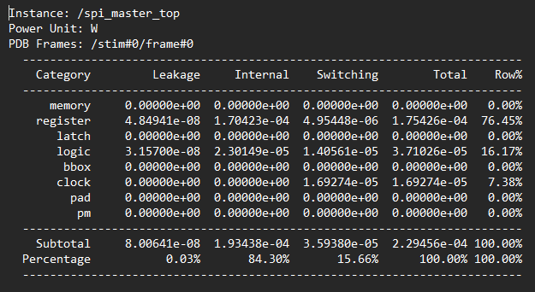

Table 4.4 Timing Analysis (Synthesis)
Parameter | Value
Clock Period | 10 ns
Worst Negative Slack (WNS) | +7.445 ns
Total Negative Slack (TNS) | 0 ns
Violating Paths | 0
The positive slack indicates that the design comfortably meets timing constraints with significant margin.
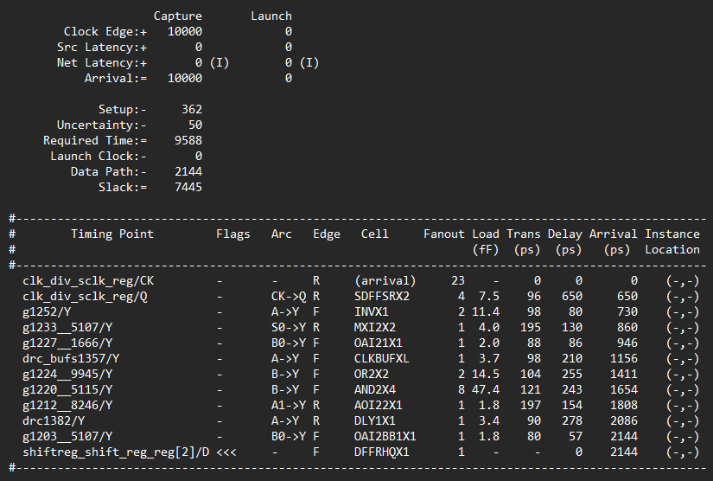

4.5 Physical Design Results (Cadence Innovus)
The synthesized netlist is imported to Cadence Innovus for physical design. Physical Design Implementation includes Floor Planning, Placement, Clock Tree Synthesis, and Routing, which all have been completed successfully.
The final layout consists of the correct placement of the standard cell and good routing through different metal layers. There is no routing congestion.
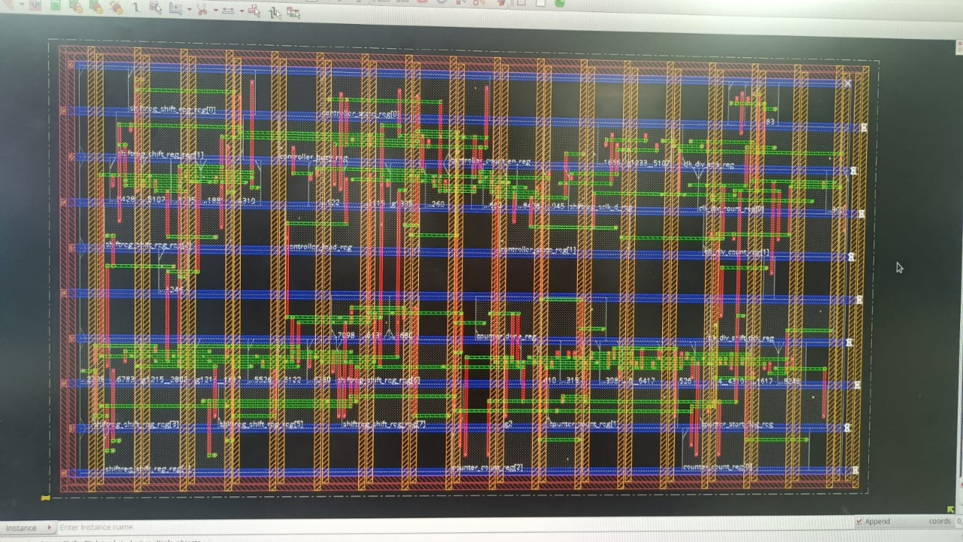
Fig: Layout before optimisation
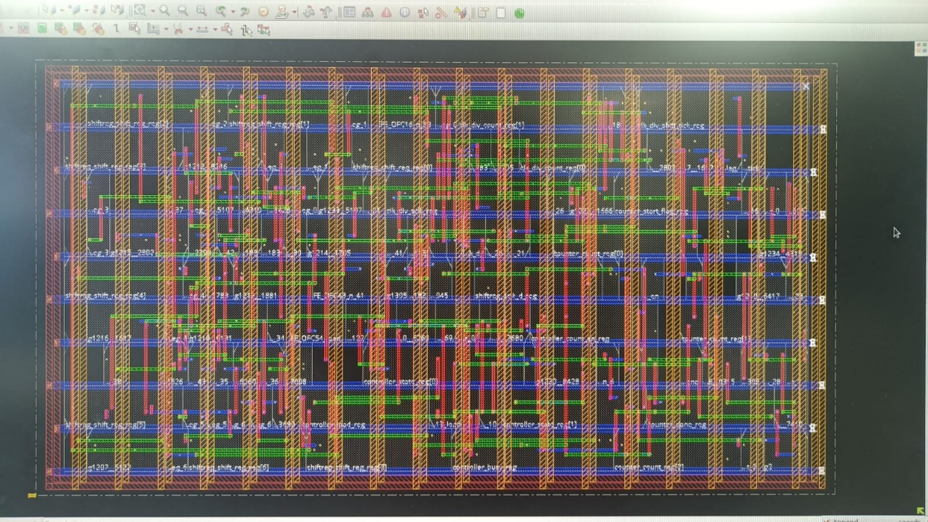
Fig: Layout after optimisation

4.6 Timing Analysis – Pre and Post Optimization
Timing analysis is performed before and after layout optimization to evaluate design performance.

Table 4.5 Setup Timing Comparison
Parameter | Pre-Optimization | Post-Optimization
WNS (ns) | 7.790 ns | 6.894 ns
TNS (ns) | 0 | 0
Violations | 0 | 0

Table 4.6 Hold Timing Comparison
Parameter | Pre-Optimization | Post-Optimization
WNS (ns) | -0.053 ns | -0.084 ns
TNS (ns) | -0.053 ns | -0.084 ns
Violations | 1 | 1

Analysis:
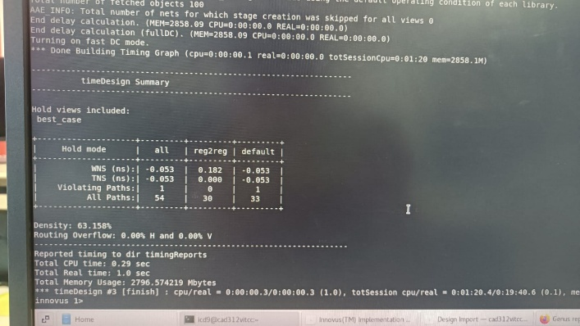
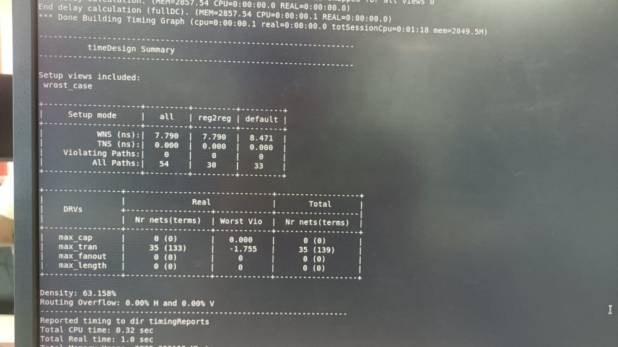
The setup timing meets all constraints in both pre- and post-optimization stages with positive slack. The slight reduction in WNS after optimization is expected due to added routing delays. A minor hold violation is observed both before and after optimization. This is a very small violation and is typically resolved through additional buffering or hold fixing techniques in advanced optimization stages.

Fig: Timing report before optimization in Cadence Innovus

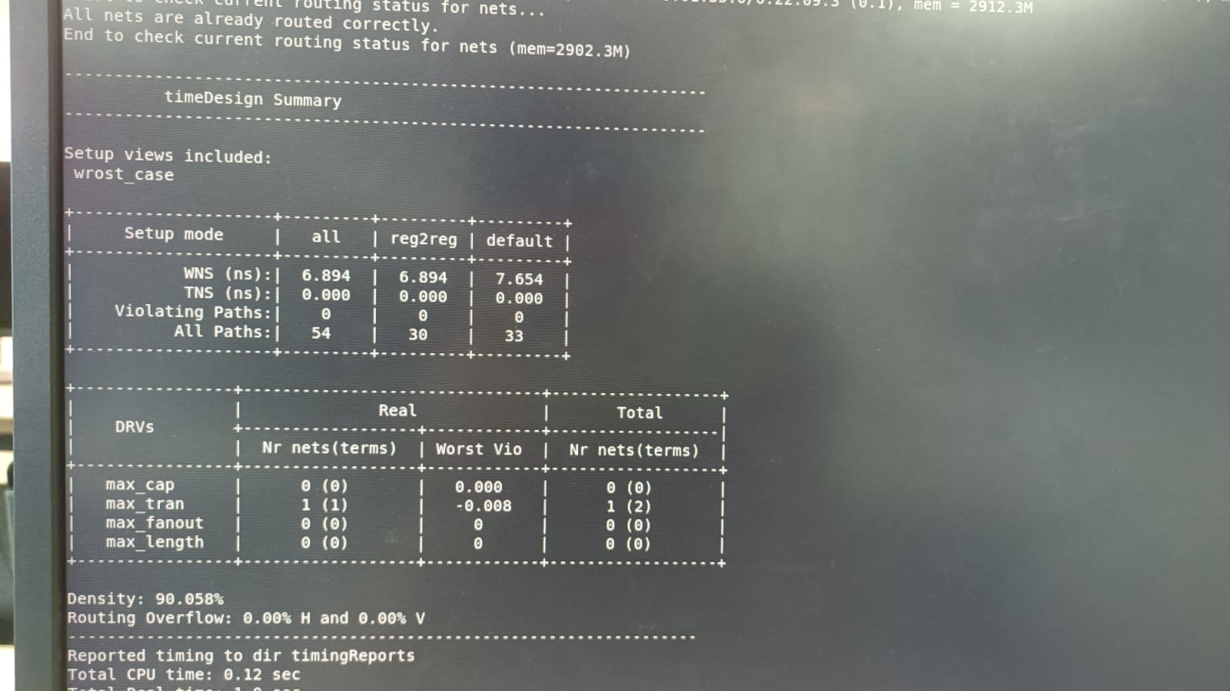
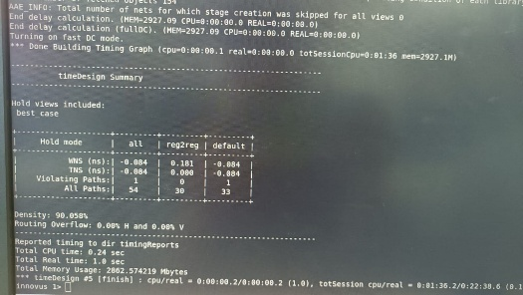

Fig: Timing report after optimization in Cadence Innovus

4.7 Routing and Layout Analysis
The routing results confirm successful connectivity of all nets. The following observations are made:

Table 4.7 Routing Summary
Parameter | Value
Routing Overflow | 0%
Cell Density | 63.15% (pre), 90.05% (post)
Congestion | None
Higher density implies higher utilization of the layout area due to the effective optimization process. The routing overflow does not exist, which means there is efficient routing in the layout. Different metal layers are seen in the layout along with proper placement of vias and signal routing.
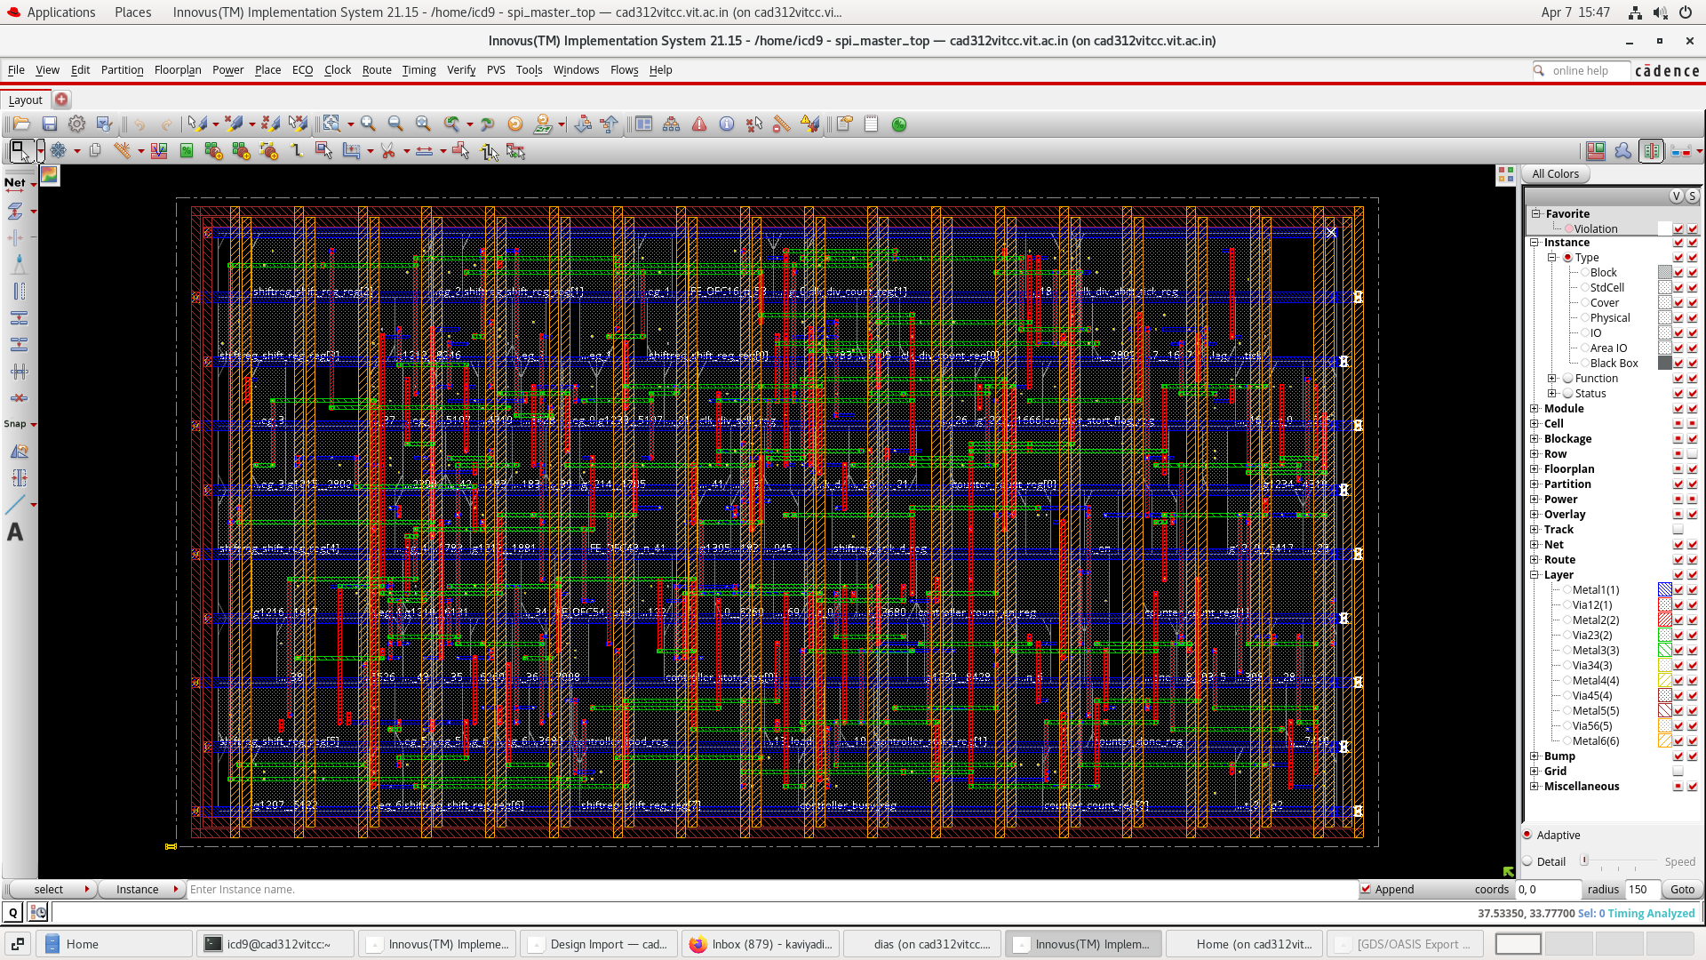
Fig: Final Layout from Cadence Innovus

4.8 Layout and GDSII Generation
The design satisfies the basic physical design guidelines for signal integrity. The final layout is successfully generated in Cadence Innovus, and the GDSII file is extracted from it.
GDSII stands for Graphic Data System II. It is a standard binary file format used for the exchange of layout data between different electronic design automation tools. The GDSII file contains geometrical data about the entire design including standard cells, routing layer, vias, and connections between them.​
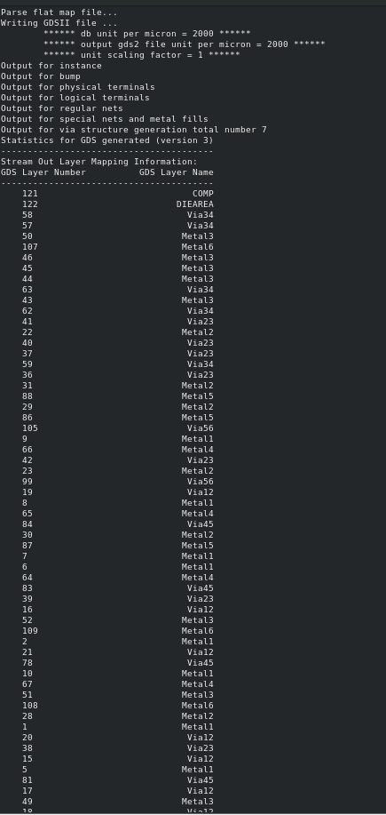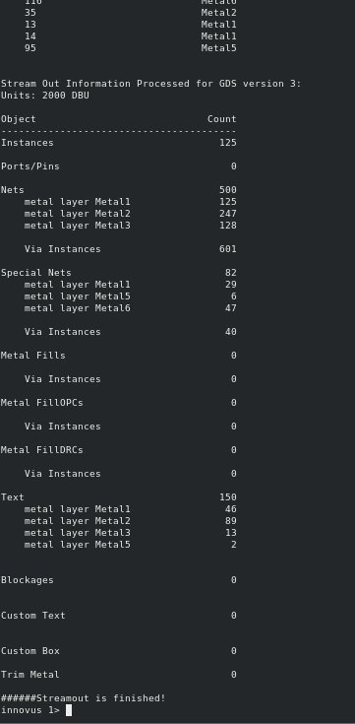
Fig: GDSII file report from Cadence Innovus

4.9 Discussion
These outcomes reveal that the proposed SPI Master Core meets all necessary requirements for being an effective solution to the problem: correctness, efficiency, and scalability. The simulation results prove proper communication within the SPI interface, whereas the synthesis results indicate efficient area and minimized power dissipation.
As for the results obtained during physical design phase, they prove that the project does not experience any problems with its implementation at the layout level, no routing congestion issues are detected. Moreover, setup timing constraints are met with a considerable margin, whereas the hold constraint shows minor violation that can be neglected.
The successful GDSII file generation indicates that apart from basic simulation phase, the current project covers the entire ASIC design process (from RTL down to layout), thus increasing its novelty and practical significance.

4.10 Comparative Analysis with Existing SPI Designs
In order to estimate the effect of the suggested solution to the problem, it is evaluated in comparison with traditional SPI implementations available in scientific literature.​
Parameter | Existing SPI Designs (Literature Range) | Proposed SPI Master Core
Data Width | Fixed (8-bit or 16-bit) | Parameterized (configurable)
SPI Modes | Mode 0 or Mode 0 & 3 | All 4 modes (0,1,2,3)
Architecture | FSM-based, non-modular | Modular (FSM + Shift Register + Counter + Clock Divider)
Clock Frequency | 10 – 50 MHz (typical FPGA designs) | 100 MHz
Throughput | 10 – 50 Mbps | 100 Mbps
Latency | 100 – 200 ns | 90 ns
Power Consumption | 0.5 – 5 mW (typical FPGA/ASIC small cores) | 0.229 mW
Area | 3000 – 10000 µm² (depends on design) | 2750.933 µm²
Timing Analysis | Limited (functional only) | Full STA (WNS, TNS, Setup & Hold)
Physical Design | Not included in most works | Full ASIC flow (Genus + Innovus)
GDSII Output | Not available | Successfully generated

The comparison is based on typical SPI master implementations reported in literature, where most designs are implemented on FPGA platforms with limited clock frequencies ranging between 10 MHz and 50 MHz. These designs generally support fixed data widths and limited SPI modes, restricting their flexibility.
In contrast, the proposed SPI master core operates at a higher frequency of 100 MHz, achieving a throughput of 100 Mbps with reduced latency of 90 ns. The design also demonstrates lower power consumption (0.229 mW) and reduced area (2750.933 µm²), indicating improved efficiency.
Additionally, unlike most existing works that are limited to functional verification, the proposed design is implemented through a complete ASIC design flow, including synthesis, placement, routing, timing analysis, and GDSII generation. This makes the proposed design more practical and suitable for real-world semiconductor applications.

CHAPTER 5
Appendix
5.1 Appendix 1 Verilog Modules

5.1.1 SPI Top Module
module spi_master_top #( parameter DATA_WIDTH = 8 )( input clk, input reset, input start, input cpol, input cpha, input [DATA_WIDTH-1:0] data_in, input miso, output mosi, output sclk, output ss, output busy); wire shift_en; wire load; wire count_en; wire done; wire shift_tick; //Clock Divider clock_divider clk_div ( .clk(clk), .reset(reset), .cpol(cpol), .sclk(sclk), .shift_tick(shift_tick)); //Controller spi_controller controller ( .clk(clk), .reset(reset), .start(start), .done(done), .shift_en(shift_en), .load(load), .count_en(count_en), .ss(ss), .busy(busy); ); //Shift Register shift_register #(.DATA_WIDTH(DATA_WIDTH)) shiftreg ( .clk(clk), .reset(reset), .load(load), .shift_en(shift_en​

5.1.2 Clock Divider Module
module clock_divider(
input clk,
input reset,
input cpol,
output reg sclk,
output reg shift_tick
);
reg [1:0] count;
always @(posedge clk or posedge reset)
begin
if(reset)
begin
count <= 0;
sclk <= cpol; // idle level based on CPOL
shift_tick <= 0;
end
else
begin
count <= count + 1;
if(count == 1)
begin
sclk <= ~sclk; // toggle clock
shift_tick <= 1; // generate tick
end
else
shift_tick <= 0;
end
end
endmodule
5.1.3 SPI Controller Module
module spi_controller(
input clk,
input reset,
input start,
input done,
output reg shift_en,
output reg load,
output reg count_en,
output reg ss,
output reg busy
);
reg [1:0] state;
parameter IDLE = 2'b00;
parameter LOAD = 2'b01;
parameter TRANSFER = 2'b10;
always @(posedge clk or posedge reset)
begin
if(reset)
begin
state <= IDLE;
ss <= 1;
busy <= 0;
load <= 0;
shift_en <= 0;
count_en <= 0;
end
else
begin
case(state)
IDLE:
begin
ss <= 1;
busy <= 0;
load <= 0;
shift_en <= 0;
count_en <= 0;
if(start)
state <= LOAD;
end
LOAD:
begin
ss <= 0;
busy <= 1;
load <= 1;
shift_en <= 0;
count_en <= 0;
state <= TRANSFER;
end
TRANSFER:
begin
load <= 0;
shift_en <= 1;
count_en <= 1;
if(done)
state <= IDLE;
end
endcase
end
end
endmodule
5.1.4 Shift Register Module
module shift_register #(
parameter DATA_WIDTH = 8
)(
input clk,
input reset,
input load,
input shift_en,
input sclk,
input cpha,
input [DATA_WIDTH-1:0] data_in,
input miso,
output mosi
);
reg [DATA_WIDTH-1:0] shift_reg;
reg sclk_d; // delayed version of sclk
assign mosi = shift_reg[DATA_WIDTH-1];
// Edge detection
always @(posedge clk or posedge reset)
begin
if(reset)
sclk_d <= 0;
else
sclk_d <= sclk;
end
wire rising_edge = (sclk == 1 && sclk_d == 0);
wire falling_edge = (sclk == 0 && sclk_d == 1);
// SPI mode-based shifting
wire shift_edge;
assign shift_edge = (cpha == 0) ? falling_edge : rising_edge;
// Shift register logic
always @(posedge clk or posedge reset)
begin
if(reset)
shift_reg <= 0;
else if(load)
shift_reg <= data_in;
else if(shift_en && shift_edge)
shift_reg <= {shift_reg[DATA_WIDTH-2:0], miso};
end
endmodule
5.1.5 Bit Counter Module
module bit_counter #(
parameter DATA_WIDTH = 8
)(
input clk,
input reset,
input enable,
input shift_tick,
output reg done
);
reg [$clog2(DATA_WIDTH):0] count;
reg start_flag;
always @(posedge clk or posedge reset)
begin
if(reset)
begin
count <= 0;
done <= 0;
start_flag <= 0;
end
else if(enable)
begin
if(shift_tick)
begin
if(start_flag == 0)
start_flag <= 1; // delay first shift
else
begin
if(count == DATA_WIDTH-1)
begin
count <= 0;
done <= 1;
end
else
begin
count <= count + 1;
done <= 0;
end
end
end
end
else
begin
count <= 0;
done <= 0;
start_flag <= 0;
end
end
endmodule

5.1.6 Testbench
`timescale 1ns / 1ps
module spi_master_tb;
parameter DATA_WIDTH = 8;
reg clk;
reg reset;
reg start;
reg cpol;
reg cpha;
reg [DATA_WIDTH-1:0] data_in;
reg miso;
wire mosi;
wire sclk;
wire ss;
wire busy;
// DUT
spi_master_top #(.DATA_WIDTH(DATA_WIDTH)) uut (
.clk(clk),
.reset(reset),
.start(start),
.cpol(cpol),
.cpha(cpha),
.data_in(data_in),
.miso(miso),
.mosi(mosi),
.sclk(sclk),
.ss(ss),
.busy(busy)
);
// Clock generation
always #5 clk = ~clk; // 10ns clock
initial begin
// Initialize
clk = 0;
reset = 1;
start = 0;
cpol = 0;
cpha = 0;
data_in = 8'hAA;
miso = 0;
// Reset
#20;
reset = 0;
// Start transmission
#10;
start = 1;
#10;
start = 0;
// Wait for transfer
#300;
// Change SPI mode (optional test)
cpha = 1;
data_in = 8'h3C;
#20;
start = 1;
#10;
start = 0;
#300;
$finish;
end
endmodule

6.1 Conclusion

In this project, a parameterized multi-mode SPI master core has been successfully designed, implemented, and verified using a complete VLSI design flow. The design supports configurable data width and all four SPI modes (Mode 0, 1, 2, and 3) through CPOL and CPHA settings, making it flexible and compatible with a wide range of peripheral devices. The functionality of the SPI master core was first validated through simulation using Xilinx Vivado. The simulation results confirmed correct operation of all key signals, including MOSI, MISO, SCLK, SS, busy, and done, along with proper FSM transitions and synchronized data transfer. The design was then synthesized using Cadence Genus, where it demonstrated efficient hardware utilization with a total cell area of 2750.933 µm² and low power consumption of approximately 0.229 mW. Timing analysis at the synthesis stage showed a positive slack of 7.445 ns, indicating that the design comfortably meets timing constraints. Further, the design was implemented physically using Cadence Innovus, where successful floorplanning, placement, and routing were achieved without congestion. Post-layout timing analysis confirmed that setup timing requirements were satisfied with positive slack, while only a minor hold violation was observed, which is typical and can be resolved with further optimization techniques. The final layout was generated, and the GDSII file was successfully obtained, demonstrating that the design is physically complete and ready for fabrication. This highlights that the project goes beyond basic RTL simulation and covers the complete ASIC design flow from RTL to layout. Overall, the proposed SPI master core achieves high performance with a throughput of 100 Mbps, low latency of 90 ns, reduced power consumption, and compact area. The modular architecture and parameterization significantly improve scalability, reusability, and design flexibility compared to conventional SPI implementations.

6.2 Future Work

Despite fulfilling the intended requirements, there are some potential areas that can be explored to enhance the functionality of the designed SPI master core:
- Support of Multiple Slaves
- While the design is capable of operating with one slave, future enhancements may include the support of multiple slaves with the help of multiple SS pins.
- Advanced Hold Violation Fixing
- The hold violation that appears in the timing analysis stage can be rectified with the aid of techniques such as buffer insertions and optimal clock skew.
- Compatibility with Processor Systems
- The master core can be interfaced with an external processor system through the AXI or APB protocol. Low-Power Design The low-power aspects of the design can be optimized with clock gating and power gating techniques. Design for High Speed The proposed SPI core can be optimized to work with high-speed systems and operate with a greater frequency. FPGA Prototyping An FPGA can be used to test and implement the design in real-time conditions while interfacing with the SPI peripherals.​
- DFT (Design for Testability)
- Testability features like scan chain implementation and generation of test vectors can be included for manufacturing testability. Full Chip Integration The SPI master core can be integrated as a subsystem in a big ASIC design, like an IoT device or any other embedded system design.​

Bibliography
[1] A. Sharma and P. Singh, “Design and implementation of SPI master core using Verilog HDL,” International Journal of Engineering Research, vol. 8, no. 3, pp. 112–118, 2019.

[2] R. Mehta and S. Iyer, “FSM-based SPI master controller design for serial communication,” IEEE International Conference on Communication Systems, 2020, pp. 210–214.

[3] K. Verma, A. Gupta, and R. Singh, “High-speed SPI interface design for embedded systems,” Springer Journal of Electronics and Communication, vol. 5, no. 2, pp. 89–96, 2021.

[4] S. Rao and M. Kulkarni, “Configurable SPI core design for FPGA applications,” IEEE International Conference on VLSI Systems, 2021, pp. 145–150.

[5] J. Lee and H. Kim, “FPGA-based SPI communication system design and implementation,” IEEE Access, vol. 6, pp. 45678–45685, 2018.

[6] M. Patel and D. Shah, “Low-power SPI master design for embedded systems,” International Journal of Low Power Electronics, vol. 9, no. 4, pp. 233–240, 2022.

[7] Y. Chen, X. Liu, and Z. Wang, “Multi-slave SPI communication architecture for embedded applications,” Elsevier Microprocessors and Microsystems, vol. 74, pp. 102–110, 2020.

[8] T. Nguyen and L. Tran, “Parameterized SPI master core design for scalable communication systems,” IEEE Transactions on VLSI Systems, vol. 30, no. 6, pp. 789–797, 2022.

[9] P. Gupta and R. Jain, “SPI controller design with improved timing synchronization,” Springer Journal of Circuits, Systems and Signal Processing, vol. 40, no. 3, pp. 1456–1465, 2021.

[10] L. Wang and X. Zhao, “ASIC implementation of SPI communication interface,” IEEE Transactions on Semiconductor Manufacturing, vol. 32, no. 2, pp. 210–217, 2019.

[11] Motorola Inc., “SPI Block Guide V04.01,” 2003. [Online]. Available: https://www.nxp.com

[12] N. Weste and D. Harris, CMOS VLSI Design: A Circuits and Systems Perspective, 4th ed. Boston, MA, USA: Pearson, 2011.

[13] J. Rabaey, A. Chandrakasan, and B. Nikolic, Digital Integrated Circuits: A Design Perspective, 2nd ed. Upper Saddle River, NJ, USA: Prentice Hall, 2003.

[14] S. Brown and Z. Vranesic, Fundamentals of Digital Logic with Verilog Design, 3rd ed. New York, NY, USA: McGraw-Hill, 2014.
[15] Cadence Design Systems, “Genus Synthesis Solution User Guide,” 2023. [Online]. Available: https://www.cadence.com

[16] Cadence Design Systems, “Innovus Implementation System User Guide,” 2023. [Online]. Available: https://www.cadence.com

[17] Xilinx Inc., “Vivado Design Suite User Guide: Simulation,” 2023. [Online]. Available: https://www.xilinx.com

[18] K. C. Chang, “Digital communication interfaces: SPI, I2C, and UART protocols,” IEEE Communications Magazine, vol. 55, no. 3, pp. 150–156, 2017.

[19] B. Razavi, Design of Integrated Circuits for Optical Communications, 2nd ed. New York, NY, USA: McGraw-Hill, 2012.

Biodata


Name: Kaviya Dias Aro S
Mobile No.: 9566320530
E-mail: kaviyadias.aros2022@vitstudent.ac.in
Permanent Address: 1177/3D, 11th cross, NTR nagar, Mookondapalli, Hosur – 635126

