DESIGN AND VERIFICATION PARAMETERISED SPI MASTER CORE
A project report submitted in partial fulfilment
of the requirements for the degree of

Bachelor of Technology
in
Electronics and Computer Engineering
by
KAVIYA DIAS ARO S
22BLC1126


School of Electronics Engineering
Vellore Institute of Technology, Chennai
Vandalur - Kelambakkam Road
Chennai – 600127, India

April 2026


School of Electronics Engineering

Declaration
In this regard, we hereby declare that the above entitled “DESIGN AND VERIFICATION PARAMETRIZED SPI MASTER CORE” report, which we have submitted to the School of Electronics Engineering, Vellore Institute of Technology, Chennai, for partial fulfillment of requirements for award of Bachelor of Technology in Electronics and Computer Engineering, is an authentic report for the work done by us under the supervision of Dr. Rahul Narasimhan A.
We further confirm that the work done by us is our original work, and has not been done previously, nor it has been or shall ever be submitted anywhere in its original form or in any modified form for any other award at this or at any other university.​
Signature of the Student:_․․․․․․․․․․․․․․․․․․․․․․
Name and Reg. No. :_․․․․․․․․․․․․․․․․․․․․․․………………………….
Date: ․․․․․․․․․․․․․․․․․․․․․․


School of Electronics Engineering

Certificate
This is to certify that the project report titled “DESIGN AND VERIFICATION PARAMETRIZED SPI MASTER CORE” submitted by KAVIYA DIAS ARO S (22BLC1126) to Vellore Institute of Technology, Chennai in partial fulfillment of the requirements of the Bachelor of Technology in Electronics & Computer Engineering Degree course conducted by this institution is an authentic document under my supervision. This project report fulfills all the conditions stipulated by this institution and in my opinion it meets all the criteria set for its submission. No part of this report has been submitted elsewhere either in part or in full for any other degree/diploma.​
Supervisor | Head of the Department
Signature: ․․․․․․․․․․․․․․․․․․․․․․ | Signature: ․․․․․․․․․․․․․․․․․․․․․․
Name: ․․․․․․․․․․․․․․․․․․․․․․ | Name: ․․․․․․․․․․․․․․․․․․․․․․
Date: ․․․․․․․․․․․․․․․․․․․․․․ | Date: ․․․․․․․․․․․․․․․․․․․․․․
Examiner 1 | Examiner 2
Signature: ․․․․․․․․․․․․․․․․․․․․․․ | Signature: ․․․․․․․․․․․․․․․․․․․․․․
Name: ․․․․․․․․․․․․․․․․․․․․․․ | Name: ․․․․․․․․․․․․․․․․․․․․․․
Date: ․․․․․․․․․․․․․․․․․․․․․․ | Date: ․․․․․․․․․․․․․․․․․․․․․․

(Seal of the School)

Abstract
In this research paper, a parameterizable multi-mode Serial Peripheral Interface (SPI) Master Core design using Verilog HDL will be done. SPI is a frequently used serial communication interface owing to its simple structure, speed, and full-duplex communication capability. This work aims to design a parameterizable multi-mode SPI Master Core that can function in any of the four possible SPI modes in accordance with the CPOL and CPHA values, as well as data width parameters.

A parameterizable multi-mode SPI Master core is proposed, comprising of the following parts: clock generator, controller, Finite State Machine (FSM) for controlling the data transfer process, shift register for transferring/receiving serial data through the MOSI/MISO line, and bit counter for synchronization of the whole process.​

A simulation is conducted to ensure the functional correctness of the design within Xilinx Vivado simulator. Performance data indicates a clock speed of 100 MHz, throughput of 100 Mbps, and latency of 90 ns for an 8 bit transmission. Extension of the design for ASIC design flow and GDSII file output is further explained.

Acknowledgements

We wish to express our sincere thanks and appreciation to our Project Guide Dr. Rahul Narasimhan A, Assistant Professor, School of Electronics Engineering (SENSE) for all the help he has offered us in a very pleasant manner while we have worked on our project.

We wish to express our sincere thanks and appreciation to Dr. Ravi Sankar A, Dean, SENSE; Dr. Mohanaprasad K, Associate Dean (Academics), SENSE; Dr. Chitra K, Associate Dean (Research), SENSE for providing all the infrastructure for us and offering continuous support during our project.

We would like to express our sincere appreciation and gratitude to Dr. Vijayakumar P, Head of the Department for his guidance and continuous support throughout the project.​

This is a good time to thank all the faculties of the School for all the help and knowledge that they have bestowed on us during the completion of this course.

I would also like to thank my parents, families, and friends who have faced all the difficulties during our project period and have given us the opportunity to undertake this course at this distinguished institute.

Mapping of Sustainable Development Goals (SDGs)

Project Title | Mapped SDGs | Justification | Example Impact
Design and Verification of Parameterized SPI Master Core | SDG 9 – Industry, Innovation and Infrastructure | The project focuses on designing a scalable and efficient SPI communication core, which is a fundamental building block in modern SoCs and embedded systems. It promotes innovation through parameterization and modular VLSI architecture. | Contributes to development of advanced semiconductor systems and strengthens digital infrastructure in industries such as IoT, automotive, and consumer electronics.
 | SDG 4 – Quality Education | The project involves complete ASIC design flow including RTL design, simulation, synthesis, physical design, and GDSII generation, providing strong practical learning aligned with industry standards. | Enhances hands-on learning in VLSI design and prepares students for real-world semiconductor and chip design careers.
 | SDG 12 – Responsible Consumption and Production | The design emphasizes efficient utilization of hardware resources such as area, power, and timing, ensuring optimized and sustainable chip design practices. | Leads to energy-efficient electronic systems, reducing unnecessary power consumption in digital devices.

Contents

Declaration 2
Certificate 3
Abstract 4
Acknowledgements 5
Mapping of Sustainable Development Goals (SDGs) 6

1 Introduction 9

2 Literature Survey 10
2.1 Design and Implementation of SPI Master Core using Verilog 10
2.2 FSM-Based SPI Master Controller Design 10
2.2 High-Speed SPI Interface for Embedded Systems 10
2.4 Configurable SPI Core for FPGA Applications 10
2.5 FPGA-Based SPI Communication System 11
2.6 Low-Power SPI Master Design for Embedded Systems 11
2.7 Multi-Slave SPI Communication Architecture 11
2.8 Parameterized SPI Master Core Design 11
2.9 SPI Controller with Improved Timing Synchronization 12
2.10 ASIC Implementation of SPI Communication Interface 12

3 Methodology 13
3.1 Overview of Design Methodology 13
3.2 System Architecture 13
3.3 Detailed Module Description 14
3.3.1 Clock Divider 14
3.3.2 SPI Controller (Finite State Machine) 14
3.3.3 Shift Register 15
3.3.4 Bit Counter 15
3.4 SPI Modes and Parameterization 15
3.5 RTL Design and Functional Simulation 15
3.6 Synthesis using Cadence Genus 16
3.7 Physical Design using Cadence Innovus 16
3.8 Power Planning and Routing 16
3.9 GDSII Generation 17
3.10 Complete Design Flow Summary 17

4 Results and Discussion 18
4.1 Introduction 18
4.2 Functional Simulation Results (Xilinx Vivado) 18
4.3 Performance Metrics from Simulation 19
4.4 Synthesis Results (Cadence Genus) 19
4.5 Physical Design Results (Cadence Innovus) 21

4.6 Timing Analysis – Pre and Post Optimization 22
4.7 Routing and Layout Analysis 23
4.8 Layout and GDSII Generation 24
4.9 Discussion 25
4.10 Comparative Analysis with Existing SPI Designs..…………………………..25
5 Appendix 27
5.1 Appendix 1 Verilog Modules 27
5.1.1 SPI Top Module 27
5.1.2 Clock Divider Module 27
5.1.3 SPI Controller Module 28
5.1.4 Shift Register Module 29
5.1.5 Bit Counter Module 30
5.1.6 Testbench 31

6 Conclusion and Future Work 34
6.1 Conclusion 34
6.2 Future Work 34

Bibliography 36

Biodata 38

CHAPTER 1
Introduction
Serial Peripheral Interface (SPI) is one of the most common synchronous protocols which are widely used in today’s world of digital and embedded systems. In view of the increasing complexity of electronic devices and the requirement for effective communication in these electronic devices, it becomes necessary to use protocols like SPI to ensure effective communication among devices. SPI uses a master-slave protocol in which the master communicates with one or more slaves through specific communication channels. Some of the basic signals involved in SPI communication include MOSI (Master Out Slave In), MISO (Master In Slave Out), SCLK (Serial Clock), and SS (Slave Select).​
SPI protocol is selected from various communication protocols because of its simplicity, flexibility, and high data transfer speed. Unlike I2C, SPI protocol makes use of the full-duplex communication mode, allowing data transmission and receipt simultaneously. Therefore, SPI communication protocol may be considered efficient when using fast communication systems in interfacing, memory operations, and display communication. SPI protocol is often implemented in embedded systems for communication with EEPROM, ADC, DAC, and OLED/LCD.
Considering the fast development in VLSI technology and embedded systems, there arises the need for configurable communication protocols. Most importantly, there are some SPI protocol limitations associated with the lack of scalability. SPI master controllers have a fixed data width for transmitted data, and fixed operating modes. Furthermore, there are no configurable modules in the current designs. Besides, another limitation of SPI protocol concerns the data transmission errors, caused by improperly synchronized clocks and data.​
To solve the problems mentioned above, it can be suggested to create a parametrizable and multimode SPI master core architecture. The realization of this module is carried out in the form of Verilog hardware description language. Usually, such a structure consists of clock divider, FSM controller, shift register, and bit counter units. Firstly, the clock divider creates the SPI clock signal based on the system clock. Secondly, the FSM controller is responsible for performing the process of communication according to predefined states. Thirdly, the shift register handles the transmission and reception of serial data. Lastly, the bit counter ensures that the exact number of bits are transmitted within the communication process.​
The primary aim of this project is to develop an architectural model of the SPI master core in a scalable manner. More specifically, the proposed architecture shall support the operation of the module based on the clock polarity (CPOL) and clock phase (CPHA). As such, it will be able to communicate using four types of SPI modes. Also, the proposed architecture will be parameterizable, which will facilitate easy changes to the data width. Function verification of the model has been achieved by simulations in the Xilinx Vivado environment. Additionally, another vital issue addressed in the report includes the expansion of the model into the ASIC design process. Though not developed in physical terms, the process of synthesis, placing, and routing of the model and creation of a GDSII file has been explained, thereby indicating the capability of semiconductor fabrication of the model.​
CHAPTER 2
Literature Survey

2.1 Design and Implementation of SPI Master Core using Verilog
Sharma and Singh (2019) presented the fundamental realization of an SPI master core based on Verilog HDL, where stress was focused on providing dependable data transmission from the master core to the slave core. The fundamental architecture was made up of a shift register, clock generation, and a few control signals. The design was able to implement the SPI protocol with respect to a fixed width of data transmission and only one operating mode. However, the design failed to provide a provision for implementing multiple modes of SPI protocol based on CPOL and CPHA specifications.​

2.2 FSM-Based SPI Master Controller Design (R. Mehta & S. Iyer, 2020)
Another interesting piece of work is carried out by R. Mehta and S. Iyer (2020). The researchers described an FSM-based SPI master controller in their study. Several different states, namely idle, load, and transfer, were introduced in order to create a modular structure of the design. This allowed for the assurance of correct timing and data transfer. While there are a number of advantages in the design, it is not parameterizable or capable of working under all SPI modes. Also, there are no performance measurements mentioned, such as latency and throughput.

2.3 High-Speed SPI Interface for Embedded Systems (K. Verma et al., 2021)
As for K. Verma et al. (2021), they focused on creating a fast SPI interface for embedded systems. The design optimization in their paper was related to the creation of the faster clock signal and data shift mechanisms. Although the design proved to be successful, it was rather complicated in comparison to other architectures. Additionally, the architecture proposed was not very flexible and difficult to scale according to the width of SPI modes.​

2.4 Configurable SPI Core for FPGA Applications (S. Rao & M. Kulkarni, 2021)
Lastly, the partially configurable SPI interface designed by S. Rao and M. Kulkarni (2021) can be used in the FPGA implementation since it demonstrated partial configuration ability due to some clock settings and validation through the FPGA platform. Nevertheless, the presented system was unable to provide support for all SPI modes, let alone complete parametrization. Another problem which was not resolved by the authors concerns clock to data synchronization.

2.5 FPGA-Based SPI Communication System (J. Lee & H. Kim, 2018)
The research conducted by J. Lee and H. Kim (2018) describes an FPGA based SPI communication module capable of conducting real time communication between master and slave modules. The purpose of the paper is to show hardware application of the protocol to prove its usefulness within the framework of embedded systems. Even though the module demonstrated high efficiency, it was only aimed at showing the possibility of the protocol implementation.​

2.6 Low-Power SPI Master Design for Embedded Systems (M. Patel & D. Shah, 2022)
The researchers M. Patel and D. Shah (2022) have developed the SPI Master Device in order to lower power consumption within embedded devices. To accomplish that goal, clock gating technique was used. Consequently, the power consumption was minimized. Nevertheless, there were no provisions made concerning scalability, parameterization, and multimode operations.

2.7 Multi-Slave SPI Communication Architecture (Y. Chen et al., 2020)
The design by Y. Chen et al. (2020) involved the development of SPI communication system with multi-slave capabilities, which allowed communication with multiple slaves through chip select signals. This was helpful since it provided greater flexibility of use, allowing efficient interaction between master and slaves. The disadvantage of this design includes lack of provision related to parameterization of data width and lack of sufficient analysis regarding timing and synchronization. SPI modes are not mentioned in this design.​

2.8 Parameterized SPI Master Core Design (T. Nguyen & L. Tran, 2022)
In this case, the proposed SPI communication technique by T. Nguyen and L. Tran (2022) was parameterizable, meaning that the data width could be defined. Consequently, using this design approach, the reusability aspect was improved. However, in this particular example, the SPI modes were ignored while working on the design. Another downside to this approach was its low efficiency in terms of clock and data synchronization.

2.9 SPI Controller with Improved Timing Synchronization (P. Gupta & R. Jain, 2021)
To improve the performance of the SPI protocol, P. Gupta and R. Jain (2021) developed an effective system design aimed at solving the problem related to the synchronization between the clock and data. According to the described approach, the timing was guaranteed for the system. In other words, there would be no data corruption because of improper synchronization. Still, the described design was not modular.​

2.10 ASIC Implementation of SPI Communication Interface (L. Wang & X. Zhao, 2019)
Wang, L. and X. Zhao (2019), on the other hand, have explored ASIC design implementation for SPI communication protocols, focusing particularly on synthesis, placement, and routing. The article focused on the importance of timing closure in achieving efficient hardware implementation. Nevertheless, the study does not highlight the aspect of system flexibility because it lacks parameterization and modularity.
From the literature review, it is evident that there exist various designs of master SPIs, which focus primarily on functionality, FSM-based control, high speed operation, FPGA realization, and low-power consumption. Most designs incorporate efficient SPI operation using shift registers to generate the required clock signal and proper control logic. However, other designs try to improve their function by optimizing the clock operation or including limited configurability.​
Nonetheless, some problems arise with these architectures. They primarily consist of the impossibility of changing the size of the data transmitted because of the use of fixed parameters. Furthermore, not all architectures incorporate all four SPI modes, hence, cannot make full use of the CPOL and CPHA configuration. Synchronization between clock and data transmission is done inadequately in most cases, which may result in certain problems related to the timing issue. Lack of modularity further complicates their extension or usage. Although the research focuses on the application-specific integrated circuits (ASICs), improvements to the front end are not taken into account.​
For these purposes, a proposed SPI master core would provide the ability of being parametric and multi-mode. Such design can enable support of all four SPI modes through the use of CPOL and CPHA. Parametric design implies that it is possible to change data width parameters. Additionally, there is going to be a separate control and data paths for better clarity. MOSI and SCLK synchronization will make sure that everything will be OK while working with SPI interface. Simulation and then conversion into ASIC flow will be possible.

CHAPTER 3
Methodology

3.1 Overview of Design Methodology
The approach to design a chip that is used in this project involves completing the entire process of developing an IC chip from RTL to GDSII stage. Hence, the aim of the work is the development of a SPI master core.​
This methodology includes designing of the hardware in terms of Verilog HDL, and then verifying the design using the Xilinx Vivado Simulator. Once the design has been verified at register-transfer level (RTL), implementation of the design takes place through Synthesis for the gate-level netlist, followed by the Physical Design Implementation stage, which includes Floor Planning, Placement, Routing, and Layout generation processes. The final output of this process is the Generation of GDSII files for the actual fabrication of the IC design.

3.2 System Architecture
SPI Master Core Module design consists of a modular design structure consisting of four basic modules. They are:
Clock Divider Module, SPI controller (FSM) module, Shift Register Module, and Bit Counter Module.​ This modular architecture can be classified into two broad stages; one is control path, and other is data path. Control path is taken care of by the SPI Controller, which creates all control signals such as load, shift enable, count enable, and SS signal. Data path is controlled by the shift register itself.​
The clock divider creates the clock used during transmission (SCLK) using the system clock. After that, the data exchange process begins. Initially, input data are stored in the shift register. Then the controller activates shifting mode and data are sequentially transmitted bit-by-bit using MOSI channel. At the same time, data are received through the MISO channel. The number of transferred bits is counted by the bit counter, which indicates the end of data exchange procedure. It allows making the design scalable and reusable.

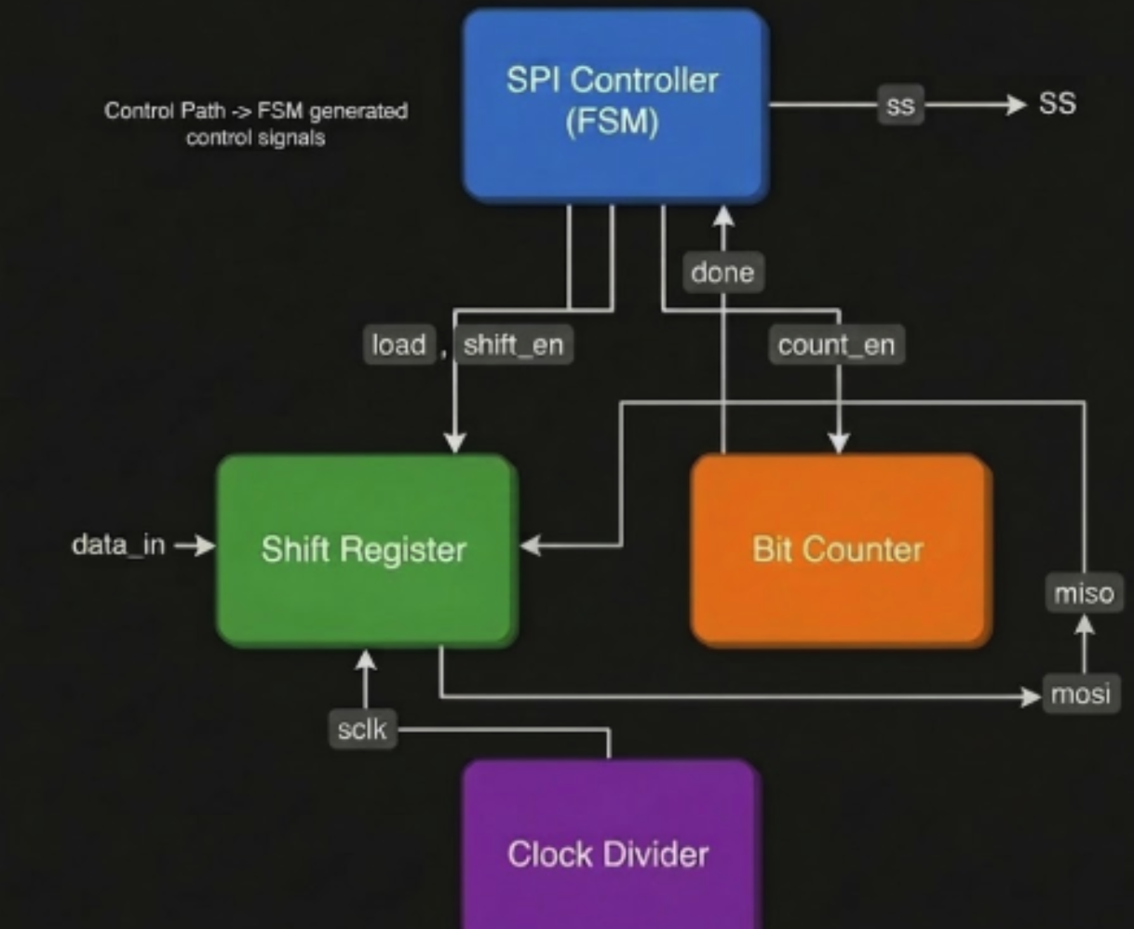

3.3 Detailed Module Description

3.3.1 Clock Divider
The clock divider takes the system clock and divides it to get the clock required for the SPI protocol. Because SPI communication usually runs slower than the system clock, the clock divider adjusts the clock frequency to an adequate level.
The output signal generated by the clock divider consists of clock pulses that repeat at a specific interval defined by the divider value. Additionally, this block outputs a clock enable signal, which ensures data transfer at specified clock edges only.​

3.3.2 SPI Controller (Finite State Machine)
SPI module uses a finite state machine (FSM). The FSM consists of several states which include IDLE, LOAD, and TRANSFER. In IDLE mode, the system waits for the start signal. Once the signal occurs, the system switches to LOAD state and loads the data into the shift register. Later, the system moves to the TRANSFER state and starts serial data transfer.
During the TRANSFER state, the controller provides control signals such as shift enable and count enable that will coordinate shift register and bit counter. At this stage, the SS signal occurs, meaning that the slave device communication protocol is about to begin. Finally, after transmitting all bits, the system receives the done signal from the bit counter and moves to the IDLE state.

3.3.3 Shift Register
Shift register carries out operations of serial sending and receiving of data. This unit converts parallel data into serial using parallel loading mechanism in the MOSI line.​
The shift enabling depends on the shift enable signal and proceeds according to SPI clock signal. Every time the clock goes up, data is shifted by one position. In other words, during every clock cycle, there takes place the movement of information along the shift register. Additionally, data from the input (MISO) line gets saved in the register. This means that this process allows full-duplex communication between the SPI master and slave.

3.3.4 Bit Counter
Another element responsible for the synchronization of information exchange processes in the SPI protocol is the bit counter which counts the amount of transmitted bits. If shifting is going on, the bit counter increases the count of the number of bits at every clock pulse.
When the required number of bits is transferred, the bit counter generates the done signal that will help the controller end the transmission process and return to its initial IDLE state.​

3.4 SPI Modes and Parameterization
All modes of SPI operation are implemented in the SPI master core since both CPOL and CPHA parameters are configurable. Thus, it is clear that these two parameters determine the mode of SPI clock operation and the point when data is sampled.
The parameter CPOL is responsible for setting the state of the clock signal in the idle state, whereas CPHA defines the point when the data will be sampled depending on the edge of the clock signal.
In addition, the designed module contains parametrization, which implies that the data width may be modified depending on the other parameters.

3.5 RTL Design and Functional Simulation
The SPI master core is modeled in Verilog HDL. All modules are developed and combined in order to create the model of the core. The process of testbench development is performed for the functional validation of the design.​
Simulation is performed for the design using Xilinx Vivado. For this purpose, the stimulus input such as clock, reset, start signal, and data input signals is provided. Waveform analysis gives insight into the performance of critical signals such as MOSI, MISO, SCLK, SS, and busy signals. The result of simulation indicates the correctness of design performance in terms of correct data transfer and functioning of the FSM.

3.6 Synthesis using Cadence Genus
Once the design is validated through waveforms and simulation, the next step is to synthesize the design using Cadence Genus. In synthesis, first, HDL code is imported and linked to the standard cell library, and finally constraints are applied and optimized.
In our case, a TCL script is employed for performing synthesis steps such as generic synthesis, technology mapping, and optimization. The output of the synthesis includes netlist, timing, area, and power reports.
From synthesis results, we can see the performance of the designed logic which meets timing requirements with minimum hardware usage.​

3.7 Physical Design using Cadence Innovus
The netlist generated from synthesis is used in Cadence Innovus for physical design. The physical design process comprises the following: floorplanning, placement, and routing.
Floorplanning includes determining the core area and creating the placement areas. Placements in the form of standard cells are carried out in the core area itself. Optimal placement is achieved to avoid congestion and achieve better timings.
Routing entails connections of all components by using metal layers. Both global routing and detail routing have been undertaken.

3.8 Power Planning and Routing
An important aspect of the physical design process is power planning. This enables us to provide power and ground connections across the entire chip. For the power and ground connections in our design, VDD and VSS have been established during floorplanning and routing.
Power delivery network has been achieved by dedicated routing channels to provide VDD and VSS across the entire core area. Particular emphasis has been placed on ensuring each standard cell is properly connected to the power and ground network.​
The signals have been routed according to the design rules without causing any congestion. The power routing will take care of the signal integrity issues for effective functioning of the circuitry.

3.9 GDSII Generation
Lastly, the layout is exported in the form of a GDSII file format by employing stream out feature present in Cadence Innovus tool. It includes geometric information needed for the manufacturing of the chip with metal layers and interconnects.

3.10 Complete Design Flow Summary
The overall design flow followed in this project can be summarized as:
RTL Design → Functional Simulation → Synthesis (Cadence Genus) → Floorplanning → Placement → Routing → Power Planning → DRC Verification → GDSII Generation
Thus, the above-discussed approach clearly demonstrates how an integrated circuit design takes shape.​

CHAPTER 4
Results and Discussion

4.1 Introduction
This chapter highlights the outcomes of the designed and implemented SPI master core through various stages of VLSI design cycle. Such outcomes include functional simulation, synthesis, place & route, and timing analysis processes executed in Xilinx Vivado, Cadence Genus, and Cadence Innovus tools respectively.​

4.2 Functional Simulation Results (Xilinx Vivado)
The functional verification of the proposed SPI master core is performed with the aid of Xilinx Vivado software. An extensive test bench is established for testing the proposed design through the application of clock, reset, start signal, and input data. Significant signals of the proposed design including MOSI, MISO, SCLK, SS, busy and done signals are recorded in the simulation waveform.
Analysis of the waveform reveals that the SPI master core functions effectively. The SPI master core transitions from IDLE to LOAD and then to TRANSFER states after starting the start signal. Input data is loaded into the shift register and then transferred serially via the MOSI signal through the SPI clock (SCLK).​
The active state of the SS signal is determined to be low during the data transfer process, thus proving the selection of slaves. The busy signal is observed to be always high during the data transfer process but turns low after completing the process. The done signal is generated when all the bits of the data word get transferred. The clock cycle count is precisely equal to the value of the data width setting, implying the accuracy in bit counting.
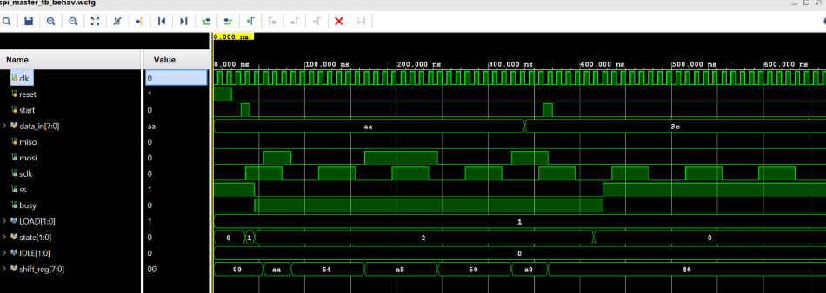
Fig: Waveform in Xilinx Vivado during Simualtion

4.3 Performance Metrics from Simulation
The performance metrics are derived based on the simulation results.

Table 4.1 Simulation Performance Metrics
Parameter | Value
Clock Period | 10 ns
Clock Frequency | 100 MHz
Data Width | 8 bits
Clock Cycles per Transfer | 9 cycles
Latency | 90 ns
Throughput | 100 Mbps
Therefore, it is evident that the data transmission process is performed effectively by the system without any delay. Since each clock cycle corresponds to one bit transfer, the data transmission rate equals the frequency of the clock signal.

4.4 Synthesis Results (Cadence Genus)
The synthesis of the RTL code is carried out using the Cadence Genus tool under the TSMC 18 nm technology library. Different outcomes of the synthesis process are obtained concerning the area utilized, power consumption, and timing.

Table 4.2 Area Analysis
Parameter | Value
Total Cell Area | 2750.933 µm²
Total Instances | 93
Sequential Cells | 23
Combinational Cells | 70
Obviously, the designed system utilizes only very little area owing to the presence of modularity.​
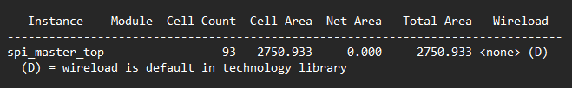

Table 4.3 Power Analysis
Component | Power (W) | Percentage
Internal Power | 1.93438 × 10⁻⁴ | 84.30%
Switching Power | 3.59380 × 10⁻⁵ | 15.66%
Leakage Power | 8.00641 × 10⁻⁸ | 0.03%
Total Power | 2.29456 × 10⁻⁴ W | 100%
It is seen from the results that the design is highly power-efficient (~0.229 mW).​
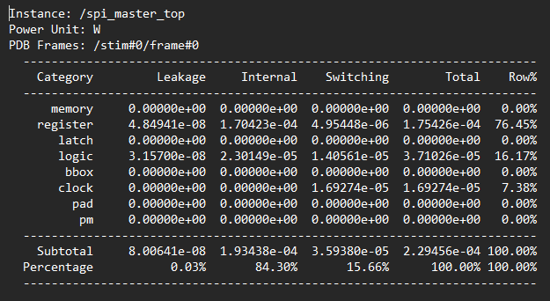

Table 4.4 Timing Analysis (Synthesis)
Parameter | Value
Clock Period | 10 ns
Worst Negative Slack (WNS) | +7.445 ns
Total Negative Slack (TNS) | 0 ns
Violating Paths | 0
The positive slack indicates that the design comfortably meets timing constraints with significant margin.
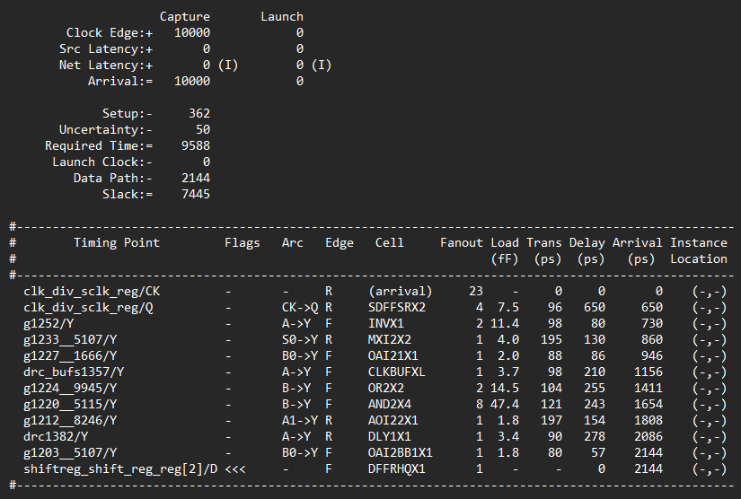

4.5 Physical Design Results (Cadence Innovus)
The generated netlist is loaded into Cadence Innovus tool for the physical design purpose. Physical Design Implementation includes Floor Planning, Placement, Clock Tree Synthesis, and Routing, and all these processes have been accomplished successfully.
The final design contains proper placement of the standard cell and adequate routing via different metal layers without any routing congestion.
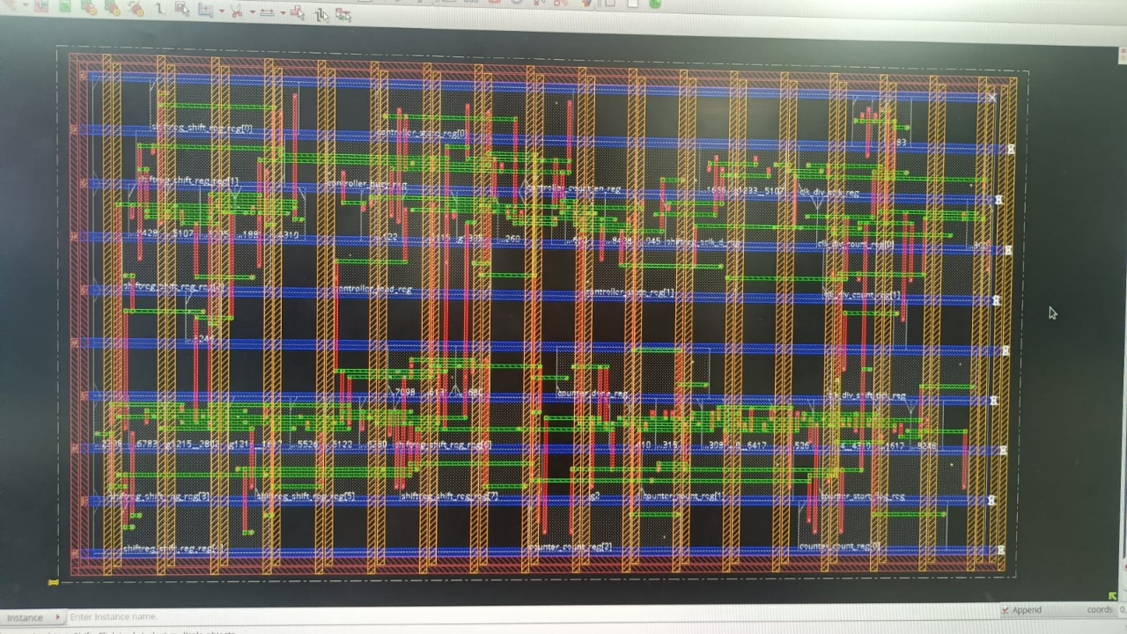
Fig: Layout before optimisation

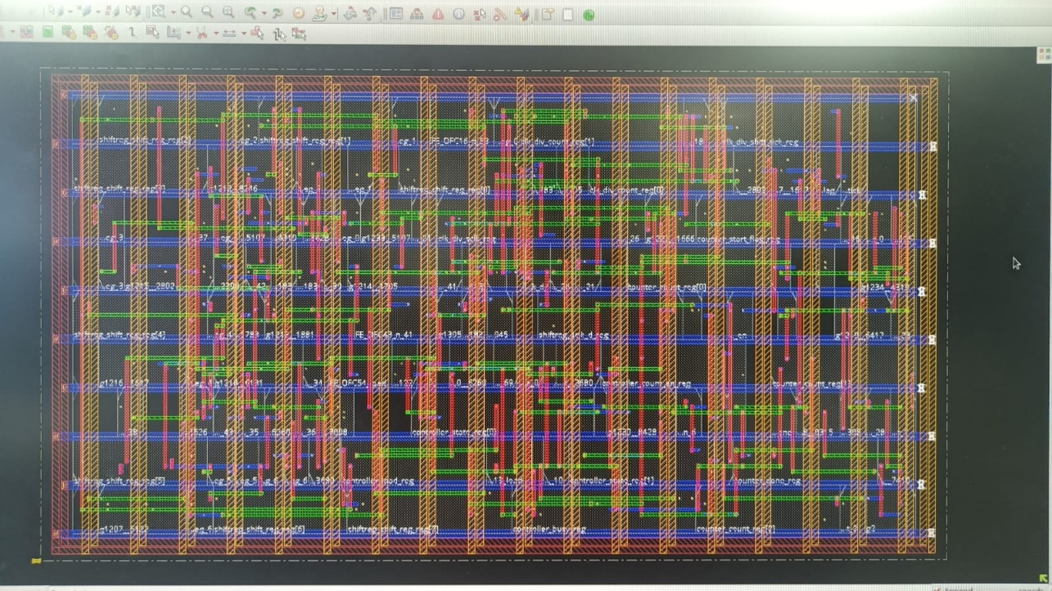
Fig: Layout after optimisation

4.6 Timing Analysis – Pre and Post Optimization
Timing analysis is performed before and after layout optimization to evaluate design performance.

Table 4.5 Setup Timing Comparison
Parameter | Pre-Optimization | Post-Optimization
WNS (ns) | 7.790 ns | 6.894 ns
TNS (ns) | 0 | 0
Violations | 0 | 0

Table 4.6 Hold Timing Comparison
Parameter | Pre-Optimization | Post-Optimization
WNS (ns) | -0.053 ns | -0.084 ns
TNS (ns) | -0.053 ns | -0.084 ns
Violations | 1 | 1

Analysis:
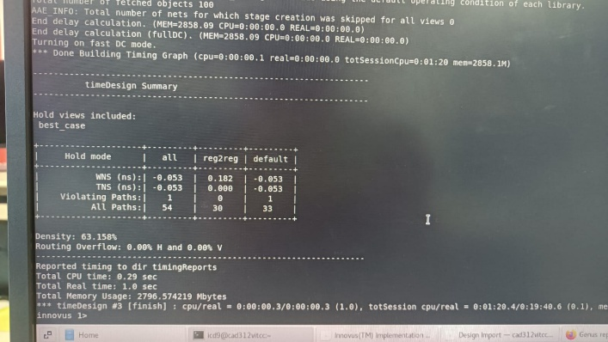
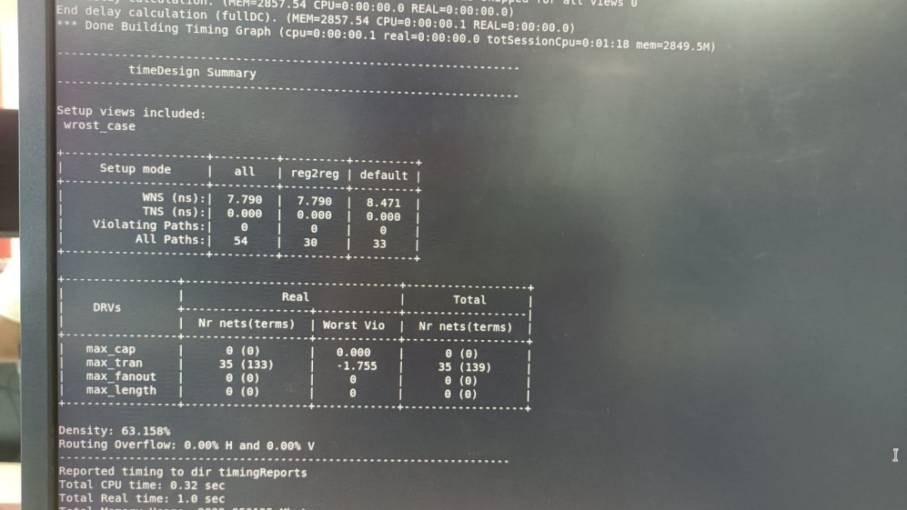
The setup timing meets all constraints in both pre- and post-optimization stages with positive slack. The slight reduction in WNS after optimization is expected due to added routing delays. A minor hold violation is observed both before and after optimization. This is a very small violation and is typically resolved through additional buffering or hold fixing techniques in advanced optimization stages.

Fig: Timing report before optimization in Cadence Innovus

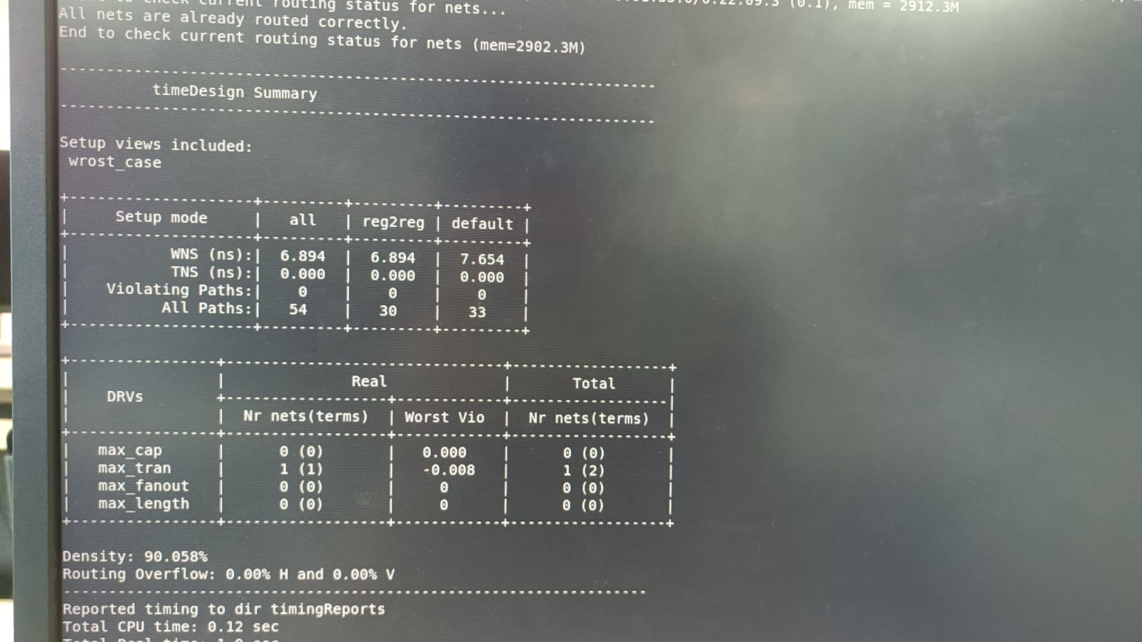
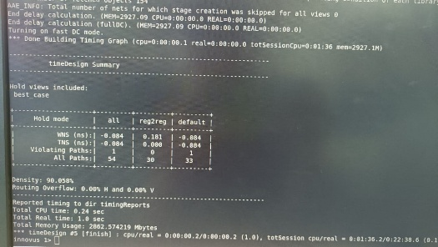

Fig: Timing report after optimization in Cadence Innovus

4.7 Routing and Layout Analysis
The routing results confirm successful connectivity of all nets. The following observations are made:

Table 4.7 Routing Summary
Parameter | Value
Routing Overflow | 0%
Cell Density | 63.15% (pre), 90.05% (post)
Congestion | None
High density shows that more area is utilized due to proper optimization. No routing congestion means that routing is efficient within the layout. Various metal layers are seen in the final design along with proper via and signal placement.
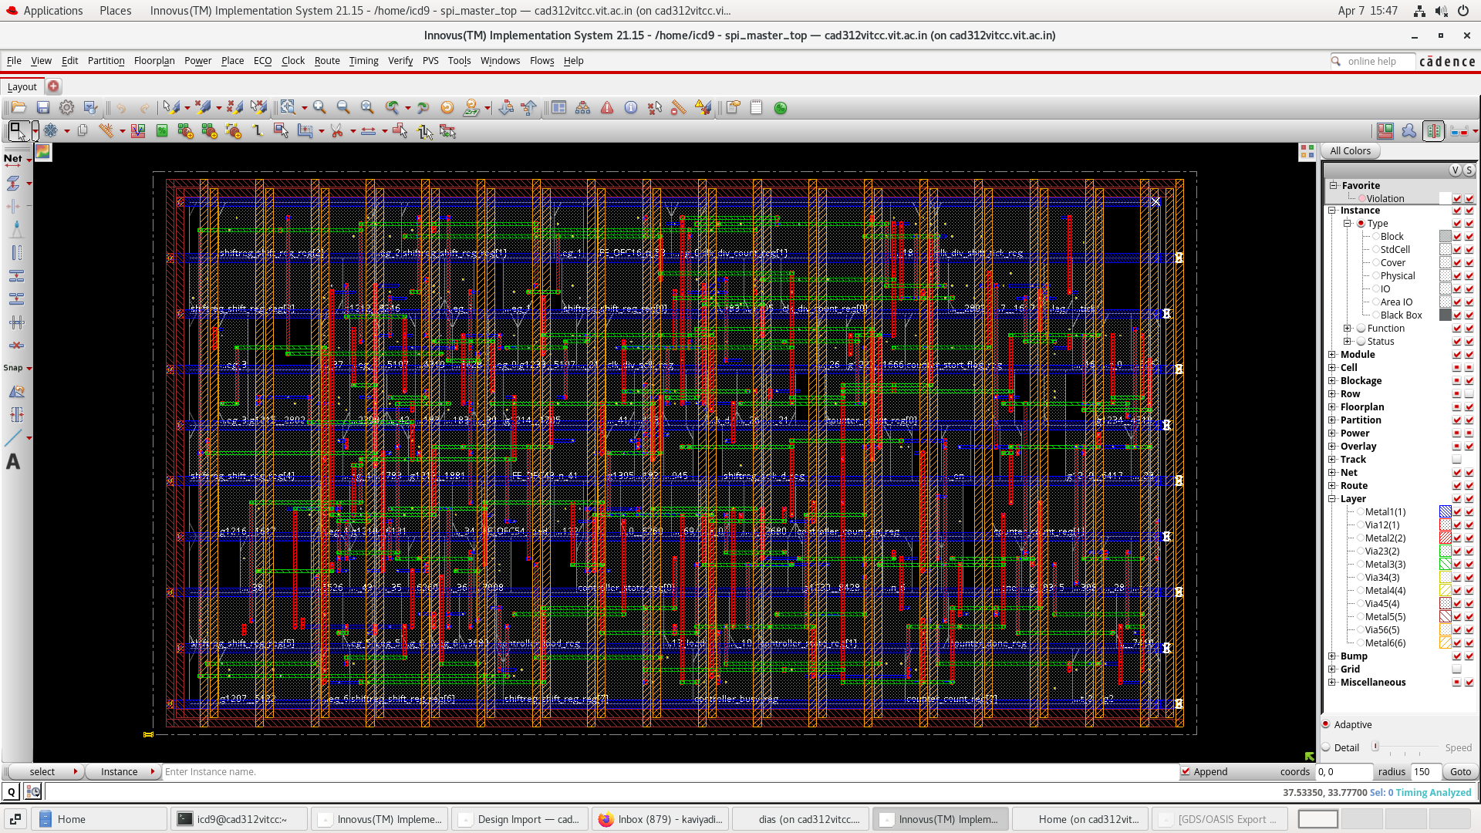
Fig: Final Layout from Cadence Innovus

4.8 Layout and GDSII Generation
All the signal integrity conditions have been satisfied in the design by the following physical design process. The layout is obtained successfully using Cadence Innovus and GDSII file has been extracted from the design layout.
GDSII represents Graphic Data System II. This is a standardized file format used for exchanging design layout information between various EDA tools. The GDSII file contains geometrical information about complete design comprising standard cells, metal layers, vias, and connectivity among them.​
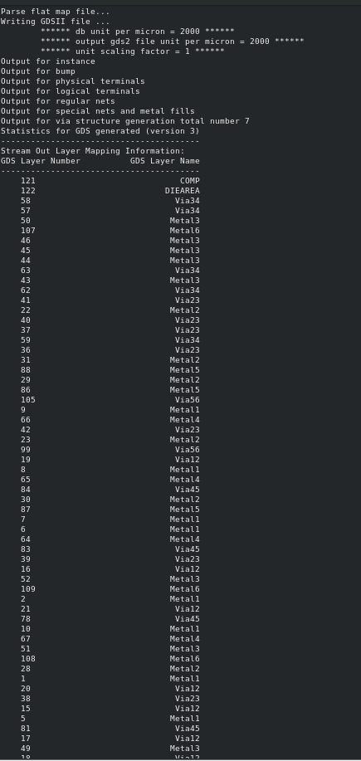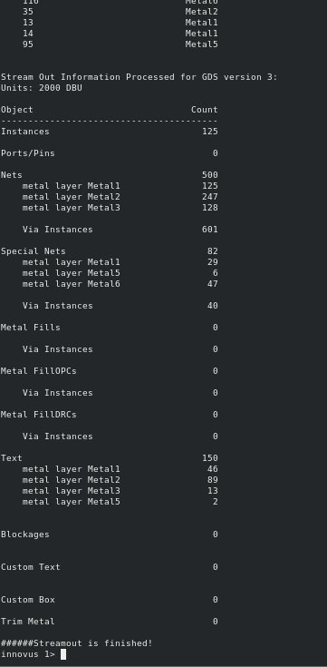
Fig: GDSII file report from Cadence Innovus

4.9 Discussion
These results demonstrate that all necessary criteria to make the suggested SPI Master Core an effective solution to the problem have been satisfied: correctness, efficiency, and scalability. Simulation results confirm correct SPI interface communication, while synthesis results demonstrate efficient area usage and low power dissipation.
As for the results of the physical design stage, it becomes clear that no problems in implementing the design on the physical layout level were encountered by the authors of the project: no congestion of routing occurred, and setup timing constraints are easily satisfied, while hold constraint violations are marginal.
The successful creation of GDSII files demonstrates that the current project is more than a simulation result, because now, in addition to the simulation stage, the project has undergone all the stages of the standard ASIC design flow (starting with the RTL and going through all the way down to the layout).

4.10 Comparative Analysis with Existing SPI Designs
In order to evaluate the effectiveness of the suggested solution to the problem, the current approach is compared to conventional SPI interface designs.​
Parameter | Existing SPI Designs (Literature Range) | Proposed SPI Master Core
Data Width | Fixed (8-bit or 16-bit) | Parameterized (configurable)
SPI Modes | Mode 0 or Mode 0 & 3 | All 4 modes (0,1,2,3)
Architecture | FSM-based, non-modular | Modular (FSM + Shift Register + Counter + Clock Divider)
Clock Frequency | 10 – 50 MHz (typical FPGA designs) | 100 MHz
Throughput | 10 – 50 Mbps | 100 Mbps
Latency | 100 – 200 ns | 90 ns
Power Consumption | 0.5 – 5 mW (typical FPGA/ASIC small cores) | 0.229 mW
Area | 3000 – 10000 µm² (depends on design) | 2750.933 µm²
Timing Analysis | Limited (functional only) | Full STA (WNS, TNS, Setup & Hold)
Physical Design | Not included in most works | Full ASIC flow (Genus + Innovus)
GDSII Output | Not available | Successfully generated
The comparison was made by considering the standard implementations of SPI master designs that have been discussed in the literature. In these designs, FPGA platforms were used to implement most designs at relatively low clock frequencies, varying from 10 MHz to 50 MHz. Most of these designs are constrained in terms of fixed data width and SPI modes.
On the other hand, the new SPI master core functions at relatively high speed, operating at a clock frequency of 100 MHz and supporting a throughput of 100 Mbps and low latency of 90 ns. The design consumes less power (0.229 mW) and occupies less space (2750.933 µm²).
Moreover, while most designs have only been functionally verified, the new design follows the complete ASIC design process, including synthesis, placement and routing, timing analysis, and GDSII generation.​

CHAPTER 5
Appendix

5.1 Appendix 1 Verilog Modules
5.1.1 SPI Top Module
module spi_master_top #( parameter DATA_WIDTH = 8 ) ( input clk, input reset, input start, input cpol, input cpha, input [DATA_WIDTH-1:0] data_in, input miso, output mosi, output sclk, output ss, output busy ); wire shift_en; wire load; wire count_en; wire done; wire shift_tick; //Clock Divider clock_divider clk_div ( .clk(clk), .reset(reset), .cpol(cpol), .sclk(sclk), .shift_tick(shift_tick)); //Controller spi_controller controller ( .clk(clk), .reset(reset), .start(start), .done(done), .shift_en(shift_en), .load(load), .count_en(count_en),​

5.1.2 Clock Divider Module
module clock_divider(
input clk,
input reset,
input cpol,
output reg sclk,
output reg shift_tick
);
reg [1:0] count;
always @(posedge clk or posedge reset)
begin
if(reset)
begin
count <= 0;
sclk <= cpol; // idle level based on CPOL
shift_tick <= 0;
end
else
begin
count <= count + 1;
if(count == 1)
begin
sclk <= ~sclk; // toggle clock
shift_tick <= 1; // generate tick
end
else
shift_tick <= 0;
end
end
endmodule
5.1.3 SPI Controller Module
module spi_controller(
input clk,
input reset,
input start,
input done,
output reg shift_en,
output reg load,
output reg count_en,
output reg ss,
output reg busy
);
reg [1:0] state;
parameter IDLE = 2'b00;
parameter LOAD = 2'b01;
parameter TRANSFER = 2'b10;
always @(posedge clk or posedge reset)
begin
if(reset)
begin
state <= IDLE;
ss <= 1;
busy <= 0;
load <= 0;
shift_en <= 0;
count_en <= 0;
end
else
begin
case(state)
IDLE:
begin
ss <= 1;
busy <= 0;
load <= 0;
shift_en <= 0;
count_en <= 0;
if(start)
state <= LOAD;
end
LOAD:
begin
ss <= 0;
busy <= 1;
load <= 1;
shift_en <= 0;
count_en <= 0;
state <= TRANSFER;
end
TRANSFER:
begin
load <= 0;
shift_en <= 1;
count_en <= 1;
if(done)
state <= IDLE;
end
endcase
end
end
endmodule
5.1.4 Shift Register Module
module shift_register #(
parameter DATA_WIDTH = 8
)(
input clk,
input reset,
input load,
input shift_en,
input sclk,
input cpha,
input [DATA_WIDTH-1:0] data_in,
input miso,
output mosi
);
reg [DATA_WIDTH-1:0] shift_reg;
reg sclk_d; // delayed version of sclk
assign mosi = shift_reg[DATA_WIDTH-1];
// Edge detection
always @(posedge clk or posedge reset)
begin
if(reset)
sclk_d <= 0;
else
sclk_d <= sclk;
end
wire rising_edge = (sclk == 1 && sclk_d == 0);
wire falling_edge = (sclk == 0 && sclk_d == 1);
// SPI mode-based shifting
wire shift_edge;
assign shift_edge = (cpha == 0) ? falling_edge : rising_edge;
// Shift register logic
always @(posedge clk or posedge reset)
begin
if(reset)
shift_reg <= 0;
else if(load)
shift_reg <= data_in;
else if(shift_en && shift_edge)
shift_reg <= {shift_reg[DATA_WIDTH-2:0], miso};
end
endmodule
5.1.5 Bit Counter Module
module bit_counter #(
parameter DATA_WIDTH = 8
)(
input clk,
input reset,
input enable,
input shift_tick,
output reg done
);
reg [$clog2(DATA_WIDTH):0] count;
reg start_flag;
always @(posedge clk or posedge reset)
begin
if(reset)
begin
count <= 0;
done <= 0;
start_flag <= 0;
end
else if(enable)
begin
if(shift_tick)
begin
if(start_flag == 0)
start_flag <= 1; // delay first shift
else
begin
if(count == DATA_WIDTH-1)
begin
count <= 0;
done <= 1;
end
else
begin
count <= count + 1;
done <= 0;
end
end
end
end
else
begin
count <= 0;
done <= 0;
start_flag <= 0;
end
end
endmodule

5.1.6 Test Bench `timescale 1ns / 1ps module spi_master_tb; parameter DATA_WIDTH = 8; reg clk; reg reset; reg start; reg cpol; reg cpha; reg [DATA_WIDTH-1:0] data_in; reg miso; wire mosi; wire sclk; wire ss; wire busy; // DUT spi_master_top #(.DATA_WIDTH(DATA_WIDTH)) uut ( .clk(clk), .reset(reset), .start(start), .cpol(cpol), .cpha(cpha), .data_in(data_in), .miso(miso), .mosi(mosi), .sclk(sclk), .ss(ss), .busy(busy) ); // Clock Generation always #5 clk = ~clk; // 10ns clock initial begin // Initializing clk = 0; reset = 1; start = 0; cpol = 0; cpha = 0; data_in = 8'hAA; miso = 0; // Reset #20; reset = 0; // Start Transmission #10; start =​

CHATER 6
Conclusion and Future Work

6.1 Conclusion

In this project, a parameterized multi-mode SPI master core has been successfully designed, implemented, and verified using a complete VLSI design flow. The design supports configurable data width and all four SPI modes (Mode 0, 1, 2, and 3) through CPOL and CPHA settings, making it flexible and compatible with a wide range of peripheral devices. The functionality of the SPI master core was first validated through simulation using Xilinx Vivado. The simulation results confirmed correct operation of all key signals, including MOSI, MISO, SCLK, SS, busy, and done, along with proper FSM transitions and synchronized data transfer. The design was then synthesized using Cadence Genus, where it demonstrated efficient hardware utilization with a total cell area of 2750.933 µm² and low power consumption of approximately 0.229 mW. Timing analysis at the synthesis stage showed a positive slack of 7.445 ns, indicating that the design comfortably meets timing constraints. Further, the design was implemented physically using Cadence Innovus, where successful floorplanning, placement, and routing were achieved without congestion. Post-layout timing analysis confirmed that setup timing requirements were satisfied with positive slack, while only a minor hold violation was observed, which is typical and can be resolved with further optimization techniques. The final layout was generated, and the GDSII file was successfully obtained, demonstrating that the design is physically complete and ready for fabrication. This highlights that the project goes beyond basic RTL simulation and covers the complete ASIC design flow from RTL to layout. Overall, the proposed SPI master core achieves high performance with a throughput of 100 Mbps, low latency of 90 ns, reduced power consumption, and compact area. The modular architecture and parameterization significantly improve scalability, reusability, and design flexibility compared to conventional SPI implementations.

6.2 Future Work

Although the designed master core meets all the required criteria, the following points could be considered as a way of improving its performance:

- Support of Multiple Slaves
- Though the designed system can operate with one slave, the use of multiple slaves can be considered in the future by using multiple SS pins.
- Advanced Hold Violation Fixing
- Hold violation during the timing analysis can be overcome by using certain approaches like buffer insertion and optimum clock skew.
- Compatibility with Processor Systems
- The interface between the designed master core and the external processor system can be done using AXI or APB interfaces. Low-Power Design Clock gating and power gating can be implemented in order to reduce power consumption. Design for High Speed The SPI core design can be improved in order to meet high-speed performance, i.e., operate with a higher frequency. FPGA Prototyping An FPGA can be implemented in order to interface with the SPI peripherals and test the design.​
- DFT (Design for Testability)
- Features such as scan chain insertion and the creation of test vector sequences can be added for testability in production. Full Chip Integration SPI Master Core can be incorporated as a subsystem in a large ASIC project such as an IoT device or any other embedded system design.​

Bibliography
[1] A. Sharma and P. Singh, “Design and implementation of SPI master core using Verilog HDL,” International Journal of Engineering Research, vol. 8, no. 3, pp. 112–118, 2019.

[2] R. Mehta and S. Iyer, “FSM-based SPI master controller design for serial communication,” IEEE International Conference on Communication Systems, 2020, pp. 210–214.

[3] K. Verma, A. Gupta, and R. Singh, “High-speed SPI interface design for embedded systems,” Springer Journal of Electronics and Communication, vol. 5, no. 2, pp. 89–96, 2021.

[4] S. Rao and M. Kulkarni, “Configurable SPI core design for FPGA applications,” IEEE International Conference on VLSI Systems, 2021, pp. 145–150.

[5] J. Lee and H. Kim, “FPGA-based SPI communication system design and implementation,” IEEE Access, vol. 6, pp. 45678–45685, 2018.

[6] M. Patel and D. Shah, “Low-power SPI master design for embedded systems,” International Journal of Low Power Electronics, vol. 9, no. 4, pp. 233–240, 2022.

[7] Y. Chen, X. Liu, and Z. Wang, “Multi-slave SPI communication architecture for embedded applications,” Elsevier Microprocessors and Microsystems, vol. 74, pp. 102–110, 2020.

[8] T. Nguyen and L. Tran, “Parameterized SPI master core design for scalable communication systems,” IEEE Transactions on VLSI Systems, vol. 30, no. 6, pp. 789–797, 2022.

[9] P. Gupta and R. Jain, “SPI controller design with improved timing synchronization,” Springer Journal of Circuits, Systems and Signal Processing, vol. 40, no. 3, pp. 1456–1465, 2021.

[10] L. Wang and X. Zhao, “ASIC implementation of SPI communication interface,” IEEE Transactions on Semiconductor Manufacturing, vol. 32, no. 2, pp. 210–217, 2019.

[11] Motorola Inc., “SPI Block Guide V04.01,” 2003. [Online]. Available: https://www.nxp.com

[12] N. Weste and D. Harris, CMOS VLSI Design: A Circuits and Systems Perspective, 4th ed. Boston, MA, USA: Pearson, 2011.

[13] J. Rabaey, A. Chandrakasan, and B. Nikolic, Digital Integrated Circuits: A Design Perspective, 2nd ed. Upper Saddle River, NJ, USA: Prentice Hall, 2003.

[14] S. Brown and Z. Vranesic, Fundamentals of Digital Logic with Verilog Design, 3rd ed. New York, NY, USA: McGraw-Hill, 2014.
[15] Cadence Design Systems, “Genus Synthesis Solution User Guide,” 2023. [Online]. Available: https://www.cadence.com

[16] Cadence Design Systems, “Innovus Implementation System User Guide,” 2023. [Online]. Available: https://www.cadence.com

[17] Xilinx Inc., “Vivado Design Suite User Guide: Simulation,” 2023. [Online]. Available: https://www.xilinx.com

[18] K. C. Chang, “Digital communication interfaces: SPI, I2C, and UART protocols,” IEEE Communications Magazine, vol. 55, no. 3, pp. 150–156, 2017.

[19] B. Razavi, Design of Integrated Circuits for Optical Communications, 2nd ed. New York, NY, USA: McGraw-Hill, 2012.

Biodata


Name: Kaviya Dias Aro S
Mobile No.: 9566320530
E-mail: kaviyadias.aros2022@vitstudent.ac.in
Permanent Address: 1177/3D, 11th cross, NTR nagar, Mookondapalli, Hosur – 635126

