project report on
Custom Honeypot for Attacker Behavior Analysis Using Centralized Monitoring and Blockchain
Submitted in partial fulfillment for the award of the degree of

Bachelor of Technology in Computer Science and Engineering with specialization in Cyber Physical System

by
Pranav T J(22BEE1134)
Dineshwer R S(22BPS1082) Allwin joshua R S(22BEE1032)



SCHOOL OF COMPUTER SCIENCE AND ENGINEERING

April,2026

project report on
Custom Honeypot for Attacker Behavior Analysis Using Centralized Monitoring and Blockchain
Submitted in partial fulfillment for the award of the degree of

Bachelor of Technology in Computer Science and Engineering with specialization in Cyber Physical System

by
Pranav T J(22BEE1134)
Dineshwer R S(22BPS1082) Allwin josua R S(22BEE1032)



SCHOOL OF COMPUTER SCIENCE AND ENGINEERING

April,2026



DECLARATION

Hereby I do solemnly declare that the aforementioned thesis titled “Custom Honeypot for Attacker Behavior Analysis Using Centralized Monitoring and Blockchain” written by Pranav TJ (Roll No. 22BEE1134) as a part of their degree program B.Tech in Electrical & Electronics Engineering with minors in Computer Science Engineering from Vellore Institute of Technology, Chennai, is my genuine effort conducted under the guidance of Dr. Balraj E (Assistant Professor).
Apart from this, I hereby solemnly affirm that the research carried out and documented in the said thesis has neither been presented anywhere else nor will it be presented in the future anywhere else as a part of an academic qualification.​

Place: Chennai
Date: Signature of the Candidate



School of Computer Science and Engineering

CERTIFICATE
Authorship Statement: The above-mentioned report titled "Custom Honeypot for Attacker Behavior Analysis Through Centralized Monitoring and Blockchain" authored by Pranav TJ (22BEE1134), which is a prerequisite submission to the Vellore Institute of Technology, Chennai, for obtaining the Bachelor of Technology in Electrical and Electronics Engineering, with minors in Computer Science Engineering, is an honest report prepared under my guidance. This report adheres to all the rules set forth by the institute, and I am convinced that this report meets all the criteria of submission. None of the content provided in this report has been or will be used elsewhere to acquire any other degree or diploma in the future.​

Signature of the Guide:
Name: Dr. Balraj E Date:

Signature of the Examiner Signature of the Examiner
Name: Name:
Date: Date:

Approved by the Head of Department,
Electrical and Electronics Engineering with Minors in Computer Science Engineering
Name: Dr. Angeline Ezhilarasi .G Date:

ABSTRACT
A secure shell (SSH) protocol is considered one of the most critical protocols often utilized in an effort to get remote access. As such, many types of attacks can be committed against this protocol, such as a brute force attack or an unauthenticated login attempt. Honeypots can be seen as valuable tools used to protect oneself from attacks and determine the motives of an attacker. Nevertheless, conventional SSH honeypots suffer from several issues, including complicated configuration procedures, inability to control communications, and data integrity. The current study focuses on an SSH honeypot designed to analyze the behavior of attackers based on the use of virtual file systems and integrity verification of logs using blockchain technology.​
These attacker-related actions are recorded in structured logs that will eventually be shown on the dashboard. Moreover, all sessions are registered as SHA-256 hashes in the blockchain to make logs unalterable, hence providing reliable information for forensic analysis. To put it differently, one can state that the results provided show that the created system successfully solves tasks related to the registration of attacker's actions and ensures system security through isolation methods and blockchain technology used for logging purposes. In other words, one can conclude that the suggested system provides a powerful and effective way of cyber attack research. Additionally, this system can create an absolutely safe environment that will allow one to monitor the activity of the attacker permanently without risking damaging life support systems. This tool will help researchers analyze and investigate cyber-attacks.​

i

ACKNOWLEDGEMENT
It is my pleasure to express with deep sense of gratitude to Balraj E
Firstly, I would like to express my sincere gratitude towards Assistant Professor, School of Computer Science & Engineering, VIT Chennai, for their invaluable guidance and motivation throughout the project.
My sincere gratitude goes to the visionaries:
Dr. G Viswanathan, Honorable Chancellor, Mr. Sankar Viswanathan, Dr. Sekar Viswanathan, Dr. G V Selvam, Vice Presidents, Dr. Sandhya Pentareddy, Executive Director, Ms. Kadhambari S. Viswanathan, Assistant Vice President, Dr. V.S.Kanchana Bhaaskaran, Vice Chancellor, Dr. T. Thyagarajan, Pro-Vice Chancellor, VIT Chennai, Dr. P.​
Additional Registrar K. Manoharan for creating a wonderful environment for working and motivating us throughout the course of our studies. Deep from within my heart, I would like to express my heartfelt gratitude to Dr. Viswanathan V, Dean, Dr. Nithyanandam P, Dr. Suganya G, and Dr. Sweetlin Hemalatha C, Associate Deans, School of Computer Science and Engineering, Vellore Institute of Technology, Chennai, for spending their valuable time and energy in guiding us and enlightening us with their wisdom. With utmost happiness in my heart, I would like to thank Dr. Tulasi Prasad, Head of the Department, B.Tech Computer Science and Engineering with Artificial Intelligence and Machine Learning, and the Project Coordinators for their remarkable efforts towards the completion of this project.
From the bottom of my heart, I would like to thank all the faculty members and other staff members of VIT, Chennai, who have helped me gather the relevant data concerning this subject matter. I am grateful to my parents for supporting my research study on this subject matter.​
Place: Chennai
Date: Pranav TJ

CONTENTS

CONTENTS
………………………………………………………………ⅲ

LIST OF FIGURES v
LIST OF TABLES vii
LIST OF ACRONYMS viii
CHAPTER 1 INTRODUCTION
  - INTRODUCTION 1
  - PROBLEM STATEMENT 2
  - SCOPE OF THE STUDY 3
CHAPTER 2 LITERATURE REVIEW
  - LITERATURE REVIEW 4
  - RESEARCH CHALLENGES 6
CHAPTER 3
PROPOSED ARCHITECTURE AND METHODOLOGY
  - PROPOSED SYSTEM 7
  - SYSTEM ARCHITECTURE 9
  - HONEYPOT AND VIRTUAL FILESYSTEM 18
  - BLOCKCHAIN-BASED LOGGING 22
  - MONITORING SYSTEM 25
  - SUMMARY 26
CHAPTER 4
RESULTS AND OUTPUT
  - IMPLEMENTATION OVERVIEW 27
  - HONEYPOT IMPLEMENTATION 29
  - BLOCKCHAIN VERIFICATION RESULTS 41
  - VIRTUAL FILESYSTEM IMPLEMETAION 48
  - PERFORMANCE ANALYSIS 50
CHAPTER 5 CONCLUSION
  - CONCLUSION 52
  - LIMITATION 54
  - FUTURE WORK 56

REFERENCES 58

LIST OF FIGURES

Fig. no | Title | page no
1 | System Overview | 7
2 | System Architecture | 9
3 | Flow Diagram | 11
4 | System Data FlowChart | 12
5 | SSH Connection Flowchart | 16
6 | Virtual File System | 19
7 | Consensus and Block formation | 23
8 | SIEM Monitoring tool Dashboard | 28
9 | SIEM Monitoring tool authentication | 32
10 | Blockchain Logs | 41

LIST OF TABLES

Table no | Content | page no
1 | Overall components | 8
2 | Security Threat Model | 14
3 | Comparison of Existing Honeypots and Proposed System | 17
4 | API Endpoint Documentation | 20
5 | Smart Contract Logic Mapping | 22
6 | Transaction Lifecycle | 24
7 | Consensus Mechanism Details | 26

LIST OF ACRONYMS
SSH - Secure Shell VM - Virtual Machine
IDS - Intrusion Detection System IPS - Intrusion Prevention System
SIEM - Security Information and Event Management CLI - Command Line Interface
FS - Filesystem
VFS - Virtual Filesystem IP - Internet Protocol
TCP – Transmission Control Protocol
SHA-256 - Secure Hash Algorithm 256-bit PoC - Proof of Concept
DoS - Denial of Service MITM - Man-in-the-Middle
CTI - Cyber Threat Intelligence OS - Operating System
CPU - Central Processing Unit

Chapter 1 INTRODUCTION

INTRODUCTION

ELK – Elasticsearch, Logstash, Kibana
API – Application Programming Interface JSON – JavaScript Object Notation Due to the trends for cloud computing and other kinds of internet-based management, cases occurred in which critical systems have become victims to the breach of their security through attacks that took place on the basis of cyberspace. The secure shell protocol has fallen victim to cyber attacks made by hackers who have tried to break it using techniques like brute force attacks. Apart from detecting these attacks and stopping them, it is crucial to learn about the actions performed by the attackers in order to enhance the security of the system even further. The issue with the conventional technique, such as firewalls and IDS, is that they cannot give us an understanding of how the attackers perform. Therefore, to overcome this issue, SSH honeypots have been developed since they belong to deceptive technologies that allow the attacker to interact with them. Nevertheless, there are many issues with the present SSH honeypots.​
In order to address this problem, this research paper suggests a new SSH honeypot framework that gives the ability to interact with the attackers realistically while maintaining system security through virtual file systems. The actions of the attackers will be limited to the virtual files only without any connection to the real system. Furthermore, the employment of the blockchain technology to record logs during log interaction by recording session logs on the blockchain is applied in this research work. This enables the analysis of the attacker’s actions through forensic examination of the logs using blockchain technology.​

PROBLEM STATEMENT
SSH, which is one of the services that can be attacked because of its vulnerability when exposed to the Internet and depending on various forms of authentication, enables hackers to access the network via the exploitation of the vulnerable service mentioned above. Although the use of SSH technology has been extensively used in studying attacker behavior, some problems remain associated with the use of such techniques. To begin with, most of them involve complex setups and installation processes. In addition, they do not provide sufficient control of the attacker’s actions, thereby leading to the creation of artificial behavior models for them. Lastly, most SSH honeypots are dependent on other software to monitor attacker activities.​
Yet another problem that arises due to the tools currently being used is related to the quality of the logs produced by the latter. For example, such logs usually contain data in clear format that is easily amendable or deletable. What is more, the information provided by the log cannot be of use in any further analysis.​
To make up for these disadvantages, the main goal of the research is to create a proper SSH honeypot system, which will contribute to the analysis of such attacks. This honeypot should imitate the behavior of the real system and allow the hackers to freely work with the system without granting access to any information. Moreover, the goals of this study would include creating a totally isolated file system to protect the honeypot from being compromised and also the computer network it functions in. Furthermore, another aspect to be covered within this project is to develop a system to integrate all hacker activities (attempting to log into the system and executing commands). Finally, the utilization of blockchain technology would ensure safe logging of this activity.

SCOPE OF THE STUDY
The scope of this project is to develop a new SSH honeypot system.​

Firstly, this is about utilizing the virtual filesystem to execute the commands in order for the actions of the attacker to remain limited within the virtual filesystem without affecting the system. Blockchain technology is employed to ensure the security of logs and enable forensic investigation. The whole process of implementing this system is carried out in the virtual environment itself. Testing is done using brute force attacks and running of the command in the virtual environment. Even though the system is working perfectly well on analyzing the actions of attackers, improvements can be made in analytics and machine learning for optimal utilization of dashboards.

Chapter 2 Literature Review

LITERATURE REVIEW
Lately, advancements have taken place concerning predicting rainfall using machine learning, deep learning, and explainable AI techniques.​
In the realm of cybersecurity, emphasis is shifting towards approaches that could be useful in deterring the occurrence of the attacks while also studying the activities of the attacker. As such, honeypot is a growing research area where the attacker is lured and tricked into a virtual environment that observes their activities. For instance, Spitzner's previous works on honeypot emphasized the importance of the same as a method of deceiving the attacker and analyzing attacks and not blocking attacks. Another significant classification of honeypots is that done by Provos and Holz.​
Though low-interaction honeypots may emulate various services, high-interaction honeypots provide a full environment that allows analyzing the actions of an intruder even after a compromise occurred. While low-interaction honeypots are relatively simple to create, as they involve low realism and can easily be detected by intruders, high-interaction honeypots involve greater risks as attackers gain total control of the computer system. To overcome these disadvantages of both kinds of honeypots, the necessity of developing hybrid honeypots arises, and currently this trend becomes quite popular.
There are several SSH honeypots (for instance, Cowrie and Kippo) that are used to examine the behaviors of an intruder (such as brute force or command attacks on the system). Information that can be obtained through analysis of an attack comprises credentials of the attacker, sets of commands employed, and probing. It is known that there are specific patterns of attacks that include scanning, authentication attempts, and finally, probing, which can contribute to the improvement of intrusion systems.
Currently, there are numerous innovations concerning the use of honeypots. First of all,​

Also, some experts recommend using IDS together with honeypots, studying their results, and taking actions accordingly. There exist numerous types of IDS; one of them is worth considering by example: Snort and SIEM may serve as good options. Second, as another researcher states, machine learning techniques would be rather efficient in terms of the classification process. Nevertheless, although there is much to benefit from these techniques, it is obvious that the use of both implies the implementation of certain software tools.
First of all, one of the main problems associated with log management and considered in literature concerns its safety and reliability. First of all, conventional honeypots store the logs in the plaintext format, which makes them open to possible attacks and manipulations with logs and makes them less useful for forensic purposes. Therefore, to resolve the aforementioned issue, blockchain technology may be used in order to store only hashes of log files and not their content.​
Taking into account all mentioned above, it may be concluded that there are specific trends in terms of honeypots' development that involve high interaction and efficient log management. Nevertheless, according to modern studies, there are some issues related to the utilization of honeypots, namely, implementation complexity, inefficient interaction management, no isolation, and interference with logs.

RESEARCH CHALLENGES

Realistic Interaction with the Attacker:
It seems to be challenging to create a honeypot for a regular SSH, as interactions will be too simple and noticeable, which will enable the hacker to understand that a honeypot is at work. However, there is still a necessity to make it real but not risky.

Isolating the Entire System from Attackers:
In order to develop a system that would not allow any interferences in case the machine was hijacked by the hacker, it is necessary to consider creating an environment for interaction without executing any commands.​

Security of Log Files:
Logs that could be acquired by conducting an attack on the honeypot could be helpful when it comes to conducting investigations. However, conventional ways of ensuring the security of logs have proven themselves to be unproductive since it was rather easy to change their information. The integrity of logs must be maintained.

Performance and Efficiency:
Although there exist methods such as blockchain technology and virtualization that could help protect honeypot, one needs to understand that these methods might have a negative effect on the performance of the system.

Detection and Fingerprinting by Attackers:
Nowadays, it is rather difficult for cybercriminals to detect honeypots based on the system response and its behavior. In order to prevent being detected, it is necessary to create a system with high-level dynamism and simulate real system behavior.​

Chapter 3

PROPOSED ARCHITECTURE AND METHODOLOGY

SYSTEM OVERVIEW
It is advised to use the improved SSH honeypot system as the honeypot system. The purpose of developing such a honeypot system is to give a chance to the attacker to interact with the system without exposing the actual system. It is different from other honeypot systems in the sense that other honeypot systems require other systems for responding to the attacks. The proposed honeypot system is the complete honeypot system.
To achieve the above objective, the SSH honeypot engine would be used. The engine would be responsible for allowing the attacker to gain access to the system. After gaining access, the attacker would be able to interact with the system using the command line interface. The processing of the command issued by the attacker would be done in a virtual environment.​
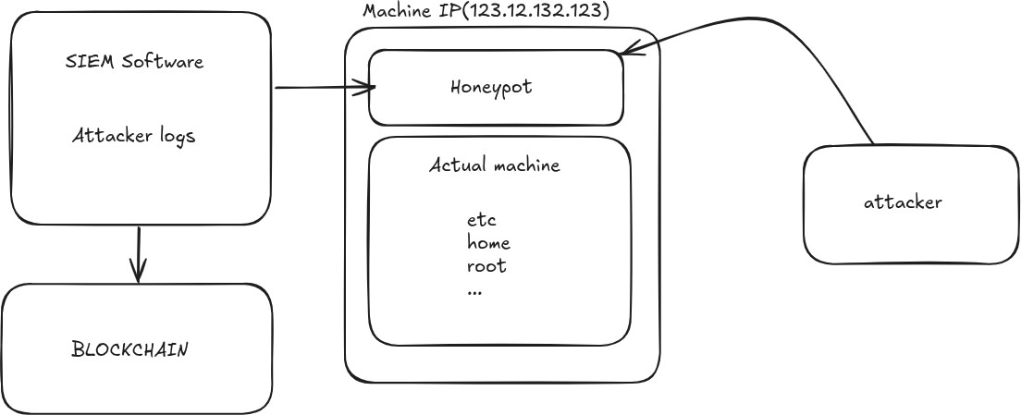

(Figure:1 System overview)
In addition to that, there exists a virtual file system in the system that functions in almost the same manner as the actual file system. Instead of carrying out the actual work as is done in reality, the system will respond to commands entered by some rules.

pre-configured functions for various commands.

Moreover, the system also possesses a logging system that captures all the actions that are carried out by the hackers. Information captured will include things like logging activities of the hacker, execution of commands, and sessions conducted by them. All this information will be analyzed using some data structures in order to examine what actions were carried out by the attackers. To make sure that the quality and the credibility of the information collected are high, there is use of blockchain technology to store session hashes.
Furthermore, the system has incorporated a lightweight monitoring system for capturing information about the activities carried out by the attackers.​
(Table 1 : Overall components)

Component | Description | Purpose
SSH Honeypot Engine | Simulates an SSH login interface and shell environment | Attracts attackers and captures behavior
Virtual Filesystem | Mimics Linux file structure and command outputs | Ensures complete host isolation
Monitoring Module | Captures attacker sessions in real time | Enables behavior analysis
Blockchain Logger | Stores SHA-256 hashes of session logs | Ensures tamper-proof evidence
Session Manager | Tracks active sessions and timestamps | Maintains session continuity

SYSTEM ARCHITECTURE
The architecture of the proposed SSH honeypot is designed in such a way that the attacker can be studied in an effective manner, and without any security risks. The system is designed using the philosophy of modularity and layering whereby the task for every single module is to do its own task in a sequential manner and without interfering with other parts of the whole process of the system. Some of the essential components of the proposed SSH honeypot include honeypot, log generation using blockchain technology, and monitoring system.
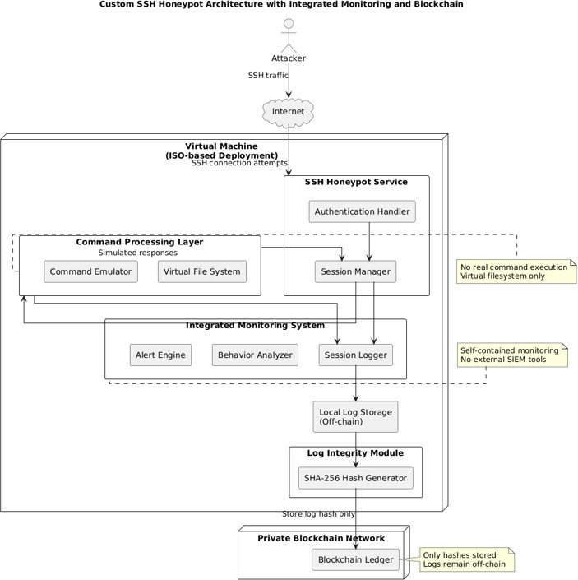

(Figure 2 : System Architecture)

From the point of view of overall interaction process flow within the system, it may be said that after the process of the attacker's attempt to create an SSH connection to the honeypot has begun, then the honeypot will try to imitate the normal process of the interface used for an SSH connection, unlike the traditional systems that would check if the credentials presented match those of any registered user.​

From the point of view of overall interaction process flow within the system, it may be said that after the process of the attacker's attempt to create an SSH connection to the honeypot has begun, then the honeypot will try to imitate the normal process of the interface used for an SSH connection, unlike the traditional systems that would check if the credentials presented match those of any registered user.​
After the completion of the authentication process successfully, the attacker will be provided with an interface similar to the real shell. All the commands will be intercepted by the system and will be sent to the virtual file system to simulate the operation without invoking the OS at all.
Virtual File System is considered to be the basic building block of this architecture which will be responsible for simulating all the operations associated with the file system and the execution of commands. The structure of the virtual file system will reflect that of a Linux based operating system wherein all directory navigation and execution operations can take place.​
The logging using blockchain technology represents the second module of the proposed framework. Any actions taken by the attacker including login attempts, executed commands, timestamp information, and other session information are logged and placed in structured logs. The session information is generated in a form of unique cryptographic hashes based on the SHA-256 algorithm and stored in a private blockchain. Thanks to the structure of blockchain technology, the immutability of the records made is guaranteed.
The third part of the framework that allows monitoring activities of attackers is the monitoring system. The logs generated using the honeypot are fed to the monitoring system. The logs are shown in structured format using the dashboard interface. The monitoring function will allow observing all the sessions performed and monitoring their progress including commands, login attempts, and other activities. In contrast to other types of frameworks, using the monitoring system does not involve additional software installation.​

COMPONENT INTERACTION FLOW
Processes of interaction take place among various components. Firstly, in the interaction process among the intruder and the system, the honeypot component will be used for handling interactions and permissions. When permission has been given, then an interaction will take place between the intruder and command shell whereby the commands are sent to the virtual file system component.
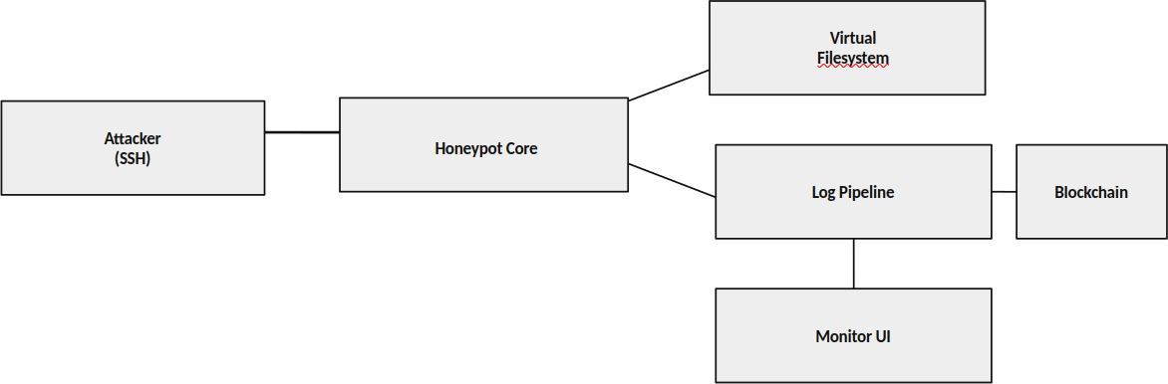

(Figure 3 : Flow Diagram)

The virtual file system will create the reply, and the reply will be sent back to the intruder via the honeypot component. Furthermore, the logging component will handle the activity by converting it into hashes and storing them on the blockchain. In contrast, the monitoring system will collect all the logs and display them on the screen.
It is evident from the diagram above that components work together in handling the task.​

DATA FLOW AND PROCESSING
Data flow within the architecture design is very much systematic in order for data management and acquisition and to ensure utmost security during the whole process. Data and information are managed and handled using the sequential method in order to ensure that data is appropriately processed to keep the data secured throughout the process. This is the way by which the system can actually mimic real-life processes and logs the actions performed by the attacker.

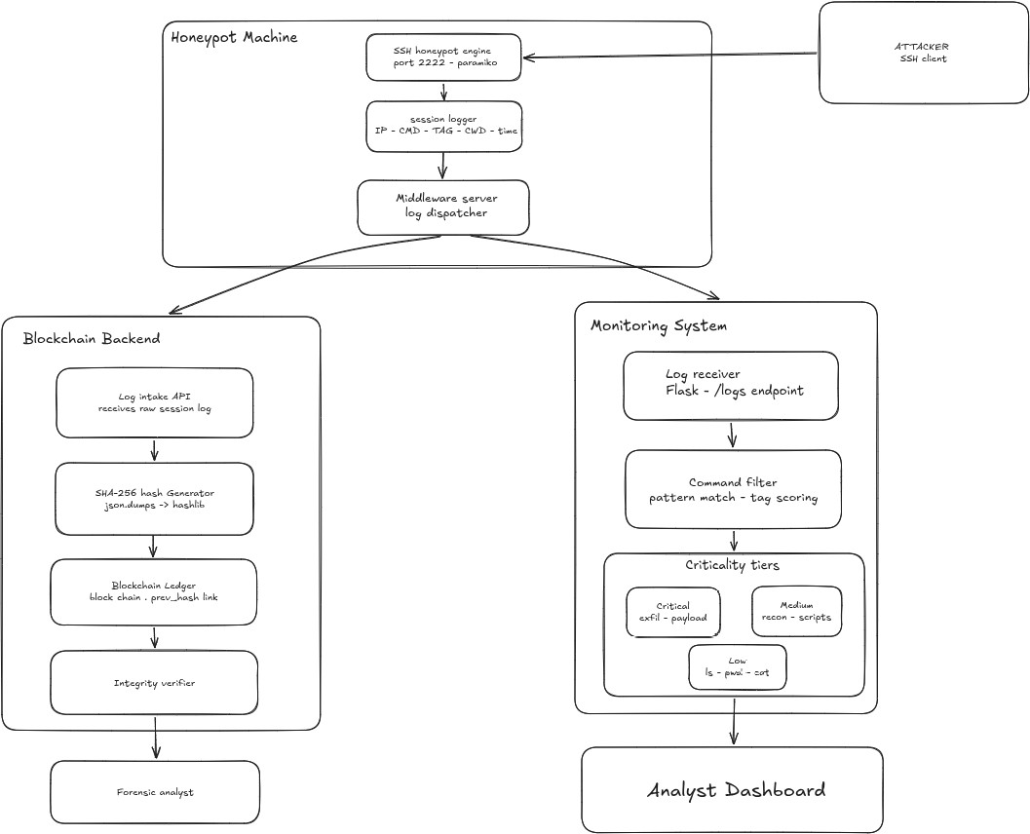

(Figure 4 : System Data Flowchart)
In the data flow process, the very first thing that happens is that the attacker creates an SSH session to the honeypot. The packets created here involve network data such as IP addresses and ports needed to connect the attack with the honeypot. After which, the honeypot module captures this information and establishes an SSH session to the attacker. After this, the attacker will be inputting his login details.​
With the credentials submitted, they are authenticated using the authentication mechanism that exists within the honeypot application. The system does not depend on the presence of matches in the database but depends on the criteria that define the commands required for accessing the system. In this case, no hacker will be restricted from accessing the computer until they are identified as such. All attempts at authentication are recorded in the session.
Following successful authentication, the attacker gains access to the command line

interface. At this point, it starts receiving the commands from the users rather than authentication credentials. The commands are collected by capturing input and then analyzed in the command handler routine.​
The command will be passed to the virtual filesystem that serves as the environment for the virtual filesystem. This virtual filesystem will interpret the command according to the predefined algorithm and structure that will be followed for the representation of files and directories. In other words, all the commands related to directories will be interpreted as virtual commands by the virtual filesystem and the necessary data will be fetched and displayed back.
The output will be displayed through the honeypot user interface by means of command handler to the attacker. The entire operation will take place in real-time, i.e., the attacker will have a feeling of a real-time operating environment with no delay in response times. The system will keep track of session states, thus maintaining consistency among the output of different commands.​
In addition, every bit of information relating to the interaction will be recorded at several stages during the process. The information consists of login requests, command executions, commands' outputs, timestamp, session IDs, and connections' information. The recorded information will be saved in log files in an organized manner and ready for further analysis. The analysis of each session will be done independently to detect any form of attack that has been carried out.
The log files will be stored on the local computer securely to ensure instant retrieval. The log files are sent to the blockchain component for verification purposes. In doing so, the SHA-256 cryptographic hash algorithm is utilized in the blockchain component. This means that the hash code will be uniquely formed depending on the file contents. As a result, any alteration of the information within the file will generate a totally different hash code.​
Hash will be written down in the blocks of the blockchain ledger. Hashes will link them between themselves. This means that it is impossible to change the stored hash, unless the ledger is modified as a whole. Thus, hashing can be considered an important procedure for protecting logs.
Secondly, the logging tool will access structured logs, presenting an overview of the

at the dashboards. In this case, it will become much easier to analyze the activity of hackers, since data will be presented in the form of easily legible logs. The following information will be extracted by using the logging tool: login attempts, actions, time and connections.
From the point of view of performance, there will be no issues related to inefficiency, because everything will be accomplished properly and without any performance concerns. As it was mentioned before, all the procedures will be performed within the virtual file system, which means that no resources will be accessed. Therefore, low power will be consumed. Using hybrid logging, which uses the hash of the command instead of the command itself, will contribute to reducing system load.​
All of this will lead to interaction between the attacker and the program, isolation of the attacked system, integrity of data, and, finally, monitoring of interactions. All this matters if the system operates efficiently.
(Table 2 : Security Threat Model)
Threat Vector | Description | Impact Level | Mitigation Strategy
51% Attack | Malicious nodes collude to rewrite history | Critical | Infeasible mapping; known nodes & CFT/BFT consensus used
Sybil Attack | Entity creates massive fake identities | High | CA (Certificate Authority) strictly regulates node/user enrollment
Unauthorized Access | Calling admin contract logic illegally | High | Strict RBAC enforcement at API & Smart Contract layers
Replay Attack | Valid tx intercepted and re-sent | Medium | Nonce tracking & TxID uniqueness checks before block commit
Data Privacy Leak | Competitors see each other's loans | Medium | Private Data Collections or isolated channels implementation

SECURITY DESIGN CONSIDERATIONS
Of course, security will play an important role in the design of such a system architecture. Various mechanisms will be used to secure the system. The most important one will be the isolation of the computer host from the external environment due to the use of a virtual file system. In simple terms, everything will happen in a virtual environment without the system being attacked.
Also, it must be said that in this type of system architecture there is absolutely no interaction with the host operating system. There will be no system level operations, no exposure of confidential information in the operation of the system. Moreover, network-level restrictions will make the system architecture resistant to the pivot attacks via the honeypot machine.​
Fourthly, the advantage offered by the architecture of the system is that logs in the system have been developed using blockchains; hence, ensuring log integrity since any change will be detected because all logs include hash sums of the original information.
Moreover, it is worth noting that the modularity of the architecture of the system ensures system security since it ensures that all the elements are independent. Consequently, any problem in one of them will not affect the others.

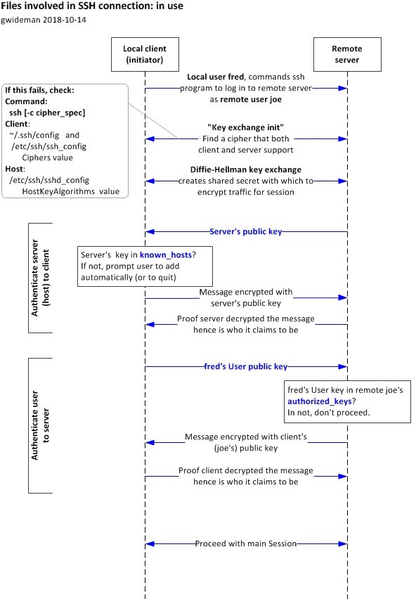

(Figure 5 : SSH connection flowchart)

ARCHITECTURAL ADVANTAGES
The system being proposed has several advantages as compared to other similar ones. First, it is important to note that integration of all the elements in the system means that no third party applications will be needed. Secondly, it is also worth noting that the virtual filesystem ensures necessary isolation.
Thirdly, use of blockchain for logging purposes in the system ensures log integrity since logs cannot be modified after they are logged. Moreover, the monitoring system in the system is user friendly since it allows real-time attack actions monitoring.​

In summary, the entire architecture presents a wonderful balance between security and effectiveness. The architecture is sufficiently realistic and provides immense possibilities for monitoring the actions of the attacker in addition to providing the maximum security for the system.
(Table 3 : Comparison of Existing Honeypots and Proposed System)

Feature | Existing Honeypots | This System
Deployment | Complex configuration | Single package, minimal setup
Interaction depth | Limited command support | Realistic session simulation
Monitoring | Requires external tools | Built-in dashboard
Log integrity | Not guaranteed | SHA-256 hash on blockchain
Host safety | Varies by tool | Complete vFS isolation

HONEYPOT AND VIRTUAL FILESYSTEM
The honeypot and virtual file system present the essential elements in the proposed architecture that make the SSH environment seem more real and provide full security for the system. In this regard, one may state that the primary motivation for applying the essential element in developing the proposed architecture is that attackers would be offered a replica of the SSH environment in which they cannot directly gain access to the host computer.​
Functionally, the honeypot is one which operates exactly as a real SSH service. On the part of the attacker, once he/she connects to the server, then he/she will see the usual login screen that one would expect from a regular server computer. Authentication is done based on pre-programmed settings and the attacker is guaranteed access because our aim is to deceive the attacker into thinking that he/she is connecting to a real server.
After the attacker completes his/her login, then he/she will receive access to a shell, and at the same time, he/she will have access to a command-line interface which appears exactly like that of an operating system. However, there is a twist to it because, in this case, no command can ever be run through a real operating system.​

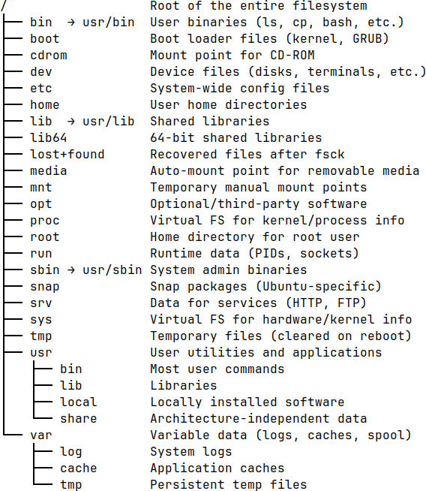

(Figure 6 : Virtual File System)
The structure of the proposed virtual file system ensures that the files and directories of the system will be generated following the directory structure, which resembles the typical file system structure containing directories such as configuration directories, user home directories, log directories, and so forth. Data structures have been defined for each file and directory present in the file system, in order to simulate the process of file manipulation without impacting the actual file system.
Another key aspect of the proposed virtual file system is the storage of the system’s state per session. During the time when the attacker is searching through some directories or other files, the current directory will be stored in order to provide more realistic output for future commands. This means that changing the directory will impact the results of the commands.​

The processing capability associated with these commands is vital in keeping reality maintained. In this case, these commands by the attackers are identified while actions are taken in the virtual world based on them. The virtual filesystem recognizes several commands ranging from listing directories to obtaining system information or even accessing files. There should not be an issue when new commands not recognized by the system are run.
Isolation and security represent the two key elements in this section. Firstly, the attacks that occur throughout this process remain isolated within the simulated environment owing to the existence of the virtual filesystem in which all the commands run by the system. This is the reason why the attacks will not affect the OS since they will not communicate with the OS. Secondly, there is nothing like communication between the attacks and other entities outside the system.​
(Table 4 : API Endpoint Documentation)

Endpoint | HTTP  Method | Request Body / Params | Description / Expected Response
/api/v1/users/regist er | POST | {role, pubKey, kycData} | Enrolls new identity -> 201 Created
/api/v1/loans/create | POST | {amount, rate, terms} | Proposes new loan -> 202 Accepted
/api/v1/assets/valid ate | GET | ?assetId=123 | Fetches asset provenance -> 200 OK
/api/v1/ledger/quer y | POST | {query_string} | Executes state DB query -> 200 OK

The next critical feature that should be included in the architecture is logging all the interactions. Any interaction and commands that the attackers have executed with their results and timestamps are supposed to be logged in session logs. Analyzing this data will allow us to get insight into how attackers work when attacking different systems.

Thus, we can say that the whole process of designing the honeypot and virtual file system can be regarded as a harmonious combination of realism and security for a computer system. Firstly, by offering attackers a chance to communicate with the system deeply, they will feel that they attack something real enough. Secondly, it will be isolated from the rest of the world to ensure its security.
In other words, we can claim that honeypot and virtual file system are the basis for our architecture design because we provide the possibility of realistic communication, isolation, and collecting data for analysis purposes.​

BLOCKCHAIN-BASED LOGGING
Logging using the blockchain technique is integrated into the proposed architecture to make sure that all the logs that have been created by the attack process are not corrupted. Because of the importance of logs acquired through the honeypot system in behavior analysis and forensics, it becomes necessary to guarantee that the logs do not get modified once they are collected. It should be noted that this technique is used for performing validation without adding complexity.

BDD Scenario (Gherkin) | Technical Logic Flow | Database/Ledger Action | Expected Outcome
Given user has Banker role & valid KYC | Verify RBAC token & Status | Query State DB (User Profile) | Authorized = True
When Banker approves Loan Request 'L123' | Invoke 'ApproveLoan' logic | Write 'L123.Status=Approved' | Valid State Transition
Then Loan asset is minted on ledger | Token Minting Logic | Update Balances & emit event | State Updated / Event Emitted
And Asset transfer completes | Unlocking Logic | Tx Commit | Success Response
(Table 5 : Smart Contract Logic Mapping)

In respect of each attack, certain parameters like authentication processes, command executions, timestamps, and other relevant information are obtained. All the information can be accessed and processed conveniently from the local computer. Nevertheless, all the information contained in the log details can be modified, deleted, or manipulated. In order to solve this problem, a cryptographic hash code for every session is generated using SHA-256. This cryptographic code will serve as a signature for all the data logged during the attack process. The log details containing all the logs can be stored in the blockchain; however, the amount of space required will be excessive, and​

increase in efficiency. Thus, a mixed method is used whereby the hash alone and not the original log file is stored on the blockchain, while the logs stay at the client’s end.

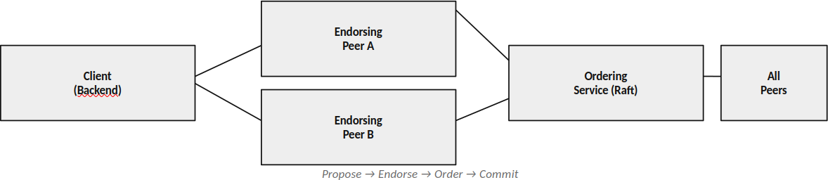

(Figure 7 : Consensus and Block formation)
Blockchains are constructed in such a way that each of them forms a chain of blocks consisting of hashes of the current block as well as the hashes of previously existing blocks. It makes blockchains tamper-proof because if anything happens to previous blocks, then all other following blocks become invalidated. Hence, when a hash is placed on the blockchain, any alterations in it can be detected immediately.​
Authentication of data takes no time at all. In order to verify the validity of data logged in the log, the system verifies whether the hash value of the logged data and the hash value of the blockchain coincide. If they do coincide, it means that the log is legitimate, while different values show that the log has been tampered with. Checking the validity of data takes no time at all. Secondly, this solution makes the process of working more efficient as the size of the blockchain will remain relatively small. This is because there will be only hashes but no logs stored in the blockchain.
The method of logging using blockchain leads to the improvement of the integrity

from the perspective of an attack on the honeypot, as this feature has absolutely nothing to do with an attacker's behavior. This feature can be called the collection of logs efficiently and effectively.​
(Table 4 : Transaction Lifecycle)

State | Step Description | Actor | Consensus Requirement | Ledger Status
Draft | Transaction proposed locally | Customer / Banker | None | Off-chain
Submitted | Signed and submitted to network API | Client Node | None | Pending Pool
Validated | Endorsed by required peer nodes via Smart Contract evaluation | Endorsing Nodes | Yes (Valid Signatures) | Pending Pool /  Endorsed
Ordered | Grouped into block by Orderer | Ordering Service (e.g. Raft) | Leader Election / Raft | In Block
Immutable Commit | Block validated and appended to ledger | All Peer Nodes | Validation Check Passed | On-chain (Immutable  )

MONITORING SYSTEM
The monitoring component of the proposed system will be used for monitoring of operations performed by the hackers. Just like the name suggests, this functionality will provide logs in readable form to any user wishing to look at what was performed using the honeypot. It is different from other systems since this one features a surveillance component built in and does not involve any external tools or SIEM systems. This happens because the surveillance component is supposed to monitor all operations carried out by the attackers.
All operations, including login, executed command, timestamp, and session, are tracked by the surveillance component and forwarded to the monitoring component. The monitoring component then analyzes the logs and provides them through the dashboard.​
And in regards to logs gathering for monitoring purposes, each session should be viewed as an independent entity containing data about the sequence of actions performed, the time when they were made, and characteristics of the connection, among which we will highlight IP addresses of the initiators. Thus, one may obtain a complete picture of the entire session.
Even primary analysis of the logs is possible. For instance, one may choose to explore one specific aspect of the processes occurring. It means that one can analyze various aspects of the process, including repeatable login attempts, unusual commands, and sessions themselves without using any additional programs. The monitor was intentionally made user-friendly. Furthermore, the program requires no external services and few setting options. Its only purpose is visualizing and performing preliminary analysis so as not to disrupt other components of the system, especially the honeypot module and blockchain module.​
To conclude, the integration of the monitoring system improves the efficiency of the proposed system by providing a deeper analysis of the actions taken by the intruder. Nonetheless, the monitoring system is not considered a vital element in the proposed system, even though it is extremely important for analyzing the data collected from the honeypot.

  - SUMMARY
In summary, the current chapter reviewed the general architecture and design of the SSH honeypot system discussed in the research paper. In particular, the chapter concentrated on the components of the system and their interaction process. Finally, it should be noted that the distinguishing feature of the proposed system is a unique honeypot connected with the virtual file system. Thus, the intruder can use the system normally without dealing with the real hardware.​
(Table 7 : Consensus Mechanism Details)

Phase | Component Responsible | Action Performed | Validation Criteria
Proposal | Client SDK / API | Broadcasts generated tx to Endorsers | Valid schema & payload
Endorseme nt | Peer Nodes | Execute smart contract locally | Deterministic state & RBAC allowed
Ordering | Ordering Nodes | Sequences signed txs into logical blocks | Sequential integrity / Raft leader valid
Validation | Committing Peers | Check read-write sets & signatures | No double spending (MVCC)
Commitme nt | Committing Peers | Append block & update state DB | Final network agreement validation passes

This chapter provided more insights on the logging process using blockchain, which enabled the generation of a logging process that is not tampered with due to its capability of offering reliable storage for hash codes. Although the logging process does not consume too much from the performance of the computer, it is very useful in providing forensic logging, which is very essential in the next stage of the analysis process. It is worth noting that the monitoring process was light-weight because of which it would be easier to understand what is going on with the hacker.​

Chapter:4 Results and Perfomance

IMPLEMENTATION OVERVIEW
The deployment and analysis of the SSH honeypot system will be considered in this chapter. An SSH honeypot system was developed and deployed in a virtual environment so as to test its performance and also observe how the attacker would attack the system. This chapter is going to focus on how each of the components of the SSH honeypot system was developed. It is important to mention that in order to develop the system, one had to deploy the honeypot, blockchain log, and the monitor, which would observe the activities of the attacker as he attacked the honeypot system. In this case, the honeypot was developed in such a way that it acted as a true SSH server.​
The logging was done to track all activities that the attacker did in his own session, such as logins, command execution, time of doing the activity, and other session activities. Logging was structured and kept in a local area for easy access. To ensure there is no tampering with the logs, SHA-256 was used because it involves hashing the record of each session to make a blockchain type where the hash is privately hashed.
Monitoring of the attacker's activities is done via a dashboard that shows real-time logging of activities that include logins, command execution, and other activities that occur in the session. Tracking the session of the attacker will enable an understanding of how he interacts with the computer. This is done on a virtual machine since it was set up for that purpose. The attacks involve SSH brute force attacks, manual login, and commands execution.​
On the whole, according to the above implementation, it may be noted that the suggested solution will succeed in considering all three factors mentioned, namely interaction, logging security, and monitoring actions in a safe environment. Furthermore, the interaction data collected enables one to receive the necessary information on the adversary's activities.

The SSH honeypot is definitely the main component of the suggested system design, since it allows one to simulate the safe environment needed to analyze the attack. In other words, the SSH honeypot serves as the interaction layer that helps set up the communication between the user and the system under investigation. Therefore, one can log into the system and execute different commands.​
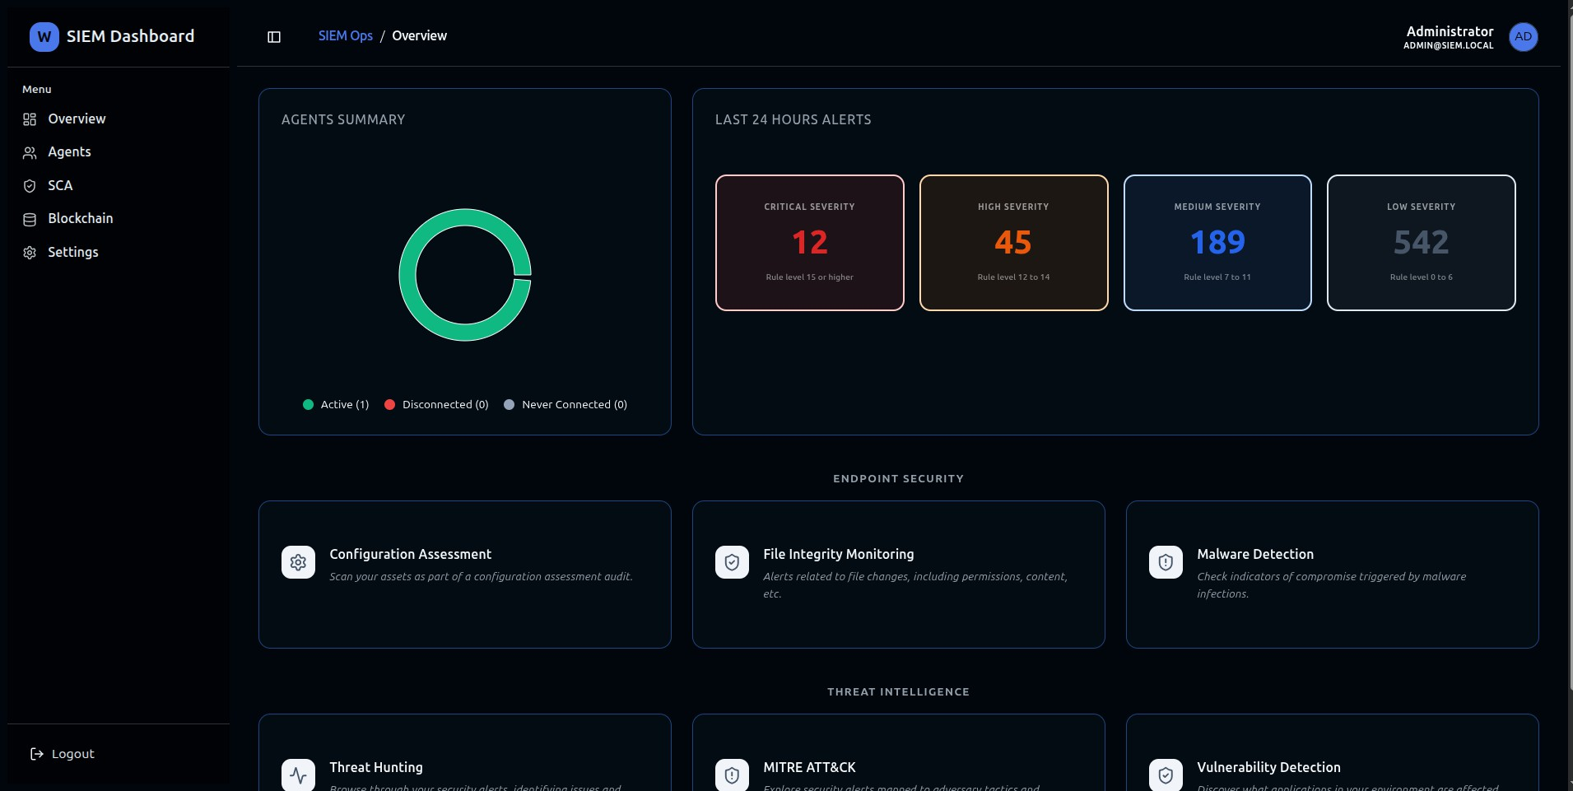

(Figure 8 : SIEM Monitoring tool Dashboard)

HONEYPOT IMPLEMENTATION
The SSH honeypot is definitely the main component of the suggested system design, since it allows one to simulate the safe environment needed to analyze the attack. In other words, the SSH honeypot serves as the interaction layer that helps set up the communication between the user and the system under investigation. Therefore, one can log into the system and execute different commands.​
The design of the system aims at making sure that the maximum degree of realism is achieved during the performance of the two operations of authentication and command execution. When an attacker attempts to get into the system, the system sees him/her in the same manner as it would see any other user, offering the SSH login prompt among other session management tools. Most of the attack tools will function well in the environment and this makes it possible to intercept both automated and manual attacks. The authentication process will take place in a manner that the attackers can get into the system and launch attacks which will later be analyzed.
It needs to be emphasized that the implementation is based on the principle of incorporating both realism and security measures. Whereas the implementation will provide a realistic environment for launching attacks, it is worth noting that none of the actions undertaken will have any effect on the host machine.​
Moreover, the honeypot should have the capacity for supporting multiple connections at once. The honeypot can facilitate more than one session; therefore, several attackers will be able to use the honeypot at the same time. Every session will be analyzed separately, ensuring that all actions undertaken in a specific session by attackers are registered. Actions such as the logging-in procedure, execution of commands, and the length of sessions will be captured by the honeypot.
Moreover, all actions in the session should be documented. This implies that data concerning interactions will be gathered and reported in logs. Logs will include details about connection attempts to the honeypot, credentials used in the authentication process, commands used by attackers, and any other relevant details about every action with the honeypot.

In general, the SSH honeypot is operational because it provides real-time interactions with the attackers, performs commands in a virtual environment, and records logs for each command.​
In general, the SSH honeypot is operational because it provides real-time interactions with the attackers, performs commands in a virtual environment, and records logs for each command.​

SSH Connection Handling

Essentially, what the honeypot system will do is to mimic the actions of an SSH server which listens to any connections established using the preset port number, in the same way a typical SSH server would respond to such connection request by default. When the connection request is established by the hacker, the system automatically responds to the request as would any normal SSH service; thus, starting the process of establishing the connection handshaking session by the server. In the end, the hacker will believe that he is connected to a genuine SSH service rather than a honeytrap system.​
This is where the system gathers critical information related to the nature of the attack in terms of the source IP address, the port used, timestamps of the connections as well as other information regarding the attack. This information is vital in helping determine the type of attack, along with its pattern. Connection Handler module ensures that the honeypot functions effectively when dealing with several connection attempts without compromising on performance.

HOST = "0.0.0.0"
PORT = 2222

def handle_connection(client_socket, addr):
print(f"[+] Connection from {addr[0]}:{addr[1]} at {datetime.now()}") client_socket.send(b"SSH-2.0-OpenSSH_7.4\r\n") client_socket.recv(1024)
authenticate(client_socket, addr)

def start_server():
server = socket.socket(socket.AF_INET, socket.SOCK_STREAM) server.bind((HOST, PORT))
server.listen(100)

print("[*] Honeypot listening...")

Authentication Simulation

In case the honeypot system is compromised by the attacker, a virtual page for login that resembles a genuine one will be displayed to the attacker. The login process will involve entering of username and password, following which the operation of the honeypot will be similar to any other server. Through such a technique, the system gains credibility, thereby encouraging attackers to carry out further attacks.​
Instead of verifying the credentials against any real user, the system implements a policy

in cases where the credentials do not have any impact on the process. By doing so, it makes sure that the attacker accesses the system and executes some activities that might prove to be impossible. All the entered credentials will be saved together with the timestamp showing what the user did in particular instances. Such credentials will be used to understand the pattern involved in breaking into the system through brute force attacks.
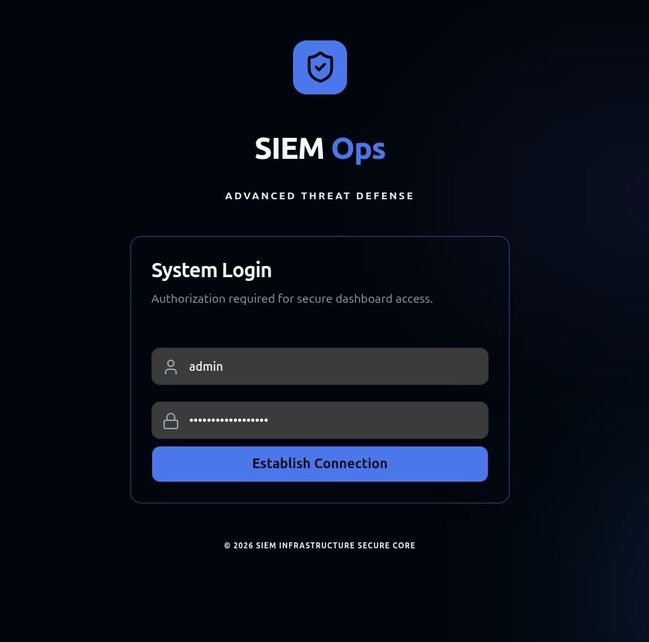
(Figure 9 : SIEM Monitoring tool authentication)
In designing this form of authentication, no warning is raised to the attacker.

def authenticate(client_socket, addr): client_socket.send(b"login: ")
username = client_socket.recv(1024).strip().decode() client_socket.send(b"Password: ")
password = client_socket.recv(1024).strip().decode() log_event("AUTH_ATTEMPT", addr, username, password) # Always allow login (for interaction) client_socket.send(b"\nWelcome to Ubuntu Server\n") start_shell(client_socket, addr, username)

Command-Line Interface Simulation

After authenticating the process is completed, the attacker will be given a virtual command-line interface that acts as a normal shell. The virtual command-line interface will run in a way that imitates the regular command-line interface. As a result, the attacker can input commands and receive corresponding responses like a normal user.​
The program displays commands that a regular user will use while using the system and produces response similar to what it would do under normal conditions. The program observes activities performed by the user based on the user’s status during a particular interaction. Thus, for instance, when an attacker switches the directory, the program changes the prompt automatically.
Invalid commands will be treated as those that would be produced in a normal operating system environment. This means that errors such as “command not found” and “permission denied” will be thrown up. Such actions make the simulation very realistic and reduce chances of detection.

All commands issued by the attacker are intercepted and then executed in the system. It is important to note that the commands are intercepted, parsed, and then action determined. In simpler terms, all commands must be known before they are executed.​

def start_shell(client_socket, addr, username): current_dir = "/home/" + username
while True:
prompt = f"{username}@server:{current_dir}$ " client_socket.send(prompt.encode())
command = client_socket.recv(1024).decode().strip() if not command:
continue
output, current_dir = process_command(command, current_dir) client_socket.send((output + "\n").encode()) log_event("COMMAND", addr, command, output)

Command Processing Mechanism

All commands issued by the attacker are intercepted and then executed in the system. It is important to note that the commands are intercepted, parsed, and then action determined. In simpler terms, all commands must be known before they are executed.​
However, unlike direct command execution in the host, all commands go through a virtual filesystem. Hence, all commands are analyzed, and the output will be identical to those generated by the actual operating system. This refers to the need to create

commands related to files’ navigation, exploring system, and other utilities.

There also are advanced techniques for error management. In case some of the commands are wrong or unsupported, they are handled by the unique technique, with specific error messages such as "command not found", "permission denied", and others being provided.
One more feature that should be taken into consideration while creating the program is its responsiveness to the requests and fast output generation. Indeed, this is vital because no delays while providing the output will increase the realism of this honeypot, which is extremely important since the lack of such delays can trigger suspicion.​
virtual_fs = {
"/": ["home", "var", "etc"],"/home": ["user"], "/home/user": ["file.txt"]
}
def process_command(cmd, current_dir): tokens = cmd.split()
if tokens[0] == "ls":
return "\n".join(virtual_fs.get(current_dir, [])), current_dir elif tokens[0] == "cd":
new_dir = tokens[1] if len(tokens) > 1 else "/home/user" if new_dir == "..":
current_dir = "/" else:
current_dir = new_dir if new_dir in virtual_fs else current_dir return "", current_dir

elif tokens[0] == "pwd":
return current_dir, current_dir

Session Management

In order to ensure security for each session and monitor the attacks effectively, session isolation will be used. For instance, this will be useful in the isolation of each session from the perspective of the attacker. This implies that each attacker will be monitored in his/her own separate sessions.
Through the management of the sessions, various attackers can be allowed to attack the system and carry out their own activities without being affected by any other attacker's activities. In this case, each attacker will conduct his/her attacks in his/her respective isolated session.
Considering that it monitors the duration of the session and the events occurring within the session, it is easier for the researcher to analyze the activities of the attackers. The fact that each attacker's sessions will be stored will help in the identification of the steps undertaken by the attackers.​

import uuid sessions = {}
def create_session(addr): session_id = str(uuid.uuid4()) sessions[session_id] = {
"ip": addr[0],
"start_time": datetime.now(), "commands": [],
"cwd": "/home/user"
}
return session_id

Logging of Attacker Activities

The most important aspect regarding this specific implementation of honeypot is its ability to capture and log all the activities of the attackers in real-time. Besides the time required to perform the attack, logs also contain other types of data, such as command line and session ID.
Logs become input and output data for all the attacks performed by the attacker; hence, they provide a full description of all actions of the attacker within the system.
The information will be useful for both monitoring and blockchain in their respective operations. As far as monitoring goes, logs will prove helpful in displaying the current activity of the attacker within the honeypot. Moreover, information stored in logs will be completely safe from any form of alterations because cryptographic hashes are generated and stored using blockchain technology.

To conclude, logging is an essential element of capturing, analyzing and protecting all the attacks performed by the attacker on the honeypot.​
To conclude, logging is an essential element of capturing, analyzing and protecting all the attacks performed by the attacker on the honeypot.​
import json
def log_event(event_type, addr, input_data, output_data=""): log = {
"timestamp": str(datetime.now()), "ip": addr[0],
"event": event_type, "input": input_data, "output": output_data
}
with open("logs.json", "a") as f: f.write(json.dumps(log) + "\n")

Security and Isolation Mechanism

Besides, the need for safeguarding the honeypot from attacks has been observed. In order to do so, it would be essential that the execution of all commands occurs in the sandbox platform and does not have any impact on the system.
The process of isolation will be accomplished through ensuring that all commands are routed through the virtual file system so that even complex commands will execute in the sandbox and have no impact on the system whatsoever.
Apart from isolating the file system, the system will also prevent any form of interference from the network levels. Therefore, the attacker will have no ability to connect with any other external resources while using the honeypot system or to launch an attack against any other computer system.
The process of isolation has proved to be highly effective in ensuring that the honeypot remains unaffected despite carrying out the actions of the attackers.​
# No real command execution allowed def safe_execute(command):
blocked_commands = ["rm", "shutdown", "reboot", "wget", "curl"] if any(cmd in command for cmd in blocked_commands):
return "Permission denied"
return process_command(command)

Testing and Validation

Different attacks such as automatic login into the system and command execution via SSH were carried out against the honeypot system. Such a method of testing was applied in order to find out how realistically the system operates under such attack circumstances.
It is necessary to point out that the honeypot system was able to withstand several sessions at once without stopping functioning. They were totally independent from each other, which made sure that the activities of the attackers were logged properly. What is more, the system gave adequate response to all the attacker's commands, which added up to its realistic performance.
The users were able to operate the system normally – to execute different commands, change directories and perform various actions. At no point during the process did the attackers suspect that they dealt with a simulated environment.
Furthermore, all of their actions were logged properly; the logs included such aspects as user login, command execution and other elements. Thus, the process could be successfully performed.​

BLOCKCHAIN VERIFICATION RESULTS
This technique was applied specifically for the authentication of the logs developed using the honeypots. It is important to note that the development of logs during the usage of honeypots is essential in analyzing and understanding the attacks of the attackers; thus, securing these logs is necessary as any alteration of the logs affects the credibility of the analysis of the attacks.
In solving this issue, this system makes use of a strategy, which entails applying the concept of blockchain through hash creation using cryptography. Specifically, the logs that have been developed at the end of every attack activity are subjected to hash generation in order to ensure that they are different from other logs that have been developed previously.​
This section gives a brief explanation of the implementation process and the outcomes obtained from using blockchain technology to implement the experiment. Specifically, this section describes how the logs were encrypted in the form of hashes before storing and using them for the purpose of verifying the logs. The results indicate that the system is able to detect any changes made to the logs and ensures that the data within the honeypot are intact and reliable.
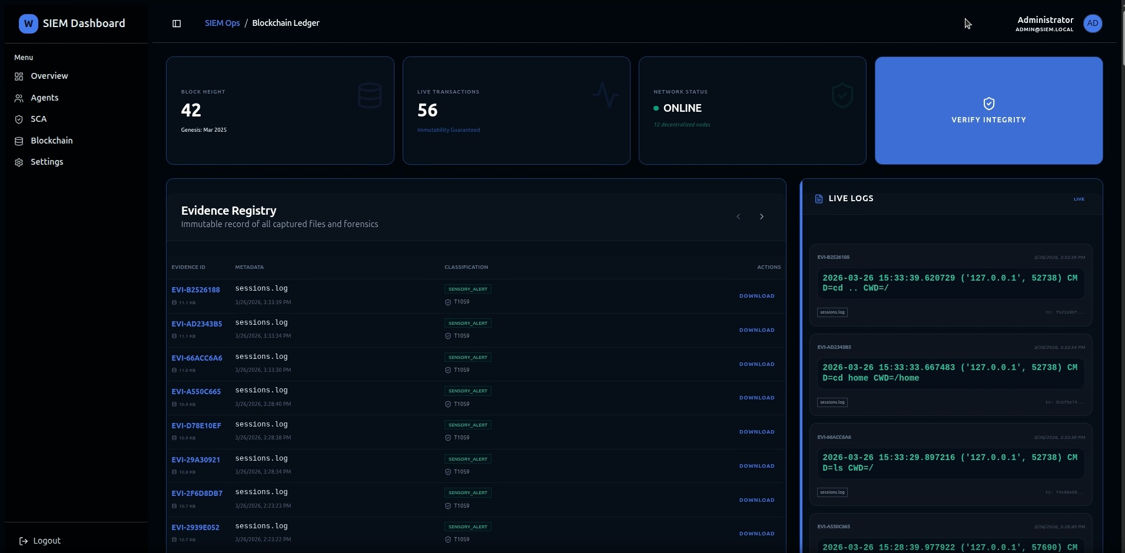

(Figure 10 : Blockchain logs)

Log Generation and Storage

Log files with the total number of logins, commands, timestamps, and other attack information were created during every session. In addition to this, connection logs were also created having details such as the source IP address and the duration of each session.
Data in the logs were structured in such a way that they can be easily accessed, retrieved, analyzed, monitored, and verified. Data in the logs is structured because all the actions performed by the attacker during each session will be recorded in chronological order.
Each session log consists of all data relating to all the actions performed by the attacker during the session.​
LOG_FILE = "session_logs.json"

def generate_log(session_id, ip, commands): log_data = {
"session_id": session_id, "ip_address": ip, "commands": commands,
"timestamp": str(datetime.now())
}

with open(LOG_FILE, "a") as f: f.write(json.dumps(log_data) + "\n")

return log_data

Hash Generation and Recording

There was a unique hash created for every session log using the SHA-256 hashing algorithm. It was a unique code that depended on the information within the session log. Any change in the session log would result in a unique code because the data within the log determined its uniqueness.
It was simple to create the hash code because of the uniqueness of every session log. Once created, it was saved in the blockchain database.
The hash code was saved in the blockchain database together with other data in the newly created block. The blocks were linked by the hash codes of the previous block. This meant that there was a chain formed that guaranteed the validity of all the blocks in the chain. This meant that any attempt to alter a block after saving the hash code in the database had far-reaching effects on the chain.​
def generate_hash(log_data):
log_string = json.dumps(log_data, sort_keys=True) hash_value = hashlib.sha256(log_string.encode()).hexdigest() return hash_value
class Block:
def init (self, index, timestamp, data_hash, previous_hash): self.index = index
self.timestamp = timestamp self.data_hash = data_hash self.previous_hash = previous_hash self.block_hash = self.calculate_hash()
def calculate_hash(self):

block_string = f"{self.index}{self.timestamp}{self.data_hash}{self.previous_hash}" return hashlib.sha256(block_string.encode()).hexdigest()

Verification Process

To confirm the integrity of the logs generated from this process, validation tests were done. To do this, a hash of the data that was originally in the log was created using the SHA-256 hashing method, and then compared with the hash in the blockchain.
If the two hashes matched, this would mean that the integrity of the log was intact throughout.
In a situation where the two hashes do not match, it would mean that something must have happened to alter the log file. From this, it means that the use of this new technique will make it possible for any manipulation of the log file to be detected. This is very simple to accomplish at any time.
def verify_log_integrity(log_data, stored_hash): recalculated_hash = generate_hash(log_data)

if recalculated_hash == stored_hash: return True
else:
return False

Tampering Detection

To evaluate the efficiency of the validation process, modifications were made to the data captured. These changes were minor, including changing some commands, timestamps, and deleting data.​
In turn, the hash value of the modified logs was calculated through the application of exactly the same hashing algorithm referred to as SHA-256. In particular, it could be noted that a minimal change in the data results in a substantial difference in the output hash value generated by the system. After that, a comparison between the modified and initial hash value was performed.
Obviously, the existence of such difference confirms the manipulation with the log file. The ability of the system to recognize such manipulations confirms the effectiveness of the applied cryptographic hash function.
It can be concluded that the above tampering process demonstrates that the logging system provides sufficient levels of data integrity. Hence, the logging system can be considered reliable in terms of providing the best possible data security.

def simulate_tampering(original_log): tampered_log = original_log.copy() # Modify data
tampered_log["commands"].append("rm -rf /") return tampered_log
# Example usage
log = generate_log("sess_1", "192.168.1.10", ["ls", "pwd"]) original_hash = generate_hash(log)
tampered_log = simulate_tampering(log)
if not verify_log_integrity(tampered_log, original_hash): print("[!] Tampering Detected")
else:
print("[+] Log is Authentic")

Performance Observation

This explains the need to assess the impact of the blockchain-based verification technique on the system performance. Specifically, it should be noted that the use of blockchain technology does not imply storing the entire logs but only their hash values.​
The computation of the hash using the SHA-256 algorithm was sufficiently fast so that the session could be recorded immediately. Meanwhile, recording and checking the hash value on the blockchain network happened quickly.
It should be noted that this did not influence the functioning of the system in cases where several session records were analyzed at once. Concurrent analysis of several sessions did not affect the blockchain part of the system, which worked in tandem with the honeypot software.
That is the reason why applying blockchain for validation purposes will not have any effect on the efficiency of the system. That is the reason why such validation can always be used in practice.​

VIRTUAL FILESYSTEM IMPLEMENTATION
One might argue that the virtual file system can be considered as the most important component of the proposed honeypot as it provides for the ability to simulate the user experience in a totally isolated environment, preventing any possible interference between the honeypot actions and any other processes in operation within the computer system where the honeypot operates. The virtual file system can be regarded as a sandbox in which any harmful actions occur in a virtual space without affecting any system files. This is precisely what the purpose of the presented part of the honeypot is aimed at.
The virtual file system is organized similarly to the ordinary file systems of the operating system of Linux-based computers, as it comprises various directories such as system directories, directories specific to certain users, directories with log files, directories with temporary files, and directories with configurations. However, all these directories and files cannot be treated as physical elements of the computer's filesystem, as they are represented in a more abstract form by hierarchical structures within the virtual filesystem.​
If the attacker opts for running commands on the SSH shell, these commands would go through the command handler and eventually reach the virtual filesystem manager module. The virtual filesystem interpreter will interpret the command and act accordingly according to the rule set. Therefore, in case of any command dealing with directories and files, the internal representation of the system is used to produce the required output.
It is interesting to note the management of the state of every session in the system. Every single attacker’s session operates independently; every session has its own working directory and interaction environment. Any manipulation of the attacker's session by the attacker, like switching to another directory or accessing any file, alters the state of the session. As a result, the execution of the next command on the session will be affected by previously performed manipulations on the session.​
Additionally, for more realistic output generation, dynamic generation of output responses is also incorporated in the system. Instead of providing fixed responses,

the system will generate appropriate responses based on what is happening at that moment. If there were any non-existing commands or permissions problems and access to files problems, then it would generate the proper message in the same manner as any normal computer would react.
The most significant feature of the virtual filesystem implementation is its security aspect. The entire process runs within the virtual machine without anything being transmitted to the host computer. This means that the host computer is always safe from any harm since no hacker could interfere with the information that is kept on the disk of the computer. Moreover, there are also limitations put onto the command execution process. Specifically, they cannot actually create or delete any files or perform system-level actions.​
The next area where the use of the virtual filesystem seems to be necessary is collecting information for further analysis according to the data collected. The activity performed by the user and its result as well as the moment when the command was run are recorded in the log file describing the activity of the hacker. Such data provides important information regarding the command used, navigational method employed, etc.
When it comes to the issue of the implementation testing, several commands have been tested using the virtual filesystem, which included the change of directories, file handling and commands that fail to run correctly leading to certain errors appearing on the screen. According to the results of the test conducted, all commands turned out to be real enough.​
In addition, another advantage of utilizing the virtual file system consists in the total isolation of the virtual file system from the OS. Thus, no matter what actions the malicious users execute, their requests will never harm the system since all these actions will be handled by the virtual file system itself.
In general, taking into account all the findings mentioned above, one can conclude that the utilization of the virtual file system implementation is crucial for honeypot functionality. In other words, the required compromise between security and authenticity can be guaranteed by using the interactive mode of working with commands while not interacting with the OS.

PERFORMANCE ANALYSIS
As for the performance test of the implemented SSH honeypot, the purpose of conducting such a test consisted in ensuring effective functioning of the system together with the maximum security and authenticity of the honeypot. Thus, the performance test includes the following elements: responsiveness of the system, consumption of the system resources, and stability of the system in the case of multiple attacks on the honeypot at the same time.​
In order to evaluate the response time of the system, it was checked under conditions of intrusion. The attacker was attacking the system through entering commands that lead to some output from the virtual file system. As a result, the response time under conditions of commands processing became extremely low.
The next testing criterion considered was resource consumption in order to make sure that the system consumes a minimal amount of memory for operation within a controlled environment. Honeypot, virtual file system, and other monitoring systems consumed insignificantly large amounts of RAM and CPU, because command processing was not very intensive. Additionally, blockchain-based system itself consumed lower amounts of RAM and CPU, as it contained only hash values of log files.
It was also important to test system under several concurrent access sessions. It became evident that the system was able to work successfully with multiple sessions; performance degradation was not observed. No crash occurred due to accessing network by two or more attackers simultaneously. Every session remained isolated and individualized.​
Lastly, the logging and monitoring functionality of the developed system was assessed concerning their impact on the system's performance. All interactions between the attacker and the system were logged in real time, and no performance issues were reported when processing logs using the provided monitor window.
To be specific, in accordance with the assessment carried out in relation to the performance of the system, the system can be regarded as efficient, stable, and scalable. It should be stressed that there are no negative impacts on the performance of the system caused by its implementation, and moreover, it provides real interaction and isolation of the

attacker and guarantees the security of the system.​

CONCLUSION

Chapter 5 Conclusion and Future Work

The major objective in the present study has been to design an SSH honeypot tool for the purpose of carrying out analysis of attacker behavior within a safe and controlled environment. It should be mentioned first of all that one should emphasize the importance of the concept on which the design of this particular honeypot tool was based – an interaction environment that was fully realistic yet isolated from the entire system.
With the help of the developed honeypot tool, it was possible to catch the incoming SSH connections and authenticate them. In other words, using this tool, it became possible to create the conditions under which the attacker could actually log in and interact with the system. Thus, it was possible to obtain information concerning behavior of the attacker and his or her actions during the attack.​
One particular characteristic of this mentioned system is the fact that it can implement the virtual file system as the environment for all of the operations performed within it. The operations will be done not in the physical operating system but in the virtual one. It should be noted that the virtual file system is fully safe due to the fact that there will be no chance to perform any operation within the physical OS, as the operations are done in the virtual one.​
Beyond the challenge related to ensuring security while communicating data, the other aspect of integrity of log can be solved through incorporation of logging that is based on use of blockchain architecture. Logs can be hashed using SHA-256 algorithm and stored in the blockchain database in such a manner that any effort to alter stored data becomes easily noticeable. This will ensure that the log becomes reliable and it can be used to perform different purposes including carrying out a forensic analysis. Hybridization technique involves hashing and storing logs in blockchain database, thus improving efficiency.
The monitor feature of the tool makes its operation and analysis easy. Through this

Another advantage of utilizing blockchain architecture is that it allows monitoring of all activities undertaken by attackers.​
Regarding the analysis of results, it should be noted that the mentioned objectives formulated by the designers of the software are accomplished satisfactorily. The system demonstrates its ability to identify any type of attack, isolate it, ensure data integrity, and function efficiently in several simultaneous sessions. Therefore, the modular structure of the proposed system makes it possible to implement the program easily and increase its scalability according to users' requirements.
In conclusion, the current study is significant for the field of cybersecurity due to the development of a highly effective and reliable SSH honeypot that could be used for academic research purposes. With the help of the system described above, one can detect malicious actions of the attackers.

LIMITATIONS
Nevertheless, even though the implemented system operates effectively and performs successfully in detecting cyberattacks and safeguarding the computer network from intruders, there are certain limitations to consider. The limitations of the suggested honeypot will be discussed in the next section of the paper.​
A major limitation is associated with the architectural design of the virtual file system. Even though the virtual file system enables one to build up a realistic directory structure as well as simulate the execution of certain commands, it operates within the constraints imposed by programmed reactions. Thus, the actions of such a system could be different from those made by the real one, providing the attacker with additional information concerning the presence of a honeypot.
The final limitation concerns the way of interacting with the threat. This means that the system will operate strictly within the boundaries of the SSH protocol and a command-line interface and not deal with various types of threats, including network and website-based ones.​
Although the application of this technique allows for ensuring the integrity of data stored in the database, one should admit the existence of some drawbacks related to the application of private and lightweight blockchain technology in this case. For example, due to the fact that it operates based on the principles of keeping cryptographic hashes of log files instead of keeping all log files in storage, the utilization of this solution does not ensure the creation of a complete decentralized system featuring numerous advantages inherent in blockchain technology.
On the one hand, the proposed solution looks rather lightweight and straightforward. Indeed, although this technique will be quite helpful for detecting actions performed by hackers and their efforts to penetrate certain systems in real time, it will not allow for carrying out any sort of predictive analysis to detect threats at an early stage of their formation.​
Thus, it should be pointed out that the system is designed and tested under full isolation from any external influences, which makes it possible to perform a reliable testing procedure of software. Nevertheless, such an approach may affect the overall efficiency of

the program as the conditions in the environment where it will operate are more complex than in isolation.
In conclusion, one should highlight the importance of solving all the aforementioned issues as their solutions may significantly increase the effectiveness of the system. This is due to the fact that although the suggested SSH honeypot system provides a good basis for analyzing attacks, the elimination of the mentioned problems will make the system truly efficient.

FUTURE WORK
The proposed SSH honeypot system can be viewed as a good foundation for further analysis of attacks; nevertheless, one should pay attention to the fact that several changes can be made in order to increase the effectiveness of the system.​
In the future, improvements can be made by further enhancing the current virtual file system. In this case, besides using the predefined logic for detecting the threat, the response to it should also be included. Moreover, various command sets and additional system utilities must be taken into consideration, along with changes to the files in a realistic fashion.
On top of that, machine learning algorithms may serve as a way to improve upon this project. This technology can be used for analysis purposes through automation, using the information provided by the system. The outcome of implementing this function into the system is that the system is able not only to gather data but also to analyze it, creating intelligence about the attack.​
Finally, the visualization and alerting system can also be enhanced when building the monitoring tool. Receiving notifications about any malicious activities and visualizing the attack will facilitate the process of analyzing collected information. Besides, connecting this software to other systems will make the interaction much simpler for users.
One of the things that should be researched further in this project is related to the application of blockchain technology. In particular, using the public chain will contribute to increasing the level of transparency in the process. Moreover, enhancing the blockchain architecture and metadata will also have to be taken into consideration in order to increase the effectiveness of this tool.
Furthermore, this solution may be implemented in different types of honeypots. Web, database, and network honeypots may be used to collect a wider variety of data about different types of attacks and analyze the behavior of attackers. Using this solution in a distributed, and even in the cloud environment, will increase the scalability and collect data from a​

large scale.

In addition, practical evaluation can be regarded as another path towards improvement. Testing in real-world production environments under real traffic and attacks will yield relevant insights concerning the scalability and reliability of the software.
Consequently, all suggested improvements will result in a highly developed solution capable of being smart, effective, scalable, and versatile enough to function as a comprehensive platform for exploring and deploying different cybersecurity strategies.

REFERENCES
- A. Shankhdhar, P. Selvaraj, R. Radhakrishnan, N. K. Upadhyay, A. Kumar and R. Perumal, "Behavioral Analysis of SSH Attacks Using a Honeypot-Centric Framework," 2025 International Conference on Digital Innovations for Sustainable Solutions (ICDISS), Faridabad, India, 2025, pp. 1-5, doi: 10.1109/ICDISS68238.2025.11320667.
- A. A. Setiawan and M. Irsan, "Integrated Log Management with WAZUH and OPNsense for Mitigating Brute Force Attacks in Cloud Infrastructure," 2025 IEEE 9th International Conference on Software Engineering & Computer Systems (ICSECS), Pekan, Pahang, Malaysia, 2025, pp. 282-286, doi: 10.1109/ICSECS652​
- Kumar C.M., Kumar A., and Devi B.S.K., “Advance Threat Detection Using Machine Learning Techniques With Ssh Honeypot An Integrated Approach,” in International Conference on Data Science, Agents & Artificial Intelligence (ICDSAAI), Chennai, India, 2025, pp. 1-6, doi: 10.1109/ICDSAAI65575.2025.11011618.
- Satria M.E., Huda T., Iqbal M., and Sarjana F., "The investigation on cowrie honeypot logs in establishing rule signature snort," in IOP Conference Series: Earth and Environmental Science, vol. 644, no. 1. IOP Publishing, 2021, p. 012031.
- Zemene S., and Avadhani P.S., "Implementing high interaction honeypot to study SSH attacks," in 2015 International Conference on Advances in Computing, Communications and Informatics (ICACCI), Kochi, India, 2015, pp. 1898-1903, doi: 10.1109/ICACCI.2015.7275895.
- Spyros A.et al​
- Sarker A., Mondal J. P., Seraj M. and Noor J., "Optimizing endpoint detection and monitoring in enterprise solution: A cyber threat intelligence approach," 2024 27th International Conference on Computer and Information Technology (ICCIT), Cox's Bazar, Bangladesh, 2024, pp. 2683-2688, doi: 10.1109/ICCIT64611.2024.11021895.
- TY - CONF TI - Digital Forensic analysis for enhancing information security T2 - 2015 International Conference on Cyberspace (CYBER-Abuja) SP - 38 EP - 44 AU -
Adebayo O.J. AU - Suleiman I. AU - Ade A.Y. AU - Ganiyu S.O. AU - Alabi I.O. PY - 2015 DO - 10.1109/CYBER-Abuja.2015.7360517 JO - 2015 International
Conference on Cyberspace (CYBER-Abuja) IS - SN - VO - VL - JA - 2015 International Conference on Cyberspace (CYBER-Abuja) Y1 - 4-7 Nov. 2015 ER -
- Bai W., "​

- TY - CONF TI - Network Anomaly Detection Analysis using Artillery Honeypot and Wazuh SIEM T2 - 2023 IEEE 9th International Conference on Computing, Engineering and Design (ICCED) SP - 1 EP - 6 AU - M. R. A. Suhendi AU - Alfarizi AU - A. A. Sukmandhani AU - Y. D. Prabowo PY - 2023 DO - 10.1109/ICCED60214.2023.10425009 JO - 2023 IEEE 9th International Conference on Computing, Engineering and Design (ICCED) IS - SN - 2767-7826 VO - VL - JA
- 2023 IEEE 9th International Conference on Computing, Engineering and Design (ICCED) Y1 - 7-8 Nov. 2023 ER -
- T. Suryantoro, B. D. P. Purnomosidi and W. Andriyani, "The Analysis of Attacks Against Port 80 Webserver with SIEM Wazuh Using Detection and OSCAR Methods," 2022 5th International Seminar on Research of Information Technology and Intelligent Systems (ISRITI), Yogyakarta, Indonesia, 2022, pp. 1-6, doi: 10.1109/ISRITI56927.2022.10052950.
- K. Z. Htet, H. T. Zaw and A. H. Maw, "Brute Force Detection and Active Response for Secure Web Login using Wazuh," 2025 6th International Conference on Advanced Information Technologies (ICAIT), Yangon, Myanmar, 2025, pp. 1-6, doi: 10.1109/ICAIT68809.2025.11236796.
- M. N. Zaidan, P. Sukarno and A. A. Wardana, "Collaborative Detection of SQL Injection Attacks using SIEM, Multi-Wazuh Agents, and Diverse Web Application Firewalls," 2024 5th International Conference on Communications, Information, Electronic and Energy Systems (CIEES), Veliko Tarnovo, Bulgaria, 2024, pp. 1-6, doi: 10.1109/CIEES62939.2024.10811420.
- S. Ansari, K. Hans and S. K. Khatri, "A Naive Bayes classifier approach for detecting hypervisor attacks in virtual machines," 2017 2nd International Conference on Telecommunication and Networks (TEL-NET), Noida, India, 2017, pp. 1-6, doi: 10.1109/TEL-NET.2017.8343551.
- D. Tarace, P. Lai, K. Dang and U. Tatar, "AI-Powered Assessment of Wazuh for Obfuscated Threat Detection," 2025 Systems and Information Engineering Design Symposium (SIEDS), Charlottesville, VA, USA, 2025, pp. 336-341, doi: 10.1109/SIEDS65500.2025.11021218.

