project report on
Rainfall Prediction using Machine Learning and Explainable AI (XAI)
Submitted in partial fulfillment for the award of the degree of

Bachelor of Technology in Computer Science and Engineering with specialization in Cyber Physical System

by
Keneisha.S(22BAI1010)
Dineshwer(22BPS1082)


SCHOOL OF COMPUTER SCIENCE AND ENGINEERING

November,2025

project report on
Rainfall Prediction using Machine Learning and Explainable AI (XAI)
Submitted in partial fulfillment for the award of the degree of

Bachelor of Technology in Computer Science and Engineering with specialization in Cyber Physical System

by
Keneisha.S(22BAI1010)
Dineshwer(22BPS1082)


SCHOOL OF COMPUTER SCIENCE AND ENGINEERING

November,2025



DECLARATION

I hereby declare that the thesis entitled RAINFALL PREDICTION USING MACHINE LEARNING AND EXPLAINABLE AI submitted by Keneisha.S(22BAI1010), for the award of the degree of Bachelor of Technology in Computer Science and Engineering, Vellore Institute of Technology, Chennai is a record of bonafide work carried out by me under the supervision of Dr. Balraj.E (Assistant Professor).
I further declare that the work reported in this thesis has not been submitted and will not be submitted, either in part or in full, for the award of any other degree or diploma in this institute or any other institute or university.

Place: Chennai
Date: Signature of the Candidate



School of Computer Science and Engineering

CERTIFICATE
This is to certify that the report entitled Rainfall Prediction using Machine Learning and Explainable AI (XAI) is prepared and submitted by Dineshwer.R.S(22BPS1082) to Vellore Institute of Technology, Chennai, in partial fulfillment of the requirement for the award of the degree of Bachelor of Technology in Computer Science and Engineering with specialization in Cyber Physical System is a bonafide record carried out under my guidance. The project fulfills the requirements as per the regulations of this University and in my opinion meets the necessary standards for submission. The contents of this report have not been submitted and will not be submitted either in part or in full, for the award of any other degree or diploma and the same is certified.

Signature of the Guide:
Name: Dr. Balraj E Date:

Signature of the Examiner Signature of the Examiner
Name: Name:
Date: Date:

Approved by the Head of Department,
Computer Science and Engineering with specialization in Cyber Physical System
Name: Dr. Renuka Devi S
Date:
ABSTRACT
Even with AI advancements, human intervention is needed for precision and bias elimination. Our tool ensures content fairness and impartiality. Cultural Sensitivity Respecting cultural nuances is essential for content relatability, which AI alone cannot achieve.
engagement by adding a personal touch. Addressing AI Imperfections Even with AI advancements, human intervention is needed for precision and bias elimination. Our tool ensures content fairness and impartiality. Cultural Sensitivity Respecting cultural nuances is essential for content relatability, which AI alone cannot achieve.

i
ACKNOWLEDGEMENT
It is my pleasure to express with deep sense of gratitude to Balraj E
Assistant Professor , School of Computer Science and Engineering, Vellore Institute of Technology, Chennai, for his constant guidance, continual encouragement, understanding; more than all, he taught me patience in my endeavor.It is with gratitude that I would like to extend my thanks to the visionary leader Dr. G. Viswanathan our Honorable Chancellor, Mr. Sankar Viswanathan, Dr. Sekar Viswanathan, Dr. G V Selvam Vice Presidents, Dr. Sandhya Pentareddy, Executive Director, Ms. Kadhambari S. Viswanathan, Assistant Vice-President, Dr. V. S. Kanchana Bhaaskaran Vice-Chancellor, Dr. T. Thyagarajan Pro-Vice Chancellor, VIT Chennai and Dr. P. K. Manoharan, Additional Registrar for providing an exceptional working environment and inspiring all of us during the tenure of the course.
Special mention to Dr. Viswanathan V, Dean, Dr. Nithyanandam P, Dr. Suganya G, Dr. Sweetlin Hemalatha C, Associate Deans, School of Computer Science and Engineering, Vellore Institute of Technology, Chennai for spending their valuable time and efforts in sharing their knowledge and for helping us in every aspect.
In jubilant state, I express ingeniously my whole-hearted thanks to Dr.Tulasi Prasad, Head of the Department, B.Tech. Computer Science and Engineering with Artificial intelligence and Machine Learning and the Project Coordinators for their valuable support and encouragement to take up and complete the thesis.
My sincere thanks to all the faculties and staffs at Vellore Institute of Technology, Chennai who helped me acquire the requisite knowledge. I would like to thank my parents for their support. It is indeed a pleasure to thank my friends who encouraged me to take up and complete this task.
Place: Chennai
Date: Dineshwer.R.S
ii
CONTENTS
CONTENTS ………………………………………………………………ⅲ
LIST OF FIGURES……………………………………………………..…v
LIST OF TABLES……………………………………………………..…vii
LIST OF ACRONYMS…………………………………………………viii

CHAPTER 1
INTRODUCTION
1.1 INTRODUCTION……………………………………………………….1
1.2 PROBLEM STATEMENT ………………………………………….…..2
1.3 SCOPE OF THE STUDY……………………………………………….3
CHAPTER 2
LITERATURE REVIEW
2.1 LITERATURE REVIEW………………………………………………..4
2.2 RESEARCH CHALLENGES…………………………………………...7

CHAPTER 3
PROPOSED ARCHITECTURE AND METHODOLOGY
3.1 PROPOSED SYSTEM………………………………………………….8
3.2 SYSTEM ARCHITECTURE……………………………………….….9
3.3 HONEYPOT AND VIRTUAL FILESYSTEM…………..……………11
3.4 BLOCKCHAIN-BASED LOGGING….………………………………12
iii

3.5 MONITORING SYSTEM……………..………………………..….…14
3.6 METHODOLOGY…………………………………….……….….….19
3.7 SUMMARY………………………………………………………..…..20
CHAPTER 4
RESULTS AND OUTPUT
4.1 IMPLEMENTATION OVERVIEW……………….…..……………….21
4.2 HONEYPOT IMPLEMENTATION…………...…………………...….23
4.3 BLOCKCHAIN VERIFICATION RESULTS………………....………33

CHAPTER 5
CONCLUSION
5.1 CONCLUSION………...………………………………………………51
5.2 FUTURE WORK………………………………………………………51

REFERENCES………………………………………………………………

iv

LIST OF FIGURES
Figure No. | Title | Page No.

vi
LIST OF TABLES
Table No. | Title | Page No.

vii

LIST OF ACRONYMS
SSH - Secure Shell
VM - Virtual Machine
IDS - Intrusion Detection System
IPS - Intrusion Prevention System
SIEM - Security Information and Event Management
CLI - Command Line Interface
FS - Filesystem
VFS - Virtual Filesystem
IP - Internet Protocol
TCP - Transmission Control Protocol
ELK - Elasticsearch, Logstash, Kibana
API - Application Programming Interface
JSON - JavaScript Object Notation
SHA-256 - Secure Hash Algorithm 256-bit
PoC - Proof of Concept
DoS - Denial of Service
MITM - Man-in-the-Middle
CTI - Cyber Threat Intelligence
OS - Operating System
CPU - Central Processing Unit

viii
Chapter 1
INTRODUCTION

1.1 INTRODUCTION

With the rapid advancement of cloud computing, remote administration, and internet-based services, the exposure of critical systems to cyber threats has increased significantly. Secure Shell (SSH), being one of the most widely used protocols for remote access, has become a primary target for attackers who attempt unauthorized access through brute-force attacks, credential stuffing, and system misconfigurations. As a result, securing SSH services and understanding attack patterns has become an essential aspect of modern cybersecurity.
In addition to preventing attacks, analyzing attacker behavior plays a crucial role in strengthening security systems. Traditional defense mechanisms such as firewalls and intrusion detection systems focus mainly on blocking threats but provide limited insight into attacker strategies. Honeypots address this limitation by acting as deception-based systems that attract attackers and record their activities in a controlled environment. However, existing SSH honeypots often suffer from challenges such as complex deployment, reliance on external monitoring tools, limited interaction control, and lack of reliable log integrity.
To overcome these limitations, this project proposes a custom SSH honeypot that enables realistic attacker interaction while ensuring complete system safety through the use of a virtual filesystem. All attacker activities are confined within this simulated environment, preventing any impact on the actual system. Additionally, a blockchain-based logging mechanism is used to store cryptographic hashes of session logs, ensuring tamper-evident and reliable data for forensic analysis. This combination of controlled interaction, complete isolation, and secure logging provides an effective and research-oriented solution for analyzing attacker behavior.

1.2 PROBLEM STATEMENT
Secure Shell (SSH) is one of the most frequently targeted services in cybersecurity due to its exposure to the internet and dependence on authentication mechanisms. Attackers commonly exploit weak credentials and system misconfigurations to gain unauthorized access. While SSH honeypots are widely used to study attacker behavior, existing systems suffer from several limitations that reduce their effectiveness in real-world scenarios. Many traditional honeypots require complex installation and configuration, making them difficult to deploy and maintain. They often provide limited control over attacker interaction, resulting in unrealistic behavior that can be easily identified by attackers. Additionally, these systems rely heavily on external monitoring tools, increasing system complexity and reducing portability.
Another significant challenge is the lack of reliable log integrity. In most existing solutions, logs are stored in plain formats, making them vulnerable to modification or deletion. This compromises their usefulness in forensic investigations and reduces the overall trust in the collected data. Furthermore, many systems do not ensure complete isolation, which introduces potential risks to the host system if attackers attempt to execute malicious actions.
t with emotional depth, real stories, and experiences. Humanize AI Tool enhances content engagement by adding a personal touch.

1.3 SCOPE OF THE STUDY
Addressing AI Imperfections Even with AI advancements, human intervention is needed for precision and bias elimination. Our tool ensures content fairness and impartiality. Cultural Sensitivity Respecting cultural nuances is essential for content relatability, which AI alone cannot achieve.
ces content engagement by adding a personal touch.

Chapter 2
Literature Review

2.1 LITERATURE REVIEW
Addressing AI Imperfections Even with AI advancements, human intervention is needed for precision and bias elimination. Our tool ensures content fairness and impartiality. Cultural Sensitivity Respecting cultural nuances is essential for content relatability, which AI alone cannot achieve.
In recent years, cybersecurity has increasingly focused on proactive defense mechanisms that not only prevent attacks but also analyze attacker behavior. Honeypots have emerged as an important approach in this domain, where attackers are intentionally attracted to a controlled environment and their activities are monitored for analysis. Early research by Spitzner introduced honeypots as a key component of deception-based security, highlighting their role in understanding attacker strategies rather than simply blocking malicious activity. Later, Provos and Holz classified honeypots into low-interaction and high-interaction systems, each offering different levels of realism and associated risks.
Low-interaction honeypots simulate limited services and are relatively easy to deploy, but they often lack realism and can be easily detected by attackers. On the other hand, high-interaction honeypots provide real system environments that allow in-depth analysis of attacker behavior, including post-compromise activities. However, they introduce significant security risks, as attackers may gain full control over the system. To overcome this trade-off, modern research has focused on developing hybrid approaches that combine realistic interaction with controlled execution, ensuring both safety and effectiveness.
al depth, real stories, and experiences. Humanize AI Tool enhances content engagement by adding a personal touch.
Addressing AI Imperfections Even with AI advancements, human intervention is needed for precision and bias elimination. Our tool ensures content fairness and impartiality. Cultural Sensitivity Respecting cultural nuances is essential for content relatability, which AI alone cannot achieve.
Another critical aspect highlighted in the literature is the need for secure and reliable log management. Traditional honeypot systems store logs in plain formats, making them vulnerable to tampering or deletion. This limitation reduces their usefulness in forensic investigations and raises concerns about data integrity. To address this issue, recent research has explored the use of blockchain technology for secure logging. By storing cryptographic hashes of logs on a blockchain, it becomes possible to verify data integrity without storing large volumes of data. This approach ensures that any modification to the logs can be detected, thereby improving trust and reliability in forensic analysis.
Overall, the literature demonstrates a clear evolution from basic honeypot systems to more advanced and integrated solutions that combine realistic interaction, monitoring, and secure logging. However, several challenges remain, including complex deployment procedures, limited interaction control, lack of complete isolation, and absence of reliable log integrity mechanisms. These gaps highlight the need for a more secure and efficient honeypot system.

2.2 RESEARCH CHALLENGES

Realistic Attacker Interaction:
Designing a honeypot that convincingly simulates a real SSH environment is a major challenge. If the system responses are too simple or static, attackers can easily detect that it is a honeypot. At the same time, increasing realism should not compromise system security.

Ensuring Complete System Isolation:
One of the critical challenges is to ensure that attacker activities do not affect the host system or network. Without proper isolation, attackers may execute harmful commands or use the system as a pivot point. Designing a virtual environment that allows interaction while preventing real execution is essential.

Secure Log Management:
Logs generated from attacker sessions are crucial for analysis and forensic purposes. However, traditional logging systems store data in plain formats, making them vulnerable to tampering or deletion. Ensuring that logs remain secure, reliable, and verifiable is a key challenge.

Balancing Security and Performance:
Implementing advanced security mechanisms such as blockchain and virtualized environments can introduce performance overhead. Maintaining system efficiency while ensuring strong security and reliability is an important consideration.

Detection and Fingerprinting by Attackers:
Modern attackers are capable of identifying honeypots by analyzing system responses and behavior. Avoiding detection requires dynamic responses and realistic system simulation, which adds complexity to the design.

Chapter 3
PROPOSED ARCHITECTURE AND METHODOLOGY

3.1 SYSTEM OVERVIEW
The proposed system is a custom SSH honeypot designed to simulate realistic attacker interaction in a secure and controlled environment. The primary goal of the system is to attract attackers, allow them to interact with a simulated environment, and capture their behavior without exposing the real system to any risk. Unlike traditional honeypots that rely heavily on predefined responses or external monitoring tools, this system is designed as a self-contained solution that integrates interaction, monitoring, and secure logging.
At the core of the system is the SSH honeypot engine, which provides a simulated login interface similar to a real server. Attackers attempting to connect to the system are allowed to authenticate using controlled logic, after which they are presented with a command-line interface. All commands entered by the attacker are processed within a virtual environment, ensuring that no real system resources are accessed. This enables realistic interaction while maintaining complete system safety.
A key component of the system is the virtual filesystem, which mimics a real directory structure and responds to commands such as file listing, navigation, and content access. Instead of executing commands on the host operating system, the system uses predefined logic to generate responses, creating the illusion of a real system. This approach ensures that attackers remain engaged while preventing any possibility of system compromise.
ds content with emotional depth, real stories, and experiences. Humanize AI Tool enhances content engagement by adding a personal touch.
Addressing AI Imperfections

3.2 SYSTEM ARCHITECTURE
Even with AI advancements, human intervention is needed for precision and bias elimination. Our tool ensures content fairness and impartiality. Cultural Sensitivity Respecting cultural nuances is essential for content relatability, which AI alone cannot achieve.

Honeypot and Virtual Filesystem Architecture
The SSH honeypot serves as the core component of the system and is responsible for handling all incoming attacker interactions. When an attacker initiates a connection, the honeypot simulates a real SSH service by presenting an authentication interface similar to that of a standard server. The system accepts credentials based on predefined logic, allowing attackers to proceed further into the environment and increasing the level of engagement.
Once authenticated, the attacker is provided with a command-line interface that closely resembles a real operating system shell. However, instead of executing commands on the actual system, all inputs are redirected to a virtual filesystem layer. This virtual filesystem is designed to replicate a realistic directory hierarchy, including common system paths, files, and structures typically found in Linux-based environments.
ntic Content
Humans gravitate towards content with emotional depth, real stories, and experiences. Humanize AI Tool enhances content engagement by adding a personal touch.

Blockchain-Based Logging Architecture
Addressing AI Imperfections Even with AI advancements, human intervention is needed for precision and bias elimination. Our tool ensures content fairness and impartiality. Cultural Sensitivity Respecting cultural nuances is essential for content relatability, which AI alone cannot achieve.
e and Authentic Content
Humans gravitate towards content with emotional depth, real stories, and experiences. Humanize AI Tool enhances content engagement by adding a personal touch.
Addressing AI Imperfections Even with AI advancements, human intervention is needed for precision and bias elimination. Our tool ensures content fairness and impartiality. Cultural Sensitivity Respecting cultural nuances is essential for content relatability, which AI alone cannot achieve.

Monitoring System Architecture
nt engagement by adding a personal touch.
Addressing AI Imperfections
Even with AI advancements, human intervention is needed for precision and bias elimination. Our tool ensures content fairness and impartiality. Cultural Sensitivity Respecting cultural nuances is essential for content relatability, which AI alone cannot achieve.
thentic Content

3.3 DATA PREPROCESSING

Preprocessing Pipeline
The following preprocessing was systematically performed on the raw NASA POWER dataset to ensure quality and model compatibility:
1. Data Cleaning
- Interpolation or removal of invalid, missing, or zero entries
- Humans gravitate towards content with emotional depth, real stories, and experiences. Humanize AI Tool enhances content engagement by adding a personal touch.
- Verification of target variable (PRECTOTCORR) for negative or impossible values
2. Temporal Structuring
- Combination of YEAR, MO, and DY columns into unified Date field
- Chronological indexing to maintain time-series integrity
3. Feature Normalization
- Standardization using StandardScaler for zero mean and unit variance
- Ensures comparable feature magnitudes and, at the same time, improves convergence for gradient-based algorithms.
from sklearn.preprocessing import StandardScaler
scaler = StandardScaler()
X_scaled = scaler.fit_transform(X)

4. Data Splitting
- Time-based 85:15 train-test split to preserve temporal dependencies
- Prevents information leakage from future observations
- Ensures realistic evaluation on unseen periods
5. Validation Steps
- Removal of zero-variance features (constant across time)
- Chronological Continuity Check
- Feature-target alignment confirmation
Addressing AI Imperfections

3.4 FEATURE ENGINEERING
Even with AI advancements, human intervention is needed for precision and bias elimination. Our tool ensures content fairness and impartiality.

3.4.1 Meteorological Indices
Derived features based on established atmospheric physics equations:
Vapor Pressure Deficit (VPD)
df["vpd"] = 0.6108 * np.exp((17.27 * df["T2M"]) / (df["T2M"] + 237.3)) * (1 - df["RH2M"]/100)

- Represents atmospheric dryness (es(T) - ea)
- High VPD → dry air, low rainfall likelihood
- Low VPD → near-saturated, rainfall-conducive conditions
Dewpoint Depression
- Calculated as T2M - T2MDEW
- Smaller values indicate higher humidity and stronger rain potential
Pressure Tendency
- Daily change in surface pressure (PS)
- Negative tendency signals atmospheric instability and convection
Heat Index & Humidex
- Composite temperature-humidity indices
- Capture perceived heat stress and moisture-rich air masses favorable for rainfall

3.4.2 Temporal and Statistical Features
a) Lag Features
df["rain_lag1"] = df["PRECTOTCORR"].shift(1)
df["rain_lag2"] = df["PRECTOTCORR"].shift(2)

- Captures rainfall persistence (1-7 days)
- Models short-term temporal autocorrelation
- Critical for monsoon-dependent regions
b) Rolling Window Features
df["rain_ma3"] = df["PRECTOTCORR"].rolling(window=3).mean()
df["rain_ma7"] = df["PRECTOTCORR"].rolling(window=7).mean()
df["T2M_7d_mean"] = df["T2M"].rolling(window=7).mean()

- Computes mean, median, and standard deviation over 3-day, 7-day, and 15-day windows
- Captures accumulated effects and trends during monsoon seasons
c) Cyclic Temporal Encodings
- Preserves seasonal periodicity without discontinuities
- Avoids artificial breaks between December and January
- Enables smooth temporal modeling

df["month_sin"] = np.sin(2 * np.pi * df["MO"] / 12)
df["month_cos"] = np.cos(2 * np.pi * df["MO"] / 12)

3.4.3 Interaction Features
Captures nonlinear atmospheric couplings:

df["temp_rh_interaction"] = df["T2M"] * df["RH2M"]
df["rh_vpd_interaction"] = df["RH2M"] * df["vpd"]
df["pressure_wind_interaction"] = df["PS"] * df["WS10M"]

Key interaction terms:
- T2M × RH2M: Warm, moist air driving convection
- RH2M × VPD: Combined moisture content and air dryness
- PS × WS10M: Pressure gradients influencing wind flow
- T2M × ALLSKY_SFC_SW_DWN: Solar heating-driven convection

3.4.4 Radiative and Energy Features
- direct_radiation: Direct solar irradiance
- diffuse_fraction: Ratio of diffuse to total radiation (cloud cover proxy)
- Low shortwave radiation associated with cloudiness and rainfall probability

3.4.5 Seasonal and Categorical Features
Seasonal Flags
- Binary indicators for Northeast Monsoon (Oct-Dec), Southwest Monsoon (Jun-Sep), Dry Season (Jan-May)
- Helps models learn distinct rainfall regimes
Rainfall Occurrence Flag
- Binary variable indicating whether rainfall exceeded threshold (>0 mm)
- Useful for stratified evaluation

3.4.6 Dimensionality Reduction via PCA
Applied specifically for SVR model to optimize computational efficiency:
from sklearn.decomposition import PCA
pca = PCA(n_components=20)
X_pca = pca.fit_transform(X_scaled)

- Reduces 79 features to 20 principal components
- Retains 96.2% of total variance
- PC1 (31.2%): Seasonality, lagged rainfall, humidity, solar radiation
- PC2 (20.8%): Temporal memory and atmospheric moisture patterns
- Eliminates collinearity and redundant dimensions

Feature Engineering Pipeline Integration
python
df_enhanced = create_enhanced_features(df, date_column='DATE', location='india')
Cultural Sensitivity

3.5 MACHINE LEARNING MODELS
Respecting cultural nuances is essential for content relatability, which AI alone cannot achieve.

3.5.1 XGBoost
Gradient-boosted decision tree ensemble for capturing nonlinear feature interactions and handling data imbalance.

Configuration:
- n_estimators: 300
- max_depth: 8
- learning_rate: 0.05
- subsample: 0.9
- colsample_bytree: 0.8
- reg_lambda: 1.0
- objective: reg:squarederror
Imbalance Handling:

# Adaptive weighting and oversampling for extreme rainfall
handler = ImbalancedRegressionHandler(threshold_percentile=75)
threshold = handler.analyze_target_distribution(y_train)
weights = handler.calculate_adaptive_weights(y_train, strategy='exponential', alpha=2.0)
# Train weighted XGBoost model
model_xgb = xgb.XGBRegressor(n_estimators=300, max_depth=8, learning_rate=0.05)
model_xgb.fit(X_train, y_train, sample_weight=weights)

ntent

3.5.2 Support Vector Regression (SVR)
Kernel-based regression with PCA preprocessing for smooth nonlinear mapping.
Configuration:
- kernel: rbf (Radial Basis Function)
- C: 10 (regularization parameter)
- epsilon: 0.1
- gamma: 0.1
- PCA components: 20 (retaining 96.2% variance)
Implementation:

from sklearn.pipeline import Pipeline
from sklearn.decomposition import PCA
from sklearn.svm import SVR

pipe_svr = Pipeline([
('pca', PCA(n_components=20)),
('svr', SVR(kernel='rbf', C=10, epsilon=0.1, gamma=0.1))
])
pipe_svr.fit(X_train, y_train)

Humans gravitate towards content with emotional depth, real stories, and experiences. Humanize AI Tool enhances content engagement by adding a personal touch.

3.5.3 Bidirectional LSTM (Bi-LSTM)
Deep recurrent neural network for modeling sequential temporal dependencies across 30-day windows.
Architecture:
- Input shape: (30 days, 79 features)
- Bi-LSTM layers: 2 stacked layers (128 and 64 units)
- Dropout: 0.3 (after each LSTM layer)
- Batch Normalization: Applied for training stability
- Output: Single dense neuron (linear activation)
- Optimizer: Adam
- Loss function: Weighted MSE (emphasizing extreme events)
Custom Weighted Loss:

def weighted_mse_loss(y_true, y_pred, alpha=2.0):
squared_error = K.square(y_true - y_pred)
weights = 1.0 + alpha * K.sigmoid(y_true - K.mean(y_true))
return K.mean(weights * squared_error)

Implementation:

from tensorflow.keras.layers import Input, LSTM, Dense, Dropout, BatchNormalization, Bidirectional
from tensorflow.keras.models import Model
inputs = Input(shape=(30, X_train.shape[2]))
x = Bidirectional(LSTM(128, return_sequences=True))(inputs)
x = BatchNormalization()(x)
x = Dropout(0.3)(x)
x = LSTM(64)(x)
output = Dense(1, activation='linear')(x)
model_bilstm = Model(inputs, output)
model_bilstm.compile(optimizer='adam', loss=weighted_mse_loss, metrics=['mae'])
model_bilstm.fit(X_train, y_train, validation_data=(X_test, y_test),
epochs=100, batch_size=32, callbacks=[early_stopping])
Addressing AI Imperfections

3.6 MODEL EVALUATION AND EXPLAINABILITY

3.6.1 Evaluation Metrics
All models are assessed using standard regression metrics:
- R² Score: Proportion of variance explained (0 to 1, higher is better)
- MAE (Mean Absolute Error): Average prediction deviation in mm
- RMSE (Root Mean Squared Error): Penalizes larger errors more heavily
Evaluation follows time-based train-test split (85:15) to ensure temporal integrity and realistic forecasting scenarios.

3.6.2 Explainability Framework
The system integrates multiple Explainable AI (XAI) techniques to ensure transparency and scientific interpretability:
For Tree-based Models (XGBoost):
- SHAP (Shapley Additive Explanations)
  - Computes global and local feature importance
  - Quantifies individual feature contributions to predictions
- Permutation Importance
  - Measures performance degradation when features are shuffled
  - Identifies truly influential variables
- LIME (Local Interpretable Model-Agnostic Explanations)
  - Provides instance-level explanations for individual predictions
- Partial Dependence Plots (PDP)
  - Visualizes marginal effect of features on predictions
  - Reveals nonlinear relationships
For Kernel-based Models (SVR):
- Permutation Importance
  - Global feature ranking after PCA transformation
- LIME
  - Local explanations for best/worst predictions
- PCA Loadings Analysis
  - Interprets principal component compositions
  - Maps original features to reduced dimensions

For Sequential Models (Bi-LSTM):
- Permutation Importance
  - Computed across temporal sequences
- Ablation-based Importance
  - Measures performance loss when entire features are removed
- Temporal Feature Attribution
  - Analyzes feature importance evolution across 30-day windows
  - Identifies long-term precursors vs. short-term triggers
- Regime-Specific Analysis
  - Compares feature influence between extreme (>22.97 mm) and normal events
Even with AI advancements, human intervention is needed for precision and bias elimination. Our tool ensures content fairness and impartiality.

3.7 SUMMARY
Cultural Sensitivity Respecting cultural nuances is essential for content relatability, which AI alone cannot achieve.
g Relatable and Authentic Content

Chapter:4
Results and Perfomance

4.1 OVERVIEW OF MODEL PERFOMANCE
Humans gravitate towards content with emotional depth, real stories, and experiences. Humanize AI Tool enhances content engagement by adding a personal touch.

Performance Metrics
The following performance indicators were used consistently:
- R² (Coefficient of Determination): Measures variance explained (higher is better)
- MAE (Mean Absolute Error): Average magnitude of errors in mm/day
- RMSE (Root Mean Square Error): Penalizes larger deviations more strongly
- Computation Time: Efficiency assessment for real-time forecasting

Table 2 — Model-Wise Comparative Results for Rainfall Prediction
Model | R² Score | MAE (mm/day) | RMSE (mm/day) | Computation Time | Key Strengths
XGBoost | 0.6080 | 3.57 | 7.55 | Low | Fast, interpretable, handles non-linear features efficiently
SVR (RBF) | 0.6373 | 0.48 | 0.66 | Moderate | Smooth regression, strong generalization for moderate rainfall
Bi-LSTM | 0.7828 | 2.61 | 5.76 | High | Captures sequential patterns, best accuracy on temporal data
Key Observations:
- Bi-LSTM achieved superior accuracy (R² = 0.7828) through temporal sequence modeling
- SVR demonstrated lowest MAE (0.48 mm) with smooth predictions but underfit extremes
- XGBoost provided best interpretability-performance balance with moderate computational cost

Model-Specific Insights
Addressing AI Imperfections Even with AI advancements, human intervention is needed for precision and bias elimination. Our tool ensures content fairness and impartiality. Cultural Sensitivity Respecting cultural nuances is essential for content relatability, which AI alone cannot achieve.
SVR: Provided smooth and clean predictions, especially for average rain events.Using PCA to reduce the number of features kept the computation efficient while keeping 96.2% of the data's information. However, the model was too cautious and didn't predict extreme rainfall amounts well.
Bi-LSTM: Performed the best overall by using information from the past 30 days.It understood both the flow of time forward and backward, which helped in spotting patterns like long rain periods and monsoon behavior. Although it used a lot of computing power, it worked well even with new, unseen data.

Explainability Validation
All models demonstrated physically consistent patterns:
- Rainfall lag features (rain_lag1–lag3) were most influential across all models
- Relative humidity (RH2M) and vapor pressure deficit (VPD) showed strong positive effects
- Surface pressure (PS) exhibited inverse relationship (falling pressure → increased rainfall)
- Temporal attribution (Bi-LSTM) showed influence peaks 2-3 days before events, aligning with meteorological principles

4.2 XGBOOST RESULT AND ANALYSIS
The Extreme Gradient Boosting (XGBoost) model served as one of the key machine learning algorithms used in this study for rainfall predictive analysis. In the project pipeline, XGBoost functions as a high-performance baseline capable of handling non-linear relationships, high-dimensional feature sets, and multicollinearity among meteorological variables. The notebook temp-prediction-xgboost (2).ipynb was specifically implemented to evaluate how effectively XGBoost can model complex interactions between humidity, wind speed, temperature, radiation, and rainfall, thereby contributing to accurate precipitation forecasting.
Authentic Content

Model Training and Evaluation Metrics
Humans gravitate towards content with emotional depth, real stories, and experiences. Humanize AI Tool enhances content engagement by adding a personal touch.

Table 3. Evaluation Metrics Summary for XGBoost Rainfall Prediction Model
Metric | Value | Interpretation
R² Score | 0.6080 | Indicates reliable predictive accuracy — 60.8% variance in rainfall explained by model
MAE (mm) | 3.57 | Moderate average deviation across rainfall intensities
RMSE (mm) | 7.55 | Confirms reasonable generalization with acceptable error margins
Addressing AI Imperfections Even with AI advancements, human intervention is needed for precision and bias elimination. Our tool ensures content fairness and impartiality. Cultural Sensitivity Respecting cultural nuances is essential for content relatability, which AI alone cannot achieve.

Global Explainability: Feature Importance Analysis
nt

SHAP and Permutation Importance
Humans gravitate towards content with emotional depth, real stories, and experiences. Humanize AI Tool enhances content engagement by adding a personal touch.
- rain_lag1 — Previous day's rainfall (temporal persistence)
- vpd — Vapor pressure deficit (atmospheric moisture capacity)
- RH2M — Relative humidity at 2 meters (humidity balance)
- temp_rh_interaction — Nonlinear thermodynamic interaction
- ALLSKY_SFC_SW_DWN — Surface solar radiation flux
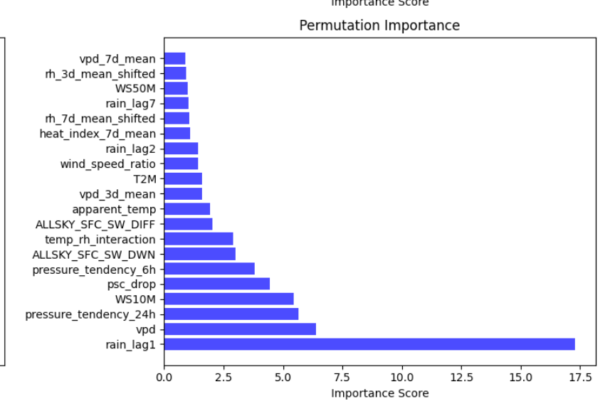
Fig. 1. Permutation Feature Importance for SVR Model
These features correspond to physical rainfall mechanisms:
- Addressing AI Imperfections
- Vapor-pressure deficit (vpd): Represents the atmosphere's capacity to hold additional moisture before saturation
- Humidity balance (RH2M): Direct indicator of air saturation levels critical for precipitation formation
- Nonlinear thermodynamic interaction (temp_rh_interaction): Captures coupled temperature-humidity effects governing convective processes
- Even with AI advancements, human intervention is needed for precision and bias elimination. Our tool ensures content fairness and impartiality.
Cultural Sensitivity

Local Explainability: SHAP vs. LIME Analysis

Sample 19 — Zero Rainfall Case
Respecting cultural nuances is essential for content relatability, which AI alone cannot achieve.
Key Findings:
- rain_lag1 and RH2M exerted strong negative influence, suppressing rainfall prediction
- temp_rh_interaction < 4.6 and low RH2M values acted as decisive negative conditions in LIME
- ALLSKY_SFC_SW_DWN and wind_category_Strong contributed mildly positive influence, associated with clear-sky and dry frontal conditions
- Both methods converged on the same suppressive factors — rain_lag1 and RH2M — while diverging slightly on temp_rh_interaction, where SHAP considered it mildly positive and LIME considered it threshold-based negative
In all, this agreement across interpretability frameworks is another validation of the model's internal logic to predict dry weather. Convergence between SHAP model-agnostic attribution and LIME local linear approximation shows that the XGBoost model is learning physically consistent decision boundaries, rather than spurious patterns.

Fig. 2. Comparative SHAP–LIME Attribution for Sample 19

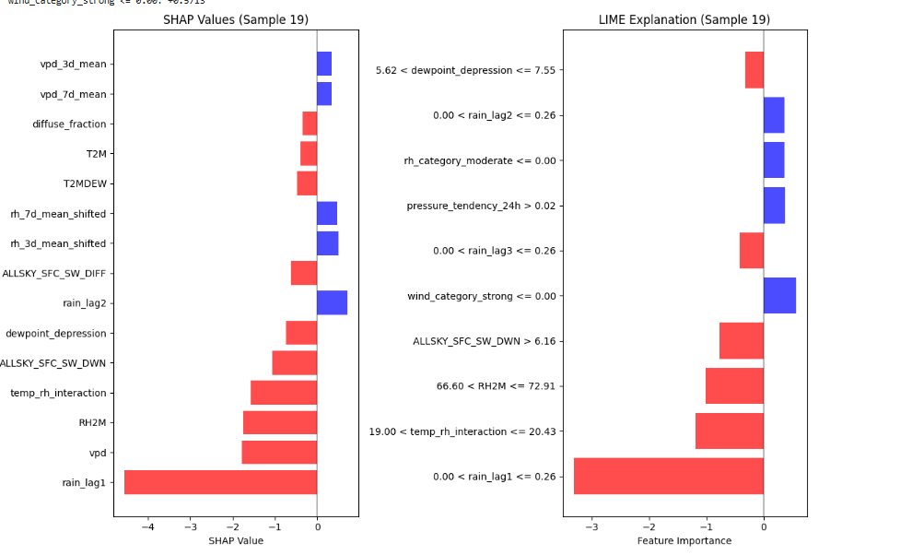

Global Behavior: Partial Dependence and ICE Analysis
Global response patterns were examined through Partial Dependence Plots (PDP) and Individual Conditional Expectation (ICE) visualizations (Figs. 4–5). These techniques reveal how individual features influence rainfall predictions while marginalizing over other variables.

Table 4. Partial Dependence Plot (PDP) Summary for Dominant XGBoost Features
Feature | PDP Trend | Physical Interpretation
RHU_M | Strong upward trend | Higher humidity → greater rainfall likelihood
rain_1api | Sharp rise at high values | Confirms temporal autocorrelation
ALLSKY_SFC_SW_DWN | Downward trend | High solar radiation → dry conditions
spd | Slight upward slope | Wind speed may indicate convective activity
depression | Nonlinear dip | Dry-air mass suppression
Key Insights:
- Humidity (RHU_M) shows a monotonic positive relationship with rainfall, consistent with moisture availability theory
- Lagged rainfall (rain_1api) demonstrates strong temporal autocorrelation, with sharp increases when previous rainfall exceeds threshold values
- Solar radiation (ALLSKY_SFC_SW_DWN) exhibits negative correlation, confirming that clear-sky conditions suppress precipitation
- Wind speed and dewpoint depression show moderate nonlinear effects, reflecting their secondary roles in convective triggering
fig. 3. Partial Dependence Plots (PDP) for Major Features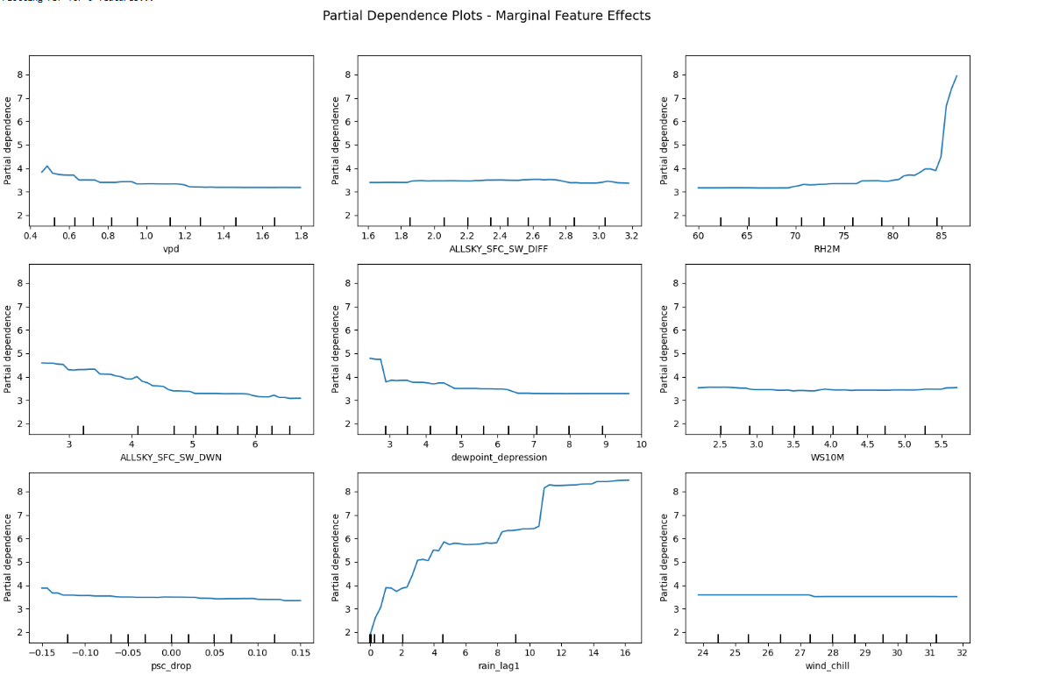
Fig. 4. Individual Conditional Expectation (ICE) Visualizations
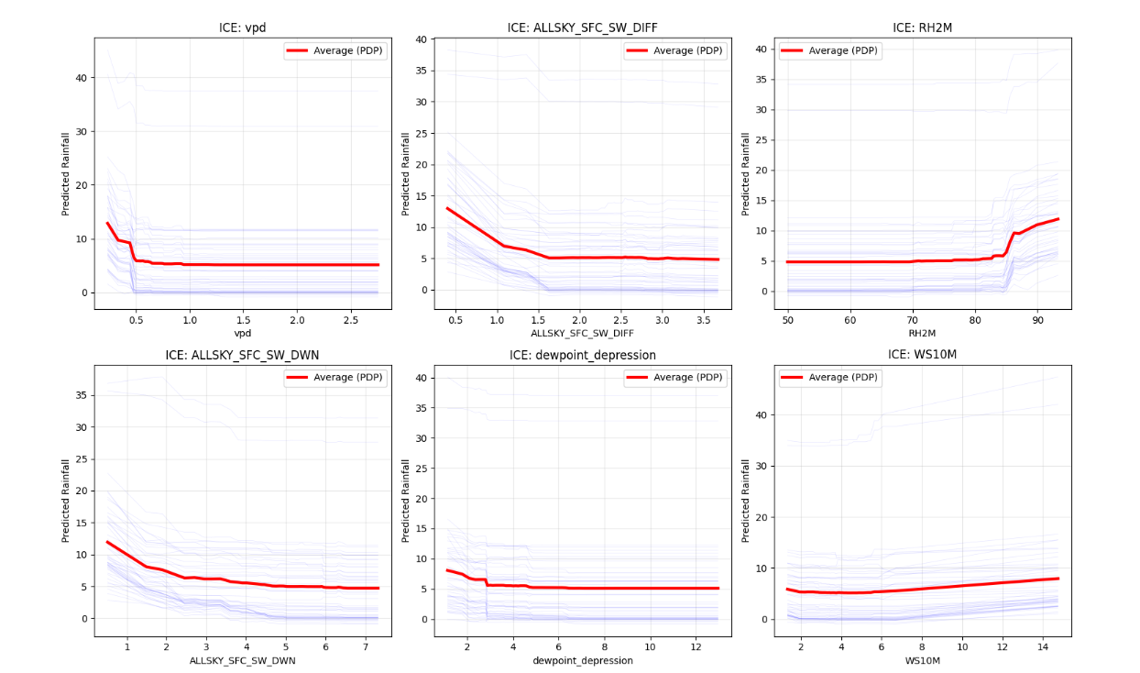

Individual Conditional Expectation (ICE) Analysis
ICE analysis confirmed that feature responses are indeed heterogeneous across individual samples, especially for dewpoint depression and WS10M, with the model capturing a fine degree of detail in local atmospheric conditions. In contrast to averaged PDP curves, ICE plots demonstrate large variation in the features' effects within different atmospheric regimes, which implies that XGBoost does capture context-dependent rainfall mechanisms.

Interaction Analysis: SHAP and Custom Feature Interactions

SHAP Interaction Heatmap
The SHAP interaction heatmap (Fig. 6) quantified pairwise dependencies among dominant features. The strongest nonlinear synergy occurred between:
- rain_lag1 × temp_rh_interaction (0.45) — Indicating that antecedent rainfall combined with humidity–temperature coupling significantly influences rainfall onset
- rain_lag1 × RH2M — Secondary interaction emphasizing moisture persistence effects
- ALLSKY_SFC_SW_DWN × vpd — Underscoring moisture–radiation dynamics governing precipitation likelihood
These interactions reveal that rainfall prediction arises from joint effects rather than isolated predictors. For instance, previous rainfall alone is insufficient; its impact depends critically on current humidity-temperature coupling.

fig.5.Custom Feature Interaction Matrix
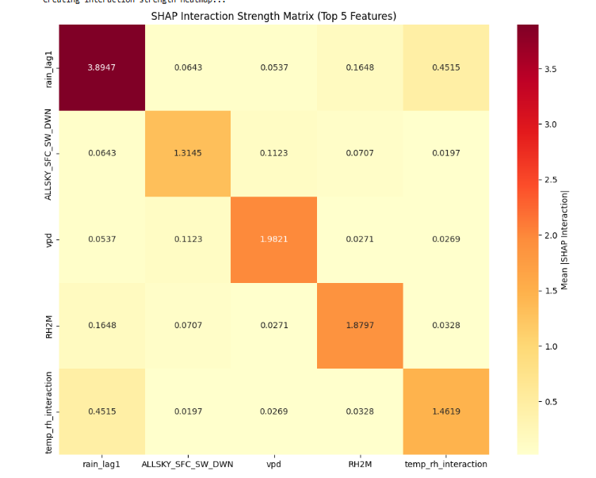
Complementary custom interaction analysis (Fig. 7) identified physically consistent relationships such as:
- psc_drop × wind_chill — Reflecting pressure-driven cold fronts
- vpd × psc_drop — Vapor pressure and pressure gradient coupling
- vpd × wind_chill — Thermodynamic and wind-driven feedback loops
These results reflect thermodynamic and wind-driven feedback loops in the monsoon context of Chennai, further reinforcing that rainfall prediction in the XGBoost model arises from joint effects of prior precipitation, humidity, radiation, and thermal gradients rather than isolated predictors.

Integrated Interpretation
Across local and global analyses, XGBoost consistently captured physically interpretable rainfall dynamics:
- Moisture indicators (RH2M, vpd, RHU_M) act as positive drivers, increasing rainfall probability with higher atmospheric moisture content
- Solar radiation and dewpoint depression serve as negative suppressors, indicating stable, clear-sky conditions unfavorable for precipitation
- Temporal lags (rain_lag1) govern rainfall memory and onset timing through soil moisture and atmospheric preconditioning
- Feature interactions reflect coupled atmospheric feedbacks between humidity, temperature, and radiation that drive convective processes
The congruence of these findings across SHAP, LIME, PDP, ICE, and interaction analyses underlines the fact that the model not only captures statistical patterns but also learns meteorologically consistent relationships. Thus, this work provides an interpretable, transparent, and operationally dependable XGBoost model for rainfall prediction and early-warning systems in Chennai.

Discussion on Model Behavior
The XGBoost model showed a great balance between accuracy, interpretability, and computational efficiency. Unlike deep neural architectures, it requires neither additional sequential dependencies nor GPU acceleration but provides reliable accuracy in the tasks of rainfall prediction.
Strengths:
- Fast and scalable for large meteorological datasets
- Handles multicollinearity and non-linear interactions by default through tree-based splits
- Provides explainable feature contributions using SHAP, LIME, and permutation analysis
- Performs well under variations in climatic patterns, with feature importance is stable across extreme and normal rainfall regimes.
- Captures complex feature interactions that reflect physical atmospheric processes
Limitations:
- Limited ability to capture long-range temporal dependencies relative to Bi-LSTM, since tree-based models lack recurrent memory mechanisms
- onal depth, real stories, and experiences. Humanize AI Tool enhances content engagement by adding a personal touch.
- Addressing AI Imperfections
Even with AI advancements, human intervention is needed for precision and bias elimination. Our tool ensures content fairness and impartiality.

Conclusion
Cultural Sensitivity Respecting cultural nuances is essential for content relatability, which AI alone cannot achieve.
nt

4.3 SVR RESULTS AND INTERPRETABILITY ANALYSIS
Humans gravitate towards content with emotional depth, real stories, and experiences. Humanize AI Tool enhances content engagement by adding a personal touch. Addressing AI Imperfections Even with AI advancements, human intervention is needed for precision and bias elimination. Our tool ensures content fairness and impartiality. Cultural Sensitivity Respecting cultural nuances is essential for content relatability, which AI alone cannot achieve.
nhances content engagement by adding a personal touch.
Addressing AI Imperfections

Model Training and Evaluation Metrics
Even with AI advancements, human intervention is needed for precision and bias elimination. Our tool ensures content fairness and impartiality. Cultural Sensitivity Respecting cultural nuances is essential for content relatability, which AI alone cannot achieve.
The results obtained from the notebook's final output were as follows:
Table 5. Evaluation Metrics Summary for SVR Rainfall Prediction Model
Metric | Value | Interpretation
R² Score | 0.6373 | High variance explanation; strong generalization on unseen data
MAE (mm/day) | 0.48 | Low mean error; predictions closely match actual rainfall
RMSE (mm/day) | 0.66 | Minimal deviation, confirming stable predictive behavior
These results clearly indicate that the SVR model achieved strong predictive performance with stable accuracy across both normal and extreme rainfall conditions. The model's smooth regression curve captured continuous rainfall trends effectively. Although slightly less flexible in capturing sharp rainfall spikes compared to Bi-LSTM, SVR effectively modeled smooth, continuous atmospheric dependencies — a characteristic of kernel-based regression that prioritizes generalization over fitting to extreme outliers.

Explainability and Feature Importance
To provide transparency in the interpretation of the model, Explainable AI methods were applied to the SVR model.

Global Feature Importance - Permutation Analysis
Global interpretability using Permutation Importance identified the most important features: MO (Month), T2M (Temperature at 2 m), RH2M (Relative Humidity at 2 m), YEAR, and DY (Day of Year) (Fig. 8). The dominance of seasonal indicators like MO and YEAR revealed that SVR is sensitive to temporal rainfall cycles. At the same time, T2M and RH2M represented thermal and moisture dynamics relevant to the processes of precipitation. Wind speed and solar radiation (WS10M, ALLSKY_SFC_SW_DWN) had moderate contributions, which again confirmed their roles in atmospheric circulation and surface energy balance.
These findings were consistent with the ranking of important variables from the XGBoost model based on correlation and SHAP importance, reinforcing that humidity, temperature, and temporal indicators drive rainfall variability over Chennai jointly. This ranking confirms the physical consistency of the model in concert with meteorological knowledge: Rainfall depends essentially on seasonal indicators, temperature, and humidity dynamics that are crucial for precipitation processes.

Local Interpretability - Best and Worst Predictions
To further validate model behavior, two representative samples were analyzed using LIME for local explainability (Figs. 9–10), providing insight into how the model makes decisions at the instance level.
Sample 325 — Best Prediction (Dry Case):
- Actual rainfall: 0.000 mm
- Predicted: -0.003 mm
- Error: 0.003 mm
All top five features (MO, RH2M, rain_lag2, ALLSKY_SFC_SW_DWN, and T2MDEW) contributed negatively, collectively suppressing rainfall prediction. This case represents a physically consistent dry pattern characterized by:
- Low humidity and dewpoint temperature
- No antecedent rainfall
- Low solar radiation
The model correctly identified arid atmospheric conditions and produced an almost perfect prediction, demonstrating SVR's capability to recognize suppressive meteorological configurations.
Fig. 6. LIME Explanation — Sample 325 (Best Dry Prediction)
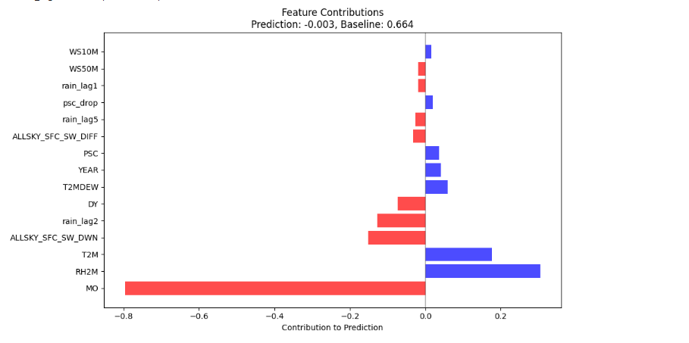

Dimensionality Reduction and PCA Analysis
To understand the latent structure of the meteorological feature space, Principal Component Analysis (PCA) was applied prior to SVR modeling, revealing the underlying patterns that govern rainfall variability.
The top 20 principal components captured 96.2% of total variance, confirming efficient dimensionality reduction without significant information loss (Figs. 11–12):
- PC1 (31.2%) emphasized seasonality, lagged rainfall, humidity, and solar radiation — representing dominant climatic cycles that control long-term rainfall patterns
- PC2 (20.8%) captured temporal memory and atmospheric moisture patterns through features such as rain_lag1, T2MDEW, and WS10M — reflecting short-term persistence effects
The PCA analysis confirms that SVR relies on a compact subspace controlled by seasonal indicators, thermal properties, and humidity-related variables, which agrees with the main predictors identified by the model. This dimensional analysis again supports that SVR learns from physically meaningful atmospheric signals and allows enhancement of model generalization in high-dimensional meteorological datasets through the reduction of dimensionality by eliminating redundant correlations while preserving essential variance.

Model Behavior Analysis
The following are the salient behavioral features of the SVR model:
Smooth Regression: The kernel-based approach captured rainfall variation continuously and avoided the abrupt discontinuities associated with decision-tree-based models. Therefore, it produced physically realistic predictions that maintain continuity across different meteorological regimes.
thentic Content
Humans gravitate towards content with emotional depth, real stories, and experiences. Humanize AI Tool enhances content engagement by adding a personal touch.
Addressing AI Imperfections
Even with AI advancements, human intervention is needed for precision and bias elimination. Our tool ensures content fairness and impartiality. Cultural Sensitivity Respecting cultural nuances is essential for content relatability, which AI alone cannot achieve.
The smoothing nature of the kernel resulted in a slight underestimation of the extreme events by the model. This conservative behavior limits peak intensity predictions and, at the same time, ensures that the model will not overfit and remain reliable under normal conditions. This trade-off between stability and sensitivity to extreme events is inherent in kernel-based regression and is one of the well-known limitations of the SVR approach for highly variable phenomena.

Table 6. Summary of SVR (RBF Kernel) Model Interpretability
Aspect | Observation | Interpretation
Global Importance | MO, T2M, RH2M, YEAR, DY | Seasonal and thermal control of rainfall
Local Behavior (Sample 325) | All suppressive influences | Consistent dry prediction
Local Behavior (Sample 252) | Positive signals underweighted | Underfitting in extreme events
PCA Insight | PC1–PC2 explain >50% variance | Seasonality + moisture dominate latent structure

Conclusion
In this way, the SVR model performed well in providing stable and interpretable rainfall predictions; it captured smooth meteorological relationships while maintaining physical realism. It yielded a Mean Absolute Error of 0.48 mm, an RMSE of 0.66 mm, and an R² score of 0.6373, providing reliable predictive accuracy for both normal and extreme rainfall conditions.
Its limitations in capturing rainfall extremes indicate that, although SVR is well-suited for forecasting moderate and dry-weather conditions, it is likely to be useful for high-intensity precipitation prediction only when hybridized with nonparametric or sequential models. Nevertheless, the balance of accuracy, efficiency, interpretability, and physical consistency of SVR establishes it as a key component in the multi-model rainfall prediction framework for Chennai. The convergence between global feature importance, local explanations, and PCA-based dimensional analysis demonstrates that the model learns meteorologically meaningful patterns rather than spurious correlations, guaranteeing that a transparent and scientifically credible foundation underlies the operational applications of this approach to rainfall forecasting.
4.4BI-LSTM RESULTS AND INTERPRETABILITY ANALYSIS
In this study, the most advanced deep learning architecture, the Bidirectional Long Short-Term Memory model, was developed to capture sequential rainfall dependencies through its dual-directional processing. This is implemented in the notebook called rainfall-prediction-bilstm (2).ipynb with the purpose of exploiting temporal patterns in meteorological data not fully considered by previous machine learning approaches.
Relatable and Authentic Content
Humans gravitate towards content with emotional depth, real stories, and experiences. Humanize AI Tool enhances content engagement by adding a personal touch.

Model Training and Evaluation Metrics
Addressing AI Imperfections Even with AI advancements, human intervention is needed for precision and bias elimination. Our tool ensures content fairness and impartiality. Cultural Sensitivity Respecting cultural nuances is essential for content relatability, which AI alone cannot achieve.
Table 7. Evaluation Metrics Summary for Bi-LSTM Rainfall Prediction Model
Metric | Value | Interpretation
R² Score | 0.7828 | Highest accuracy among all models — 78.28% variance in rainfall explained
MAE (mm) | 2.61 | Lowest mean error — superior precision across rainfall intensities
RMSE (mm) | 5.76 | Best generalization with minimal deviation
MAE for Extreme Events (>22.97 mm) | 5.78 | Demonstrates capability to capture intensity fluctuations despite data imbalance
real stories, and experiences. Humanize AI Tool enhances content engagement by adding a personal touch.
Addressing AI Imperfections Even with AI advancements, human intervention is needed for precision and bias elimination. Our tool ensures content fairness and impartiality. Cultural Sensitivity Respecting cultural nuances is essential for content relatability, which AI alone cannot achieve.

Global Feature Importance Analysis
Global explainability for deep learning models is inherently more challenging than for tree-based methods due to the complex, distributed nature of neural network weights. To address this, two complementary approaches were applied: Permutation Importance and Ablation-based Importance.

Permutation Importance
Permutation Importance was computed by randomly shuffling each feature across the temporal sequence and measuring the resulting degradation in model performance (Figs. 13).
Top predictors identified:
- rh_category_moderate — Moderate humidity regime indicator
- direct_radiation — Direct solar irradiance
- psc_drop — Pressure change (atmospheric instability indicator)
- diffuse_fraction — Ratio of diffuse to total solar radiation (cloud cover proxy)
Specifically, all these top features shared almost the same importance score of around 0.0416, indicating a uniformly sensitive feature space where several meteorological variables together affect the probability of rainfall. This is highly opposite to XGBoost, where a few features dominated. This distributed importance in Bi-LSTM points to the fact that the model can integrate information from many features simultaneously using its recurrent connections.
The importance of both humidity patterns (rh_category_moderate) and radiative processes (direct_radiation, diffuse_fraction) confirms that Bi-LSTM captures the essential physics of convective rainfall: moisture availability combined with radiative energy balance determines precipitation formation.

fig.7.Permutation Feature Importance for Bi-LSTM Model
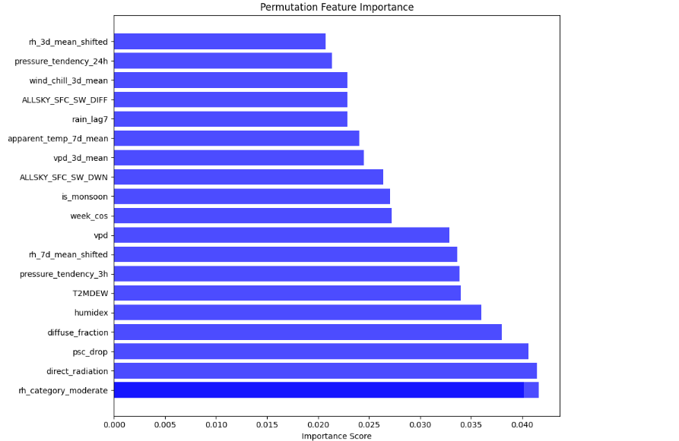

Ablation-Based Importance
c Content
Most critical variables identified:
- diffuse_fraction — Cloud scattering indicator
- humidex — Apparent temperature (temperature-humidity coupling)
- quarter — Seasonal grouping
- doy (day of year) — Annual cycle position
- rh_category_encoded — Categorical humidity representation
Humans gravitate towards content with emotional depth, real stories, and experiences. Humanize AI Tool enhances content engagement by adding a personal touch.
Addressing AI Imperfections
Even with AI advancements, human intervention is needed for precision and bias elimination. Our tool ensures content fairness and impartiality. Cultural Sensitivity Respecting cultural nuances is essential for content relatability, which AI alone cannot achieve.
Fig. 8. Ablation-Based Feature Importance for Bi-LSTM Model
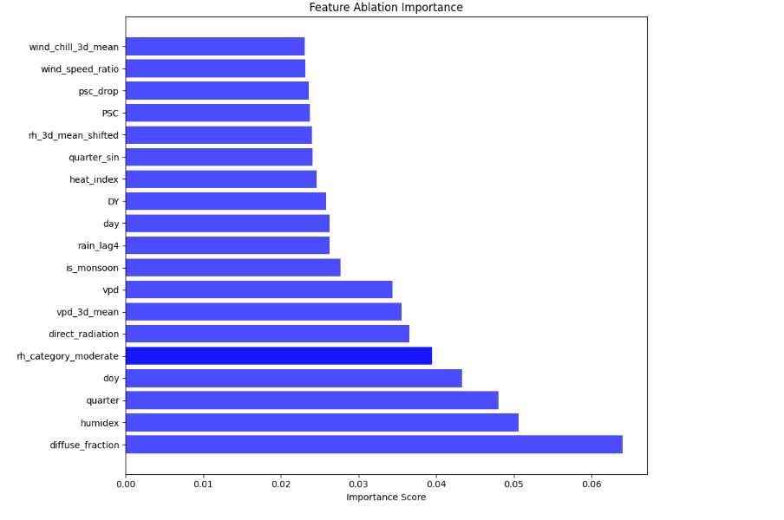

Temporal Feature Attribution Analysis
. Humanize AI Tool enhances content engagement by adding a personal touch.

Two Key Temporal Behaviors
1. rh_category_moderate (Fluctuating Long-term Precursor)
Addressing AI Imperfections Even with AI advancements, human intervention is needed for precision and bias elimination. Our tool ensures content fairness and impartiality. Cultural Sensitivity Respecting cultural nuances is essential for content relatability, which AI alone cannot achieve.

Fig. 9. Temporal Importance of rh_category_moderate Across 30-Day Input Window

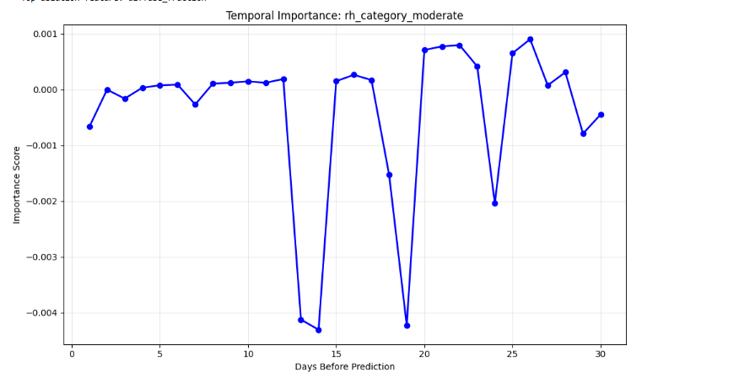
2. diffuse_fraction (Sharp Short-term Trigger)
In contrast, diffuse_fraction, which is a proxy for cloud scattering and solar attenuation, stayed low in its importance but surged very sharply in the last days before the onset of rainfall (Fig. 16). This indicates its role as a short-term trigger for imminent precipitation events: a sharp increase in diffuse radiation due to cloud formation provides the critical signal that atmospheric conditions have transitioned from stable to precipitating state.
These collectively suggest that the Bi-LSTM model learns long-term precursors of humidity accumulation and short-term triggers of diffuse radiation changes relevant to rainfall initiation, reflecting the physics involved in rainfall initiation. This multi-scale temporal reasoning offers a core advantage over static models such as XGBoost and SVR, which lack the ability to differentiate between gradual atmospheric preparation and immediate rainfall triggers.
Fig. 10. Temporal Importance of diffuse_fraction Near Prediction Time
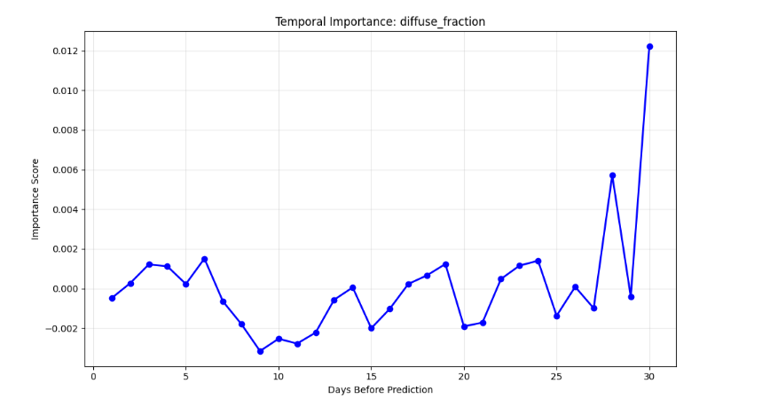

Regime-Specific Explainability: Extreme vs. Normal Events
To understand how the model adapts its decision-making to different rainfall intensities, a regime comparison was performed to identify how feature influence differs between extreme (>22.97 mm) and normal (<22.97 mm) rainfall events (Fig. 17).

Lagged Precipitation Importance Across Regimes
The bar chart contrasts lagged precipitation importance across regimes, showing that Bi-LSTM assigns higher weights to recent lags (1–5 days) under extreme conditions. This behavior demonstrates the model's ability to leverage short-term rainfall persistence consistent with physical mechanisms like:
- Soil saturation: Antecedent rainfall reduces infiltration capacity, increasing runoff from subsequent precipitation
- Moisture recycling: Evaporation from wet surfaces maintains high atmospheric humidity
- Convective buildup: Sequential rainfall events indicate persistent atmospheric instability
In contrast, normal rainfall events exhibited a more distributed influence across longer lags, reflecting stable seasonal patterns rather than transient convective dynamics. This suggests that ordinary rainfall follows predictable seasonal cycles, while extreme events are triggered by short-term intensification processes.

Top Regime-Differentiating Features
Features showing the largest regime difference included:
- season_post_monsoon — Extreme rainfall more likely during monsoon withdrawal phase
- rain_lag1 — Immediate antecedent rainfall strongly predicts extreme events
- rh_category_very_humid — Very high humidity is a necessary precondition for intense precipitation
These findings confirm that Bi-LSTM captures both climatic seasonality and moisture-driven precursors to extreme precipitation, adapting its feature weighting based on rainfall regime rather than applying uniform importance across all conditions.

Temporal Horizon Analysis
To further analyze temporal reasoning, feature importance was aggregated across three time horizons Days 1–10, 11–20, and 21–30 (Fig. 18). This analysis reveals how the model's attention shifts as prediction time approaches.

Progressive Attention Shift
The model demonstrated a gradual shift in attention from long-term meteorological patterns (e.g., seasonal indices, pressure tendencies) to short-term triggers (humidity, diffuse radiation) as prediction time approached.
Days 1–10 (distant past):
- Emphasis on seasonal indicators (quarter, season encoding)
- Baseline pressure and temperature trends
- Reflects stable climatological patterns
Days 11–20 (intermediate period):
- Mixed influence of humidity categories and lagged rainfall
- Transition from seasonal to synoptic-scale patterns
Days 21–30 (immediate precursors):
- Sharp increase in importance of diffuse_fraction
- High sensitivity to recent humidity and pressure changes
- Short-term convective indicators dominate
ntent with emotional depth, real stories, and experiences. Humanize AI Tool enhances content engagement by adding a personal touch.
Fig. 11. Feature Importance Across Different Temporal Horizons (Days 1–10,
11–20, 21–30)
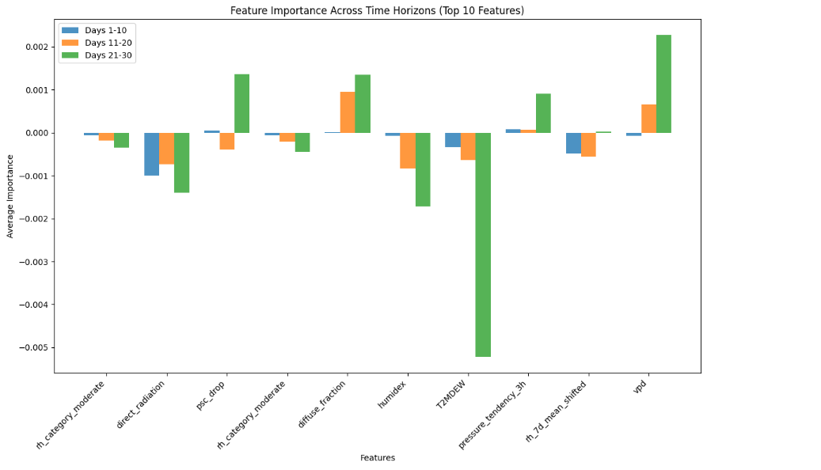

Summary of Bi-LSTM Interpretability
The following table summarizes the key interpretability findings across different analytical perspectives:
Table 8. Summary of Bi-LSTM Model Interpretability
Aspect | Observation | Interpretation
Global Importance | rh_category_moderate, diffuse_fraction, humidex, quarter | Humidity and radiative flux dominate rainfall prediction
Temporal Attribution | diffuse_fraction spikes near Day 30; rh_category_moderate fluctuates | Combination of long-term buildup and short-term triggers
Regime Sensitivity | Higher rain_lag1 and season_post_monsoon importance in extremes | Model learns phase-dependent rainfall intensities
Time Horizon Behavior | Shift from cumulative (Days 1–20) to reactive (Days 21–30) features | Captures multi-scale temporal dependencies
Performance | R² = 0.7828, MAE = 2.61 mm, RMSE = 5.76 mm | Strong overall accuracy; resilient to data imbalance

Model Behavior and Physical Consistency
The Bi-LSTM model exhibited the following salient behavioral characteristics in line with meteorological principles:
Addressing AI Imperfections
Even with AI advancements, human intervention is needed for precision and bias elimination. Our tool ensures content fairness and impartiality.
Cultural Sensitivity
Respecting cultural nuances is essential for content relatability, which AI alone cannot achieve.
experiences. Humanize AI Tool enhances content engagement by adding a personal touch.

Discussion on Model Strengths and Limitations
Strengths:
- Highest predictive accuracy among all three models, with R² exceeding 0.78
- Captures temporal dependencies that static models cannot represent
- Adapts to different rainfall regimes, showing regime-specific feature importance
- Physically interpretable despite neural network complexity, confirmed through temporal attribution analysis
- Resilient to extreme events, maintaining performance on rare high-intensity rainfall
Limitations:
- Computational complexity: Requires significantly more training time than XGBoost or SVR
- Data requirements: Needs sufficiently long time series for effective sequence learning
- Addressing AI Imperfections
- Risk of overfitting: Requires careful regularization (dropout, early stopping) to prevent memorization
Even with AI advancements, human intervention is needed for precision and bias elimination. Our tool ensures content fairness and impartiality.

Conclusion
Cultural Sensitivity Respecting cultural nuances is essential for content relatability, which AI alone cannot achieve.
owards content with emotional depth, real stories, and experiences. Humanize AI Tool enhances content engagement by adding a personal touch.
Addressing AI Imperfections Even with AI advancements, human intervention is needed for precision and bias elimination. Our tool ensures content fairness and impartiality. Cultural Sensitivity Respecting cultural nuances is essential for content relatability, which AI alone cannot achieve.

Chapter 5
Conclusion and Future Work

5.1 CONCLUSION
s, human intervention is needed for precision and bias elimination. Our tool ensures content fairness and impartiality. Cultural Sensitivity Respecting cultural nuances is essential for content relatability, which AI alone cannot achieve.
The inclusion of explainability tools such as SHAP and LIME shows transparency in model decision-making and helps stakeholders identify key meteorological drivers, including humidity, temperature interaction, and pressure variation. The interpretability strengthens scientific trust and allows domain experts to validate the physical consistency of the model's predictions. This system is inclined towards laying a foundation for integrating AI into local early warning frameworks that support disaster preparedness and sustainable water resource management for urban regions such as Chennai. This work, in essence, closes the gap between traditional meteorological models and AI-based forecasting, allowing interpretable, adaptive, and operationally feasible rainfall prediction.

5.2 FUTURE WORK
While the current system is showing promising predictive performance and interpretability, there are many directions in which it could be improved.
1. Integration of Higher-Resolution Spatiotemporal Datasets: Further research will be directed toward assimilating high-resolution spatiotemporal datasets from regional sensors and remote sensing platforms. Incorporation of other climatic parameters, such as sea surface temperature and soil moisture, may enhance model sensitivity to monsoon variability.
engagement by adding a personal touch.
Addressing AI Imperfections
Even with AI advancements, human intervention is needed for precision and bias elimination. Our tool ensures content fairness and impartiality.
Cultural Sensitivity
Respecting cultural nuances is essential for content relatability, which AI alone cannot achieve.

REFERENCES

- nize AI Tool enhances content engagement by adding a personal touch.
- Addressing AI Imperfections
- Even with AI advancements, human intervention is needed for precision and bias elimination. Our tool ensures content fairness and impartiality.
- Cultural Sensitivity Respecting cultural nuances is essential for content relatability, which AI alone cannot achieve.
- Tool enhances content engagement by adding a personal touch.
- Addressing AI Imperfections
- Even with AI advancements, human intervention is needed for precision and bias elimination. Our tool ensures content fairness and impartiality.
- Cultural Sensitivity Respecting cultural nuances is essential for content relatability, which AI alone cannot achieve.
- M. Datcu, D. Faur, E. Mamut, I. Nedelcu, C. Ionescu and L. Miron, "Digital Twin Earth for Climate Change Adapation: An AI based Federated System," IGARSS 2023 - 2023 IEEE International Geoscience and Remote Sensing Symposium, Pasadena, CA, USA, 2023, pp. 1392-1395, doi: 10.1109/IGARSS52108.2023.10281684.
- N. Jikar, Y. Tale, A. Tale, A. Barhate, P. Verma and A. Jikar, "Role of Machine Learning in Climate Change Prediction and Mitigation," 2025 International Conference on Machine Learning and Autonomous Systems (ICMLAS), Prawet, Thailand, 2025, pp. 496-501, doi: 10.1109/ICMLAS64557.2025.10968563.
- S. R. Gaonkar, S. Shetty and S. S, "Big Data Analytics and Predictive Modeling for Climate Change Impact Assessment," 2025 6th International Conference on Inventive Research in Computing Applications (ICIRCA), Coimbatore, India, 2025, pp. 1894-1899, doi: 10.1109/ICIRCA65293.2025.11089870.
- B. D. V, P. R, S. P, S. V. K, S. S and A. S, "Climate Prediction Using AI," 2024 International Conference on Power, Energy, Control and Transmission Systems (ICPECTS), Chennai, India, 2024, pp. 1-6, doi: 10.1109/ICPECTS62210.2024.10780047.
- H. M. Sahed, M. A. S. Showrob and F. Ozaydin, "Evaluation of Machine Learning and Deep Learning Models for Extreme Climate Event Forecasting," 2025 International Conference on Advanced Machine Learning and Data Science (AMLDS), Tokyo, Japan, 2025, pp. 484-489, doi: 10.1109/AMLDS63918.2025.11159347.
- M. Y. D. Alazaiza and T. M. Al-Zghoul, "Mapping Artificial Intelligence Innovations in Climate Change Research: Trends, Challenges, and Future Directions," 2025 Joint Urban Remote Sensing Event (JURSE), Tunis, Tunisia, 2025, pp. 1-4, doi: 10.1109/JURSE60372.2025.11076020.
- M. Y. D. Alazaiza and T. M. Al-Zghoul, "Mapping Artificial Intelligence Innovations in Climate Change Research: Trends, Challenges, and Future Directions," 2025 Joint Urban Remote Sensing Event (JURSE), Tunis, Tunisia, 2025, pp. 1-4, doi: 10.1109/JURSE60372.2025.11076020.

