project report on
Custom Honeypot for Attacker Behavior Analysis Using Centralized Monitoring and Blockchain
Submitted in partial fulfillment for the award of the degree of

Bachelor of Technology in Computer Science and Engineering with specialization in Cyber Physical System

by
Dineshwer R S(22BPS1082)
Allwin joshua R S(22BEE1032)
Pranav T J(22BEE1134)


SCHOOL OF COMPUTER SCIENCE AND ENGINEERING

April,2026

project report on
Custom Honeypot for Attacker Behavior Analysis Using Centralized Monitoring and Blockchain
Submitted in partial fulfillment for the award of the degree of

Bachelor of Technology in Computer Science and Engineering with specialization in Cyber Physical System

by
Dineshwer R S(22BPS1082)
Allwin josua R S(22BEE1032)
Pranav T J(22BEE1134)


SCHOOL OF COMPUTER SCIENCE AND ENGINEERING

April,2026



DECLARATION

Hereby, I do certify that the thesis stated above titled Custom Honeypot for Attacker Behaviour Analysis Using Centralised Monitoring & Blockchain written by Dineshwer RS (22BPS1082), Allwin Joshua RS (22BEE1032), Pranav TJ (22BEE1134) for the course Bachelor of Technology in Computer Science & Engineering from Vellore Institute of Technology, Chennai is my true and faithful effort made with the guidance of Dr. Balraj.E (Assistant Professor).
Apart from this, by oath, I hereby state that the work carried out and documented in the thesis mentioned above has not been submitted or will not be submitted in the future in whole or in parts for any academic purpose in any other place.​

Place: Chennai
Date: Signature of the Candidates


School of Computer Science and Engineering

CERTIFICATE
Statement of Authorship: This report titled “Custom Honeypot for Attack Behaviour Analysis through Centralised Monitoring and Blockchain” authored by Dineshwer.R.S(22BPS1082), Allwin Joshua RS(22BEE1032), Pranav TJ(22BEE1134) with respect to the submission requirement for obtaining the Bachelor of Technology in Computer Science and Engineering, Specialization in Cyber Physical System from the Vellore Institute of Technology, Chennai, is an authentic report prepared under my supervision. The report complies with all the norms laid down by this institute, and I strongly believe that it meets all the criteria required for submission. The information contained in this report has never been submitted anywhere else previously or at any other point in the future for the award of any other degree/diploma.​

Signature of the Guide:
Name: Dr. Balraj E Date:

Signature of the Examiner Signature of the Examiner
Name: Name:
Date: Date:

Approved by the Head of Department,
Computer Science and Engineering with specialization in Cyber Physical System
Name: Dr Renuka Devi S
Date:
ABSTRACT
The secure shell (SSH) is considered one of the most essential protocols commonly applied for gaining remote access. Thus, numerous types of attacks may be carried out on this protocol, including brute-force attacks or login without authentication. Honeypots have been recognized as efficient means of protecting oneself against attacks and learning about what the attacker aims at. Nonetheless, regular SSH honeypots have been connected with such disadvantages as complicated configuration, absence of command control, and log integrity. The present paper focuses on the SSH honeypot designed for examining the behavior of the attacker based on virtual file systems and log integrity checking using blockchain technology.​
The actions of the hacker are recorded in structured logs that appear on the dashboard later on. Moreover, all the sessions are recorded in the form of SHA-256 hashes within the blockchain in order to guarantee the integrity of logs so that they could be used for forensic analysis. To put it briefly, it may be said that the research proves the efficiency of the developed tool regarding the logging of hacker actions, the complete protection of the system through isolation, and the usage of blockchain technologies for providing the integrity of logs, meaning that an effective way of cyber-attack analysis is offered. Apart from this, the suggested system can provide a safe environment where it would be possible to analyze a hacker's actions without any risks to the life infrastructure. It means that the proposed system will be able to help investigators in cybersecurity investigations and analyzing cyber-attacks for educational purposes.​

i
ACKNOWLEDGEMENT
It is my pleasure to express with deep sense of gratitude to Balraj E
My sincere gratitude goes to the visionaries:
To Dr. G. Viswanathan, Honorable Chancellor, Mr. Sankar Viswanathan, Dr. Sekar Viswanathan, Dr. G V Selvam, Vice Presidents, Dr. Sandhya Pentareddy, Executive Director, Ms. Kadhambari S. Viswanathan, Assistant Vice President, Dr. V. S. Kanchana Bhaaskaran, Vice Chancellor, Dr. T. Thyagarajan, Pro-Vice Chancellor, VIT Chennai, and Dr. P. K. Manoharan, Additional Registrar, for giving us an excellent working environment and inspiring us throughout the period of studies. From my heart, I express my gratitude to Dr. Viswanathan V, Dean, Dr. Nithyanandam P, Dr. Suganya G, Dr. Sweetlin Hemalatha C, Associate Deans, School of Computer Science and Engineering, Vellore Institute of Technology, Chennai, for taking out valuable time and efforts in guiding us. With great happiness, I extend my thanks to Dr. Tulasi Prasad, Head of the Department, B.Tech Computer Science and Engineering with Artificial Intelligence and Machine Learning, and Project Coordinators for their valuable contribution to our project.​
I am really grateful to all the professors and other staff members at VIT, Chennai, who helped me gather the information related to the subject. I am really indebted to my parents for the assistance provided to me with respect to my research on the subject. I thank my friends who helped me complete the assignment.
Place: Chennai
Date: Dineshwer.R.S
Allwin Joshua R S
Pranav TJ

ii
CONTENTS
CONTENTS ………………………………………………………………ⅲ
LIST OF FIGURES……………………………………………………..…v
LIST OF TABLES……………………………………………………..…vii
LIST OF ACRONYMS…………………………………………………viii

CHAPTER 1
INTRODUCTION
1.1 INTRODUCTION……………………………………………………….1
1.2 PROBLEM STATEMENT ………………………………………….…..2
1.3 SCOPE OF THE STUDY……………………………………………….3
CHAPTER 2
LITERATURE REVIEW
2.1 LITERATURE REVIEW………………………………………………..4
2.2 RESEARCH CHALLENGES…………………………………………...6

CHAPTER 3
PROPOSED ARCHITECTURE AND METHODOLOGY
3.1 PROPOSED SYSTEM………………………………………………….7
3.2 SYSTEM ARCHITECTURE……………………………………….….9
3.3 HONEYPOT AND VIRTUAL FILESYSTEM…………..……………18
3.4 BLOCKCHAIN-BASED LOGGING….………………………………22
iii

3.5 MONITORING SYSTEM……………..………………………..….…25
3.6 SUMMARY…………………………………………….……….….….26
CHAPTER 4
RESULTS AND OUTPUT
4.1 IMPLEMENTATION OVERVIEW……………….…..……………….27
4.2 HONEYPOT IMPLEMENTATION…………...…………………...….29
4.3 BLOCKCHAIN VERIFICATION RESULTS………………....………41
4.4 VIRTUAL FILESYSTEM IMPLEMETAION...…………………...….48
4.5 PERFORMANCE ANALYSIS...…………………………………...….50

CHAPTER 5
CONCLUSION
5.1 CONCLUSION………...………………………………………………52
5.2 LIMITATION……………………………………………..……………54
5.3 FUTURE WORK………………………………………………………56

REFERENCES……………………………………………………………58

iv
LIST OF FIGURES

Fig. no | Title | page no
1 | System Overview | 7
2 | System Architecture | 9
3 | Flow Diagram | 11
4 | System Data FlowChart | 12
5 | SSH Connection Flowchart | 16
6 | Virtual File System | 19
7 | Consensus and Block formation | 23
8 | SIEM Monitoring tool Dashboard | 28
9 | SIEM Monitoring tool authentication | 32
10 | Blockchain Logs | 41

v
LIST OF TABLES

Table no | Content | page no
1 | Overall components | 8
2 | Security Threat Model | 14
3 | Comparison of Existing Honeypots and Proposed System | 17
4 | API Endpoint Documentation | 20
5 | Smart Contract Logic Mapping | 22
6 | Transaction Lifecycle | 24
7 | Consensus Mechanism Details | 26

vi
LIST OF ACRONYMS
SSH - Secure Shell
VM - Virtual Machine
IDS - Intrusion Detection System
IPS - Intrusion Prevention System
SIEM - Security Information and Event Management
CLI - Command Line Interface
FS - Filesystem
VFS - Virtual Filesystem
IP - Internet Protocol
TCP - Transmission Control Protocol
ELK - Elasticsearch, Logstash, Kibana
API - Application Programming Interface
JSON - JavaScript Object Notation
SHA-256 - Secure Hash Algorithm 256-bit
PoC - Proof of Concept
DoS - Denial of Service
MITM - Man-in-the-Middle
CTI - Cyber Threat Intelligence
OS - Operating System
CPU - Central Processing Unit

vii
Chapter 1
INTRODUCTION

1.1 INTRODUCTION

With the increase in the trend of cloud computing and other Internet-based management, there are some cases in which vital systems are affected by any security breach in the form of cyber attacks. The secure shell protocol is vulnerable to attacks from hackers who try to break into the system using any unauthorized method, including brute force attacks.​
Not only should we identify these attacks and prevent them, but we must also conduct analysis on the attacker to ensure that our systems become more secure. The major drawback of using a firewall and IDS approach is that it does not give any information regarding how the attackers perform their actions. To overcome this drawback, it was felt that SSH honeypot technology needed to be employed since it is one of the technologies of deception that enables communication between the attacker and the target system. But there are various drawbacks to the use of these honeypots.​
To overcome this problem, a new design of SSH honeypot system that enables a realistic interaction experience by the attacker while securing the system with the use of virtual file systems is presented in this paper. The actions taken by the attacker will be confined to only the virtual files without touching the real system. Furthermore, blockchain technology will be used in this study through the utilization of logging of session logs using the blockchain for interactions between the logging of the attack events.​

1.2 PROBLEM STATEMENT
One of the services that often becomes the target for cyber attacks is Secure Shell (SSH). The possibility of becoming visible on the internet and relying on various forms of authentication makes it easy to penetrate into the network using the weak credentials or configurations of the above-mentioned service. Despite being widely used in studying the behavior patterns of the intruders, these methods are often accompanied by some drawbacks. Primarily, they are complicated to implement and install. Moreover, it is impossible to fully control the activities of the hacker; therefore, the created scenarios do not seem realistic. Finally, most of the honeypots for SSH rely on other software to monitor their actions.
Another problem concerning the existing tools is the authenticity of the logs that can be generated by the tools. These logs contain information in plaintext format, which can be easily manipulated or even deleted. Consequently, the use of such logs would not bring any value to the analysis process.​
In order not to have to deal with the problems mentioned above, the aim of the research will be the creation of an effective honeypot for the analysis of such attacks. The honeypot will be created to behave like an SSH protocol and enable attackers to exchange information with the system, without allowing them to penetrate into it. Another aim of this research will be the development of a fully isolated virtual file system, ensuring that whatever happens on its account will neither affect the honeypot itself nor any computer network where it will operate. Moreover, another question that will be analyzed throughout this research concerns the need to create the system for integrating all activities carried out by the attacker, including login attempts and commands.​

1.3 SCOPE OF THE STUDY
The first aspect is the application of virtual file systems to execute commands so that the actions of the attacker remain restricted to the virtual system without impacting the real one. The blockchain technology has been employed to guarantee integrity in log files and conduct forensics. The whole process of implementation is carried out virtually, while testing is performed using brute-force attacks and command execution within the environment. Despite the success in conducting analysis of actions by attackers, the system can benefit from enhancements in analytics and machine learning for optimal dashboard use.​

Chapter 2
Literature Review

2.1 LITERATURE REVIEW
The field of cybersecurity is gradually shifting its focus towards preventive actions that will enable a deterrent effect against the attack as well as analysis of the actions carried out by the attacker. In this case, honeypots have become an area of interest in which attackers can be lured into operating in an artificial environment, with the aim of analyzing their operations. In the previous research studies on honeypots conducted by Spitzner, there was a focus on the significance of honeypots as a means of deception as well as analysis of attacks, and not blocking attacks.​
Unlike low-interaction honeypots which simulate services, high-interaction honeypots offer an ideal platform for analyzing what the attacker does after successfully breaching the system. Low-interaction honeypots are easy to implement since they do not offer any level of realism in their simulations, thus making it possible for attackers to easily notice them. High-interaction honeypots are dangerous since the attackers have total control over the computer system. In order to counteract these drawbacks, it is important to find ways of overcoming these limitations and this has been the reason why hybrid honeypots are increasingly becoming common now.
The use of SSH honeypots like Cowrie and Kippo has always been done in order to identify behaviors carried out by attackers such as brute force and command attacks on the system. Among what could be learned through analysis of attacks include credentials of the attacker, various commands performed as well as probing. It has been discovered that there are certain trends followed when attackers breach the system and these involve scanning, attempting to authenticate themselves, and probing.​
Today, there exist several innovations related to honeypots' implementation. First, some experts recommend combining IDSs with honeypots and investigating the obtained results. There exist various types of IDSs; for instance, Snort or SIEM can be taken as an example. Second, other researchers believe that the use of machine learning techniques will help improve classification efficiency. Nonetheless, even though both techniques have proven to be beneficial, their implementation requires extra software.
One of the issues raised in the literature is the aspect related to security and stability associated with log management. As stated above, conventional honeypots store information in plaintext and, hence, create risks of any manipulation. This factor decreases honeypots' attractiveness when it comes to forensic research due to possible manipulation of data. In order to overcome this issue, blockchain can be implemented, which would allow keeping logs' hashes rather than their full content.​
In general, it should be admitted that there are specific trends related to the development of honeypots through the incorporation of such characteristics as interaction at a high level and proper log management. However, contemporary research reveals specific limitations associated with the utilization of honeypots, and the most common issues include complexity, ineffective interaction management, absence of isolation, and tampering with logs.

2.2 RESEARCH CHALLENGES

Realistic Interaction with the Attacker:
It seems rather difficult to establish a honeypot within the framework of an SSH system, since interactions will be too obvious for the hacker to suspect the role of the machine as a honeypot. On the other hand, it is crucial to create a realistic environment without jeopardizing the whole system.​
Isolating the Entire System from Attackers:
The creation of a special system that could prevent the intrusion by the hacker into the target machine and the target network is essential. Indeed, the attacker may take advantage of the machine for launching a cyberattack on the target system. In this regard, it is necessary to create an interaction environment where no commands are executed.​
Security of Log Files:
The logs that might be obtained from the attack on the honeypot can prove to be useful during investigations. Conventional approaches towards the protection of log files have been identified to be futile as it is easy for an attacker to modify the data contained therein. It is imperative that integrity and security be maintained for the logs.
Detection and Fingerprinting by Attackers:
It is fairly simple for today's attackers to detect honeypots based on analyzing the response and the nature of behavior of the computer system. For effective avoidance of detection by the attacker, it becomes imperative that there be dynamic behavior in the computer and simulate the normal system. Thus, it becomes complicated to design the system.
Chapter 3
PROPOSED ARCHITECTURE AND METHODOLOGY

3.1 SYSTEM OVERVIEW
The suggested honeypot system can be termed as the improved SSH honeypot system. It has been devised to act as a medium through which interaction between attacker and the system can take place. The aim of such a system is to lure the attacker into interacting with the system while protecting the real system from any kind of danger. It stands out from others in the sense that no other system is required.​
It shall be done via SSH honeypot engine, whose main design is to allow the attackers to gain entry into the system. When they enter the system, they will be allowed to communicate with the system through the command line interface. The processing of the command will take place within a virtual environment in order to protect the security of the system.
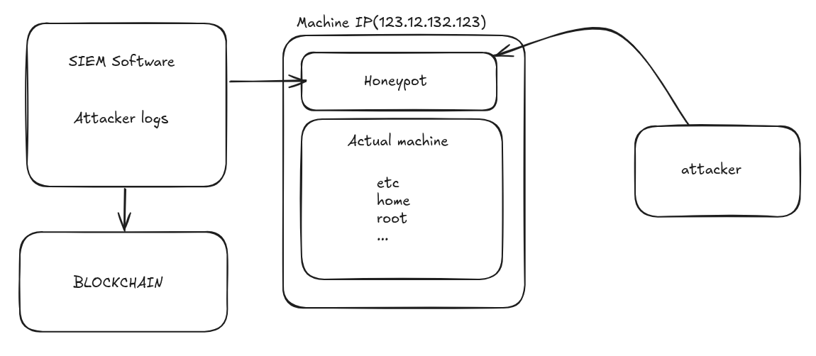
(Figure:1 System overview)
Within the system, there is a virtual file system that works just like the normal file system but reacts to different commands that are inputted. However, it does not perform the function that is expected of it in a real-life situation but rather performs certain predefined functions to different commands.​
Moreover, the system is designed in such a manner that a logging system is included in it, which helps log all activities performed by attackers. These logs contain important information like login activity, commands executed by the attacker, and any other information regarding sessions conducted. All of these logs are analyzed through certain data structures in order to analyze actions performed by the attackers. In order to maintain the reliability of information logged by the system, a blockchain system is utilized.

3.2 SYSTEM ARCHITECTURE

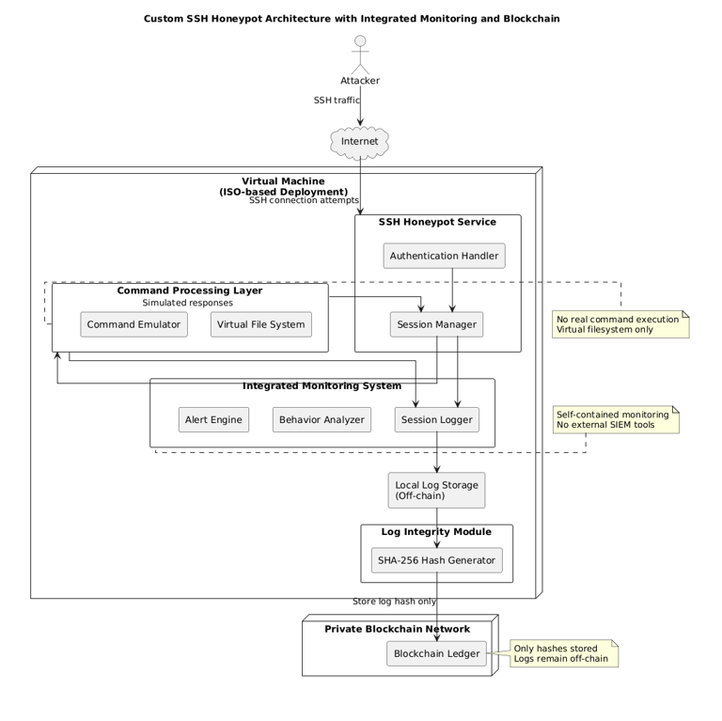
(Figure 2 : System Architecture)

From a holistic view of system functioning, the process of interaction between the honeypot and the attackers begins at the time when the attacker attempts to establish SSH connection. Honeypot detects such activity and tries to mimic the usual process involved in establishing SSH connection. However, unlike other systems where the process involves checking whether provided credentials match those of any registered user, no checks are performed.​
After the successful implementation of the authentication process, a user interface will be generated that resembles a shell interface to the hacker. The commands issued by the hacker will be received by the computer, and then those commands will be executed by using the virtual file system without having any interaction with the underlying operating system.
The virtual file system will play a vital role in this system and is the basic building block for simulating operations regarding the file system and command executions. The file system structure of the system will be designed in such a manner that it resembles a Linux-based system, where file system operations, directory traversal, and command executions are possible. The system will generate a dynamic response for each command executed.​
Blockchain logging is the next part of the suggested framework design. All actions taken by the hacker are logged, including login attempts, executed commands, timestamps, and session data. Each session gets a unique identifier generated with the use of SHA-256 cryptographic hash algorithms and recorded on the private blockchain. Blockchain logging guarantees immutability of all log records because of the interrelation between blocks.
Monitoring system is another component of the framework aimed at observing the activities of hackers. Logs gathered by the honeypot get transferred to the monitoring system that presents all the structured logs on the dashboard UI. The monitoring process allows analyzing the executed sessions and observing login attempts, the executed commands, and other activities made during sessions. As opposed to other framework designs, the usage of the monitoring system does not require the installation of additional software.​

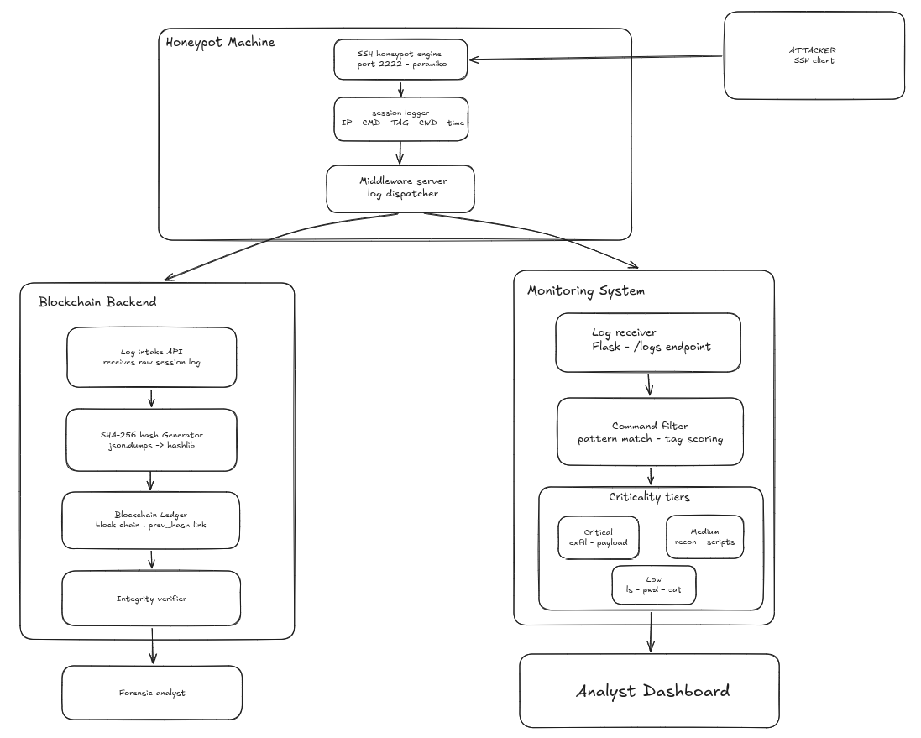
(Figure 4 : System Data Flowchart)
As far as the data flow process is concerned, the initial event in the whole process is establishing an SSH session to the honeypot by the hacker. The data present in these packets include network data such as IP addresses and port numbers required for communicating with the honeypot. After collecting all these data, the honeypot collects these packets, establishing its own SSH session with the hacker. Then the hacker logs into the honeypot using the credentials.
After entering the credentials, the verification process occurs. The point of this verification process is to confirm whether the user enters his credentials right or wrong. It does not depend on comparing credentials with any database entry but rather on whether or not these credentials allow him/her to perform certain operations on the machine. Consequently, no intruder is restricted from logging into the machine before being identified. All authentication attempts are stored in sessions.​

This will be passed to the virtual filesystem, which serves as the environment where the virtual filesystem runs. This will be processed by the virtual filesystem based on an existing logic and data structure of how files and directories should be represented. In other words, any command regarding directories will be translated into virtual actions by the virtual filesystem, and the appropriate data will be retrieved and returned.
The output will be sent to the user interface of the honeypot through the command handler and presented to the attacker. This entire process is done with great speed to make sure that the attacker feels like he is working in a realistic environment without delays in his responses. Session states will also be maintained to ensure that command outputs are properly synchronized during the session.​
Concurrently, all interaction-related information will be recorded during the execution process at multiple stages. The information will consist of login attempts, command execution, commands’ results, timestamp, session identifier, and connection information. The collected information will be saved in logs with a standardized format and ready for analysis. All sessions will be examined individually to identify any attacks conducted by intruders.
The records will be stored locally within the computer system securely to facilitate easy access. The logs are sent to the blockchain module to conduct verification. This task will be achieved through applying the SHA-256 cryptography hashing algorithm. This indicates that the hash codes created will be distinct from the contents of the file. This means that any alteration in the information within the file will produce different hash codes.​
Regarding performance issues, none would arise in this case since the entire process will run very smoothly, and there won't be any performance issues whatsoever. As noted before, all the commands will be executed in the virtual file system; this implies that there will be no access of any resources, thus saving power. Hybrid logging, whereby the hash of the command is stored in the blockchain but not the command itself, is also a good strategy that would save the system from any unnecessary loading.
All these steps would help create an interaction between the hacker and the program, as well as creating isolation of the attacked system, ensure data integrity, and real-time interaction monitoring.​
(Table 2 : Security Threat Model)
Threat Vector | Description | Impact Level | Mitigation Strategy
51% Attack | Malicious nodes collude to rewrite history | Critical | Infeasible mapping; known nodes & CFT/BFT consensus used
Sybil Attack | Entity creates massive fake identities | High | CA (Certificate Authority) strictly regulates node/user enrollment
Unauthorized Access | Calling admin contract logic illegally | High | Strict RBAC enforcement at API & Smart Contract layers
Replay Attack | Valid tx intercepted and re-sent | Medium | Nonce tracking & TxID uniqueness checks before block commit
Data Privacy Leak | Competitors see each other's loans | Medium | Private Data Collections or isolated channels implementation

SECURITY DESIGN CONSIDERATIONS
One more important issue to discuss here is that of security. Various measures will be taken to ensure the security of the system, but the most basic measure will be isolation of the computer from the surrounding environment by use of virtual file system, meaning that everything will happen within a virtualized environment and therefore will avoid being attacked at any cost.
It is also important to emphasize the fact that there will not be any interaction between the system and the operating system of the host computer. There will be no any kind of system level process performed on the system, as well as there will not be any exposure of critical information when the system performs.
Finally, the modularity of the architecture will ensure safety of the system from any kind of crash because of the independence of every module in relation to others.​

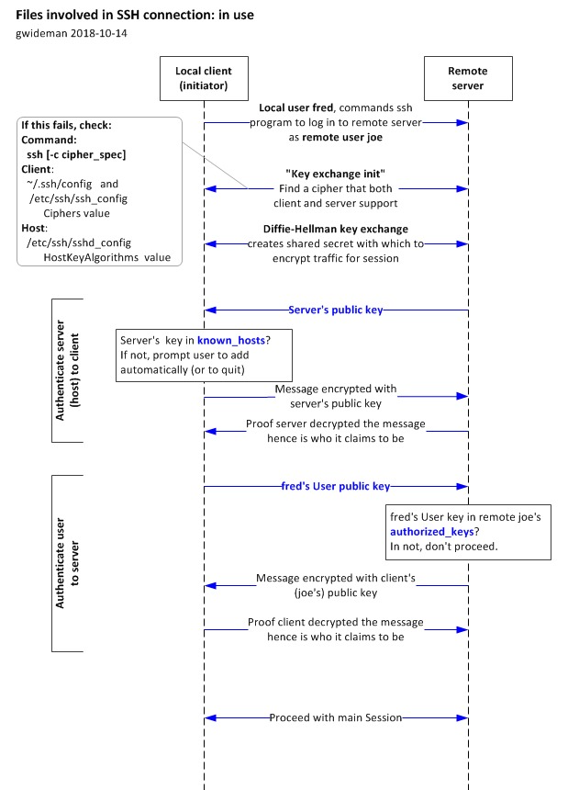
(Figure 5 : SSH connection flowchart)

ARCHITECTURAL ADVANTAGES
In comparison with other architectures, the one being discussed here has several advantages. For instance, the combination of various elements eliminates the necessity of using other software applications. Besides, the virtual filesystem allows isolating the files from each other.
​
(Table 3 : Comparison of Existing Honeypots and Proposed System)
Feature | Existing Honeypots | This System
Deployment | Complex configuration | Single package, minimal setup
Interaction depth | Limited command support | Realistic session simulation
Monitoring | Requires external tools | Built-in dashboard
Log integrity | Not guaranteed | SHA-256 hash on blockchain
Host safety | Varies by tool | Complete vFS isolation

3.3 HONEYPOT AND VIRTUAL FILESYSTEM
The honeypot and virtual filesystem are essential elements in the suggested architecture which provide additional realism of the SSH environment and its complete security. In this respect, it should be emphasized that the primary purpose of using this element when developing the architecture is the possibility of providing attackers with the simulated SSH environment in which it is impossible to penetrate into the host computer.​
In terms of functioning, the honeypot is designed in such a way that its functioning is exactly the same as a real SSH service. Upon the attempt by the attacker to connect to the server, the user will be shown the usual login window seen in an actual server machine. The login process will be based on predefined criteria, and in all cases, the attacker is guaranteed access, since our aim is to lure the attacker in the way that he will normally behave when trying to gain entry into the server.​
Once the process of successful login is complete, the attacker will gain access to the shell where he will be given an interface just as in any other operating system. All commands will be allowed just like a real OS, but in reality, none of them will be executed in the real OS.​
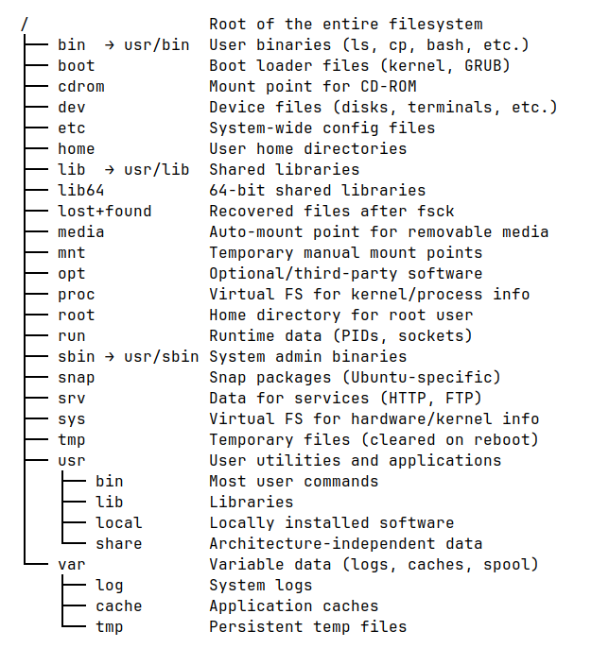
(Figure 6 : Virtual File System)
Virtual file system design guarantees that all files and directories of the virtual file system are created according to the standard file system structure containing, e.g., directories of configurations, users' homes, log directories, and other. For each file and directory from this system certain data structures are applied to imitate the process of the operation with file system objects without influence on real files.​
Yet another useful feature of the file system under discussion is the ability to store the state of the file system per session. In the course of directory or file manipulation, the current directory is saved to return realistic output after receiving commands from the attacker. Thus, any changes to the directory will affect the output of future commands.​
This command processing capability aids in keeping reality in perspective. Through this, attackers' commands are evaluated and appropriate responses to those commands are made by the virtual environment. The virtual file system recognizes many commands such as listing the directory, obtaining system information, and opening of files. There will be no difficulty at all if an unrecognized command is run by the system.
The key components of this section are isolation and security. Firstly, since the existence of a virtual filesystem exists, where all the attackers' commands are carried out, all the attacks are isolated in the simulation environment. Since there will be no interaction between the attackers' operations and the OS, no changes can be made to the system's information. Secondly, due to isolation, there is no possibility of communicating through the network.​
(Table 4 : API Endpoint Documentation)
Endpoint | HTTP Method | Request Body / Params | Description / Expected Response
/api/v1/users/register | POST | {role, pubKey, kycData} | Enrolls new identity -> 201 Created
/api/v1/loans/create | POST | {amount, rate, terms} | Proposes new loan -> 202 Accepted
/api/v1/assets/validate | GET | ?assetId=123 | Fetches asset provenance -> 200 OK
/api/v1/ledger/query | POST | {query_string} | Executes state DB query -> 200 OK

Logging of all interactions is another important feature that would be required in this architecture. Logging of all the interactions that take place along with the commands used by the attackers and their outcomes would be carried out using the session logs. Analysis of this data would provide some understanding about the way attackers attack a system.
In this way, it could be said that the whole setup of the honeypot and virtual file system constitutes the ideal blend of reality and security in relation to the computer system. While on one side, by allowing interaction with the system, attackers will assume that there is something worth hacking; at the same time, on the other side, this system would remain isolated from the rest.​

3.4 BLOCKCHAIN-BASED LOGGING

BDD Scenario (Gherkin) | Technical Logic Flow | Database/Ledger Action | Expected Outcome
Given user has Banker role & valid KYC | Verify RBAC token & Status | Query State DB (User Profile) | Authorized = True
When Banker approves Loan Request 'L123' | Invoke 'ApproveLoan' logic | Write 'L123.Status=Approved' | Valid State Transition
Then Loan asset is minted on ledger | Token Minting Logic | Update Balances & emit event | State Updated / Event Emitted
And Asset transfer completes | Unlocking Logic | Tx Commit | Success Response
(Table 5 : Smart Contract Logic Mapping)

Each time the attacker establishes a session, several attributes are collected, including authentication, commands run, timestamps, session IDs, etc. The data is collected in a way that makes it easy to retrieve and process from the local machine. However, any modifications, alterations, or tampering with the data could still occur in the unencrypted logs. In order to address this problem, a unique cryptographic hash for every session is created using SHA-256. The cryptographic hash contains all the information collected during logging and acts as a signature for the logs. Storing all the log information in the blockchain requires substantial storage capacity, which would make it inefficient. Therefore, a combined method is utilized, whereby only the hash, but not the logs, is recorded in the blockchain, while the logs themselves stay with the client.​

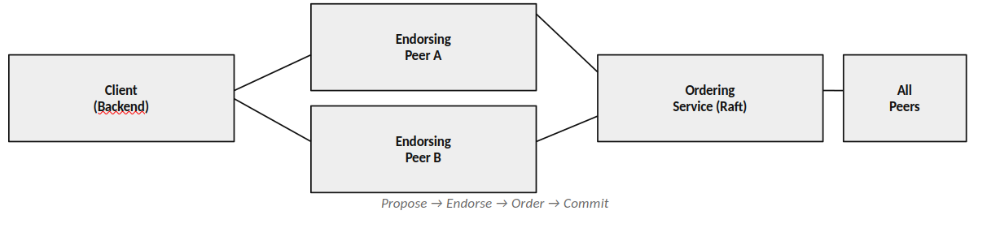
(Figure 7 : Consensus and Block formation)
The blockchains have been designed to operate like a chain of blocks, with each block made up of the hash value of the current process and the hash value of the previous block. The reason for this is that the blockchains are immutable, meaning that should there be alterations to previous blocks, then this would make all the other blocks obsolete.​
Checking for the integrity of the data authenticity is a swift process. In case it becomes necessary to check whether the data logged is authentic, the system generates the hash value of the logged data and compares it against the hash value in the blockchain. In case the values coincide, the log is authentic; otherwise, the log has been compromised. Checking for the integrity of data is relatively simple and straightforward. The second way this technique improves efficiency is by ensuring that the size of the blockchain is relatively small. This is because no logs but hashes are stored within the blockchain, making the blockchain light-weight.
Logging through the blockchain technique leads to improved integrity of the logs gathered because it ensures that the data gathered is protected in a secure manner. To put it in perspective, this is not directly related to the action that an attacker takes against the honeypot. Instead, its function is to collect the logs in a secure manner.​
(Table 4 : Transaction Lifecycle)
State | Step Description | Actor | Consensus Requirement | Ledger Status
Draft | Transaction proposed locally | Customer / Banker | None | Off-chain
Submitted | Signed and submitted to network API | Client Node | None | Pending Pool
Validated | Endorsed by required peer nodes via Smart Contract evaluation | Endorsing Nodes | Yes (Valid Signatures) | Pending Pool / Endorsed
Ordered | Grouped into block by Orderer | Ordering Service (e.g. Raft) | Leader Election / Raft | In Block
Immutable Commit | Block validated and appended to ledger | All Peer Nodes | Validation Check Passed | On-chain (Immutable)

3.5 MONITORING SYSTEM
The monitoring component of the proposed system will be used for observing the activities of the operations carried out by the attackers. As indicated by its name, this tool will provide logs that are easy to understand for any person willing to observe what is done in the honeypot. Unlike other systems, the existing system features an in-built surveillance module and does not require the implementation of any third-party software or SIEM system. This is because the surveillance module only needs to track all the activities conducted by the attackers.
All the activities like logins, commands executed, timestamps, and sessions are captured by the module and then transmitted to the monitoring component. The monitoring component further analyzes the logs and displays them through the dashboard for users to observe the activities in real-time.​
Concerning the logs collection process in monitoring, the sessions can be considered as individual entities containing the data about the sequence of events, their time of occurring and also the parameters of connection, including the source IP addresses. Thus, there would be a complete picture of the entire session.
In addition, the user may conduct the primary analysis of the logs. The user can choose which aspect of the operations he needs to analyze. It means that one can easily investigate some aspects like re-login attempts, suspicious commands or the sessions as a whole without using any specific software. The monitor was specifically designed to have simple use. Moreover, no third-party service and multiple settings are required for its work. Its only purpose is to visualize and conduct the analysis of data without interfering with other system components, especially the honeypot and blockchain modules.​

3.6 SUMMARY
In summary, this chapter provided a general overview of the design structure of the discussed SSH honeypot system. The primary emphasis in the design has been put on the system elements themselves, along with the process of interaction between them. In conclusion, it should be noted that what makes this particular system different from others is the unique honeypot which is connected to a virtual file system. Therefore, the attacker can interact with the system naturally without contacting real physical devices.​
(Table 7 : Consensus Mechanism Details)
Phase | Component Responsible | Action Performed | Validation Criteria
Proposal | Client SDK / API | Broadcasts generated tx to Endorsers | Valid schema & payload
Endorsement | Peer Nodes | Execute smart contract locally | Deterministic state & RBAC allowed
Ordering | Ordering Nodes | Sequences signed txs into logical blocks | Sequential integrity / Raft leader valid
Validation | Committing Peers | Check read-write sets & signatures | No double spending (MVCC)
Commitment | Committing Peers | Append block & update state DB | Final network agreement validation passes

This chapter has provided more information regarding logging through the use of blockchain technology. This is because it is possible to create tamper proof logs using the capabilities of blockchain due to the reliability of storage for hash codes. Logging does not have an extensive performance cost since it offers forensic logging which will definitely be essential during the subsequent steps in analysis. It should be noted that the process of lightweight monitoring was possible due to the following reasons; hence it will be easy to have an idea about the activities of the attacker.​
Chapter:4
Results and Perfomance

4.1 IMPLEMENTATION OVERVIEW
The SSH honeypot deployment and analysis will be discussed in this chapter. The development of the SSH honeypot is carried out in an isolated environment where the attacks are tested and analyzed for the reaction of the attacker against the honeypot system. In this chapter, the discussion will focus on the development of each part of the SSH honeypot system. For example, the development process involves setting up the honeypot, the Blockchain log mechanism, and the monitor that was used in analyzing the activities of the attacker while attacking the honeypot system. The honeypot is configured in such a way that it acts like a real SSH server where the attacker can attack using the honeypot system as an SSH server.​
The logging was done to track down every action made by the attacker while doing a particular session; the things being logged included the logging-in attempts, commands execution, time stamping of every action, and every single thing regarding sessions. The logging had been properly set up and was being stored in the local computer for convenience. In order to prevent the alteration of the loggings, a SHA-256 hashing was done; because the activity required logging into the record of every session and making a blockchain out of it where hashes would be privately stored.
The monitoring of the actions of the attacker was carried out by using a light dashboard for real-time logging for logging in, command execution, and overall behavior. The session tracking helps to understand the way an attacker behaves while he uses the machine. This was done in a virtual environment, as the experiment itself was conducted to achieve this purpose. The attacks that have been carried out include SSH brute-force attacks and manual login and commands executions.​
In particular, based on the implementation process, it is possible to state that the designed solution will be able to consider all three above-indicated aspects, which include interaction, security of logs, and actions monitoring in a secure environment. Moreover, the gathered data concerning interaction provides the possibility to obtain the necessary data on the behavior of the attacker.
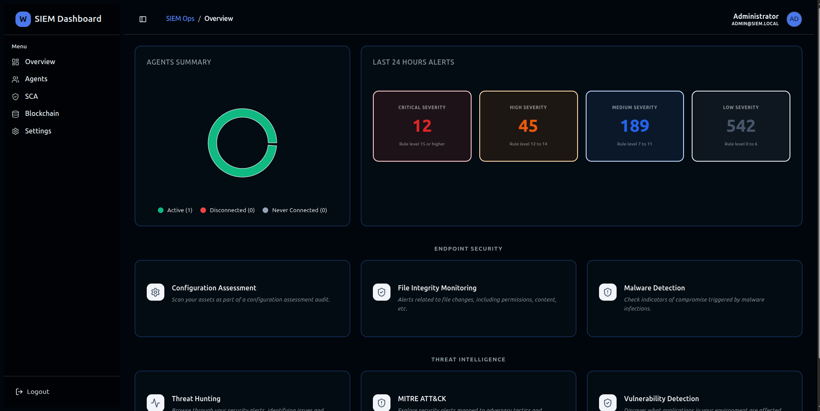
(Figure 8 : SIEM Monitoring tool Dashboard)

4.2 HONEYPOT IMPLEMENTATION
The SSH honeypot implementation is definitely the most important aspect of the designed system architecture, as it allows simulating the secure environment for analyzing the actions of attackers. In other words, the implementation of the honeypot serves as the interaction layer that provides the interaction between the user and the system. One can connect to the system, log in, and launch different commands.​
The design of the system is supposed to offer the best degree of realism possible while performing the two tasks of authenticating and executing commands. An attempt by the attacker to log into the system is treated as another regular login request. Most of the attack tools will perform their task quite well in the simulated environment and this would allow the interception of both automated attacks as well as manually operated ones. The users would be authenticated in such a manner that would facilitate the attacker’s ability to access the system and conduct attacks, which would be later analyzed.
It must be noted that the system implementation has taken into consideration not only security but also realism factors. Even though the system creates a realistic environment for carrying out an attack, it has been done in such a manner that no action performed during the process has any impact on the host computer.​
Additionally, the honeypot should be capable of supporting multiple connections simultaneously. The honeypot is capable of supporting multiple sessions at once; hence, several hackers can be accessing the honeypot simultaneously. Each session is processed independently, which implies that all actions carried out during each session will be recorded, including the logon procedure, commands executed, and the period of time spent within each session.

SSH Connection Handling
When the hacker makes an attempt to connect to the honeypot, the system responds as though it is a normal SSH service, where there will be a handshake between the client and the server, followed by establishing various sessions. This will make the hacker believe that he is actually connected to an SSH service.​
This is where the system gathers important data on the nature of the attack, such as the IP address of the attacker and the port number used by him, time stamps of the connection among others. This data is important in helping the system to determine the type of attack being carried out. Connection handler plays an important role in ensuring that the honey pot is able to handle many connections simultaneously without having problems of efficiency.

HOST = "0.0.0.0"
PORT = 2222

def handle_connection(client_socket, addr):
print(f"[+] Connection from {addr[0]}:{addr[1]} at {datetime.now()}")
client_socket.send(b"SSH-2.0-OpenSSH_7.4\r\n")
client_socket.recv(1024)
authenticate(client_socket, addr)

def start_server():
server = socket.socket(socket.AF_INET, socket.SOCK_STREAM)
server.bind((HOST, PORT))
server.listen(100)

print("[*] Honeypot listening...")

Authentication Simulation
After the compromise of the honey pot by the attacker, a simulated authentication page similar to that of the normal server is displayed to the attacker. The attacker will be prompted to enter the required credentials. Once the user is through, he will experience the same treatment as any other user. In this way, the system gains a lot of credibility.​
Unlike validating the credentials against any actual user, the system has a policy that ensures that the credentials have no bearing. In this case, the system guarantees that the attacker will access the system and complete many activities that may never be possible without the said approach. All credentials provided by the user will be stored alongside timestamps denoting actions made by the user at a certain point in time. This can enable the identification of any trend followed in breaking into the system using methods like brute-forcing.
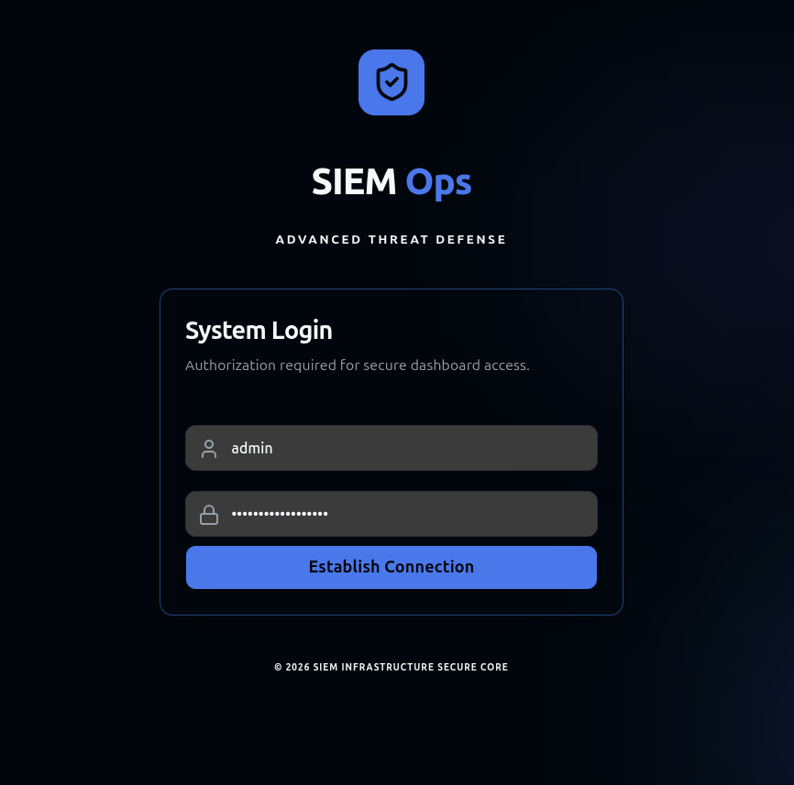
(Figure 9 : SIEM Monitoring tool authentication)

def authenticate(client_socket, addr):
client_socket.send(b"login: ")
username = client_socket.recv(1024).strip().decode()
client_socket.send(b"Password: ")
password = client_socket.recv(1024).strip().decode()
log_event("AUTH_ATTEMPT", addr, username, password)
# Always allow login (for interaction)
client_socket.send(b"\nWelcome to Ubuntu Server\n")
start_shell(client_socket, addr, username)

Command-Line Interface Simulation
Upon successful validation, the attacker will be offered a virtual command line interface similar to a regular shell. The virtual command line interface is configured to operate in a manner consistent with that of the conventional terminal window.​
The program displays typical commands for users in systems and responds to them in a similar fashion. The program observes the actions of the user based on the current status of the user in the respective session. For instance, if the attacker attempts to change the directory, then the prompt automatically changes as well.
If the attacker enters invalid commands, then they are handled like any other invalid command in a typical operating system. For instance, an error like “command not found” or “permission denied” would be displayed. Such operations help make the whole procedure realistic and lessen the likelihood of detection.

def start_shell(client_socket, addr, username):
current_dir = "/home/" + username
while True:
prompt = f"{username}@server:{current_dir}$ "
client_socket.send(prompt.encode())
command = client_socket.recv(1024).decode().strip()
if not command:
continue
output, current_dir = process_command(command, current_dir)
client_socket.send((output + "\n").encode())
log_event("COMMAND", addr, command, output)

Command Processing Mechanism
All the commands entered by the attacker are intercepted and then executed within the system. It is important to note that all the commands are intercepted, parsed, and determine whether certain action should be taken. In simpler terms, all the commands have to be predicted beforehand.​
Since there is no direct execution of commands in the host environment, all of them are executed using the virtual filesystem. All of the commands will thus be executed and produce exactly the same output as in the case of using the real OS. It concerns the commands connected to file management, exploring the system, and others.
In addition, this system includes very sophisticated mechanisms of managing errors during operation. If there are any commands that cannot be executed due to their incorrectness or unsupported format, they will be executed using the special mechanism with the generation of particular error messages ("command not found," "access denied," etc.).
Another crucial feature that should be taken into account when developing this system is its very fast response to the input and generation of output. Its necessity is associated with the fact that there shouldn't be any lags in these processes since they would spoil the appearance of the honeypot making users suspicious about the system.​

virtual_fs = {
"/": ["home", "var", "etc"],"/home": ["user"], "/home/user": ["file.txt"]
}
def process_command(cmd, current_dir):
tokens = cmd.split()
if tokens[0] == "ls":
return "\n".join(virtual_fs.get(current_dir, [])), current_dir
elif tokens[0] == "cd":
new_dir = tokens[1] if len(tokens) > 1 else "/home/user"
if new_dir == "..":
current_dir = "/"
else:
current_dir = new_dir if new_dir in virtual_fs else current_dir
return "", current_dir
elif tokens[0] == "pwd":
return current_dir, current_dir

Session Management
In order to ensure that each session remains secure, and at the same time to have an effective way of monitoring any attacks, session isolation will be adopted. In fact, this will assist in making sure that each session is isolated in relation to the attacker, such that each attacker is dealt with differently, and at the same time, every activity carried out is recorded and monitored.​
Through the management of sessions, there will be many attackers who will attack the honeypot while at the same time not interfering with one another's activities. In fact, each attacker will conduct his/her attack during the process of a particular session.​
Since it monitors the duration of time of the session and events, a complete and detailed study of the activities conducted by the attackers is possible. Since there will be recordings of the sessions, a proper investigation of the attacks can be done.​

import uuid
sessions = {}
def create_session(addr):
session_id = str(uuid.uuid4())
sessions[session_id] = {
"ip": addr[0],
"start_time": datetime.now(),
"commands": [],
"cwd": "/home/user"
}
return session_id

Logging of Attacker Activities
One of the key aspects of this specific implementation of the honeypot is the ability to capture the behaviors of the hackers in real-time. Besides the time that was spent on conducting the attack, there are other data captured such as the command line and the session ID.
Logs will work as input and output information in attacks made by the hackers; therefore, they help give a full understanding of all that the attackers are doing within the system.​
In regard to monitoring and blockchain, it will help the two parties to benefit in their tasks. Monitoring will help capture the behaviors of the attackers within the honeypot in real-time. On the other hand, the data will remain intact without any change since the creation of hashes will be made via blockchain technology.
Conclusively, logging process is essential in capturing the behaviors of attackers in a honeypot.​

Security and Isolation Mechanism
Isolation is ensured by the process of routing of all commands through the virtual file system which ensures that any sophisticated commands can be executed only in the sandbox mode and do not have any effect whatsoever on the system.
Besides the isolation of the file system, there is also a prevention of any type of network level intervention from the part of the attacker. Therefore, it will not be possible for the attacker to communicate with any external sources via the honeypot system or attack any other computer system.
Clearly, it can be stated that the process of isolation is rather effective in ensuring a safe environment in which the actions of the attacker can be monitored without affecting the security of the system.

# No real command execution allowed
def safe_execute(command):
blocked_commands = ["rm", "shutdown", "reboot", "wget", "curl"]
if any(cmd in command for cmd in blocked_commands):
return "Permission denied"
return process_command(command)

Testing and Validation
The honeypot system was subjected to various types of attacks including the automated attacks aimed at gaining access to the system and executing commands using the SSH command. This was done to test the behavior of the system under these conditions.​
As regards the system capabilities, it is worth saying that the system turned out to be capable of handling several sessions simultaneously without any problems with stability. The sessions were independent from each other, which means that the actions of the attackers were successfully tracked. Additionally, it should be noted that the honeypot responded consistently to all the commands entered by the attackers.
The users were capable of interacting with the system in a natural manner and performing various operations, such as entering commands and changing directories. At no point in time, the attackers assumed that they dealt with a fake system.
Furthermore, the system generated logs of all the actions performed, including logins and the commands run. All the logs were accurate and relevant and facilitated the process of testing significantly.​

4.3 BLOCKCHAIN VERIFICATION RESULTS
The technology of blockchain verification was used for authenticating the logs.​
The way to address this problem is by the use of a strategy that involves the application of blockchain technology by adopting the generation of hash values for session logs through cryptography. This means that the log generated at the end of the activities by the attackers will be subjected to hashing, thus producing unique hash values from other data sets applied in previous logging exercises to ensure that the data produced does not appear as those obtained earlier.
This part explains how the verification was done and the results achieved from the use of blockchain technology. Here, one is going to learn about how the logs were hashed before being used in the verification of the logs. It can be noted that this ensured that any changes on the logs were detected, hence maintaining the integrity and reliability of the data in the honeypot.
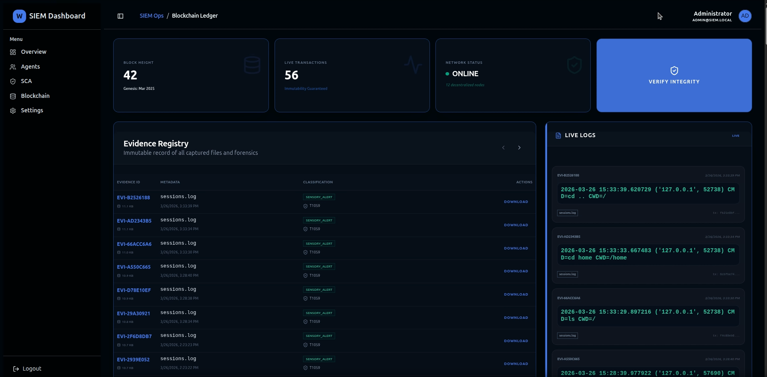
(Figure 10 : Blockchain logs)

Log Generation and Storage
Logs were generated showing details such as the number of logins attempted, the commands used, time stamps, and other information relating to the attacks. On top of that, connection logs were generated providing information regarding the source IP addresses and session durations.​
The information in the logs was structured to ensure that it could be accessed, retrieved, analyzed, monitored, and verified. The structuring of information in the logs guarantees that any action carried out by the attacker in a single session is captured sequentially. Each session log consists of all the information concerning the actions of the attacker and would constitute the primary source of information needed for verification through blockchain technology.
A unique hash code was created for each session log through the use of the SHA-256 hashing protocol. It is a unique identifier whose creation depends on the information in the session log. Any alteration in the session log results in the creation of another unique identifier because the content of the log influences the uniqueness of the hash code.

Hash Generation and Recording
It is easy to create the hash code because of the uniqueness of each session log. Upon generation, the hash codes are uploaded into the blockchain database.​
It is easy to create the hash code because of the uniqueness of each session log. Upon generation, the hash codes are uploaded into the blockchain database.​
The hash value is thereafter saved in the blockchain database as part of the content in the newly created block. The connection between the blocks is via the hash value of the last block. For this reason, a chain is formed such that integrity of the whole chain is ensured from anywhere within the chain. For this reason, whenever a hash value is saved into the database, the slightest modification done to it will affect the whole chain.

def generate_hash(log_data):
log_string = json.dumps(log_data, sort_keys=True)
hash_value = hashlib.sha256(log_string.encode()).hexdigest()
return hash_value
class Block:
def __init__(self, index, timestamp, data_hash, previous_hash):
self.index = index
self.timestamp = timestamp
self.data_hash = data_hash
self.previous_hash = previous_hash
self.block_hash = self.calculate_hash()
def calculate_hash(self):
block_string = f"{self.index}{self.timestamp}{self.data_hash}{self.previous_hash}"
return hashlib.sha256(block_string.encode()).hexdigest()

Verification Process
The authentication of the logs file was carried out through validation testing. In the validation test, the information initially captured in the log was accessed and the hash generated using SHA-256 Hashing Algorithm.
In the event where the two hashes matched, then this meant that the log had not been tampered with.​
Where the two hashes did not match, there must have been an interference with the integrity of the log file. In other words, in this case, we shall be able to detect any sort of corruption with the help of the proposed method since only valid logs will be analyzed through this process. It is quite simple and can be conducted at any time.

def verify_log_integrity(log_data, stored_hash):
recalculated_hash = generate_hash(log_data)

if recalculated_hash == stored_hash:
return True
else:
return False

Tampering Detection
For testing the efficiency of this verifying process, several changes were made to the logs captured. These included changing some of the commands used, modifying the timestamps, as well as removing some records from the captured logs.​
The same algorithm was then used to calculate the hash values of the modified logs. It turned out that the smallest change in data caused drastic changes in the hash value computed by the system. The next step was a comparison of the two hash values to note the changes.​
Undoubtedly, the difference indicates that there has been some sort of tampering with the log file. The fact that the system detects any changes made in the structure confirms the efficiency of the cryptographic hashing approach used.
As can be seen from the process of tamper detection described above, the logging system ensures high data integrity. Thus, the system can be considered reliable in logging applications where high reliability is needed.​

def simulate_tampering(original_log):
tampered_log = original_log.copy()
# Modify data
tampered_log["commands"].append("rm -rf /")
return tampered_log
# Example usage
log = generate_log("sess_1", "192.168.1.10", ["ls", "pwd"])
original_hash = generate_hash(log)
tampered_log = simulate_tampering(log)
if not verify_log_integrity(tampered_log, original_hash):
print("[!] Tampering Detected")
else:
print("[+] Log is Authentic")

Performance Observation
That is why the efficiency of the verification approach based on the blockchain technology was analyzed to evaluate its impact on the system. However, it must be emphasized that there was no need to save entire log entries in the blockchain but only their hashes.
The hashing of a message using the SHA-256 algorithm did not take much time, so that it could be performed instantly during the session record creation. In addition, the logging and checking of the hash in the blockchain were also fast enough.​
Nevertheless, it should be noted that it had no effect on the efficiency of the operation of the system, regardless of the fact that several records about sessions were processed at once. The analysis of several sessions did not affect the functioning of the blockchain module of the system that operated in conjunction with the honeypot program.
That is why the application of blockchain technology for verification has no effect on the efficiency of the system operation. That is why such technologies for verification may be used constantly.​

4.4 VIRTUAL FILESYSTEM IMPLEMENTATION
The virtual file system can be considered the main element of the designed honeypot, as its main task is the simulation of real user interaction with the operating system, but, however, in a way that guarantees that all these interactions will occur in isolation from any other activity of the user, performed on the computer. The virtual file system can be considered a special sandbox, in which any potentially dangerous operations will be conducted in virtual space, but no harm will be inflicted on any system files.​
The structure of the virtual filesystem resembles quite much structure of a regular filesystem in some Linux-based operating system, since it includes system directories, directories belonging to particular users, log directories, temporary files directories and configuration files. Still, all these files do not exist as actual files on the filesystem of the underlying operating system, instead they are represented in a more abstract way via tree-like structures and hierarchies inside the virtual filesystem itself.​
Should the attacker choose to run commands in the SSH shell, then such commands pass through the command handler to the virtual filesystem manager module. The virtual filesystem interpreter interprets the command and takes appropriate action based on the rules defined. Hence, if the command relates to anything to do with directories and files, the system uses its internal representation to generate the desired output.
Another important aspect of the system is the management of the state of the attacker's session. The attacks run individually; every attack has its own directory and interaction space. Any actions that are taken by an attacker against the session, including navigation to another directory or reading of a file, alter the state of that particular session. Therefore, the following command executed by the session will depend on what happened previously to that session. For instance, once the directory has been changed, then every subsequent command will be executed from that directory.
In order to make the simulation more realistic, the system dynamically generates the output responses as well. Rather than just generating static predefined answers, the program will generate appropriate responses based on the context. If a command does not exist, or access to the file is prohibited for some reason, then the relevant message will be generated, just like a regular computer would do in a similar situation.​
One of the most vital features of virtual filesystem implementation is its security. The command execution takes place in the virtualized environment without sending anything to the hosting machine. Therefore, we can say that the computer itself is safe because even if the hacker managed to gain access to this virtualized machine, nothing bad would happen to the actual computer. In addition, there are some limitations for executing some commands as they can neither create nor delete files and do not execute system commands.
One of the situations where the implementation of a virtual filesystem seems to be necessary is data collection and analysis. The actions taken by the user, the results of the command executed by the user, and the time at which the user ran the command will be recorded in a log file. We should keep track of all these factors in order to understand which commands are used, which method of navigation was employed, etc.​
As for implementation testing, several commands have been tested within the framework of the virtual file system including the switch between directories and work with the files and other commands which do not function well causing problems to show on the screen. All these tests proved to be real, and the maintenance of the sessions' state was not an issue at all.

All in all, based on the above discussion, one can conclude that the implementation of the virtual file system is a vital component of honeypot's functioning and it is possible to achieve the needed balance between authenticity and security through interactive work with commands and not the operating system.​

4.5 PERFORMANCE ANALYSIS
These tests have been carried out in order to make sure that the system works effectively and the highest level of security and authenticity has been achieved. So, performance tests cover such aspects as responsiveness of the system, usage of resources by the system, and stability of the system under conditions when several attacks occur at the same time. System responsiveness is very important because it helps to mislead the attacker in a way that everything works fine.
For the sake of testing, response time of the system was tested under attack by the intruder. He attacked the system by entering some commands; as a result, there were outputs from the virtual file system. Response time of commands processing was extremely quick.​
Resource utilization was yet another factor used in testing to see whether the system was sufficiently lightweight for deployment in a controlled setting. There was hardly any utilization of CPU and memory as there were no heavy command executions involved, while the blockchain system utilized fewer resources since all it held were hashes of the logs and not the logs themselves.
It was important to test the system’s ability to support multiple simultaneous sessions. Performance issues were not identified during this process as the system did not fail even when two or more attackers interacted simultaneously within the network. Each session was isolated from the others, and each of them was logged independently.
Lastly, the logging and monitoring facilities of the system were evaluated with respect to their impact on system performance. Successful logging of all attacker interactions took place in real-time without any delays in the analysis of the log files through the monitoring panel.​
In conclusion, considering the evaluation made concerning the efficiency of the system, it is possible to state that the developed solution is efficient, stable, and scalable. Specifically, it is important to note that the system operates effectively, which does not impact its effectiveness. Also, it allows interacting with the attacker and isolating him/her from other parts of the system, making it possible to guarantee security of the system. Moreover, thanks to a lightweight structure and module-based design, the system can be implemented in practice.

Chapter 5
Conclusion and Future Work

5.1 CONCLUSION
The main aim of the current study has been creating and implementing the SSH honeypot system, which will make it possible to analyze the activity of the attackers in a secure way. First and foremost, it is necessary to emphasize the significance of the concept used while developing the system in question; namely, the concept of creating a realistic and isolated interaction platform.​
One of the characteristics of the above-described system is the ability to conduct all the activities within the virtual file system. No activities will be conducted within the physical operating system; instead, they will take place within the virtual file system. It should be noted that the virtual file system guarantees absolute security as no actions will be possible to be undertaken in the real OS as all of them will take place within the virtual one. What is more, the virtual file system maintains session consistency and allows commands to work properly.​
The question of integrity of the log is another one apart from the matter of securing the communication which is resolved in the proposed solution by applying a logging approach relying on blockchain technology. Hashed logs using SHA-256 hash function are inserted in the blockchain database in such a manner that any tampering with the log is easily detectable. This makes it possible to use the data stored in the log for whatever purpose since it becomes highly reliable for analysis. Hybridization method, consisting of log hashing and insertion into the blockchain system, proves efficient.
When analyzing the results obtained, we can say that all the goals set initially for the system were successfully achieved. In particular, the following capabilities of the system can be pointed out, including detecting any possible type of attack and isolation thereof, ensuring data integrity, and performing efficiently in multiple sessions. Therefore, the modularity of the suggested system ensures an easy implementation and scalability depending on user needs.​
In conclusion, the described project is quite significant for the domain of cybersecurity since a highly effective and reliable SSH honeypot was developed specifically for the purposes of conducting the corresponding academic research. Since the presented system has all the mentioned attributes, it can act as a tool for detecting and analyzing malicious activities performed by potential attackers.

5.2 LIMITATIONS
The first and major limitation related to the current approach is associated with the design of the system itself and its functioning principles. Although it offers a chance to create a simulated directory structure and execute various commands, it still performs according to a predetermined set of logic and response mechanisms. Hence, its performance differs from that of a typical operating system which can become an evident clue to a professional hacker regarding a honeypot.
At last, the third and final limitation concerns the way the user will interact with the given threat. As such, the proposed system will operate solely via the SSH protocol at the command line interface and cannot be used to deal with various other threats, including network attacks or website-based ones.​
However, despite the ability of the technique to help create a highly-integrated environment for processing database-contained information, it is necessary to take into account the private and lightweight nature of the blockchain used in this situation. Specifically, considering that the blockchain in this particular case is based on the creation of hash sums for log files instead of storing all logs in question, this method fails to make the blockchain a full-fledged tool due to the absence of other valuable features.
On the other hand, it is essential to admit that this particular solution is relatively simple. In other words, while such an approach will help recognize any attempts made by hackers to intrude into a system, there will be no possibility of predicting further moves and making some predictions regarding future steps.​
It should be pointed out that the whole system is created in completely isolated mode, meaning that it does not get any interference from outside. Thus, the process of software testing can take place effectively. Nevertheless, the efficiency of the entire program can suffer from the fact that there are many different conditions in reality that cannot be fully imitated.
In summary, the aforementioned deficiencies of the system can be corrected to make it work better. The reason for this is the fact that the currently described SSH honeypot system is a good platform for interacting with attacks; nevertheless, removing these deficiencies will yield the desired outcome.

5.3 FUTURE WORK
Thus, the SSH honeypot system discussed above is an excellent basis for safe interaction with attacks and further analysis. Nonetheless, some improvements may be required in order to enhance the performance of the system.​
The enhancements that will be made in the future include improvements on the existing virtual file system. This means that apart from utilizing the prearranged logic, the reaction to the attacks by the perpetrator must also be taken into account. Furthermore, it is necessary to take into consideration other commands and even system utilities while making changes in the files in real-life settings.
In addition, advanced analytics may be viewed as another area where improvements can be made for the current project. Machine learning can be used as a method of analyzing the information collected through automation. This means that in addition to the capability of collecting the information regarding the attacks, this system is also able to analyze the data and extract intelligence about the attacks.​
Another element that can be optimized while developing the monitoring system is visualization and alerting. The ability to get real-time alerts about any suspicious activity and see attacks visually will make it easier to analyze collected data. Besides, it is possible to integrate the proposed system with other security solutions to make its use easier for users.
In conclusion, one of the areas of further investigation in the project is blockchain-based solutions. Application of public blockchains will improve transparency in the whole process. Moreover, it can be considered how to improve the blockchain framework and add metadata to the system in order to enhance its performance.

Also, practical testing should be considered as an additional area of improvement. The practical test of the developed software will help obtain valuable feedback about the scalability and reliability of the solution in real-world settings.​
As such, all the proposed improvements will lead to the development of a sophisticated system that will be intelligent, efficient, scalable, and versatile enough to act as a comprehensive platform for the research and implementation of different cybersecurity solutions.
REFERENCES
- A. Shankhdhar, P. Selvaraj, R. Radhakrishnan, N. K. Upadhyay, A. Kumar and R. Perumal, "Behavioral Analysis of SSH Attacks Using a Honeypot-Centric Framework," 2025 International Conference on Digital Innovations for Sustainable Solutions (ICDISS), Faridabad, India, 2025, pp. 1-5, doi: 10.1109/ICDISS68238.2025.11320667.
- A. A. Setiawan and M. Irsan, "Integrated Log Management with WAZUH and OPNsense for Mitigating Brute Force Attacks in Cloud Infrastructure," 2025 IEEE 9th International Conference on Software Engineering & Computer Systems (ICSECS), Pekan, Pahang, Malaysia, 2025, pp. 282-286, doi: 10.1109/ICSECS65227.2025.11279251.
- C. M. Kumar, A. Kumar and B. S. K. Devi, "Advance Threat Detection Using Machine Learning​
- Satria, M.E.; Huda, T.; Iqbal, M. & Sarjana, F. "The investigation on cowrie honeypot logs in establishing rule signature snort." In IOP Conference Series: Earth and Environmental Science, Vol. 644, Issue 1, 2021. IOP Publishing, p. 012031.
- Zemene, S. and Avadhani, P. S. "Implementing high interaction honeypot to study SSH attacks." In Proceedings of 2015 International Conference on Advances in Computing, Communications and Informatics (ICACCI). Kochi, India, 2015. Pages 1898-1903. doi: 10.1109/ICACCI.2015.7275895.
- Spyros, A. et al. "Towards Continuous Enrichment of Cyber Threat Intelligence: A Study on a Honeypot Dataset." In Proceedings of 2022 IEEE International Conference on Cyber Security and Resilience (CSR). Rhodes, Greece, 2022. Pages 267-272. doi: 10.1109/CSR54599.2022.9850295.​
- Spyros, A. et al. "Towards Continuous Enrichment of Cyber Threat Intelligence: A Study on a Honeypot Dataset." In Proceedings of 2022 IEEE International Conference on Cyber Security and Resilience (CSR). Rhodes, Greece, 2022. Pages 267-272. doi: 10.1109/CSR54599.2022.9850295.​
- TY - CONF TI - Digital Forensic analysis for enhancing information security T2 - 2015 International Conference on Cyberspace (CYBER-Abuja) SP - 38 EP - 44 AU - O. J. Adebayo AU - I. Suleiman AU - A. Y. Ade AU - S. O. Ganiyu AU - I. O. Alabi PY - 2015 DO - 10.1109/CYBER-Abuja.2015.7360517 JO - 2015 International Conference on Cyberspace (CYBER-Abuja) IS - SN - VO - VL - JA - 2015 International Conference on Cyberspace (CYBER-Abuja) Y1 - 4-7 Nov. 2015 ER -
- W. Bai, “Phishing website detection based on machine learning algorithm,” in Proceedings - 2020 International Conference on Computing and Data Science, CDS 2020, 2020, pp. 293–298. doi: 10.1109/CDS49703.2020.00064.
- TY - CONF TI - Network Anomaly Detection Analysis using Artillery Honeypot and Wazuh SIEM T2 - 2023 IEEE 9th International Conference on Computing, Engineering and Design (ICCED) SP - 1 EP - 6 AU - M. R. A. Suhendi AU - Alfarizi AU - A. A. Sukmandhani AU - Y. D. Prabowo PY - 2023 DO - 10.1109/ICCED60214.2023.10425009 JO - 2023 IEEE 9th International Conference on Computing, Engineering and Design (ICCED) IS - SN - 2767-7826 VO - VL - JA - 2023 IEEE 9th International Conference on Computing, Engineering and Design (ICCED) Y1 - 7-8 Nov. 2023 ER -
- T. Suryantoro, B. D. P. Purnomosidi and W. Andriyani, "The Analysis of Attacks Against Port 80 Webserver with SIEM Wazuh Using Detection and OSCAR Methods," 2022 5th International Seminar on Research of Information Technology and Intelligent Systems (ISRITI), Yogyakarta, Indonesia, 2022, pp. 1-6, doi: 10.1109/ISRITI56927.2022.10052950.
- K. Z. Htet, H. T. Zaw and A. H. Maw, "Brute Force Detection and Active Response for Secure Web Login using Wazuh," 2025 6th International Conference on Advanced Information Technologies (ICAIT), Yangon, Myanmar, 2025, pp. 1-6, doi: 10.1109/ICAIT68809.2025.11236796.
- M. N. Zaidan, P. Sukarno and A. A. Wardana, "Collaborative Detection of SQL Injection Attacks using SIEM, Multi-Wazuh Agents, and Diverse Web Application Firewalls," 2024 5th International Conference on Communications, Information, Electronic and Energy Systems (CIEES), Veliko Tarnovo, Bulgaria, 2024, pp. 1-6, doi: 10.1109/CIEES62939.2024.10811420.
- S. Ansari, K. Hans and S. K. Khatri, "A Naive Bayes classifier approach for detecting hypervisor attacks in virtual machines," 2017 2nd International Conference on Telecommunication and Networks (TEL-NET), Noida, India, 2017, pp. 1-6, doi: 10.1109/TEL-NET.2017.8343551.
- D. Tarace, P. Lai, K. Dang and U. Tatar, "AI-Powered Assessment of Wazuh for Obfuscated Threat Detection," 2025 Systems and Information Engineering Design Symposium (SIEDS), Charlottesville, VA, USA, 2025, pp. 336-341, doi: 10.1109/SIEDS65500.2025.11021218.

