Construction Management System

Anup Shaw

Table of Contents
Introduction & Objective of the Project: 3
Project Category: 5
Analysis of the Project: 6
Construction Management System GUI 6
Design & Plan Viewer 7
Work Planner Interface 7
Material Management Interface 8
Payment Interface 8
Worker Management Interface 8
Safety &Security Management Interface 8
Construction Management System Engine 9
Engine controller: 10
GUI Interactor: 10
Database Controller: 10
Plan & Design Controller: 10
Worker Controller: 11
Security Controller: 11
Safety Controller: 11
Work Estimation Controller: 11
Raw Material Controller: 11
Search Engine: 11
Payment Handler: 11
Machine & Transport Controller: 11
Construction Management System Database 12
Hardware & Software Requirements for the application to run 12
Hardware Requirements 12
Software Requirements 12
Project Structure: 13
Project Estimation: 13
E-R Diagram: 14
Tools/Platforms used (Hardware/Software): 17
Hardware: 17
Software: 17
Client/Industry: 18
Future Scope and Further enhancement of the project: 19

Introduction& Objective

Introduction

Objective

  - Background:

With the progress of advanced technologies, managing a construction site is being more and more complicated these days. Whether it’s a personal residence or a huge multiplex, every person wants it to be developed as fast as possible. Constructors struggle to complete their projects in time as they need to manage lots of resource, i.e. various raw materials, labors, engineers, money etc. So, it is really necessary to develop an application that would let contractor/company mange each and every resource through his project sufficiently. Construction Site Management System is developed to minimize all the problems that might arise in a construction site and it helps users to complete their esteemed projects in time.

1.2 Objective:

Construction Management System is software for managing and maintaining a construction site. A construction site has lots of activity going on parallel. Construction management software will enable the site manager to monitor workers, materials used, work progress, planning & estimation of future work. In simple words, Construction Site Management System is developed to erase all the problems and complexity of a construction site and help user monitor his project(s) and plan for the future projects as well. Go through the main features of the software described below to know more.

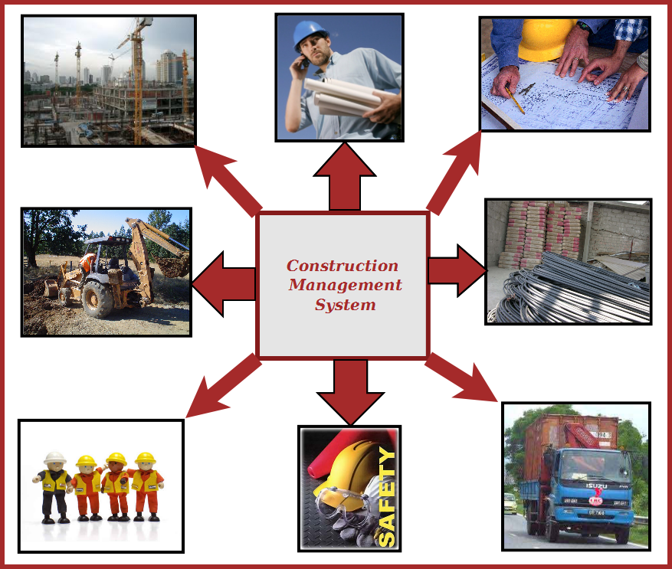
Figure: Overview of Construction Management System

The main features of this software are given below:
  - Construction design and planning using external designer software
  - Design viewer and add comments.
  - Worker attendance management.
  - Worker Identity info saving and security management
  - Raw material stock & pricing information query.
  - Estimation & planning of future work.
  - Monthly / daily progress report
  - Supply management & payment tracking.
  - Safety assurance
  - Transport management
  - Legal work management
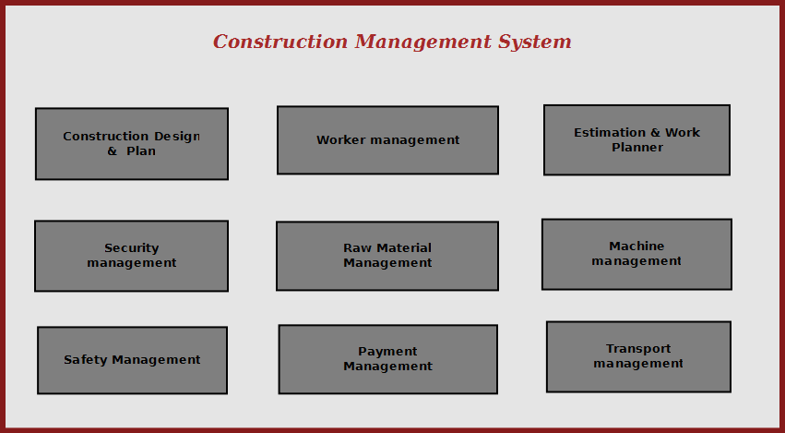

Figure: Overview of Construction Management System

Construction management system will enable the site manager to control all aspects of construction from a standalone solution. It allows managing, searching and referring important data used in construction; it makes site managers life easy to operate construction activities flawlessly.

Project Category:

This software will follow Object Oriented Programming Paradigm and use below mentioned areas.

Front End/ GUI Tools: Visual Studio 2010, .NET 4, C#
Backend: MySQL
Networking Technologies: TCP/IP
Wireless Technologies: Bluetooth
Operating Systems: Windows XP, Windows

4. Hardware and Software Specification

4.1 Hardware Requirement
- Disc capacity : 10 MB of available hard disk space
- RAM : 1 GB (32 Bit) or 2 GB (64 Bit)
- Processor : 1.6GHz or faster

4.2 Software Requirement
- Windows XP (x86) with Service Pack 3 / Windows Vista (x86 & x64) with
Service Pack 2 / Windows 7 (x86 & x64)
- Microsoft .NET 4.0

5. REQUIREMENTS AND ANALYSIS
Construction Management System will provide a cost effective & efficient software solution for managing everything about Construction. Different components of Construction Management System are depicted below.

5.1 Problem Definition
Construction Management System is being developed keeping in mind the hectic management and control procedure of a construction site. A contractor not only needs to manage his workers and raw materials, he also needs to plan properly to keep his commitment to his customers. Bringing raw materials, scheduling works and tracking progress would be lot easier using the application Construction Management System.

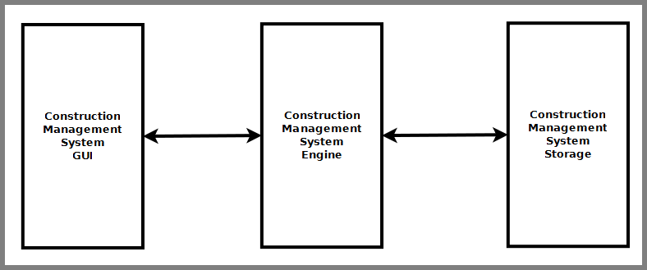
Figure: Components of Construction Management System

Construction Management System is divided into three main components. Such as:
- Construction Management System GUI
- Construction Management System Engine
- Construction Management System Database

Project Category

Hardware and Software Specification

Hardware Requirement

Software Requirement

Tools/Platforms used (Hardware/Software):

Hardware:
- Laptop with 2GHZ processor
- 2 GB RAM
- 320 GB hard disk (NTFS File System)

Software:
- Windows XP (x86) with Service Pack 3 / Windows Vista (x86) with Service Pack 2 / Windows 7 (x86)
- Microsoft .NET 4.0
- Windows Presentation Framework(WPF)
- Windows Communication Framework(WCF)
- Visual Studio 2010 Express Edition (IDE)
- MySQL database
- Dia for Diagram Drawing & Modelling.

REQUIREMENTS AND ANALYSIS

Problem Definition

Requirements Specification

Functional Requirement

Add Worker/Labor
Inroduction :
Add a new Worker or labor.
Input :
Relevant worker or labor information like name, address, qualification, contact, experiance etc.
Processing:
Admin will enter data in the CMS and create a new worker or labor entry.
Output:
CMS will create a new worker or labor for future referance.

Add Raw material/Machine
Inroduction :
Add raw material or machine.
Input :
Related raw material or machine information like name, quantity, vandor, etc.
Processing:
Admin will enter data in the CMS and create a new raw material or machine entry.
Output:
CMS will create a new raw material or machine for construction.

Assignment of work to Worker/Labor
Inroduction :
Assign work for Worker or labor.
Input :
Related info of job and worker or labour details etc.
Processing:
Admin will assign job in the CMS and create a new job profile entry.
Output:
CMS will create a new job index by assigning worker or labor for construction.

Apply for security and safety
Inroduction :
Ensure safety and security for Worker and labor.
Input :
Any kind of task assign for the worker and labor.
Processing:
Superviser will check security and safety for the task.
Output:
If the security and safety process is not well the system will generate a reminder in CMS.

Search Worker/Labor
Inroduction :
Anyone can search for worker or labor.
Input :
He will enter data like worker name, address, etc.
Processing:
CMS will search for the labor or Worker.
Output:
CMS will display the search result.

Payment for Worker/Labor
Inroduction :
Payment calculation for the Worker or labor.
Input :
Get the job details of the worker or labour etc.
Processing:
Admin will calculate the payment in the CMS and send notification to the accounts department.
Output:
CMS will create a coupon, by which worker or labor can get payment from account.

Get design and plan
Inroduction :
Design and proper planning for the particular task.
Input :
Assign the plan and design job to the planner and designer.
Processing:
Planner and designer will plan and design the proper task schedule.
Output:
CMS will get the plan and design.

Technical Specification

Construction Management System GUI
Construction Management System GUI will allow users to view existing construction data, enter new data & modify existing data. It will have a user friendly interface so that user can use the software efficiently. It is divided into six modules. Such as:
- Design & Plan viewer
- Work Planner Interface
- Payment Interface
- Material Management Interface
- Worker Management Interface
- Safety & Security Management Interface

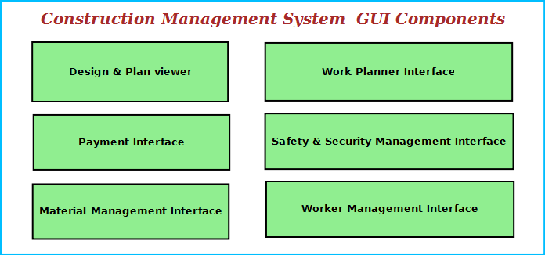
Figure: Construction Management System GUI Components

Design & Plan Viewer
It will allow to view design & planning file using some external editors & viewer. It will also allow scanning existing plan and view it as a image file. Users can add comments for modification and also generate reports.

Work Planner Interface
This interface will allow user to plan and estimate future work. It will have link to worker management interface so that workers can be assigned certain work. It will also enable to add costing and budget data for the work. It will have a option to add legal data associated with a work item and instruction to be followed.

Material Management Interface
This interface will allow user to manage the material used for construction.
    - to search any kind of material of the Construction and view price information and stock details.
    - Enter & modify material availability and usage data.

Payment Interface
This interface will allow users to enter payment data associated with various aspects construction work.
    - Workers payment
    - Raw materials purchase information
    - Future budgets
    - Infrastructure payments.
    - Loan information
    - cash flow and cheque information
    - bank information

Worker Management Interface
This module will maintain information about workers.
    - Construction sites need to maintain the worker personal data, professional experience info.
    - This will allow to track workers attendance and work hours data.
    - This interface will allow managing security measures to taken about the workers. It will have a interface for entering the worker’s security data, photo and scan the photo identity card of the worker.

Safety &Security Management Interface
This interface will ensure safety & security of the construction site.
    - Video Surveillance Interface: This interface will display the video of specific areas of the Construction and save the video for future reference. The site manager can monitor from video surveillance window.
    - First Aid browser: This displays the location first aid boxes and instructions on what to do in case of emergency.
    - Emergency contact interface: This will allow user to call ambulance driver, doctor & hospital in case of emergency.

Construction Management System Engine
Construction Management System Engine controls the overall system. It provides logical and tactical solutions for managing the whole system. The Construction Management System is divided into 12 divided modular components. Such as:
- Engine controller | - Raw Material Controller
- GUI Interactor | - Machine & Transport Controller
- Database Controller | - Payment Handler
- Plan & Design Controller | - Search Engine
- Worker Controller | - Safety Controller
- Work Estimation Handler | - Security Controller
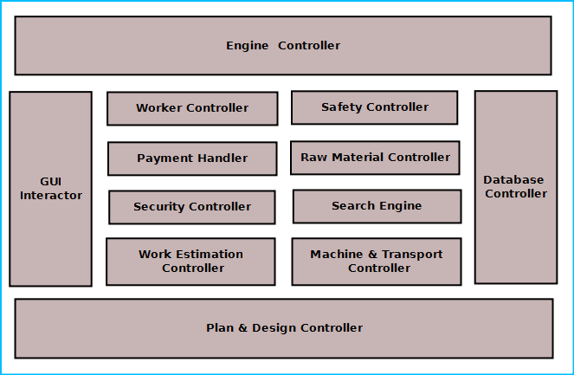
Figure: Components of Engine

Engine controller:
This controls the overall interaction between all the backend modules. It schedules the priority of the actions in case of overlapping. It helps user to consolidate overall reports and print them from GUI.

GUI Interactor:
It interacts with the GUI and polls GUI calls. It exposes APIs and events for GUI to use. GUI Interactor helps Engine to maintain wrapper around the Engine modules so that the GUI can be ported to any other framework without much changes in Engine code.

Database Controller:
It controls the database interactions. It forms query to fetch information from the database. It also sends data to be saved in database for future use.

Plan & Design Controller:
It allows integration with other designer software to view the design. It processes the design comments and helps generating reports.

Worker Controller:
It keeps track of worker information. It has an algorithm for maintaining worker data like
    - Attendance information
    - Work hours
    - Area of expertise
    - Payment details
    - Personal data
All these data will BE saved and are available for other modules to use and modify.

Security Controller:
It saves information for security measures. It can send it to the authority or police whenever required. It will ensure state of the existing security measures and generate warning if one of the steps is breached.

Safety Controller:
It ensures the safety of the construction site. It controls the safety alarms, fire alarms and instructions to be displayed at the hazardous places.

Work Estimation Controller:
This will allow users to estimate future work depending on the design,deadline and workers expertise. It will have algorithms to control estimation and assignment of work to the workers.

Raw Material Controller:
This module will maintain the information about raw materials. It will derive the figures about available materials, required amount to meet requirements, purchase deadline and allowable stock. It will save the information in database and retrieve them when required.

Search Engine:
Search engine enables rapid and efficient searching of data about workers, raw materials and suppliers. Search Engine prepares search indexes depending most accessed data. It improves the efficiency and performance of the software.

Payment Handler:
Payment Handler allows generating the report for material purchases. It calculates the salary of a worker. It will get the work & salary information from the database depending on worker data and calculates the payable amount.

Machine & Transport Controller:
This module keeps track machine to be used by the construction workers, machine purchase or hiring information, vendor information. This also handles logistics transport, worker transport.

Construction Management System Database
Construction Management System will maintain a centralized database for storing information. We will design a RDBMS to manage the database and engine interaction. It will have optimized design and archive older data to save space and increase performance.

]

Hardware & Software Requirements for the application to run

Hardware Requirements

Computer that has a 1.6GHz or faster processor | Security Cameras
1 GB (32 Bit) or 2 GB (64 Bit) RAM | Barcode Reader
10 MB of available hard disk space | Report Printing Machine
DVD-ROM Drive / USB Port | Webcam
Weight Machine

Software Requirements

Windows XP (x86) with Service Pack 3 / Windows Vista (x86 & x64) with Service Pack 2 / Windows 7 (x86 & x64)
Microsoft .NET 4.0
Windows WPF & WCF

Project Structure:

Project Estimation:

Task Group | Task | Duration ( Man-Days)
Construction management GUI | Design & Plan viewer | 40 days
Construction management GUI | Work Planner Interface | 40 days
Construction management GUI | Payment Interface | 40 days
Construction management GUI | Product Stock & Price Info browser | 40 days
Construction management GUI | Customer Management Interface | 40 days
Construction management GUI | Material Management Interface | 40 days
Construction management GUI | Worker Management Interface | 40 days
Construction management GUI | Safety & Security Management Interface | 40 days
Construction management Engine | Engine controller | 50 days
Construction management Engine | GUI Interactor | 50 days
Construction management Engine | Database Controller | 50 days
Construction management Engine | Plan & Design Controller | 50 days
Construction management Engine | Worker Controller | 50 days
Construction management Engine | Work Estimation Controller | 50 days
Construction management Engine | Raw Material Controller | 50 days
Construction management Engine | Machine & Transport Controller | 50 days
Construction management Engine | Payment Handler | 50 days
Construction management Engine | Search Engine | 50 days
Construction management Engine | Safety Controller | 50 days
Construction management Engine | Security Controller | 50 days
Construction management Database | Database Design | 30 days
Construction management Database | Database Implementation | 30 days
Construction management Database | Optimization | 30 days
Integration | Application Integration | 20 days
Integration | Creating Installer | 20 days
Testing | Unit Testing | 20 days
Testing | Integration Testing | 20 days
Testing | Regression Testing | 20 days
Testing | System Testing | 20 days
Documentation | Synopsis | 20 days
Documentation | Design Document | 20 days
Documentation | Help Document | 20 days

Planning and Scheduling

Gantt chart

Tracking Gantt

Pert Chart

Scope of the Solution

Analysis

Context Diagram

0-Level DFD

1-Level DFD

2-Level DFD

E-R Diagram:

We will design a RDBMS for Construction Management System. The entities and their attributes are listed below. Attributes in Bold letter is the unique key.

Entities | Attributes
Worker | User Id, Name, Address , Contact Number, skillset, Photo ID Num, Photo
Construction Management System | Construction site Id , Name, Address, Registered no
Construction Machine | Machine Id, Name, purpose
Work Session | Session Id, worker Id, Time, Expense amount
Engineer | engineer Id, Name, address, contact number
Design Preference | Preference Id, Type, Description
Raw Material | Product id, stock, name, price

Relationship between Entities:

- Construction Management System has Workers→ 1 : N
- Construction Management System has Machines→ 1 : N
- Workers does Work Session→ 1 : 1
- Construction Management System manages Raw Material → 1 : N
- Engineer provides Design Preferences → M : N

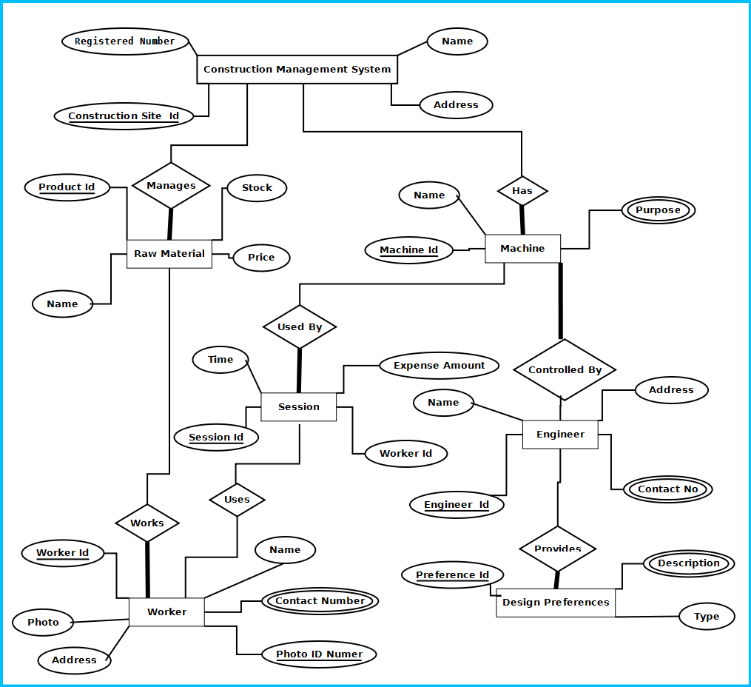

Figure: E-R Diagram of Construction Management system

Class Diagram

Database & Table Details

Complete Structure

Module Description

Estimation

Data Structure

Implementation Methodology

List of Reports

Implementation of Security Mechanism at Various Levels
- It provides users a login interface that requires a password. The password could be changed by admin only.
- There would be multiple user login option, i.e. clerk, officer, admin etc.
- The login password will be saved in encrypted format in database.
- This software will use Google open-id authentication for web interface.

Future Scope and Further enhancement of the project:

    - To sink with multiple Construction sites with a centralized database.
    - To support UNIX / Linux, MAC OSX Operating systems.
    - Mobile application for querying the progress of works assigned to the workers.

BIBLOGRAPHY:

http://www.google.co.in
http://en.wikipedia.org
http://msdn.microsoft.com/en-us/
http://www.microsoft.com/en-us/default.aspx
http://www.codeplex.com/
http://stackoverflow.com/
http://www.codeguru.com/
http://www.w3schools.com

---------------------------- Thank You-------------------------

