Arindam Ghosh
Enrolment Number: 093052638
MCA 6th Semester
MCSP-060(Project Synopsis)
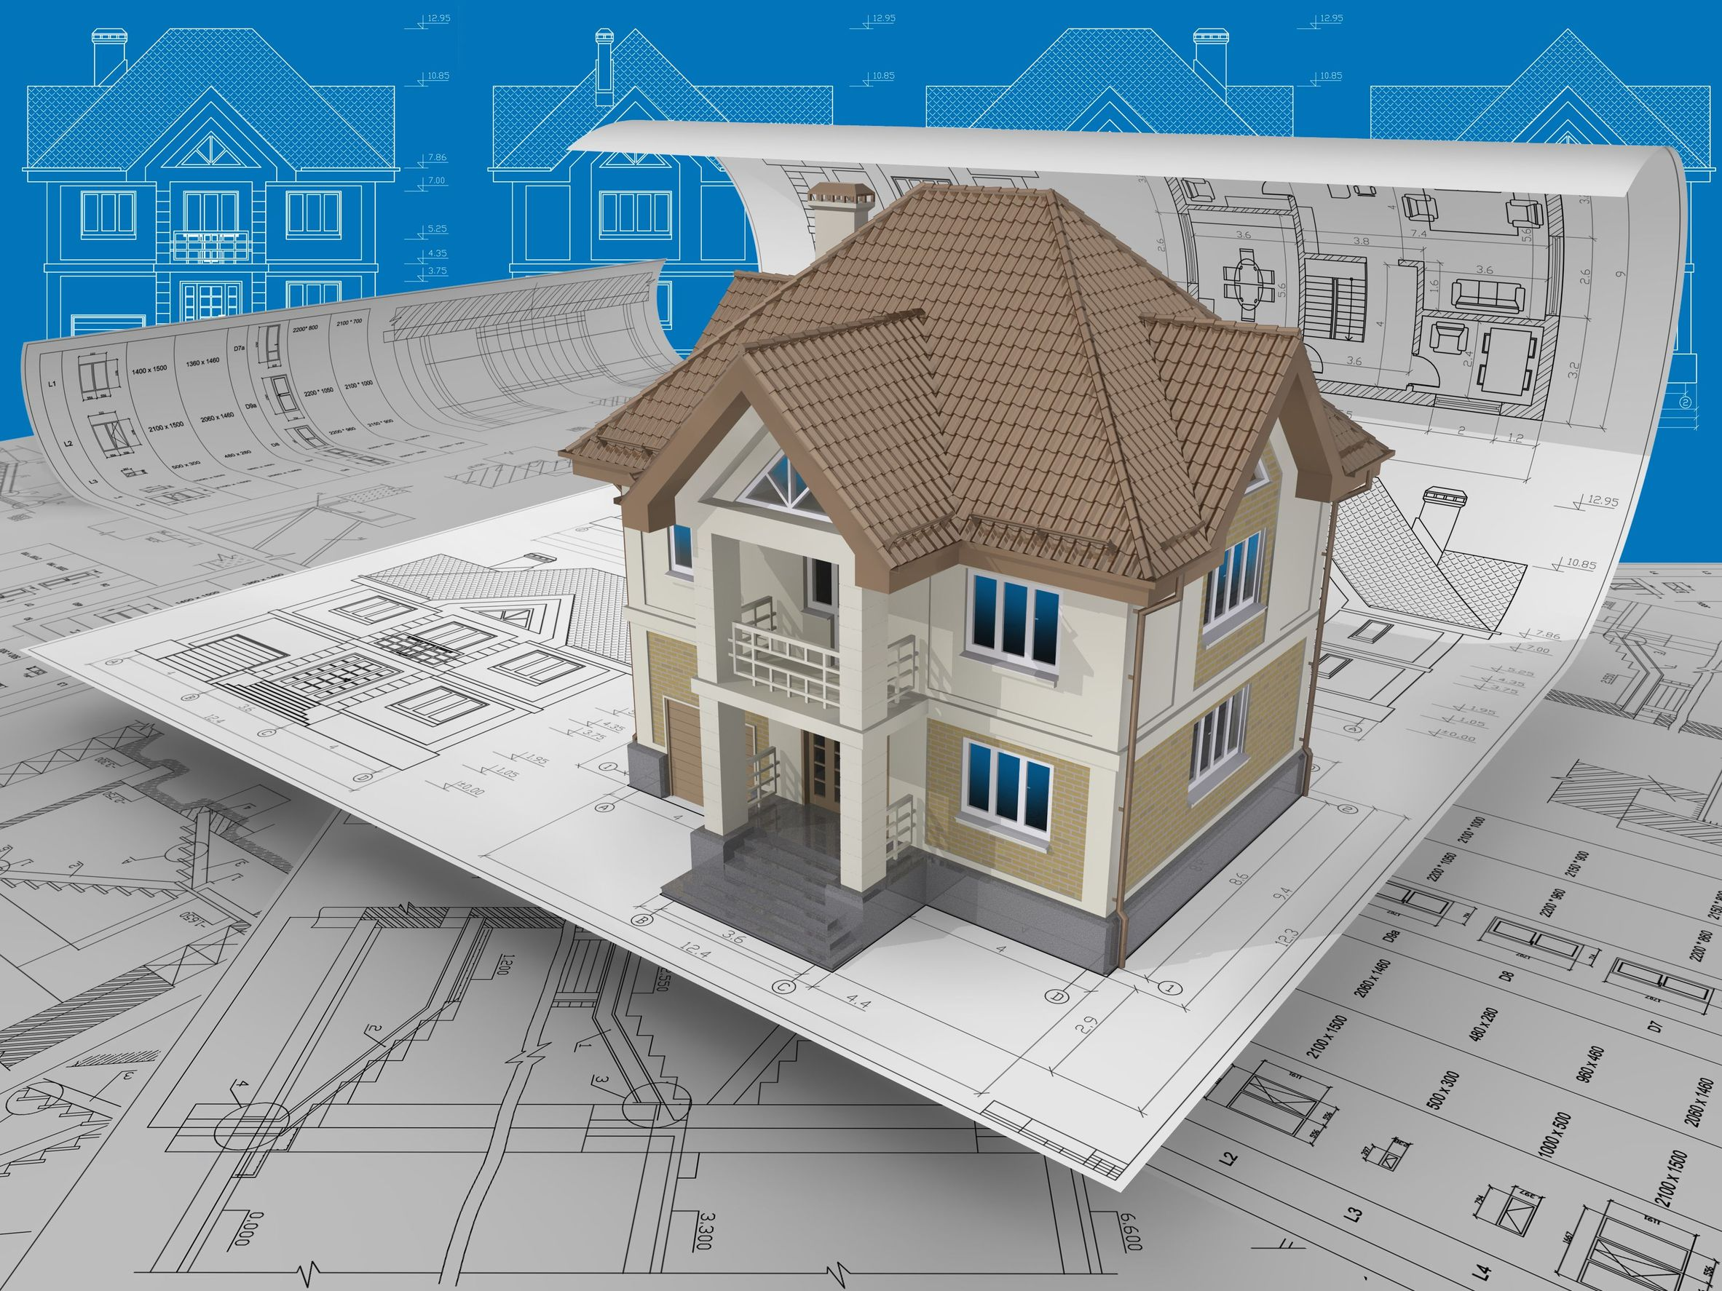
Construction Management System

Table of Contents
• Introduction & Objective 4
I. Introduction 4
II. Objective 4
Project Category: 6
Tools/Platform, Hardware and Software Specification 6
Hardware and Software Specification 6
Hardware Requirement 6
Software Requirement 6
Tools/Platforms used (Hardware/Software): 6
Hardware Used 6
Software Used 7
REQUIREMENTS AND ANALYSIS 7
Problem Definition 7
Requirements Specification 7
Functional Requirement 7
Add Worker/Labor 7
Add Raw material/Machine 7
Assignment of work to Worker/Labor 8
Apply for security and safety 8
Search Worker/Labor 8
Payment for Worker/Labor 8
Get design and plan 9
Technical Specification 9
Planning and Scheduling 10
Gantt chart 10
Tracking Gantt 11
Pert Chart 12
Scope of the Solution 12
Analysis 14
Context Diagram 14
0-Level DFD 14
1-Level DFD 15
2-Level DFD 18
E-R Diagram: 19
Class Diagram 22
Database & Table Details 23
Complete Structure 24
Module Description 24
Construction Management System GUI 24
Design & Plan Viewer 25
Work Planner Interface 25
Material Management Interface 25
Payment Interface 25
Worker Management Interface 26
Safety &Security Management Interface 26
Construction Management System Engine 26
Engine controller: 27
GUI Interactor: 27
Database Controller: 27
Plan & Design Controller: 28
Worker Controller: 28
Security Controller: 28
Safety Controller: 28
Work Estimation Controller: 28
Raw Material Controller: 28
Search Engine: 28
Payment Handler: 28
Machine & Transport Controller: 28
Construction Management System Database 29
Estimation 29
Process Logic 30
Data Structure 30
Implementation Methodology 34
List of Reports 35
Implementation of Security Mechanism at Various Levels 35
Future Scope and Further enhancement of the project: 35
BIBLOGRAPHY: 36

Introduction & Objective

Introduction
With the progress of advanced technologies, managing a construction site is being more
and more complicated these days. Whether it’s a personal residence or a huge multiplex, every person wants it to be developed as fast as possible. Constructors struggle to complete
their projects in time as they need to manage lots of resource, i.e. various raw materials, labors, engineers, money etc.
So, it is really necessary to develop an application that would let contractor/company mange each and every resource through his project sufficiently.
Construction Site Management System is developed to minimize all the problems that might arise in a construction site and it helps users to complete their esteemed projects in time. This software is based on work of constructor.

Objective

Construction Management System is software for managing and maintaining a construction site. A construction site has lots of activity going on parallel. Construction management software will enable the site manager to monitor workers, materials used, work progress, planning & estimation of future work. In simple words, Construction Site Management System is developed to erase all the problems and complexity of a construction site and help user monitor his project(s) and plan for the future projects as well. Go through the main features of the software described below to know more.

It has some advantage that helps the admin head of the construction to enhance his/her knowledge on construction and the effort of their employees and also helps the user to get there answer on their query such as how long their job has done, how much money they need to invest to enjoy the construction work etc. some other advantages are discussed below :

- Advantage –

- Fully user friendly : The software is fully user friendly. That is the software is prepared with user friendly scope (like keyboard facility). It is also help full for the user that they can get there entire query result on line.
- This software provides the security as much as possible.
- The tools used in the software are easily portable. That is easily installable.
- It helps the user, admin and manager of the work to make a proper decision. That helps him/her to get good result.
- It is remove the network criteria. That is the software is not stand alone type software. The connections used in this project will not only work for that machine.
- It also save a lot of time of admin, employee etc. and the interested users of the construction.
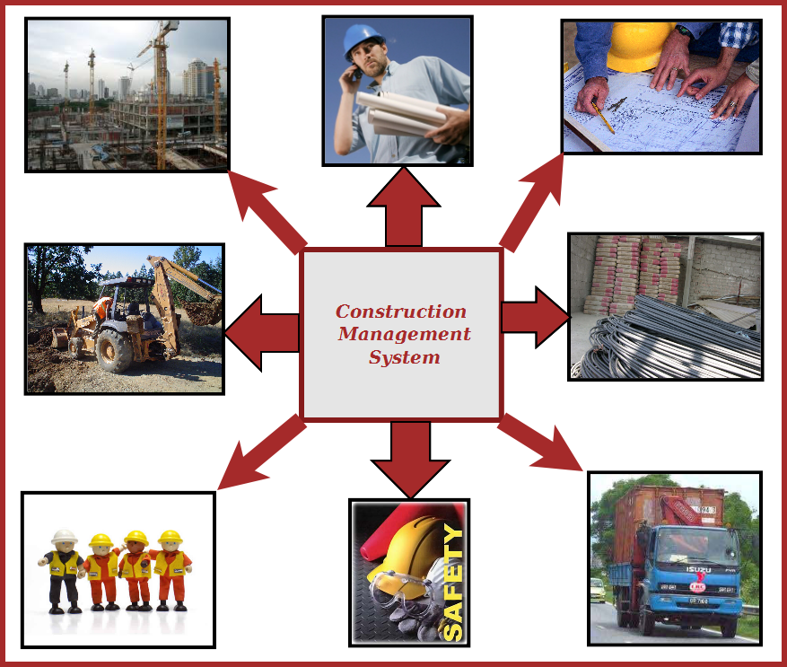
Figure: Overview of Construction Management System

Project Category:

This software will follow Object Oriented Programming Paradigm and use below mentioned areas.

Front End/ GUI Tools: Visual Studio 2010, .NET 4, C#
Backend: MySQL
Networking Technologies: TCP/IP
Wireless Technologies: Bluetooth
Operating Systems: Windows XP, Windows

Tools/Platform, Hardware and Software Specification

Hardware and Software Specification

Hardware Requirement
- Disc capacity : 10 MB of available hard disk space
- RAM : 1 GB (32 Bit) or 2 GB (64 Bit)
- Processor : 1.6GHz or faster

Software Requirement
- Windows XP (x86) with Service Pack 3 / Windows Vista (x86 & x64) with
Service Pack 2 / Windows 7 (x86 & x64)
- Microsoft .NET 4.0

Tools/Platforms used (Hardware/Software):

Hardware Used
- Laptop with 2GHZ processor
- 2 GB RAM
- 320 GB hard disk (NTFS File System)

Software Used
- Windows XP (x86) with Service Pack 3 / Windows Vista (x86) with Service Pack 2 / Windows 7 (x86)
- Microsoft .NET 4.0
- Windows Presentation Framework(WPF)
- Windows Communication Framework(WCF)
- Visual Studio 2010 Express Edition (IDE)
- MySQL Workbench
- Dia for Diagram Drawing & Modeling.

REQUIREMENTS AND ANALYSIS
Construction Management System will provide a cost effective & efficient software solution for managing everything about Construction. Different components of Construction Management System are depicted below.

Problem Definition
Construction Management System is being developed keeping in mind the hectic management and control procedure of a construction site. A contractor not only needs to manage his workers and raw materials, he also needs to plan properly to keep his commitment to his customers. Bringing raw materials, scheduling works and tracking progress would be lot easier using the application Construction Management System.

Requirements Specification

Functional Requirement

Add Worker/Labor
Inroduction :
Add a new Worker or labor.
Input :
Relevant worker or labor information like name, address, qualification, contact, experiance etc.
Processing:
Admin will enter data in the CMS and create a new worker or labor entry.
Output:
CMS will create a new worker or labor for future referance.

Add Raw material/Machine
Inroduction :
Add raw material or machine.
Input :
Related raw material or machine information like name, quantity, vandor, etc.
Processing:
Admin will enter data in the CMS and create a new raw material or machine entry.
Output:
CMS will create a new raw material or machine for construction.

Assignment of work to Worker/Labor
Inroduction :
Assign work for Worker or labor.
Input :
Related info of job and worker or labour details etc.
Processing:
Admin will assign job in the CMS and create a new job profile entry.
Output:
CMS will create a new job index by assigning worker or labor for construction.

Apply for security and safety
Inroduction :
Ensure safety and security for Worker and labor.
Input :
Any kind of task assign for the worker and labor.
Processing:
Superviser will check security and safety for the task.
Output:
If the security and safety process is not well the system will generate a reminder in CMS.

Search Worker/Labor
Inroduction :
Anyone can search for worker or labor.
Input :
He will enter data like worker name, address, etc.
Processing:
CMS will search for the labor or Worker.
Output:
CMS will display the search result.

Payment for Worker/Labor
Inroduction :
Payment calculation for the Worker or labor.
Input :
Get the job details of the worker or labour etc.
Processing:
Admin will calculate the payment in the CMS and send notification to the accounts department.
Output:
CMS will create a coupon, by which worker or labor can get payment from account.

Get design and plan
Inroduction :
Design and proper planning for the particular task.
Input :
Assign the plan and design job to the planner and designer.
Processing:
Planner and designer will plan and design the proper task schedule.
Output:
CMS will get the plan and design.

Technical Specification

Front End/ GUI Tools: Windows Presentation Framework (WPF)
IDE: Visual Studio 2010
Framework: Microsoft .NET 4.0
Database: MySQL
Database Tool: MySQL workbench CE
Operating Systems: Windows XP, Windows 7
Cloud Technology: Google Drive, Google forms

Planning and Scheduling

Gantt chart

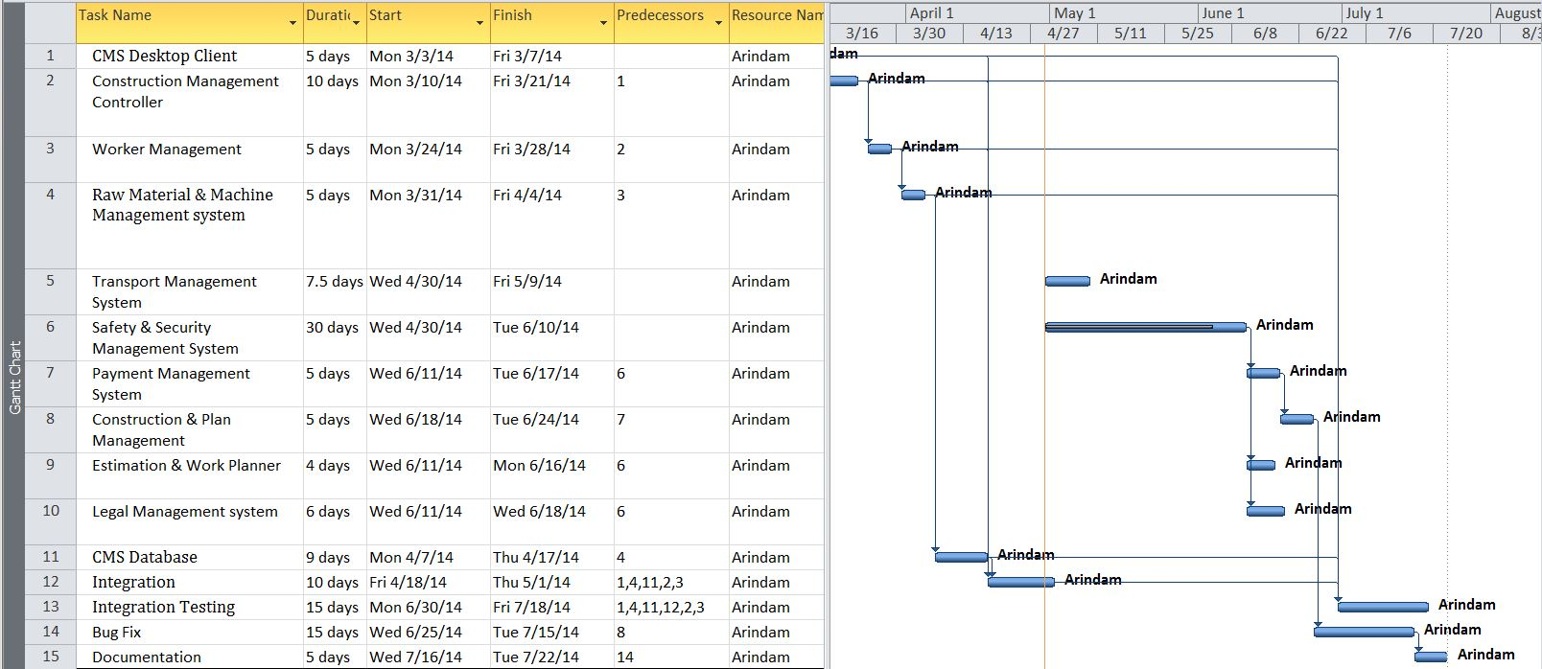

Tracking Gantt

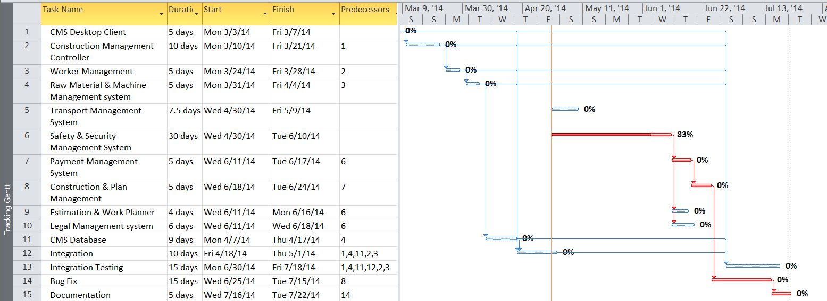

Pert Chart

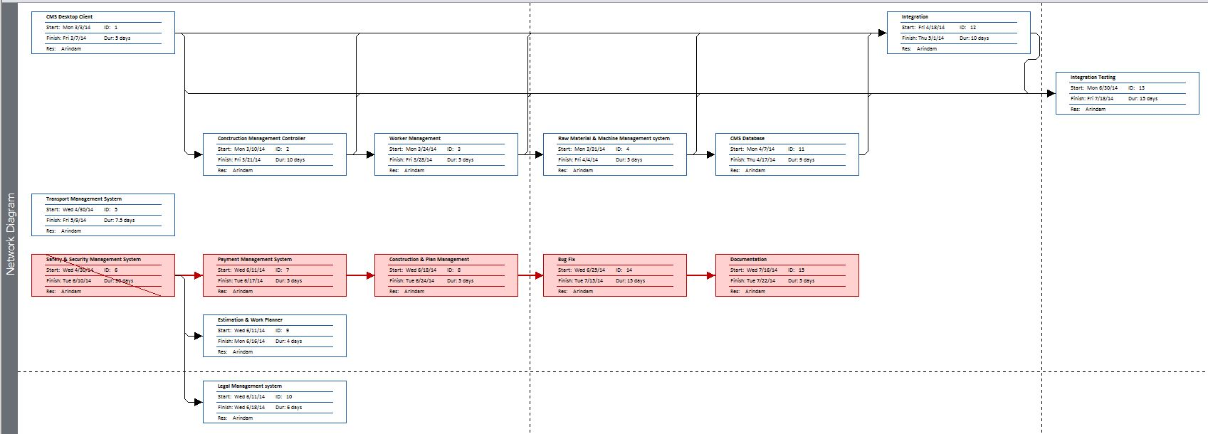

Scope of the Solution
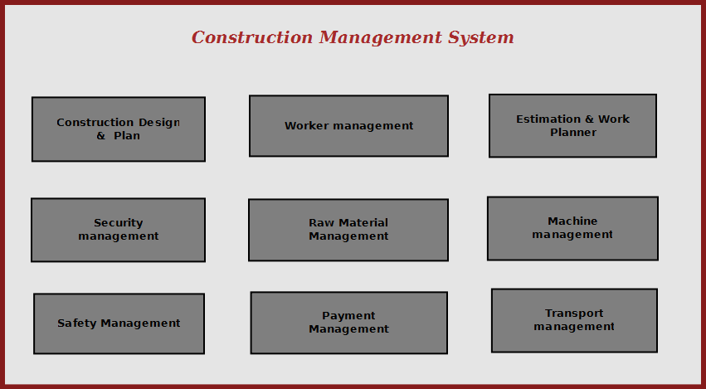

Figure: Scope of Construction Management System

Construction management system will enable the site manager to control all aspects of construction from a standalone solution. It allows managing, searching and referring important data used in construction; it makes site managers life easy to operate construction activities flawlessly.
The main features of this software are given below:
  - Construction design and planning using external designer software
  - Design viewer and add comments.
  - Worker attendance management.
  - Worker Identity info saving and security management
  - Raw material stock & pricing information query.
  - Estimation & planning of future work.
  - Monthly / daily progress report
  - Supply management & payment tracking.
  - Safety assurance
  - Transport management
  - Legal work management

Analysis

Context Diagram
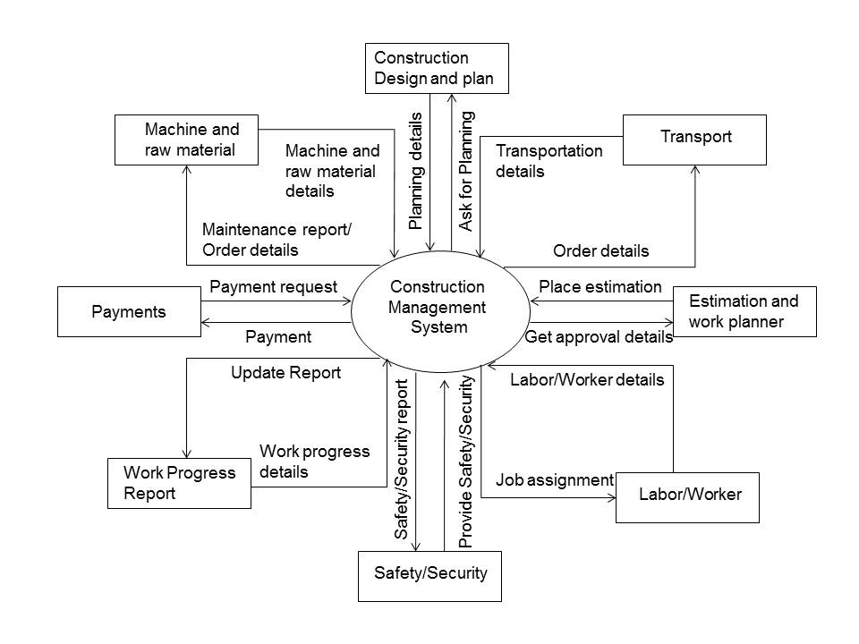

0-Level DFD
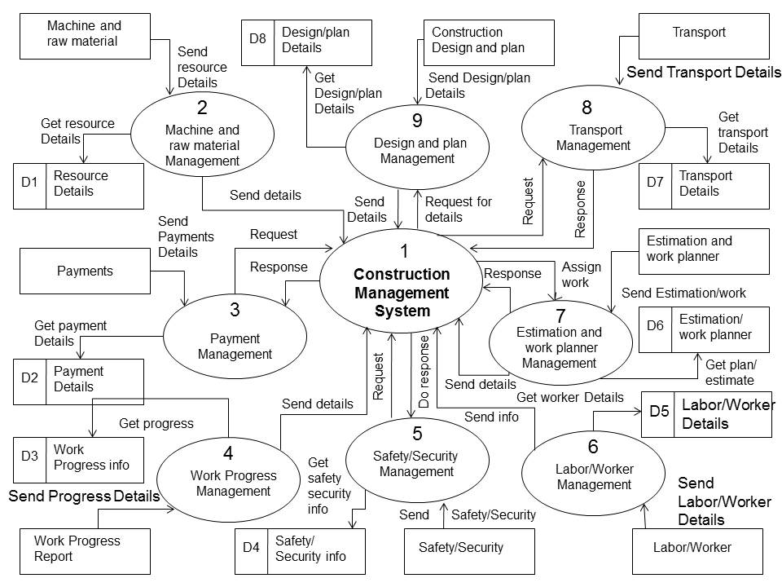

1-Level DFD
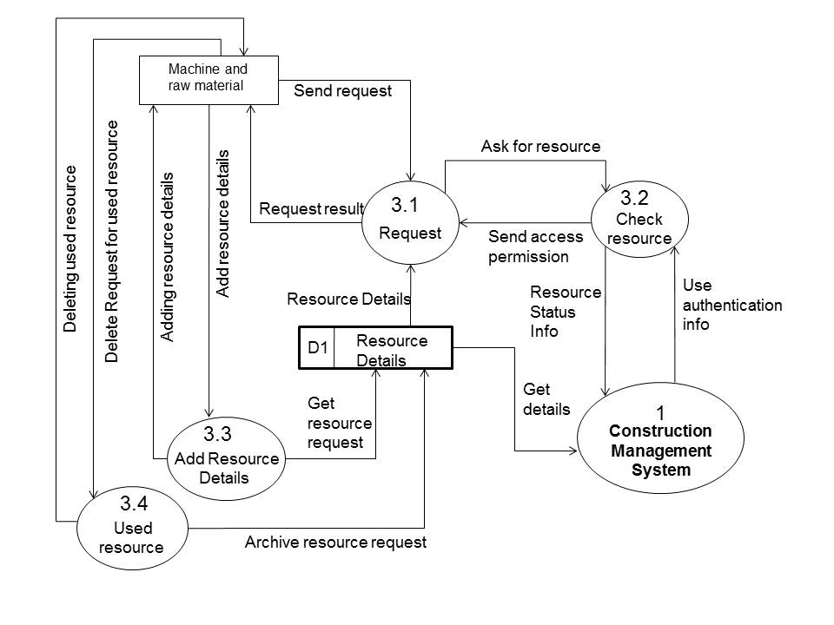
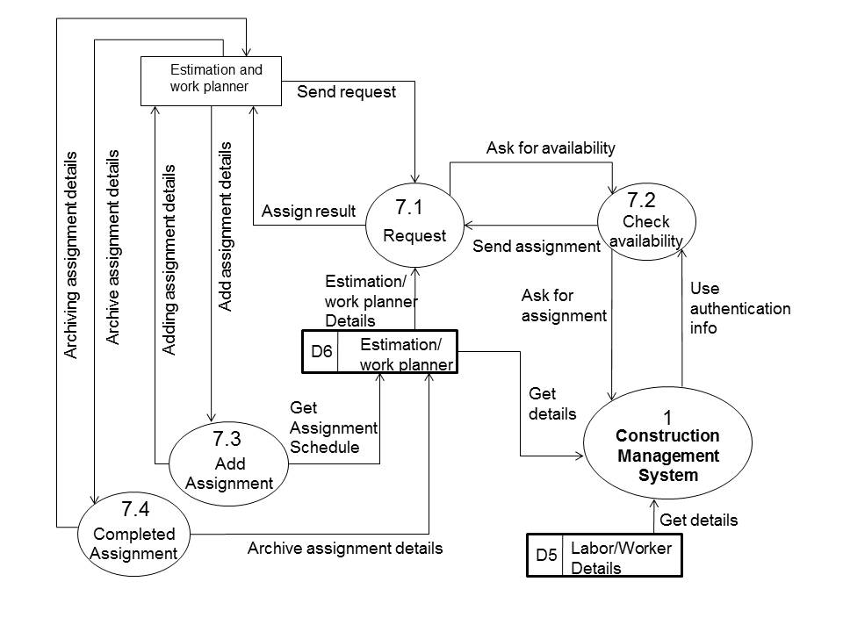
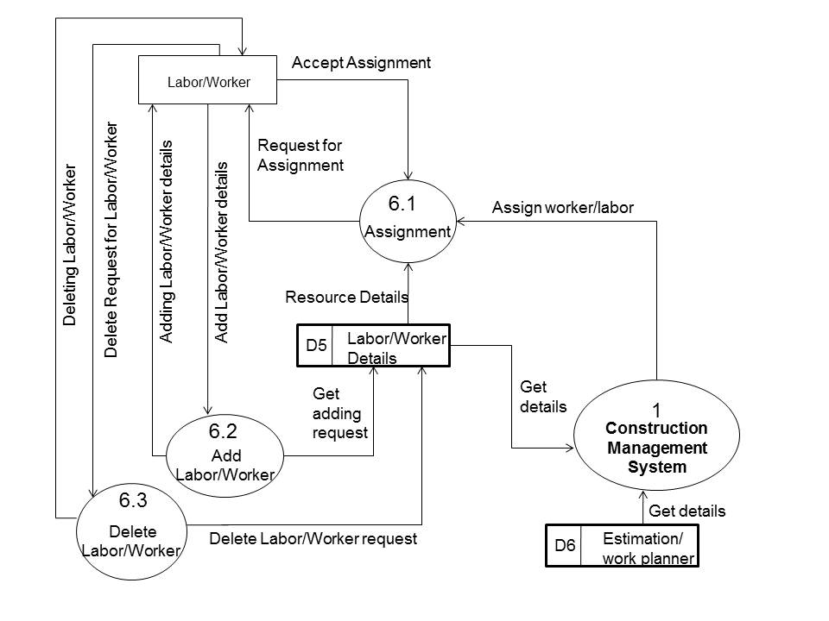

2-Level DFD

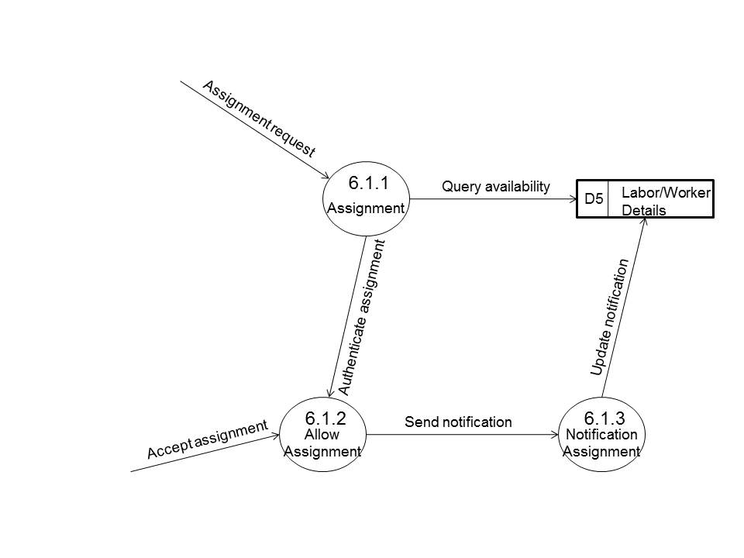

E-R Diagram:

We will design a RDBMS for Construction Management System. The entities and their attributes are listed below. Attributes in Bold letter is the unique key.

Entities | Attributes
Worker | User Id, Name, Address , Contact Number, skillset, Photo ID Num, Photo
Construction Management System | Construction site Id , Name, Address, Registered no
Construction Machine | Machine Id, Name, purpose
Work Session | Session Id, worker Id, Time, Expense amount
Engineer | engineer Id, Name, address, contact number
Design Preference | Preference Id, Type, Description
Raw Material | Product id, stock, name, price

Relationship between Entities:

- Construction Management System has Workers→ 1 : N
- Construction Management System has Machines→ 1 : N
- Workers does Work Session→ 1 : 1
- Construction Management System manages Raw Material → 1 : N
- Engineer provides Design Preferences → M : N

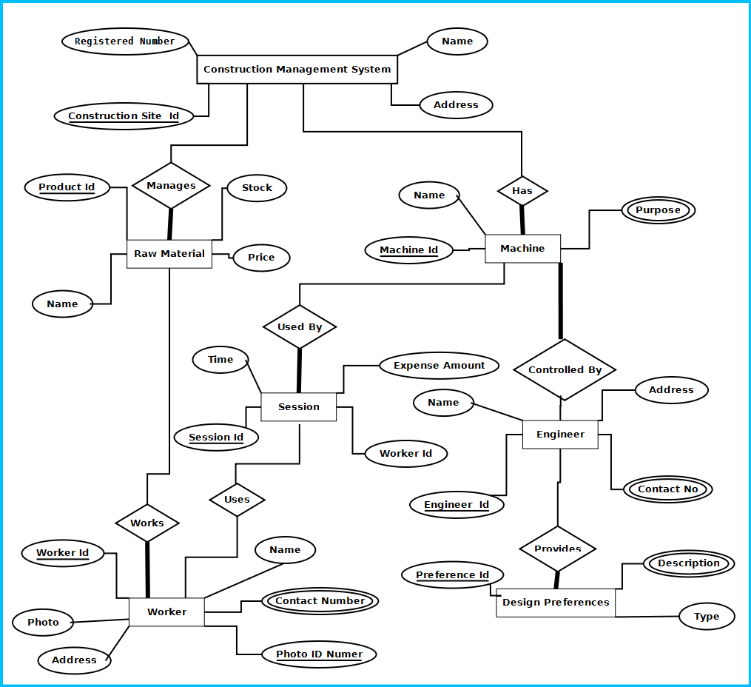

Figure: E-R Diagram of Construction Management system

Class Diagram

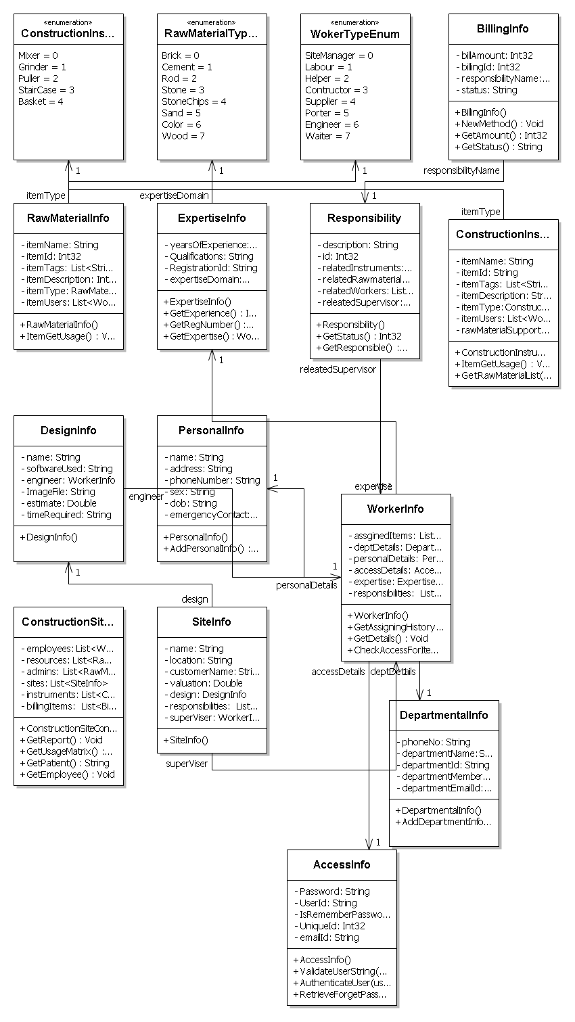
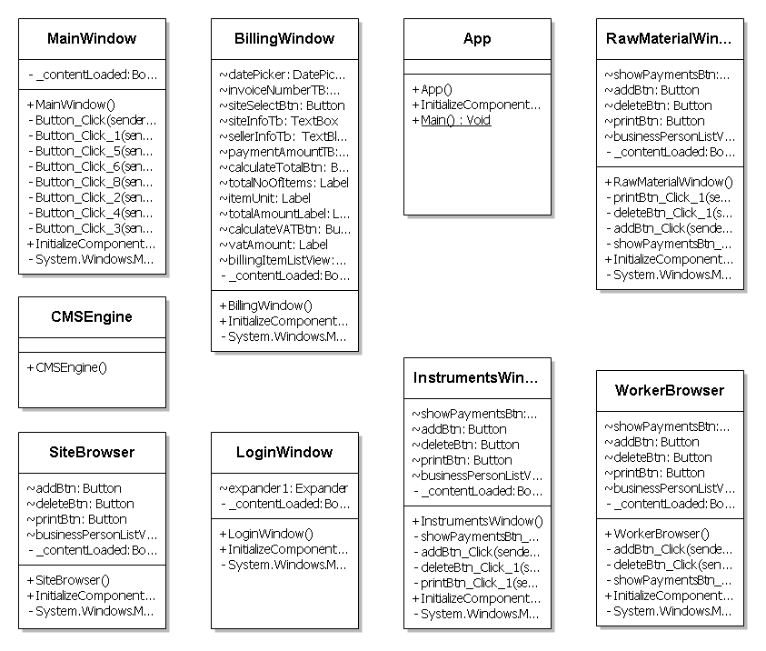

Database & Table Details
Tables | Keys
Worker | User Id, Name, Address , Contact Number, skillset, Photo ID Num, Photo
Construction Management System | Construction site Id , Name, Address, Registered no
Construction Machine | Machine Id, Name, purpose
Work Session | Session Id, worker Id, Time, Expense amount
Engineer | engineer Id, Name, address, contact number
Design Preference | Preference Id, Type, Description
Raw Material | Product id, stock, name, price

Complete Structure

Module Description
Construction Management System is divided into three main components. Such as:
- Construction Management System GUI
- Construction Management System Engine
- Construction Management System Database

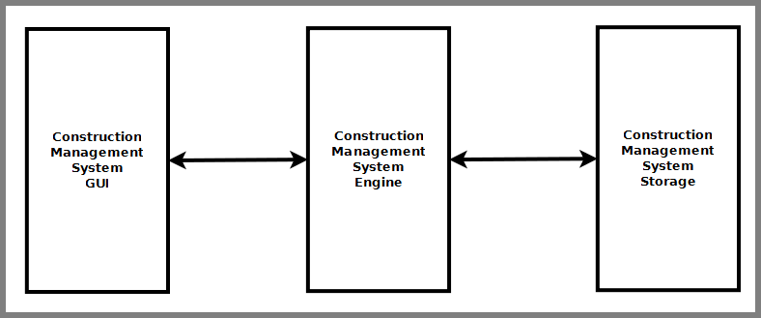
Figure: Components of Construction Management System

Construction Management System GUI
Construction Management System GUI will allow users to view existing construction data, enter new data & modify existing data. It will have a user friendly interface so that user can use the software efficiently. It is divided into six modules. Such as:
- Design & Plan viewer
- Work Planner Interface
- Payment Interface
- Material Management Interface
- Worker Management Interface
- Safety & Security Management Interface

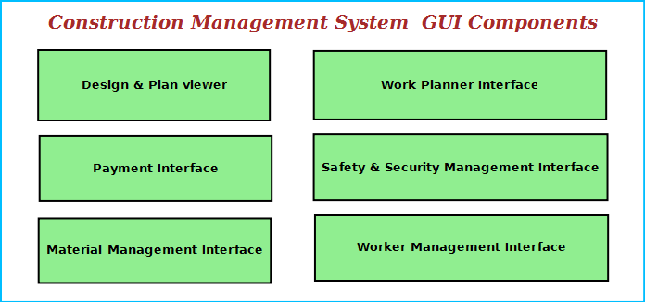
Figure: Construction Management System GUI Components

Design & Plan Viewer
It will allow to view design & planning file using some external editors & viewer. It will also allow scanning existing plan and view it as a image file. Users can add comments for modification and also generate reports.

Work Planner Interface
This interface will allow user to plan and estimate future work. It will have link to worker management interface so that workers can be assigned certain work. It will also enable to add costing and budget data for the work. It will have a option to add legal data associated with a work item and instruction to be followed.

Material Management Interface
This interface will allow user to manage the material used for construction.
    - to search any kind of material of the Construction and view price information and stock details.
    - Enter & modify material availability and usage data.

Payment Interface
This interface will allow users to enter payment data associated with various aspects construction work.
    - Workers payment
    - Raw materials purchase information
    - Future budgets
    - Infrastructure payments.
    - Loan information
    - cash flow and cheque information
    - bank information

Worker Management Interface
This module will maintain information about workers.
    - Construction sites need to maintain the worker personal data, professional experience info.
    - This will allow to track workers attendance and work hours data.
    - This interface will allow managing security measures to taken about the workers. It will have a interface for entering the worker’s security data, photo and scan the photo identity card of the worker.

Safety &Security Management Interface
This interface will ensure safety & security of the construction site.
    - Video Surveillance Interface: This interface will display the video of specific areas of the Construction and save the video for future reference. The site manager can monitor from video surveillance window.
    - First Aid browser: This displays the location first aid boxes and instructions on what to do in case of emergency.
    - Emergency contact interface: This will allow user to call ambulance driver, doctor & hospital in case of emergency.

Construction Management System Engine
Construction Management System Engine controls the overall system. It provides logical and tactical solutions for managing the whole system. The Construction Management System is divided into 12 divided modular components. Such as:
- Engine controller | - Raw Material Controller
- GUI Interactor | - Machine & Transport Controller
- Database Controller | - Payment Handler
- Plan & Design Controller | - Search Engine
- Worker Controller | - Safety Controller
- Work Estimation Handler | - Security Controller

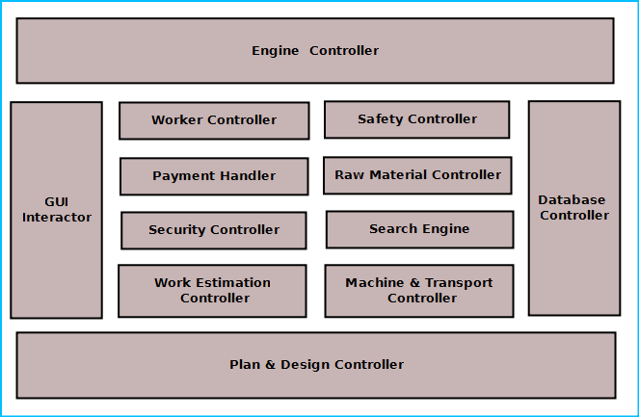
Figure: Components of Engine

Engine controller:
This controls the overall interaction between all the backend modules. It schedules the priority of the actions in case of overlapping. It helps user to consolidate overall reports and print them from GUI.

GUI Interactor:
It interacts with the GUI and polls GUI calls. It exposes APIs and events for GUI to use. GUI Interactor helps Engine to maintain wrapper around the Engine modules so that the GUI can be ported to any other framework without much changes in Engine code.

Database Controller:
It controls the database interactions. It forms query to fetch information from the database. It also sends data to be saved in database for future use.

Plan & Design Controller:
It allows integration with other designer software to view the design. It processes the design comments and helps generating reports.

Worker Controller:
It keeps track of worker information. It has an algorithm for maintaining worker data like
    - Attendance information
    - Work hours
    - Area of expertise
    - Payment details
    - Personal data
All these data will BE saved and are available for other modules to use and modify.

Security Controller:
It saves information for security measures. It can send it to the authority or police whenever required. It will ensure state of the existing security measures and generate warning if one of the steps is breached.

Safety Controller:
It ensures the safety of the construction site. It controls the safety alarms, fire alarms and instructions to be displayed at the hazardous places.

Work Estimation Controller:
This will allow users to estimate future work depending on the design,deadline and workers expertise. It will have algorithms to control estimation and assignment of work to the workers.

Raw Material Controller:
This module will maintain the information about raw materials. It will derive the figures about available materials, required amount to meet requirements, purchase deadline and allowable stock. It will save the information in database and retrieve them when required.

Search Engine:
Search engine enables rapid and efficient searching of data about workers, raw materials and suppliers. Search Engine prepares search indexes depending most accessed data. It improves the efficiency and performance of the software.

Payment Handler:
Payment Handler allows generating the report for material purchases. It calculates the salary of a worker. It will get the work & salary information from the database depending on worker data and calculates the payable amount.

Machine & Transport Controller:
This module keeps track machine to be used by the construction workers, machine purchase or hiring information, vendor information. This also handles logistics transport, worker transport.

Construction Management System Database
Construction Management System will maintain a centralized database for storing information. We will design a RDBMS to manage the database and engine interaction. It will have optimized design and archive older data to save space and increase performance.

Estimation

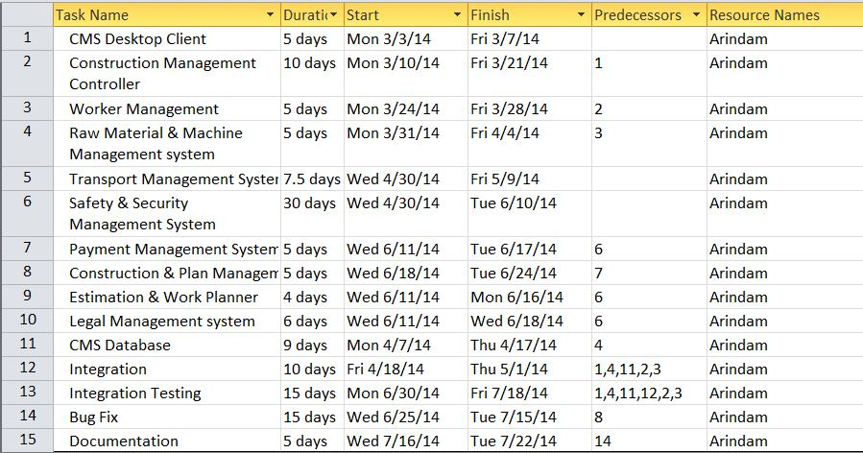

Process Logic
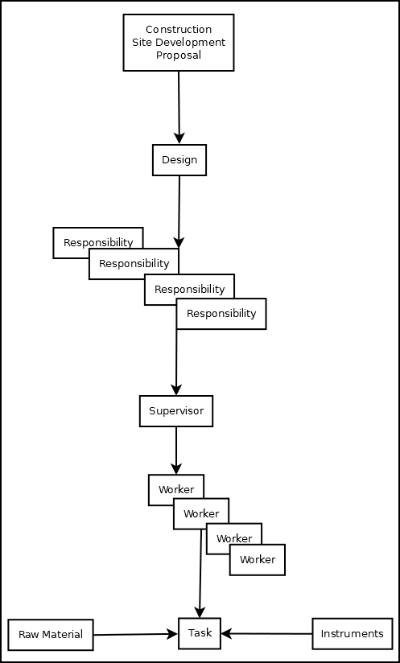

Data Structure
AccessInfo
public class AccessInfo
{
string Password;
string UserId;
bool IsRememberPassword;
int UniqueId;
string emailId;
}

BillingInfo
public class BillingInfo
{
int billAmount;
int billingId;
Responsibility responsibilityName;
string status;
}

ConstructionInstruments
public class ConstructionInstruments
{
string itemName;
string itemId;
List<string> itemTags;
string itemDescription;
ConstructionInstrumentsTypeEnum itemType;
List<WorkerInfo> itemUsers;
List<RawMaterialInfo> rawMaterialSupportedList;

}

ConstructionInstrumentsTypeEnum
public enum ConstructionInstrumentsTypeEnum
{
Mixer,
Grinder,
Puller,
StairCase,
Basket
}

ConstructionSiteController
public class ConstructionSiteController
{
List<WorkerInfo> employees;
List<RawMaterialInfo> resources;
List<RawMaterialInfo> admins;
List<SiteInfo> sites;
List<ConstructionInstruments> instruments;
List<BillingInfo> billingItems;
}

DepartmentalInfo
public class DepartmentalInfo
{
string phoneNo;
string departmentName;
string departmentId;
string departmentMemberId;
string departmentEmailId;
}

DesignInfo
public class DesignInfo
{
string name;
string softwareUsed;
WorkerInfo engineer;
string ImageFile;
double estimate;
string timeRequired;
}
}

ExpertiseInfo
public class ExpertiseInfo
{
int yearsOfExperience;
string Qualifications;
string RegistrationId;
WokerTypeEnum expertiseDomain;
}

PersonalInfo
public class PersonalInfo
{
string name;
string address;
string phoneNumber;
string sex;
string dob;
string emergencyContact;
}

RawMaterialInfo
public class RawMaterialInfo
{
string itemName;
int itemId;
List<string> itemTags;
int itemDescription;
RawMaterialTypeEnum itemType;
List<WorkerInfo> itemUsers;

}

RawMaterialTypeEnum
public enum RawMaterialTypeEnum
{
Brick,
Cement,
Rod,
Stone,
StoneChips,
Sand,
Color,
Wood
}

Responsibility
public class Responsibility
{
string description;
int id;
List<ConstructionInstruments> relatedInstruments;
List<RawMaterialInfo> relatedRawmaterials;
List<WorkerInfo> relatedWorkers;
WorkerInfo releatedSupervisor;

}

SiteInfo
public class SiteInfo
{
string name;
string location;
string customerName;
double valuation;
DesignInfo design;
List<Responsibility> responsibilities;
WorkerInfo superViser;
}

WokerTypeEnum
public enum WokerTypeEnum
{
SiteManager,
Labour,
Helper,
Contructor,
Supplier,
Porter,
Engineer,
Waiter
}

public class WorkerInfo
{
List<ConstructionInstruments> assginedItems;
DepartmentalInfo deptDetails;
PersonalInfo personalDetails;
AccessInfo accessDetails;
ExpertiseInfo expertise;
List<Responsibility> responsibilities;

}

Implementation Methodology
- Object Oriented Programming methodology will be adopted and C# will be used as programming language.
- Apache tomcat web server will be used to implement the server
- User interface development will be done in MVC architecture using WPF (Windows Presentation Framework).
- Relational DBMS MySQL will be used to implement & execute SQL query to database.
- Agile Software Development model will be used while developing this software.

List of Reports

List of reports that are likely to be generated in this software are given below:
- List of Raw materials used/purchased can be generated
- List of Labors/workers can be generated
- List of buyers can be generated
- Work progress details can be generated
- Fund details can be generated

Implementation of Security Mechanism at Various Levels
- It provides users a login interface that requires a password. The password could be changed by admin only.
- There would be multiple user login option, i.e. clerk, officer, admin etc.
- The login password will be saved in encrypted format in database.
- This software will use Google open-id authentication for web interface.

Future Scope and Further enhancement of the project:

    - To sink with multiple Construction sites with a centralized database.
    - To support UNIX / Linux, MAC OSX Operating systems.
    - Mobile application for querying the progress of works assigned to the workers.

BIBLOGRAPHY:

http://www.google.co.in
http://en.wikipedia.org
http://msdn.microsoft.com/en-us/
http://www.microsoft.com/en-us/default.aspx
http://www.codeplex.com/
http://stackoverflow.com/
http://www.codeguru.com/
http://www.w3schools.com

---------------------------- Thank You-------------------------

