Codebook for data.set2

Autogenerated data summary from dataMaid

2019-06-17 19:06:16

# Data report overview

The dataset is in file tidyData.txt. The background information of the dataset can be found in the document README.md

The dataset has the following dimensions:

|  |  |  |  |  |  |  |
| --- | --- | --- | --- | --- | --- | --- |
| Feature | | | Result | | | |
| Number of observations | | | 180 | | | |
| Number of variables | | | 81 | | | |
| **Identifiers:** | | |  | | | |
|  | | **Subject** | integer | |  | |  | |  |
|  | **Activity** | Factor | | |  | |  |  |
| There are 6 activities:   * WALKING * WALKING_UPSTAIRS * WALKING_DOWNSTAIRS * SITTING * STANDING * LAYING   Feature Selection  =================  The features selected for this database come from the accelerometer and gyroscope 3-axial raw signals tAcc-XYZ and tGyro-XYZ.  These time domain signals (prefix 't' to denote time) were captured at a constant rate of 50 Hz. Then they were filtered using a  median filter and a 3rd order low pass Butterworth filter with a corner frequency of 20 Hz to remove noise. Similarly, the  acceleration signal was then separated into body and gravity acceleration signals (tBodyAcc-XYZ and tGravityAcc-XYZ) using another  low pass Butterworth filter with a corner frequency of 0.3 Hz.  Subsequently, the body linear acceleration and angular velocity were derived in time to obtain Jerk signals (tBodyAccJerk-XYZ  and tBodyGyroJerk-XYZ). Also the magnitude of these three-dimensional signals were calculated using the Euclidean norm (tBodyAccMag,  tGravityAccMag, tBodyAccJerkMag, tBodyGyroMag, tBodyGyroJerkMag).  Finally a Fast Fourier Transform (FFT) was applied to some of these signals producing fBodyAcc-XYZ, fBodyAccJerk-XYZ, fBodyGyro-XYZ,  fBodyAccJerkMag, fBodyGyroMag, fBodyGyroJerkMag. (Note the 'f' to indicate frequency domain signals).  These signals were used to estimate variables of the feature vector for each pattern:  '-XYZ' is used to denote 3-axial signals in the X, Y and Z directions.  tBodyAcc-XYZ  tGravityAcc-XYZ  tBodyAccJerk-XYZ  tBodyGyro-XYZ  tBodyGyroJerk-XYZ  tBodyAccMag  tGravityAccMag  tBodyAccJerkMag  tBodyGyroMag  tBodyGyroJerkMag  fBodyAcc-XYZ  fBodyAccJerk-XYZ  fBodyGyro-XYZ  fBodyAccMag  fBodyAccJerkMag  fBodyGyroMag  fBodyGyroJerkMag  The set of variables that were estimated from these signals are:  mean(): Mean value  std(): Standard deviation  Additional vectors obtained by averaging the signals in a signal window sample. These are used on the angle() variable:  gravityMean  tBodyAccMean  tBodyAccJerkMean  tBodyGyroMean  tBodyGyroJerkMean | | |  | | | |

# Codebook summary table

|  |  |  |  |  |  |
| --- | --- | --- | --- | --- | --- |
| Label | Variable | Class | # unique values | Missing | Description |
|  | **Subject** | integer | 30 | 0.00 % |  |
|  | **Activity** | factor | 6 | 0.00 % |  |
|  | **tBodyAcc-mean-X** | numeric | 180 | 0.00 % |  |
|  | **tBodyAcc-mean-Y** | numeric | 180 | 0.00 % |  |
|  | **tBodyAcc-mean-Z** | numeric | 180 | 0.00 % |  |
|  | **tBodyAcc-std-X** | numeric | 180 | 0.00 % |  |
|  | **tBodyAcc-std-Y** | numeric | 180 | 0.00 % |  |
|  | **tBodyAcc-std-Z** | numeric | 180 | 0.00 % |  |
|  | **tGravityAcc-mean-X** | numeric | 180 | 0.00 % |  |
|  | **tGravityAcc-mean-Y** | numeric | 180 | 0.00 % |  |
|  | **tGravityAcc-mean-Z** | numeric | 180 | 0.00 % |  |
|  | **tGravityAcc-std-X** | numeric | 180 | 0.00 % |  |
|  | **tGravityAcc-std-Y** | numeric | 180 | 0.00 % |  |
|  | **tGravityAcc-std-Z** | numeric | 180 | 0.00 % |  |
|  | **tBodyAccJerk-mean-X** | numeric | 180 | 0.00 % |  |
|  | **tBodyAccJerk-mean-Y** | numeric | 180 | 0.00 % |  |
|  | **tBodyAccJerk-mean-Z** | numeric | 180 | 0.00 % |  |
|  | **tBodyAccJerk-std-X** | numeric | 180 | 0.00 % |  |
|  | **tBodyAccJerk-std-Y** | numeric | 180 | 0.00 % |  |
|  | **tBodyAccJerk-std-Z** | numeric | 180 | 0.00 % |  |
|  | **tBodyGyro-mean-X** | numeric | 180 | 0.00 % |  |
|  | **tBodyGyro-mean-Y** | numeric | 180 | 0.00 % |  |
|  | **tBodyGyro-mean-Z** | numeric | 180 | 0.00 % |  |
|  | **tBodyGyro-std-X** | numeric | 180 | 0.00 % |  |
|  | **tBodyGyro-std-Y** | numeric | 180 | 0.00 % |  |
|  | **tBodyGyro-std-Z** | numeric | 180 | 0.00 % |  |
|  | **tBodyGyroJerk-mean-X** | numeric | 180 | 0.00 % |  |
|  | **tBodyGyroJerk-mean-Y** | numeric | 180 | 0.00 % |  |
|  | **tBodyGyroJerk-mean-Z** | numeric | 180 | 0.00 % |  |
|  | **tBodyGyroJerk-std-X** | numeric | 180 | 0.00 % |  |
|  | **tBodyGyroJerk-std-Y** | numeric | 180 | 0.00 % |  |
|  | **tBodyGyroJerk-std-Z** | numeric | 180 | 0.00 % |  |
|  | **tBodyAccMag-mean** | numeric | 180 | 0.00 % |  |
|  | **tBodyAccMag-std** | numeric | 180 | 0.00 % |  |
|  | **tGravityAccMag-mean** | numeric | 180 | 0.00 % |  |
|  | **tGravityAccMag-std** | numeric | 180 | 0.00 % |  |
|  | **tBodyAccJerkMag-mean** | numeric | 180 | 0.00 % |  |
|  | **tBodyAccJerkMag-std** | numeric | 180 | 0.00 % |  |
|  | **tBodyGyroMag-mean** | numeric | 180 | 0.00 % |  |
|  | **tBodyGyroMag-std** | numeric | 180 | 0.00 % |  |
|  | **tBodyGyroJerkMag-mean** | numeric | 180 | 0.00 % |  |
|  | **tBodyGyroJerkMag-std** | numeric | 180 | 0.00 % |  |
|  | **fBodyAcc-mean-X** | numeric | 180 | 0.00 % |  |
|  | **fBodyAcc-mean-Y** | numeric | 180 | 0.00 % |  |
|  | **fBodyAcc-mean-Z** | numeric | 180 | 0.00 % |  |
|  | **fBodyAcc-std-X** | numeric | 180 | 0.00 % |  |
|  | **fBodyAcc-std-Y** | numeric | 180 | 0.00 % |  |
|  | **fBodyAcc-std-Z** | numeric | 180 | 0.00 % |  |
|  | **fBodyAcc-meanFreq-X** | numeric | 180 | 0.00 % |  |
|  | **fBodyAcc-meanFreq-Y** | numeric | 180 | 0.00 % |  |
|  | **fBodyAcc-meanFreq-Z** | numeric | 180 | 0.00 % |  |
|  | **fBodyAccJerk-mean-X** | numeric | 180 | 0.00 % |  |
|  | **fBodyAccJerk-mean-Y** | numeric | 180 | 0.00 % |  |
|  | **fBodyAccJerk-mean-Z** | numeric | 180 | 0.00 % |  |
|  | **fBodyAccJerk-std-X** | numeric | 180 | 0.00 % |  |
|  | **fBodyAccJerk-std-Y** | numeric | 180 | 0.00 % |  |
|  | **fBodyAccJerk-std-Z** | numeric | 180 | 0.00 % |  |
|  | **fBodyAccJerk-meanFreq-X** | numeric | 180 | 0.00 % |  |
|  | **fBodyAccJerk-meanFreq-Y** | numeric | 180 | 0.00 % |  |
|  | **fBodyAccJerk-meanFreq-Z** | numeric | 180 | 0.00 % |  |
|  | **fBodyGyro-mean-X** | numeric | 180 | 0.00 % |  |
|  | **fBodyGyro-mean-Y** | numeric | 180 | 0.00 % |  |
|  | **fBodyGyro-mean-Z** | numeric | 180 | 0.00 % |  |
|  | **fBodyGyro-std-X** | numeric | 180 | 0.00 % |  |
|  | **fBodyGyro-std-Y** | numeric | 180 | 0.00 % |  |
|  | **fBodyGyro-std-Z** | numeric | 180 | 0.00 % |  |
|  | **fBodyGyro-meanFreq-X** | numeric | 180 | 0.00 % |  |
|  | **fBodyGyro-meanFreq-Y** | numeric | 180 | 0.00 % |  |
|  | **fBodyGyro-meanFreq-Z** | numeric | 180 | 0.00 % |  |
|  | **fBodyAccMag-mean** | numeric | 180 | 0.00 % |  |
|  | **fBodyAccMag-std** | numeric | 180 | 0.00 % |  |
|  | **fBodyAccMag-meanFreq** | numeric | 180 | 0.00 % |  |
|  | **fBodyBodyAccJerkMag-mean** | numeric | 180 | 0.00 % |  |
|  | **fBodyBodyAccJerkMag-std** | numeric | 180 | 0.00 % |  |
|  | **fBodyBodyAccJerkMag-meanFreq** | numeric | 180 | 0.00 % |  |
|  | **fBodyBodyGyroMag-mean** | numeric | 180 | 0.00 % |  |
|  | **fBodyBodyGyroMag-std** | numeric | 180 | 0.00 % |  |
|  | **fBodyBodyGyroMag-meanFreq** | numeric | 180 | 0.00 % |  |
|  | **fBodyBodyGyroJerkMag-mean** | numeric | 180 | 0.00 % |  |
|  | **fBodyBodyGyroJerkMag-std** | numeric | 180 | 0.00 % |  |
|  | **fBodyBodyGyroJerkMag-meanFreq** | numeric | 180 | 0.00 % |  |

# Variable list

## Subject

|  |  |
| --- | --- |
| Feature | Result |
| Variable type | integer |
| Number of missing obs. | 0 (0 %) |
| Number of unique values | 30 |
| Median | 15.5 |
| 1st and 3rd quartiles | 8; 23 |
| Min. and max. | 1; 30 |

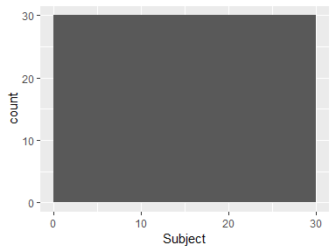

## Activity

|  |  |
| --- | --- |
| Feature | Result |
| Variable type | factor |
| Number of missing obs. | 0 (0 %) |
| Number of unique values | 6 |
| Mode | “WALKING” |
| Reference category | WALKING |

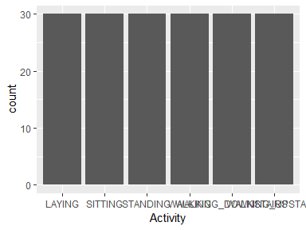

* Observed factor levels: "LAYING", "SITTING", "STANDING", "WALKING", "WALKING_DOWNSTAIRS", "WALKING_UPSTAIRS".

## tBodyAcc-mean-X

|  |  |
| --- | --- |
| Feature | Result |
| Variable type | numeric |
| Number of missing obs. | 0 (0 %) |
| Number of unique values | 180 |
| Median | 0.28 |
| 1st and 3rd quartiles | 0.27; 0.28 |
| Min. and max. | 0.22; 0.3 |

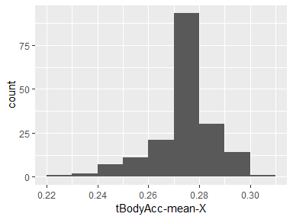

## tBodyAcc-mean-Y

|  |  |
| --- | --- |
| Feature | Result |
| Variable type | numeric |
| Number of missing obs. | 0 (0 %) |
| Number of unique values | 180 |
| Median | -0.02 |
| 1st and 3rd quartiles | -0.02; -0.01 |
| Min. and max. | -0.04; 0 |

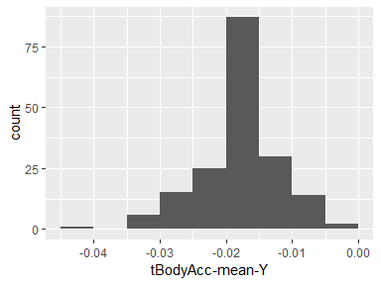

## tBodyAcc-mean-Z

|  |  |
| --- | --- |
| Feature | Result |
| Variable type | numeric |
| Number of missing obs. | 0 (0 %) |
| Number of unique values | 180 |
| Median | -0.11 |
| 1st and 3rd quartiles | -0.11; -0.1 |
| Min. and max. | -0.15; -0.08 |

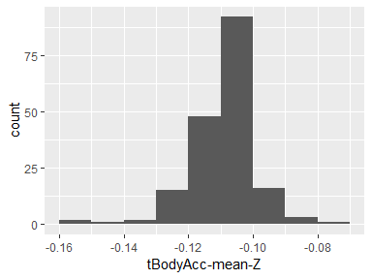

## tBodyAcc-std-X

|  |  |
| --- | --- |
| Feature | Result |
| Variable type | numeric |
| Number of missing obs. | 0 (0 %) |
| Number of unique values | 180 |
| Median | -0.75 |
| 1st and 3rd quartiles | -0.98; -0.2 |
| Min. and max. | -1; 0.63 |

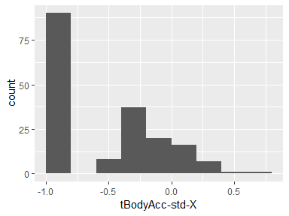

## tBodyAcc-std-Y

|  |  |
| --- | --- |
| Feature | Result |
| Variable type | numeric |
| Number of missing obs. | 0 (0 %) |
| Number of unique values | 180 |
| Median | -0.51 |
| 1st and 3rd quartiles | -0.94; -0.03 |
| Min. and max. | -0.99; 0.62 |

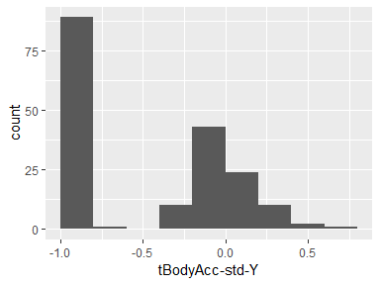

## tBodyAcc-std-Z

|  |  |
| --- | --- |
| Feature | Result |
| Variable type | numeric |
| Number of missing obs. | 0 (0 %) |
| Number of unique values | 180 |
| Median | -0.65 |
| 1st and 3rd quartiles | -0.95; -0.23 |
| Min. and max. | -0.99; 0.61 |

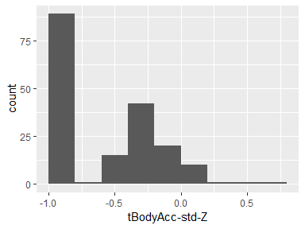

## tGravityAcc-mean-X

|  |  |
| --- | --- |
| Feature | Result |
| Variable type | numeric |
| Number of missing obs. | 0 (0 %) |
| Number of unique values | 180 |
| Median | 0.92 |
| 1st and 3rd quartiles | 0.84; 0.94 |
| Min. and max. | -0.68; 0.97 |

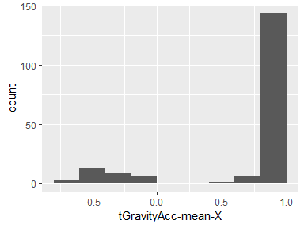

## tGravityAcc-mean-Y

|  |  |
| --- | --- |
| Feature | Result |
| Variable type | numeric |
| Number of missing obs. | 0 (0 %) |
| Number of unique values | 180 |
| Median | -0.13 |
| 1st and 3rd quartiles | -0.23; 0.09 |
| Min. and max. | -0.48; 0.96 |

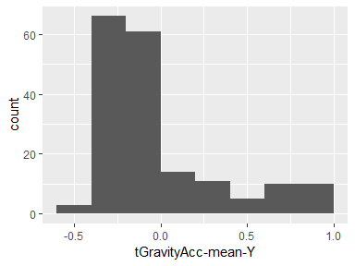

## tGravityAcc-mean-Z

|  |  |
| --- | --- |
| Feature | Result |
| Variable type | numeric |
| Number of missing obs. | 0 (0 %) |
| Number of unique values | 180 |
| Median | 0.02 |
| 1st and 3rd quartiles | -0.12; 0.15 |
| Min. and max. | -0.5; 0.96 |

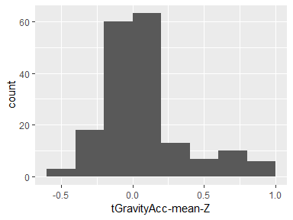

## tGravityAcc-std-X

|  |  |
| --- | --- |
| Feature | Result |
| Variable type | numeric |
| Number of missing obs. | 0 (0 %) |
| Number of unique values | 180 |
| Median | -0.97 |
| 1st and 3rd quartiles | -0.98; -0.95 |
| Min. and max. | -1; -0.83 |

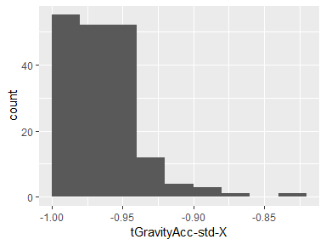

## tGravityAcc-std-Y

|  |  |
| --- | --- |
| Feature | Result |
| Variable type | numeric |
| Number of missing obs. | 0 (0 %) |
| Number of unique values | 180 |
| Median | -0.96 |
| 1st and 3rd quartiles | -0.97; -0.94 |
| Min. and max. | -0.99; -0.64 |

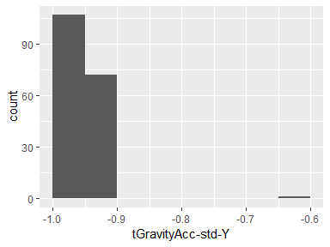

## tGravityAcc-std-Z

|  |  |
| --- | --- |
| Feature | Result |
| Variable type | numeric |
| Number of missing obs. | 0 (0 %) |
| Number of unique values | 180 |
| Median | -0.95 |
| 1st and 3rd quartiles | -0.96; -0.92 |
| Min. and max. | -0.99; -0.61 |

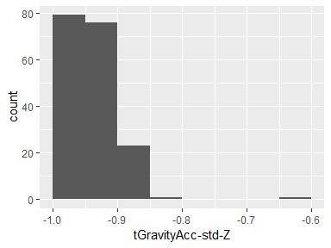

## tBodyAccJerk-mean-X

|  |  |
| --- | --- |
| Feature | Result |
| Variable type | numeric |
| Number of missing obs. | 0 (0 %) |
| Number of unique values | 180 |
| Median | 0.08 |
| 1st and 3rd quartiles | 0.07; 0.08 |
| Min. and max. | 0.04; 0.13 |

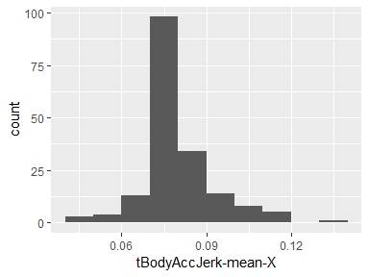

## tBodyAccJerk-mean-Y

|  |  |
| --- | --- |
| Feature | Result |
| Variable type | numeric |
| Number of missing obs. | 0 (0 %) |
| Number of unique values | 180 |
| Median | 0.01 |
| 1st and 3rd quartiles | 0; 0.01 |
| Min. and max. | -0.04; 0.06 |

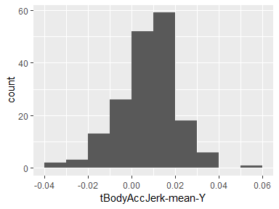

## tBodyAccJerk-mean-Z

|  |  |
| --- | --- |
| Feature | Result |
| Variable type | numeric |
| Number of missing obs. | 0 (0 %) |
| Number of unique values | 180 |
| Median | 0 |
| 1st and 3rd quartiles | -0.01; 0 |
| Min. and max. | -0.07; 0.04 |

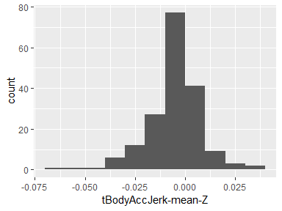

## tBodyAccJerk-std-X

|  |  |
| --- | --- |
| Feature | Result |
| Variable type | numeric |
| Number of missing obs. | 0 (0 %) |
| Number of unique values | 180 |
| Median | -0.81 |
| 1st and 3rd quartiles | -0.98; -0.22 |
| Min. and max. | -0.99; 0.54 |

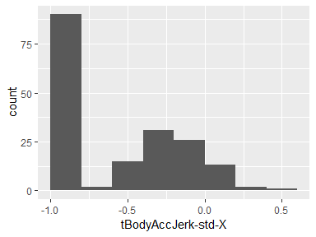

## tBodyAccJerk-std-Y

|  |  |
| --- | --- |
| Feature | Result |
| Variable type | numeric |
| Number of missing obs. | 0 (0 %) |
| Number of unique values | 180 |
| Median | -0.78 |
| 1st and 3rd quartiles | -0.97; -0.15 |
| Min. and max. | -0.99; 0.36 |

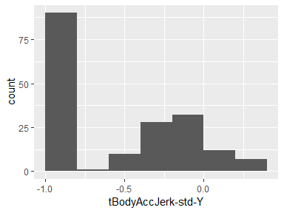

## tBodyAccJerk-std-Z

|  |  |
| --- | --- |
| Feature | Result |
| Variable type | numeric |
| Number of missing obs. | 0 (0 %) |
| Number of unique values | 180 |
| Median | -0.88 |
| 1st and 3rd quartiles | -0.98; -0.51 |
| Min. and max. | -0.99; 0.03 |

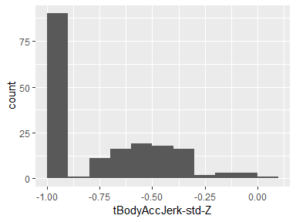

## tBodyGyro-mean-X

|  |  |
| --- | --- |
| Feature | Result |
| Variable type | numeric |
| Number of missing obs. | 0 (0 %) |
| Number of unique values | 180 |
| Median | -0.03 |
| 1st and 3rd quartiles | -0.05; -0.02 |
| Min. and max. | -0.21; 0.19 |

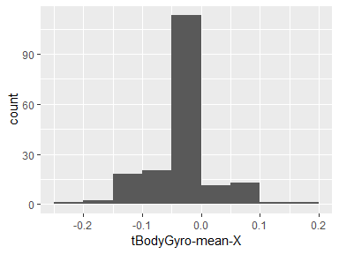

## tBodyGyro-mean-Y

|  |  |
| --- | --- |
| Feature | Result |
| Variable type | numeric |
| Number of missing obs. | 0 (0 %) |
| Number of unique values | 180 |
| Median | -0.07 |
| 1st and 3rd quartiles | -0.09; -0.06 |
| Min. and max. | -0.2; 0.03 |

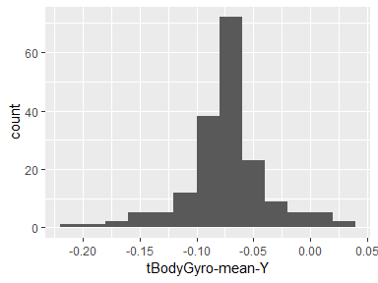

## tBodyGyro-mean-Z

|  |  |
| --- | --- |
| Feature | Result |
| Variable type | numeric |
| Number of missing obs. | 0 (0 %) |
| Number of unique values | 180 |
| Median | 0.09 |
| 1st and 3rd quartiles | 0.07; 0.1 |
| Min. and max. | -0.07; 0.18 |

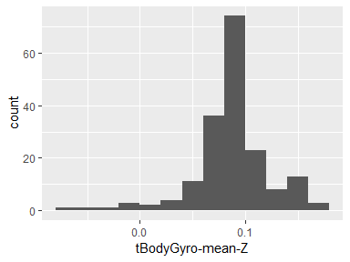

## tBodyGyro-std-X

|  |  |
| --- | --- |
| Feature | Result |
| Variable type | numeric |
| Number of missing obs. | 0 (0 %) |
| Number of unique values | 180 |
| Median | -0.79 |
| 1st and 3rd quartiles | -0.97; -0.44 |
| Min. and max. | -0.99; 0.27 |

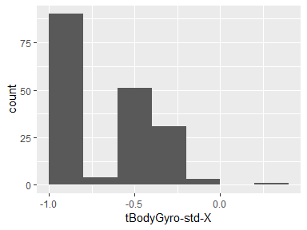

## tBodyGyro-std-Y

|  |  |
| --- | --- |
| Feature | Result |
| Variable type | numeric |
| Number of missing obs. | 0 (0 %) |
| Number of unique values | 180 |
| Median | -0.8 |
| 1st and 3rd quartiles | -0.96; -0.42 |
| Min. and max. | -0.99; 0.48 |

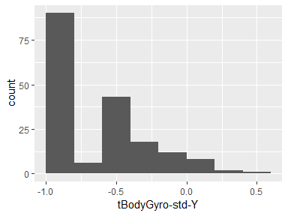

## tBodyGyro-std-Z

|  |  |
| --- | --- |
| Feature | Result |
| Variable type | numeric |
| Number of missing obs. | 0 (0 %) |
| Number of unique values | 180 |
| Median | -0.8 |
| 1st and 3rd quartiles | -0.96; -0.31 |
| Min. and max. | -0.99; 0.56 |

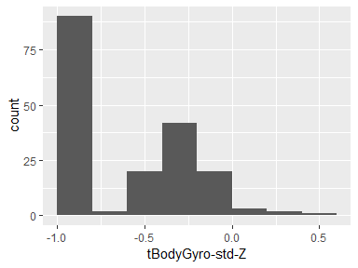

## tBodyGyroJerk-mean-X

|  |  |
| --- | --- |
| Feature | Result |
| Variable type | numeric |
| Number of missing obs. | 0 (0 %) |
| Number of unique values | 180 |
| Median | -0.1 |
| 1st and 3rd quartiles | -0.1; -0.09 |
| Min. and max. | -0.16; -0.02 |

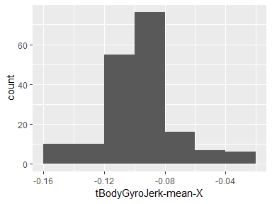

## tBodyGyroJerk-mean-Y

|  |  |
| --- | --- |
| Feature | Result |
| Variable type | numeric |
| Number of missing obs. | 0 (0 %) |
| Number of unique values | 180 |
| Median | -0.04 |
| 1st and 3rd quartiles | -0.05; -0.04 |
| Min. and max. | -0.08; -0.01 |

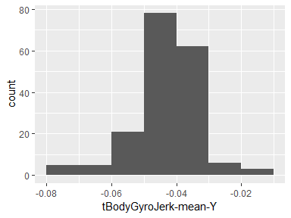

## tBodyGyroJerk-mean-Z

|  |  |
| --- | --- |
| Feature | Result |
| Variable type | numeric |
| Number of missing obs. | 0 (0 %) |
| Number of unique values | 180 |
| Median | -0.05 |
| 1st and 3rd quartiles | -0.06; -0.05 |
| Min. and max. | -0.09; -0.01 |

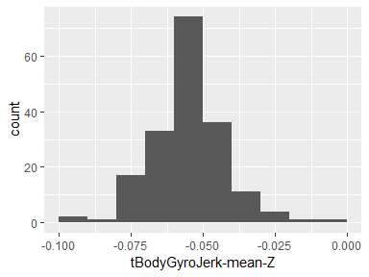

## tBodyGyroJerk-std-X

|  |  |
| --- | --- |
| Feature | Result |
| Variable type | numeric |
| Number of missing obs. | 0 (0 %) |
| Number of unique values | 180 |
| Median | -0.84 |
| 1st and 3rd quartiles | -0.98; -0.46 |
| Min. and max. | -1; 0.18 |

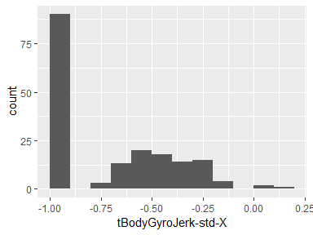

## tBodyGyroJerk-std-Y

|  |  |
| --- | --- |
| Feature | Result |
| Variable type | numeric |
| Number of missing obs. | 0 (0 %) |
| Number of unique values | 180 |
| Median | -0.89 |
| 1st and 3rd quartiles | -0.98; -0.59 |
| Min. and max. | -1; 0.3 |

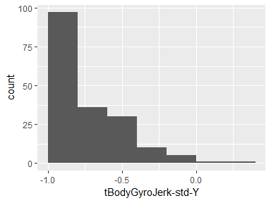

## tBodyGyroJerk-std-Z

|  |  |
| --- | --- |
| Feature | Result |
| Variable type | numeric |
| Number of missing obs. | 0 (0 %) |
| Number of unique values | 180 |
| Median | -0.86 |
| 1st and 3rd quartiles | -0.98; -0.47 |
| Min. and max. | -1; 0.19 |

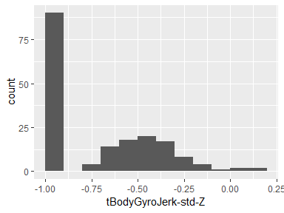

## tBodyAccMag-mean

|  |  |
| --- | --- |
| Feature | Result |
| Variable type | numeric |
| Number of missing obs. | 0 (0 %) |
| Number of unique values | 180 |
| Median | -0.48 |
| 1st and 3rd quartiles | -0.96; -0.09 |
| Min. and max. | -0.99; 0.64 |

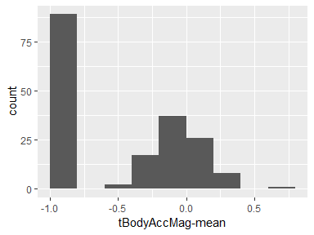

## tBodyAccMag-std

|  |  |
| --- | --- |
| Feature | Result |
| Variable type | numeric |
| Number of missing obs. | 0 (0 %) |
| Number of unique values | 180 |
| Median | -0.61 |
| 1st and 3rd quartiles | -0.94; -0.21 |
| Min. and max. | -0.99; 0.43 |

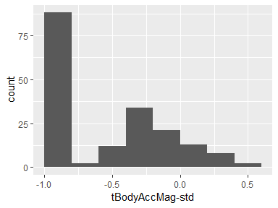

## tGravityAccMag-mean

|  |  |
| --- | --- |
| Feature | Result |
| Variable type | numeric |
| Number of missing obs. | 0 (0 %) |
| Number of unique values | 180 |
| Median | -0.48 |
| 1st and 3rd quartiles | -0.96; -0.09 |
| Min. and max. | -0.99; 0.64 |

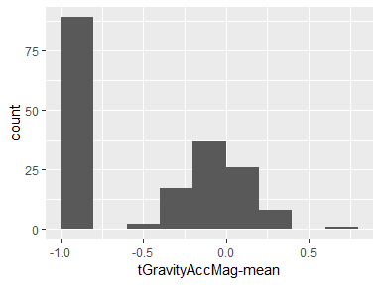

## tGravityAccMag-std

|  |  |
| --- | --- |
| Feature | Result |
| Variable type | numeric |
| Number of missing obs. | 0 (0 %) |
| Number of unique values | 180 |
| Median | -0.61 |
| 1st and 3rd quartiles | -0.94; -0.21 |
| Min. and max. | -0.99; 0.43 |

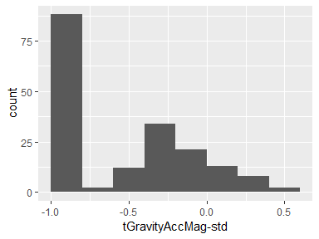

## tBodyAccJerkMag-mean

|  |  |
| --- | --- |
| Feature | Result |
| Variable type | numeric |
| Number of missing obs. | 0 (0 %) |
| Number of unique values | 180 |
| Median | -0.82 |
| 1st and 3rd quartiles | -0.98; -0.25 |
| Min. and max. | -0.99; 0.43 |

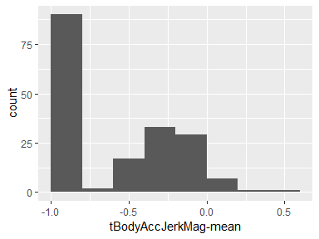

## tBodyAccJerkMag-std

|  |  |
| --- | --- |
| Feature | Result |
| Variable type | numeric |
| Number of missing obs. | 0 (0 %) |
| Number of unique values | 180 |
| Median | -0.8 |
| 1st and 3rd quartiles | -0.98; -0.22 |
| Min. and max. | -0.99; 0.45 |

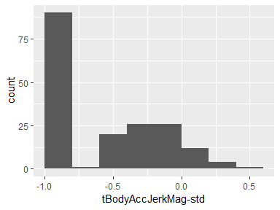

## tBodyGyroMag-mean

|  |  |
| --- | --- |
| Feature | Result |
| Variable type | numeric |
| Number of missing obs. | 0 (0 %) |
| Number of unique values | 180 |
| Median | -0.66 |
| 1st and 3rd quartiles | -0.95; -0.22 |
| Min. and max. | -0.98; 0.42 |

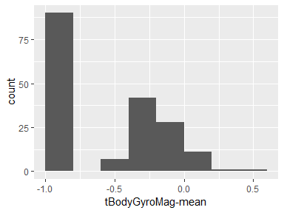

## tBodyGyroMag-std

|  |  |
| --- | --- |
| Feature | Result |
| Variable type | numeric |
| Number of missing obs. | 0 (0 %) |
| Number of unique values | 180 |
| Median | -0.74 |
| 1st and 3rd quartiles | -0.95; -0.36 |
| Min. and max. | -0.98; 0.3 |

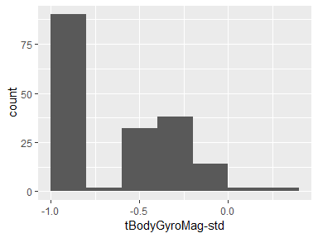

## tBodyGyroJerkMag-mean

|  |  |
| --- | --- |
| Feature | Result |
| Variable type | numeric |
| Number of missing obs. | 0 (0 %) |
| Number of unique values | 180 |
| Median | -0.86 |
| 1st and 3rd quartiles | -0.99; -0.51 |
| Min. and max. | -1; 0.09 |

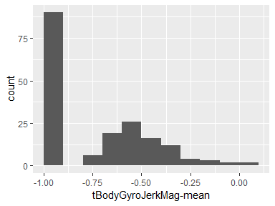

## tBodyGyroJerkMag-std

|  |  |
| --- | --- |
| Feature | Result |
| Variable type | numeric |
| Number of missing obs. | 0 (0 %) |
| Number of unique values | 180 |
| Median | -0.88 |
| 1st and 3rd quartiles | -0.98; -0.58 |
| Min. and max. | -1; 0.25 |

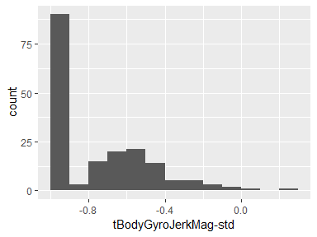

## fBodyAcc-mean-X

|  |  |
| --- | --- |
| Feature | Result |
| Variable type | numeric |
| Number of missing obs. | 0 (0 %) |
| Number of unique values | 180 |
| Median | -0.77 |
| 1st and 3rd quartiles | -0.98; -0.22 |
| Min. and max. | -1; 0.54 |

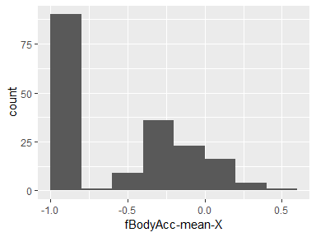

## fBodyAcc-mean-Y

|  |  |
| --- | --- |
| Feature | Result |
| Variable type | numeric |
| Number of missing obs. | 0 (0 %) |
| Number of unique values | 180 |
| Median | -0.59 |
| 1st and 3rd quartiles | -0.95; -0.06 |
| Min. and max. | -0.99; 0.52 |

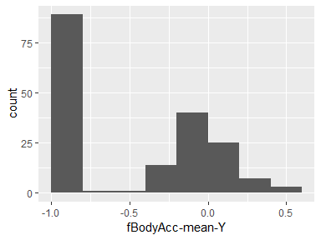

## fBodyAcc-mean-Z

|  |  |
| --- | --- |
| Feature | Result |
| Variable type | numeric |
| Number of missing obs. | 0 (0 %) |
| Number of unique values | 180 |
| Median | -0.72 |
| 1st and 3rd quartiles | -0.96; -0.32 |
| Min. and max. | -0.99; 0.28 |

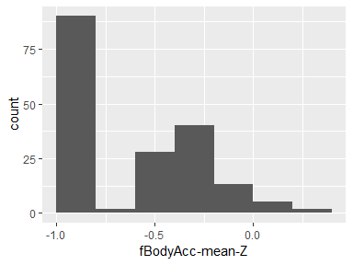

## fBodyAcc-std-X

|  |  |
| --- | --- |
| Feature | Result |
| Variable type | numeric |
| Number of missing obs. | 0 (0 %) |
| Number of unique values | 180 |
| Median | -0.75 |
| 1st and 3rd quartiles | -0.98; -0.2 |
| Min. and max. | -1; 0.66 |

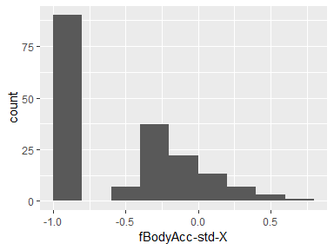

## fBodyAcc-std-Y

|  |  |
| --- | --- |
| Feature | Result |
| Variable type | numeric |
| Number of missing obs. | 0 (0 %) |
| Number of unique values | 180 |
| Median | -0.51 |
| 1st and 3rd quartiles | -0.94; -0.08 |
| Min. and max. | -0.99; 0.56 |

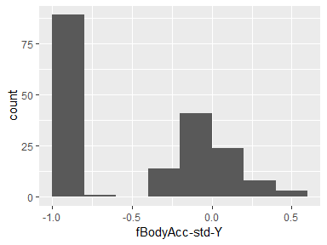

## fBodyAcc-std-Z

|  |  |
| --- | --- |
| Feature | Result |
| Variable type | numeric |
| Number of missing obs. | 0 (0 %) |
| Number of unique values | 180 |
| Median | -0.64 |
| 1st and 3rd quartiles | -0.95; -0.27 |
| Min. and max. | -0.99; 0.69 |

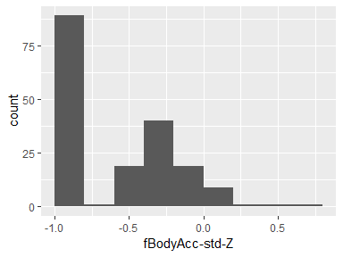

## fBodyAcc-meanFreq-X

|  |  |
| --- | --- |
| Feature | Result |
| Variable type | numeric |
| Number of missing obs. | 0 (0 %) |
| Number of unique values | 180 |
| Median | -0.26 |
| 1st and 3rd quartiles | -0.39; -0.06 |
| Min. and max. | -0.64; 0.16 |

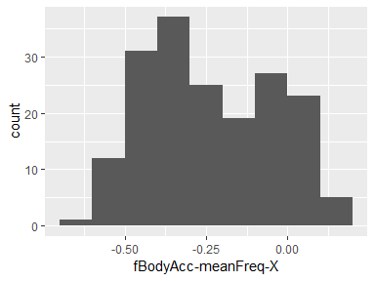

## fBodyAcc-meanFreq-Y

|  |  |
| --- | --- |
| Feature | Result |
| Variable type | numeric |
| Number of missing obs. | 0 (0 %) |
| Number of unique values | 180 |
| Median | 0.01 |
| 1st and 3rd quartiles | -0.08; 0.09 |
| Min. and max. | -0.38; 0.47 |

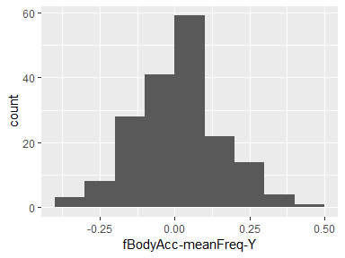

## fBodyAcc-meanFreq-Z

|  |  |
| --- | --- |
| Feature | Result |
| Variable type | numeric |
| Number of missing obs. | 0 (0 %) |
| Number of unique values | 180 |
| Median | 0.07 |
| 1st and 3rd quartiles | -0.04; 0.18 |
| Min. and max. | -0.52; 0.4 |

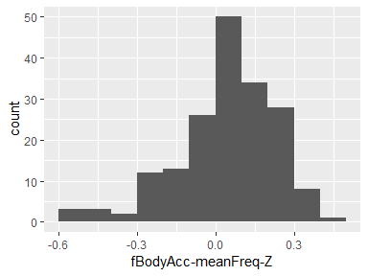

## fBodyAccJerk-mean-X

|  |  |
| --- | --- |
| Feature | Result |
| Variable type | numeric |
| Number of missing obs. | 0 (0 %) |
| Number of unique values | 180 |
| Median | -0.81 |
| 1st and 3rd quartiles | -0.98; -0.28 |
| Min. and max. | -0.99; 0.47 |

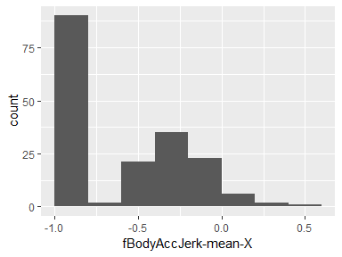

## fBodyAccJerk-mean-Y

|  |  |
| --- | --- |
| Feature | Result |
| Variable type | numeric |
| Number of missing obs. | 0 (0 %) |
| Number of unique values | 180 |
| Median | -0.78 |
| 1st and 3rd quartiles | -0.97; -0.2 |
| Min. and max. | -0.99; 0.28 |

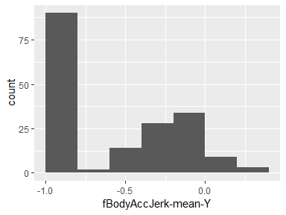

## fBodyAccJerk-mean-Z

|  |  |
| --- | --- |
| Feature | Result |
| Variable type | numeric |
| Number of missing obs. | 0 (0 %) |
| Number of unique values | 180 |
| Median | -0.87 |
| 1st and 3rd quartiles | -0.98; -0.47 |
| Min. and max. | -0.99; 0.16 |

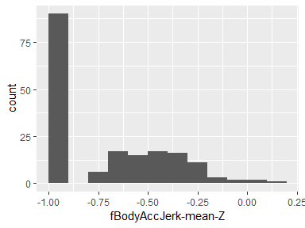

## fBodyAccJerk-std-X

|  |  |
| --- | --- |
| Feature | Result |
| Variable type | numeric |
| Number of missing obs. | 0 (0 %) |
| Number of unique values | 180 |
| Median | -0.83 |
| 1st and 3rd quartiles | -0.98; -0.25 |
| Min. and max. | -1; 0.48 |

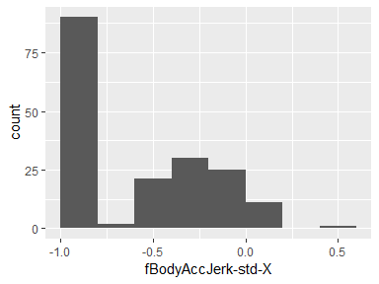

## fBodyAccJerk-std-Y

|  |  |
| --- | --- |
| Feature | Result |
| Variable type | numeric |
| Number of missing obs. | 0 (0 %) |
| Number of unique values | 180 |
| Median | -0.79 |
| 1st and 3rd quartiles | -0.97; -0.17 |
| Min. and max. | -0.99; 0.35 |

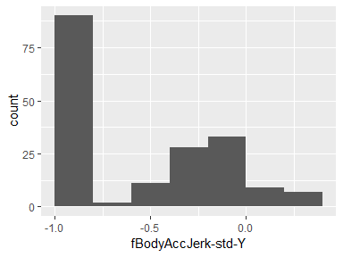

## fBodyAccJerk-std-Z

|  |  |
| --- | --- |
| Feature | Result |
| Variable type | numeric |
| Number of missing obs. | 0 (0 %) |
| Number of unique values | 180 |
| Median | -0.9 |
| 1st and 3rd quartiles | -0.98; -0.54 |
| Min. and max. | -0.99; -0.01 |

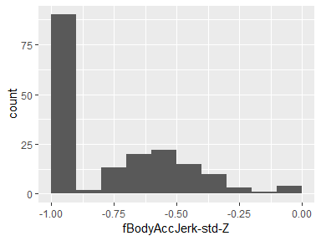

## fBodyAccJerk-meanFreq-X

|  |  |
| --- | --- |
| Feature | Result |
| Variable type | numeric |
| Number of missing obs. | 0 (0 %) |
| Number of unique values | 180 |
| Median | -0.06 |
| 1st and 3rd quartiles | -0.29; 0.18 |
| Min. and max. | -0.58; 0.33 |

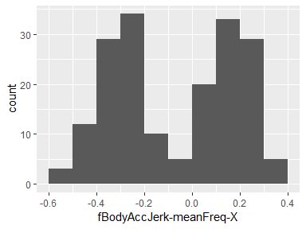

## fBodyAccJerk-meanFreq-Y

|  |  |
| --- | --- |
| Feature | Result |
| Variable type | numeric |
| Number of missing obs. | 0 (0 %) |
| Number of unique values | 180 |
| Median | -0.23 |
| 1st and 3rd quartiles | -0.4; -0.05 |
| Min. and max. | -0.6; 0.2 |

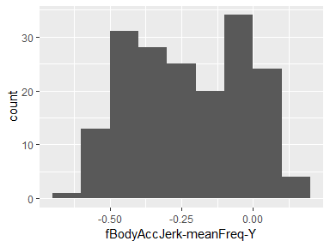

## fBodyAccJerk-meanFreq-Z

|  |  |
| --- | --- |
| Feature | Result |
| Variable type | numeric |
| Number of missing obs. | 0 (0 %) |
| Number of unique values | 180 |
| Median | -0.09 |
| 1st and 3rd quartiles | -0.31; 0.04 |
| Min. and max. | -0.63; 0.23 |

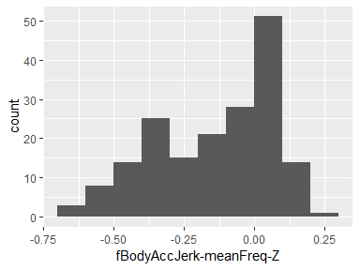

## fBodyGyro-mean-X

|  |  |
| --- | --- |
| Feature | Result |
| Variable type | numeric |
| Number of missing obs. | 0 (0 %) |
| Number of unique values | 180 |
| Median | -0.73 |
| 1st and 3rd quartiles | -0.97; -0.34 |
| Min. and max. | -0.99; 0.47 |

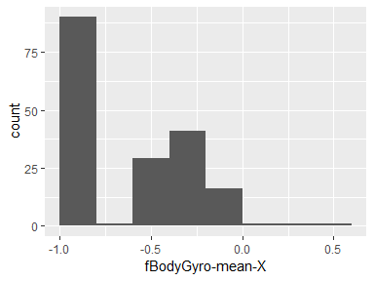

## fBodyGyro-mean-Y

|  |  |
| --- | --- |
| Feature | Result |
| Variable type | numeric |
| Number of missing obs. | 0 (0 %) |
| Number of unique values | 180 |
| Median | -0.81 |
| 1st and 3rd quartiles | -0.97; -0.45 |
| Min. and max. | -0.99; 0.33 |

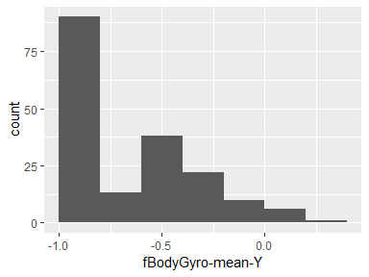

## fBodyGyro-mean-Z

|  |  |
| --- | --- |
| Feature | Result |
| Variable type | numeric |
| Number of missing obs. | 0 (0 %) |
| Number of unique values | 180 |
| Median | -0.79 |
| 1st and 3rd quartiles | -0.96; -0.26 |
| Min. and max. | -0.99; 0.49 |

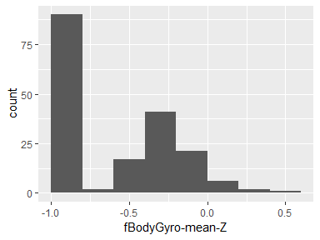

## fBodyGyro-std-X

|  |  |
| --- | --- |
| Feature | Result |
| Variable type | numeric |
| Number of missing obs. | 0 (0 %) |
| Number of unique values | 180 |
| Median | -0.81 |
| 1st and 3rd quartiles | -0.98; -0.48 |
| Min. and max. | -0.99; 0.2 |

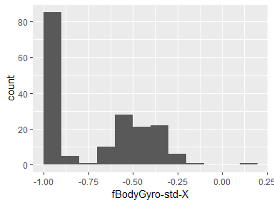

## fBodyGyro-std-Y

|  |  |
| --- | --- |
| Feature | Result |
| Variable type | numeric |
| Number of missing obs. | 0 (0 %) |
| Number of unique values | 180 |
| Median | -0.8 |
| 1st and 3rd quartiles | -0.96; -0.42 |
| Min. and max. | -0.99; 0.65 |

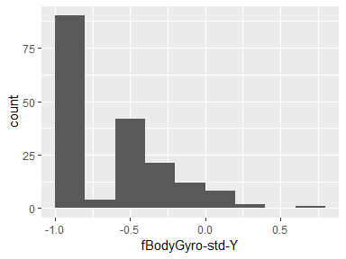

## fBodyGyro-std-Z

|  |  |
| --- | --- |
| Feature | Result |
| Variable type | numeric |
| Number of missing obs. | 0 (0 %) |
| Number of unique values | 180 |
| Median | -0.82 |
| 1st and 3rd quartiles | -0.96; -0.39 |
| Min. and max. | -0.99; 0.52 |

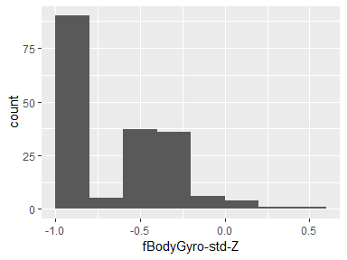

## fBodyGyro-meanFreq-X

|  |  |
| --- | --- |
| Feature | Result |
| Variable type | numeric |
| Number of missing obs. | 0 (0 %) |
| Number of unique values | 180 |
| Median | -0.12 |
| 1st and 3rd quartiles | -0.21; 0 |
| Min. and max. | -0.4; 0.25 |

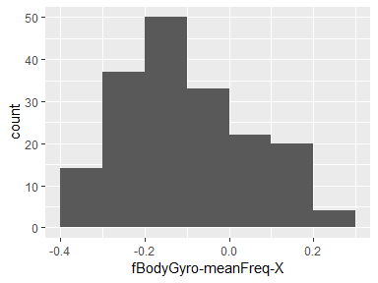

## fBodyGyro-meanFreq-Y

|  |  |
| --- | --- |
| Feature | Result |
| Variable type | numeric |
| Number of missing obs. | 0 (0 %) |
| Number of unique values | 180 |
| Median | -0.16 |
| 1st and 3rd quartiles | -0.29; -0.04 |
| Min. and max. | -0.67; 0.27 |

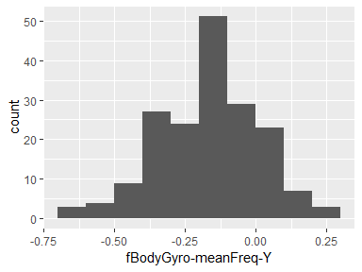

## fBodyGyro-meanFreq-Z

|  |  |
| --- | --- |
| Feature | Result |
| Variable type | numeric |
| Number of missing obs. | 0 (0 %) |
| Number of unique values | 180 |
| Median | -0.05 |
| 1st and 3rd quartiles | -0.15; 0.04 |
| Min. and max. | -0.51; 0.38 |

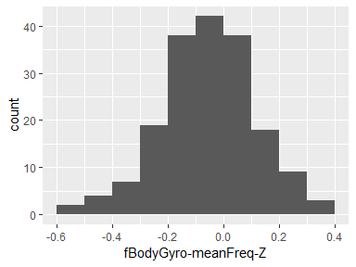

## fBodyAccMag-mean

|  |  |
| --- | --- |
| Feature | Result |
| Variable type | numeric |
| Number of missing obs. | 0 (0 %) |
| Number of unique values | 180 |
| Median | -0.67 |
| 1st and 3rd quartiles | -0.96; -0.16 |
| Min. and max. | -0.99; 0.59 |

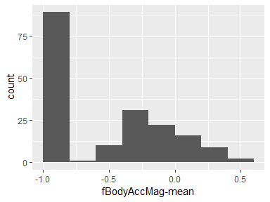

## fBodyAccMag-std

|  |  |
| --- | --- |
| Feature | Result |
| Variable type | numeric |
| Number of missing obs. | 0 (0 %) |
| Number of unique values | 180 |
| Median | -0.65 |
| 1st and 3rd quartiles | -0.95; -0.37 |
| Min. and max. | -0.99; 0.18 |

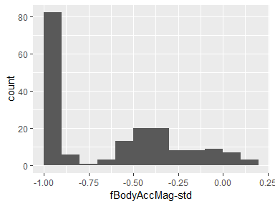

## fBodyAccMag-meanFreq

|  |  |
| --- | --- |
| Feature | Result |
| Variable type | numeric |
| Number of missing obs. | 0 (0 %) |
| Number of unique values | 180 |
| Median | 0.08 |
| 1st and 3rd quartiles | -0.01; 0.17 |
| Min. and max. | -0.31; 0.44 |

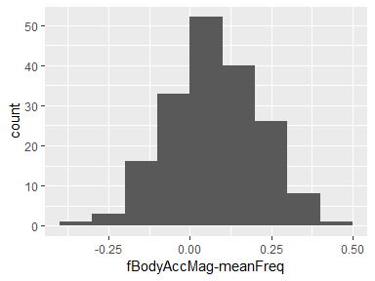

## fBodyBodyAccJerkMag-mean

|  |  |
| --- | --- |
| Feature | Result |
| Variable type | numeric |
| Number of missing obs. | 0 (0 %) |
| Number of unique values | 180 |
| Median | -0.79 |
| 1st and 3rd quartiles | -0.98; -0.19 |
| Min. and max. | -0.99; 0.54 |

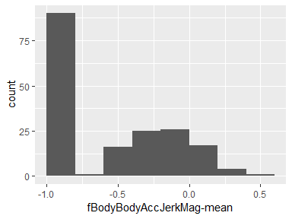

## fBodyBodyAccJerkMag-std

|  |  |
| --- | --- |
| Feature | Result |
| Variable type | numeric |
| Number of missing obs. | 0 (0 %) |
| Number of unique values | 180 |
| Median | -0.81 |
| 1st and 3rd quartiles | -0.98; -0.27 |
| Min. and max. | -0.99; 0.32 |

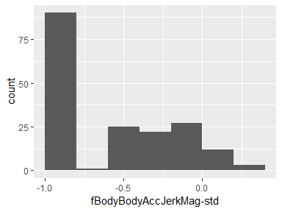

## fBodyBodyAccJerkMag-meanFreq

|  |  |
| --- | --- |
| Feature | Result |
| Variable type | numeric |
| Number of missing obs. | 0 (0 %) |
| Number of unique values | 180 |
| Median | 0.17 |
| 1st and 3rd quartiles | 0.05; 0.28 |
| Min. and max. | -0.13; 0.49 |

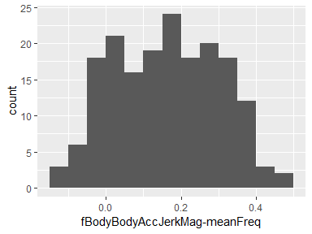

## fBodyBodyGyroMag-mean

|  |  |
| --- | --- |
| Feature | Result |
| Variable type | numeric |
| Number of missing obs. | 0 (0 %) |
| Number of unique values | 180 |
| Median | -0.77 |
| 1st and 3rd quartiles | -0.96; -0.41 |
| Min. and max. | -0.99; 0.2 |

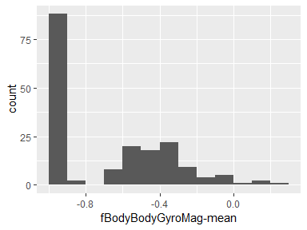

## fBodyBodyGyroMag-std

|  |  |
| --- | --- |
| Feature | Result |
| Variable type | numeric |
| Number of missing obs. | 0 (0 %) |
| Number of unique values | 180 |
| Median | -0.77 |
| 1st and 3rd quartiles | -0.95; -0.43 |
| Min. and max. | -0.98; 0.24 |

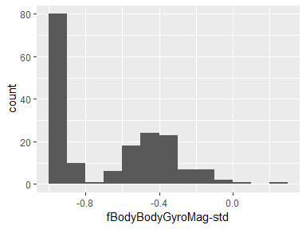

## fBodyBodyGyroMag-meanFreq

|  |  |
| --- | --- |
| Feature | Result |
| Variable type | numeric |
| Number of missing obs. | 0 (0 %) |
| Number of unique values | 180 |
| Median | -0.05 |
| 1st and 3rd quartiles | -0.17; 0.08 |
| Min. and max. | -0.46; 0.41 |

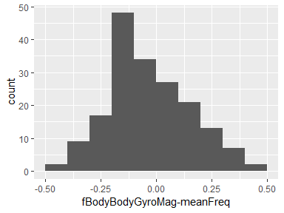

## fBodyBodyGyroJerkMag-mean

|  |  |
| --- | --- |
| Feature | Result |
| Variable type | numeric |
| Number of missing obs. | 0 (0 %) |
| Number of unique values | 180 |
| Median | -0.88 |
| 1st and 3rd quartiles | -0.98; -0.58 |
| Min. and max. | -1; 0.15 |

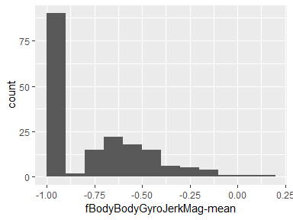

## fBodyBodyGyroJerkMag-std

|  |  |
| --- | --- |
| Feature | Result |
| Variable type | numeric |
| Number of missing obs. | 0 (0 %) |
| Number of unique values | 180 |
| Median | -0.89 |
| 1st and 3rd quartiles | -0.98; -0.61 |
| Min. and max. | -1; 0.29 |

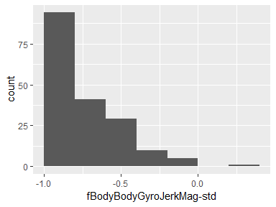

## fBodyBodyGyroJerkMag-meanFreq

|  |  |
| --- | --- |
| Feature | Result |
| Variable type | numeric |
| Number of missing obs. | 0 (0 %) |
| Number of unique values | 180 |
| Median | 0.11 |
| 1st and 3rd quartiles | 0.05; 0.21 |
| Min. and max. | -0.18; 0.43 |

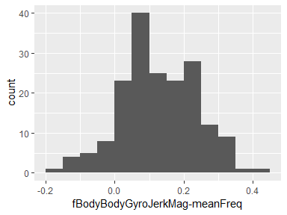

Report generation information:

* Created by Allie Xiong (username: allie).
* Report creation time: Sat Jun 15 2019 19:06:17
* Report was run from directory: C:/MyDocuments/ProfessionalDevelopment/TechnicalSkillDevelopment/DataScience/JohndHopkinsUniversity_DS_program/C3_Getting_n_cleaning_data/Lab_assignment
* dataMaid v1.3.0 [Pkg: 2019-06-07 from CRAN (R 3.6.0)]
* R version 3.6.0 (2019-04-26).
* Platform: x86_64-w64-mingw32/x64 (64-bit)(Windows 10 x64 (build 17134)).
* Function call: makeDataReport(data = data.set2, mode = c("summarize", "visualize", "check"), smartNum = FALSE, file = "codebook_data.set2.Rmd", checks = list(character = "showAllFactorLevels", factor = "showAllFactorLevels", labelled = "showAllFactorLevels", haven_labelled = "showAllFactorLevels", numeric = NULL, integer = NULL, logical = NULL, Date = NULL), listChecks = FALSE, maxProbVals = Inf, codebook = TRUE, reportTitle = "Codebook for data.set2")