**Kickstart My Chart Analysis**

**Background**

Over $2 billion has been raised using the massively successful crowdfunding service, Kickstarter, but not every project has found success. Of the more than 300,000 projects launched on Kickstarter, only a third have made it through the funding process with a positive outcome.

Getting funded on Kickstarter requires meeting or exceeding the project's initial goal, so many organizations spend months looking through past projects in an attempt to discover some trick for finding success.

**Objective**

Analyze a database of 4,000 past projects in order to uncover any hidden trends.

**Conclusions**

1. **Given the provided data, what are three conclusions we can draw about Kickstarter campaigns?**

Kickstart projects has a successful (54%) rate compared to a failed (36%) rate. The three categories that have the highest success rates are: music (77%), film & video (62%), and theater (58%), which is greater than the average successful rate of all projects (54%). Food (20%), games (35%), and publishing (39%) have the lowest success rate. One more thing to note is technology projects have a 1/3 chance each of being successful, failed or canceled.

Next, looking into the individual forty sub-categories, we can see many 100% successful projects: classical music, documentary, electronic music, hardware, metal, nonfiction, pop, radio & podcasts, shorts, small batch, tabletop games, and television. As well, there are many 100% failed projects in animation, children’s book, drama, gadgets, jazz, mobile games, nature, people, places and restaurants. Plays is the most popular sub-category. It has 65% successful rate and holds 26% of the all the projects.

Finally, successful projects start to increase in the Spring from March and peaks mid-May. Then it declines rapidly in the Summer months until September. It increases again for a month before it levels out and decline again until the month of December when the successful and failed lines intersect and the failed project count is greater than successful. Since theater has the largest number of projects by far, if the theater category is filtered, February has the highest number of success. The season also seem to affect success rate.

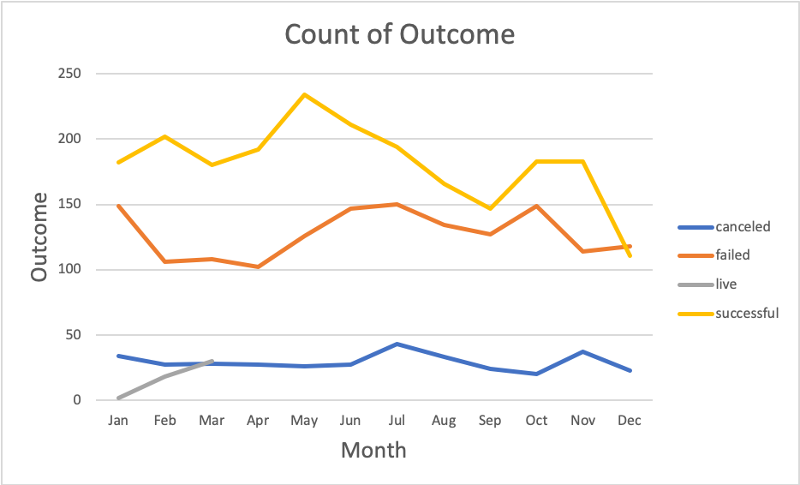

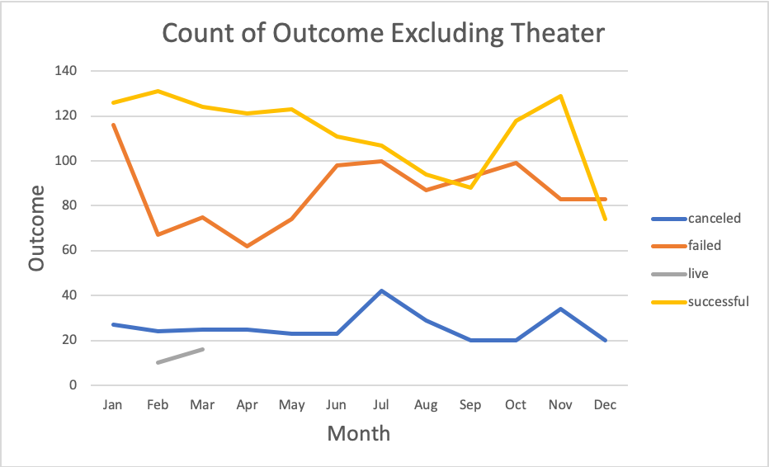

1. **What are some limitations of this dataset?**

The dataset is that it is not big enough. It is only a subset of the real Kickstarter dataset. In the background homework assignment instruction, it mentioned that ‘only a third have made it through the funding process with a positive outcome’ but my result shows that 54% of projects are successful. My prediction would be more accurate if I had the whole dataset of Kickstarter.

The dataset does not have information about the perks for backers. This would be an incentive for backers when they are considering whether to back up a project and pledge amount.

It would be interesting to know the timeline and location of the projects.

1. **What are some other possible tables and/or graphs that we could create?**

Perks are important in the Kickstarter campaigns. A graph to study the relationship between backers and perk affects pledges. A graph showing whether perks varies by categories and its success rates.

A graph showing the average percentage of overfunded projects by category. A chart showing the duration and location of projects.

A chart table display showing the timelines the creators have to complete the campaign: state, goal, pledge, average donation, date created conversion, date end conversion