# **Soil Microbiome Beta, Taxonomic and Functional Diversity in British Columbian Logged Douglas-fir Stands Differs Across the A and O Horizon**

Jas Aujla, Anu Chauhan, Ally Howard, Fatima Nadeem, Vera Pu

*Department of Microbiology and Immunology, University of British Columbia, Canada*

**ABSTRACT**

Soil bacterial composition varies based on a wide variety of factors and is responsible for much of soil nutrient cycling. To date, the correlations between these communities and different soil layers or horizons are not well studied. There is also limited knowledge of whether logging impacts the microbial communities in soil. We investigated the top two organic soil layers, the A horizon and O horizon, in sites of logged British-Columbian Douglas-fir trees and their correlations with microbial diversity. We investigated microbial diversity through alpha, beta and core microbiome analyses. Additionally, we aimed to characterize the microbiota through indicator taxa analysis and PICRUSt2 analysis to determine specific taxonomic and functional differences between the horizons. Alpha diversity analyses indicated no significant differentiations across the A and O horizons, whereas, beta diversity analyses indicated significant clustering within each respective horizon. Furthermore, core microbiome investigations revealed some overlap at the genus level along with significantly greater taxonomic diversity in the O horizon. Indicator taxa analysis also revealed significant differences in the top indicator taxa for each horizon, which was further supported by the functional pathway analysis performed downstream: 407 MetaCyc functional pathways, including the ‘incomplete reductive TCA cycle’ pathway involved in nutrient cycling, were also significantly differentially abundant between horizons, indicating distinct functional niches. These results affirm the clear differences between the microbial diversity and community composition in the A and O horizons, indicating the need for more microbial diversity research regarding horizon depth and logged soil. This will hence improve our understanding of microbial community formation and the potential impact of environmental and human-made factors.

**INTRODUCTION**

Initiated in 1989, the Long-term Soil Productivity (LTSP) Study has aimed to quantify site productivity, measured by the growth capacity in volume for a given tree species, on timber harvesting land based on soil profiles (1, 2). Soil composition influences forest productivity and, in turn, affects climate stability, biodiversity, and economic development (3, 4). Industrial harvesting of coniferous forests alters the local soil communities and the intensity of organic matter removal (1, 3, 4). To better understand the changes in soil microbiomes post timber harvest, and provide a baseline for future LTSP studies, Wilhelm et al. collected 724 16S bacterial samples between 2008 and 2014, in regions preceding a post-logging period of 11-17 years (1). A total of 18 sites were sampled to determine the LTSP in six predetermined coniferous ecozones of North America based on dominant tree type (1). One of these tree types is the Douglas-fir, a large evergreen conifer native to Western North America and one of the most important timber trees of this region (5).

The data collected during the LSTP study has since been applied as a baseline in further investigations done by the original authors, now addressing the specific effects and changes within soil microbial communities in timber harvesting regions (3, 4, 6, 7, 8). Additionally, the dataset has been implemented in downstream studies to further examine various physical, chemical, and biological measures related to microbial diversity in the reforested sites in North America (9, 10, 11, 12, 13). These studies expand on some of the main factors which play a role in soil biodiversity, which could in turn be used to better reforestation strategies in timber harvesting areas. There is, however, a lack of focus on soil horizon data, which is a key factor in distinguishing microbial composition between the layered soil niches.

A vertical cross-section of soil reveals layers, otherwise known as soil horizons (14). Of the six master horizons (Fig. 1), Wilhelm et al. collected samples from the O horizon via trowel, along the atmospheric exposed soil, and A horizon via Stoney auger, 20 cm into the topsoil (1). As shown in Fig. 1, the O horizon is the top organic layer and forms continuously over 6-12 months (15, 16). The humus, otherwise known as the A horizon, lies just beneath this top layer and can take anywhere from a mere 25 years, to thousands of years to regenerate (17). Due to the direct atmospheric contact, the proximity to the logging event, and the differences in horizon formation rates, the O horizon soil composition will have changed dramatically post-logging, whereas the A horizon soil would not have had time to change. Therefore, the elemental composition of the A horizon soil may bear more similarity to the pre-logging or pre-timber harvesting conditions.

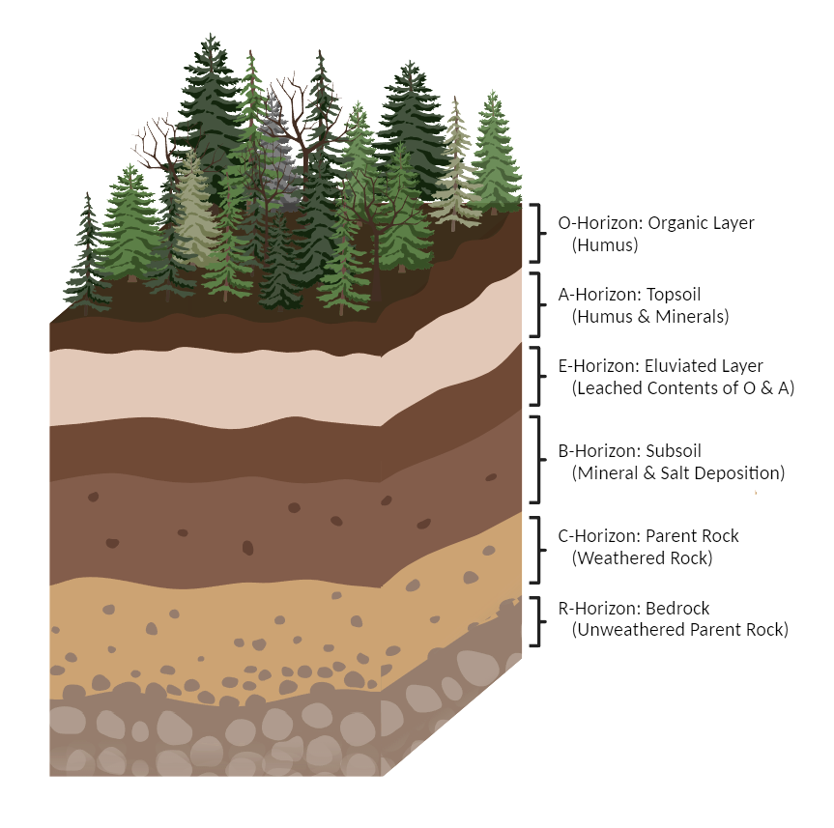

**FIG. 1** **Soil profile**. Distinct layers (horizons) of coniferous soil.

Different soil horizons exhibit varying physical and chemical properties, such as pH and nutrient content, creating distinct niches that influence microbial communities (13). The microorganisms in forest soil impact nutrient cycling within that system and could play an essential role in the conservation and restoration of logged environments (18). With this information, environmental scientists can assess the health of forest ecosystems and farmers may utilize it as a predictor for crop selection and planting practices (17). While significant differences in taxonomy and function have been observed in the microbiomes of various soil horizons in a tundra environment (14), there has been a scarcity of investigations pertaining to the microbiota inhabiting soil horizons in temperate regions like the Douglas-fir ecozones of BC. Furthermore, these parameters have also not been thoroughly studied in sites where there has been previous clear-cutting for timber harvesting. Organic matter removal at these sites has significant impacts on the composition and depth of the soil horizons (6) and therefore the lack of studies on the microbial communities of these environments post-logging represents a significant knowledge gap.

Yarwood et al. (18) also suggest that the microbial content of the soil in Douglas-fir stands may exhibit correlations with tree growth rates. Therefore, it is crucial to understand how logging practices impact these populations and how they could lead to improvements in forest management and more effective reforestation initiatives following timber harvesting. Due to the necessity of specific soil conditions for microbial growth, and the different compositions of the A and O horizons, we hypothesize that there will be significant variability in the taxonomic and functional profiles of the respective soil ecosystems. Our objective is to utilize the dataset provided by Wilhelm et al. (1) to investigate these potential differences in previously logged Douglas-fir stands. By doing so, we aim to provide an analysis of microbial profiles at different soil depths which can then pose as a baseline for further investigations into the role of the soil microbiome as reforestation continues.

**METHODS**

**Forest Soil Microbiome Data.** The dataset contained a collection of samples from eighteen reforested sites from six North American ecozones from the LTSP Study (1). Of these sites, we focused on the interior Douglas-fir biogeoclimatic zone (IDFBC), which predominantly housed the native interior Douglas-firs. For many of the 16s rRNA gene amplicon and whole shotgun sequencing libraries, samples were collected from five soil horizons and then distinguished using the Canadian Systems of Soil Classification. Further sample collection details can be found in the paper published by Wilhelm et al. Amplicon libraries were prepared for the 16s rRNA gene (V1-V3 regions). 697 samples were available from the original dataset including all of the sampled ecozones. Filtration of the original dataset to include only the IDFBC ecozone produced a readout of 150 samples which were then downloaded to be used in our study.

**Preliminary QIIME2 Processing.** The QIIME2 DADA2 software package was used to denoise our dataset to correct Illumina-sequenced amplicon errors (19, 20). The classifier was trained by aligning the sequences to reference 16S rRNA V1 and V3 regions. The forward primer used was AGAGTTTGATCMTGGCTCAG, and the reverse primer used was GWATTACCGCGGCKGCTG. The sequences were then truncated to 410 base pairs (bp) and a feature table containing the amplicon sequence variants (ASVs) for the BC Douglas-firs was generated.

**Alpha and Beta Diversity Metrics based on Horizons.** Alpha and beta diversity metrics were conducted through RStudio 2023.09.0 to determine species richness and diversity. Data wrangling was performed in R using the ‘tidyverse’, ‘vegan’, ‘phyloseq’, ‘ggplot2’, and ‘ggpubr’ packages (21, 22, 23, 24, 25). A rarefaction depth of 4092 sequence reads per sample was chosen which retained 216 samples as well as 50.19% of the total ASVs. To determine species richness, the Shannon's diversity index was employed specifically looking at horizon type as the factor (26). To determine the significance of this alpha diversity test, a Wilcoxon test was conducted (27). Beta diversity was evaluated using the weighted Unifrac and unweighted Unifrac metrics to incorporate phylogenetic distance (28). Principal Coordinate Analysis (PCoA) plots were then generated based on these analyses. Significance of these beta diversity plots were then determined via PERMANOVA (29).

**Indicator Species Analysis.** Data wrangling was performed in RStudio 2023.09.0 using the ‘tidyverse’, ‘dplyr’, ‘phyloseq’, ‘vegan’, ‘ape’, and ‘indicspecies’ packages (21, 30, 23, 22, 31, 32). The indicspecies package was used to perform an indicator species analysis to identify genera that are most uniquely associated with a single soil horizon. The sequencing data was agglomerated to the genus level to give insight into the lowest annotated taxonomic level. Reads were then converted to relative abundance, using filtration measures of 0.001 abundance and 0.1 prevalence. Thus, the ASV’s would be present in the designated horizon with at least 0.1% abundance, and found in at least 10% of the samples. Once everything was in place, the indicator species analysis proceeded following the execution of the ‘multipatt’ command with 999 permutations (‘nperm’ = 999) (33, 34). The mean relative abundances per horizon of each indicator taxon were visualized as a bubble grid chart.

**Determine Taxon Abundance using Core Microbiome.** Core Microbiome (35, 36) was conducted through RStudio 2023.09.0 to visually elucidate the shared and unique genera within the A and O horizon groups. Taxonomic counts were agglomerated to the genus level using tax_glom(). Subsequently, the dataset was filtered to include one predictor variable, denoted as the soil horizon, to represent the different soil layers. The core microbiome analysis was executed with the core_members() function, specifying a detection threshold of 0.0001 and a prevalence threshold of 0.1 to identify robust and prevalent microbial taxa across the groups. Finally, genera that were prevalent in each horizon were compared using a Venn diagram (37).

**Functional Analysis using PICRUSt2.** The picrust2_pipeline.py command from the PICRUSt2 QIIME2 plugin was employed to understand the metabolic pathways utilized by microorganisms in different horizons. PICRUSt2 uses marker gene data such as 16s rRNA to infer functional profiles by matching the sequences against a precomputed reference genome. Differential abundance was performed on the MetaCyc data using the ggpicrust2 package, pathway_daa() with daa_method = DESeq2. Pathways were annotated using pathway_annotation() and filtered for only significant results with adjusted p-value ≤ 0.05. The PCA plot was generated using the ggpicrust2 package pathway_pca(). The bar plot was generated with a modified version of the pathway_errorbar() function which implemented an adjusted p-value cut off of ≤ 0.05 and an absolute log 2 fold change cut off of 0.58 which represents a 50% increase or decrease in abundance.

All scripts and visualizations can be viewed at <https://github.com/allyhoward/micb475.git>

**RESULTS**

**A and O Horizon microbial samples are more similar to themselves than they are to the opposing horizon.** The biodiversity of the niche at each horizon was evaluated. The alpha diversity Shannon box plot illustrates no significant differences between the species richness of the A and O horizons (Fig. 2A). The Wilcoxin test confirms this absence of significance with a p-value of 0.17. Two beta diversity PCoA plots, Weighted (Fig. 2B) and Unweighted (Fig. 2C) Unifrac analysis show that the samples cluster strongly within their respective horizons and therefore suggest that these are distinct from one another. These differences are also demonstrated to be significant as seen by PERMANOVA which returned a p-value < 0.001. Furthermore, comparing the two PCoA plots, the weighted Unifrac analysis, with an F-value of 3.958, indicatesthat sample clustering is weaker when considering relative abundance compared to the unweighted analysis which considers only absence and presence. In the unweighted analysis, the F-value is 1.2999, suggesting slightly less statistical significance.

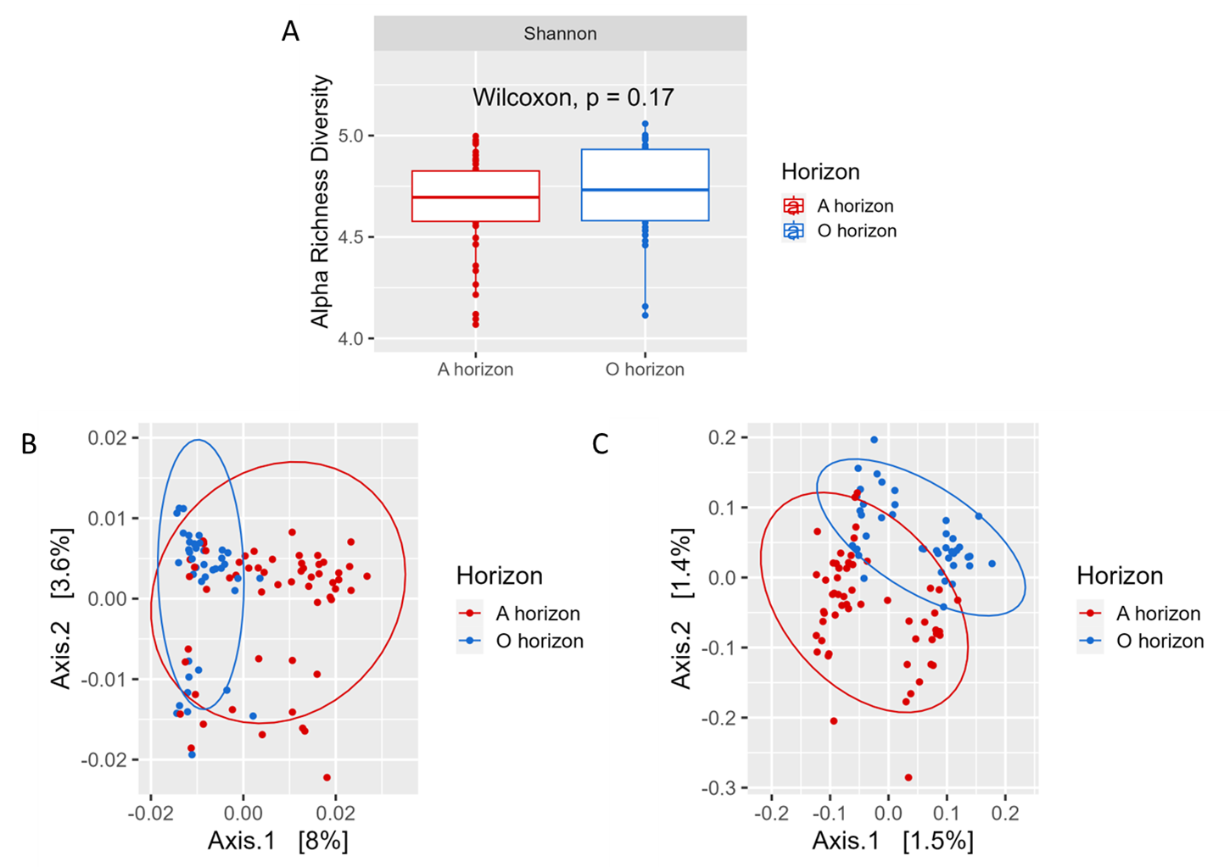

**FIG. 2 Alpha and Beta Diversity Analysis at A and O Horizons.** (A) No significant alpha diversity patterns across the two horizons. Y axis denotes Shannon’s diversity index. Wilcoxon test was conducted to test significance, p-value = 0.17. (B) Weighted Unifrac and (C) Unweighted Unifrac PCoA plots. The red ellipses encompass A horizon samples that cluster together, and the blue ellipses show the O horizon sample clustering with a 95% confidence interval for the t-distribution of points within each group. PERMANOVA significance was evaluated at p-value < 0.001.

**The O Horizon exhibits a greater proportion of microbiome diversity.** In the Venn diagram (Fig. 3) illustrating the microbial composition of the A and O horizons, an overlap was observed between the two horizons. This indicates substantial similarity in the microbial composition at the genus level, showcasing a degree of continuity or shared ecological niches within the soil layers of the Douglas-fir stand environment. The higher proportion shown in the O horizon also highlights that this soil layer harbours a greater number of unique microorganisms than the A horizon.

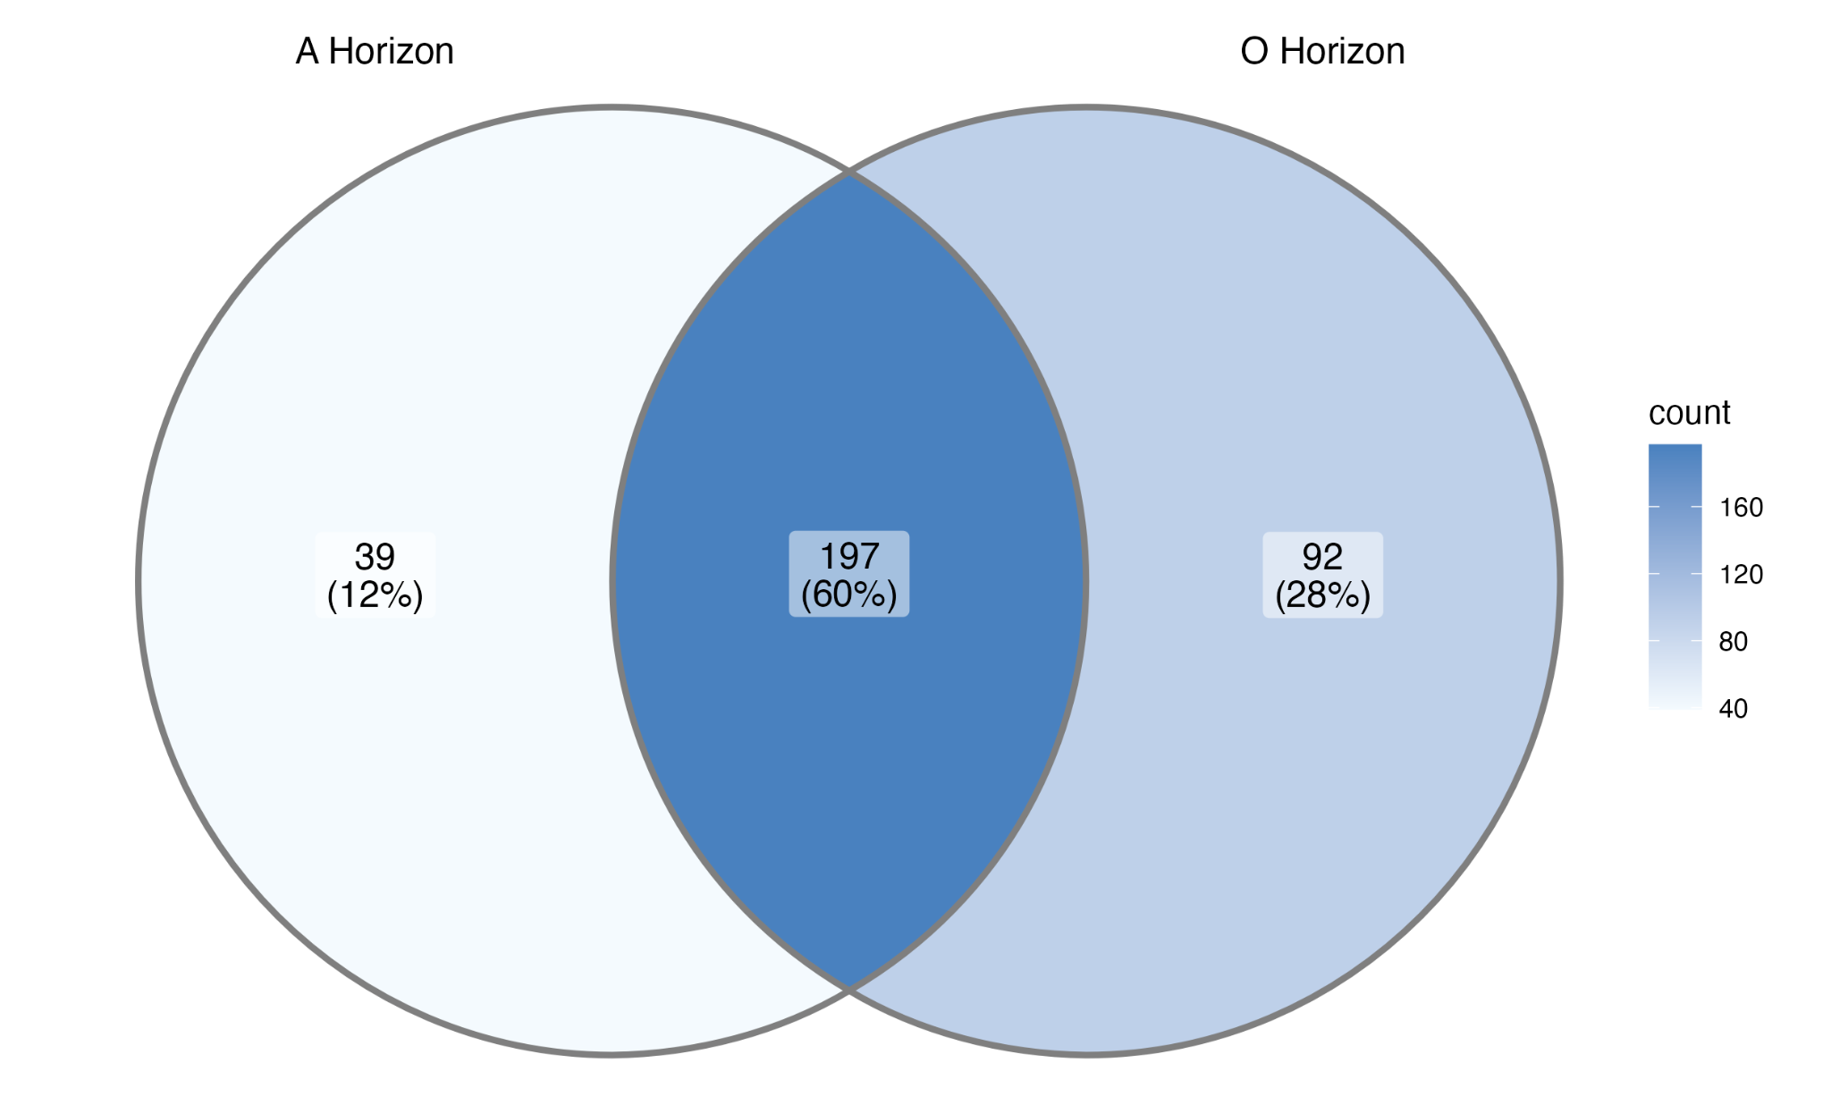

**FIG. 3 Core microbiome of the A and O horizons at the genus level.** A detection threshold of 0.0001 and a prevalence threshold of 0.1 was employed to identify the key organisms of each horizon. The A horizon constitutes 12% of the total population, whereas the O horizon makes a more substantial contribution at 28%, indicating a more diverse and distinct makeup of the microbiome in this soil layer compared to the A horizon. Notably, 60% of the core taxonomic group were shared between these two horizons, emphasizing the presence of significant core microbial communities that are common to both.

**A large number of indicator taxa are abundant in one soil horizon only**

An indicator taxa analysis at the genus level showed a significant difference in the microbial composition of each horizon. The data was filtered to visualize results surpassing an indicator value of 0.8 to select genera with a high relative abundance and frequency that suggests the genus are likely to be indicator species for the respective horizons. 8 genera were produced that were indicative of the O horizon and 12 genera that were indicative of the A horizon. The large number of indicator taxa that are significantly different between the two horizons suggests the horizons act as separate ecological niches. While the A horizon had a greater number of readouts for the conditions set (*IV > 0.8 & p-value = 0.001*), only 4 of the 12 genera were classified, whereas, the rest were unknown or uncultured. Contrastingly, all genera from the O horizon belonged to a known genus, suggesting that microorganisms collected from deeper horizon depths are not as well studied.

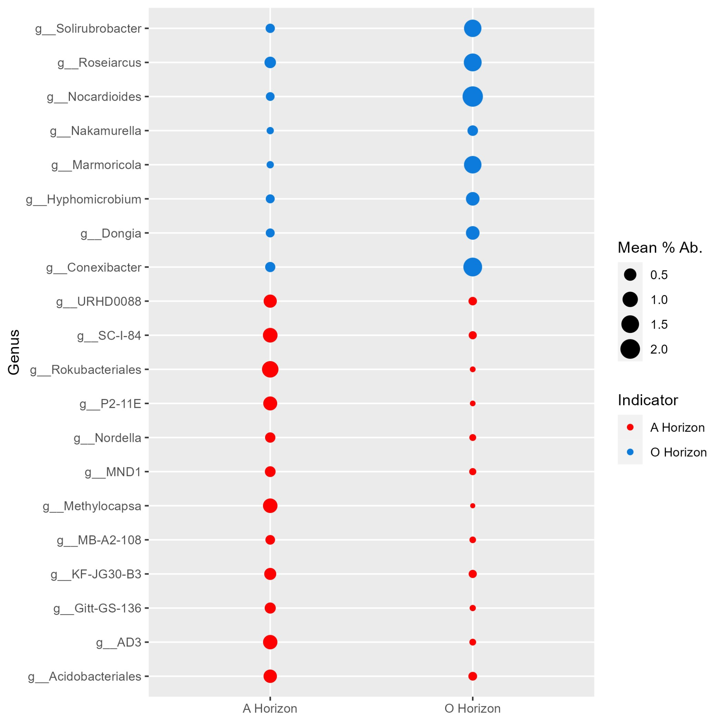

**FIG. 4 A large number of indicator taxa are abundant in one soil horizon only.** Indicator taxa analysis shows the mean percent abundance (illustrated by dot size) of genera in the A and O horizons with an indicator value of at least 0.8 and a p-value of 0.001 for samples in each respective horizon. Dot colour is representative of the horizon each genus is an indicator for.

A and O horizon soil microbiomes represent distinct functional communities **and are more functionally similar to themselves than to each other.** Principal Component Analysis (PCA) of the predicted MetaCyc functional data for each horizon showed clear clustering within the A horizon and the O horizon, but little overlap between the two horizons. This indicates greater similarity in functionality among samples in the same horizon than between horizons (Fig. 5).

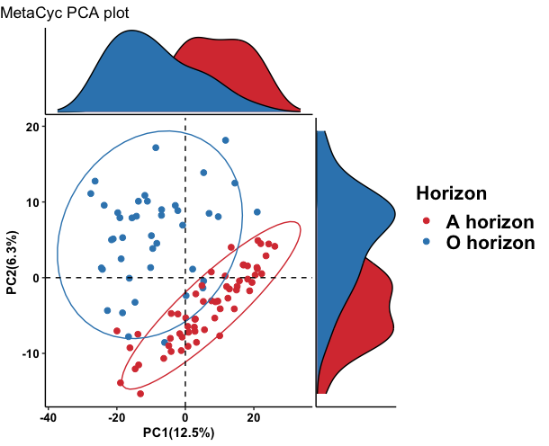

**FIG. 5 Functional pathways cluster within A and O horizons but are significantly different between horizons.** PCA ordination of MetaCyc pathways present in the A and O horizons generated with PICRUSt2. Samples are coloured by horizon.

The differences in these functional profiles were further explored and visualized in Fig. 6 using a bar plot to show direct comparisons in representation between MetaCyc predicted pathways. There were 407 significant (adjusted p-value< 0.05) differentially abundant pathways among our 103 samples. Of these, 20 pathways had log2 fold changes of ≥ 0.58. Five of these pathways were over-representedt in the A horizon and 15 were more greatly over-represented in the O horizon. These results show that the microbiomes of the A and O horizons act with functional profiles that are very different from each other.

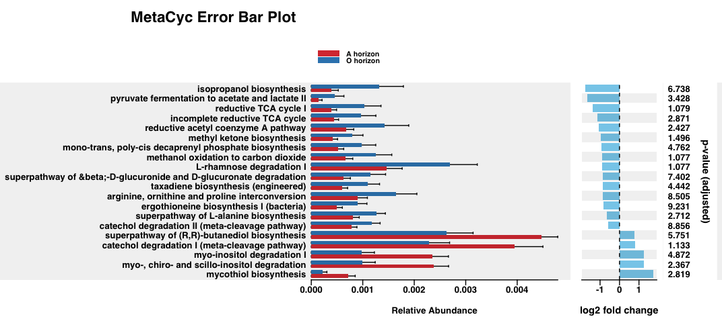

**FIG. 6 Functional pathways are significantly differentially abundant between A and O horizons.** Bar plot showing the top 20 most differentially abundant pathways between horizons based on predicted MetaCyc pathways. All pathways shown have significant adjusted p-value < 0.05 and log2 fold change abundances of at least ± 0.58. Positive log2 fold change indicates higher abundance of the pathway in the A horizon and negative log2 fold change indicates higher abundance of the pathway in the O horizon.

**DISCUSSION**

The microbial richness and evenness within the A and O horizons are similar to one another, however, the taxonomic diversity across these horizons is quite different. Beta diversity suggests that each horizon is a specific niche, and although the core microbiome analysis shows these niches have around the same number of taxa, the actual overlap of genera is quite small. Strong niche differentiation and little overlap suggests that the roles these bacteria may play in their respective communities are unique to each horizon. Conversely, the core microbiome illustrates a major overlap between the two horizons. The O horizon also contains more unique genera, aligning with the notion that the layer contains the newest organic material which constitutes a diverse makeup that changes when interacting with a dynamic environment. Many bacterial taxa from the O horizon would most likely, therefore, not survive in the A horizon community. Such niche differentiation is supported by previous findings (38). Both horizons are very rich, which is expected of a soil microbiome, but they differ greatly in which microorganisms they attract (39). Because of the heterogeneity of soil, it has the niche variety necessary for many forms of life, but differing physical, chemical, and biological conditions between the layers seem to exclude different taxa. However, it is noteworthy that previous research in microbial diversity across horizons has found results that are in contrast to our findings. Luo et al. (2023) showed a significant increase in species richness in the O horizon and no significant differences in beta diversity (40), however, data was collected on unlogged forests. These differing results could suggest that logging is a significant factor in horizon research and greatly alters microbial diversity, and thus community structure and composition, but further investigation is required.

The A and O horizons in British Columbia Douglas-fir stands exhibit distinct ecological niches that attract specific bacteria which are more suited to their respective conditions. The functional profiles of the microbiomes at different horizons exhibit differences in nutrient cycling and soil pH which may impact Douglas-fir growth rates (41). We sought to determine the composition of the A and O soil horizons of BC Douglas-fir trees with respect to indicator taxa generated, while also correlating results to the functional differences exhibited by these niches. To investigate this, we evaluated the top indicator species from each horizon. Of the classified genera in the A horizon, the functional properties were linked to general metabolic activity, such as the substrate oxidations and dissimilation reactions required by the bacteria for survival, while (most) of the bacteria in the O horizon had functional roles associated with nutrient cycling and environmental interactions in addition to their metabolic roles. The top 2 bacterial taxa indicative of the A horizon are the genera *Rokubacteriales*, which is functionally associated with alcohol cycling in wetlands, and *Methylocapsa*, which acts as a methane-oxidizing bacteria (42, 43). Each of these two bacteria thus has unique metabolic roles. On the other hand, the 3 most abundant genera in the O horizon were *Nocardioides*, which has been shown to play a role in ecological nutrient cycling and chitin degradation (44, 45, 46), *Conexibacter*, which engages in the nitrification process in oxygen-limiting states (47), and *Marmoricola*, which is shown to improve the antifungal activity of soil (48, 49).

Furthermore, a large number of functional pathways were differentially abundant between the A and O horizons in these Douglas Fir stands. In the O horizon, the relative abundance of the ‘incomplete reductive TCA cycle’ and ‘reductive acetyl coenzyme A’ pathways are significantly greater than in the A horizon. These pathways are important to autotrophic organisms such as *Chlorobium* and can contribute to carbon and nitrogen cycling in the soil, which is essential to plant growth (50). The increased abundance of these pathways in the O horizon is likely due to the organic matter layer having greater access to sunlight allowing for the colonization by these autotrophic bacteria. Similarly, the O horizon had a higher abundance of organisms with the ‘L-rhamnose degradation I’ and ‘superpathway’ beta-D-glucuronide and D-glucuronate degradation’ metabolic pathways which are characteristic of plant matter degradation (51). Again, the organic layer is more likely to contain new plant matter and therefore would provide another source of nutrient cycling. This plant matter could be acting to attract taxa such as the indicator *Nocardioides* which uses L-rhamnose as a carbon source.

In the A horizon, one pathway of note is the ‘Superpathway of (R, R)-butanediol biosynthesis’ which is indicative of acid production by lactic acid bacteria (LABs) and could be a component of alcohol cycling by the indicator *Rokubacteriales*. Past studies have shown that more acidic conditions can be beneficial to the growth of Douglas-firs (52), while other studies have shown the benefit of LAB in association with other plants (53). It is possible that these pathways are creating soil conditions of lower pH that can improve the growth rate of Douglas-firs in this area. Additionally, the ‘myo-inositol degradation I’ pathway, which is essential to nitrogen-fixing bacteria, especially in association with the rhizosphere of plants (54), is also more abundant in the A horizon. The significant differences between the functional profiles of these horizons could simply be a factor of natural variation in environmental conditions, but since timber logging occurred between the formations of the O horizon and A horizon, they may also be an indicator that logging drastically impacts the soil microbiome. One piece of evidence that supports the second theory is another article by Wilhelm et al. that showed that organic matter removal due to timber logging did have significant impacts on the soil composition at different horizons (6). Additionally ‘catechol degradation’ pathways were present in both the A and O horizons (‘catechol degradation I’ in the A horizon and ‘catechol degradation II’ in the O horizon). Catechol is an environmental pollutant and is present in polycyclic aromatic hydrocarbons (PAHs) which are one of the primary components of diesel (55, 56). Aside from CO2 emissions, diesel spills are one of the primary sources of pollution in timber harvesting camps (57) and could account for this increase in catechol degradation. Although from this study we are unable to conclude correlation to logging, this could be an avenue for future research. .

**LIMITATIONS**.

The lack of a pre-logging baseline of soil samples limited the depth of interpretation that our results could support in this study. Due to this limitation we were unable to easily extrapolate our results to a strong correlation with logging. Another limitation of this study was the possibility of soil mixing between the A and O horizons caused by the movement of timber harvesting equipment in this area (58). This could mean that the soil horizons are not as clearly defined as in an environment with little disturbance. Additionally, our focus on the British Columbian Douglas-fir ecozone limits the extrapolation of our results, which cannot be applied to similar timber harvesting sites in locations outside of British Columbia, nor to timber harvesting sites for different tree species.

**CONCLUSIONS AND FUTURE DIRECTIONS**

The microbiomes of the A and O horizons are significantly different from one another, both taxonomically and functionally. This is evidenced by distinct horizon clustering in weighted and unweighted Unifrac analysis, with the O horizon possessing a greater proportion of the microbial taxa in regards to the genus level, and both horizons exhibiting large numbers of significantly distinct indicator taxa. Additionally, a number of differentially expressed bacterial genera and pathways between the two horizons have roles in nutrient cycling which may have impacts on Douglas-fir growth. Future research should thus aim to incorporate horizon depth and classification when investigating soil microbial communities. Furthermore, currently, our results are limited to British Columbian Douglas-firs and with microbial data present only post-logging. Future research should consider different tree covers across different sites to investigate a possible significant effect based on the horizon. Additionally, collecting samples from the same site pre and post-logging could help to establish a stronger causal relationship across patterns observed with microbial diversity and differing horizons. Similarly, we suggest collecting samples at varying intervals of depth and across multiple horizons. Investigating the differences in diversity with these metrics would determine if similar results are found, and once more increase the possibilities of determining causal relationships with horizon type. Such research would help to gain insights into the role of soil microbiomes as reforestation continues.

**ACKNOWLEDGEMENTS**

Many thanks to Dr. Sun and Avril Metcalfe-Roach for their continuous support throughout the research journey, Dr. Wilhelm et al. for providing the data, Joey711 for all the coding troubleshooting, and all our dedicated teammates for their hard work and collaboration!

**CONTRIBUTIONS**

Ally contributed to all methods, results and discussion relating to PICRUSt2 analysis and helped with the introduction. Anu contributed to the introduction, and all methods and discussion relating to Indicator Species Analysis. Fatima contributed to all methods, results and discussions relating to alpha and beta diversity analysis. Jas contributed to all results and discussion relating to Indicator Species Analysis, and references. Vera contributed to all methods, results and discussion relating to Core Microbiome, and acknowledgements. Everyone proofread and edited one another’s works.

**REFERENCES**

1. Wilhelm RC, Cardenas E, Leung H, Maas K, Hartmann M, Hahn A, Hallam S, Mohn WW. 2017. A metagenomic survey of forest soil microbial communities more than a decade after timber harvesting. Scientific Data 4:170092.
2. S. Berch, C. Bulmer, M. Curran, W. Chapman, G. Hope, R. Kabzems. 2019. Long-term Soil Productivity Study: the Effects of Soil Compaction and Organic Matter Retention on Long-term Soil Productivity in British Columbia (EP1148): Updated Establishment Report. Government of BC.
3. Cardenas E, Kranabetter JM, Hope G, Maas KR, Hallam S, Mohn WW. 2015. Forest harvesting reduces the soil metagenomic potential for biomass decomposition. The ISME Journal 9:2465–2476.
4. Hartmann M, Howes CG, VanInsberghe D, Yu H, Bachar D, Christen R, Henrik Nilsson R, Hallam SJ, Mohn WW. 2012. Significant and persistent impact of timber harvesting on soil microbial communities in Northern coniferous forests. The ISME Journal 6:2199–2218.
5. Government of British Columbia. Douglas-fir. Government of British Columbia.
6. Wilhelm RC, Cardenas E, Maas KR, Leung H, McNeil L, Berch S, Chapman W, Hope G, Kranabetter JM, Dubé S, Busse M, Fleming R, Hazlett P, Webster KL, Morris D, Scott DA, Mohn WW. 2017. Biogeography and organic matter removal shape long-term effects of timber harvesting on forest soil microbial communities. The ISME Journal 11:2552–2568.
7. Leung HTC, Maas KR, Wilhelm RC, Mohn WW. 2016. Long-term effects of timber harvesting on hemicellulolytic microbial populations in coniferous forest soils. The ISME Journal 10:363–375.
8. Wilhelm RC, Cardenas E, Leung H, Szeitz A, Jensen LD, Mohn WW. 2017. Long-Term Enrichment of Stress-Tolerant Cellulolytic Soil Populations following Timber Harvesting Evidenced by Multi-Omic Stable Isotope Probing. Frontiers in Microbiology
9. Chen X, Nguyen J, Chan R. 2021. Annual precipitation and soil moisture level strongly associate with the bacterial community structure in Interior Douglas-fir and Sub-Boreal Spruce ecozones in British Columbia. UJEMI+. 7:1-12.
10. An S, Gill P, Park B, Williams C. 2021. Weak correlations between soil properties and bacterial diversity at reforested sites in North America. UJEMI. 26:1-10.
11. Burckhardt J, Dorner A, Breden C, Liang D. 2021. Differences in organic matter removal treatments do not influence soil microbial diversity in British Columbia managed forests. UJEMI. 26:1-13.
12. Pitblado M, Kowalski S, Vaz E, Wilson A. 2021. Soil abiotic factors are not consistently associated with microbial diversity or organic matter removal intensity in regions of long-term reforestation. UJEMI. 26:1-13.
13. Gawol D, Nichvolodoff T, Floyd R. 2022. Carbon to nitrogen ratios influence microbial diversity in the soil of interior Douglas-fir forests in British Columbia. UJEMI. 27:1-12.
14. Hartemink AE, Zhang Y, Bockheim JG, Curi N, Silva SHG, Grauer-Gray J, Lowe DJ, Krasilnikov P. 2020. Chapter Three - Soil horizon variation: A review, p. 125–185. *In* Sparks, DL (ed.), Advances in Agronomy. Academic Press.
15. Tripathi BM, Kim1 HM, Jung JY, Nam S, Ju HT, Kim M, Lee YK. 2019. Distinct Taxonomic and Functional Profiles of the Microbiome Associated With Different Soil Horizons of a Moist Tussock Tundra in Alaska. Frontiers in Microbiology 10.
16. Martin JP, Haider K. 1971. Microbial Activity in Relation to Soil Humus Formation. Soil Science 111.
17. Burger DJ, Bauke SL, Amelung W, Sommer M. 2023. Fast agricultural topsoil re-formation after complete topsoil loss – Evidence from a unique historical field experiment. Geoderma 434:116492.
18. Yarwood SA, Bottomley PJ, Myrold DD. 2010. Soil Microbial Communities Associated with Douglas-fir and Red Alder Stands at High- and Low-Productivity Forest Sites in Oregon, USA. Microbial Ecology 60:606–617.
19. Callahan B, McMurdie P, Rosen M, Han A, Johnson A, Holmes S. 2016. DADA2: High-resolution sample inference from Illumina amplicon data. Nature Methods 13: 581-583
20. Bolyen E, Rideout JR, Dillon MR, Bokulich NA, Abnet CC, Al-Ghalith GA, Alexander H, Alm EJ, Arumugam M, Asnicar F, Bai Y, Bisanz JE, Bittinger K, Brejnrod A, Brislawn CJ, Brown CT, Callahan BJ, Caraballo-Rodríguez AM, Chase J, Cope EK, Da Silva R, Diener C, Dorrestein PC, Douglas GM, Durall DM, Duvallet C, Edwardson CF, Ernst M, Estaki M, Fouquier J, Gauglitz JM, Gibbons SM, Gibson DL, Gonzalez A, Gorlick K, Guo J, Hillmann B, Holmes S, Holste H, Huttenhower C, Huttley GA, Janssen S, Jarmusch AK, Jiang L, Kaehler BD, Kang KB, Keefe CR, Keim P, Kelley ST, Knights D, Koester I, Kosciolek T, Kreps J, Langille MGI, Lee J, Ley R, Liu Y-X, Loftfield E, Lozupone C, Maher M, Marotz C, Martin BD, McDonald D, McIver LJ, Melnik AV, Metcalf JL, Morgan SC, Morton JT, Naimey AT, Navas-Molina JA, Nothias LF, Orchanian SB, Pearson T, Peoples SL, Petras D, Preuss ML, Pruesse E, Rasmussen LB, Rivers A, Robeson MS, Rosenthal P, Segata N, Shaffer M, Shiffer A, Sinha R, Song SJ, Spear JR, Swafford AD, Thompson LR, Torres PJ, Trinh P, Tripathi A, Turnbaugh PJ, Ul-Hasan S, van der Hooft JJJ, Vargas F, Vázquez-Baeza Y, Vogtmann E, von Hippel M, Walters W, Wan Y, Wang M, Warren J, Weber KC, Williamson CHD, Willis AD, Xu ZZ, Zaneveld JR, Zhang Y, Zhu Q, Knight R, Caporaso JG. 2019. Reproducible, interactive, scalable and extensible microbiome data science using QIIME 2. Nature Biotechnology 37:852–857.
21. Wickham H, Averick M, Bryan J, Chang W, McGowan LD, François R, Grolemund G, Hayes A, Henry L, Hester J, Kuhn M, Pedersen TL, Miller E, Bache SM, Müller K, Ooms J, Robinson D, Seidel DP, Spinu V, Takahashi K, Vaughan D, Wilke C, Woo K, Yutani H. 2019. Welcome to the Tidyverse. Journal of Open Source Software 4:1686.
22. Oksanen J, Simpson GL, Blanchet FG, Kindt R, Legendre P, Minchin PR, O’Hara RB, Solymos P, Stevens MHH, Szoecs E, Wagner H, Barbour M, Bedward M, Bolker B, Borcard D, Carvalho G, Chirico M, Caceres MD, Durand S, Evangelista HBA, FitzJohn R, Friendly M, Furneaux B, Hannigan G, Hill MO, Lahti L, McGlinn D, Ouellette M-H, Cunha ER, Smith T, Stier A, Braak CJFT, Weedon J. 2022. vegan: Community Ecology Package. [https://CRAN.R-project.org/package=vegan](https://cran.r-project.org/package=vegan).
23. McMurdie PJ, Holmes S. 2013. phyloseq: An R package for reproducible interactive analysis and graphics of microbiome census data. PLoS ONE 8:e61217.
24. Wickham H. 2016. ggplot2: Elegant Graphics for Data Analysis. Springer-Verlag New York.<https://ggplot2.tidyverse.org>.
25. Kassambara A. 2023. ggpubr: “ggplot2” Based Publication Ready Plots. [https://CRAN.R-project.org/package=ggpubr](https://cran.r-project.org/package=ggpubr).
26. Spellerberg I, Fedor P. 2003. A tribute to Claude Shannon (1916–2001) and a plea for more rigorous use of species richness, species diversity and the ‘Shannon–Wiener’ Index. Global Ecology & Biogeography 12:177–179.
27. Rey D, Neuhäuser M. 2011. Wilcoxon-Signed-Rank Test, p. 1658–1659. *In* Lovric, M (ed.), International Encyclopedia of Statistical Science. Springer Berlin Heidelberg, Berlin, Heidelberg.
28. Lozupone C, Lladser ME, Knights D, Stombaugh J, Knight R. 2011. UniFrac: an effective distance metric for microbial community comparison. The ISME Journal 5:169–172.
29. Anderson MJ. 2017. Permutational Multivariate Analysis of Variance (PERMANOVA), p. 1–15. *In* Wiley StatsRef: Statistics Reference Online.
30. Wickham H, François R, Henry L, Müller K, Vaughan D. 2023. dplyr: A Grammar of Data Manipulation. [https://CRAN.R-project.org/package=dplyr](https://cran.r-project.org/package=dplyr).
31. Paradis E, Schliep K. 2019. ape 5.0: an environment for modern phylogenetics and evolutionary analyses in R. Bioinformatics 35:526–528.
32. Cáceres MD, Legendre P. 2009. Associations between species and groups of sites: indices and statistical inference. Ecology 90:3566–3574.
33. multipatt: Multi-level pattern analysis. rdrr.io. <https://rdrr.io/cran/indicspecies/man/multipatt.html>.
34. Dombro A. 2016. Indicator Species Analysis (ISA). University of Alberta.
35. Wang Y, Xu L, Gu YQ, Coleman-Derr D. 2016. MetaCoMET: a web platform for discovery and visualization of the core microbiome. Bioinformatics 32:3469–3470.
36. Lahti L, Shetty S. 2012. microbiome R package.
37. Gao C-H. 2023. ggVennDiagram: A “ggplot2” Implement of Venn Diagram. [https://CRAN.R-project.org/package=ggVennDiagram](https://cran.r-project.org/package=ggVennDiagram).
38. Ren B, Hu Y, Bu R. 2022. Vertical distribution patterns and drivers of soil bacterial communities across the continuous permafrost region of northeastern China. Ecological Processes 11:6.
39. Costantini EAC, Mocali S. 2022. Soil health, soil genetic horizons and biodiversity#. Journal of Plant Nutrition and Soil Science 185:24–34.
40. Luo X, Gong Y, Xu F, Wang S, Tao Y, Yang M. 2023. Soil horizons regulate bacterial community structure and functions in Dabie Mountain of the East China. Scientific Reports 13:15866.
41. Wallace B, Bulmer C, Hope G, Curran M, Philpott T, Murray M. 2021. Soil compaction and organic matter removal effects on soil properties and tree growth in the Interior Douglas-fir zone of southern British Columbia. Forest Ecology and Management 494:119268.
42. Ivanova AA, Oshkin IY, Danilova OV, Philippov DA, Ravin NV, Dedysh SN. 2022. Rokubacteria in Northern Peatlands: Habitat Preferences and Diversity Patterns. Microorganisms 10.
43. Tveit AT, Hestnes AG, Robinson SL, Schintlmeister A, Dedysh SN, Jehmlich N, von Bergen M, Herbold C, Wagner M, Richter A, Svenning MM. 2019. Widespread soil bacterium that oxidizes atmospheric methane. Proceedings of the National Academy of Sciences 116:8515–8524.
44. Prauser H. 1976. Nocardioides, a New Genus of the Order Actinomycetales. International Journal of Systematic and Evolutionary Microbiology. Microbiology Society.
45. Loynachan T. 2008. Soil Actinomycetes.
46. Zheng C, Kong K, Zhang Y, Yang W, Wu L, Munir MZ, Ji B, Muneer MA. 2022. Differential response of bacterial diversity and community composition to different tree ages of pomelo under red and paddy soils. Frontiers in Microbiology 13.
47. Pukall R, Lapidus A, Glavina Del Rio T, Copeland A, Tice H, Cheng J-F, Lucas S, Chen F, Nolan M, Bruce D, Goodwin L, Pitluck S, Mavromatis K, Ivanova N, Ovchinnikova G, Pati A, Chen A, Palaniappan K, Land M, Hauser L, Chang Y-J, Jeffries CD, Chain P, Meincke L, Sims D, Brettin T, Detter JC, Rohde M, Göker M, Bristow J, Eisen JA, Markowitz V, Kyrpides NC, Klenk H-P, Hugenholtz P. 2010. Complete genome sequence of Conexibacter woesei type strain (ID131577T). Standards in Genomic Sciences 2:212–219.
48. Evtushenko LI. 2015. Marmoricola, p. 1–27. In Bergey’s Manual of Systematics of Archaea and Bacteria.
49. Jia M, Sun X, Chen M, Liu S, Zhou J, Peng X. 2022. Deciphering the microbial diversity associated with healthy and wilted Paeonia suffruticosa rhizosphere soil. Frontiers in Microbiology 13.
50. Singavarapu Bala, Du Jianqing, Beugnon Rémy, Cesarz Simone, Eisenhauer Nico, Xue Kai, Wang Yanfen, Bruelheide Helge, Wubet Tesfaye. 2023. Functional Potential of Soil Microbial Communities and Their Subcommunities Varies with Tree Mycorrhizal Type and Tree Diversity. Microbiology Spectrum 11:e04578-22.
51. Grueninger D, Schulz GE. 2006. Structure and Reaction Mechanism of l-Rhamnulose Kinase from Escherichia coli. Journal of Molecular Biology 359:787–797.
52. Wallace B, Bulmer C, Hope G, Curran M, Philpott T, Murray M. 2021. Soil compaction and organic matter removal effects on soil properties and tree growth in the Interior Douglas-fir zone of southern British Columbia. Forest Ecology and Management 494:119268.
53. Jaffar NS, Jawan R, Chong KP. 2023. The potential of lactic acid bacteria in mediating the control of plant diseases and plant growth stimulation in crop production - A mini review. Frontiers in Plant Science 13.
54. Chanway CP, Holl FB. 1992. Influence of soil biota on Douglas-fir (Pseudotsuga menziesii) seedling growth: the role of rhizosphere bacteria. Can J Bot 70:1025–1031.
55. Hareesha N, Manjunatha JG, Girish T, ALOthman ZA. Analysis of catechol as an environmental pollutant based on electropolymerised methyl orange modified carbon paste sensor. International Journal of Environmental Analytical Chemistry 1–13.
56. Garrido-Sanz D, Redondo-Nieto M, Guirado M, Pindado Jiménez O, Millán R, Martin M, Rivilla R. 2019. Metagenomic Insights into the Bacterial Functions of a Diesel-Degrading Consortium for the Rhizoremediation of Diesel-Polluted Soil. Genes 10.
57. Prinz R, Spinelli R, Magagnotti N, Routa J, Asikainen A. 2018. Modifying the settings of CTL timber harvesting machines to reduce fuel consumption and CO2 emissions. Journal of Cleaner Production 197:208–217.
58. Crawford L, Heinse R, Kimsey M, Page-Dumroese D. 2021. Soil Sustainability and Harvest Operations: A Review. General Technical Report RMRS-421. U.S. Department of Agriculture, Forest Service, Rocky Mountain Research Station.