**SUPPLEMENTAL MATERIALS:**

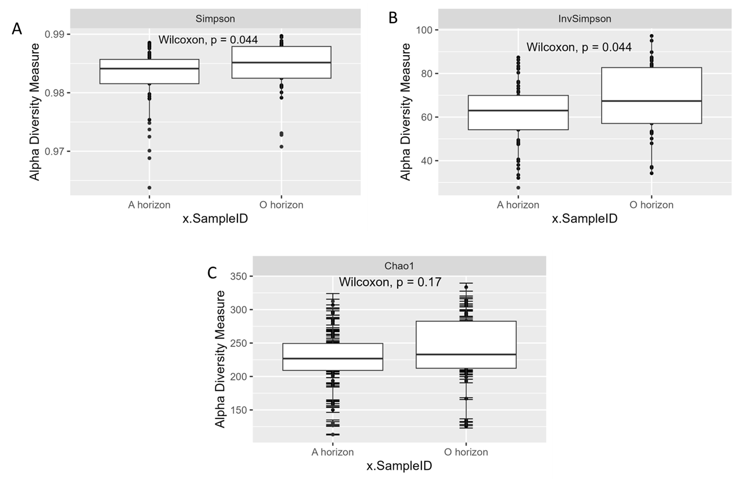

**Supplemental FIG. 1** No significant alpha diversity patterns across different metrics. Alpha diversity box plots were created using the Simpson (A), Inverse Simpson (B) and Chao1 (C).