EXERCISE 1

  - Write a query that lists all Customers in either Paris or London. Include Customer ID, Company Name and all address fields.

We want to use the SELECT function to bring appropriate columns, using the where function to select only Parisian and London companies. We can also concatenate the address fields to get a nicer looking column

SELECT CustomerID, CompanyName AS “Company Name”,
--selects the columns
CONCAT(Address, ', ', City,', ', Country,', ', PostalCode)
--selects all address information and joins it, aliasing it
AS "Address"
FROM Customers
WHERE City = 'London'
OR City = 'Paris'
--looks for the condition

  - List all products stored in bottles.

We want to bring the bottles from the products table, this information is stored in the “quantity per unit” column. We then bring back the product name with a select query.

SELECT ProductName FROM Products
WHERE QuantityPerUnit LIKE '%bottle%'
--looks for bottle anywhere in quantity per unit

  - Repeat question above, but add in the Supplier Name and Country.
We only need a slight modification to the last query to select the additional information, as the supplier information is stored as a foreign key we join the tables and then fetch all columns

SELECT ProductName AS “Product Name”, CompanyName AS “Company Name”, Country FROM Products P
JOIN Suppliers S
ON P.SupplierID = S.SupplierID
--joins the table to add additional information
WHERE QuantityPerUnit LIKE '%bottle%'

  - Write an SQL Statement that shows how many products there are in each category. Include Category Name in result set and list the highest number first.

We can use the Count function to count up each category, then use the group function to join all the results together, ordering by descending to get the highest first

SELECT C.CategoryName, COUNT(C.CategoryName) FROM Categories C
--lists category names and counts how many of each are present
JOIN Products P
ON P.CategoryID = C.CategoryID
--joins the tables for appropriate information
GROUP BY CategoryName
--groups the categories together
ORDER BY COUNT(C.CategoryName) DESC
-sorts with highest first

  - List all UK employees using concatenation to join their title of courtesy, first name and last name together. Also include their city of residence.

We just use a simple select statement, concatenating the appropriate column and aliasing it.

SELECT CONCAT(TitleOfCourtesy, ', ',
FirstName, ', ', LastName) AS "Name", City
--cocatenates and fetches the appropriate columns, aliasing it as appropriate
FROM Employees;

  - List Sales Totals for all Sales Regions (via the Territories table using 4 joins) with a Sales Total greater than 1,000,000. Use rounding or FORMAT to present the numbers.

We require a lot of Joins to link the Regions to the values of sales in Order Details, we then use a group by function to link the regions, then a sum function to add together the quantity*unitprice*(1-discount) to work out the total value of each order.

SELECT *
FROM(
SELECT R.RegionDescription AS “Region”,
ROUND(SUM(Quantity*UnitPrice*(1-Discount)),2) AS "Total order value for region"
--rounds the sum of the overall cost of the orders and renames
FROM Territories T
JOIN Region R
ON R.RegionID = T.RegionID
JOIN EmployeeTerritories ET
ON ET.TerritoryID = T.TerritoryID
JOIN Employees E
ON E.EmployeeID = ET.EmployeeID
JOIN Orders O
ON O.EmployeeID = E.EmployeeID
JOIN [Order Details] OD
ON OD.OrderID = O.OrderID
GROUP BY R.RegionDescription
--groups all the region together
) "Sales total by region"
--joins all the tables to link regions to order details
WHERE [Total order value for region] > 1000000
--uses the subquery to run the where on the aliased column
  - Count how many Orders have a Freight amount greater than 100.00 and either USA or UK as Ship Country.

We want to select the count for the orders that have the correct ship city AND the freight amount over 100, this can be done using the in function in the where clause

SELECT COUNT(*) FROM Orders
--counts our columns
WHERE ShipCountry IN ('UK','USA')
--Looks if the city is in our search condition
AND Freight > 100
--and ensure the freight is high enough

  - Write an SQL Statement to identify the Order Number of the Order with the highest amount of discount applied to that order.
We want to select the top 1 of all orders sorted by descending discount

SELECT TOP(1) OrderID FROM [Order Details]
--selects only the top entry
ORDER BY Discount DESC
--ensures we have the highest first

EXERCISE 2

2.1 Write the correct SQL statement to create the following table:
Spartans Table – include details about all the Spartans on this course. Separate Title, First Name and Last Name into separate columns, and include University attended, course taken and mark achieved. Add any other columns you feel would be appropriate.

We can create a table in the query line to house the information

CREATE TABLE Spartans (
--creates the table
Id INT IDENTITY PRIMARY KEY,
--sets up the ID with auto increment and as a primary key
Title VARCHAR(50),
FirstName VARCHAR(50),
LastName VARCHAR(50),
University VARCHAR(50),
Course VARCHAR(50),
Grade VARCHAR(50),
--adds required columns
PreferedName VARCHAR(50),
ContactNumber VARCHAR(50),
--adds additional information columns
);

2.2 Write SQL statements to add the details of the Spartans in your course to the table you have created.

We use the insert into function to insert information into the appropriate table, filling all columns except the first one as that will automatically fill in the information.

INSERT INTO Spartans
--starts the insert
(Title, FirstName, LastName, University, Course, Grade, PreferedName, ContactNumber)
--lists the columns we are filling in
Values
('Mr', 'Ally', 'Preston', 'Brunel University London', 'Mathematics' , 'First with honours', 'Not Shav', '0787878874')
--example input
--would list all the entries but i have not got enough information to complete those rows

EXERCISE 3

3.1 List all Employees from the Employees table and who they report to. No Excel required. (5 Marks)

We use a select function to select the employees, linking the table to itself to list whom they report to using a left outer join

SELECT E1.EmployeeID,
CONCAT(E1.FirstName,' ', E1.LastName) AS "Employee Full Name",
--joins the names of the employees together
CONCAT(E2.FirstName,' ', E2.LastName) AS "Reports to"
--lists whom they report to
FROM Employees E1
LEFT JOIN Employees E2
--joins the second table, left to allow null information to be kept
ON E1.ReportsTo = E2.EmployeeID;
--allows the reports to information to be put in properly

3.2 List all Suppliers with total sales over $10,000 in the Order Details table. Include the Company Name from the Suppliers Table and present as a bar chart as below: (5 Marks)

We need to use a subqueried function to select the information from the joins

SELECT * FROM(
SELECT S.CompanyName, ROUND(SUM(OD.UnitPrice*OD.Quantity*(1-Discount)),2) AS Total
FROM [Order Details] OD
JOIN Products P
ON OD.ProductID = P.ProductID
JOIN Suppliers S
ON P.SupplierID = S.SupplierID
GROUP BY S.CompanyName
) Total
WHERE Total > 10000
ORDER BY Total DESC

We then use the information into EXCEL to create the chart, using a different colour to make the chart look slightly different from the example

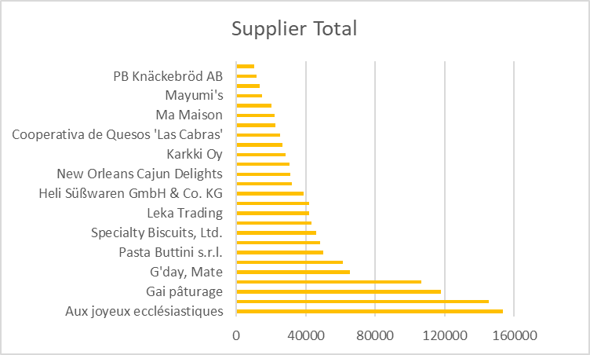

3.3 List the Top 10 Customers YTD for the latest year in the Orders file. Based on total value of orders shipped. No Excel required. (10 Marks)

We need to select the top 10 from the order details total, grouped by the customer names.

SELECT TOP(10)
--top 10
C.CompanyName, ROUND(SUM(UnitPrice*Quantity*(1-Discount)),2) AS "Order Total" FROM Orders O
--selects the total of the quantity ordered
JOIN [Order Details] OD
ON O.OrderID = OD.OrderID
JOIN Customers C
ON O.CustomerID = C.CustomerID
--joins so we can see the names of the customers
GROUP BY C.CompanyName
--groups all customers orders
ORDER BY [Order Total] DESC
--puts the highest first

3.4 Plot the Average Ship Time by month for all data in the Orders Table using a line chart as below. (10 Marks)

We need to fetch date difference and average it, then fetch just the month and year from the ordered date column, then group by the date

SELECT
AVG(DATEDIFF(Day, OrderDate, ShippedDate)) AS "Average shipping",
--finds the time to ship and averages
CONCAT(DATEPART(YEAR, OrderDate),'-' ,DATEPART(MONTH, OrderDate)) AS "Date"
--selects only the month and year from the date
FROM Orders
GROUP BY CONCAT(DATEPART(YEAR, OrderDate),'-' ,DATEPART(MONTH, OrderDate))
--groups by shipping month
Order by Date ASC;

Then we put in EXCEL to get the chart

