Allyson Pascua

Assignment 0205

I/O File Gymnastics

1. Create an ssh tunnel from this computer to a service that is visible from another ssh-capable computer (but, of course, not necessarily visible from the computer you’re using). Then, access that service from your computer through localhost and the tunneled port number. Submit a screenshot of your successful connection to the remote service via the tunnel.

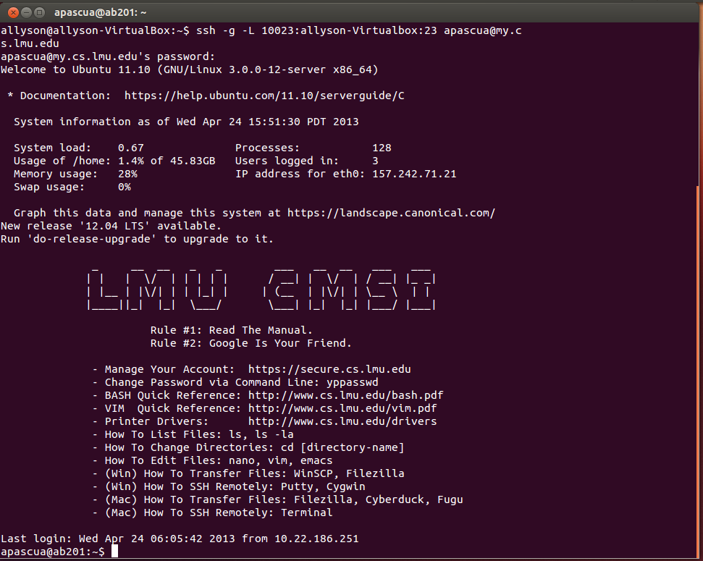

1. Run something lengthy (ping, vm_stat/vmstat, loooooong download, finding the quadrillionth prime number…) inside screen; logout of that computer entirely, login again, and reconnect to screen to prove to yourself that the process has continued to run without interruption.

**Before logging out**

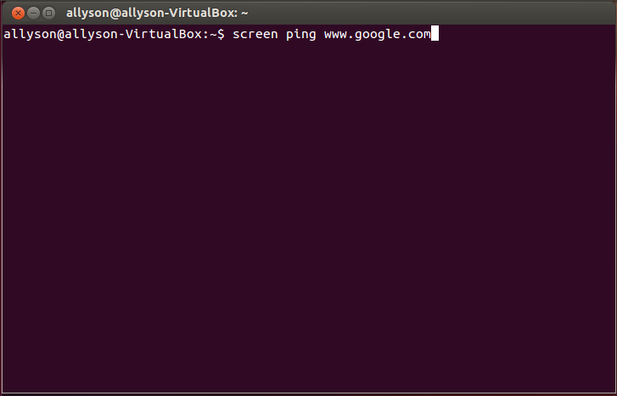

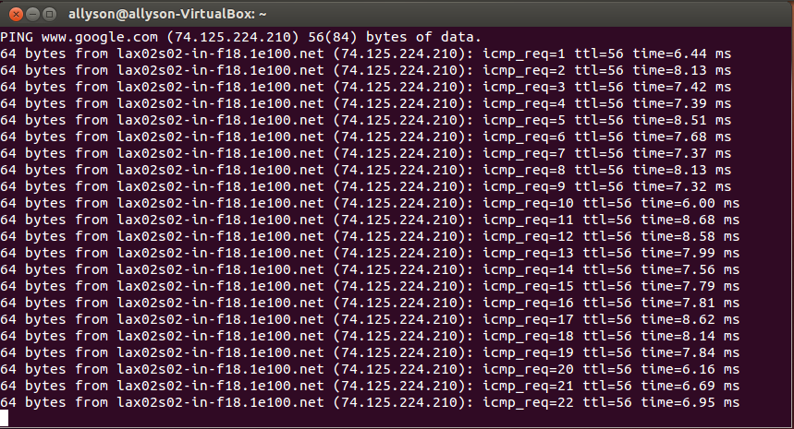

**After logging out**

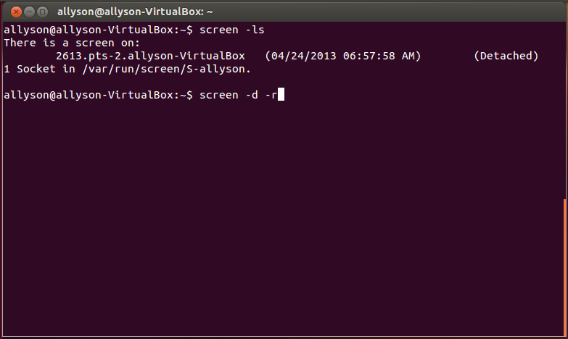

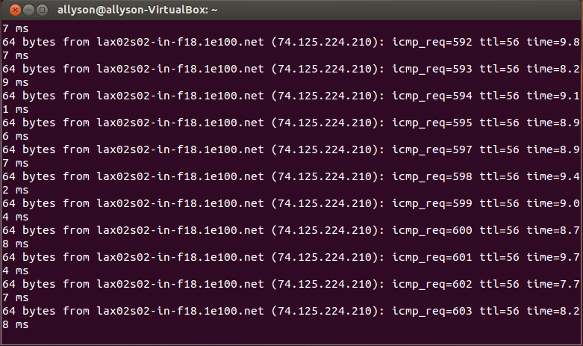

1. Learn how to use du, which tells you how much disk space you’re using in a given directory.
   1. Which first-level subdirectory in ~ is taking up the most space? Submit the command that includes this information in as little output as possible.

|  |
| --- |
| du –sh * | sort –rn | head -1 |

* 1. Submit a command that displays only the disk usage of directories matching some regular expression. Hint: |.

For this assignment, I have chosen my regular expression to be “homework”

|  |
| --- |
| du –h * | grep homework |

1. On a Keck lab machine, create a file within ~. Run ls -i to determine that file’s inode number. Move this file to another directory inside ~, then move it to /tmp, then move it back to your home directory. After each move, use ls -i to see its inode number.
   1. Submit the output of ls -i both right after you created the file and after each file move.

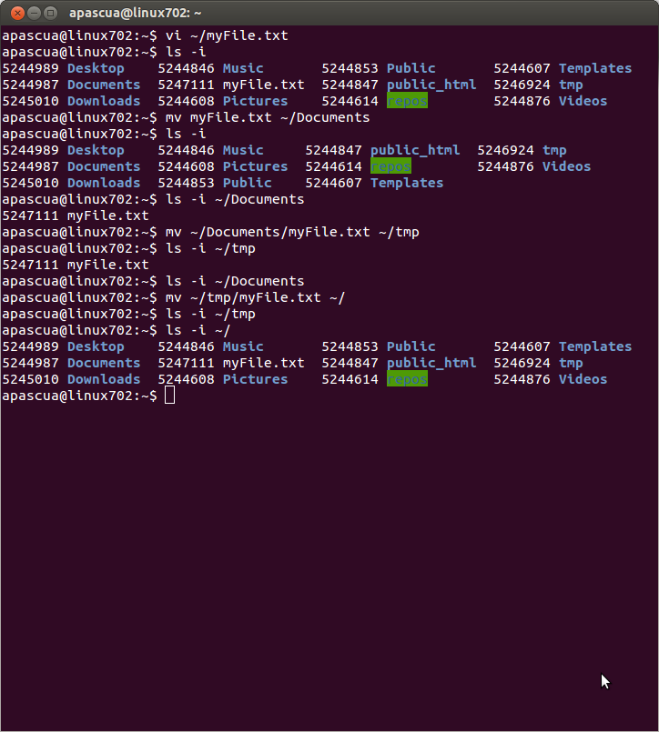

* 1. Submit the piped commands that you would type in order to filter out all lines of ls -i’s output except for the file that you created.

|  |
| --- |
| ls –i | grep myFile.txt |

1. Pop a few storage devices (CD, DVD, flash drive, network drive, etc.) into your computer. Figure out the mount points for each device.

I plugged in an external hard drive titled Iomega_HDD (listed on the bottom). Its mount point is /media/Iomega_HDD.

