Install the latest version of Ubuntu

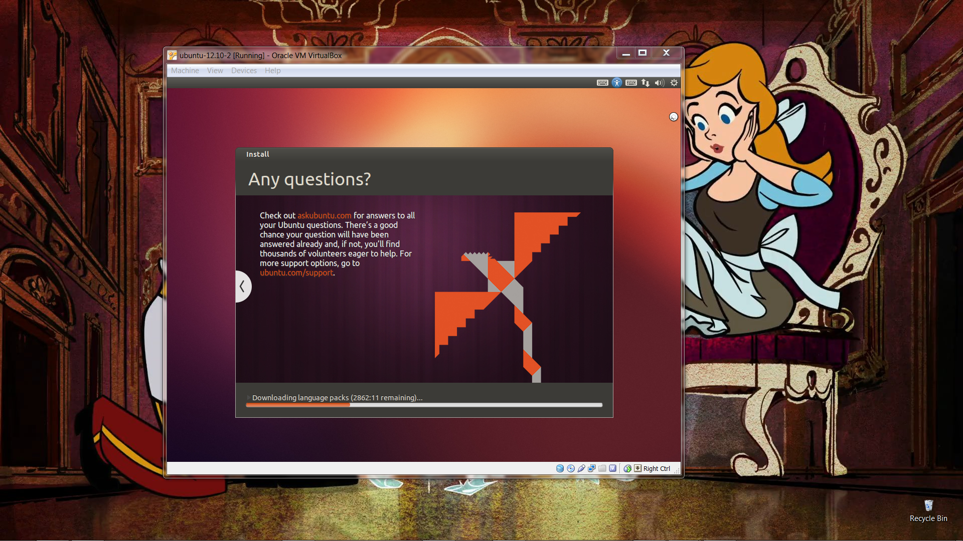

Ensure that you have git installed in your system

You will be using git to obtain the entire Ubuntu Kernel source.

You can install git using the following command if it is not already in your machine:

|  |
| --- |
| sudo apt-get git |

Git clone the repository for the Ubuntu version you want.

You can see a list of repositories of Kernel source code for all releases and from other users on <http://kernel.ubuntu.com/>.

To obtain your own local copy of the Kernel source, clone the repository for the Ubuntu release you want with the following command:

|  |
| --- |
| git clone git://kernel.ubuntu.com/ubuntu/ubuntu-<release>.git |

For example if you wanted the Kernel source Quantal, you would type the type the following:

|  |
| --- |
| git clone git://kernel.ubuntu.com/ubuntu/ubuntu-quantal.git |

Next you will need to download the necessary tools for building a kernel on your system.

The following command will do so for the version of linux you are running:

|  |
| --- |
| sudo apt-get build-dep linux-image-$(uname -r) |

If configuration changes are desired, type the following set of commands:

|  |
| --- |
| chmod a+x debian/scripts/*  chmod a+x debian/scripts/misc/*  fakeroot debian/rules clean  fakeroot debian/rules editconfigs |

This will call the menuconfig command, which is a tool used to configure the Linux kernel source.

To build the actual kernel, change your working directory to the root of the kernel source tree.

Type in the following commands:

|  |
| --- |
| fakeroot debian/rules clean  fakeroot debian/rules binary-headers binary-generic |

The first command deletes a bunch of build products to build fresh.

The second command essentially builds the kernel.

The above process will take quite a bit of time. At this time you should take a break, read a magazine, solve a puzzle, etc.

You will know the build was successful if you see a set of .deb files one directory above the build root directory.

You have now officially built your own kernel!

Now you are ready to install the kernel.

If the build is successful, a set of three .deb binary package files will be produced in the directory above the build root directory. For example after building a kernel with version "2.6.38-7.37" on an amd64 system, these three .deb packages would be produced:

* cd ..
* ls *.deb
* linux-headers-2.6.38-7_2.6.38-7.37_all.deb
* linux-headers-2.6.38-7-generic_2.6.38-7.37_amd64.deb
* linux-image-2.6.38-7-generic_2.6.38-7.37_amd64.deb