Amutan, Alyssa Angela

Palmiano, Martin

**PROOF AND TESTING ON MACHINE PROBLEM (MATLAB) 1**

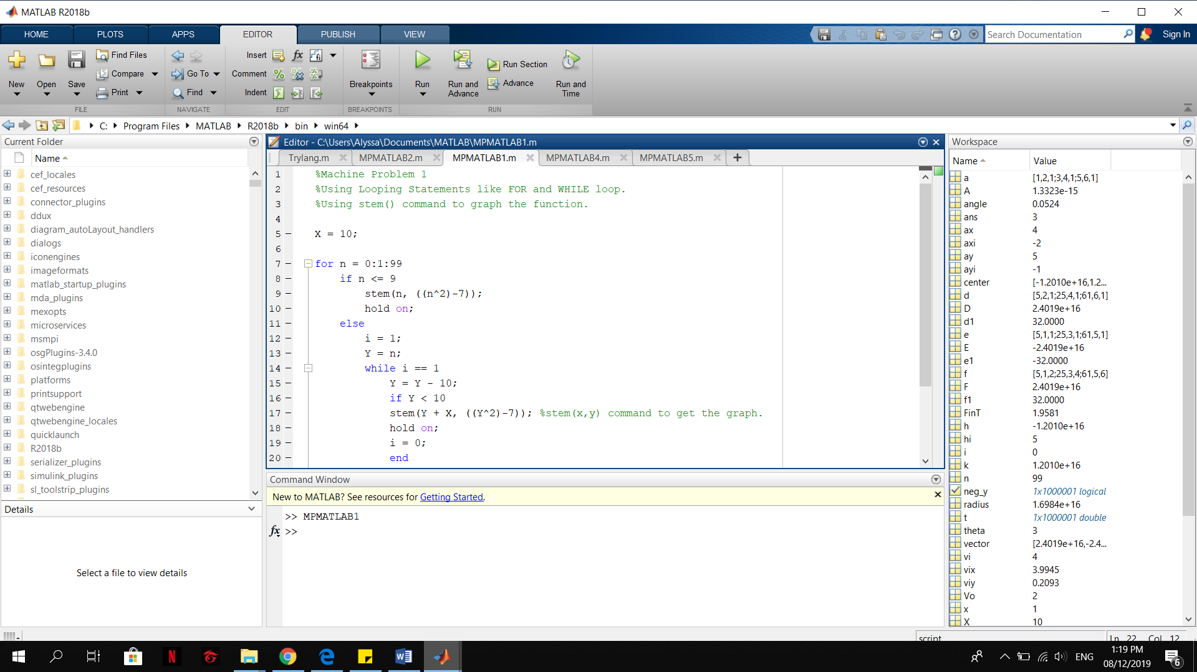

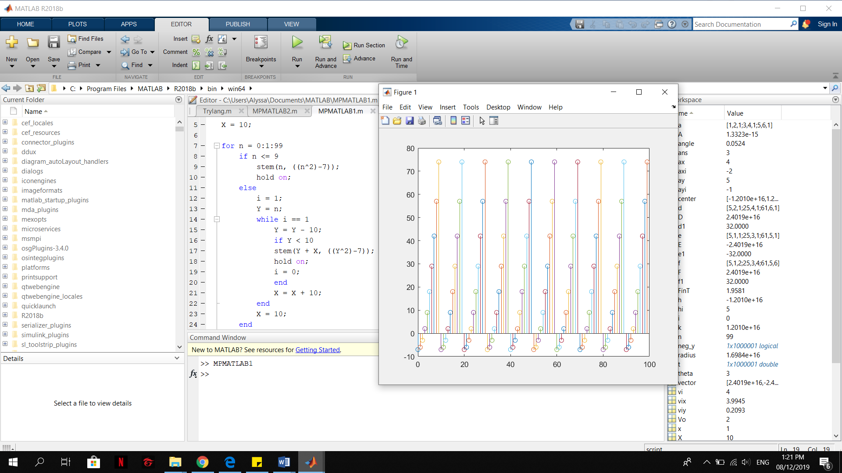

Figure:

