Amutan, Alyssa Angela

Palmiano, Martin

2-ECE-E

**PROOF AND TESTING MACHINE PROBLEM (MATLAB) 4**

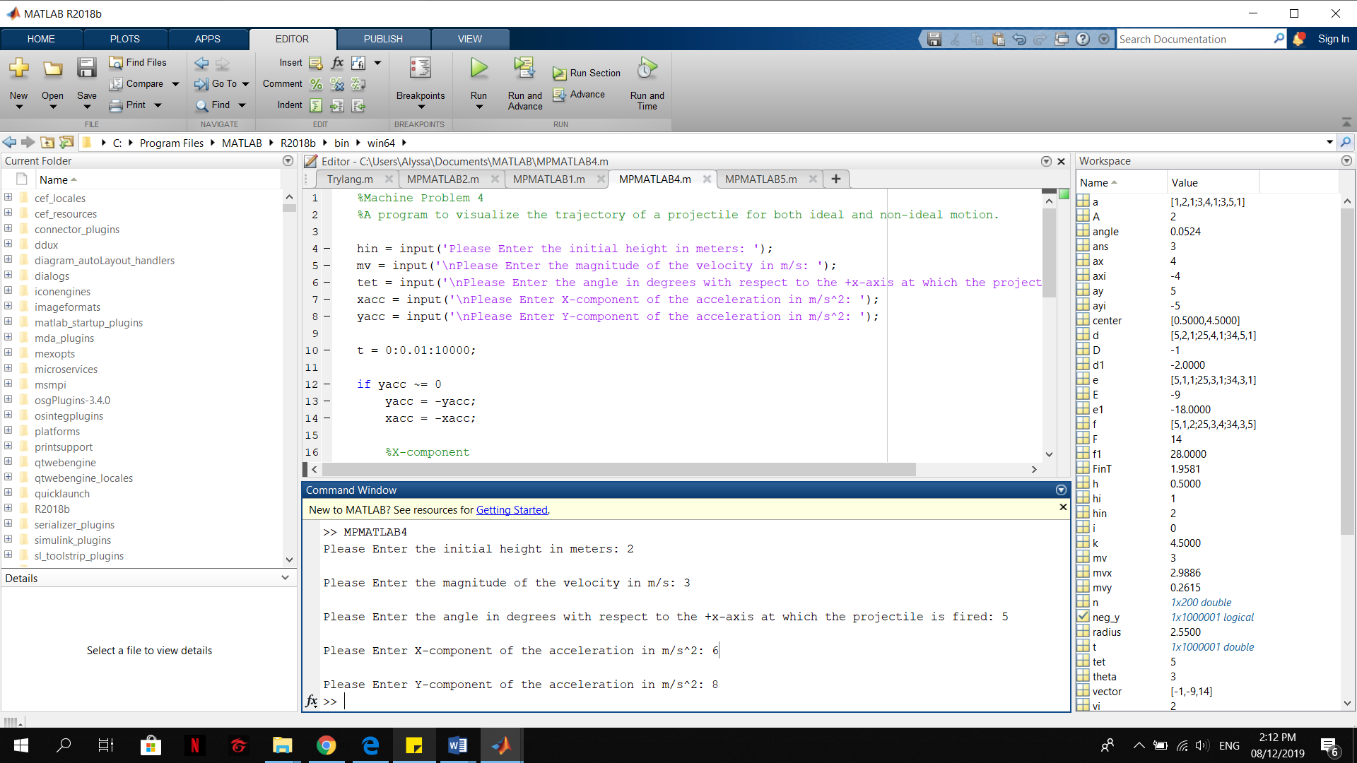

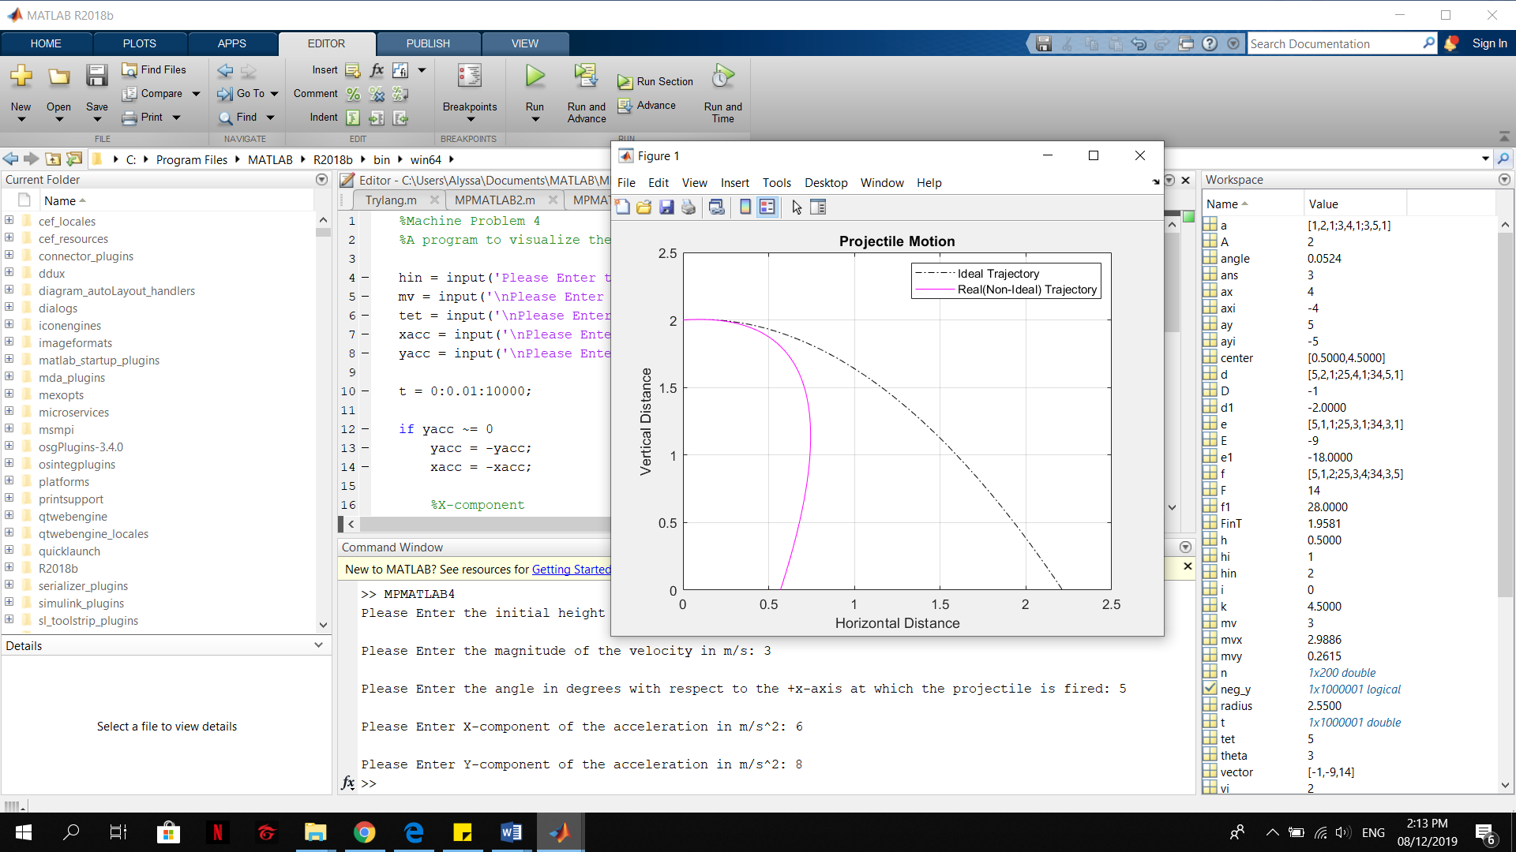

**Figure:**

