Amutan, Alyssa Angela

Palmiano, Martin

**PROOF OF TESTING IN MACHINE PROBLEM MATLAB 5**

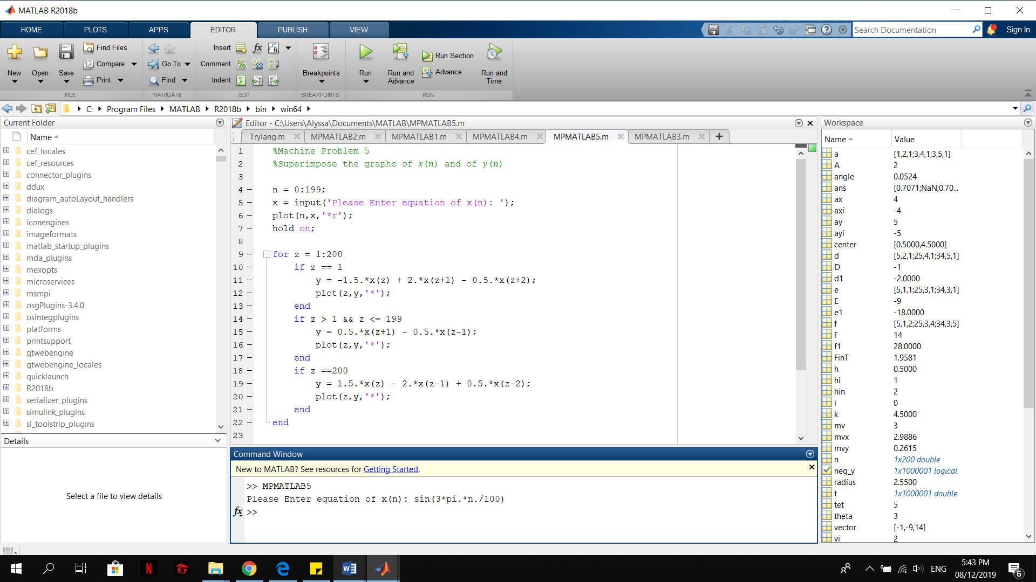

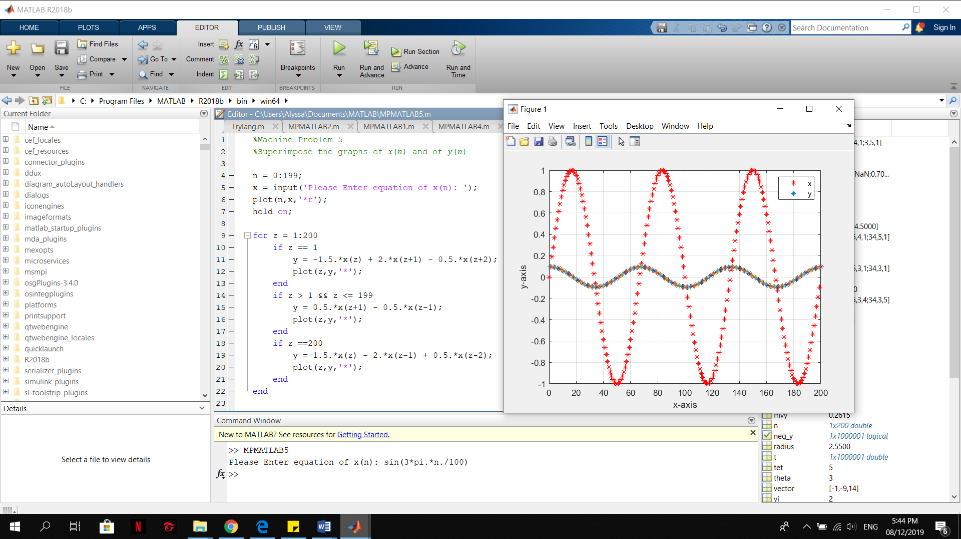

FIGURE:

