Selenium Sampling Protocol for Baseline Assessment at Benton Lake NWR

By K. Irvine, V. Fields

December 23, 2015

1. **INTRODUCTION**

BACKGROUND

The purpose of this study is to develop an updated baseline assessment of selenium contamination in water, sediment, macroinvertebrates, and waterfowl eggs throughout the wetland basin at Benton Lake refuge.

The potential for a selenium contamination problem at Benton Lake National Wildlife refuge (NWR) was first identified in 1985. Subsequently, numerous studies have been conducted to understand selenium dynamics, distribution and accumulation patterns on the refuge and model future scenarios (Knapton et al. 1988, Lambing et al. 1994, Nimick et al. 1996, Zhang and Moore 1997a, 1997b, Henny et al. 2000, refuge studies 2006, 2008, 2011). Through these studies it has become clear that selenium enters the refuge wetlands primarily through Lake Creek in natural run-off and pumped water and that selenium accumulates most rapidly in wetland units nearest this input (“inlet units”). In addition, drying wetland basins, which enables volatilization from wetland sediments to the air, is an essential process for keeping selenium concentrations below levels hazardous to wildlife. Selenium has also been sampled in refuge water, sediment, macro-invertebrates and birds (livers, eggs) as part of these studies over the last 24 years. The results have been variable, but all of these studies have found selenium concentrations moderately to considerably higher than established standards and sufficient to impair reproduction in sensitive species, such as waterfowl, in some portion of the samples collected.

The Comprehensive Conservation Plan for the Benton Lake NWR Complex was completed in December 2012. The CCP outlines a new management direction for Benton Lake refuge that will strive to reduce selenium contamination to levels where there is no reproductive harm to wildlife (i.e. “minimal hazard”) as well as prevent any net increase in selenium contamination over the life of the plan. Although there have been many past selenium studies that have been essential to understanding selenium dynamics and hazard on the refuge, for several of the wetland units the data is more than 15 years old. For a more information about the history of selenium on Benton Lake NWR, see the draft CCP/Environmental Assessment and the final CCP (http://www.fws.gov/mountain-prairie/refuges/bnl.php).

In order to determine if the refuge is meeting its objectives for selenium, a comprehensive, accurate and updated assessment of the current levels of selenium contamination in the wetland basin must be completed. This inventory will be used as a baseline from which to develop future management, monitoring and evaluate success.

Objective:

Refuge staff will complete a comprehensive assessment of the current levels of selenium contamination in water, sediment, macro-invertebrates and the eggs of sensitive birds across the Benton Lake wetland basin within 5 years. This inventory will be used as a baseline from which to develop future management, monitoring and evaluate success. The following management objectives are from the Benton Lake NWR Complex CCP.

OBJECTIVES

*MANAGEMENT OBJECTIVES*

Objective 1: Over the next 15 years, manage and/or protect water quality for wetlands and riparian habitats on fee-title lands within the complex such that there is minimal hazard to wildlife from contaminants.

*Note: Minimal hazard is defined as conditions where “hazardous constituents may be elevated in one or more ecosystem components, but no imminent toxic threat is identified”. The exact numerical value for this will vary with the contaminant and the constituent (water, soil, etc).*

|  |  |  |  |  |
| --- | --- | --- | --- | --- |
| **Hazard** | **Water**  **(ug/l)** | **Sediments**  **(ug/g)** | **Invertebrates**  **(ug/g)** | **Aquatic bird eggs**  **(ug/g)** |
| None | 1 | 1 | 2 | 3 |
| **Minimal** | **2** | **2** | **3** | **5** |
| Low | 3 | 3 | 3 | 12 |
| Moderate | 5 | 4 | 5 | 20 |
| High | >5 | >4 | >5 | >20 |

For Benton Lake refuge, specifically, the contaminant of greatest concern is selenium. Selenium accumulates through the food chain and therefore “minimal” hazard concentrations have been described multiple trophic levels (Lemly 2002) (Table X).

Objective 2: Over the next 15 years, manage the Benton Lake refuge wetland basin so that there is no net increase in s­elenium contamination.

*SAMPLING OBJECTIVES*

Objective 1: Develop the most accurate estimate possible (smallest 95% confidence interval) of the mean concentrations of selenium in water, sediment, macroinvertebrates and waterfowl eggs for each wetland unit on Benton Lake refuge given the staff time and resources available.

1. **SAMPLING DESIGN**

Refuge staff will complete a comprehensive assessment of the current levels of selenium contamination in water, sediment, macro-invertebrates and the eggs of sensitive birds (waterfowl) across the Benton Lake wetland basin within 5 years. This inventory will be used as a baseline from which to develop future management, monitoring and evaluate success.

SAMPLE FRAME AND SAMPLING UNITS

The basin is physically separated into 9 distinct management units by roads, dikes, ditches etc., although water does flow between these areas based on the current infrastructure (Figure 1 the sampling frame map). Within each unit there are possibly three areas based on the history of water management prior to initiating the inventory (we refer to them as “zones”): areas that typically are flooded with standing water when pumping occurs (hereafter, the “flooded” zone), areas that become saturated when pumping occurs (hereafter, the “saturated” zone), but do not typically have standing water, and areas that are only flooded or saturated when high levels of natural run-off occur or (hereafter, the “intermittent” zone). [See SOP 2, Sampling Design for full description of how these zones were developed.]

Because of the nature of water flow throughout the refuge, selenium levels differ greatly across units (Zhang and Moore 1997, refuge surveys 2006) and possibly across zones within the same unit (e.g., unit 1 and 2).

The sampled population is the collection of potential accessible wet areas that are not seeps across the 9 units within the basin. Seeps were excluded due to the increased variability in our estimates of the mean that these samples would cause.

We used a stratified random design to specify spatial locations for sampling selenium within the basin. Each management unit was considered a separate strata (or subarea). There are nine total: Unit 1, Unit 2, Unit 3, Unit 4B, Unit 4A, Unit 4C, Inter-unit canal, Unit 5 and Unit 6 (Figure 1). Within a unit we specified an unequal probability sample, essentially this approach allows for differential sampling effort across the different water zones (e.g., “flooded”, “saturated”, and ”intermittent”). Based on previous studies, the expectation is that selenium levels, and variation in selenium concentrations, will be related to the historical duration of flooding. The unequal probability sampling places more sample locations within the flooded zones which we assume will be more variable than the saturated and intermittent zones (Table x). Also, in order to co-locate samples for water, macro-invertebrates, and sediments locations with standing water needed to be preferentially selected.

We then used a generalized random tessellation stratified (GRTS) design to select the point locations (sampling unit) for sampling selenium. Within the GRTS draw we specified the strata and unequal probability sampling. The R-code is provided in SOP 2, Sampling Design.

SAMPLE SELECTION AND SIZE

There were pilot data available for selenium samples taken from the Benton Lake NWR. For several units there was data spanning several years. Consequently, we explored different variance estimates by year and pooling data across years. Based on different estimates of the standard deviation, we explored sample sizes necessary for several combinations of confidence level and margin of error. We considered margins of error of 0.5, 0.25, 0.1, and 0.05; and confidence levels of 80%, 90%, and 95%.

We explored different scenarios for total sample size by summing the number of samples needed for each confidence level and margin of error across all the units using the estimates of standard deviation. We had to balance the desire for the highest confidence level and lowest margin of error with realities of sampling effort and funding limitations for analysis. Although sediment is the primary reservoir of selenium in the Benton Lake wetland (Zhang and Moore 1997), funding and staff time also had to be allocated to sampling water, macro-invertebrates and waterfowl eggs. Therefore, given all of these considerations, a total of 330 sediment samples seemed reasonable. With this sample size, we could achieve a margin of error of 0.25 with 95% confidence in sediment samples for all units.

The next step in this process was to consider stratified samples within each unit to accommodate the differences in variance across the different water level zones in each unit. We allocated the samples to the different zones in order to minimize the variance of the total sample. We believe there are three zones within each unit: flooded, saturated and intermittent. In order to allocate sample sizes to each zone we used an estimated variance within each zone and the total size of each zone. These estimates were based primarily on expert opinion. We used optimal allocation to determine the sample size required from each zone h, $n_{h}$, is proportional to the total population size in each zone times the standard deviation from each zone, $N_{h}S_{h}$ (Lohr 2010, p. 88).

A similar analysis was used to determine the sample sizes needed for the other constituents, water, macro-invertebrates and eggs. As with sediment, previous data from the refuge was synthesized to estimate the standard deviation within each unit for each historical sampling period and across all samples. The data for the other constituents was not as consistent as the sediment data across time and wetland units but we still used the highest estimate of variance available in each unit in developing the sample size calculations.

As with sediment, final samples sizes for each of these constituents was a combination of maximizing the confidence level, minimizing the margin of error, and consideration for available funding and staff time. For water samples, a margin of error of 1 and at least 90% confidence was considered acceptable . For macro-invertebrate and egg samples, a larger margin of error was considered acceptable because, in these constituents, selenium concentrations must increase by larger intervals than water or sediment before the hazard to wildlife increases.

Water and macroinvertebrate samples were co-located with sediment samples in the flooded and intermittent zones. Allocation of these samples between the zones…..[Kathi]

Egg samples were collected by systematically searching the margins of each wetland unit. Searches continued until 5 eggs were found for each unit.

SURVEY TIMING

This baseline inventory was conducted from 2013-2015. Water, macro-invertebrates and waterfowl eggs were sampled during the breeding season (May-July), depending on water availability. Selenium concentrations in sediment were not expected to vary significantly within a given year, so sampling occurred any time during the ice-free season (April – October). When water was present during the breeding season in a unit, all samples from that unit were collected in the same year. When water was not available, all sediment samples from a given unit were collected in the same year.

SOURCES OF ERROR

TBD

1. FIELD METHODS AND SAMPLE PROCESSING

PRE-SURVEY LOGISTICS AND PREPARATION

Before going into the field to collect selenium samples, it is important to make sure the field crew has all of the materials to locate sample points and sampling equipment.

ESTABLISHMENT OF SAMPLING UNITS

The sampling unit is simply a point location identified on a GPS unit. There are no sampling units to establish and no permanent markers. Sampling points must be loaded into a GPS unit and labelled with the sample ID before going into the field.

DATA COLLECTION PROCEDURES

Sampling points for water, macro-invertebrates and sediment must be evaluated (visited) in the order generated during the sample draw (see SOP 2). As a practical matter, this may not be the most efficient path through the wetland, therefore during sampling care must be taken to track the order visited and whether a samples were taken, and if not, why. Once a sampling point for water, macro-invertebrates or sediment has been located with a GPS, and is deemed appropriate for sampling, there are specific sampling protocols for each trophic level. See SOP 3 for detailed descriptions of procedures and sampling equipment.

Eggs were collected for each unit based on availability. Nests were located systematically by nest dragging or searching on foot along the perimeter of the wetland. Eggs from all waterfowl species were collected. One egg was collected randomly from each nest. Contaminant residues are generally consistent among eggs within a clutch and therefore any single egg should be representative of the clutch (Blus 1984). Eggs were ‘assigned’ to the nearest unit to the collection site (nest).

PROCESSING OF COLLECTED MATERIALS

Once samples are collected, they are entered into the Service’s Environmental Contaminants Data Management System (ECDMS) (ecos.fws.gov). Once samples are entered into ECDMS, the “catalog” of samples is submitted for approval and assigned to a lab for analysis. We have found that a review of the sample jars against the catalog is very useful prior to submission to catch any data entry or labelling errors and to avoid confusion for the lab. For this inventory, we used EnviroSystems Inc. for all samples. Selenium concentrations were determined by inductively coupled plasma (ICP) analysis. Samples should be analyzed within 6 months of collection. We submitted samples throughout the sampling season to avoid exceeding the 6 month hold time. It typically takes 1-2 months from submitting a catalog of samples until the samples arrive at the lab. Samples should be sent overnight with sufficient packing and blue ice to keep them cold and well protected. If the total cost of analysis is less than $3,000 the samples can be submitted at any time. If >$3,000, the samples will need to be submitted before a deadline established by the contaminants program in HQ (usually mid-late July) or at the beginning of the new fiscal year.

END OF SEASON PROCEDURES

After the collection season is done, all equipment should be cleaned and dried for storage. An inventory of supplies should be conducted.

1. **DATA MANAGEMENT AND ANALYSIS**

DATA ENTRY, VERIFICATION AND EDITING

The Service’s Environmental Contaminants Data Management System (ECDMS) is the primary data management repository for the selenium sampling data associated with this inventory (ecos.fws.gov). Once a user has access to the system, results from Benton Lake NWR can be easily searched for and retrieved. For each sample, metadata about the survey, collection and analysis methodology, and location is stored in the system, as well as the resulting selenium concentration. [see if specific lat-longs for samples can be easily added?] The 2013-2014 data can be found by searching for catalog numbers : 6070109 6070113, 6070114, 6070115 or by doing a search for Benton Lake refuge.

The results can be downloaded and stored locally. Currently, the results from the 2013-2014 inventory are stored on the biologist’s computer:

D:\bnl_biological_program\Abiotic\Contaminants\selenium\bnl_selenium_sampling_13\

se_samplingplan\results\RAWLabResults

METADATA

There are two primary repositories of the data associated with the 2013-2104 Baseline Selenium Inventory.

*Hardcopy*

A hardcopy file of the baseline inventory is currently stored in the files in the Biologist’s office. It is located under Abiotic/Contaminants/Selenium. The folder is titled “Updated Selenium Baseline, 2013-2014”. The folder contains hardcopies of all reports, memos, data, field maps/notes, supply costs and sources and other relevant supporting materials.

*Electronic*

All of the documents and data (tabular, GIS) are stored on the Benton Lake refuge server under:

GroupData\Refuge\BNL_HMP\Monitoring\Selenium\BaselineInventory

The information is organized by Introduction and Background materials, Methods, Results and Reports. A geodatabase with all of the spatial information, including sampled selenium concentrations, is organized in a geodatabase under the GISData folder (bnl_selenium_apr13.gdb). There is basic metadata under the “Item Description” for most of the features in this geodatabase. The server is backed up periodically by the Regional Office. The GIS data and Maps were created using ArcMap 10.1. The Excel and Word files were created in Microsoft Office 2010.

**ANALYSIS METHODS**

A complete description of the data analysis is saved on the G drive in the “Results” folder:

G:\Refuge\BNL_HMP\Monitoring\Selenium\BaselineInventory\Results\ USGS Selenium Data Report 2015.pdf. This is originally a ‘dynamic document’ which means the R code is built into the report, which makes updates easier. In order for this process to work, a computer workstation must have the software “R” and the software “MikTex” (free and available for download from the web).

The final report has been added to SOP 4 in the hardcopy version of this protocol.

**SURVEY REPORTS**

Two reports have been generated to date for the baseline selenium inventory. An interim report after the 2013 sampling (G:\Refuge\BNL_HMP\Monitoring\Selenium\BaselineInventory\Reports\

BNLSelenium_Progress_Report1_apr2014.pdf) and a second report after the 2014 sampling (G:\Refuge\BNL_HMP\Monitoring\Selenium\BaselineInventory\Reports\ BNLSelenium_Progress_Report2_feb2015.pdf). This protocol summary will also be stored in the Reports folder.

**REFERENCES**

Blus, LJ. 1984. DDE in birds’ eggs: comparison of two methods for estimating critical levels, Wilson Bulletin 96:268-76.

Henny, CJ, Grove, RA and VR Bentley. 2000. Effects of selenium, mercury and boron on waterbird egg hatchability at Stillwater, Malheur, Seedskadee, Ouray and Benton Lake National Wildlife Refuges and surrounding vicinities. National Irrigation Water Quality Program Information Report No. 5, 79pp.

Knapton, JR, Jones, WE, and JW Sutphin. 1988. Reconnaissance investigation of water quality, bottom sediment, and biota associated with irrigation drainage in the Sun River. US Geological Survey. Water Resources Investigation Report 87-4244. Helena, Montana. 78pp.

Lemly, AD. 2002. Protocol for aquatic hazard assessment. In Alexander, DA (ed) Selenium assessment in aquatic ecosystems: a guide for hazard evaluation and water quality criteria. Springer-Verlag, New York, NY. 176pp.

Nimick, DA, JH Lambing, DU Palawski and JC Malloy. 1996. Detailed study of selenium in soil, water, bottom sediment, and biota in the Sun River Irrigation Project, Freezeout Lake Wildlife Management Area and Benton Lake National Wildlife Refuge, west-central Montana, 1990-92. US Geological Survey Water-Resources Investigation Report 95-4170. Helena, MT. 120pp.

Zhang, Y. and J. Moore. 1997. Final report on biogeochemical cycling of selenium in Benton Lake, Montana. University of Montana, Missoula, MT, 228p

**SOP 2. SAMPLING DESIGN**

The sampling frame was a GIS polygon layer of the basin with the units and zones delineated. The file was provided by Vanessa Fields and named “bnl_SeSampleZones_042613.dbf”. This GIS layer contained a distinct polygon for each unit and zone combination.

In order to identify these zones (flooded (pumped), saturated (pumped), intermittent (natural run-off only), and seeps) the following steps were taken:

1. First, the water use records for 1991-2012 were compiled in a single excel spreadsheet (bnl_unitwaterlevels _1991-2012.xls). The years 2000-2007 were “typical” of the extent of pumped water and were relatively dry so there was little added input from natural run-off. The elevations for each unit were averaged for these 8 years and used as the “benchmark” for the extent of flooding under typical pumping conditions.
2. These elevations for each unit were compared to basin elevation and vegetation data that was available as of April 2013. Detailed elevation (0.5ft) contours are available for all of the basin except Units 1 and 2. Detailed vegetation data was available for Units 1,2,4A, and 5. A combination of the elevations identified in step 1, the vegetation (if available), National Wetlands Inventory wetland classifications and professional expertise of the manager and biologist were used to delineate the sample zones.
3. Flooded: this zone includes areas where there may be standing water through the breeding season and water would typically be available for sampling water and macroinvertebrates when pumping has occurred the previous fall. This “flooded” zone is saved in a separate feature class (bnl_flooded_byunit – where there is a “flooded” polygon for each wetland unit; and bnl_flooded _Dislv- where there is only one polygon that includes the “flooded” area for the entire basin/all units). Initially, cattails areas in the flooded zone were mapped separately as “inaccessible”, but these were later included in the flooded zone when sample locations were drawn.
4. Saturated: this zone includes areas where the soil may be saturated or influenced by pumped water, but there likely is not standing water through the breeding season.
5. Intermittent: this zone includes the areas within each wetland unit that would not typically be flooded by pumped water and would only be flooded in wet years with high natural runoff.
6. Seeps: seeps were mapped with “heads-up” digitizing based on a 2008 aerial image and the experience of the refuge biologist.
7. After the sampling zones were mapped in GIS, the roads and other minor administrative or upland sites (boardwalk , islands) were added to the feature class.
8. The resulting feature class is available in several formats: bnl_SeSamplyPolys_All includes all of the sampling zones broken into individual polygons at least 0.1ac in size. Bnl_SeSamplyPolys_Dislv combines all of the individual polygons for a given zone into a single polygon. BN_SeSamplePolys_Final was the feature class used to generate the sample points and is the result of unioning the wetland basin units with the sampling zones.
9. All of the feature classes relative to sampling zones are contained in the feature dataset “SeSamplePlan”.
10. In addition, the streams, ditches, canals, water control structures, moats and any other hydrological features/alterations are included in the geodatabase in the feature dataset “Water_Mgmt”.
11. Both of these feature datasets are contained in the geodatabase “bnl_selenium_apr13.gdb”.
12. All of the files associated with this process are on the refuge biologist’s computer at:

Vfields/bnl_biological_program/abiotic/contaminants/selenium/bnl_selenium_sampling_13/se_samplingplan

# R code GRTS draw

The necessary sample size for a survey is based on the expected variation within the sample, the desired margin of error, and the desired confidence level. The latter two can be set by the researcher, but the expected variation with in the sample must be estimated from pilot data or expert opinion. The formula for estimated sample size is $n={\left(\frac{zS}{e}\right)}^{2}$ where $z$ represents the $\frac{α}{2}$ th percentile from the standard normal distribution (e.g., 1.96 for 95% confidence interval), *e* represents the margin of error (or the confidence interval half-width), and *S* represents the standard deviation of the sample (Lohr 2010, p. 47).

There was pilot data available for Selenium samples taken from the Benton Lake NWR. For several units there was data spanning several years. Consequently, we explored different variance estimates by year and pooling data across years. For example, unit 1 has sample data from 1985, 1992-1993, 2008, and 2011, so we could have 5 estimates of standard deviation (one using all the years combined together, only 1992-1993, only 2008, etc). In this case there was only one observation from 1985 so no standard deviation calculation is possible, so unit 1 has 4 estimates of standard deviation (Table 1).

|  |  |  |  |
| --- | --- | --- | --- |
| All years | 1992 - 1993 | 2008 | 2011 |
| 1.417 | 2.015 | 0.822 | 1.207 |

Table 1. Example of standard deviations for previous sediment samples in Unit 1.

Based on different estimates of the standard deviation, S, we explored sample sizes necessary for several combinations of confidence level and margin of error. We considered margins of error of 0.5, 0.25, 0.1, and 0.05; and confidence levels of 80%, 90%, and 95%, which correspond to $z_{α/2}$ values of approximately 1.28, 1.645, and 1.96 respectively (Table 2).

For example, using the standard deviation from all the samples, a margin of error of 0.5 and a confidence level of 80% we can calculate the necessary sample size as follows:

$$n=(\frac{z_{\frac{α}{2}} S}{e})^{2}=(\frac{1.281552*1.417}{0.5})^{2}={3.632}^{2}=13.191$$

Obviously you can’t take 0.191 of an observation, so we will round this value up to 14. To achieve 80% confidence with a margin of error of 0.5 we need to take a sample of at least 14, assuming the standard deviation of the data is 1.417.

|  |  |  |  |  |
| --- | --- | --- | --- | --- |
| **All Samples** | | | | |
|  | **Margin of Error** | |  |  |
| **Confidence** | **0.5** | **0.25** | **0.1** | **0.05** |
| **80%** | 14 | 53 | 330 | 1319 |
| **90%** | 22 | 87 | 543 | 2172 |
| **95%** | 31 | 124 | 771 | 3084 |

Table 2. Sample size calculations for several combinations of confidence level and margin of error in sediment samples in Unit 1.

After doing similar calculations for all of the units, we decided to use the largest variance estimate for each unit for the final sample size calculations (Table 3). [Kathi – this doesn’t seem to be true for Unit 1 – the 1992-93 SD is 2.015?)

The original sample draw was provided in file “SampleDrawSe_2013.csv”, but then closer inspection of the points suggested that there were issues:

from emails “ with the inter-unit canal, we estimated we want a total of 51 sediment samples, but when I look at the sample point draw, 39 of the 61 points come from the roads/uplands stratum.  Given the GIS error, and the narrow canal and dikes, some of these may very well be in the canal, but I am guessing we would be better off drawing  all points and over-samples from the flooded stratum (there is no saturated or intermittent in the canal).

Also, for Units 3,5, and 6 we estimated that we needed 15 sediment samples overall in each unit, it looks like the stratification works out that with the oversample draws, I only have about 10points to choose in the flooded zone in each unit.  This is fine for sediment since I only really need 7 or less, but we are planning 10 co-located invertebrate samples from the flooded zone, so that means I would not have any "extras" for invertebrate sampling in case a few points were inaccessible or non-target.

So...I think I need some new points in the flooded zone in the canal and some additional over-sample sites in the flooded zone in units 3,5 and 6.  If so, do we need a whole new file or can the new points be added?

From ME: oops I see what happened...I didn't realize there were different strata within the inter-unit canal...

I can't seem to trick spsurvey to ignore the other zones within the inter-unit canal. Can you just send me the shapefile again without the roads/upland. So just flooded for inter-unit canal; and flooded, saturated, and intermittent for the other units.

These fixes were made in the file: “SampleDrawSe_2013May20.csv”.

The file was updated with additional points provided in file “SampleDrawSe_2013July1.csv”.

We did another draw because after going through the panelone points and all of the oversample points we had not reached our desired sample size yet.

Within each file the oversample is a list of points within a unit that can be used if the original point was inaccessible or non-target [fell on a road or ditch]. Each point should be evaluated and its condition noted in the csv file under the column, EvalReason. TS- target and sampled, NT- site was non-target, NN-site was not needed (not evaluated).

The columns of Water Sample and Bug Sample in the original file indicate a yes if should be sampled for those within the flooded areas for each unit. [I can’t find the file that has this…]

**Questions to discuss:**

1. Why did we need two draws?
2. What is final sample size in each zone*unit?
3. Did we benefit from the unequal prob. draw within a unit?
4. Vanessa will add a discussion about logistical issues/efficiencies/ways to deal with it, etc.
5. Do we have a final combined file with the points sampled and coded as NT or NN or TS?

|  |  |
| --- | --- |
| Unit | SD |
| 1 | 1.42 |
| 2 | 0.82 |
| 3 | 0.27 |
| 4A | 0.52 |
| 4B | 0.72 |
| 4C | 0.72 |
| 5 | 0.24 |
| 6 | 0.43 |
| Inter-unit canal | 0.91 |

Table 3. Estimated standard deviation (SD) used in final sample size calculations based on the largest estimate of variance available in each unit.

We explored different scenarios for total sample size by summing the number of samples needed for each confidence level and margin of error across all the units using the estimates of standard deviation in Table 3 (Table 4). We had to balance the desire for the highest confidence level and lowest margin of error with realities of sampling effort and funding limitations for analysis. Although sediment is the primary reservoir of selenium in the Benton Lake wetland (Zhang and Moore 1997), funding and staff time also had to be allocated to sampling water, macro-invertebrates and waterfowl eggs. Therefore, given all of these considerations, a total of 330 sediment samples seemed reasonable. With this sample size, we could achieve a margin of error of 0.25 with 95% confidence in sediment samples for all units (Table 4).

|  |  |  |  |  |
| --- | --- | --- | --- | --- |
|  | **Margin of Error** | |  |  |
| **Confidence** | **0.5** | **0.25** | **0.1** | **0.05** |
| **80%** | 34 | 134 | 839 | 3354 |
| **90%** | 55 | 221 | 1381 | 5525 |
| **95%** | 78 | 314 | 1961 | 7845 |

Table 4. Total sample sizes for the entire basin for sediment sampling across all units using the largest variance estimate for each unit (provided in Table 3) and the specified margin of errors and confidence levels. The numbers are simply the sum of the unit specific tables (not shown).

The breakdown by unit using a margin of error =0.25 and 95% CI and a minimum of 15 in each unit would be as in Table 5.

|  |  |  |
| --- | --- | --- |
|  | 95% margin of error =.25 | |
|  | Sample Size | Adjusted |
| 1 | 125 | 125 |
| 2 | 42 | 42 |
| 3 | 5 | 15 |
| 4A | 17 | 17 |
| 4B | 16 | 16 |
| 4C | 31 | 31 |
| 5 | 3 | 15 |
| 6 | 12 | 15 |
| inter-unit canal | 51 | 51 |
|  | **302** | **327** |

Table 5. By unit sample sizes based on calculations and adjusted to have a minimum of 15 in each unit.

The next step in this process was to consider stratified samples within each unit to accommodate the differences in variance across the different water level zones in each unit. We allocated the samples to the different zones in order to minimize the variance of the total sample. We believe there are three zones within each unit: flooded, saturated and intermittent. In order to allocate sample sizes to each zone we used an estimated variance within each zone and the total size of each zone (Table 6). These estimates were based primarily on expert opinion.

|  |  |  |  |
| --- | --- | --- | --- |
|  |  | SD Estimates by zone | |
|  | Flooded | Saturated | Intermittent |
| 1 | 1.4 | 0.7 | 0.5 |
| 2 | 0.82 | 0.5 | 0.4 |
| Inter-Canal | 0.91 | NA | NA |
| 4B | 0.5 | 0.4 | NA |
| 4A | 0.5 | 0.4 | 0.3 |
| 4C | 0.7 | 0.5 | 0.3 |
| 3 | 0.3 | 0.3 | 0.3 |
| 5 | 0.3 | 0.3 | 0.3 |
| 6 | 0.4 | 0.4 | 0.4 |

Table 6. Estimated SD by zone within each management unit within Benton lake NWR using expert opinion and pilot data.

We used optimal allocation to determine the sample size required from each zone h, $n_{h}$, is proportional to the total population size in each zone times the standard deviation from each zone, $N_{h}S_{h}$ (Lohr 2010, p. 88). From this we can find the sample sizes for each zone using the following formula:

$$n_{h}=\left(\frac{A_{h}S_{h}}{\sum_{l=1}^{H}{A_{l}S_{l}}}\right)n$$

Where $A_{h}$ is the total area of zone h (“flooded”,”saturated”,or ”intermittent”), $S_{h}$ is the variance of zone h, and $n$ is the total sample size from the unit (Lohr 2010, p. 89) (Table 7).

|  |  |  |  |  |  |  |  |  |  |  |  |
| --- | --- | --- | --- | --- | --- | --- | --- | --- | --- | --- | --- |
|  | 95% margin of error =.25 | | | | Sampling Fraction |  |  | Sample Size | |  | |
| UNIT | | Sample Size | Adjusted | Flooded | Saturated | Intermittent | Flooded | Saturated | Intermittent | |
| 1 | | 125 | 125 | 0.726 | 0.176 | 0.098 | 91 | 22 | 12 | |
| 2 | | 42 | 42 | 0.662 | 0.286 | 0.052 | 28 | 12 | 2 | |
| 3 | | 5 | 15 | 0.464 | 0.198 | 0.338 | 7 | 3 | 5 | |
| 4A | | 17 | 17 | 0.529 | 0.213 | 0.258 | 9 | 4 | 4 | |
| 4B | | 16 | 16 | 0.765 | 0.235 | 0.000 | 12 | 4 | 0 | |
| 4C | | 31 | 31 | 0.314 | 0.550 | 0.136 | 10 | 17 | 4 | |
| 5 | | 3 | 15 | 0.631 | 0.144 | 0.225 | 9 | 2 | 4 | |
| 6 | | 12 | 15 | 0.328 | 0.254 | 0.418 | 5 | 4 | 6 | |
| inter-unit canal | | 51 | 51 | 1.000 | 0.000 | 0.000 | 51 | 0 | 0 | |
|  | **302** | | **327** |  |  |  |  |  | |  | |

Table 7. Sediment sample sizes by zone and unit (including inaccessible areas within the flooded zone) for each unit.

A similar analysis was used to determine the sample sizes needed for the other constituents, water, macroinvertebrates and eggs. As with sediment, previous data from the refuge was synthesized to estimate the standard deviation within each unit for each historical sampling period and across all samples. The data for the other constituents was not as consistent as the sediment data across time and wetland units but we still used the highest estimate of variance available in each unit in developing the sample size calculations (Tables 7-9).

As with sediment, final samples sizes for each of these constituents was a combination of maximizing the confidence level, minimizing the margin of error, and consideration for available funding and staff time. For water samples, a margin of error of 1 and at least 90% confidence was considered acceptable (Table 7). For macroinvertebrate and egg samples, a larger margin of error was considered acceptable because, in these constituents, selenium concentrations must increase by larger intervals than water or sediment before the hazard to wildlife increases (Table 8,9).

|  |  |  |  |  |
| --- | --- | --- | --- | --- |
|  | |  |  |  |
| UNIT | Sample Size | SD Used | Conf. Level | Margin of Error |
| 1 | 6 | 1.368 | 90% | 1 |
| 2 | 13 | 2.121 | 90% | 1 |
| 3 | 5 | 0.28 | 95% | <.5 |
| 4A | 5 | NA |  |  |
| 4B | 5 | NA |  |  |
| 4C | 5 | NA |  |  |
| 5 | 5 | 0.849 | 80% | 0.5 |
| 6 | 5 | NA |  |  |
| inter-unit canal | 5 | NA |  |  |

Table 7. Summary for water sampling of selenium based on sample size of 5 or more within a unit with reported confidence level and margin error based on the assumed SD (standard deviation) and the sample size.

|  |  |  |  |  |
| --- | --- | --- | --- | --- |
|  |  |  |  |  |
| UNIT | Sample Size | SD Used | Conf. Level | Margin of Error |
| 1 | 5 | 3.665 | 90% | 3 |
| 2 | 5 | 2.999 | 95% | 3 |
| 3 | 5 | 2.513 | 90% | 2 |
| 4A | 5 | 2.13 | 95% | 2 |
| 4B | 5 | 2.341 | 90% | 2 |
| 4C | 5 | 2.828 | 95% | 3 |
| 5 | 5 | 1.784 | 95% | 2 |
| 6 | 5 | 1.074 | 95% | 2 |
| inter-unit canal | 5 | NA |  |  |

Table 8. Summary for selenium sampling in eggs based on sample size of 5 within a unit with reported confidence level and margin error based on the assumed SD (standard deviation) and the sample size.

|  |  |  |  |  |
| --- | --- | --- | --- | --- |
|  |  |  |  |  |
| UNIT | Sample Size | SD Used | Conf. Level | Margin of Error |
| 1 | 13 | 4.272 | 90% | 2 |
| 2 | 14 | 6.599 | 90% | 3 |
| 3 | 10 | 3.07 | 95% | 2 |
| 4A | 10 | NA |  |  |
| 4B | 10 | NA |  |  |
| 4C | FIXING | 3.641 |  |  |
| 5 | 10 | 3.633 | 90% | 2 |
| 6 | 10 | 3.719 | 90% | 2 |
| inter-unit canal | 10 | NA |  |  |

Table 9. Summary for selenium sampling in invertebrates based on minimum sample size of 10 within a unit with reported confidence level and margin error based on the assumed SD (standard deviation) and the sample size.

Water and macroinvertebrate samples were co-located with sediment samples in the flooded and intermittent zones. Allocation of these samples between the zones…..[Kathi]

Egg samples were collected by systematically searching the margins of each wetland unit. Searches continued until 5 eggs were found for each unit.

**SOP 3. FIELD METHODS AND SAMPLE PROCESSING**

Sampling Protocols for Selenium in Water:

1. Before sampling water, prep 5 gallon bucket by washing with Alconox detergent, rinsing with 10% Nitric Acid and a final rinse with distilled water.
2. Rinse bucket with a little site water just before sampling.
3. Dip bucket into water to get water from all of water column, but not sediment and minimal vegetation. Fill bucket ~1/2 full.
4. Prep peristaltic pump by pumping a small amount of 10% Nitric acid through followed by distilled water
5. Run a bit of the site water in your bucket through the pump.
6. Attach the filter, and run a bit more site water from the bucket through.
7. Rinse the sample jar with a bit of the filtered site water from the bucket.
8. Fill the sample jar with filtered site water from the bucket nearly full but leave some room. Add 70% Nitric acid (~2ml at a time) until the pH registers 2.0 using the pH test strips.
9. Attach lid to jar, fill out label and data sheets. Make sure the sample ID# is on the jar label.
10. Measure the temperature, pH and specific conductance of the site water in your bucket using a hand held meter (YSI or other).
11. Place clear packing tape over the label and around the lid to secure it. Store samples in **refrigerator** until submitted to lab

**Supplies:**

-Alconox

-distilled water

-10% nitric acid

-70% nitric acid vials

- peristaltic pump and accessories (Geotech Environmental Equipment)

- 0.45 micron high capacity disposable filters (Geotech Environmental Equipment, Inc. Item #73050004)

-5 gal bucket

-pre-cleaned, certified sample jars and labels (e.g. QEC, Inc. Item #B008)

-pH strips

-sharpie or pencil

-data sheets

-GPS unit

-cooler for transport

-gloves

-waders or hip boots

-bug suit and/or spray

-pH and conductivity meters

Sampling Protocols for Selenium in Sediment:

1. Prep either a plastic spoon (<6” water) or polycarbonate sampling tube and accessories1 with alconox-10% nitric acid-distilled water before sampling.
2. Locate random position for sampling sediment.
3. Collect sample from the upper 2cm of sediment using the properly cleaned tool of choice.
4. Use a chemically clean funnel to assist with getting sediment into jars, if needed. Leave room for expansion when sample is frozen.
5. Attach lid to jar, fill out label and data sheets
6. Place clear packing tape over the label and around the lid to secure it. Store samples in freezer until submitted to lab

**Supplies:**

-alconox

-distilled water

-10% nitric acid

-plastic spoon and/or knife

-polycarbonate sampling tube (forestry suppliers Item #77281) and core extruding rod/plug (Item #77283)

-pre-cleaned sample jars and labels (e.g. QEC Inc., Item #3213-0008)

-plastic funnel

-sharpie or pencil

-data sheets

-GPS unit

-cooler for transport

-gloves

-waders or hip boots

-bug suit and/or spray

1. 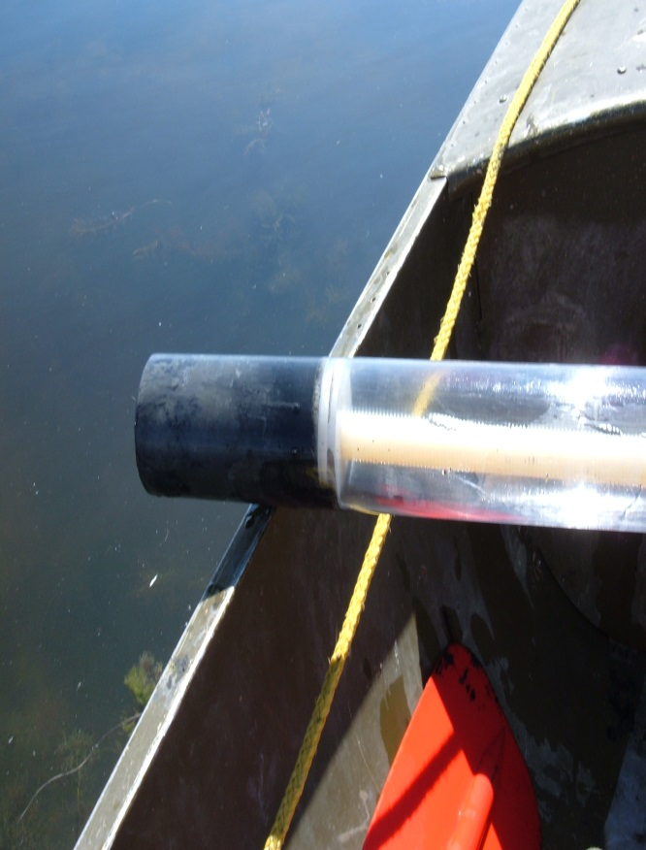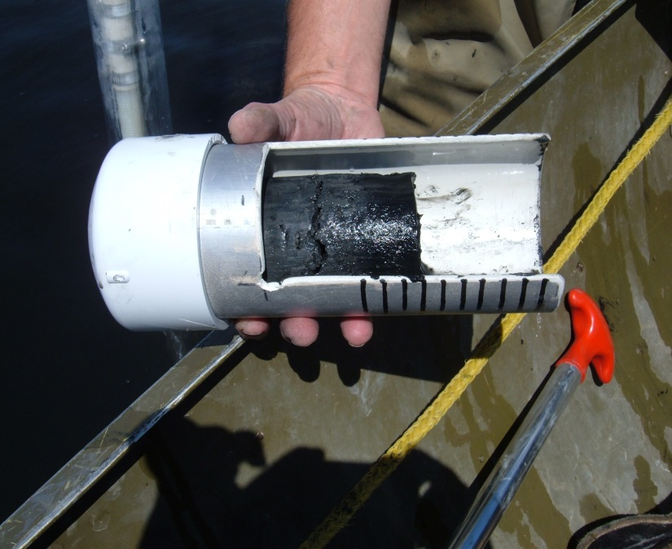polycarbonate sampling tube and plunger, receiving PVC container (with 1cm demarcations) (other needed supplies include chemically clean plastic knife and funnel).

Sampling Protocol for Invertebrates:

1. Prep the sweep net, 5 gal buckets, plastic sieves, and tweezers with an alconox-10% nitric acid-distilled water wash.
2. Weigh sample jars with lids in lab and write weight on label.
3. Locate random position for sampling invertebrates.
4. Using sweep net or buckets, sample the upper layers of sediment, water and vegetation for invertebrates.
5. Collect invertebrates in sieves and rinse with site water for ease of identification.
6. If possible, select Chironomids with plastic tweezers and place in sample jars. Otherwise, select a random sample of available macroinvertebrates.
7. Weigh sample jar regularly to determine when the minimum of 5g has been collected.
8. Attach lid to jar, fill out label and data sheets.
9. Place clear packing tape over the label and around the lid to secure it. Store samples in freezer until submitted to lab

**Supplies:**

-alconox

-distilled water

-10% nitric acid

-5 gal bucket

-sweep net

-sieves

-plastic tweezers

-scale

-pre-cleaned and pre-weighed sample jars and labels (e.g. QEC Inc., Item #3213-0004)

-sharpie or pencil

-data sheets

-GPS unit

-cooler for transport

-gloves

-waders or hip boots

-bug suit and/or spray

Sampling Protocol for Eggs:

Field:

1. Randomly select one egg from each nest by dropping a blade of grass or leaf onto the nest.
2. Wrap egg in alconox-10% nitric acid-distilled water cleaned aluminum foil labeled with specimen ID #.
3. Record species, date, location, nest status and collector.
4. Transport egg carefully back to lab.

Lab:

1. Unwrap egg, and if necessary, clean any debris off gently using a sponge and cool tap water.
2. Dry and weigh whole egg. (Use plastic weigh boats and make sure you tare the scale)
3. Measure egg volume by water displacement [ask Bob for help]
4. Place label with sample ID# on jar. Weigh clean, empty sample jar with lid on and record weight. Place jar in alconox-nitric acid-distilled water cleaned weigh boat (in case egg spills during transfer to jar).
5. Score equator of egg with chemically cleaned serrated knife (several small, gentle strokes work best)
6. Loosen lid from jar. Finish cutting through membrane with sterile or chemically cleaned scalpel blade and empty contents of egg into jar.
7. Weigh full jar and subtract empty weight to calculate weight of egg.
8. Record “contents condition” on data sheet (see menu below).
9. Place clear packing tape over the label and around the lid to secure it. Store samples in freezer until submitted to lab

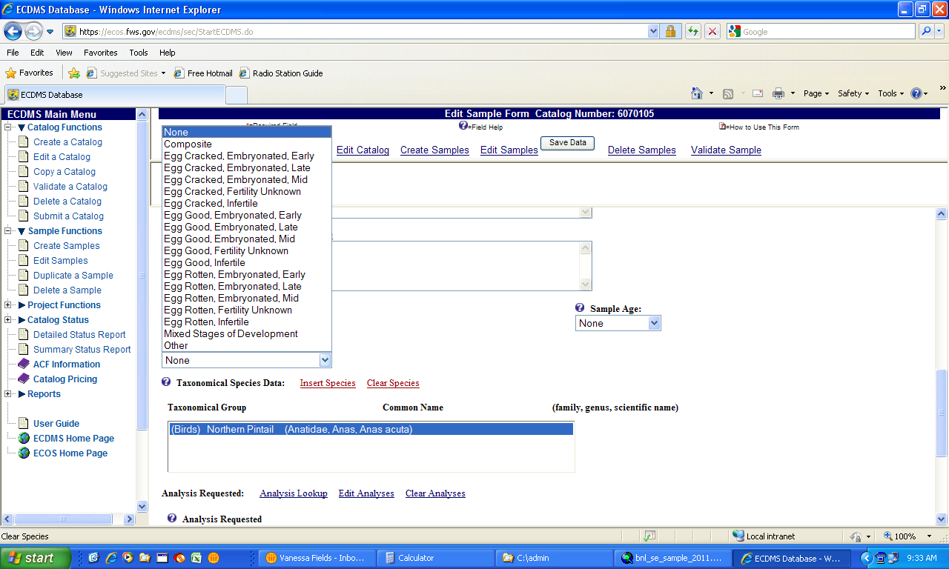**Supplies:**

-alconox

-distilled water

-10% nitric acid

-padded box/cooler for transport

-chemically clean aluminum foil

-pre-cleaned and pre-weighed sample jars and labels (e.g. QEC Inc., Item #3114-0004)

-sharpie or pencil

-data sheets

-plastic weighing boats

-scale (0.1g)

-serrated stainless steel knife

-scalpel blades

-GPS unit

-gloves

-waders or hip boots

-bug suit and/or spray