Sebastjan Poredoš

01-Cestitka
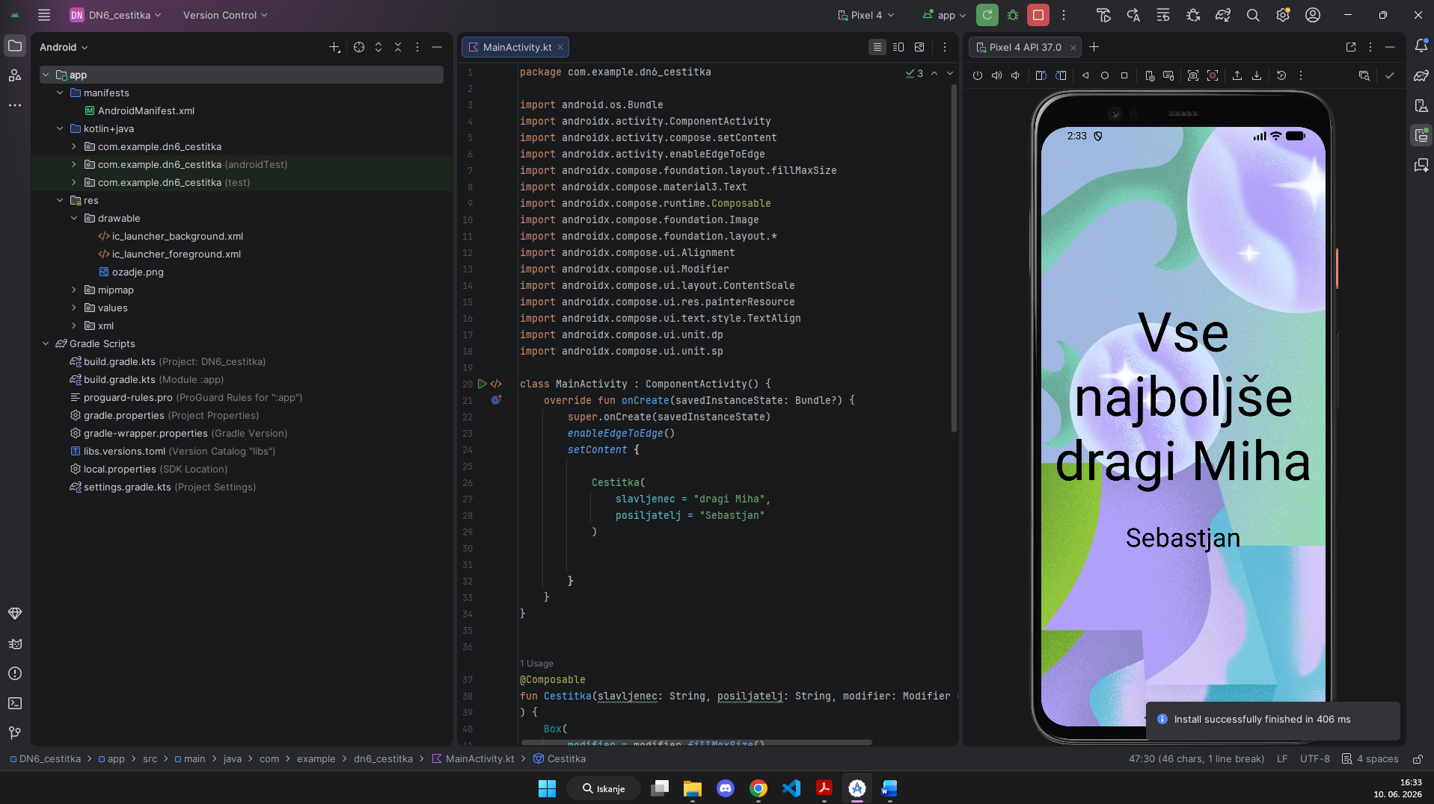

MainActivity.kt
package com.example.dn6_cestitka
import android.os.Bundle
import androidx.activity.ComponentActivity
import androidx.activity.compose.setContent
import androidx.activity.enableEdgeToEdge
import androidx.compose.foundation.layout.fillMaxSize
import androidx.compose.material3.Text
import androidx.compose.runtime.Composable
import androidx.compose.foundation.Image
import androidx.compose.foundation.layout.*
import androidx.compose.ui.Alignment
import androidx.compose.ui.Modifier
import androidx.compose.ui.layout.ContentScale
import androidx.compose.ui.res.painterResource
import androidx.compose.ui.text.style.TextAlign
import androidx.compose.ui.unit.dp
import androidx.compose.ui.unit.sp
class MainActivity : ComponentActivity() {
override fun onCreate(savedInstanceState: Bundle?) {
super.onCreate(savedInstanceState)
enableEdgeToEdge()
setContent {
Cestitka(
slavljenec = "dragi Miha",
posiljatelj = "Sebastjan"
)
}
}
}
@Composable
fun Cestitka(slavljenec: String, posiljatelj: String, modifier: Modifier = Modifier
) {
Box(
modifier = modifier.fillMaxSize()
) {
Image(
painter = painterResource(id = R.drawable.ozadje),
contentDescription = null,
contentScale = ContentScale.Crop,
modifier = Modifier.fillMaxSize()
)
Column(
modifier = Modifier.fillMaxSize(),
horizontalAlignment = Alignment.CenterHorizontally,
verticalArrangement = Arrangement.Center
) {
Text(
text = "Vse najboljše\n$slavljenec",
fontSize = 76.sp,
textAlign = TextAlign.Center
)
Spacer(modifier = Modifier.height(40.dp))
Text(
text = posiljatelj,
fontSize = 36.sp,
textAlign = TextAlign.Center
)
}
}
}

02-Clanek
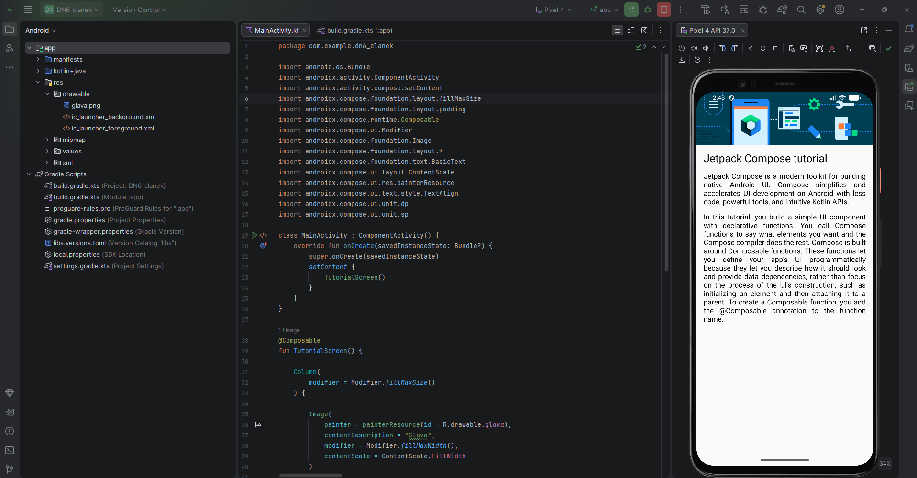

MainActivity.kt
package com.example.dn6_clanek
import android.os.Bundle
import androidx.activity.ComponentActivity
import androidx.activity.compose.setContent
import androidx.compose.foundation.layout.fillMaxSize
import androidx.compose.foundation.layout.padding
import androidx.compose.runtime.Composable
import androidx.compose.ui.Modifier
import androidx.compose.foundation.Image
import androidx.compose.foundation.layout.*
import androidx.compose.foundation.text.BasicText
import androidx.compose.ui.layout.ContentScale
import androidx.compose.ui.res.painterResource
import androidx.compose.ui.text.style.TextAlign
import androidx.compose.ui.unit.dp
import androidx.compose.ui.unit.sp
class MainActivity : ComponentActivity() {
override fun onCreate(savedInstanceState: Bundle?) {
super.onCreate(savedInstanceState)
setContent {
TutorialScreen()
}
}
}
@Composable
fun TutorialScreen() {
Column(
modifier = Modifier.fillMaxSize()
) {
Image(
painter = painterResource(id = R.drawable.glava),
contentDescription = "Glava",
modifier = Modifier.fillMaxWidth(),
contentScale = ContentScale.FillWidth
)
BasicText(
text = "Jetpack Compose tutorial",
modifier = Modifier.padding(16.dp),
style = androidx.compose.ui.text.TextStyle(
fontSize = 24.sp
)
)
Odstavek(
text = "Jetpack Compose is a modern toolkit for building native Android UI. Compose simplifies and accelerates UI development on Android with less code, powerful tools, and intuitive Kotlin APIs."
)
Spacer(modifier = Modifier.height(15.dp))
Odstavek(
text = "In this tutorial, you build a simple UI component with declarative functions. You call Compose functions to say what elements you want and the Compose compiler does the rest. Compose is built around Composable functions. These functions let you define your app's UI programmatically because they let you describe how it should look and provide data dependencies, rather than focus on the process of the UI's construction, such as initializing an element and then attaching it to a parent. To create a Composable function, you add the @Composable annotation to the function name."
)
}
}
@Composable
fun Odstavek(text: String) {
BasicText(
text = text,
modifier = Modifier.padding(horizontal = 16.dp),
style = androidx.compose.ui.text.TextStyle(
textAlign = TextAlign.Justify,
fontSize = 16.sp
)
)
}

03-taskManager (Na sliki je vidna tudi koda)
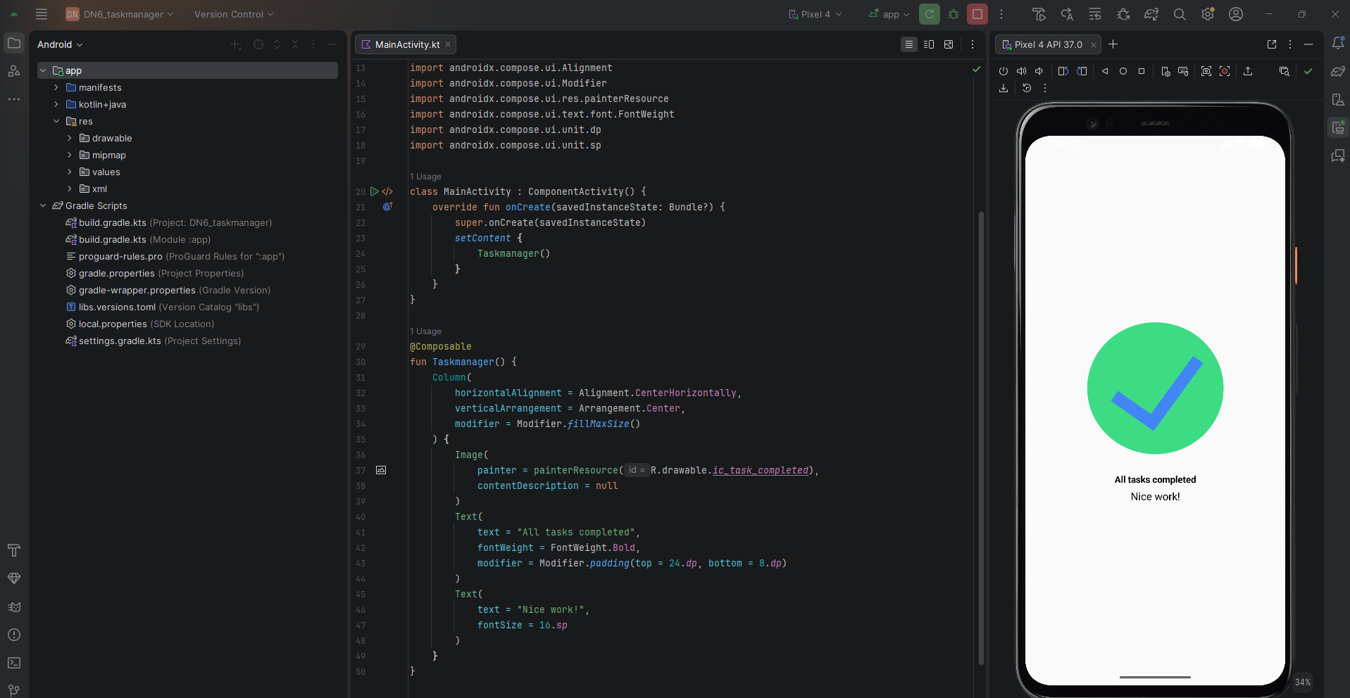

04-kvadrant
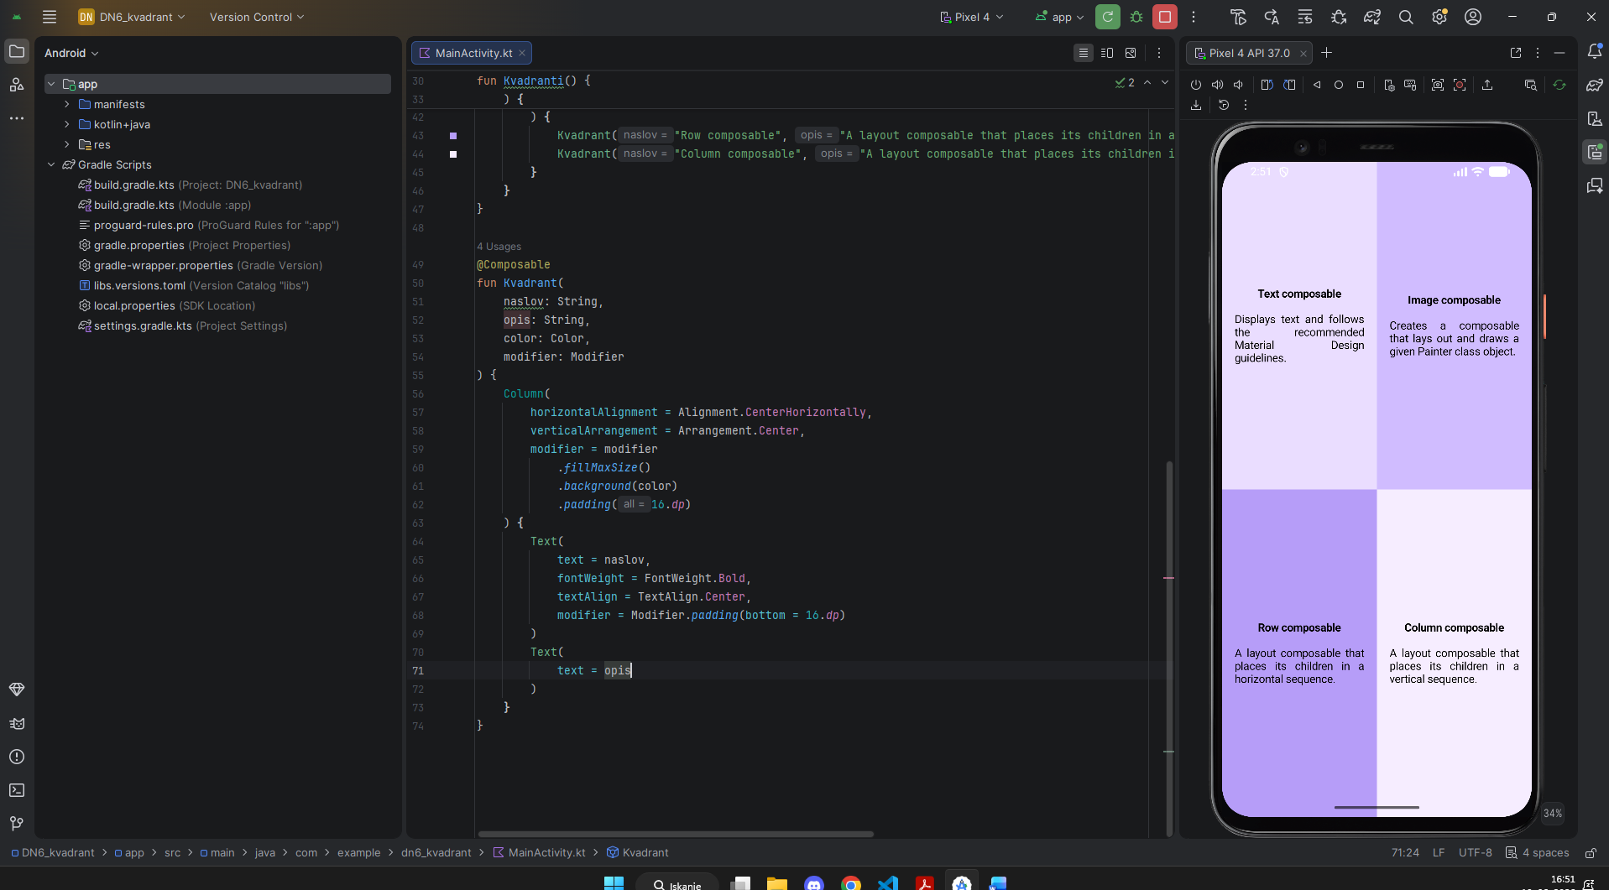

MainActivity.kt
class MainActivity : ComponentActivity() {
override fun onCreate(savedInstanceState: Bundle?) {
super.onCreate(savedInstanceState)
setContent {
Kvadranti()
}
}
}
@Composable
fun Kvadranti() {
Column(
modifier = Modifier.fillMaxSize()
) {
Row(
modifier = Modifier.weight(1f)
) {
Kvadrant("Text composable", "Displays text and follows the recommended Material Design guidelines.", Color(0xFFEADDFF), Modifier.weight(1f))
Kvadrant("Image composable", "Creates a composable that lays out and draws a given Painter class object.", Color(0xFFD0BCFF), Modifier.weight(1f))
}
Row(
modifier = Modifier.weight(1f)
) {
Kvadrant("Row composable", "A layout composable that places its children in a horizontal sequence.", Color(0xFFB69DF8), Modifier.weight(1f))
Kvadrant("Column composable", "A layout composable that places its children in a vertical sequence.", Color(0xFFF6EDFF), Modifier.weight(1f))
}
}
}
@Composable
fun Kvadrant(
naslov: String,
opis: String,
color: Color,
modifier: Modifier
) {
Column(
horizontalAlignment = Alignment.CenterHorizontally,
verticalArrangement = Arrangement.Center,
modifier = modifier
.fillMaxSize()
.background(color)
.padding(16.dp)
) {
Text(
text = naslov,
fontWeight = FontWeight.Bold,
textAlign = TextAlign.Center,
modifier = Modifier.padding(bottom = 16.dp)
)
Text(
text = opis
)
}
}

05-aliens
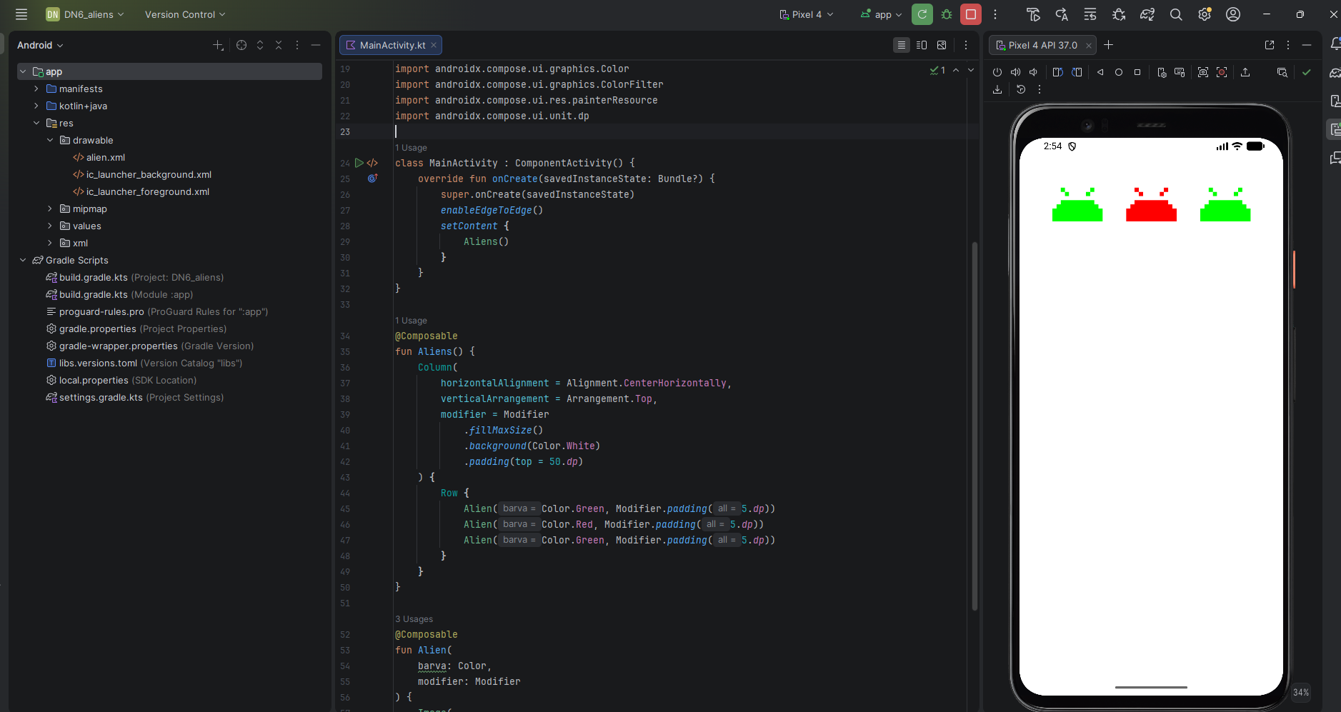

MainActivity.kt
class MainActivity : ComponentActivity() {
override fun onCreate(savedInstanceState: Bundle?) {
super.onCreate(savedInstanceState)
enableEdgeToEdge()
setContent {
Aliens()
}
}
}
@Composable
fun Aliens() {
Column(
horizontalAlignment = Alignment.CenterHorizontally,
verticalArrangement = Arrangement.Top,
modifier = Modifier
.fillMaxSize()
.background(Color.White)
.padding(top = 50.dp)
) {
Row {
Alien(Color.Green, Modifier.padding(5.dp))
Alien(Color.Red, Modifier.padding(5.dp))
Alien(Color.Green, Modifier.padding(5.dp))
}
}
}
@Composable
fun Alien(
barva: Color,
modifier: Modifier
) {
Image(
painter = painterResource(R.drawable.alien),
contentDescription = null,
colorFilter = ColorFilter.tint(barva),
modifier = modifier.size(100.dp)
)
}
06-BusinessCard
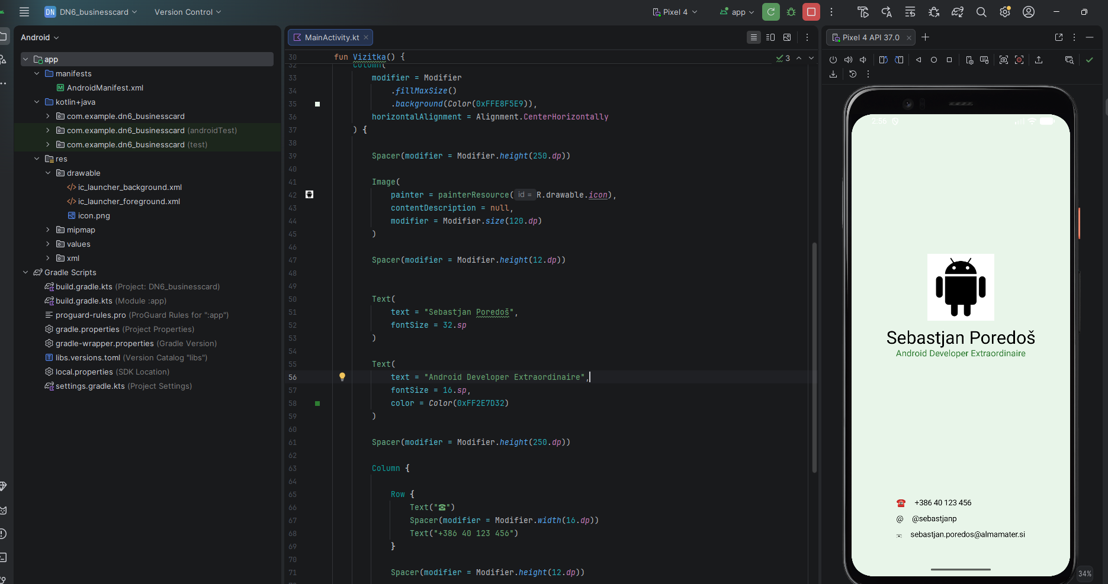

MainActivity.kt
class MainActivity : ComponentActivity() {
override fun onCreate(savedInstanceState: Bundle?) {
super.onCreate(savedInstanceState)
setContent {
Vizitka()
}
}
}
@Composable
fun Vizitka() {
Column(
modifier = Modifier
.fillMaxSize()
.background(Color(0xFFE8F5E9)),
horizontalAlignment = Alignment.CenterHorizontally
) {
Spacer(modifier = Modifier.height(250.dp))
Image(
painter = painterResource(R.drawable.icon),
contentDescription = null,
modifier = Modifier.size(120.dp)
)
Spacer(modifier = Modifier.height(12.dp))
Text(
text = "Sebastjan Poredoš",
fontSize = 32.sp
)
Text(
text = "Android Developer Extraordinaire",
fontSize = 16.sp,
color = Color(0xFF2E7D32)
)
Spacer(modifier = Modifier.height(250.dp))
Column {
Row {
Text("☎")
Spacer(modifier = Modifier.width(16.dp))
Text("+386 40 123 456")
}
Spacer(modifier = Modifier.height(12.dp))
Row {
Text("@")
Spacer(modifier = Modifier.width(16.dp))
Text("@sebastjanp")
}
Spacer(modifier = Modifier.height(12.dp))
Row {
Text("✉")
Spacer(modifier = Modifier.width(16.dp))
Text("sebastjan.poredos@almamater.si")
}
}
}
}

07-Kockanje
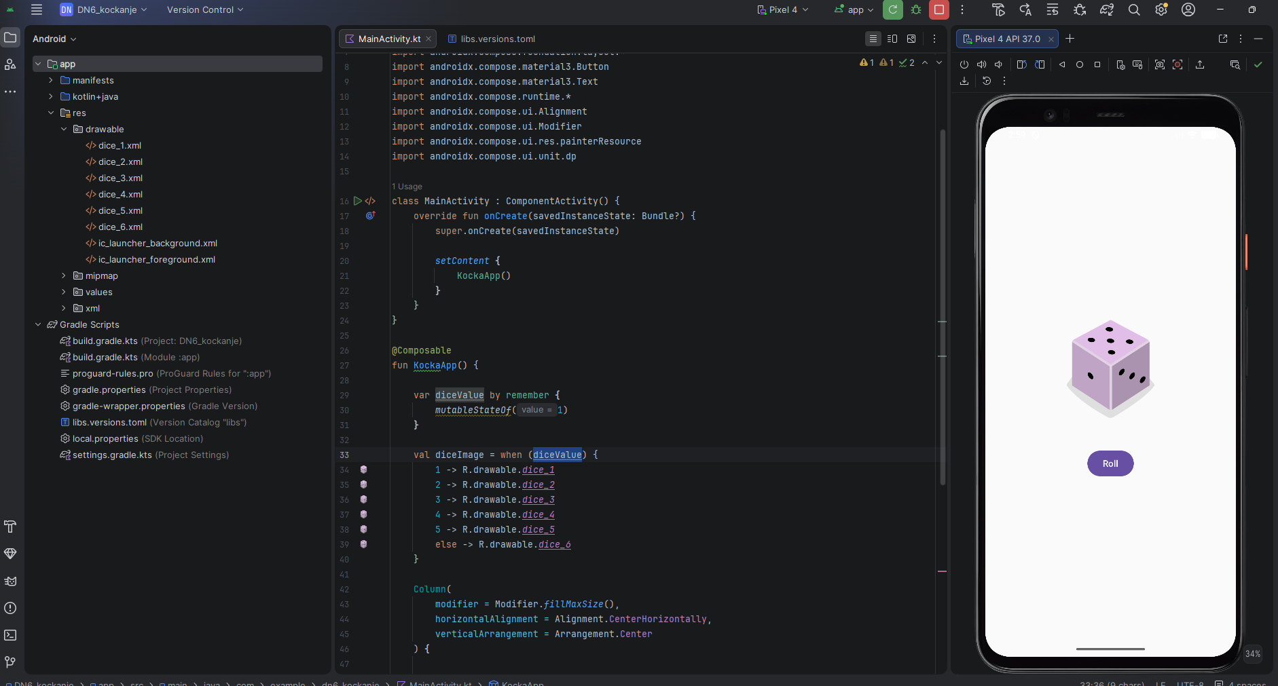

Mainactivity.kt
class MainActivity : ComponentActivity() {
override fun onCreate(savedInstanceState: Bundle?) {
super.onCreate(savedInstanceState)

setContent {
KockaApp()
}
}
}

@Composable
fun KockaApp() {

var diceValue by remember {
mutableStateOf(1)
}

val diceImage = when (diceValue) {
1 -> R.drawable.dice_1
2 -> R.drawable.dice_2
3 -> R.drawable.dice_3
4 -> R.drawable.dice_4
5 -> R.drawable.dice_5
else -> R.drawable.dice_6
}

Column(
modifier = Modifier.fillMaxSize(),
horizontalAlignment = Alignment.CenterHorizontally,
verticalArrangement = Arrangement.Center
) {

Image(
painter = painterResource(id = diceImage),
contentDescription = "Kocka",
modifier = Modifier.size(200.dp)
)

Spacer(modifier = Modifier.height(24.dp))

Button(
onClick = {
diceValue = (1..6).random()
}
) {
Text("Roll")
}
}
}

08-lemons
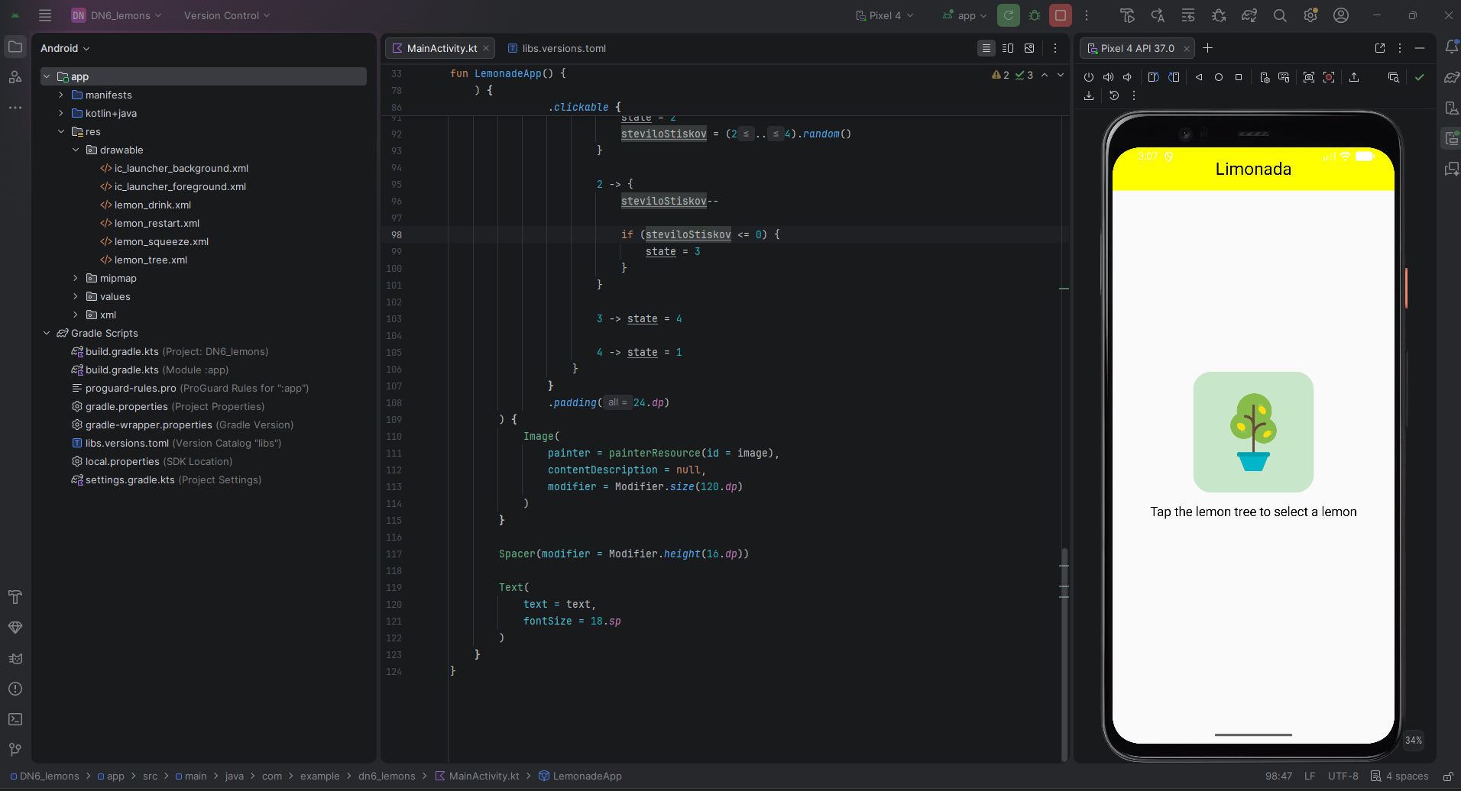

Mainactivity.kt
class MainActivity : ComponentActivity() {
override fun onCreate(savedInstanceState: Bundle?) {
super.onCreate(savedInstanceState)

setContent {
LemonadeApp()
}
}
}

@Composable
fun LemonadeApp() {

var state by remember {
mutableStateOf(1)
}

var steviloStiskov by remember {
mutableStateOf(0)
}

val image = when (state) {
1 -> R.drawable.lemon_tree
2 -> R.drawable.lemon_squeeze
3 -> R.drawable.lemon_drink
else -> R.drawable.lemon_restart
}

val text = when (state) {
1 -> "Tap the lemon tree to select a lemon"
2 -> "Keep tapping the lemon to squeeze it"
3 -> "Tap the lemonade to drink it"
else -> "Tap the empty glass to start again"
}

Column(
modifier = Modifier
.fillMaxSize(),
horizontalAlignment = Alignment.CenterHorizontally,
) {

Text(
text = "Limonada",
fontSize = 24.sp,
modifier = Modifier
.fillMaxWidth()
.background(Color.Yellow)
.padding(vertical = 16.dp),
textAlign = TextAlign.Center
)
}

Column(
modifier = Modifier.fillMaxSize(),
horizontalAlignment = Alignment.CenterHorizontally,
verticalArrangement = Arrangement.Center
) {

Box(
modifier = Modifier
.background(
Color(0xFFC8E6C9),
RoundedCornerShape(25.dp)
)
.clickable {

when (state) {

1 -> {
state = 2
steviloStiskov = (2..4).random()
}

2 -> {
steviloStiskov--

if (steviloStiskov <= 0) {
state = 3
}
}

3 -> state = 4

4 -> state = 1
}
}
.padding(24.dp)
) {
Image(
painter = painterResource(id = image),
contentDescription = null,
modifier = Modifier.size(120.dp)
)
}

Spacer(modifier = Modifier.height(16.dp))

Text(
text = text,
fontSize = 18.sp
)
}
}

09-TipCalculator (Srecanje5_naloga je ista, ker smo takrat dobili točno to nalogo za dokončati)
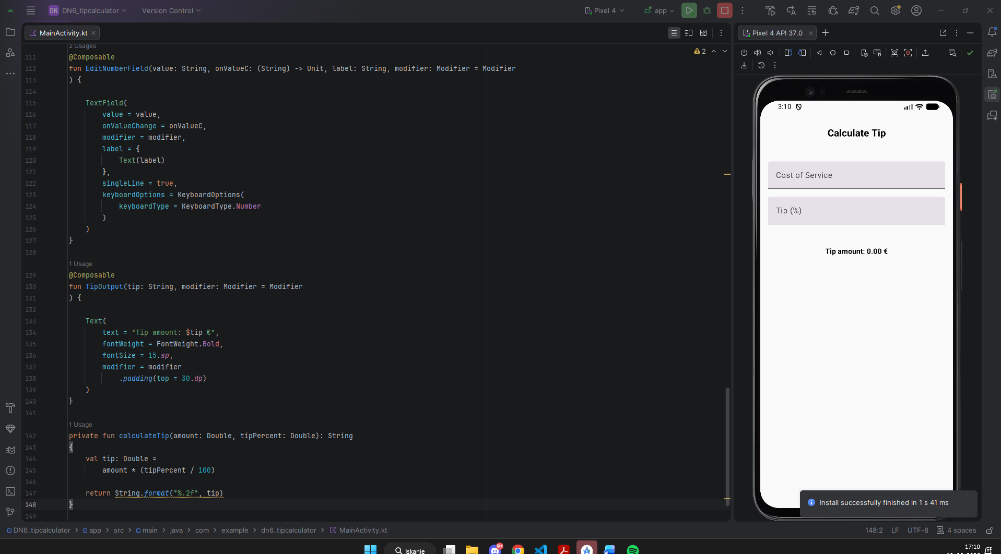

Mainactivity.kt
class MainActivity : ComponentActivity() {
override fun onCreate(savedInstanceState: Bundle?) {
super.onCreate(savedInstanceState)
enableEdgeToEdge()
setContent {
TipTimeLayout()
}
}
}
@Composable
fun TipTimeLayout(
modifier: Modifier = Modifier
) {
var amountInput: String by remember { mutableStateOf("")
}
var tipPercentInput: String by remember { mutableStateOf("")
}
val amount: Double =
amountInput.toDoubleOrNull() ?: 0.0
val tipPercent: Double =
tipPercentInput.toDoubleOrNull() ?: 0.0
val tip: String =
calculateTip(amount, tipPercent)
Column(
modifier = Modifier
.fillMaxSize()
.statusBarsPadding(),
horizontalAlignment = Alignment.CenterHorizontally,
verticalArrangement = Arrangement.Top
) {
Heading(
modifier = Modifier.padding(30.dp)
)
EditNumberField(
value = amountInput,
onValueC = {
amountInput = it
},
label = "Cost of Service",
modifier = Modifier
.fillMaxWidth()
.padding(16.dp)
)
EditNumberField(
value = tipPercentInput,
onValueC = {
tipPercentInput = it
},
label = "Tip (%)",
modifier = Modifier
.fillMaxWidth()
.padding(horizontal = 16.dp)
)
TipOutput(
tip = tip,
modifier = Modifier.padding(16.dp)
)
}
}
@Composable
fun Heading(
modifier: Modifier = Modifier
) {
Text(
text = "Calculate Tip",
fontWeight = FontWeight.Bold,
fontSize = 20.sp,
modifier = modifier
)
}
@Composable
fun EditNumberField(value: String, onValueC: (String) -> Unit, label: String, modifier: Modifier = Modifier
) {
TextField(
value = value,
onValueChange = onValueC,
modifier = modifier,
label = {
Text(label)
},
singleLine = true,
keyboardOptions = KeyboardOptions(
keyboardType = KeyboardType.Number
)
)
}
@Composable
fun TipOutput(tip: String, modifier: Modifier = Modifier
) {
Text(
text = "Tip amount: $tip €",
fontWeight = FontWeight.Bold,
fontSize = 15.sp,
modifier = modifier
.padding(top = 30.dp)
)
}
private fun calculateTip(amount: Double, tipPercent: Double): String
{
val tip: Double =
amount * (tipPercent / 100)
return String.format("%.2f", tip)
}

10-ArtSpaceApp
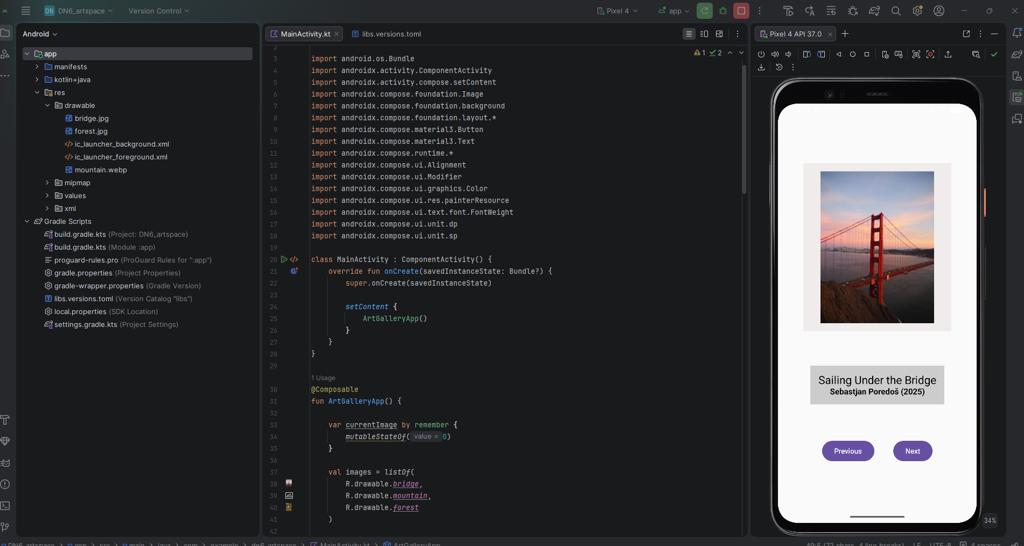

MainActivity.kt
@Composable
fun ArtGalleryapp() {

var currentImage by remember {
mutableStateOf(0)
}

val images = listOf(
R.drawable.bridge,
R.drawable.mountain,
R.drawable.forest
)

val titles = listOf(
"Sailing Under the Bridge",
"Mount Everest",
"Gozd"
)

val years = listOf(
"2025",
"2024",
"2023"
)

Column(
modifier = Modifier
.fillMaxSize()
.padding(50.dp),

horizontalAlignment = Alignment.CenterHorizontally,
verticalArrangement = Arrangement.SpaceEvenly
) {

ArtImage(images[currentImage])

ArtDescription(
title = titles[currentImage],
year = years[currentImage]
)

Row(
modifier = Modifier.fillMaxWidth(),
horizontalArrangement = Arrangement.SpaceEvenly
) {

Button(
onClick = {
currentImage--

if (currentImage < 0) {
currentImage = images.size - 1
}
}
) {
Text("Previous")
}

Button(
onClick = {
currentImage++

if (currentImage >= images.size) {
currentImage = 0
}
}
) {
Text("Next")
}
}
}
}

@Composable
fun ArtImage(imageRes: Int) {

Column(
modifier = Modifier
.background(Color(0xFFF0ECEC))
.padding(16.dp)
) {
Image(
painter = painterResource(id = imageRes),
contentDescription = null,
modifier = Modifier.size(300.dp)
)
}
}

@Composable
fun ArtDescription(
title: String,
year: String
) {

Column(
modifier = Modifier
.background(Color.LightGray)
.padding(16.dp),
horizontalAlignment = Alignment.CenterHorizontally
) {

Text(
text = title,
fontSize = 22.sp
)

Text(
text = "Sebastjan Poredoš ($year)",
fontSize = 16.sp,
fontWeight = FontWeight.Bold
)
}
}

