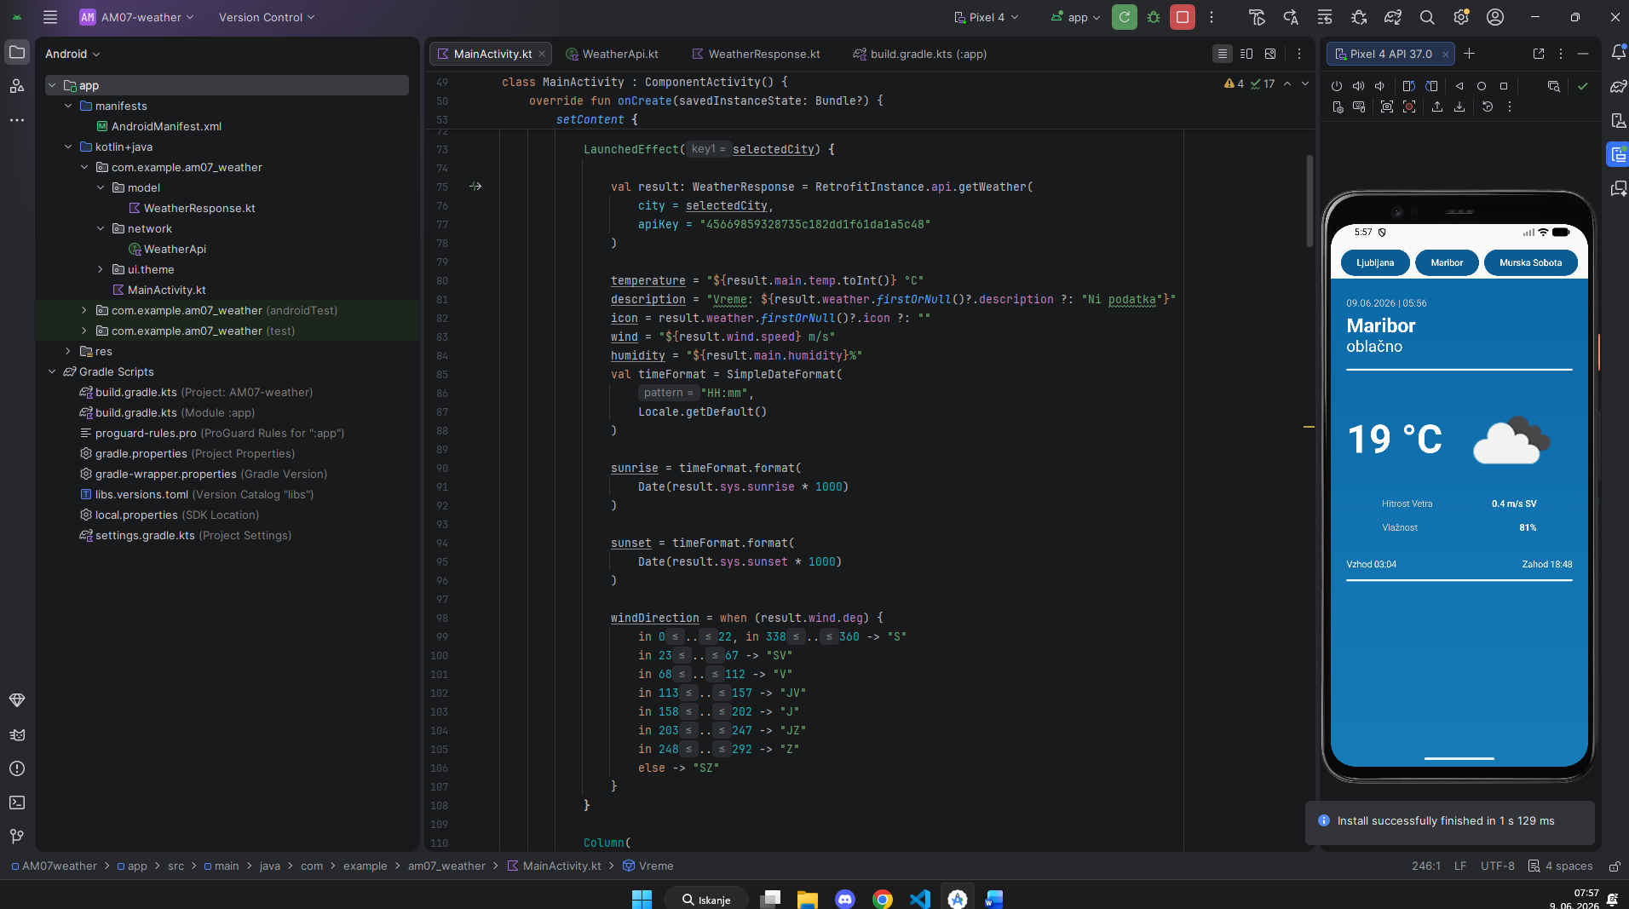

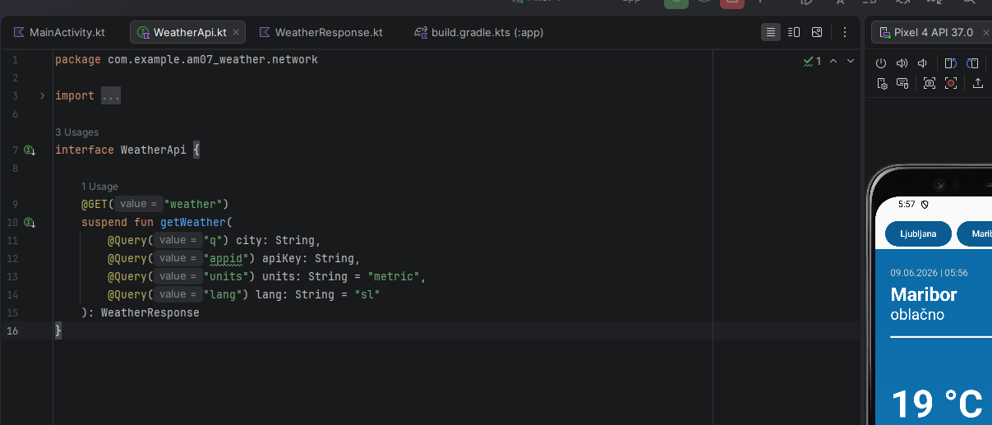

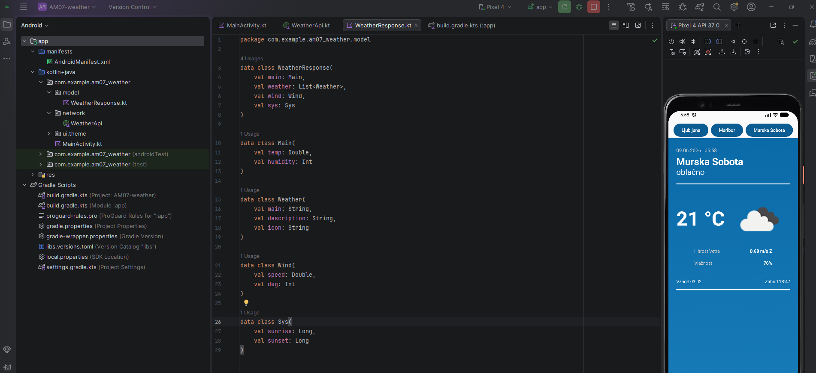

MainActivity.kt
class MainActivity : ComponentActivity() {
override fun onCreate(savedInstanceState: Bundle?) {
super.onCreate(savedInstanceState)
enableEdgeToEdge()
setContent {

var temperature by remember { mutableStateOf("") }
var description by remember { mutableStateOf("") }
var selectedCity by remember {
mutableStateOf("Murska Sobota")
}
var wind by remember { mutableStateOf("") }
var humidity by remember { mutableStateOf("") }
var sunrise by remember { mutableStateOf("") }
var sunset by remember { mutableStateOf("") }
var windDirection by remember { mutableStateOf("") }

val currentDateTime = SimpleDateFormat(
"dd.MM.yyyy | HH:mm",
Locale.getDefault()
).format(Date())
var icon by remember { mutableStateOf("") }

LaunchedEffect(selectedCity) {

val result: WeatherResponse = RetrofitInstance.api.getWeather(
city = selectedCity,
apiKey = "45669859328735c182dd1f61da1a5c48"
)

temperature = "${result.main.temp.toInt()} °C"
description = "Vreme: ${result.weather.firstOrNull()?.description ?: "Ni podatka"}"
icon = result.weather.firstOrNull()?.icon ?: ""
wind = "${result.wind.speed} m/s"
humidity = "${result.main.humidity}%"
val timeFormat = SimpleDateFormat(
"HH:mm",
Locale.getDefault()
)

sunrise = timeFormat.format(
Date(result.sys.sunrise * 1000)
)

sunset = timeFormat.format(
Date(result.sys.sunset * 1000)
)

windDirection = when (result.wind.deg) {
in 0..22, in 338..360 -> "S"
in 23..67 -> "SV"
in 68..112 -> "V"
in 113..157 -> "JV"
in 158..202 -> "J"
in 203..247 -> "JZ"
in 248..292 -> "Z"
else -> "SZ"
}
}

Column(
modifier = Modifier

) {
Row(
modifier = Modifier
.fillMaxWidth()
.padding(top = 35.dp),
horizontalArrangement = Arrangement.Center
) {

Button(
onClick = { selectedCity = "Ljubljana" },
colors = ButtonDefaults.buttonColors(
containerColor = Color(0xFF0A5C93)
)
) {
Text("Ljubljana")
}

Spacer(modifier = Modifier.width(8.dp))

Button(
onClick = { selectedCity = "Maribor" },
colors = ButtonDefaults.buttonColors(
containerColor = Color(0xFF0A5C93)
)
) {
Text("Maribor")
}

Spacer(modifier = Modifier.width(8.dp))

Button(
onClick = { selectedCity = "Murska Sobota" },
colors = ButtonDefaults.buttonColors(
containerColor = Color(0xFF0A5C93)
)
) {
Text("Murska Sobota")
}
}

Vreme(
city = selectedCity,
temp = temperature,
description = description,
dateTime = currentDateTime,
icon = icon,
wind = wind,
windDirection = windDirection,
humidity = humidity,
sunrise = sunrise,
sunset = sunset
)
}

}
}
}

@Composable
fun Vreme(
temp: String,
description: String,
city: String,
dateTime: String,
icon: String,
wind: String,
windDirection: String,
humidity: String,
sunrise: String,
sunset: String,
modifier: Modifier = Modifier
) {

Box(
modifier = Modifier
.fillMaxSize()
.background(
Brush.verticalGradient(
listOf(
Color(0xFF0B6AA8),
Color(0xFF177BB8)
)
)
)
) {

Column(
modifier = Modifier
.fillMaxSize()
.statusBarsPadding(),
horizontalAlignment = Alignment.CenterHorizontally,
verticalArrangement = Arrangement.Top
) {

Spacer(modifier = Modifier.height(5.dp))

Row(
modifier = Modifier
.fillMaxWidth()
.padding(horizontal = 24.dp),
horizontalArrangement = Arrangement.Start
) {
Column(
horizontalAlignment = Alignment.Start
) {
Text(
text = dateTime,
color = Color.LightGray,
fontSize = 15.sp
)

Spacer(modifier = Modifier.height(8.dp))

Text(
text = city,
color = Color.White,
fontSize = 30.sp,
fontWeight = FontWeight.Bold
)

Text(
text = description.replace("Vreme: ", ""),
color = Color.White,
fontSize = 24.sp
)
}
}

Spacer(modifier = Modifier.height(20.dp))

HorizontalDivider(
modifier = Modifier.padding(horizontal = 24.dp),
color = Color.White,
thickness = 3.dp
)

Spacer(modifier = Modifier.height(20.dp))

Row(
modifier = Modifier
.fillMaxWidth()
.padding(horizontal = 24.dp),
horizontalArrangement = Arrangement.Start,
verticalAlignment = Alignment.CenterVertically
) {

Text(
text = temp,
color = Color.White,
fontSize = 60.sp,
fontWeight = FontWeight.Bold
)

Spacer(modifier = Modifier.width(20.dp))

AsyncImage(
model = "https://openweathermap.org/img/wn/${icon}@2x.png",
contentDescription = null,
modifier = Modifier.size(170.dp)
)
}

Spacer(modifier = Modifier.height(5.dp))

Row(
modifier = Modifier.fillMaxWidth(),
horizontalArrangement = Arrangement.Center
) {

Column {

Row(
modifier = Modifier.fillMaxWidth(0.6f),
horizontalArrangement = Arrangement.SpaceBetween
) {
Text(
text = "Hitrost Vetra",
color = Color.LightGray
)

Text(
text = "$wind $windDirection",
color = Color.White,
fontWeight = FontWeight.Bold
)
}

Spacer(modifier = Modifier.height(20.dp))

Row(
modifier = Modifier.fillMaxWidth(0.6f),
horizontalArrangement = Arrangement.SpaceBetween
) {
Text(
text = "Vlažnost",
color = Color.LightGray
)

Text(
text = humidity,
color = Color.White,
fontWeight = FontWeight.Bold
)
}
}
}

Spacer(modifier = Modifier.height(40.dp))

Row(
modifier = Modifier
.fillMaxWidth()
.padding(horizontal = 24.dp),
horizontalArrangement = Arrangement.SpaceBetween
) {
Text("Vzhod $sunrise", color = Color.White)
Text("Zahod $sunset", color = Color.White)
}

Spacer(modifier = Modifier.height(15.dp))

HorizontalDivider(
modifier = Modifier.padding(horizontal = 24.dp),
color = Color.White,
thickness = 3.dp
)
}
}
}

object RetrofitInstance {

private const val BASE_URL = "https://api.openweathermap.org/data/2.5/"

val api: WeatherApi by lazy {
Retrofit.Builder()
.baseUrl(BASE_URL)
.addConverterFactory(GsonConverterFactory.create())
.build()
.create(WeatherApi::class.java)
}
}

