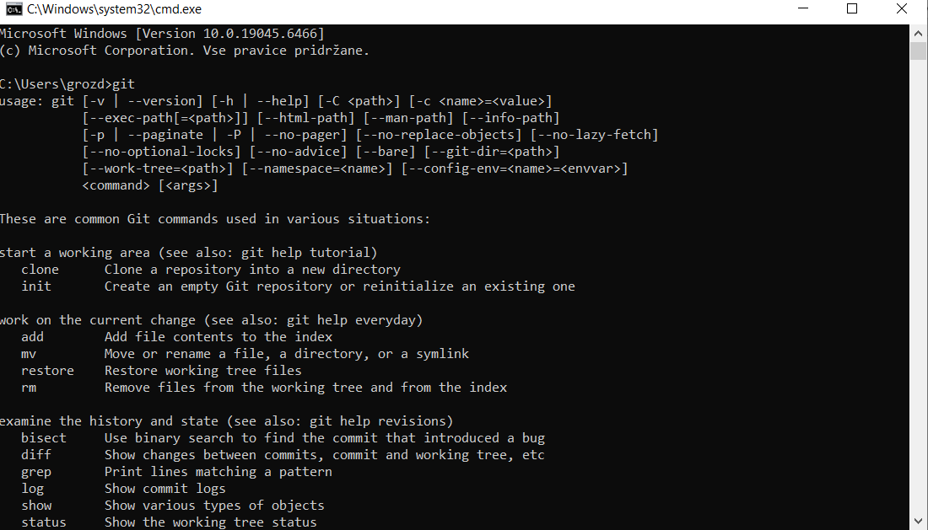
https://github.com/almaGrozdanovic2026

