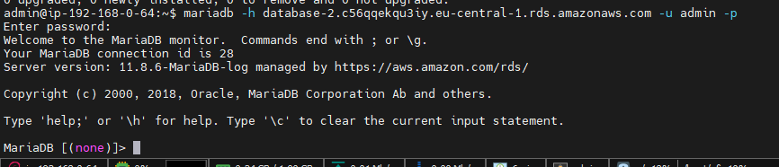
mariadb -h database-2.c56qqekqu3iy.eu-central-1.rds.amazonaws.com -u admin -p

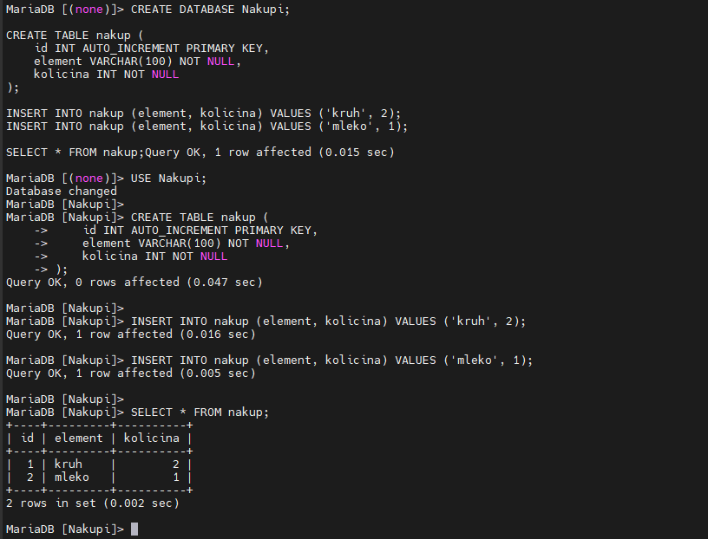

CREATE DATABASE Nakupi;
USE Nakupi;

CREATE TABLE nakup (
id INT AUTO_INCREMENT PRIMARY KEY,
element VARCHAR(100) NOT NULL,
kolicina INT NOT NULL
);

INSERT INTO nakup (element, kolicina) VALUES ('kruh', 2);
INSERT INTO nakup (element, kolicina) VALUES ('mleko', 1);

SELECT * FROM nakup;

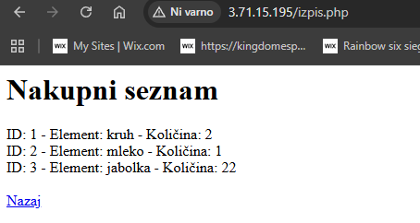

mariadb -h database-2.c56qqekqu3iy.eu-central-1.rds.amazonaws.com -u admin -p
