*UREG-QF-14*



Republic of the Philippines

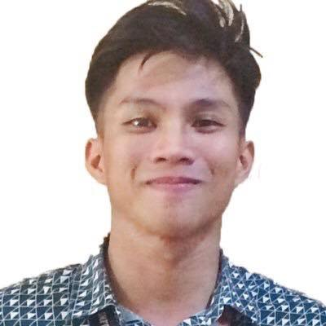

**CAVITE STATE UNIVERSITY**

**Don Severino delas Alas Campus**

Indang, Cavite

# APPLICATION FOR GRADUATION

**Personal Information**

Name: ______Lorence_____________Versola________________Almadrigo_________ Sex: ___M____ Age: __22______

(First Name) (Middle Name) (Family Name)

Date of Birth: _____October 29, 1997______________________ Phone No.:__09959700225 / 09652762309______

Place of Birth: _Quezon City___________________________________________________________________________

Present Address: ____BLK 62, LOT 4 HOLIDAY HOMES, BICLATAN_GENERAL TRIAS CAVITE_____________________

Permanent Address: _ BLK 62, LOT 4 HOLIDAY HOMES, BICLATAN GENERAL TRIAS CAVITE ____________________

**Educational Background**

Elementary: ___General Aloña Memorial Elementary School_________________________Year Attended: __2006 - 2011___

High School: __Governor Ferrer Memorial National High School Biclatan_______________ Year Attended: __2011 - 2014___

Address: __Brgy. Biclatan General Trias Cavite_________________________________________________________

School/College attended other than Cavite State University

____N/A_______________________________________________________ Year Attended: ____N/A___________

Address: ____N/A_________________________________________________________________________________

**Date of Admission to CvSU**: __March 2014_____________________

Semester and Academic Year Attended:

First Semester ____2014 – 2015_______ Second Semester ____2014 – 2015_______ Summer _______________

First Semester _________–___________ Second Semester ____2015 – 2016_______ Summer _______________

First Semester ____2016 – 2017_______ Second Semester ____2016 – 2017_______ Summer _______________

First Semester ____2017 – 2018_______ Second Semester ____2017 – 2018_______ Summer _______________

First Semester ____2018 – 2019_______ Second Semester ____2018 – 2019_______ Summer ___2018 - 2019__

First Semester ____2019 – 2020_______ Second Semester ____2019 – 2020_______ Summer _______________

First Semester _____________________ Second Semester _____________________ Summer _______________

First Semester _____________________ Second Semester _____________________ Summer _______________

First Semester _____________________ Second Semester _____________________ Summer _______________

Subjects Currently Enrolled: Unit

________RESIDENCY______ _____0______

_________________________ ____________

_________________________ ____________

____________1____________ ____________

Total ____________

**================================================================================================**

I have the honor to apply for graduation in the course leading to the degree of _______Bachelor of Science______ major in _Information Technology_____ this Graduation 20_20_.

It is understood that I shall be entitled to a diploma / certificate if and after I have satisfactorily completed all the requirements for graduation including but not limited to the submission of my bound manuscript / special problem / narrative reports and clearance for my graduation in this University.



______LORENCE V.ALAMADRIGO_______

Printed name and Signature of Applicant

Noted:

______ GLADYS G. PEREY____________ ____________________________________

Registration Adviser College Registrar

Recommending Approval:

_______ _MARLON R. PEREÑA__________ ____DAVID L. CERO, PhD, *ASEAN* Engr.___

Department Chairperson College Dean

Date: _______________________________ Date: _______________________________