

Republic of the Philippines

**CAVITE STATE UNIVERSITY**

**Don Severino delas Alas Campus**

Indang, Cavite

**COLLEGE OF ENGINEERING AND INFORMATION TECHNLOGY**

**Department of Information Technology**

**COLLEGE OF ENGINEERING AND INFORMATION TECHNOLOGY**

**DEPARTMENT OF INFORMATION TECHNOLOGY**

**Accomplishment Report for Undergraduate Thesis**

**First Semester, AY 2020 – 2021**

Name of Researcher/s: **Almadrigo, Lorence V. / Gado, John Philip V.**

Course: **BSIT**

Title of the Study: **“DEVELOPMENT OF E-LEARNING SYSTEM FOR SCIENCE, TECHNOLOGY AND SOCIETY SUBJECT FOR THE STUDENTS UNDER K-12 PROGRAM IN CAVITE STATE UNIVERSITY – INDANG MAIN CAMPUS”**

**I. SHORT BACKGROUND / DESCRIPTION OF THE STUDY**

Mobile phones, Computers, Internet connections and other gadgets that can be useful to them are very common for this era. Most of the time, peoples are also relying in this medias to gather information, find jobs, make a business, order some foods, watch movies, and also to work, to travel, to entertain themselves. There are so many things that we can do with the use of the modern gadgets and with the help of internet.

This study is going to help not only the students, but also the instructors and professors. This will help the students to learn anywhere or anytime, as long as they have access on internet. The instructors and professors can now upload their manuals or soft copy of the lectures and distribute to all of its handled students. These are the simple features and purpose of this study.

**II. DETAILED ACCOMPLISHMENT REPORT**

**Week 1 – August 27 – 31, 2021**

*Actions Taken*

* *Creating the Graphic User Interface (GUI) of the system for user login.*

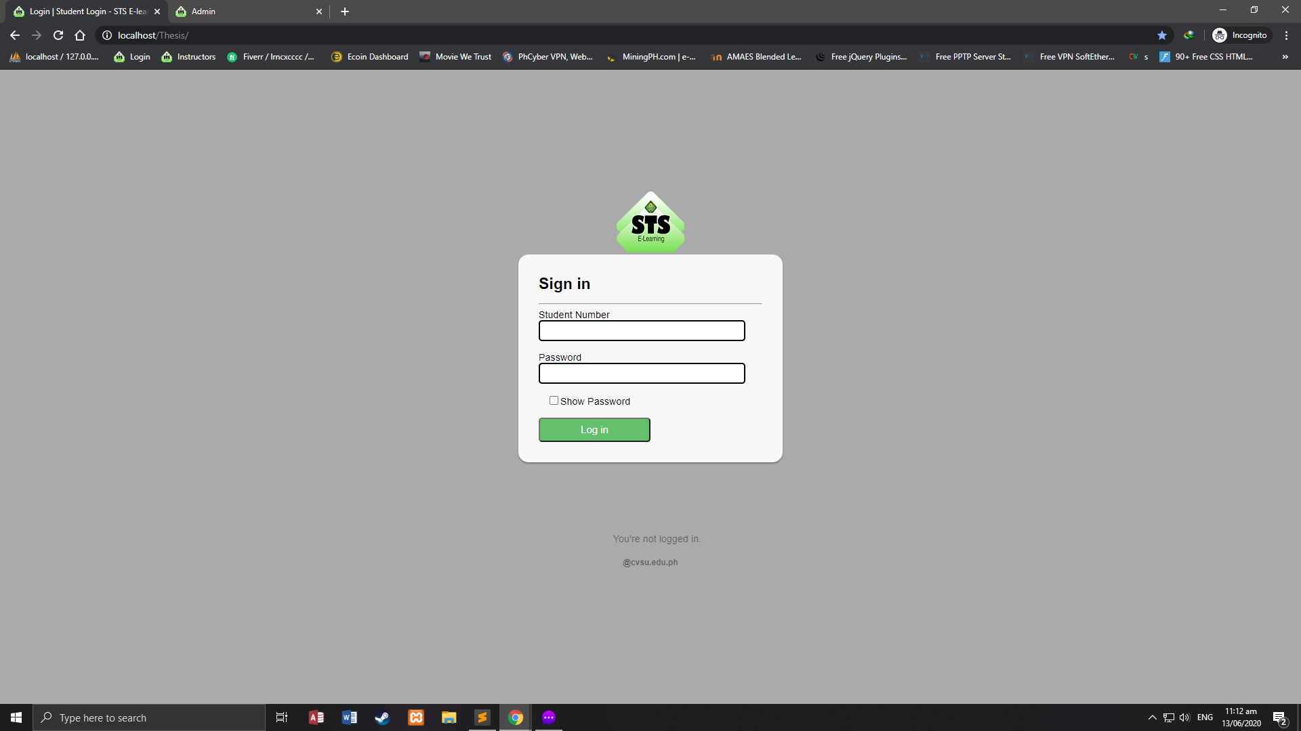

Figure 1: User Login Interface

User login interface is used for the users to login their accounts. The accounts will be provided by the administrator. Once you enrolled all of your subjects, the admin will automatically add your account to their database. This is to secure that all of the users of this system are enrolled.

*Accomplishment / Output and Remarks*

* *Complete 60%*

**Week 2 – September 3 – 7, 2021**

*Actions Taken*

* *Creating the Graphic User Interface (GUI) for Account Management Module.*
* *Creating database and syntax.*

*Accomplishment / Output and Remarks*

* 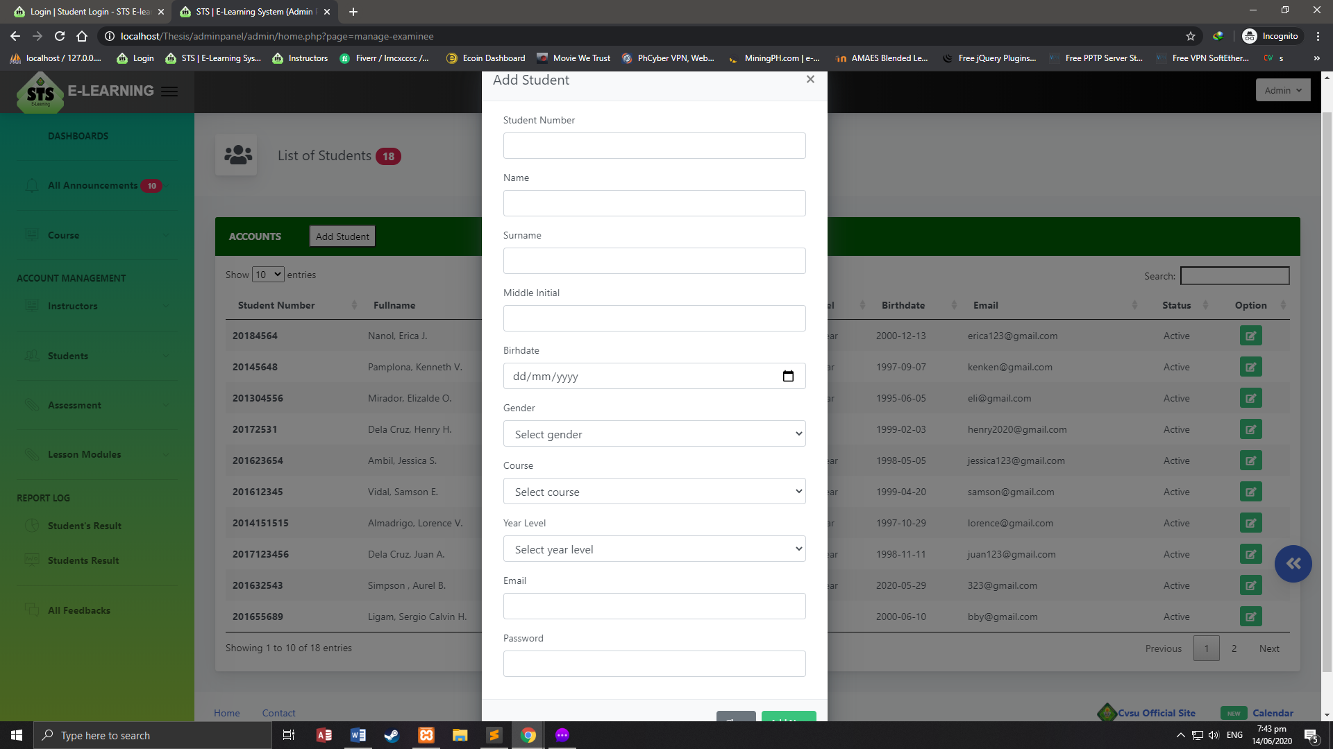*50% complete*

Figure 2.1: Account Management Module (Students)

This is a sample output of Account Management Module. Account Management Module has three level of access, the students, instructors and administrator. For students, they can only change and update their profile and password. And the administrator, they can manage all the files and profiles inserted into the system database.

**Week 3 – September 10 – 14, 2021**

*Actions Taken*

* *Creating the Graphic User Interface (GUI) for Account Management Module.*

*Accomplishment / Output and Remarks*

* 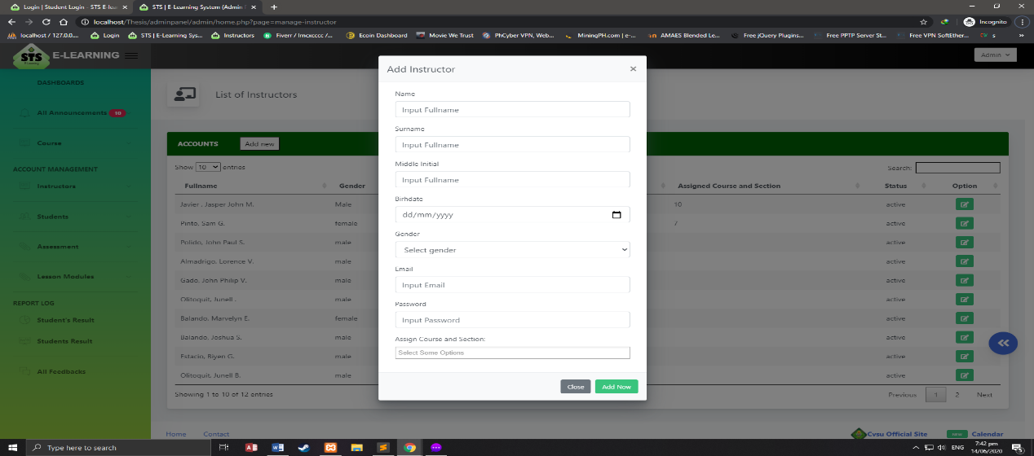*Complete 70%*

Figure 2.2: Account Management Module (Instructors)

This is a sample output of Account Management Module. Account Management Module has three level of access, the students, instructors and administrator. For instructors, they can see all the students registered to this instructor. And the administrator, they can manage all the files and profiles inserted into the system database.

**Week 4 – September 17 – 21, 2021**

*Actions Taken*

* *Creating Graphic User Interface (GUI) for Report Module.*

*Accomplishment / Output and Remarks*

* *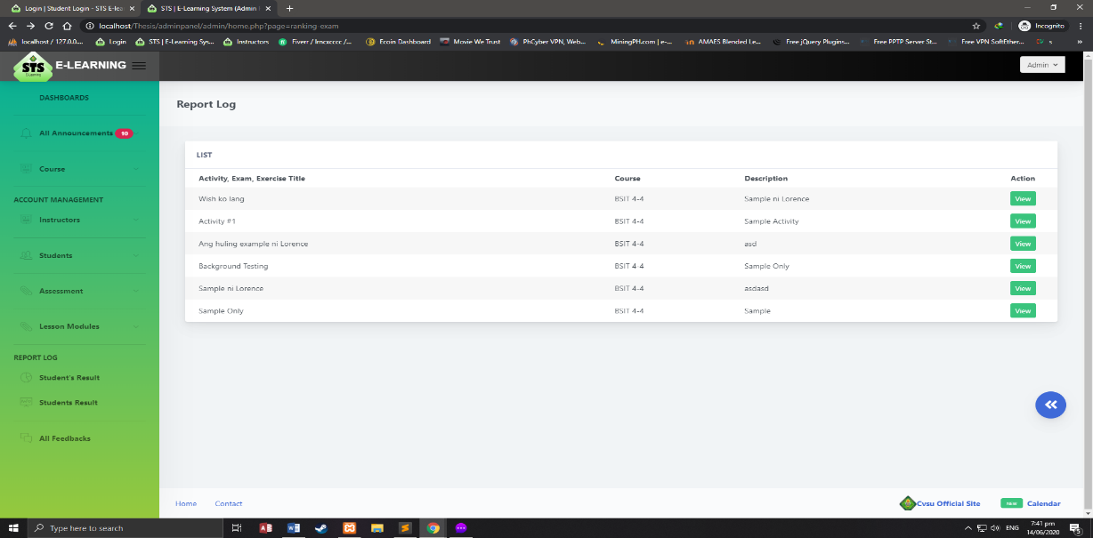Complete 70%*

Figure 3: Report Module

This is just a sample output of Report Module. Report Module is use to view all the list of students who enrolled in this subject, list of instructors that handles Science, Technology, and Society (STS) subject. This can only be access by the administrator.

**Week 5 September 24 – 28, 2021**

*Actions Taken*

* *Creating Graphic User Interface (GUI) for Lesson Module.*

*Accomplishment / Output and Remarks*

* 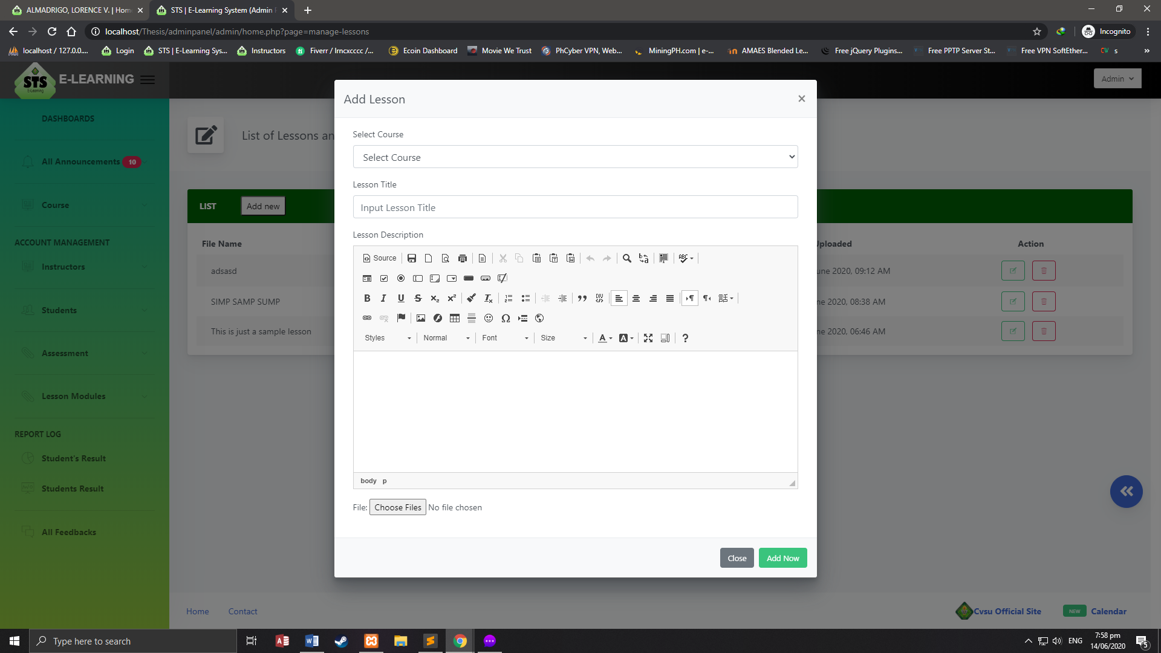*Complete 70%*

Figure 4: Lesson Module

This is a sample output for Lesson Module. This module is consisting of all the references that a student needed. This references can be uploaded by the administrator and instructors only. Students can only view the uploaded lessons.

**Week 6 – October 2 – 6, 2021**

*Actions Taken*

* *Creating the Graphic User Interface (GUI) for Announcement Module.*

*Accomplishment / Output and Remarks*

* *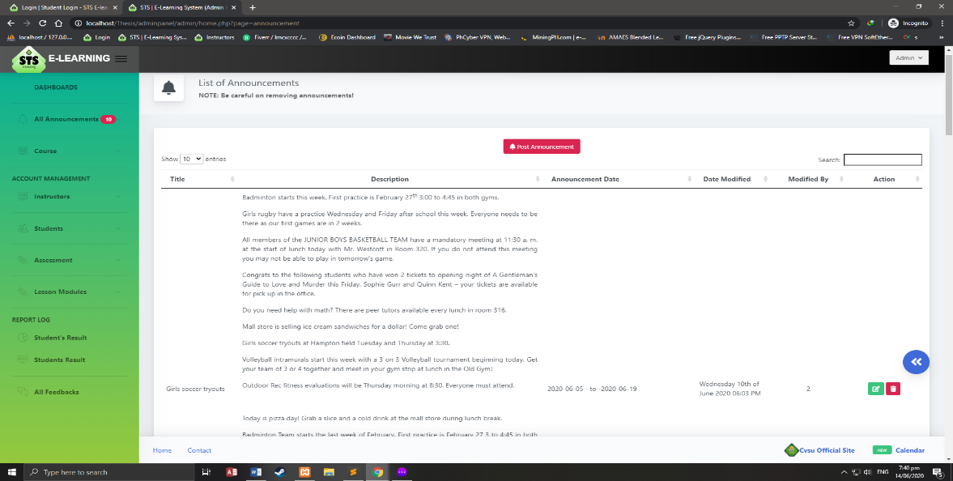Complete 70%*

Figure 5: Announcement Module

This is the sample output for Announcement Module. This module is used to post announcements, news, upcoming exams, etc. so that the students would be updated. In this module, only the instructors and Administrator can post any important announcement about the subject.

**Week 7 – October 9 – 13, 2021**

* From October 9 to 31, we can't start our system because we have a problem in our equipment. We can't buy a new parts because we are lack of money to buy a new one.

**Week 8 – November 16 – 20, 2020**

* From November 1 - 19, we didn’t do the other modules because the laptop that we are using for coding was not working or crushed. From November 16, we bought a part for a cheaper price and start working in our system.

**Week 14 – December 7 – 12, 2021**

* By this week, we still working in our system but in the unlikely event, the pc that we are also using for coding was crushed and we are now finding a way to fix it.

**Week 18 – December 25 - 29, 2021**

*Actions Taken*

* *Creating the Graphic User Interface (GUI) for Assessment Module.*

*Accomplishment / Output and Remarks*

* 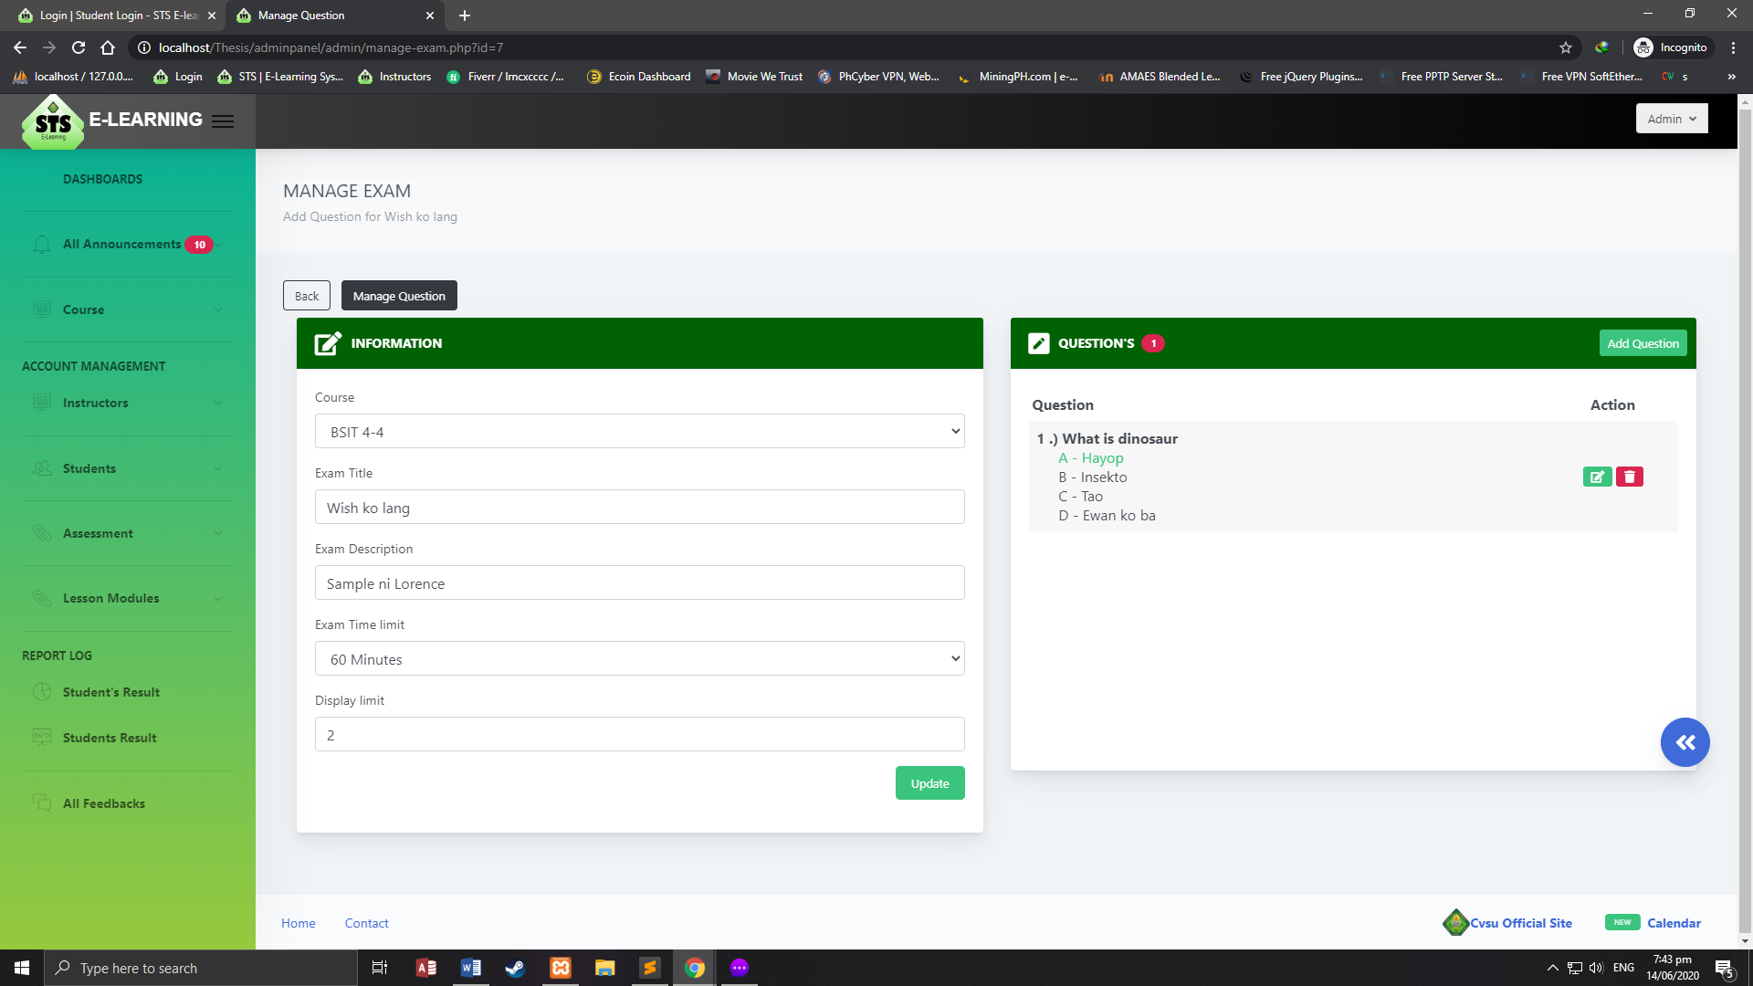*Complete 70%*

Figure 6: Assessment Module

This is a sample output for Assessment Module. This module is use to take exams, quizzes and assignments. The instructors and admin can edit, delete, add, and view and the students can do the assessment.

**III**. **BRIEF SUMMARY OF THE COMPLETION OF THE SYSTEM**

|  |  |  |
| --- | --- | --- |
| **RESEARCH OBJECTIVES** | **ACTIONS TAKEN** | **PERCENTAGE OF COMPLETION** |
| 1. Identify problems encountered both by the students and the research coordinators using surveys and interviews | Survey questionnaires and interview report  *** attach the questionnaires, summary of the answers in the interview, the survey, the graphical representation based on the survey results, etc. based on the tools that you used in gathering / collecting the data in Appendices so that, the reader/s can clearly see the details on your diagram. Then call the Appendix Figure number that correspond the document. Then call the Appendix letter that correspond the document | Completed |
| 1. Analyze the problems through fishbone diagram | *** provide another copy of your Fishbone Diagram in Appendices so that, the reader/s can clearly see the details on your diagram. Then call the Appendix Figure number that correspond the document | Completed |
| 1. Design and develop a module that will 2. lessen the time consumed in monitoring he researches of the college 3. minimize the inconsistency of the data entry 4. help the students in tracking the thesis/study title if it is already existing or not. | *** in each modules call the Figure number that correspond the discussion based on Week 1-18   * ***Account Management Module* –** In this section, where users can create an account to enter and access different features of the program. Each module offers three forms of level of access rate – the administrator, the instructors and the students. The administrator has the priority level of access which can add instructor, add student, update every profile and change the passwords of the registered students and instructors' accounts. Only students can be added their own profile updated and their password changed. The students may only update their profile and change their password. For the purpose of security, the administrator manages all the files and profiles inserted into the system database (see Figure ___)   *** Apply to all this concept…   * ***Assessment Module* –** In this module, it acts as an assessment of the students' instructors. This module includes all quizzes, activities and assignments. The teachers and administrator can only add, edit, delete and view these and the students will take the assessment. The type of the quizzes is fill in the blanks, enumeration and multiple choices. * ***Lesson Module* –** This module includes all of the class references and lessons that are added to the program. The lessons are supervised by the administrator and instructors when adding modules, the administrator and instructors are the one who manages the uploading of the lesson data. The lessons uploaded that include multimedia forms, such as videos, photographs, texts and audios viewed by the students. * ***Announcements Module* -** This module contains administrator and teacher updates and reminders for each of the students and sections that they manage. * ***Report Module* –** Through this, it can easily project various collected data from all the users and all the activities. In this module, report logs can be generated for the administrator, the instructors and the students. All lists of students enrolled in the subject, list of instructors handling STS and student grades can be downloaded and printed by administrator, and the instructor can only print out the list of the students and grades of the students they are handling. | *** provide percentage here in each module based on your Week 1-18 discussion above |
| 1. Test the system functionality using unit testing and system testing. | Unit testing/system testing |  |
| 1. Evaluate the system using ISO 9126 | *** |  |

*** insert here the Appendices to support your discussion

**IV. INSIGHTS**

We have a lot of experiences and developments when the Covid-19 pandemic started. Due to the pandemic, we realize in the current event that time and life are precious. We 're just doing our daily routine before the whole event happens that we don't know what's going to happen in another day. And all of us affected by the pandemic happen. The situation that we face today has positive as well as negative consequences for us. The positive impact will give us time for ourselves, for our friends, and because of less noise, nature is curative. The adverse consequence is that certain households are unable to afford a basic need and experience deprivation. We just hope this pandemic will stop.

Prepared by:



**LORENCE V. ALMADRIGO**

**JOHN PHILIP V. GADO**

Recommending Approval:

**AIZA E. BIHIS RACHEL O. RODRIGUEZ**

Thesis Adviser Technical Critic

**GLADYS G. PEREY MARIVIC G. DIZON**

Unit Research Coordinator College Research Coordinator

Approved by:

**DAVID L. CERO, PhD**

College Dean