Lab Protocol Nº 1
Building and Manipulating 3D Models of
Amino Acids and Small Peptides

Biostructure Modeling - Q3009

Abstract

Installation and utilization of the open-source software Avogadro.
Analysis of the three-dimensional structure of proteinogenic amino acids.
Study of the peptide bond and the concept of dihedral (torsion) angles.
Manipulation of molecular models and geometry optimization

Structure of Amino Acids and Peptides

The general structure of an amino acid consists of a central carbon (Cα) bonded to an amine group, a carboxylic acid group, a hydrogen atom, and a variable side chain (R):
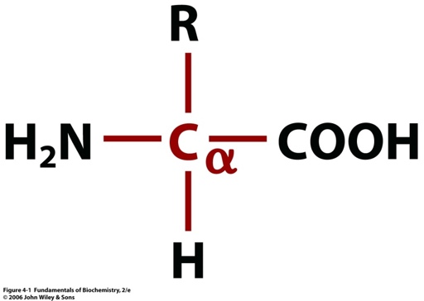

The average pKa values of the amino and carboxylic acid groups are approximately 9.4 and 2.2, respectively; consequently, amino acids are often present in the form of a dipolar ion (zwitterion).
The properties that distinguish each of the 20 amino acids encoded in DNA are determined by the nature of the side chain (R group). The structures and nomenclature of these amino acids are provided in the annex. The central carbon atom (Cα) is a chiral center, except in the case of glycine, and thus amino acids exhibit optical activity. The two possible enantiomers are generally designated as L- or D-, and, in the presence of a molecular model, they can be identified using the CORN rule. However, only L-amino acids are incorporated into proteins in living organisms.
Amino acids are linked through peptide bonds:

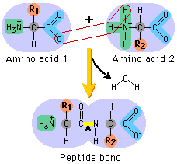

that are stabilized by resonance, which results in the coplanarity of the C, O, N, and H atoms:
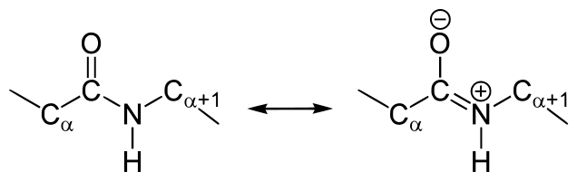
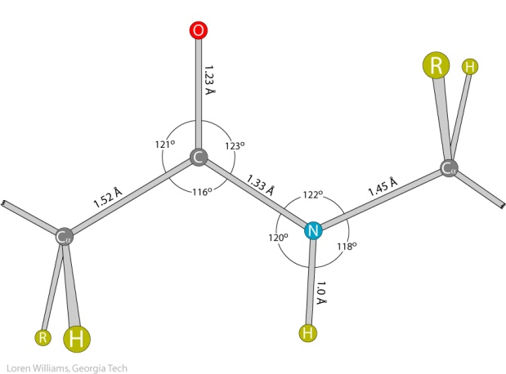

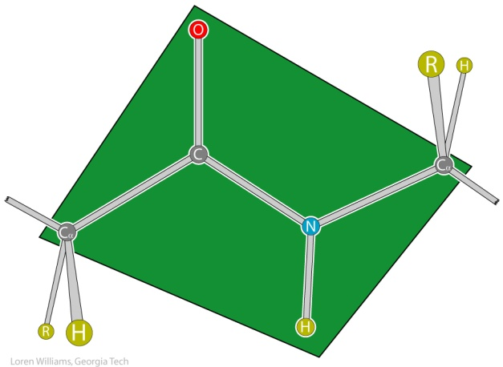

The dihedral (torsion) angle, ∠(k, i, j, l), quantifies the rotation around the bond i - j.

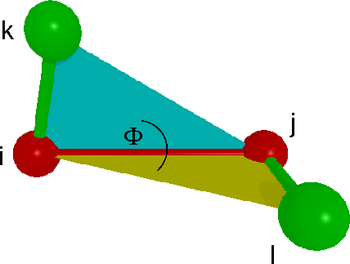
∠(k, i, j, l) = ∠(l, j, i, k)

The C, O, N, and H atoms of the peptide bond are coplanar, which promotes electron delocalization through resonance. Consequently, the dihedral angle ωᵢ, defined by ∠($C_{i}^{α},C_{i},N_{i+1},C_{i+1}^{α}$), can adopt values of 0° or 180°. However, the value is 180° in the vast majority of cases.
Other important dihedral angles that define the geometry of peptides and proteins are Φ (phi) and Ψ (psi), defined as follows:
Φ = ∠($C_{i-1},N_{i},C_{i}^{α},C_{i}$) Ψ = ∠(${N_{i},C}_{i}^{α},C_{i},N_{i+1}$)

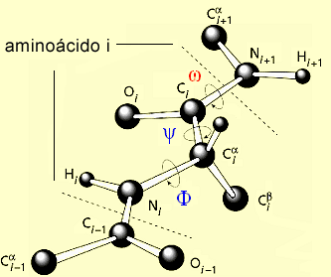
amino acid i

Practical Exercises with Avogadro Software

Setup: Install the "molecules" package via the Plugin Downloader in the Extensions menu.

Exercise A: Modeling L-Cysteine (Cys)
- Open the file L-cysteine.cml.
- Use the Navigate tool to rotate, translate, and scale the model. Explore different Display Types.
- Verify the L-enantiomer configuration using the CORN rule.

Exercise B: Building the Cys-Ala Dipeptide (Atom-by-Atom Method)
- In the Cys model, use the Draw tool to remove the O and H atoms from the carboxyl group.
- Select Nitrogen (N) and bond it to the carbonyl carbon. Continue adding atoms to construct the Alanine residue.
- Geometry Optimization: Select Extensions > Open Babel > Optimize geometry to achieve a chemically stable conformation.
- Analysis: Use the Measure tool to determine bond lengths, bond angles, and the ω dihedral angle (selecting O-C-N-H).
- Manipulation: Use Bond Centric Manipulation on the N-Cα bond to adjust the dihedral angle to a structurally acceptable position.
- Export: Save the final structure in .pdb format.

Exercise C: Building the Cys-Leu Dipeptide (Model Merging Method)
- Open the separate models for Cysteine and Leucine.
- Use the Selection tool to copy and paste the Leucine model into the Cysteine window.
- Remove the overlapping atoms (O and H from Cys carboxyl; H from Leu amine) and establish the peptide bond by joining the C and N atoms.
- Perform a final geometry optimization

IUPAC rules : http://www.chem.qmul.ac.uk/iupac/AminoAcid/

Annex



