Lab Protocol Nº 2
Protein Data Bank and VMD

Biostructure Modeling– Q3009

Abstract

The Protein Data Bank (PDB) is a repository of three-dimensional structural data for large biological macromolecules, such as proteins and nucleic acids. The data, typically obtained through X-ray diffraction or nuclear magnetic resonance (NMR) spectroscopy, are submitted by researchers worldwide and are freely accessible on the Internet (URL: https://www.rcsb.org).
The database is updated weekly, and as of June 20, 2023, its contents were as follows:

Method | Proteins | DNA | Proteins/DNA | Total
X-ray diffraction | 156692 | 2697 | 8195 | 176935
NMR | 12225 | 1454 | 283 | 14034
Electron microscopy | 10820 | 103 | 3404 | 16239
Total: | 73974 | 2342 | 3512 | 207540

Compare these values with the current data (Analyze >> PDB Statistics).

In addition to atomic coordinates, each entry also includes primary and secondary structural information, details of the three-dimensional structure, and possible interactions with other molecules. This extensive set of structural data highlights the importance of this database for both research and education.
PDB format
A PDB file consists of a sequence of lines containing specific information. Each record line is composed of 80 columns; this format originates from the character limit of punched cards used in early computers. Each structural entry in the database is assigned a four-character code (PDB ID). This identifier refers to the structure rather than the biomolecule itself, since multiple structures of the same biomolecule—obtained under different conditions—generally have distinct PDB IDs.

The various sections and records of a PDB file are outlined below

SECTION DESCRIPTION RECORD TYPE
-------------------------------------------------------------------------------------
Title Summary descriptive remarks HEADER, OBSLTE, TITLE, SPLIT,
CAVEAT, COMPND, SOURCE, KEYWDS,
EXPDTA, NUMMDL, MDLTYP, AUTHOR,
REVDAT, SPRSDE, JRNL
Remark Various comments about entry REMARKs 0-999
Annotations in more depth than standard
records
Primary structure Peptide and/or nucleotide DBREF, SEQADV, SEQRES MODRES
sequence and the
relationship between the PDB
sequence and that found in
the sequence database(s)
Heterogen Description of non-standard HET, HETNAM, HETSYN, FORMUL
groups
Secondary structure Description of secondary HELIX, SHEET
structure
Connectivity Chemical connectivity SSBOND, LINK, CISPEP
annotation
Miscellaneous Features within the SITE
features macromolecule
Crystallographic Description of the CRYST1
crystallographic cell
Coordinate Coordinate transformation ORIGXn, SCALEn, MTRIXn,
transformation operators
Coordinate Atomic coordinate data MODEL, ATOM, ANISOU,
TER, HETATM, ENDMDL
Connectivity Chemical connectivity CONECT
Bookkeeping Summary information, MASTER, END
end-of-file marker

The Human Insulin

In this work, human insulin is used as an example. Its structure was fully characterized by the British chemist Frederick Sanger, who was awarded the Nobel Prize in Chemistry in 1958.
Insulin is a small protein with a molecular mass of approximately 5.5 kDa, consisting of two peptide chains: chain A and chain B. Chain A contains 21 amino acids, with glycine as the first residue. Cysteine at position 6 forms a disulfide bond with cysteine at position 11, resulting in the formation of a small loop within the chain. Chain B contains 30 amino acids; its first residue is phenylalanine and the last is threonine. The two chains are linked by two interchain disulfide bonds formed between cysteines 7 and 20 of chain A and cysteines 7 and 19 of chain B, respectively.
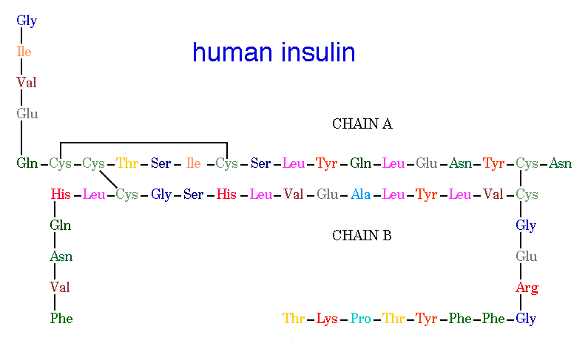
Insulina humana
cadeia A
cadeia B
Human Insulin

Insulin forms oligomers consisting of two monomers, or up to six monomers stabilized by a Zn²⁺ ion; this hexameric form is the one in which insulin is stored in the pancreas.

Lab Protocol
- Visit the Protein Data Bank (PDB) website and consult the information available for the protein insulin.
- Confirm the PDB ID of the selected structure.
- Launch VMD and open the selected file using the automatic download option (Web PDB Download; PDB ID: 5ENA). Manipulate the representations to visualize the structural features of this protein described above.
- Display only chains A and B, which together form a monomer of insulin. Identify the internal region of the protein, characterized by a large number of nonpolar amino acids, such as leucine and isoleucine, forming a hydrophobic core. Also observe the external surface, which is enriched in charged amino acids (lysine, arginine, and glutamate) that interact favorably with the surrounding aqueous environment. Finally, identify the disulfide bonds between cysteine residues that stabilize this small protein.

